Lab #3: Equilibria

Lab Day: Tuesday 2:30-5:30pm

Introduction and Theory

Equilibrium is a dynamic state when the rate of reactants becoming products equals the rate of products becoming reactants. The reaction never goes to completion, but instead continues on in this state indefinitely. In chemical equations, this is represented by a two sided arrow, indicating that the reaction is continuing in both the forward and backward direction at this point. Most reactions reach equilibrium, unless there is a limiting reactant present. In some reactions, the equilibrium favours the products, which means there will be more products than reactants present when the reaction reaches equilibrium. Other reactions are reactant favoured, indicating the opposite. In an industrial sense, reactions that favour the products are more economical than those that favour the reactants. This is why equilibriums are studied. Chemists experiment with ways to alter an equilibrium state by placing stressors on the reaction. Le Chatelier's principle explains what occurs to equilibria when a reaction is affected in a certain way. The reaction will shift to whichever side minimizes the effect of the change. For example, if excess product is added, the reaction will shift to the left to convert the excess product into reactants, establishing a new equilibrium point.¹

Strong acids and bases are identified because they dissociate completely when mixed with water. Weak acids and bases do not completely dissociate. The pH scale measures the acidity (higher concentration of H3O+ ions) or the basic nature (higher concentration of OH- ions) of solutions. With 1 being the strongest acids and 14 being the most basic bases. pH can be determined using indicators which are usually weak acids that dissociate to a certain extent depending on the acidity of the solution it is mixed with. The undissociated and dissociated indicator will have different colours, therefore indicating the strength of the acid/base based on the colour that appears.¹

pH is an important factor in the optimal functioning of the human body. Any big deviation from the optimal pH range (7.35-7.45) is extremely harmful to the body and the health of the person. The human body has a chemical buffer system in the blood that prevents any harmful change in pH. This system works with the respiratory and urinary system to regulate pH in the body. In the blood, weak carbonic acid is in constant equilibrium with bicarbonate, though there is significantly more bicarbonate than carbonic acid in the buffer system. Carbonic acid is very unstable and tends to break down into water and carbon dioxide. Since CO2 is formed in the reaction, this buffer system works in conjunction with the respiratory system. This buffer system works on metabolic acids, such as lactic acid, produced in muscles and organs that are transferred to the blood to be neutralized by the bicarbonate. The body has many methods of returning pH to normal when a change occurs, such as deep breathing and more frequent urination.
¹John W. Hill, Ralph H. Petrucci, Terry W. McCreary, Scott S. Perry, “Chimie des solutions”, Chapter 3, ERPI Sciences, 493 p., 2008

Purpose

The purpose of this experiment is to qualitatively observe different aspects of equilibria, including the effects of adding and removing reactants on equilibrium, multiple equilibria with the silver ion, and a simulated blood buffer system and how it maintains pH.

Procedure

Part 1: Equilibrium Shift

- Add approximately 1mL (20 drops) of 0.1mol/L CuSO4 to a clean test tube.
- Dropwise, add concentrated NH3 solution until a change is observed.
- Dropwise, add 1mol/L HCl until a change is observed.
- Repeat steps 2-3.

Part 2: Multiple Equilibria

- Mix 0.5 mL of 0.1mol/L Na2CO3 and 0.5 mL of 0.01 mol/L AgNO3 in a test tube.
- Dropwise, add 6 mol/L HNO3 until a change is observed.
- Dropwise, add 0.1 mol/L HCl until a change is observed.
- Dropwise, add concentrated NH3 until a change is observed.
- Repeat step 2 then step 4.
- Dropwise, add 0.1 mol/L KI until a change is observed.
- Dropwise, add 0.1 mol/L Na2S until a change is observed.

Part 3: Buffer Solution and Blood pH

- Place 100 mL of distilled water into a 150 mL beaker. Place on a stir plate, insert stir bar and create a smooth vortex in beaker.
- Insert the pH probe and connect to LabQuest 2. Observe pH changes at every step.
- Add 2.50 g of NaHCO3 to the beaker.
- Add 30mL of 0.1 mol/L HCl.
- Add 10 mL of 0.85% lactic acid to the beaker to mimic the body forming a large amount of lactic acid.
- Increase stirring rate to mimic the body increasing respiration to regulate pH.
- Add 0.50 g of NaHCO3 to the beaker to mimic intravenous being given to a critical patient with low pH.
- Add another 0.50 g of sodium bicarbonate to mimic too much being administered.
- Add a pellet of CO2 to mimic the body slowing respiration.
- Add 0.40 g of NH4Cl to the beaker to mimic a dilute weak acid being administered to a patient with critically high pH.

Limitations

For the measurements of liquids in a beaker we were relying on our eyes to make sure the liquid was at the right level, this could result in slight variations in our results. Another limitation was not knowing the exact temperature of the hot plate used for the stirring magnet as we could not be consistent enough with the temperature. In the experiment we were also using droppers to measure amounts of liquid which is also an inaccurate way of measuring.

Observations and Discussion

Table 1. Equilibrium Shift: Change of color of the solution after adding another substance

Original solution: 20 drops of 0.1 mol/L CuSO₄

Step | Change
+ concentrated NH₃ | After 1 drop: color changed from pale blue to dark blue
+ 1 mol/L HCl | After 4 drops: color change starting - From dark blue to sky blue  After 13 drops: solution becomes transparent
+ concentrated NH₃ | After 1 drop: solution’s color comes back to dark blue
+ 1 mol/L HCl | After 21 drops: solution becomes transparent

Table 2. Multiple Equilibria: Change of color of the solution after adding another substance

Original solution: 10 drops of Na₂CO₃

Step | Change
+ 10 drops of AgNO₃ | Colour change from clear, colourless liquid to opaque beige liquid
+ 6 mol/L HNO₃ | After 2 drops: solution becomes clear colourless liquid
+ 0.1 mol/L HCl | After 3 drops: solution becomes opaque - white liquid
+ concentrated NH₃ | After 4 drops: solution becomes clear, colourless liquid
+ 6 mol/L HNO₃ | After 10 drops: solution becomes opaque - white liquid
+ concentrated NH₃ | After 7 drops: solution becomes clear, colourless liquid
+ 0.1 mol/L KI | After 10 drops: solution becomes opaque – off-white liquid
+ 0.1 mol/L Na₂S | After 2 drops: solution becomes opaque, dark brown liquid

Table 3. Buffer Solution and Blood pH: Change of pH in the solution
Original solution: H₂O (pH 5.23)

Step | Change
+ 2.53g of NaHCO₃ | pH higher: 8.14
+ 30 mL 0.1 mol/L HCl | pH lower: 7.12
+ 10 mL of lactic acid | No change in the pH, but after stirring: pH higher: 7.29
+ 0.50g NaHCO₃ | pH higher: 7.40
+ 0.50g NaHCO₃ | pH higher: 7.50
+ 1 pellet of CO₂ (dry ice) | Solution produces white gas and bubbles  pH lower: 7.14
+ 0.40 g of NH₄Cl | pH higher: 7.18

Discussion (split by parts of lab)

Part A (Table 1) discussions

[Cu(H2O)4]2+ (aq) + 4 NH3 (aq) ⇌ [Cu(NH3)4]2+ (aq) + 4 H2O (l)
In the first part of the experiment. Changes in colour were observed as a visual cue of the dynamic equilibrium shifting to favour either products or reactants. Every time a change in colour is observed it is due to the added stress to the equilibrium and the equilibrium in turn shifting to counteract it.
It was observed that when the concentrated NH₃ was added to the CuSO₄ , the colour of the solution changed from pale blue to dark blue. This caused the equilibrium of the solution to shift to the right, in turn forming more Cu(NH3)4 ions. This is the system’s way of dealing with the stress added from changing the concentration of NH3 in the solution in turn causing more product to be produced. This is a prime example of Le Chatelier’s principle of the system’s equilibrium attempting to balance out the change in concentration of reactants and products.
It was then observed that when HCl was added, it shifted the equilibrium the opposite way (to the left) to favour reactants. Causing the solution to return to its original colour. When the concentration of HCl surpassed the equilibrium shifted too much to the left leading it to become fully transparent. When NH3 is added again, it is observed that the equilibrium shifts back towards the right to favour products.
This part of the experiment demonstrates Le Chatelier's principle, this can be seen with every addition of NH3 and HCl working against the equilibrium and the equilibrium in turn shifting to favour products (in the case of NH3) or favouring reactants (in the case of HCl)

Part B (Table 2) discussion

2AgNO3 (aq) + Na2CO3 (aq) ⇌ Ag2CO3 (s) + 2 NaNO3 (aq)
2H+ (aq) + CO32- (aq) ⇌ H2CO3 (aq) H2O(l) + CO2 (g)
Ag+ (aq) + Cl- (aq) ⇌ AgCl (s)
Ag+ (aq) + 2NH3 (aq) ⇌ [Ag(NH3)2]+ (aq)
H+ (aq) + NH3 (aq) ⇌ NH4+ (aq)
Ag+ (aq) + I- (aq) ⇌ AgI (s)
2Ag+ (aq) + S2- (aq) ⇌ Ag2S (s)
This part of the experiment is similar to part A as it is also a demonstration of Le Chatelier’s principle as well as the equilibrium principle. The starting solution is a mixture of AgNO₃ and Na₂CO₃. It is beige in colour. Once HNO₃ is added to the mixture the equilibrium shifts to the right favouring the formation of water and CO₂ gas. In turn causing the mixture’s colour to change to colourless. After adding HCl to the solution, the opposite effect is produced and the solution turns cloudy white. This is due to the favouring of the formation of reactants causing the equilibrium to shift towards the right in an attempt to balance out the acidity of HCl. NH₃ and HCl serve to counteract each other in the experiment. The solution then turns white after the addition of KI this is due to the equilibrium shifting to favour reactants. In the end Na₂S is added to the solution and the solution’s equilibrium is restored and it turns to a beige brown colour. It is important to note however that the colour in the end is slightly different from the colour at the start, this is due to the fact that actual yield often differs slightly from theoretical yield due to the human error of adding in the reactants.

Part C (Table 3) Discussions

2 H2O (l) + CO2 (g) ⇌ H2CO3 (aq) + H2O (l) ⇌ HCO3- (aq) + H3O+ (aq)
Our starting substance in this part of the experiment is water with a pH of 5.23, which is rather acidic because of the solution that was protecting the probe. This section of the experiment is meant to show us how different substances change the concentrations of hydronium ions and hydroxide ions in the blood. We notice that after adding NaHCO₃ , a base, the pH of our starting solution goes up to 8.14. This is due to the increase in hydronium ions in the solution in turn causing it to become more basic. While in this specific case it caused the pH to jump up, NaHCO₃ serves as a buffer to resist the change of pH and keep it constant. When the HCl was added it was observed that the pH of the solution went down to 7.12 from 8.14. Another observation that was made was with the addition of lactic acid. Lactic acid is a byproduct of anaerobic muscle activity and often causes muscle cells to be more acidic. However within the confines of the experiment the pH remained more or less constant. We believe this is due to the NaHCO₃ acting as a buffer for the solution, in turn causing the solution to be resistant to change in pH. It’s then observed that after the addition of more NaHCO₃, it did only slightly changed the pH of the solution to be more basic as opposed to the original addition of NaHCO₃.
When the CO₂ was added, it acted as an acidic agent as it does in the human body. This is why it’s important for us to exhale to lessen the amount of CO₂ in our blood so it doesn’t become too acidic. Even though the change in pH was somewhat significant, it is still apparent that it was held back by the buffer in the solution which caused the solution to originally be resistant to the change. Often the body slows down respiration when it sense that the pH of the blood is too basic in order to cause the pH to return to normal. With the addition of NH₄Cl, the OH- ions increase causing the blood pH to rise back to normal.
Questions

1a) The ammonium ion is used as the acid source instead of HCl because Hcl is a strong acid which can be very poisonous. We used a dilute weak acid in order to not cause any harm to the body.

b) A substance like NH4NO3 would not be used as in canada it is a controlled substance for its use in bomb making, a substance like NH4I poses dangers such as iodine poisoning, even if not enough is used to cause death, it would cause a lot of discomfort.

2) Every time we added an acid to the beaker i noticed that the acid dissociated into the water forming more H+ or H3O+ ions which cause the reaction to move to the left side of the equilibrium. When we added a weak acid to the beaker the pH would rise, this is do to the beaker acting as a buffer solution and the conjugate base being left over.

3) As the blood becomes more acidic there will become an excess of H+ ions that will cause the reaction HbH+ + O2 <> HbO2 + H+ to favour the reactants side thus creating HbH+ and O2 gas, this would result in the oxygen being expelled from the blood and render a patient unable to transfer oxygen through blood.

4) The colour of the blood in water is a bright red because it is enriched with oxygen, the blood that has had HCl added to it turned a dark red colour. The blood turned dark red because an acid was introduced thus causing the blood become acidic and favour HbH+ and O2 gas, the blood is dark red because all of the oxygen has been expelled from the blood.

5) The magnetic stirrer cause the soda to go flat by expelling all of the CO2 gas from the solution. Soda is made by adding CO2 to water(H2O): 2H2O +cO2<> H2CO3 +H2O<>HCO3- + H3O+ removing CO2 from this reaction causes the reaction to favour the right side of the equation thus converting the carbonic acid into H2O and CO2

6) Base on the reaction 2H2O +CO2 <> H2CO3 +H2O <> H3O+ + HCO3-2+H3O+ when a chicken gets hot and start to pant in hot weather their bodies will take in excess CO2 which will put a strain on the above equilibrium and cause it to favour the right side producing more HCO32- and H3O+ thus making their blood pH lower and their eggs stronger.

Conclusion

When a solution is at equilibrium the addition of a reactant causes the equilibrium to shift towards the products and produce more products. When reactants are removed from an equilibrium the products must then be broken back down into the reactants to yet again restore the equilibrium. As we looked at buffer solutions it was shown that with the addition of acids to the solution, the pH of the solution tended to keep close to the starting value. This is due to the fact that when you add an acid to the buffer solution the conjugate base that is already in the solution neutralizes the added acid.

Raw data

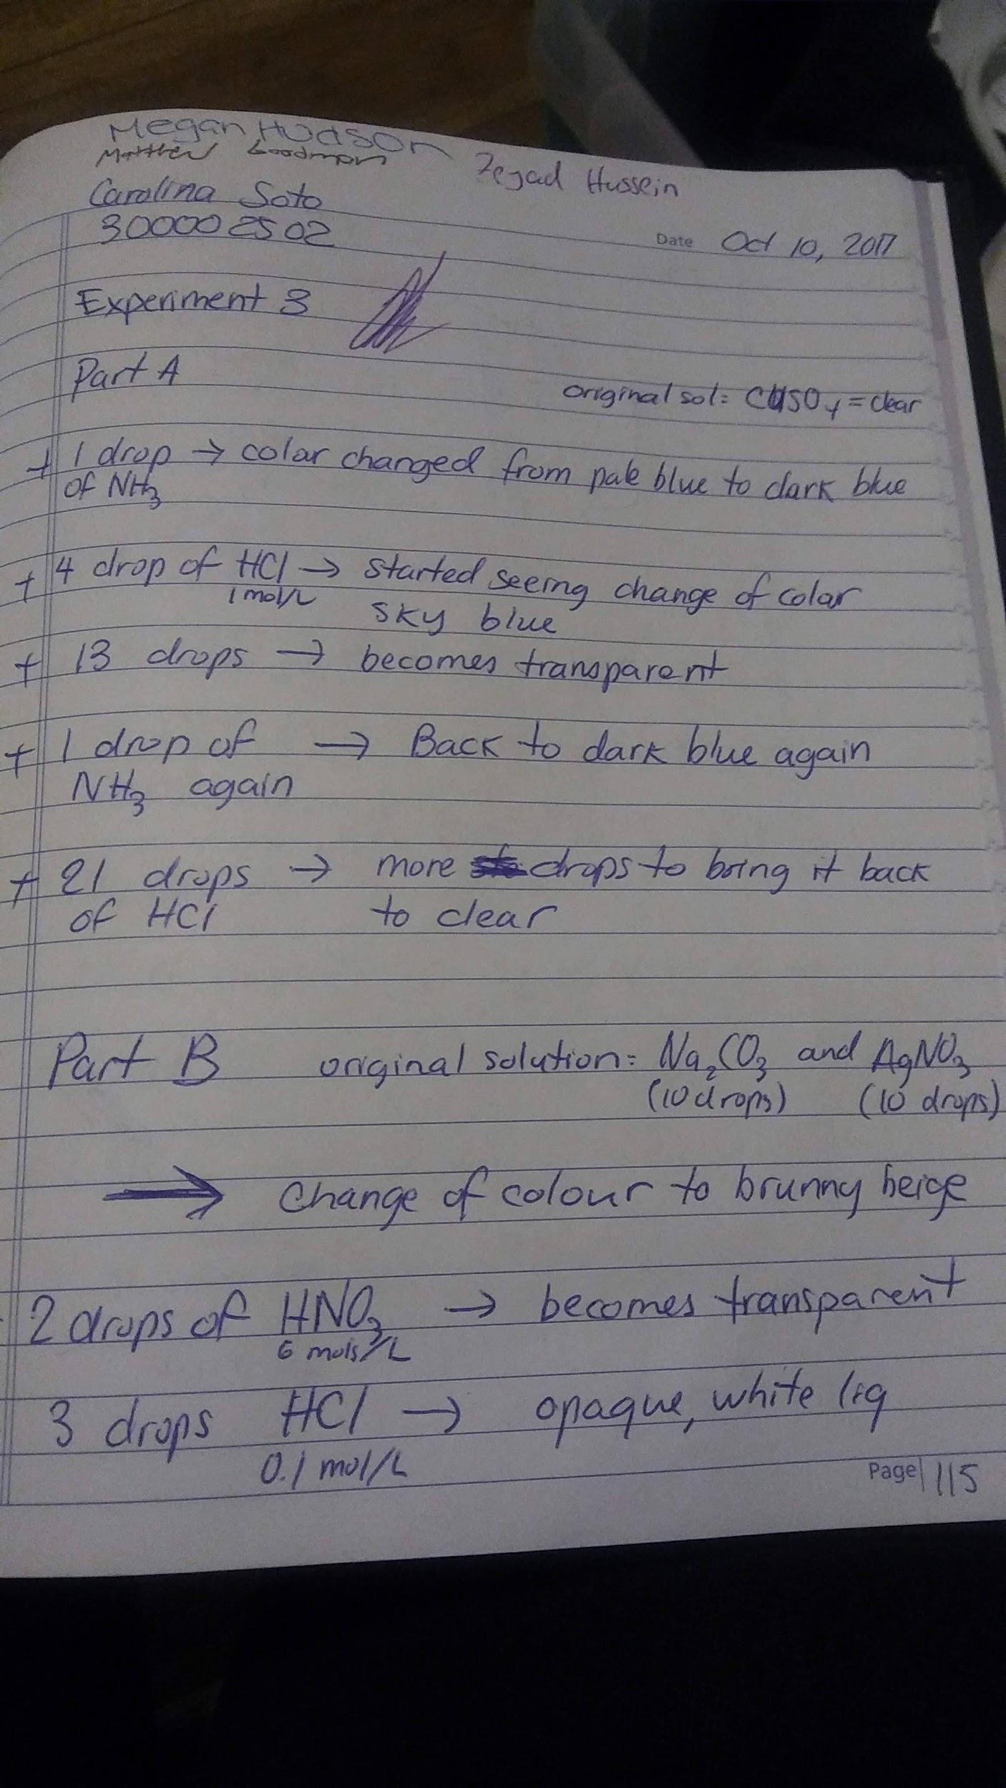
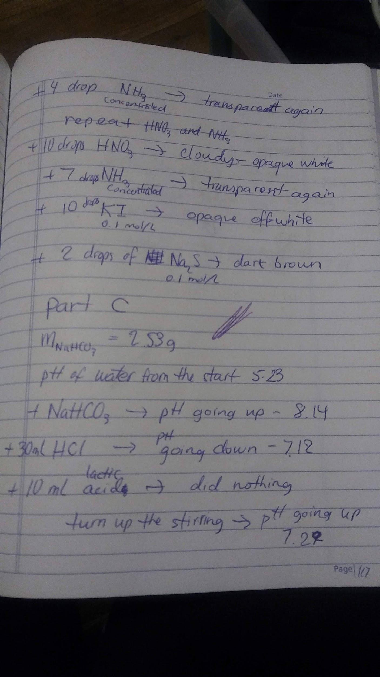
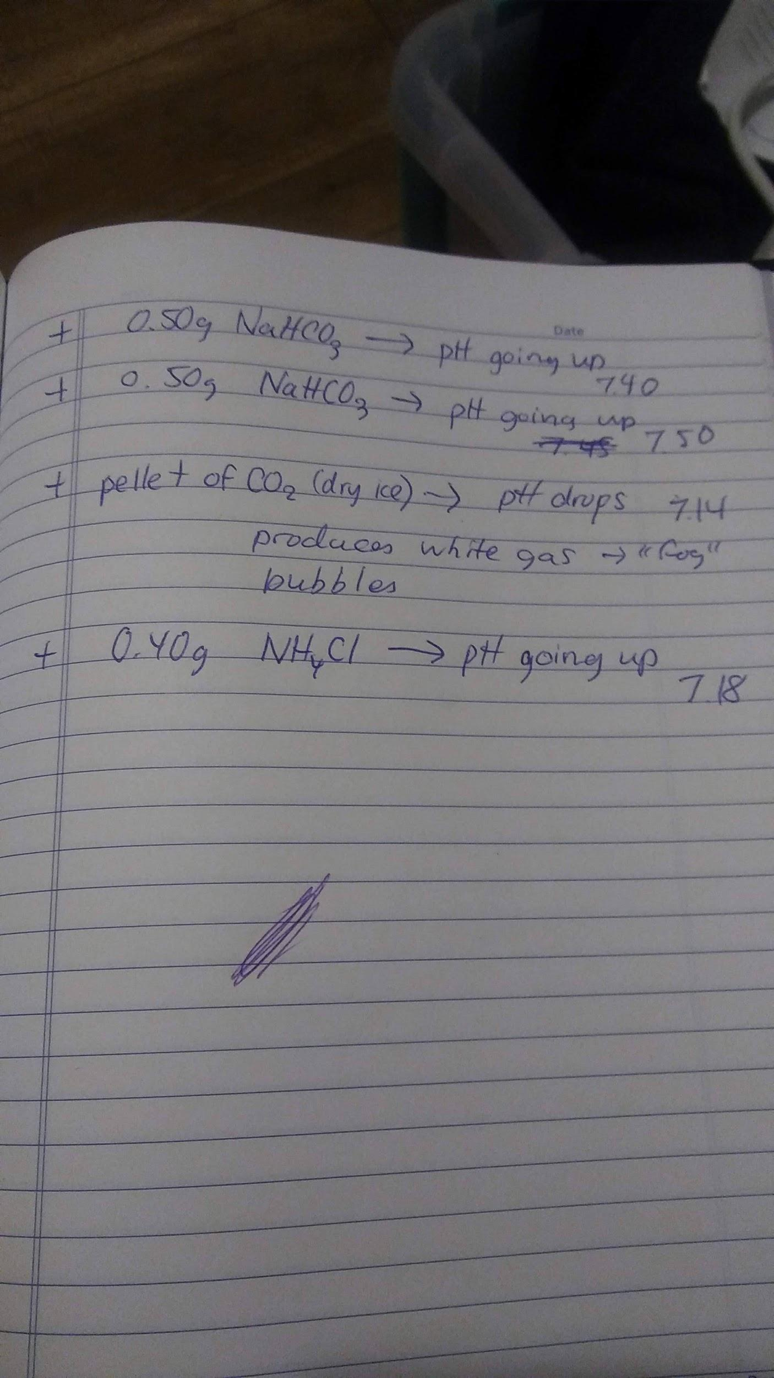

Work Cited

John W. Hill, Ralph H. Petrucci, Terry W. McCreary, Scott S. Perry, “Chimie des solutions”, Chapter 3, ERPI Sciences, 493 p., 2008

