Introduction:
With beverage warmth as a leading issue with hydration in the sports industry, people have looked to science in order to solve this vast epidemic. One specific way to remove heat from a surrounding environment is through an endothermic reaction. Endothermic reactions are reactions that absorb heat. The dissolution of salt in water was chosen as the endothermic reaction as they are soluble at room temperature and are able to absorb enough heat without using too much of the substance. We chose to encapsulate the 100 mL of water in a metal can and surround that can with 100 mL of water all enclosed in an insulated container. A sample of 100 ml of outer water volume was chosen to gain more surface area for a faster transfer of energy. The salt NH4Cl was chosen as it proved to be the most cost effective method to cool the water. For the same amount of energy absorption it would cost an effective $1.60 of NH₄Cl but $1.74 of NH4NO3.

https://www.thoughtco.com/endothermic-and-exothermic-reactions-602105, Anne Marie Helmenstine, Ph.D, 2016.

Procedure:
- Using a 100 mL graduated cylinder, measure and pour 100 mL of water into the pop can.
- Using a top-loading scale, weigh the pop can and record the mass.
- Using a 100 mL graduated cylinder, measure and pour 100 mL of water into the Styrofoam calorimeter.
- Using the LabQuest thermometer, measure and record the initial temperature of the water inside the can.
- For the first trial, add 15g of ammonium nitrate to the water in the calorimeter.
- Insert the thermometer through the tube in the lid of the calorimeter, and set a timer for 5 minutes.
- Gently shake the calorimeter to allow the ammonium nitrate to dissolve into the water.
- After 5 minutes have passed, record the final temperature of the water in the can.
- Repeat steps 5-8 for two more trials with 20g and 25g ammonium nitrate respectively.
- Graph change in temperature vs mass of ammonium nitrate and interpolate what mass is needed to have a change in temperature of 5°C.
- Repeat steps 5-8 one more time with the interpolation result.

Observations:
As we finished the first three trials we realized that our drink can was not as insulated as we hoped it to be so it took significantly more salt to cool down the water. The dissolution
of the salt in water was not a linear exchange of energy, the reaction seemed to cool down quickly to start and then slower near the end.

Data:

Table I. Change in Temperature of Water in the System During the Dissolution of Ammonium Chloride

Trial | 1 | 2 | 3 | 4
Mass of Can + Water (g)  ±0.01g | 106.50 | 105.97 | 106.91 | 106.84
Mass of NH₄Cl _{(s)} (g)  ±0.01g | 25.03 | 19.30 | 15.00 | 22.40
Volume of Water Inside the Can (mL)  ±0.5 | 100.0 | 100.0 | 100.0 | 100.0
Volume of Water Outside of the Can (mL)  ±0.5 | 100.0 | 100.0 | 100.0 | 100.0
Initial Temperature of the Water (⁰C)  ±0.1 | 23.6 | 23.3 | 22.8 | 22.7
Final Temperature of the Water (⁰C)  ±0.1 | 17.8 | 19.3 | 19.5 | 17.0

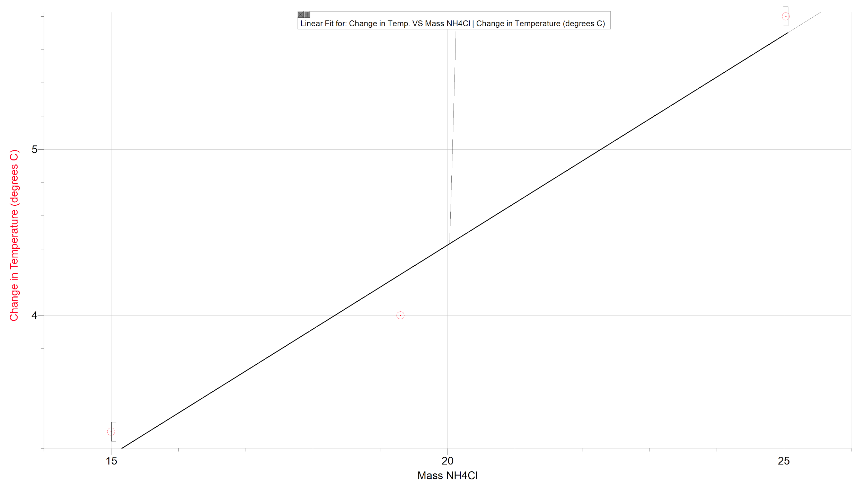

Calculations:

- Theoretical Mass of salt needed to cool water by 5°C:
q= mc△T
We decided to ignore the can, because the specific heat capacity of the aluminium is so low (0.900 J/g °C at 25°C)
http://www2.ucdsb.on.ca/tiss/stretton/database/specific_heat_capacity_table.html

Therefore, we considered the entire calorimeter as one system.

Total volume of water in the calorimeter = 100.0 mL + 100.0 mL = 200.0 mL
1 mL of water = 1 g of water
200.0 mL = 200.0 g

q = ?
m = 200.0 g
c = 4.18 J/g °C
△T = 5.0°C
q = 200.0g x 4.18 J/g °C x 5.0°C = 4.2 x 10³ J = 4.2 kJ

From prelab:
△H NH4NO3 = (△H hydration of NH₄⁺ + △H hydration of NO3⁻ ) + Lattice Energy NH4NO3

Lattice Energy NH4NO3 = -646 kJ/mol
△H hydration of NH₄⁺= -307 kJ/ mol
△H hydration of NO3⁻= -314 kJ/mol

△H NH4NO3 = (307 kJ/mol + 314 kJ/mol) + (-646 kJ/mol) = -25kJ/mol

△H NH4Cl = (△H hydration of NH₄⁺ + △H hydration of Cl⁻ ) + Lattice Energy NH4Cl

Lattice Energy NH4Cl = -705 kJ/mol
△H hydration of NH₄⁺= -307 kJ/ mol
△H hydration of Cl⁻ = -381 kJ/mol

△H NH4Cl = (307 kJ/mol + 381 kJ/mol) + (-705 kJ/mol) = -17kJ/mol

$\frac{4.2 kJ }{17Kj/mol}$= 0.247058 mol = 0.25 mol

Molar mass NH4Cl = (14.01+4x1.00+35.45)=53.46 g/mol
Mol X molar mass = mass
0.25 mols X 53.46 g/mol = 13.365 g = 13 g

Cost NH4Cl = (62.40/500)13= $1.60

$\frac{4.2 kJ }{25Kj/mol}$=0.168mol

Molar mass NH4NO3 = (14.01x2+1.00x4+16.00x3)=80.02g/mol
Mol x molar mass = mass
0.168 mols x 80.02g/mol = 13.44g

Cost NH4NO3 = (64.62/500)x13.44 = $1.74

2. Change in Temperature of Water during the Dissolution of the Ammonium Chloride

For trial 4:
△T = Tf - Ti
Tf = 17.0°C
Ti = 22.7 °C

△T = 17.0°C - 22.7°C = - 5.7 °C

Table II. Change in Temperature of Water Depending on the Amount of Ammonium Chloride Used for the Dissolution

Trial | 1 | 2 | 3 | 4
Tf | 17.8°C | 19.3°C | 19.5°C | 17.0°C
Ti | 23.6°C | 23.3 °C | 22.8°C | 22.7 °C
△T | -5.8°C | -4.0°C | -3.3°C | -5.7 °C
Mass of NH₄Cl_{(s)} | 25.03g | 19.30g | 15.00g | 22.40g

3. Error Percentage

Error Percentage = ( theoretical value - experimental value / theoretical value) x 100
= (13g - 22.40g / 13g) x 100
= 72.307 % = 72%

Discussion:

According to our results, we can conclude that our design is not really effective, because to cool 100 mL of water inside the can by 5.0°C, we had to use 22.40g of NH4Cl, instead of approximately 13g like it was predicted with our calculations. Our error percentage was 72%, which means our results are not exact. These results are due to the insulation of the outer shell used and from the sources of error discussed below. We were aware that 13g would not be enough to cool the water inside of the can so we chose to use 15g, 20g and 25g for our first data points. We then made a graph of these three points so we could interpolate our data to find how much NH4Cl we actually needed to cool the water by 5.0°C. We did another trial using the interpolation of 22.4g and it decreased the temperature of the drinkable water by 5.7°C, proving that this amount is sufficient enough to cool the water, and even giving us room for error as we will not be able to predict the conditions the product will be used in.

Sources of error in lab and suggestions for improvement

The main sources of error for this experiment had been the inconsistencies in the way the procedure had been performed and how the NH4Cl was inserted into the water surrounding the can. We observed that when procedures were not extremely explicit, performers of the lab (in this case us) tended to go about the procedure differently. For example, two experimenters had neglected to consistently shake the containers during the timing process during the first half of their trial. Resulting in inconsistencies with the data gathered in the end.
Another source of error observed was the size of the cans that were inserted into the calorimeter to be cooled. They were not uniform in shape, in turn leading the data to come out differently depending on how much water reacted with the outside surface of the cans. In turn resulting in the data slightly differing depending on which can was used for which trial.

A way to improve these errors is by developing a uniform, concrete procedure for everyone to follow specifically. That way there would be minimal confusion as to how to proceed from step a to step b. Not only is the perfecting of the procedure important, it is crucial for unifying data leading to a clearer conclusion and an overall clearer set of observations.

Conclusion

In summation, this experiment proved successful in showing the relationship between different masses of NH4Cl and their effect on temperature of water. It is also key to note that the original calculations differed from the actual data gathered in the lab. The data proved that 22.4g of NH4Cl is required as opposed to the expected 13g. It was proven that using our design with 22.4g of NH4Cl we were able to cool the drinkable water by 5.7°C.

Raw Data

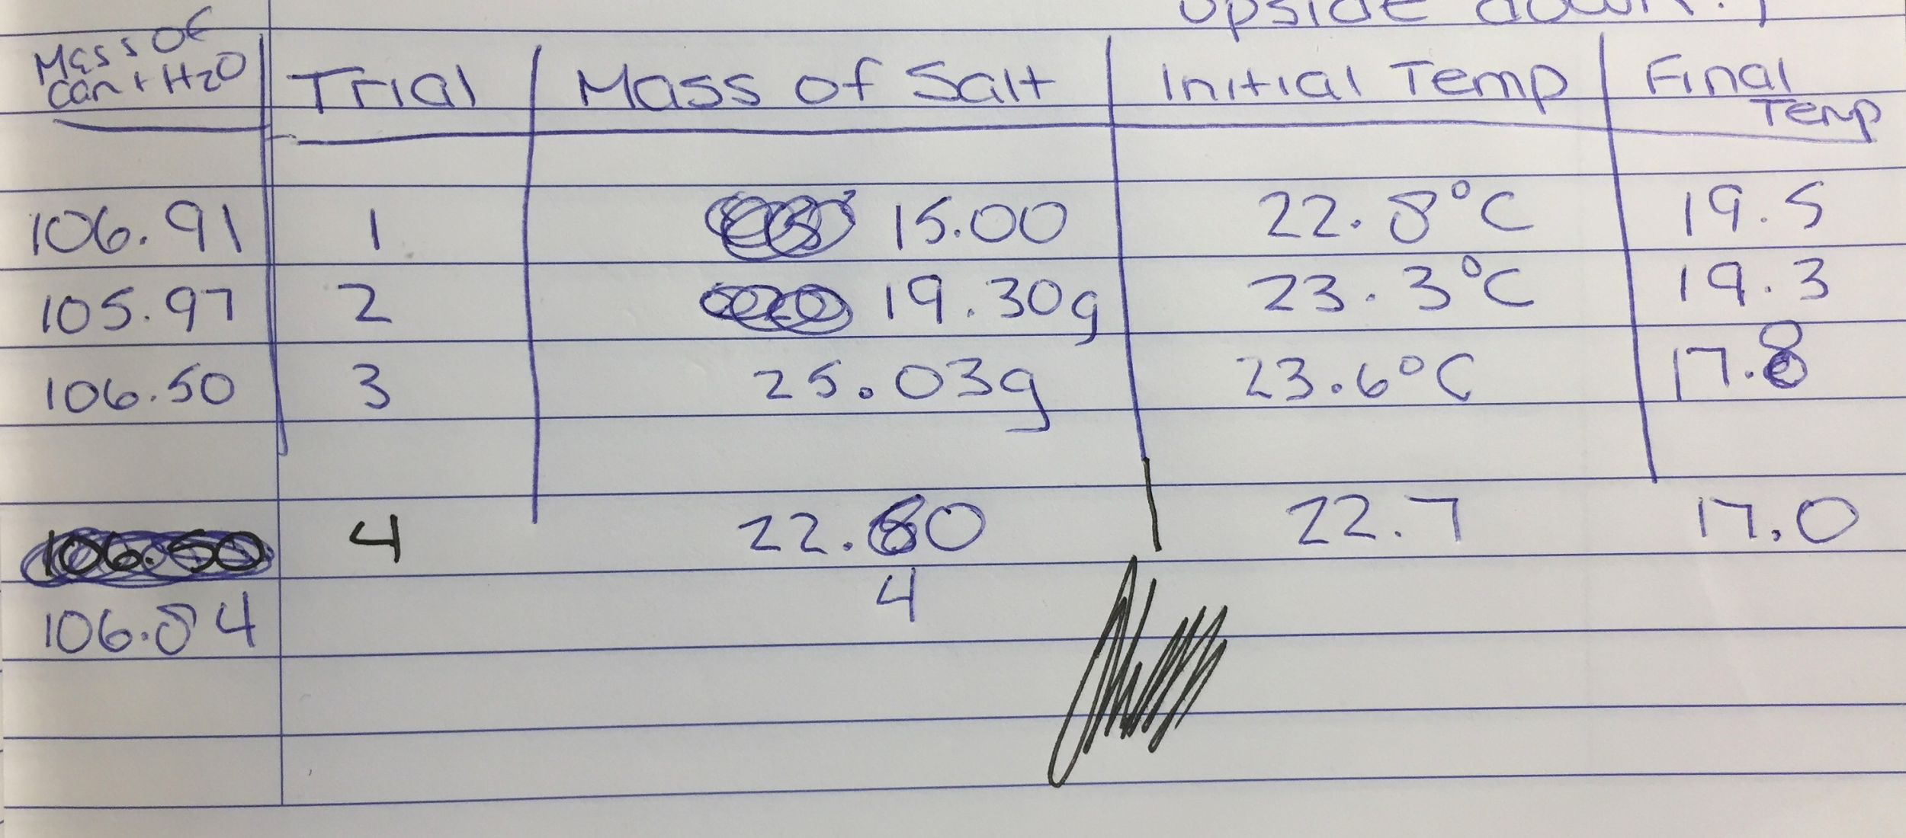

Work Cited
Rogers, Casey. “Ammonium Nitrate in Water.” Chemistry Demonstrations.
Leggett, Rochelle. “What Happens When You Add Ammonium Nitrate to Water?” Sciencing.
Flinn Scientific. “Making an Instant Cold Pack.”



