Interoffice Memorandum
To: | Nancy Mercanti, Sam Mercanti
From: | Victor Mercanti
Subject: | Progress Report (Tractor recommendation for parent’s house)
Date: | November 9 2017

This report is an assessment of the progress I have made of my recommendation as to why you should cancel your landscaping contract and purchase a Kubota BX tractor. This report is a continuation of the previous sample page while also including additional information.
Project Description
This recommendation report started when it came to my attention that you two are spending a significant amount of money each month on landscaping services for your property. The main purpose of this report is to:
- Evaluate the cost of current landscaping services
- Evaluate the uses of a law tractor
- Evaluate the advantages of Kubota BX tractor over John Deere and Mahindra tractors
Progress Summary
Work Completed:
Since the start of the project I have gathered the following information regarding the recommendation.
- The minimum wage in Ontario has increased from just $7.45 in 2005 to $11.60 in 2017 (Government of Canada, 2017).
- The cost of your services is currently$500 each month which add to be $4000 at the end of each year because the services last for 8 months, however will continue to increase due to increases in minimum wage.
- Residential lawn tractors are versatile machines that complete tasks such as mowing, bagging leaves, and moving materials such as mulch, sand, snow, gravel etc. (Wenzel, 2001). A tractor with a mower deck can cut grass through powering a mower shaft that runs power off the engine. There are distinct size mower decks depending on the size of lawn. Tractors with bagging systems suck up the leaves off the ground saving countless hours raking. Front end loader attachments equipped on tractors can carry a wide variety of attachments, a bucket can scoop materials such as dirt, snow, mulch, gravel etc (Everything Attachments.com, 2017).
- The sub compact tractor I recommend for you two is the Kubota BX series tractor with a mower deck and front-end loader. The main and most obvious advantage of Kubota over John Deere and Mahindra is its price.
Here is a table containing the starting base prices of the tractors.

Tractor | Base Price ($)
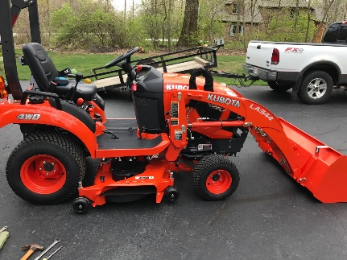  Kubota BX | 12,018
Mahindra EMAX  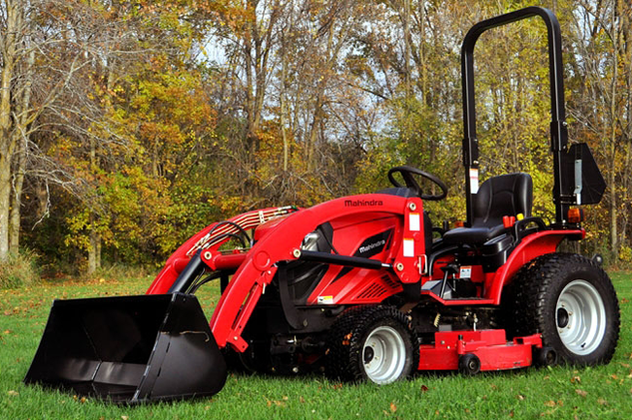 | 16,370
John Deere 1025R  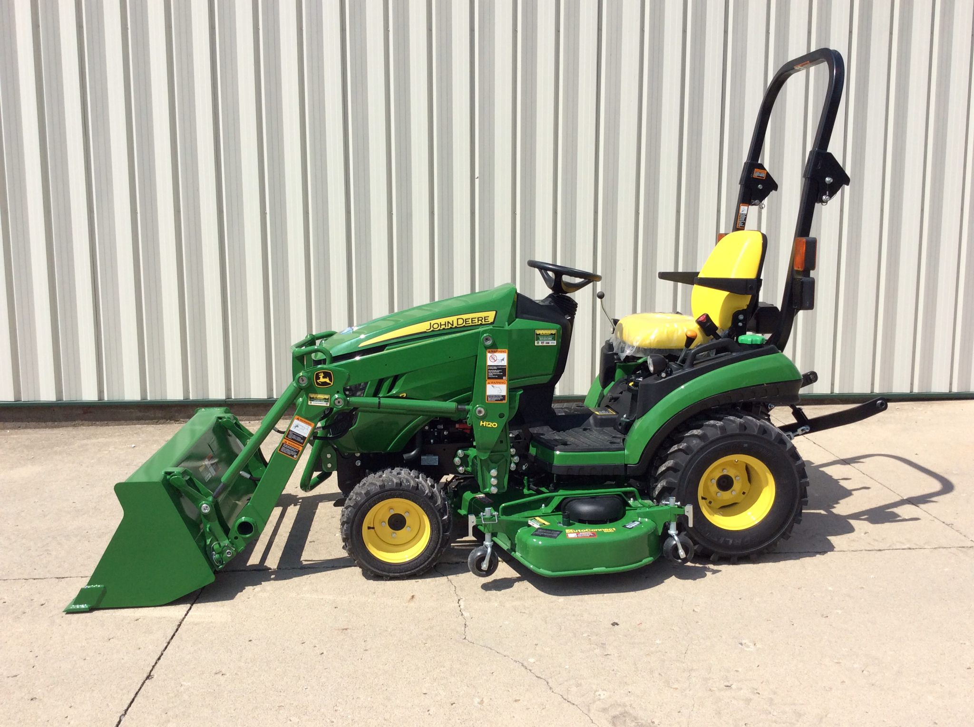 | 17,355
(Kubota.ca, 2017) (Deere.ca, 2017) (Mahindracanada.ca, 2017)

Work in Progress
I am currently waiting to get a response from all three companies regarding the price of a bundle consisting of the tractor, mower deck attachment, and front-end loader attachment. Hopefully each company will be able to offer a special deal because we are looking to purchase multiple attachments for their tractors. The quotes should only take a few business days to finish.

Work planned
It is known that the initial purchase of the tractor is a set back financially compared to the current cost of the landscaping services. However soon to come I will be calculating the time it would take to get your money back if the current landscaping fees were to be paid. This purchase is meant to be a long-time purchase and will save a large amount of money down the road.

Problems Encountered
To this date the only problem I have encountered is the inability to store the tractor at the house. Luckily this is a quick and easy fix because I know you already have an outdoor shed in the backyard, so no extra cost is required. All that is needed is for you guys to organize and eliminate some of the garbage and unused items in the shed, so the tractor has enough room to drive in and out.

Changes Made
The current table provided is only listing the base model prices of the tractors with no attachments. In the final report, a complete table of all the quoted prices of the tractors fully equipped with the mower deck and front-end loader attachments will be compared. Therefore, as of right now, the Kubota BX remains the cheapest option. Also, another change will be the addition of a table consisting of the payments each month for landscaping and the time it would take for the cost of the tractor to be fully paid off from the landscaping fees.

Overall Assessment
Everything contained in this progress report of the recommendation should look promising for the both of you in our endeavour to keep more money in our pockets at the end of the day. Soon to come in the final report I will add more specific and detailed advantages and disadvantages of each tractor other than just the cost while still showing that the Kubota BX tractor is the best option. The Final report will be completed by Friday December 8 2017. I hope I have given you two something to think about. If you have any questions, please feel free to email me at vmerc042@uottawa.ca. Thank you.

References
Everything Attachments.com(2017). Tractor front end loader attachments. Retrieved from
Everything Attachments.com:https://www.everythingattachments.com/Tractor-Front-End-Loader-Attachments-s/11059.htm
Government of Canada. Hourly Minimum Wages in CANADA for Adult Workers.
Retrieved from Government of Canada.
Kubota.ca(2017).BX series. Retrieved from Kubota.ca:https://Kubota.ca/en/products/power-equimoent/tractor-loader-backhoes/bx
Wenzel, W.(2001). Tractor versatility. Retrieved from Farm Industry News:
http://www.farmindustrynews.com/tractor-versatility

