- CHANDLER

- Major Claim:
- to reduce costs of managerial enterprises must combine:

- Economies of Scope – bigger your plant cheaper your cost

- Economies of Scale – same raw materials for one/different products

    - BUT for firms to benefit from these economies they must:
- Keep flow of materials
- Marketing & distribution must be created
- Needs to recruit lower & middle managers

+ Size and diversity are not enough to grow! 2 investments must be made:
- Companies must create national & international marketing & distribution org.
- Companies must hire top manag & lower & middle to coordinate flow of materials

First Mover Advantage – companies that first dominate a market. Very beneficial!
BUT
- Once you lose an opportunity to be First Mover it’s hard to regain competitive advantage
- Companies which do NOT make investments to create organizational capabilities can’t achieve long-term success

- Secondary Claim:
- Unrelated Diversification: when manag acquire busin. in which they have few organizational capabilities.
- Changing Buss. Ownership patterns: when stock markets allow non-managers to become owners of the company
- Growth thought unrelated diversification is poor strategy! (Don’t do it!)
- Innovation and strategy are MORE powerful than price

- GREINER

Major Claim: growth of organizations
- In order for a company to be able to progress it must go through phases of evolution and revolution + constantly be changing its organizational structure.
- Different management styles are appropriate in different phases of life cycle! (Old tactics that work in one phase bring crises to another)
- The future of an organization maybe less determined by outside forces than it’s by the organization’s history

- 5 concepts of organizational growth
- age of organization
- size of organization
- stages of evolution
- stages of revolution – manag. Must find new ways to lead their comp
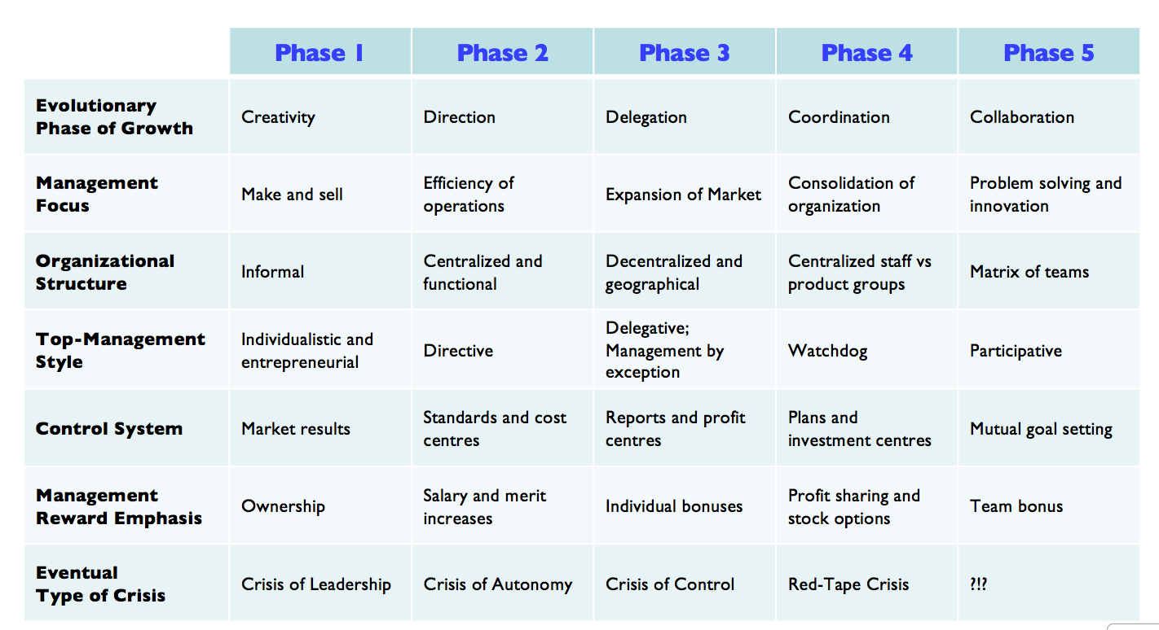
- growth of industry
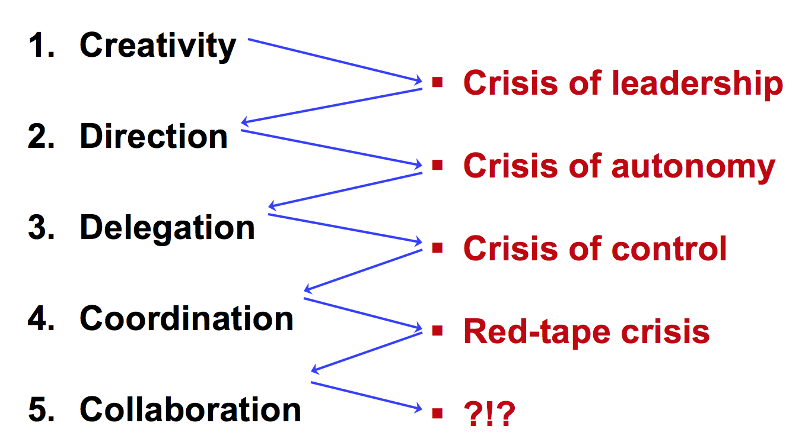
- 5 phases of growth

Greiner says:
- know where you stand in 5 phases + recognize there are NOT many solutions
- Realize that solutions will bring new problems
- Do NOT try to skip steps
- Not right managers can remove themselves from a position!

- TANNENBAUM&SCHIMDT (TEST!)

Who makes a decision now days? Groups or leaders?
‘Authoritarian’ or ‘Democratic’

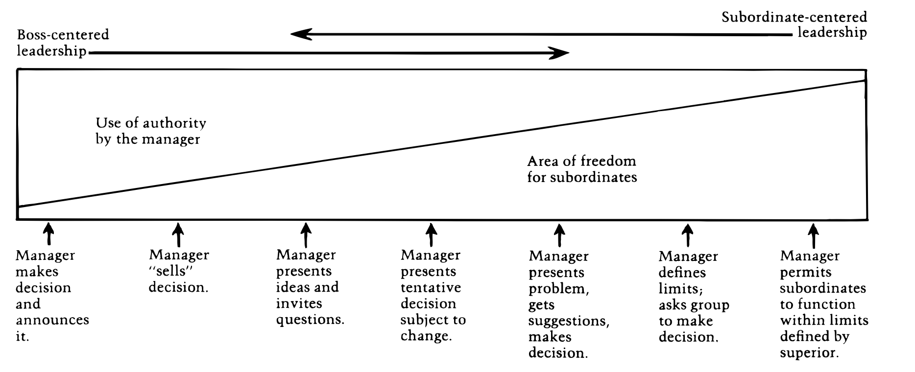
Major Claim: A successful manager can’t be characterized through authoritarian or permissive, but rather through maintaining a ‘high batting average’ in assessing appropriate behaviors at any given time and being able to act accordingly. He does not see leadership as a dilemma.

- Manager makes decision & announces it
- Decision is fully made by boss.
- NO opportunities for subordinates
- Manager "sells" the decision
- Decision made by boss.
- Does try to convince subordinates by providing explanation
- Seeks to reduce resistance by indicating positive sides of decision
- Manager presents ideas & invites questions (same as previous + ability to ask questions)
- Decision made by boss + explains to subordinates thinking and intentions.
- Ability to ask questions. Give & take approach
- Manager presents tentative decision subject to change
- Identifies the problem, considers options and makes the TENTATIVE decision
- Consults with the subordinates for possible issues with the decision
- The final decision is still manager’s
- Manager presents problem, gets suggestions, makes decisions
- Identifies the problem (1st identifies does not just make a decision)
- Consults subordinates for solutions
- Manager makes decision
- Manager defines limits, asks group to make decision.
- Manager defines problem
- Subordinates make decision
- Manager permits subordinates to function within limits defined by superior.
- Same as above but manager is NOT part of the group
3 forces that impact the choice of managerial style:

- Forces in the manager
- Value system (how they feel about individuals making decisions)
- Confidence in subordinates
- Leadership indicators (how they feel about giving orders)
- Feelings of security in an uncertain situation

- Forces in subordinates
- Need for independence
- Readiness to assume responsibility for decision-making
- Tolerance for ambiguity
- Interest in the problem
- Necessary knowledge and experience
- Expectations in decision making
- Understanding of organization’s goals
- Confidence in subordinates (can they be trusted?)

- Forces in situation
- Type of organization (values& relationships)
- Group effectiveness
- Problem itself
- Pressure of time
- Long run strategy

- COLLINS&PORRAS

Major Claim: Companies that enjoy enduring success have core values and a core purpose that remain fixed while their business strategies and practices adapt to a changing world.

CORE IDEOLOGY
Character of an organization. It is the glue that holds the organization together through time
Does NOT change

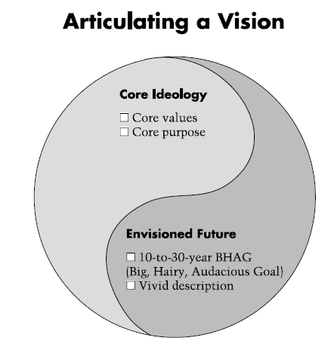
CORE VALUES
What you stand for. HOW
Beliefs about what is important
3-5 values

CORE PURPOSE
Reason for being / 5W’s. WHY
It is to guide and inspire
Lasts forever

- Needs to be meaningful to the people only inside the organization

ENVISIONED FUTURE
What we aspire to become / achieve / create

VIVID DESCRIPTION
Specific description of what it will be like to achieve BHAG.

BHAG
(big hairy audacious goal)
requires 10-30 years to complete

- MINTZBERG

Facts about managers
- Managers activities characterized by brevity, variety and discontinuity. They are action oriented, and dislike reflective activities.
- Managers work involves performing regular duties, including ritual and ceremony, negotiation and processing of soft information.
- Managers favor verbal media, telephone calls and meetings over documents.
- Manager’s program – to schedule time, process information, make decisions..-remain locked deep inside their brains .

Manager Roles
Interpersonal (creating relationship and communicated between people)
- Figurehead: Performing ceremonial duties
- Leader: Responsible for the work of the people in their unit
- Liaison: Making contacts outside the vertical chain

Informational roles
- Monitor: collecting all types of info that is relevant and useful to organization
- Disseminator: Passing privileged information to subordinates
- Spokesperson: Speaks to people outside of the company or plant

Decisional roles
- Entrepreneur: Seeks to improve unit, to adapt it to changing conditions
- Disturbance-handler: deals with disputes/problems
- Resource-allocator: Deciding who will get what
- Negotiator: Negotiate decisions

Steps for effective management
- Insight into their own work
- Find ways to share privileged information
- Make careful decisions by looking at a bigger picture
- Managers and analysts should work together
- Learn to turn obligations into advantages
- Learn to turn things you want to do into obligations

- FRENCH&RAVEN

5 bases or sources of social organizational power

- Reward power
- Power through the ability to mediate rewards
- Coercive power
- Power through negative reinforcement (one has the ability to punish other for not complying)
- Legitimate Power (законный)
- Power based on the assumption that X has the legitimate right to influence Y (ex: in some cultures, older people can influence younger)
- Referent Power
- Power of X over Y based on the fact that Y looks up to X (aspiring identity)
- Expert Power
- Power based on X’s special knowledge or expertise (doctor)

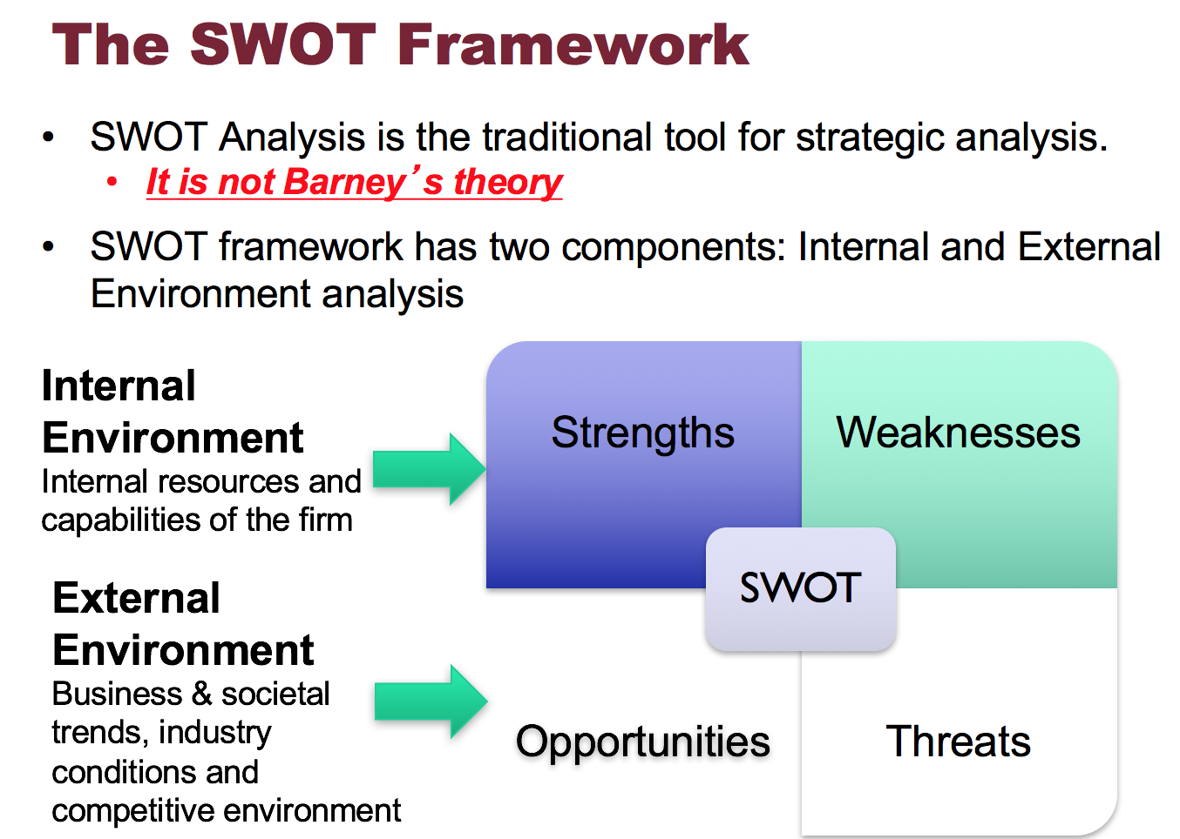
- BARNEY

Major claim: A firm gains competitive advantage if its resources and
Capabilities are valuable, rare, hard and costly to imitate, and
organized in such a manner to exploit potential opportunities.

- External
- SWOT

Firm will sustain competitive advantage, if product is:
- Internal (by BARNEY)
VRIO analysis
- Valuable
- Rare
- Inimitable
- Organization

Firm’s resources and capabilities include all of the financial, physical, human and organizational assets used by a firm:
- Financial: debt, equity, retained earnings
- Physical: machines, manufacturing facilities
- Human: experience, knowledge, judgment, wisdom
- Organizational: history, relationships, trust, culture, patents

- KAPLAN AND NORTON

Balanced scorecard is a strategic and management system that is used in business to align business activities to the vision and strategy of the organization + monitor performance.
- Tracks key elements of a company’s strategy
- Balanced presentation of both financial and operational measures
- It’s a performance measurement system/tool

Balanced Scorecard:
- A set of measures the gives top managers fast but comprehensible view of the business
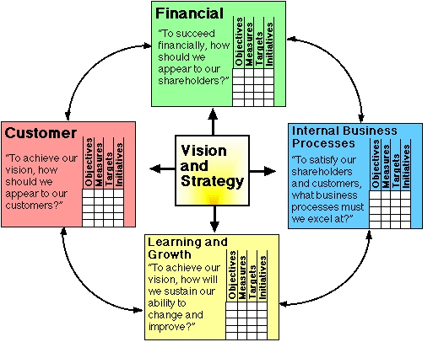
- Financial measures
- Operations Measures

Financial Perspective: How can we ensure profitability/wealth?
Customer Perspective: How do customers see us? What matters most to customers?
Internal Business Perspective: What should we be best at? (Meet customer’s expectations)
Innovation and Learning Perspective: How can we continue to improve and create value?

For every perspective: Goals + Metrics: Measure, Target, Due date
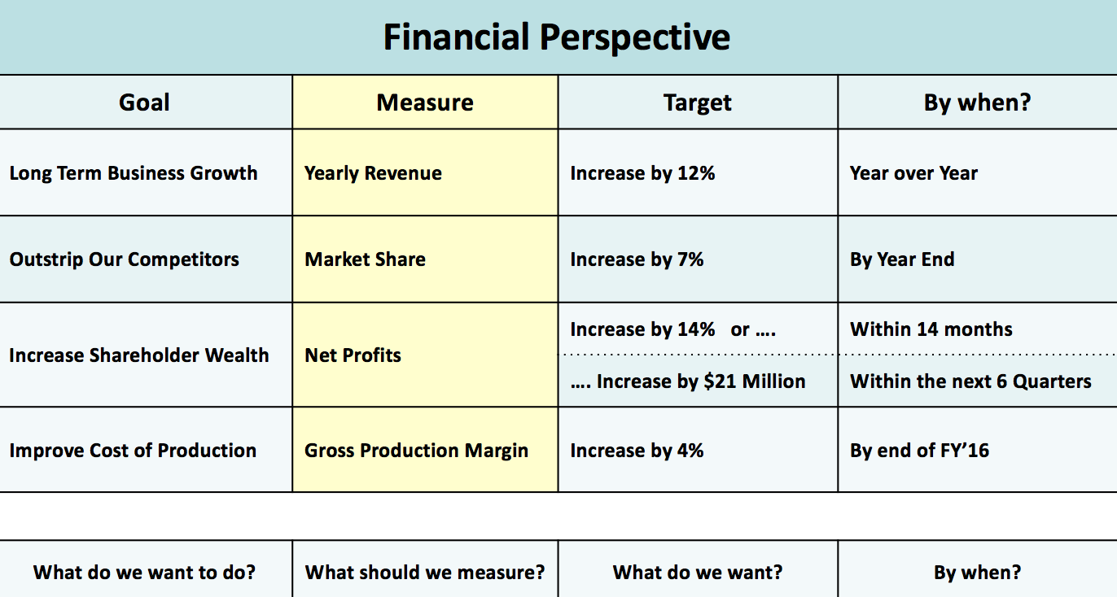

- HANDY & THE SIGMOID CURVE
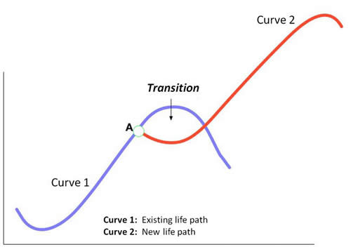
Major Claim: The secret to constant growth is to start a new sigmoid curve before the 1st one peters out

- Do NOT reinvent: 2nd curve is always different, although it is
Inspired by the 1st
- 2nd curve needs the time and resources that only 1st curve can
provide
- Seniors of the 1st curve give permission and encouragement
To the next generation (2nd curve)

Curvilinear logic:
- Means starting life over again
- Everything in the world is a Sigmoid Curve
- Ups and downs
- Does not last forever
- “What got you there will not keep you there”
- Exception to the Sigmoid Curve: Coca Cola 7

Kaizen:
- Continuous improvement

- HERZBERG – Employee Motivation (NOT on the test)

2-factor theory:
- Hygiene factors: Needed to ensure an employee does not become dissatisfied. They do not lead motivation, but without them, there is possibilities of dissatisfaction.
Ex: working conditions, quality of supervision, status, security, salary, interpersonal relations)

- Motivation factors: Needed to motivate an employee into higher performance motivators are the primary source of satisfaction.
Ex: Achievement, responsibility, growth, interest in job, recognition for achievement

Combining hygiene & motivation factors
- High hygiene & high motivation: Ideal situation where employees are highly motivated and have few complaints.
- Hygiene & low motivation: Employees have few complaints but are not motivated. Job seen as paycheck.
- Low-hygiene: Employees are motivated but have lots of complaints. Job is exciting and challenging but salaries and work conditions are poor.
- Low-hygiene & low motivation: Unmotivated employees with lots of complaints.

Job loading
Horizontal job loading:
- Adding tasks to a job but not responsibilities
- The meaning of the job is simply increased
Vertical job loading:
- Adding meaningful tasks that will lead to growth
- Additional tasks that permit growth and provide motivating factors

Job rotation planned rotation of staff between jobs to alleviate monotony (lack of interest & variety) and provide a fresh job challenge.

Job enlargement
Horizontal job enlargement – widening the range of jobs at the same level in the organization and adding them to the existing job. There is little motivation.

Vertical job enlargement (Job enrichment) – provides more tasks, responsibility, authority

APPLE BOOK

Underlying Assumptions – logical link that fills the gap between the evidence and the claim
Casual Claims – Author’s interpretation of cause and effect relationships
Contestable Claims – Opinion
Uncontestable – fact
Rebuttable claim – that goes against the claim of the article

