Week 4 – Ecological Models & Multi-level Interventions

29-09-2017
According to Giles-Corti (2006), what influences PA behaviour?
- People
- Places
- Both
Giles-Corti, 2006
- Re-iterates the interactional influence between people and places and emphasizes the reciprocal influence
  - Presence within environmental realm
  - Role in influencing their surrounding
  - Social influences within places
- As such, both factors must be considered
- Suggests that constructs from different theories strongly associated with PA should be combined within a new model
- Recommends that interventions target specific populations
  - E.g. Market segmentation by attitude toward PA and PA behaviour
- Restricted utilization of recreation centres
- Relationship between active transport and environmental health
- Quality of destinations associated with PA behaviour
- Recommendation Strategies:
  - Mass media
  - Social programs
  - Programs to increase use of recreational facilities
  - Advocacy campaigns
  - Supportive infrastructure
  - Policy that promotes supportive environments and incentives/disincentives
  - Public open space designed for multiple use
  - Workforce development
  - Research evaluation
How Could You Change the Physical Environment to Promote PA?
- Increase opportunities for incidental/utilitarian PA
  - Use traffic calming schemes to get people to walk in Neighbourhoods
  - Invest in public transit to get people out of the cars
- Make approval of new public venues contingent on environmental reviews
  - Accessibility of public open spaces accessible by foot, bike, or public transport
  - Workplaces and campuses linked to walking and cycling network
- Involve experts in PA in:
  - Public policy development
    - Set guidelines for PA
      - E.g. Goal for national, provincial, and community
    - Advocacy efforts
  - Building design
    - Stairs should be designed and position to encourage use
    - School playgrounds designed to promote varied PA and play
  - Cost benefit analysis
    - Economic benefits outweigh clinical costs
    - The price of housing increases with urban design amenities relate to PA
    - PA activities that support health also promote environmental sustainability
Population-level Multiple Intervention in Iceland
- Icelandic Model of Adolescent Substance Use Prevention
  - Population-level impacts on youth substance misuse through the enhancement of a broad range of community-based supports, including family, school, and recreation
  - Youth time spent with parents and in organized sport increased
  - Proportion of youth getting drunk on a regular basis was reduced by over 50% and the proportion of youth who had used hashish by over 60%
Ottawa/Ottawa Infrastructure Developments
- Light rail confederation line
  - Expected to generate $3.2 billion in economic activity
  - 20,000 person-years of employment
  - Approximately 38,000 tonnes reduced carbon emissions per year by 2031
- Construction and infrastructure projects
  - Bridges and pathways
  - Building and parks
  - Cycling projects
  - Sidewalk
If you build it, they will come…but not necessarily
- There are huge economic interests that would suffer if people became more active
- They work hard to promote their products, and PA promoters do not have equivalent budgets
Ecological Model & Indigenous Worldview
- Willingness by Aboriginal peoples to consider both culturally derived and mainstream values, physical activities and delivery systems in order to produce the preferred outcome
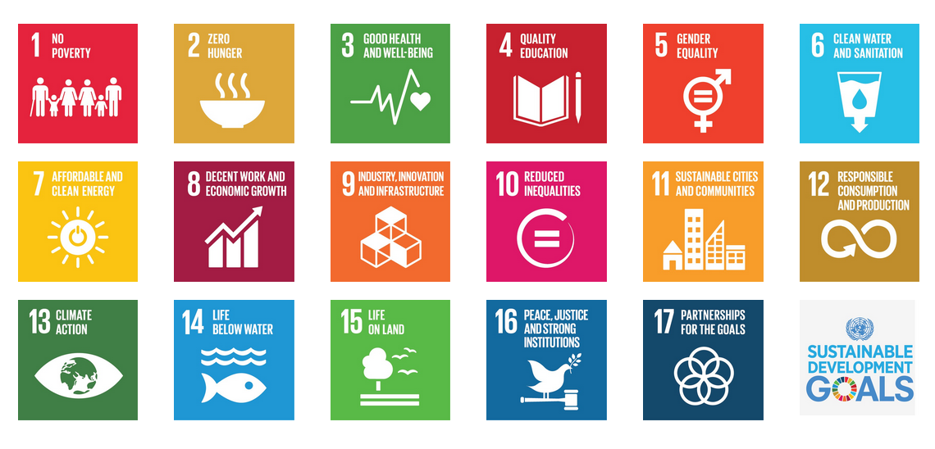
- Integrated indigenous-ecological model
- For sustainable development to be achieved, it is crucial to harmonize three core elements
  - Economic growth
  - Social inclusion
  - Environmental protection
- These elements are interconnected and all are crucial for the well-being of individuals and societies

