Week 2 – Physical Activity Promotion

13-09-2017

Exploring Different Examples of Physical Activity Interventions (Outcome or Treatment)
- Active living campaign (treatment)
  - Promote advertisement to become more active
- Physiotherapy within cancer rehabilitation (outcome)
  - Measuring level of fatigue
- Municipal recreation programs (treatment or outcome)
  - Swimming lessons (treatment)
  - Actually doing physical activity and benefiting from it (outcome)
- Sport-for-development program to support HIV awareness (outcome)
  - Physical activity is being used to grow the awareness and create beneficial outcome
- Personal fitness training (treatment or outcome)
  - Motivate you to be physically active
- Urban environmental planning (treatment)
  - Not doing any physical activity. Working on some type of structure so that people would become more active
- Worksite fitness programs (treatment or outcome)
  - Providing information or providing a way to be active
- Sport-based life skills program (outcome)
  - Using physical activity to create beneficial outcome
- 10th grade physical education class (treatment or outcome)
  - Teaching you how to be independently active and benefits of health
Learning Theory – Skinner’s (1953) Stimulus-Response Theory
- Built on the principle of classical conditioning and instrumental conditioning
- Operant/instrumental condition
- Instrumental conditioning: The notion that behaviour can be learned by pairing the behaviour with consequent reinforcement
  - Consequences are manipulated in order to increase or decrease the frequency of behaviour
- Reinforcer: Any consequence that increases the likelihood that the response will occur again
  - Positive reinforcement: An enjoyable or pleasant stimuli that makes a person feel good and increase a behaviour
  - Negative reinforcement: Remove unpleasant or aversive stimuli that, when withdrawn after a behaviour will increase the frequency of that behaviour in the future
- Punishment: An unpleasant or uncomfortable stimulus after a behaviour that decreases the probability of that behaviour happening in the future
- Extinction: Withholding a positive stimulus after a behaviour in order to decrease the likelihood of that behaviour happening in the future
Learning Theory & Implication for Physical Activity
- Physical intervention positive reinforcement
Learning Theory & Physical Activity
- Very little research that has applied the stimulus response theory to the study of exercise behaviour
- Limitation:
  - Overly simplistic; significant role of cognitions
  - Some concepts not testable
- Schedules of reinforcement:
  - Greatest effect when people are able to see the relationship between their behaviour and the reinforcement;
  - Most effective when it is delivered frequently and immediately after exercise
Social Cognitive Theory (Bandura)
- Self-efficacy: An individual’s perception about their ability to perform a behaviour; situation-specific form of self-confidence
- Four primary sources of self-efficacy
  - Past performance accomplishments
  - Vicarious experiences (if you don’t have pasts experiences and you see someone who is similar to you that has accomplished it, it can have an impact on your self-efficacy)
  - Social persuasion
  - Physiological/affective states (not going to the gym because sick, going to affect the way you think about your capability)
- Vicarious experiences (modeling): Influenced by the similarity between the model and the viewer
- Social persuasion: Most effective with a knowledgeable person or significant other
Physical Activity Related Self-efficacy
- Exercise self-efficacy: Ability to engage in physical activity
- Coping/barrier efficacy: Ability to overcome barriers or challenges to exercise
- Scheduling efficacy: Ability to schedule and manage exercise behaviour
- Task self-efficacy: Ability to complete the exercise task
Self-Efficacy in PA Research
- Strong evidence are the impact of self-efficacy on PA behaviour as well as cognitive and physiological outcomes
- Self-efficacy is also an outcome of exercise
- Limitation: theory is predictive of behaviour only when the behaviour is challenging or novel
The Theory of Planned Behaviour
- Originally the theory of reasoned action developed to predict voting behaviour, was later adapted
- Intention to perform a certain behaviour precedes the actual behaviour
- Identified two determinants of a person’s intentions to perform a behaviour
  - Attitude
  - Subjective norm
- Attitude: An evaluation of an object/subject, ranging from extremely negative to extremely positive (in this case, PA)
- Influenced by:
  - Beliefs about the consequences of the behaviour
  - Evaluation of the consequences (negative/positive)
- Subject norm is influenced by
  - Perceptions about the expectations of significant others
  - Motivation to comply
- Perceived Behavioural Control
  - Theory was later extended by adding the construct of perceived behavioural control
  - Perceived behavioural control: Degree of personal control the individual perceives to have over the behaviour
    - Similar to self-efficacy
- The Theory of Planned Behaviour & PA Interventions
- Change attitudes regarding PA (give reasons why we should do PA)
- Change subjective norms (get people involved in a group that can influence them in doing PA more)
- Limitations of intentions as predictors of exercise
  - Strong predictors of behaviour within a relatively short period of time
Self-determination Theory
- Basic assumption that individuals possess three primary psychosocial needs:
- A need for self-determination or autonomy
- A need to demonstrate competence or mastery
- A need for relatedness or social interactions
- Motivation
  - Motivation: The process that initiates, directs, and sustains behaviour to satisfy physiological or psychological needs; direction and intensity of effort
  - Global motivation: Trait
  - Contextual motivation: Stable pattern of motivation in a particular context
  - Situational motivation: Particular to an activity at a specific point in time
- Continuum of Motivation
  - Extrinsic motivation: Doing something because it leads to a separable outcome
    - Four types of extrinsic motivation:
- Integrated regulation: Engaging in the behaviour in order to confirm one’s sense of self
- Identified regulation: Behaviour is motivated by personal goals
- Introjected regulation: Behaviour is dictated by a self-imposed source of pressure
- External regulation: Engaging in a behaviour for the purpose of obtaining an external reward or avoiding an external punishment
  - Intrinsic motivation: Doing something because it is inherently interesting or enjoyable
    - Highest self-determination
- Self-determination Theory and PA
  - Apply PA interventions that support the three basic needs
  - Apply PA interventions that promote motivation (with a focus on strategies that enhance self-determination)
The Trans-Theoretical Model
- Integrative approach
- Evolved from the work of Dr. Charles Prochaska and Dr. Carlo DiClemente
Focused on smoking; individuals moved through specific stages as they quit
- Five Stages of Change
  - Stage 1 (Precontemplation): Inactive; not thinking about becoming more active; no intention to start in the next six months
  - Stage 2 (Contemplation): Inactive; thinking about becoming more active; intend to start in the next six months
  - Stage 3 (Preparation): Doing some physical activity but not at levels required for health benefits
  - Stage 4 (Action): Doing enough physical activity but for less than six months
  - Stage 5 (Maintenance): Making physical activity a habit; have participated in recommended amounts of physical activity for six months or longer
- Movement through the stages is thought to be cyclical
- Processes of behaviour change: Strategies or techniques that individuals use to modify their behaviour; two categories:
- Cognitive/experimental: Increasing awareness and changing thoughts/feelings
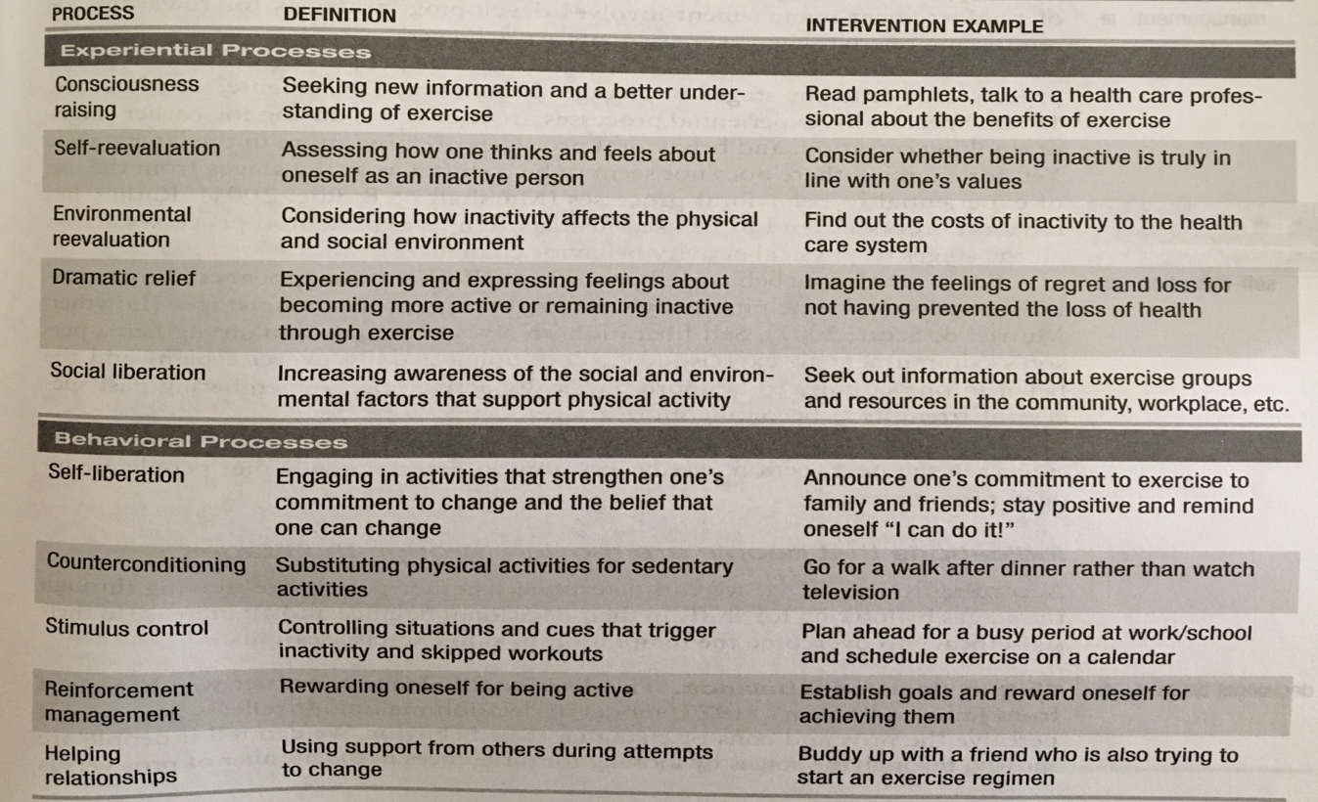
- Behavioural: Behaviours targeted at aspects of the environment that may affect exercise participation
- Trans-Theoretical and Decisional Balance
  - Decision balance: Reflects how people perceive the pros and cons of changing their behaviour
  - Precontemplation: Consider the cons or disadvantages of exercising to be greater than the pros or advantages; resistant to change; stable
  - Contemplation: Aware of the pros and cons; ambivalence; stable
  - Preparation: Perceive the pros to outweigh the cons
  - Action: Pros to outweigh the cons; unstable
  - Maintenance: Pros to outweigh the cons
- Exercise Research with Trans-Theoretical Model
  - Descriptive studies identify that stages of the trans-theoretical differ in terms of
    - Exercise self-efficacy
    - Attitudes toward exercise
    - The use of the processes of change
    - Actual exercise behaviour
  - Limitations
    - Six month cut off is arbitrary
    - Difficult to predict movement between stages
    - May have other sub-groups; e.g. late preparation stage

