NOT AS IMPORTANT:

Chapter 1: The Role of Marketing Research in Management Decisions

The Nature of Marketing

A Definition of Marketing:
The process of planning and executing the conception, pricing, promotion, and distribution of ideas, goods, and services to create exchanges that satisfy individual and organizational objectives.

The Marketing Concept

3 Tenets that are interrelated
- 1) Consumer oriented: Identify the target market and meet the needs most efficiently
- 2) Goal oriented: Satisfy the corporate goals and make a decent profit
- 3) System oriented: Monitor the external environment and deliver the desired marketing mix to the target market (staying in touch with the market changes)

External Marketing Environment

Marketing Mix:
A unique blend of product/service, pricing, promotion, and distribution strategies designed to meet the needs of a specific target market.

Marketing Research

The planning, collection and analysis of data relevant to marketing decision-making and the communication of the results to management.

It is the function that links the consumer, customer, and public to the marketer through information that is used to identify and define marketing opportunities and problems; generate, refine, and evaluate marketing actions; monitor marketing performance; and improve understanding of marketing as a process.

Marketing research specifies the information required to address these issues, designs the method for collecting information, manages and implements the data collection process, analyzes the results, and communicates the findings and their implications.

Why Should Marketing Research Be Conducted?

- Understand customers’ needs and wants
- Identify target market and create matching brand identity and marketing mix
- Understand changes in the external environment and identify opportunities and threats

3 Critical Roles of Marketing Research

Descriptive:
The gathering and presenting of statements of fact, like historic sales trend of an industry.

Diagnostic:
The explanation of data or actions. What changes need to be done. What are the effects (e.g. the effects of package design on sales and its reasons).

Predictive:
The specification of how to use descriptive and diagnostic research to predict the results of a planned marketing decision

The case of EZ Squirt Ketchup
- Heinz focused on kids and the result of the study led to a new bottle design.

Research Value, Return on Quality

Return on Quality: Management objective based on the principles that

- The quality being delivered is at a level desired by the target market.

- The quality level must have a positive impact on profitability.

Social Media and UGC

More people participating in social media (blogs, forums, product reviews, etc)
- User-generated content is unsolicited, honest, and passionate many times
- Millions of comments a day about products/brands.
- About 20 percent of all Tweets are about brands.

The Proactive Role of Marketing Research

- Proactive management alters the marketing mix to fit the emerging patterns in the market.
- Reactive management waits for the change to have a major impact on the firm before deciding to take any action.
- Marketing research can help managers to anticipate the changes in the market trends and customer desires.

Marketing Strategy: A plan to guide the long-term use of a firm’s resources based on its existing and projected internal capabilities and on projected changes in the external environment.

Types of Research Studies

Applied

Research aimed at solving a specific, pragmatic problem. Mostly done by businesses and companies.

- Solves a specific problem
- Better understanding of the marketplace
- Determines why a strategy or tactic failed
- Reduces uncertainty in management decision-making
  - EX: Should the price be raised 40 cents? What name should Toyota select for a new sedan? What commercial has a higher level of recall?

Basic

Research aimed at expanding the frontiers of knowledge rather than solving a specific, pragmatic problem.

- Expands frontiers of knowledge rather than solving a specific problem
- Validate a theory
- Learn about a concept
- Universities, grant recipients, etc. conduct basic research
- EX: testing a hypothesis about high-involvement decision-making or consumer information processing. Most results are reported in journals.

Applied Research Types

Programmatic

Research conducted to develop marketing options through market segmentation, market opportunity analyses, or consumer attitude and product usage studies.
- To realize changes in the market
- To find out potential new segments
- E.g. has its target market changed and if so, how? Does the market exhibit any new segmentation opportunities? Do some segments appear to be more likely candidates than others for the firms marketing efforts? What new product or service opportunities lie in the various segments?

Selective

Research used to test decision alternatives. Usually done after Programmatic Research.
- To test different concepts for new products.
- Conducted after several viable options have been identified by programmatic research.
- During the development of advertising copy, when various product formulations are being evaluated, or when entire marketing programs are being assessed (as in test marketing).

Evaluative

Research done to assess program performance.
- To get feedback about firm’s quality of service
- To assess the efficiency of advertising

Decision to Conduct Marketing Research

Reconsider conducting marketing research under the following circumstances:

- The resources are lacking to do proper research
  - Lack of funds, time, etc

- Research results would not be useful
  - No or limited access to the measures necessary for decision making

- The opportunity has passed
  - Obsolete technology, saturated market

- The decision as already been made, or will not be made
  - The research is done as a formality, lack of belief on the research

- Managers cannot agree on what they need to know to make a decision
  - The objective of the research should be known ahead

- Decision-making information already exists
  - The company knows the characteristics of the market

- The research cost outweighs the benefits of the research
  - The expected value of information should be greater than the research cost

Whether to Conduct Marketing Research
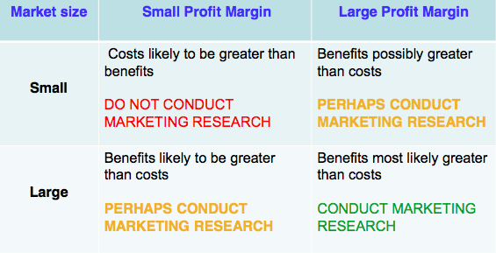

Chapter 9: Online Marketing Research

The Online World

The most popular mode of data collection is performing online surveys.

Online Secondary Data Resources

Statistics Canada: http://www.statcan.ca
Industry Canada: http://strategis.gc.ca
International Trade Canada: www.itcan-cican.gc.ca
Ipsos Canada: www.ipsos.ca
Guide to Market Research: http://www.canadabusiness.ca/eng/page/2691/

Internet and Secondary Data

Using Internet to find proper secondary data and useful information.

Newsgroups: An Internet site where people can read and post messages devoted to a specific topic.
- Threaded discussions
- Needs newsreader software
- Common interest: BMW
- Apple has a forum

Blogs
- Companies use blogs to communicate directly with customers
- Market researchers use blogs to monitor brands, track trends, etc
- Mainly for the exploratory research stage

Evaluating Web Pages

Things to Consider

- What does the URL tell you?
- Is it someone's personal page?
- What type of domain does it come from?
- If the site is up-to-date.
- Look for links that might lead to source data.
- Are sources documented with footnotes?
- Why and when was the Web page created?
- Who created it – what are their motivations / qualifications?
- What do others say about the Web page?

Creating a Database from a Website

Online stores can collect data about their customers much easier than brick- and-mortar retailers.

Customers’ demographics, browsing history, browsing pattern, visited items, purchased items, visit’s length of time, search history, etc can easily be collected and analyzed to make forecasts, develop targeted advertising, and more effective promotions.

Cookie: A text file placed on a user’s computer in order to identify the user when she or he revisits the web site.

Online Qualitative Research

Focus groups can be done online.

Online Focus Groups

Traditional (synchronous) VS. Online bulletin boards (asynchronous)

Traditional: 8 to 10 participants online at the same time, plus a moderate to propose the questions

Online Bulletin Boards: questions are posted for participants each day, and they have all day to provide their responses.
- Usually runs for 2 to 3 days (sometimes longer).
- Each day’s questions are modified based on the previous day’s responses
- Gives participants time to think, talk to others, experience products during the time of the study

Advantages

- Low costs & no geographic barriers
- Engaging hard-to-reach- segments
- It can be executed quickly (no commute is needed)
- Increased openness of the respondents
- Better moderator-client interaction
- Subjects in a more comfortable environment (e.g. their homes)

Disadvantages

- Nonverbal inputs
- There is a loss of group dynamics
- Client involvement is not live, no direct interface
- Possible participants loss of attention to the topic
- Exposure to external stimuli limited
- Limited role and ability of the moderator

Using Video Conferencing for Online Focus groups

- To overcome some of the limitations of traditional online focus groups, virtual interview rooms have been created.

- The moderator and the client can see and hear every respondent.
  - www.webex.com

Online Survey Research

In countries where the characteristics of Internet users are representative of the population’s characteristics, Web surveys can be used as a promising alternative to the traditional surveys.

Advantages

Rapid deployment, real-time reporting – surveys are potentially broadcast to thousands and corporate clients view results instantly.

Reduced costs – low data collection costs; less time than traditional surveys

Ready personalization – results in only pertinent questions being asked; ability to go back and forth; pause and continue later

High response rates – take less time than other forms of surveys; surveys are taken at the respondents’ convenience

Ability to contact the hard-to-reach – allows for busy professionals to take surveys on their own time

Simplified and enhanced panel management – are built and maintained at less cost and time than traditional panels; higher response rate; no demographic or life style question needed

Disadvantages of Online Survey

Misrepresentation – Cannot be used in all countries

Unrestricted Internet sample – Anyone who wishes to complete the questionnaire may do so; problems arise if the user can access the questionnaire over and over

Too Broad – Difficulty may occur in gathering data for smaller/local companies; this data might not be possible to collect on the Internet

Lack of “callback” – there is no way to clarify open-ended responses

Lack of bandwidth – some respondents cannot download photos or complete the survey in a timely fashion

Programming errors – can cause problems when taking the questionnaire or processing data collected
- Lack of technical expertise

Formatting a Survey for Success

Tips for getting better quality responses:

- Be conversational
- Be honest about the time requirement
- Provide open-ended questions
- Do not use “other” as an option often
- Keep the survey less than 20 minutes and provide a progress bar
- Use graphics and interaction
- Share information about a product
- Provide future updates to participants.

Online Survey Methods

Web Survey Software:

Software systems specially designed for Web questionnaire construction and delivery.
- Examples: Sawtooth CiW, Infopoll, Survey Gold

Web Hosting Sites:

Allow the researcher to design a survey online without loading design software.

- Examples: Qualtrics, Voici, Survey Monkey, Zoomerang, etc.

Commercial Online Panels

Commercial Online Panels: Group of individuals who have agreed to do online survey for a particular panel company.

- The panel company provides access to the panel for organizations doing surveys.
- The panels are created for the use of multiple projects by many different companies
- The demographic, lifestyle, and psychographic information is recorded
- Panel provider can target those members with specific criteria needed for a given survey

Panel Management

Panel Recruitment:

1) Open Online Panel Recruitment: Any person with Internet access can self-select to be in a research panel
- Very fast
- Web surfers are asked to join via ads

Drawbacks:
- Lack of control on who is recruited
- The issue of “professional survey takers”

2) Closed Online Panel Recruitment: Inviting only prevalidated individuals or those with shared known characteristics to enroll in a research panel
- Uses the customer information of trusted leading brands with large customer bases.
- This method enables a panel researcher to recruit people with specific demographics into the panel.

Respondent Cooperation

One of the most important drivers of response rate and participation is the incentive program.

Online Panel Incentives

- The sweepstakes model: chance to win a prize of hundreds or thousands of dollar
- The pay-all model: small incentive for each respondent

Controlling the Panel

- Online panel providers must have effective ongoing management of their panel to ensure a high level of quality

- Participants must be monitored to have a positive experience with every research

- Participants privacy should be protected

- Participants should be ensured to remain engaged in the research

- Process incentives are often offered to maintain and grow the number of members

- The members’ profiles should be updated regularly

Mobile Marketing Research, The Next Step

Benefits of Mobile Research and Mobile Technology Prevalence:

- Reaching people on the go
- Pictures and videos
- Time/ date stamps on responses
- GPS locations
- Anonymity for respondents
- Personalized surveys
- Used for: real-time feedback, live product concept testing, point-of- sale customer satisfaction queries,

Disadvantages

- Profile may not reflect the average customer
- Questionnaires must be short
- Question types and length of questions are limited
- Higher incentives must be offered

CHAPTER 15:

CONCENTRATE MORE ON:

Chapter 11: Basic Sampling Issues

The concept of Sampling

Population

The entire group of people about whom information is needed; also called the universe or population of interest.

Sampling

The process of obtaining information from a subset of a larger group.
- Used to estimate the characteristics of the population.

Census vs. Sample

Census:
Data collection from or about every member of the population of interest. Also called canvassing the population by asking everyone a set of questions.

Sample:
A subset of all the members of a population of interest. Hopefully that subset is statistically representative of the general population.

Developing a Sampling Plan

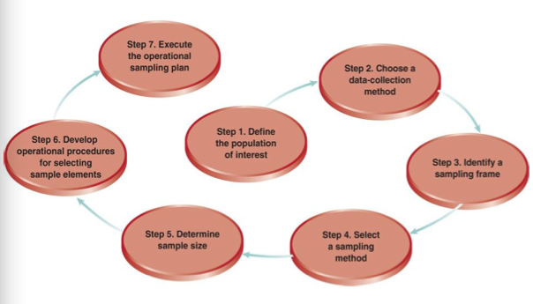

Developing a Sampling Plan
1. Defining the Population of interest

Specify the characteristics of those individual or things from whom or about whom information is needed to meet the research objectives.
- Examples: Geographic areas, demographic characteristics, product usage, etc.
- In survey design, use the screening questions to identify those satisfying the desired characteristics
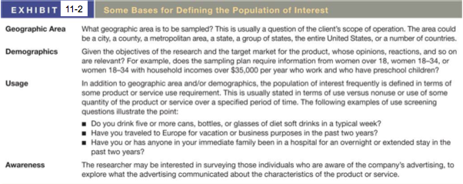

2. Choose a Data Collection Method

This was discussed in previous chapters.

The sample plan will depend on the data collection method, too.

The main methods are:
- Personal, such as mall intercepts, etc.
- Telephone
- Mail or other self-administered
- Internet

3. Identify The Sampling Frame

This is a list of the members or elements of the population from which units to be sampled are to be selected.
- Pool of people you will chose from
- Ex: pop: JMSB students, frame: Mark students

Example of an incorrect frame:
- Use the student list of one section to draw sample elements related to the population of all sections’ students.

There is seldom a perfect correspondence between the sample frame and the population of interest.

4. Sampling Methods

Probability Sampling:
Every element of the population has known nonzero likelihood of selection.
- The chance of being selected is the same for all the elements of population.

Nonprobability Sampling:
Specific elements from the population have been selected in a nonrandom manner.
- Selection is based on convenience.
- In many situations, the nonprobability sample will not differ much from a totally random sample. Hence, the use of it is quite justified considering it’s being easy and inexpensive.

Probability vs. Non-probability Samples

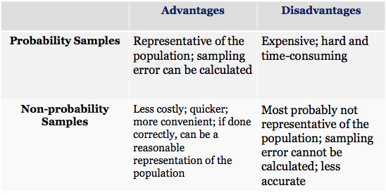

Sampling and Non-Sampling Error

Sampling Error:

An error that occurs because the sample selected is not perfectly representative of the population

Non-Sampling Error:
All error other than sampling error; also called measurement error

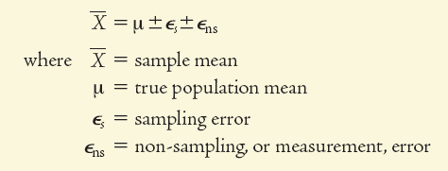

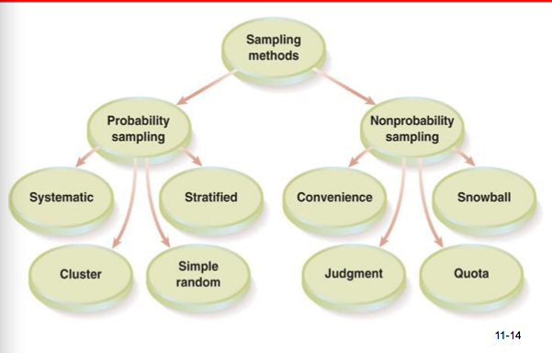

Probability Sampling

Simple Random

A sample selected by assigning a number to every element of the population and then using some method for randomly selecting elements to be in the sample such as random digit dialing.



Systematic

A sample in which the entire population is numbered and elements are selected using a skip interval – every “nth” name is selected.



Stratified

A sample that is forced to be more representative through simple random sampling of mutually exclusive and exhaustive subsets either proportionally or disproportionally. Good for data that are not normally distributed.

Proportional Allocation:

Sampling in which the number of elements selected from a stratum is directly proportional to the size of the stratum relative to the size of the population.

Disproportional, or Optimal, Allocation:

Sampling in which the number of elements taken from a given stratum is proportional to the relative size of the stratum and the standard deviation of the characteristic under consideration.

Cluster

A sample in which the sampling units are selected from a number of small geographic areas to reduce data collection costs.
- The population of interest is divided into mutually exclusive and exhaustive subsets (usually based on geographical proximity)
- A random sample of the subset is selected
- If the sample consists of all elements in the selected subset , it is called a one-stage cluster sample.
- The critical assumption is that the elements in a cluster are as heterogeneous as those in the total population.

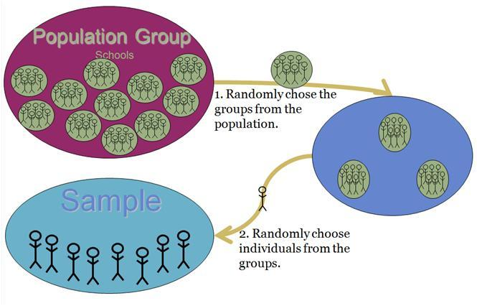

Multistage Sampling:
- Geographic areas selected for national or regional surveys in progressively smaller population units, such as counties, then residential blocks, then homes.

Nonprobability Sampling

Convenience

A sample based on using people who are easily accessible – such as mall intercepts or other high traffic locations.

Judgment

A sample in which the selection criteria are based on the researcher’s personal judgment about the representativeness of the population under study. The researcher selects who should be in the study.

Quota

A sample in which quotas, based on demographic or classification factors selected by the researcher (only based on his interest and judgment), are established for population subgroups.
- The researcher sets a quota, independent of population characteristics and proportions.
- The respondents are not selected randomly

Snowball

A sample in which additional respondents are selected based on referrals from initial respondents.

5. Determine the Sample Size

Sample size determination will be based on factors such as the level of accuracy you want to achieve, the time and money you have to do the survey, and on the sampling collection method.

The actual size could be determined by a formula or by some rule of thumb based on experience.

6. Develop Operational Procedures

The actual and practical procedure of selecting sample units.
Your operational plan to conduct the probability or non- probability sampling. Determine the phases of the sample selection process. Multi-stage sampling involves combining sampling methods.

For probability sampling, these instructions need to be detailed, clear, and unambiguous and should eliminate any interviewer discretion regarding the selection of specific sample elements.

7. Execute the Plan

Conduct Fieldwork

The execution phase of the research. Administering the questionnaire - sending the mailers, making the phone calls, conducting the mall intercepts, etc.

Good training and supervision of fieldwork personnel (if they are used) is of utmost importance.

Internet Sampling

Pros

- Target respondents can complete the survey at their convenience.
- Data collection is inexpensive.
- Survey software can facilitate the data collection process.
- The survey can be completed quickly.

Cons

- Sample might not be representative of the population.
- You cannot always be sure who is completing the survey.
- Maintaining respondent confidentially can be a challenge.
- Data security issues can be difficult to manage.

Chapter 10: Primary Data Collection: Experimentation and Test Markets

What is an Experiment?

A research approach in which one variable is manipulated and the effect on another variable is observed.

Key Variables:

- Independent: variables that are controlled directly such as price, packaging, distribution, product features, etc.
- Dependent: variables that are not directly controlled such as sales or customer satisfaction - (might control them by manipulating the independent variable)
- Treatment: the independent variable manipulated during an experiment to measure its effect on the dependent variable
- Extraneous: Factors one does not control but has to live with such as the weather

What is a Causal Research?

Research designed to determine whether a change in one variable likely caused an observed change in another.

Demonstrating Causation

A causal relationship must demonstrate the following three criteria:

Concomitant Variation:
- A statistical relationship between variables.
- X and Y must vary in some predictable fashion.

Appropriate Time Order of Occurrence (Temporal Sequence):
- Change in an independent variable occurred before an observed change in the dependent variable

Elimination of Other Possible Causal Factors:
- All the possible factors influencing the dependent variable (other than the ones under study) should be controlled.
- Spurious Association? Sun causes both ice cream consumption and sunburns to go up but the 2 are not related
- Hard to prove that something else did not cause change in the dependent variable.

Experimental Setting

Laboratory

- Experiments conducted in a controlled setting.
- Better ability to control extraneous causal factors.
- Suitable for studying causal relations.
- May not be a good simulation of actual marketplace.

Field

- Tests conducted outside the laboratory in an actual environment, such as a marketplace.
- Very hard to control all extraneous variables.
- Causal relations are difficult to prove.
- Actual market place results

Experimental Validity

- Lab experiments give you more internal validity
- Field experiments give you more external validity

Internal Validity

- The extent to which competing explanations for the experimental results observed can be ruled-out.
- If the observed effects are only due to differences in treatment conditions.

External Validity

- The extent to which causal relationships measured in an experiment can be generalized to outside persons, settings, and times.
- How representative are the subjects and the setting of the experiment of the actual population and environment of interest.

Extraneous Variables

Undesired factors influencing the dependent variable of interest.

History:
Intervention, between the beginning and end of an experiment, of outside variables that might change the dependent variable.
- Effects outputs

Maturation:
Changes in subjects occurring during the experiment that are not related to the experiment but which might affect subjects’ response to the treatment factor.
- Ex: experiments are too long and subjects get bored or tired and changes results
  - Hungry, irritated
  - External factors effects subjects

Instrument Variation:
Changes in measurement instruments (e.g., interviewers or observers) that might affect measurements.
- Ex: Interviewer gets bored, and affects results, use 2 different interviewers for different results

Selection Bias
Systematic differences between the test group and the control group due to a biased selection process, not because of treatment condition.
- Ex: all girls in one sample, all boys in another sample

Morality:
Loss of test units or subjects during the course of an experiment, which might result in a non-representativeness.
- Apple vs. Samsung

Testing Effect
An effect that is a by-product of the research process itself.
- Research process effects respondents
  - Ex: boring, effect, mood effects response

Regression to the Mean
Tendency of subjects with extreme behavior to move toward the average for that behavior during the course of the experiment.

Controlling Extraneous Variables

Randomization:
- The random assignment of subjects to treatment conditions to ensure equal representation of subject characteristics.

Physical Control:
- Holding constant the value or level of extraneous variables throughout the course of an experiment.
- Keep level of extraneous variables constant, or eliminate
- Ex: temperature constant, time of day
  - Matching the subjects in different treatment conditions can be another option.

Design Control:
Use of the experimental design to control extraneous causal factors.

Statistical Control:
Adjusting for the effects of extraneous variables by statistically adjusting the value or the dependent variable for each treatment condition.

Experimental Design, Treatment, and Effects

Experimental Design:
- A test in which the researcher has control over and manipulates one or more independent variables.
  - It includes four factors: the treatment (independent variable) to be manipulated; the subjects (participants) of the experiment; the dependent variable; some plan for dealing with extraneous causal factors.

Treatment Variable:
The independent variable that is manipulated in an experiment.

Experimental Effect
The effect of the treatment variable on the dependent variable.

An experiment may include a Control Group. For the control group, the levels of independent variable will not change (not subjected to the experiment and its treatment conditions). This is the opposite case of a Test Group, which is exposed to manipulation (change) of the independent variable.

Experimental Notation

X= Independent Variable

Indicates the exposure of an individual or a group to an experimental treatment. This variable is something the researcher can change and manipulate (such as prices and new packages). It is hoped that the change in the independent variable will cause a change in the dependent variable.

O= Dependent Variable (Y)

Indicates a variable the researcher cannot change directly. It is hoped that changing the independent variable will cause changes in the dependent variable (sales of the product). Thus the dependent variable is “dependent” on what the researcher does with the independent variable.

Selected Experimental Designs

Pre-Experimental Design:

- Designs that offer little or no control over extraneous factors.
- Simple and inexpensive.
- Not good for testing causal relations, but can be used to propose causal relations (hypothesis building).

Two Key Design Types
- One-shot case study
- One-Group pretest-posttest

Pre-Experimental Design

O = The Measurement of the Dependent Variable
X = The Manipulation/Change of Independent Variable

One-Shot Case Study: XO1

Change the independent variable, then measure the dependent variable.
- No pre experiment measurement
- No pre-test observations are made
- No control group involved
- No effects of extraneous variable can be found
- Use when dealing with new product (new concept)
- Nothing to compare to

One-Group Pretest- Posttest: O1XO2
The treatment effect is estimated by: O2 – O1

Same as “One-Shot” except measure the dependent variable before the change in the independent variable.
- No control group
- Subject to “history” and “maturation” issues
- No knowledge about the pretest trend
- Measure before experiment

True Experimental Designs

True Experimental Design:

- Research using an experimental group and a control group to which test units are randomly assigned.
- Much more validity than pre-experimental designs.

Two Key Design Types
- Before and after with control group
- After only with control group

O= The Measurement of the Dependent Variable
X = The Manipulation/Change of Independent Variable
(R) = Random Assignment of the Subjects

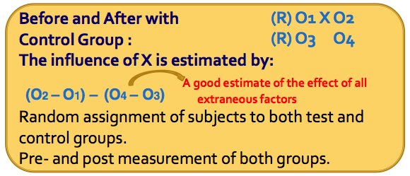

- Can change due to extraneous variable (maturation) (eliminated)
- Left with the effect of manipulation

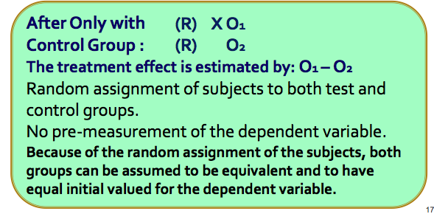

- Ex; presence of celebrity endorser on purchase intent

Quasi Experiments:

Studies in which the researcher lacks complete control over the scheduling of treatments or must assign respondents to treatments in a nonrandom manner.
- More feasible in field setting and natural environment

Two examples of Quasi-Experiments
- Interrupted Time-Series
- Multiple Time-Series

Interrupted Time-Series:

Repeated measurement of an effect “interrupts” previous data patterns.

O1 O2 O3 X O4 O5 O6

- Provides more understanding about data patterns and behavior trends. Example?

Multiple Time-Series:

Interrupted time-series design with a control group

O1 O2 O3 X O4 O5 O6
O1 O2 O3 O4 O5 O6

- Compare the values of dependent variable across groups.
- Groups are supposed to be similar regarding the characteristics of importance

Test Markets

Real world testing of a new product or some element of the marketing mix (product, price, place, and promotion) using an experimental or quasi-experimental design.

- Test market can be a single market, group of markets, a region, or different regions.
- It is used for evaluation of new elements in marketing mix, before national and full-scale rollout.
- The evaluation will give some idea about:
  - Market share and volume
  - The effect on similar products (cannibalization rate)
  - Characteristics of the target market and how to proceed with advertising and promotions accordingly.
  - Reaction of competitors

Types of Test Marketing

There exist four types of test markets:

- Traditional (standard): uses the firm’s regular channels of distribution in a real market

- Scanner (electronic): uses a consumer panel, which is provided scan able cards to record purchases

- Controlled: uses a select group of distributors and retailers who agree to participate in the experiment

- Simulated (STM): conducted in an artificial environment that is made as close as possible to the real marketplace

Cost of Test Marketing

The cost of running test markets is usually high (1 million Dollars is the least a company can expect).
- In some situations, it might be cheaper to launch the product officially rather than going through the risks and costs of market tests.

It is of great importance that the market chosen for test is the representative of the expected population of interest. Example?

Steps in the Test Market Study

1. Define the Objective:
- What do you hope to learn?
- What are the characteristics of the people/products of interest?

2. Select a Basic Approach:
- Simulated, controlled, or standard test?

3. Develop Detailed Test Procedures:
- How will you execute the study (full marketing plan)?
- Who will be involved?
- How long will it take and how much can you spend?
- Make sure that enough product is available; basic positioning is selected; actual commercials and media plan are developed; ...

4. Select the Test Market:
- Minimum of two to three markets
- The markets should be geographically dispersed
- Demographics should be similar to your target population
- Market should be large enough to provide useful results
- Distribution and other patterns should be similar to the nation

5. Execute the Plan:
- How long should the test run?
- The test should be run for at least 6 months (to 12 months and even longer). The longer it takes, the more cost incurred and the more time for competitors to react.

6. Analyze the Test Results:
- Purchase data?
- Awareness data?
- Competitive response?

Limitations of Experimental Design

High Cost:
- Is the research affordable?
- Will the research be beneficial & help solve problems? Can extraneous variables be controlled?
- Sometimes, the cost is more than the benefits of the research.

Security Issues:
- Particularly critical with field experiments
- Data and findings should be secure
- The competition might be “tipped-off”

Implementation Problems:
- Process contamination (buyers from outside the test area will go to the test are and become the undesired (unplanned) test units.
- Regional market managers are reluctant to permit their market area to be used as a test market.
- Differences between test markets and total population

Chapter 13: Data Processing, Fundamental Data Analysis, and Statistical Testing of Hypothesis

Overview of the Data Analysis Procedure

The Key Steps

- Validation and Editing
- Coding
- Data Entry
- Machine Cleaning of Data
- Tabulation and Statistical Analysis

Step one:

Validation: Process of ascertaining that interviews actually were conducted as specified. Correct administration of the survey is of concern.
- Refer to page 391 of the textbook to learn about the validation process.

Editing: Process of ascertaining that questionnaires were filled out properly and completely.

Skip Pattern: Sequence in which later questions are asked, based on a respondent’s answer to an earlier question or questions.

Step Two:

Coding: Process of grouping and assigning numeric codes to the various responses to an open-ended question.

Step Three:

Data Entry: Process of converting information to an electronic format.

Intelligent Data Entry: Form of data entry in which the information being entered into the data entry device is checked for internal logic.

Scanning: Form of data entry in which responses on questionnaires are read in automatically by the data entry device.

Step Four:

Clean the Data: Check for data entry errors or data entry inconsistencies.

Logical or Machine Cleaning: Final computerized error check of data.
Error Check Routines: Computer programs that accept instructions from the user to check for logical errors in the data.

Step Five:

Data Analysis – e.g. One Way Frequency Tables: Table showing the number (percentage) of respondents choosing each answer to a survey question.

Cross Tabulation Tables - Examination of the responses to one question relative to the responses to one or more other questions.

The Coding Process

1. List responses

2. Consolidate responses

i) Assign the responses which basically mean the same to one category.
ii) Consolidate similar categories into one.

3. Set codes

4. Enter codes

i) Read responses to individual open-ended questions on questionnaires
ii) Match individual responses with consolidated list of response categories
iii) Write the numeric code in the appropriate place on the questionnaire or directly in the computer (Exhibit 13.5 of the book)
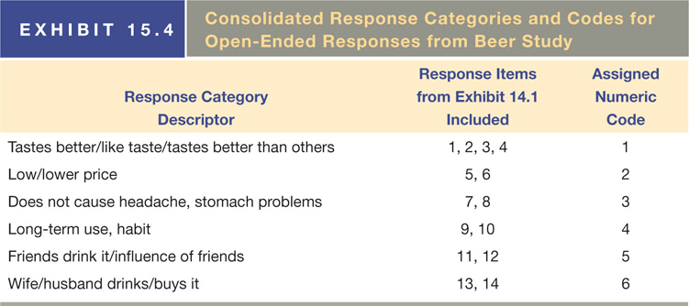

Tabulation: One-Way Frequency Table

The most basic is the one-way frequency table
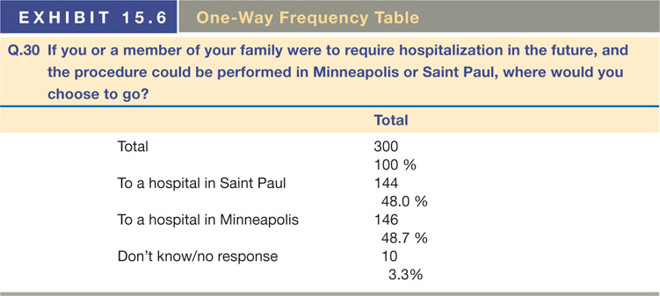

Cross Tabulations Data, Examples

Bi-variate cross-tabulation:
  - Cross tabulation two items - “Business Category” and “Gender”

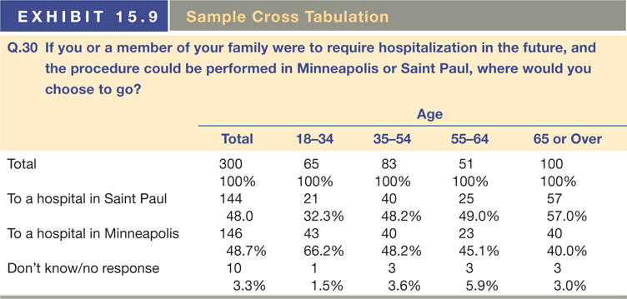

Multi-variate cross-tabulation:
  - Additional filtering criteria - “Veteran Status” - Now filtering three items.
Graphic Representation of Data

Line Chart
- Simplest form of graphs
- Good for demonstrating linear relationships
- Particularly useful for presenting a given measurement taken at several points over time
- Trends, patterns, and sudden changes can be observed over time
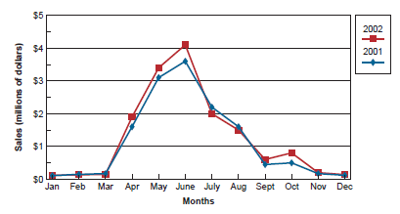
Pie Chart
- Good for proportion comparison among different categories
- Should total to 100%
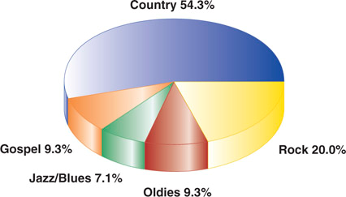

Bar Chart
- Good for side by side relationships / comparisons
- Most flexible of the graphs

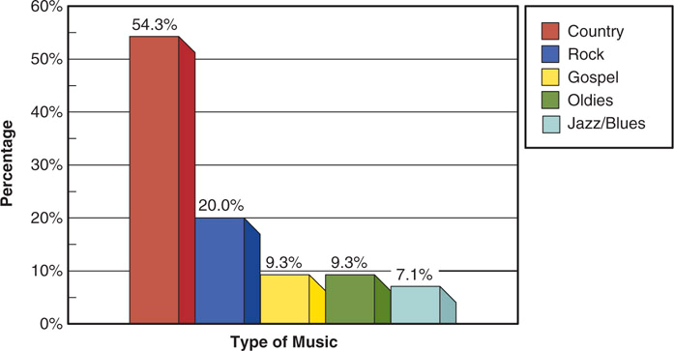
Types of Bar Chart
Cluster Bar Chart
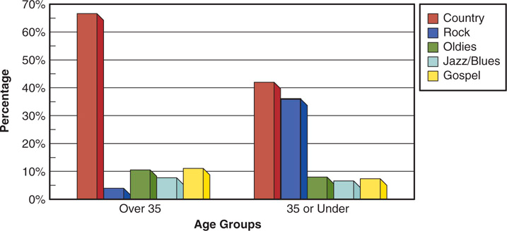
Stacked Bar Chart
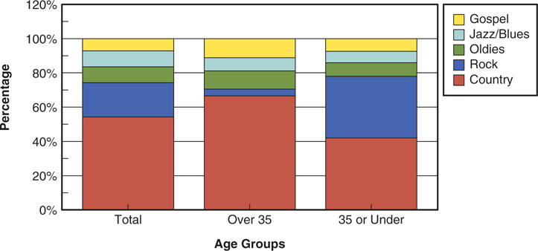
Multiple-Row Bar Chart
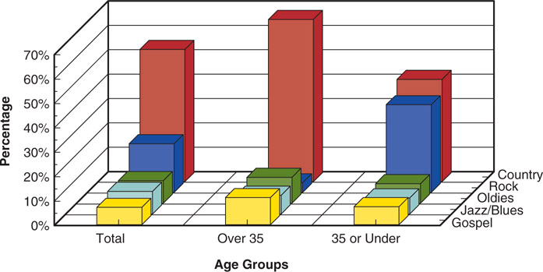
Descriptive Statistics

Descriptive statistics are the most efficient means of summarizing the characteristics of large sets of data.

In a statistical analysis, the analyst calculates one number or a few numbers that reveal something about the characteristics of large sets of data

Descriptive Statistics: Measures of Central Tendency

Mean:
  - The sum of the values for all observations of a variable divided by the number of observations.
  - Affected by outliers
Median:
  - Value below which 50 percent of the observations fall.
  - Offsets the effect of extreme values (outliers) on the mean
Mode:
  - The value that occurs most frequently.
  - Not effected by outliers

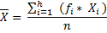
fi = frequency of the ith class
Xi = midpoint of that class
h = number of classes
n = total number of observations

Measures of Dispersion

These measures indicate how spread out the data are:

Variance:
  - The sums of the squared deviations from the mean divided by the number of observations minus one.
  - The same formula as standard deviation with the squaring.
Range:
  - The maximum value for a variable minus the minimum value for that variable.
Standard Deviation:
  - Measure of dispersion calculated by subtracting the mean of the series from each value in a series, squaring each result, summing the results, dividing the sum by the number of items minus 1, and taking the square root of this value.

  - 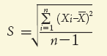

Statistical Significance

Mathematical Differences:
By definition, if numbers are not exactly the same, they are different. This does not, however, mean that the difference is either important or statistically significant. Example?

Statistical Significance:

A difference that is large enough that it is not likely to have occurred because of chance or sampling error. Example?

Important Differences for Managers:

The difference is managerially important, if it is large enough from practical perspective. In other words, if the difference is sufficiently large to be considered in managerial decision making. Example?

Hypothesis:

Assumption or theory that a researcher or manager makes about some characteristic of the population under study.

Hypothesis Testing

The Key Steps

Step One: Stating the hypothesis

  - “Null Hypothesis” – The hypothesis of status quo, no difference, no effect, equality of the values. H0 is assumed to be true, unless proven otherwise.
  - “Alternative Hypothesis” - another alternative which compliments the Null Hypothesis. Ha is true, when H0 is rejected by statistical testing.

Step Two: Choosing the appropriate test statistic

  - Test of means, test of proportions, ANOVA, etc. (Refer to Exhibit 13.8)

Step Three: Developing a decision rule

  - Determine the significance level.
  - Needed to determine whether to reject or fail to reject the null hypothesis.

Step Four: Calculating the value of the test statistic

- Use the appropriate formula to calculate the value of the statistic from the sample data.
- Compare the value of the statistic with the critical value.

Step Five: Stating the conclusion

- Stated from the perspective of the original research question.
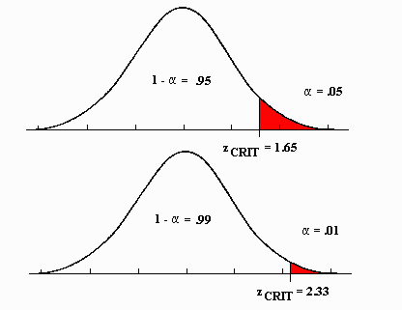

Level of Significance (Alpha)

α is the threshold or significance level (chosen by the researcher) which indicates the allowable/ acceptable degree (probability) of type I error.

One and Two Tailed Tests

Tests are either one or two-tailed. This approach depends on the nature of the situation and what the researcher is demonstrating.

One-Tailed:
  - “With the new promotion, the sales would go higher.”
  - “With the price increase of xxx$, the sales would decrease.”
Two-Tailed:
  - “This year’s sales are not equal (either higher or lower) to last year’s sales.”

Are these H0 or Ha?

Type I and Type II Errors

Type I
Rejection of the null hypothesis when, in fact, it is true (incorrectly rejecting the null hypothesis).

Type II
Acceptance of the null hypothesis when, in fact, it is false (incorrectly accepting the null hypothesis).

Type of Hypothesis Tests

About One Mean

Z Test:

Hypothesis test used for a single mean if the sample is large enough and drawn at random. Usually for samples of about 30 and above.

H0: μ= Constant Number (which is based on what the researcher expects and guesses)

H0 can also be: μ> = Constant Number (or μ<= Constant Number)

T Test:

Hypothesis test used for a single mean if the sample is too small to use the Z test. Usually for samples below 30.

H0: The same as what is stated for “Z Test” case

About Two Means

Hypothesis testing that tests the differences between groups of data.

H0: μ1 = μ2 (or μ1 >= μ2 or μ1 <= μ2 )

Z-Test Example
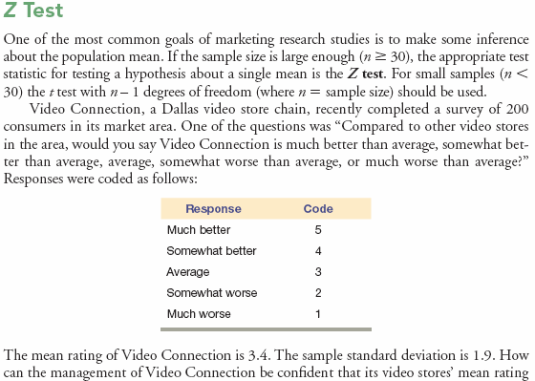

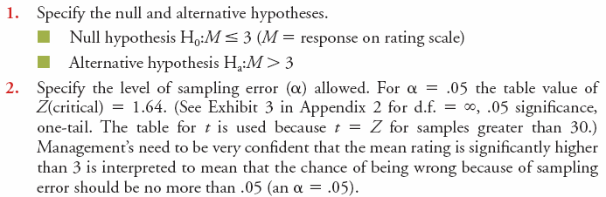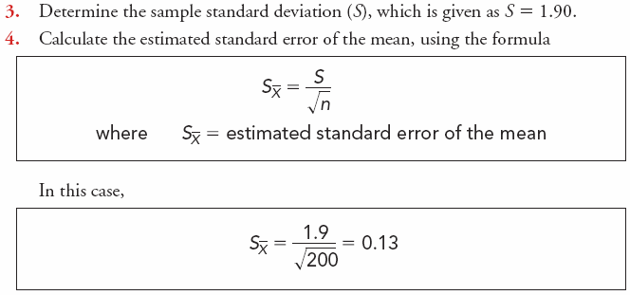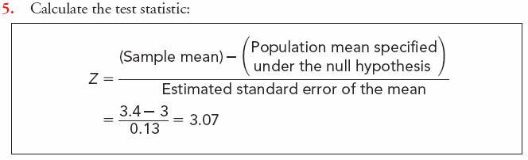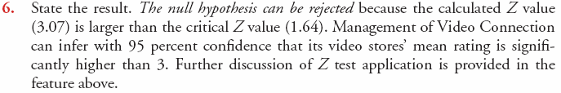

Commonly Used Statistical Hypothesis Tests

Independent Samples:
  - Samples in which the measurement of a variable in one population has no effect on the measurement of the variable in the other.
  - Example: Midterm grades of male (sample 1) and female (sample 2) students.

Related Samples:
  - Samples in which the measurement of a variable in one population may influence the measurement of the variable in the other.
  - Example: The midterm grades (sample 1) and final grades (sample 2) of one set of students.

Degrees of Freedom:
  - Number of observations in a statistical problem that are free to vary.
  - Is equal to the number of observations minus the number of assumptions or constraints necessary to calculate a statistic.

P-Value and Significance Testing

P Value:
Exact probability of getting a computed test statistic that is due to chance. The smaller the p value, the smaller the probability that the observed result occurred by chance.

P-value indicates what exactly is the probability of being wrong, if one rejects H0.

P-value is the actual and exact probability of type I error.

If p-value < α , then one has evidence to reject H0 at α level of significance

Chapter 14: Statistical Tests of Relation and Difference

Tests of Relation

Bivariate Techniques:
Statistical methods of analyzing the relationship between two variables.

Multivariate Techniques:
Statistical methods of analyzing the relationship using more than two variables

Example: the effect of advertizing expenditure, price decrease, and competitors’ new promotion on sales.

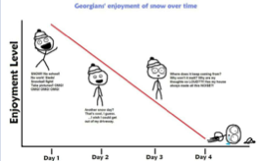

Chi-Square Test of Independence

- A statistical test to determine whether or not two nominal variables are unrelated (independent) to each other

- One would expect that the same proportions hold for both Male and Female groups

H0: The two variables (gender and grade level) are independent (unrelated).
Ha : The two variables are NOT independent.
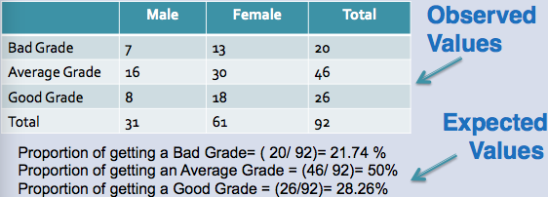

Correlation Analysis

Correlation Analysis:
- Analysis of the degree to which changes in one variable are associated with changes in another

Pearson Correlation:
- Analysis technique for use with interval or ratio data

Correlation Coefficient (R):
- A descriptive measure which shows the degree of association between the two variables. It can range from -1 to +1.

H0: The two variables are not correlated (are unrelated)
Ha: The two variables are correlated

If the p-value (of computed R) < 0.05 , then reject H0

Regression Analysis

Independent Variable:
- The variable believed to affect the value of the dependent variable (usually denoted by the letter X).

Dependent Variable:
- The variable expected to be explained or caused by the independent variable (usually denoted by the letter Y).

Bivariate Regression Analysis:
- The analysis of the strength of the linear relationship between variables when one is considered the independent (predictor) variable and the other is the dependent (predicted) variable.

Scatter Diagram

Graphic plot of the data with dependent variable on the Y (vertical) axis and the independent variable on the X (horizontal) axis. Shows the nature of the relationship between the two variables, linear or nonlinear.

- Each point represents a pair of observed (IV, DV) values (value of the observed independent variable and its related dependent variable).

Types of Relationships Found in Scatter Diagrams

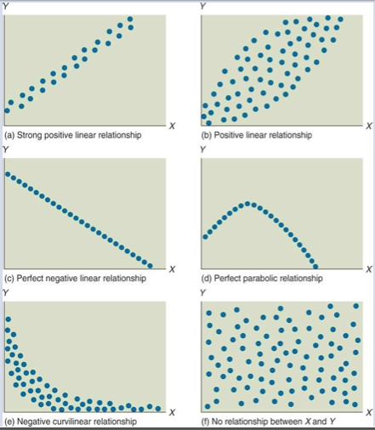

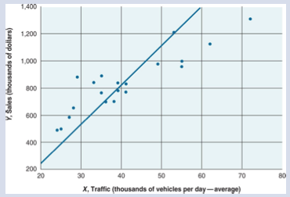
Least-Squares Estimation Procedure

- Used to fit data for X and Y not plotted
- Enables estimation of non-plotted data points
- Results in a straight line that fits the actual observations (plotted dots) better than any other line that could be fit to the observations

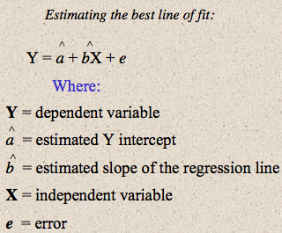
- “A” and “b” are the parameters of the regression line which corresponds to actual population data.
- Since the exact value of these parameters cannot be found, we try to estimate them using the sample data.

The least-squares procedure is a fairly simple mathematical technique that can be used to fit data for X and Y to a line that best represents the relationship between the two variables (the sum of error terms is minimized using this technique).

***How to calculate the estimates of “a” and “b” is not included in the exam.

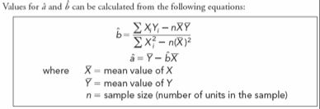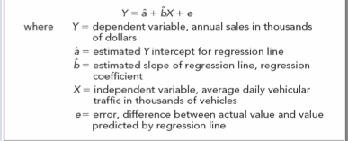

Regression Line

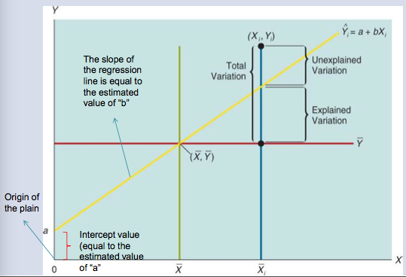

Suppose that the estimated values for “a” and “b” coefficients are found to be:

â = 240.9
b= 14.7

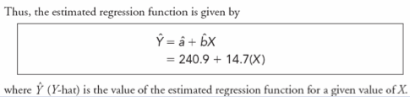
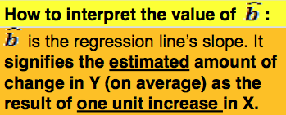

Example: Interpret the value of 14.7 of the regression line formed above.

Measures of Association

The Concepts

The Strength of Association:

The coefficient of determination (R2 ): the percentage of the total variation in the dependent variable explained by the independent variable.

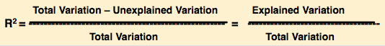

Pearson Correlation:

Analysis of the degree to which changes in one variable are associated with changes in another for use with metric data.

Statistical Significance of Regression Results

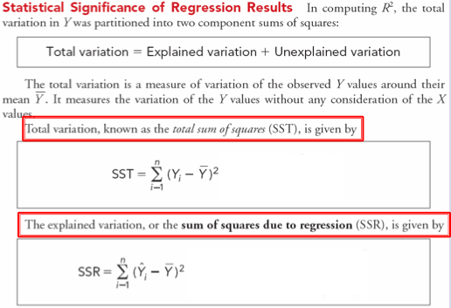

Sum of Squares Due to Regression

Error Sums of Squares (SSE)

Variation not explained by regression

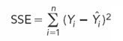

***The calculation of SST, SSR and SSE are not expected from the students.

Hypothesis Concerning Overall Regression

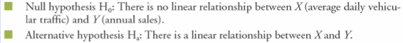

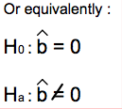
- No chapeaux (mistake)

Multiple Regression Analysis

The analysis of the nature of the relationship between two or more independent (predictor) variables and a dependent (predicted) metric variable.

Multiple Regression:

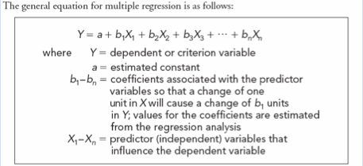

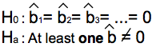

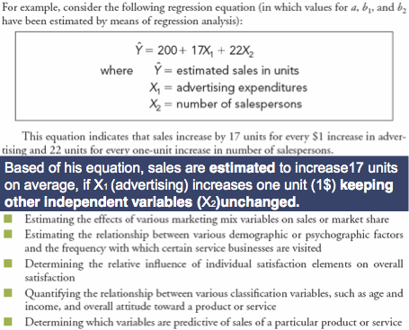

Coefficient of Determination (R-squared):

- Measure of the percentage of the variation in the dependent variable explained by variations in the independent variables.

Regression Coefficients:

- Estimates of the effect of individual independent variables on the dependent variable.

Dummy Variables:

- In regression analysis, a way of representing two-group or dichotomous, nominally scaled independent variables by coding one group as 0 and the other as 1.
- Ex: colour is green (a1), colour is red (b0), treated as a scale interval variable

Software Output

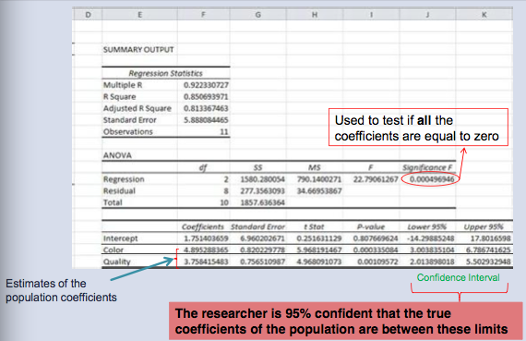

Measure of Association

Common Misapplications

Key Points

- Do not necessarily mean there is a causal relationship between variables
- Could simply represent coincidence between the relevant variables
- Should be taken in context and with the timeliness of both data sets in mind

Test of Difference

Examination of the differences between variables or groups

4 statistical techniques can be used

- Independent Samples T-Test: for the difference between two groups on one variable

- Analysis of Variance (ANOVA): for difference among three or more groups on one variable

- Non-Parametric Chi-Square: for the difference between proportions

- Paired- Samples T-Test: for difference between two variables

Independent Samples T-Test

Determines if the means of two groups are significantly different from each other

H0: The population means of the two groups are equal μ1 = μ2
Ha: The population means of the two groups are not equal μ1 = μ2

- If the p-value (of computed t-statistic) ≤ 0.05, then reject H0
- If the p-value (of computed t-statistic) > 0.05, then fail to reject H0

Analysis of Variance (ANOVA)

A statistical test to determine if three or more group means are significantly different from each other

When the goal is to test the differences among the means of two or more independent samples, analysis of variance (ANOVA) is an appropriate statistical tool. Although it can be used to test differences between two means, ANOVA is more commonly used for hypothesis tests regarding the differences among the means of several (C) independent groups (where C > or = 3). It is a statistical technique that permits the researcher to determine whether the variability among or across the C sample means is greater than expected because of sampling error.

H0: The population means of all the groups are equal ( μ1 = μ2 =μ3 = ... )
Ha: The population mean of at least one group is not equal to the others

F-Test

Test of the probability that a particular calculated value could have been due to chance.

H0: μ1 = μ2 = μ3 = ...
H1: At lest one of the means is different

- If the p-value (of computed F-statistic) ≤ 0.05, then reject H0
- If the p-value (of computed F-statistic) > 0.05, then fail to reject H0

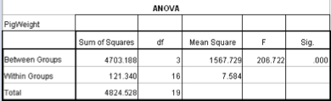

Non-Parametric Chi-Square Test of Difference Between Proportions

Determines if two or more proportions are equal

Either:

- There can be two independent samples’ proportions (not covered in the book)
- H0: π1 = π2 H1: π1 ≠ π2
- Do not worry about this type
Or:
- The test is related to different proportions regarding one population (the difference between proportions in one population).
- Used for testing proportions rather than relations between two variables
H0: The population proportions are equal
Ha: The population proportions are not equal

- If the p-value (of computed Chi-square statistic) ≤ 0.05 , then reject H0

Example: Pre-election polls about voting tendencies of the citizens

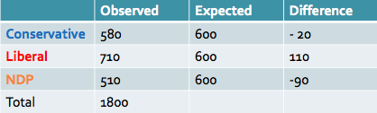

How to formulate H0 for this example?

Paired-Samples T-Test

Determines if the means of two variables are significantly different from each other within the same group

H0: The population variable means are equal
Ha: The population variable means are not equal

- If the p-value (of computed t-statistic) ≤ 0.05 , then reject H0

Example: To examine if the mean number of male friends is significantly different from the mean number of female friends for students in the class.

Chapter 12: Sample Size Determination

Sample Size for Probability

Census:
- Population canvas - not really a “sample”
- Asking the entire population

Budget Available:
- A valid factor – how much can we afford?
- Sometimes when there is a lack of budget, the necessary sample size cannot be afforded. Hence, either the project is cancelled, or the company should find new sources of funding.
- If the sample size is smaller then the minimum required size, the margin of error and certainty about the test results and conclusions will be compromised.

Rule of Thumb:
- If the client has an idea about the necessary sample size based on past experience, “gut feeling”, etc.

Number of Subgroups Analyzed:

- In any sample size determination problem, consideration must be given to the number and anticipated size of various subgroups of the total sample that must be analyzed.
  - + As a rule of thumb, a sample should provide at least 100 respondents in each major subgroup, and 20 to 50 respondents in each of the less important subgroups.

Traditional Statistical Methods:

- Variance, standard deviation, confidence interval, and maximum allowable error play a key role.

The Normal Distribution

Central Limit Theorem:

The idea that a distribution of a large number of sample means or sample proportions will approximate a normal distribution - regardless of the distribution of the population from which they were drawn.

Normal Distribution:

The continuous distribution that is bell shaped and symmetrical about the mean. The mean, median, and mode are equal. Finally, about 68% of the observations are within (+/-) one standard deviation of the mean, 96% are within two standard deviations, and 99+% are within three standard deviations of the mean respectively.

The Normal Distribution

Proportionate Properties of the Normal Distribution:

- A feature that the number of observations (probability of) falling between the mean and a given number of standard deviations from the mean is the same for all normal distributions.

Standard Normal Distribution:

- Normal distribution with a mean of zero and a standard deviation of one.

Important Characteristics of a Normal Distribution

- Bell-shaped and has only one mode.

- Symmetric about its mean

- Uniquely defined by its mean and standard deviation

- The total area under a normal curve is equal to one

- The area of a region under the normal distribution curve between any two values of a variable equals the probability of observing a value in that range when an observation is randomly selected from the distribution.

- The area between the mean and a given number of standard deviations from the mean is the same for all normal distributions.

Population and Sampling Distributions

Population Distributions:

- Frequency distribution of all the elements of population

Sampling Distributions:

- Frequency distribution of all elements of an individual sample

Sampling Distribution of the Mean:

- Theoretical frequency distribution of the means of all possible samples of a given size drawn from a population
- It is normally distributed.

Standard Error of the Mean:

- Standard deviation of a distribution of sample means
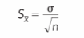

Standard Error of the Mean

Standard Error of the Mean:
- Standard deviation of a distribution of sample means.

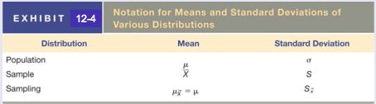

Relationship of the Three Types of Distribution

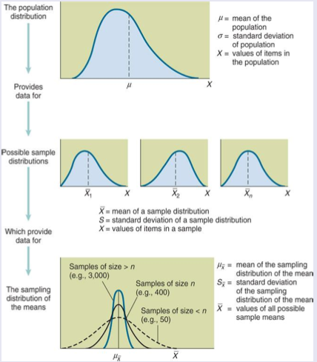

Points and Interval Estimations

Point Estimate:
- The particular estimate of a population value.

Interval Estimate:
- The interval or range of values within which the true population value is estimated to fall.

Confidence Level and Interval

Confidence Level:

- The probability that a particular interval will include the true population value; also called the confidence coefficient.

Confidence Interval:

- The interval that, at the specified confidence level, includes the true population value.

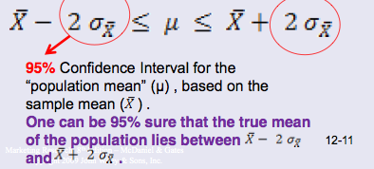
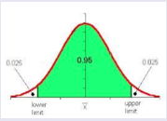

Sampling Distribution of the Proportion

Sampling Distribution of the Proportion:

- The relative frequency distribution of the sample proportions of many random samples of a given size drawn from a particular population; it is normally distributed.
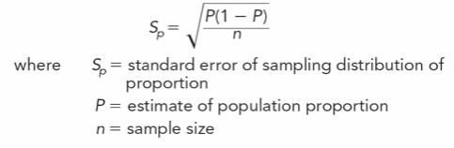

Determining the Sampling Size

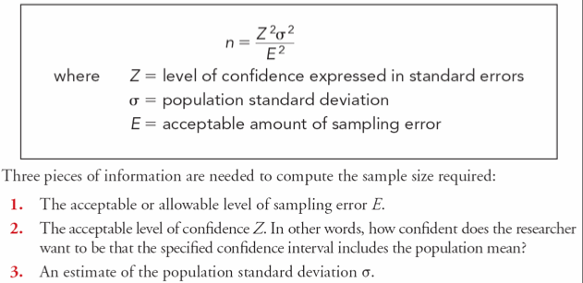

Determining the Sampling Size

1. Allowable Sampling Error:

Amount of sampling error the researcher is willing to accept, E. The maximum allowable difference between population mean and sample mean.

2. The Acceptable Level of Confidence:

How confident (Z value) does the researcher want to be that an interval includes the population mean.

3. Population Standard Deviation:

Standard deviation of a variable for the entire population, σ.

How to Estimate Population Standard Deviation Before Sample Selection

One or a combination of the following four methods can be used to come up with an estimate of the population S.D.:

1) Using results form a prior survey dealing with the same or similar issue.
2) Conducting a pilot survey.
3) Using secondary data.
4) Using judgment and asking the opinions of experts

Determining the Sampling Size

Situations Involving Proportions:
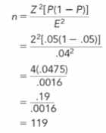

If there is no basis for estimating the population proportion (P), the researcher usually makes the worst-case (most pessimistic) assumption and assumes P=0.5. This assumption results in a sample size large enough to satisfy all sample sizes required by any other value of P.

Statistical Power

Statistical Power is the probability of not making a type II error.

A power of 50% is assumed in sample size determination formulas. A too small sample will increase the chance of type II error.

Chapter 5 Primary Data Collection: Observation

What is Observation Research?

Observation research

The systematic process of recording patterns of occurrences or behaviors without normally communicating with the people involved.

Conditions for using observations:

- The needed information must be either observable or inferable
- The behavior should be repetitive, frequent, or in some manner predictable
- The behavior must be relatively short in duration

Approaches to Observation Research

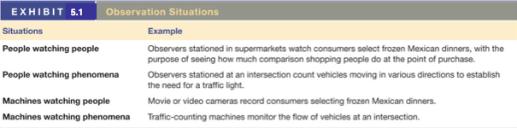

The Nature of Observation Research

Natural vs. Contrived:
- Is the setting made up (contrived) by the researcher or are you observing a naturally occurring event?

Open vs. Disguised:
- Does the subject know (open) the purpose of the research?

Human vs. Machine:
- Can a machine better capture data – or not?

Direct vs. Indirect:
- Observation of current behavior (vs. observation of some indicators/ signals of the past behavior)
- Example of indirect: “Garbologist”: Going through one’s garbage – or “stuff” to analyze consumption patterns.

Advantages of Observation Research

- You see what people actually do - rather than what they say they do
- Firsthand information is less prone to biases
- No pressure form the interviewer
- The observational data can be executed quickly and relatively accurately
  - No reliance on people’s ability to respond or remember the desired info
- Electronic collection such as scanners is more efficient than manual counts
- Clients can observe their customers along with the researcher

Disadvantages of Observation Research

- Only physical appearance and behavior can be measured
- Can’t measure attitudes, beliefs, intentions, or feelings
- Not always a good representation of the general population, specially If the choice of customers is biased
- Interpretation is somewhat subjective depending on observation type (mostly qualitative in nature)
- It can be expensive and time consuming if subjects not readily available
- Data can be time sensitive making predictive analysis tricky

Ethnographic Observation Research

The study of human behavior in its natural context, involving observation of behavior and physical setting.

Advantages:
- It is reality-based; it can show exactly how consumers live with a product, not just what they say about it or how they remember using it.
  - Reveals unexpressed needs and wants
  - Discovers unexploited consumer benefits
  - Reveals product problems
  - Reveals target markets
  - Tests the marketing mix
- It can show how, when, and where people shop for brands.
- It can show who in the family actually uses a product.
- It can reveal advertising execution ideas that derive directly from consumer experience.
- It can form a better relationship with your consumers based on an intimate knowledge of their lifestyles.

Mystery Shopping

People who pose as customers and shop at a company’s own stores or those of its competitors to collect data about customer- employee interactions and to gather observational data. They might also compare prices, displays, availability and the like.

Mystery Shopping Levels

Level 1;

The mystery shopper calls the business with a script with questions and notes the experience.
- To evaluates the service and communication

Level 2:

The mystery shopper visits the business and makes a quick purchase with little or no customer- employee interaction.
- To evaluate the transaction and the image of the facility

Level 3:

The mystery shopper visits the business for a more involved experience to include a scripted scenario to gauge the customer- employee interaction. Level III usually does not involve a purchase - although detailed discussion about the product or services will likely occur.
- Example: Discussing different services provided in a carwash and their prices and possible promotions.

Level 4:

The mystery shopper visits the business with great knowledge about the products. This knowledge can be used to test the employees. A purchase (and/or issues related to the purchases) might likely be involved.

Why Conduct Mystery Shopping

Key reasons

- Enabling an organization to monitor compliance with product/service delivery standards, and specifications
- Enabling marketers to examine the gap between promises made through advertising/sales promotion and actual service delivery
- Helping monitor the impact of training and performance improvement initiatives on compliance with or conformance to product/service delivery specifications
- Identifying differences in the customer experience across different times of day, locations, product/service types, and other potential sources of variation in product/service quality

Human Observations continued

Other types of human observation

- One-way mirror observations
- Clients observe group discussion in focus groups

Machine Observation

- Observations made by machines rather than people

- Techniques Include:

- Traffic Counters

- Physiological Measurement Devices:
  - Electroencephalograph (EEG)
  - fMRI
  - Eye Tracking
  - Voice Pitch Analysis
  - Facial Action Coding Service (FACS)
  - Gender & Age Recognition Systems

- Television Audience Measurement
- Portable People Meter
- Electronic Scanners

Observation Research on the Internet

Internet Tracking:

- Modeling surfing patterns along with demographic and psychographic data to predict consumer behavior.

- Click sequence / patterns should enhance predictive capability.

- comScore – (a leading Internet technology company that tracks what individuals do online) tracks the Internet with a panel of over 2 million users

- Scraping the Web - Used to develop a cohesive message from thousands of conversation threads in newsgroups, chat-rooms, message boards, etc.
  - companies scrape the web to determine what customers are saying about their company and products

Virtual Shopping

Simulation of the actual retail environment on a computer screen

Advantages

- Duplicates the actual environment of an actual market
- Can set up and alter the tests quickly
- Costs are low after set up

