COMM 222
Winter 2016

January 7th,2016

What can be motivating for one employee can be demotivating for another.

Organizational Behaviors are:
    - Attitudes and behaviors of individuals and groups within organizations.

Contemporary management concerns

Diversity: Labor force and customers are becoming more culturally diverse

Employee- organization Relationships

Focus on quality, speed and flexibility

Employee Recruitment and Retention

Corporate Social Responsibility

January 16th, 2016

3 Approaches to personality:

- Dispositional:
- Individuals are predisposed to behave in a certain way.
- People have stable traits/characteristics that influence their attitudes and behaviors.
- Situational:
- Organizational influence people’s behavior and attitude.
- Interactionist: This the most widely accepted approach to organizational behaviour.
The idea is that:
- Behaviours are a function of both dispositions AND situations
- To predict behaviour, we need to know the person’s personality AND the work setting.
- The importance of fit - putting the right person in the right job, group, or organization
- Strong vs. weak situations

What is learning?
- Definition: A relatively permanent change in behaviour potential that occurs due to practice or experience.
- The practice/experience that prompts learning comes from the environment
- The environment provides feedback about the consequences of that behaviour.

Social Cognitive Theory

- Emphasize the role of cognitive processes in regulating people’s behavior.
- Social learning involves:
  - observing the behaviour of others
  - seeing what consequences they experience
  - thinking about what might happen if we act the same way
  - Imitating the behaviour if we expect favourable consequences
- Components of Social Cognitive Theory
  - Modelling: process of imitating the behaviour of others.
  - How to choose model: Attractive, credible, competent, high-status
  - The model’s behaviour should result in positive consequences
  - The behaviour is vivid and memorable

  - Self-efficacy: Beliefs people have about their ability to successfully perform a specific task.
- Self-regulation: the use of learning principles to manage one’s own behaviour.
Operant Learning Theory

- The subject learns to operate on the environment to achieve certain consequences.
- Operantly learned behaviour is controlled by the consequences that follow it.
- It is the connection between the behaviour and the consequence that is learned.
Behaviour Stimulus More Behaviour

- Reinforcement is the process by which stimuli strengthen behaviours.
- A reinforcer is a stimulus that follows some behaviour and increases or maintains the probability of that behaviour.
  - Positive reinforcement
  - Negative reinforcement

January 19th, 2016

For exam:
reuse words from question as a guide.
Define theories and words you are using.
Describe behaviour.

January 26th, 2016

3 Components of perception

      - Perceiver
      - Situation (context)
      - Target (pay, other employees, task, environment)

Each component influences the perceiver’s impression, interpretation of the target.

Perception changes based on culture, personality and values.

Perception: Process of receiving from our senses and interpreting it to provide order and meaning to the environment.

The Perceiver: The Employee

- Limits of the senses.
- Past experience leads to expectations.
- Interests, values and needs can lead to focusing on certain pieces of information while ignoring others.
- Emotions color perceptions (uncertainty is key)

Perceptual Defense

- The tendency for the perceptual system to defend the perceiver against unpleasant emotions
    - See what you want to see
    - Hear what you want to hear
  - Our perceptual system works to make sure we don’t see/hear things that are threatening
    - Other employees talking bad about you
    - Poor performance

Target Characteristics

- Ambiguous targets are more susceptible to interpretation and distortion.
  - As perceivers, employees have a need to resolve ambiguities (fill in the gaps)
  - Employees don’t and can’t use all the information given by a target.
- Examples of targets:
  - Other employees
  - Your workspace/cubicle
  - Presentations by others
  - Business Clients

The Situation

- Influences whether you perceive the target’s behavior as appropriate or not
- If the situation changes, your perception of the target can change.
- The context can add information about the target (e.g., how is this person like or unlike the others)

EX:
- Uniforms and dress codes create a context for other things to be observed
- The demographic make up of the team…
- How is the lunch room organized?
- Lighting
- Cubicles… are there walls between you and employees? Psychological barriers

Bruner’s Model of the Perceptual Process

- When a perceiver encounters an unfamiliar target, the perceiver looks for informational cues contained in the target and the situation surrounding it.

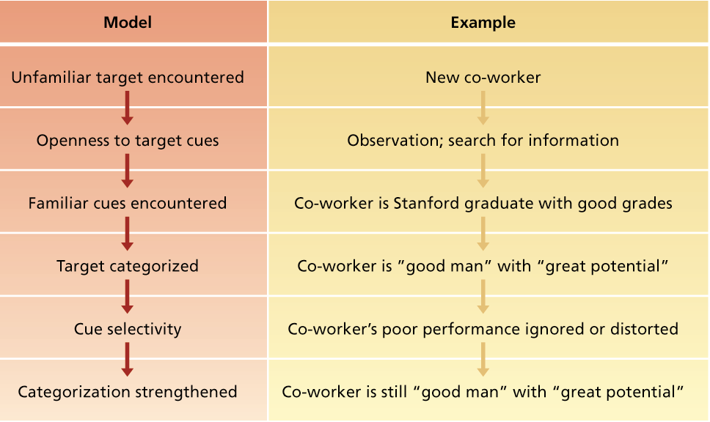

3 Important characteristics of the perceptual process

- Perceptual Selectivity: Perceivers do not retain all available cues. Retain cues that are consistent with one’s expectations, needs, and mood, and reject cues that are inconsistent.
- Perceptual Consistency: Select, ignore, and distort cues so that the retained cues fit together to form a consistent image of the target.
- Perceptual Constancy: Perceive a target in the same way over time or across situations, even in light of contradictory cues.

Primacy and Recency Effects

- The reliance on early cues or first impressions is known as the primacy effect - often has a lasting impact.
- The tendency for a perceiver to rely on recent cues or last impressions is known as the recency effect.

Reliance on Central Traits

- Central traits = personal characteristics of a target person that are of particular interest to a perceiver
- Physical appearance is a common central trait in work settings that is related to a variety of job-related outcomes.
      - Attractive people are more likely than unattractive people to be hired, given good performance evaluations, promoted, and to be paid more.

Implicit Personality Theories

- Definition: Personal theories that people have about which personality characteristics go together.
  - Ex. Hardworking people are honest, or people of average intelligence to be more friendly.
  - Such theories guide how perceivers behave and react to a target

Projection

- Definition: The tendency for perceivers to attribute their own thoughts and feelings to others.
  - Is sometimes efficient and sensible to use, but not always

Stereotyping

- Definition: The tendency to generalize about people in a social category and ignore variations among them.
- Three aspects of stereotyping:
  - 1) We distinguish some category of people
  - 2) We assume that the individuals in this category have certain traits
  - 3) We perceive that everyone in this category possesses these traits
- Why do stereotypes persist?
  - They help us process information about others quickly and efficiently.
  - Stereotypes are often reinforced by selective perception.

The point?

- How much control do employers actually have over how their employees feel/see the workplace?

Attribution Theory

Attribution: The process by which causes or motives are assigned to explain people’s behavior.
- DISPOSITIONAL ATTRIBUTIONS
  - Explanations for behavior based on an actor’s personality or intellect, e.g. lazy, intelligent.
- SITUATIONAL ATTRIBUTIONS
  - Explanations for behaviour based on an actor’s external situation or environment, e.g. bad luck, poor weather.
Attribution Questions

We rely on external cues and make inferences from them to make attributions.
In deciding whether the behavior is dispositional or situational we ask several questions….

Consistency Cues

- Definition: Attribution cues that reflect how consistently a person engages in behavior over time
  - High consistency behavior leads to dispositional attributions
  - When behavior is inconsistent, we wonder about situational attributions/explanations.
  - Does the person engage in the behavior regularly and consistently?
      - Yes - Dispositional
      - No – Situational
Distinctiveness Cues

- Definition: Attribution cues that reflect the extent to which a person engages in some behavior across a variety of situations.
    - Low distinctiveness behavior leads to a dispositional attribution
    - When a behavior is highly distinctive, it only occurs in one situation. Here, people tend to assume that some part of the situation causes that behavior.
    - Does the person engage in the behavior in many situations or is it distinctive to one situation?
    - Many situations - Dispositional
    - Distinctive - Situational

3 Attribution Biases

- Fundamental Attribution Bias
- Actor-Observer Effect
- Self-Serving Bias

Fundamental Attribution Error

Definition: The tendency to overemphasize dispositional causes for behavior at the expense of situational explanations when judging the behaviour of others.
- We usually downplay the effect that social roles/cues have on behavior
    - Ex. Is a manager outgoing and stern because you see him/her acting that way or does his/her job require them to be that way?
    - What about other jobs?
- We often downplay the impact of social roles on behavior.
- e.g., bankers are conservative because you see them acting in conservative ways, but their job requires them to be this way.
- The most salient thing is the person’s behavior. The situation is only the background.
Actor-Observer Effect

Definition: The tendency for actors and observers to view the causes of that actor’s behavior differently
  - Actors make more situational attributions of their own behavior, BUT observers tend to make more dispositional attributions of that Actor’s behavior
  - Examples:
    - Employee lateness
    - CEO appointment
  - e.g., Why are you late?
  - Your boss: you’re not disciplined, you’re lazy, you’re not dependable.
  - You: The bus was late, the kids were not getting ready, the car didn’t start, the alarm didn’t go off.

Self-Serving Bias

Definition: The tendency to take credit for successes and to deny responsibility for failures.
  - This bias tends to overcome the “actor-observer effect” when success is the result of some behavior.
    - Succeed: make dispositional attributions.
    - Fail: make situational attributions.
    - 90% of managers rate their performance as superior to their average peer.
Person Perception and Workforce Diversity

Workforce diversity: differences among recruits and employees in characteristics (gender, race, age, religion, culture, physical ability, sexual orientation)

Stereotypes & Workforce Diversity

STEREOTYPING: The tendency to generalize about people in a social category and ignore variations among them.

Stereotype Threat

Definition: The feeling that one is being be judged or treated according to a stereotype and that his/her or performance will confirm that stereotype.

Self-fulfilling Prophecy

People have an expectation about what another person is like, which influences how they act toward the person, which causes the person to act in ways consistent with your beliefs.

Workforce Diversity

- In the past, TOLERANCE was the rule. The role of the organization was to help “different” people “fit in”.
- Today, organizations recognize the value of diversity (both the workplace and marketplace are increasingly diverse) and try to exploit it for competitive advantage. Diversity is related to:
  - Client satisfaction (e.g. being served by someone of one’s own minority group)
  - Creativity and problem-solving efficiency.
  - Adaptation to globalization
  - Better brand image.
  - Superior financial performance.
What Companies are doing…

Diversity needs to be managed to have a positive impact on work behaviour and an organization.
- Recruitment in “diverse” places
- Retention measures through support systems (flexible schedules) and teamwork.
- Equal opportunity development programs (mentoring, language training, management training).
- Community service programs (to help employees in lower socio-economic areas).
- Diversity awareness and skills training (e.g., communication training, lunch & learns).
- Diversity issues committees.

Diversity Training Programs

- One of the most common approaches for managing diversity.
  - can cause disruption and bad feelings when all they do is get people to open up and generate stereotypes.
  - Awareness training should be accompanied by skills training that is relevant to the particular needs of the organization.

Summary: We are all Biased!

- The perceiver is inaccurate: he/she is victim of his/her own senses, experiences, the situation and the target.
- The perceiver relies too much on past experiences and desires, wanting to keep the world a predictable place.
- Perceivers attribute another’s actions to the person, while actors attribute it to the situation (but not when they succeed…).
- The perceiver relies on easily accessible information (first or last), and information that is relevant to him/herself.
- The perceiver simplifies the information (categorizes), which leads to biases and prejudice.

January 26th, 2016

Consistency cue: Do behavior consistently, not dependent on situation.

Consensus cue: Someone’s behavior is the same as those around you, it is a consensus behavior.

Distinctive cue: Not unique to the situation, his behavior happens in every situation.

January 28th, 2016

Chapter 4: Values and Attitudes

Consequences of Job Satisfaction

- Mental health (vs. anxiety, somatization, depression)
- General life satisfaction (influences other domains of life)
- Absence ($10 billion/yr. in Canada)
- Turnover (resigning from work)
- Performance (very complicated)
- Organizational Citizenship Behaviour
(OCB)
- Customer satisfaction
- Profit

Attitude Formation: Values (general tendency to prefer something over another, what we feel) + Beliefs (what we think) leads to attitudes which leads to behavior

Value: Broad tendency to prefer certain states of affairs over others.

Preference: Values have to do with what we consider good or bad. How we should and should not behave.

Broad tendency: General emotional orientations that do not predict behaviour in specific situations.

4 distinctive generations in the workplace today:
- Traditionalists (1922-1945): hard working, meticulous, frugal, loyal, respect authority.
- Baby boomers (1946-1964): revolutionary, optimistic, materialistic, democratic.
- Generation X (1965-1980): Independent, skeptical, defy authority, creative.
- Generation Y/Millenials (1981-now): Multitaskers, technological, want challenge.

Hofstede: Power distance, uncertainty avoidance, masculinity/femininity and individualism/collectivism

Power distance: The extent to which an unequal distribution of power is accepted by society members

Uncertainty Avoidance: Extent to which people are uncomfortable with uncertain and ambiguous situations

Masculinity vs Femininity: The degree to which a culture differentiate gender roles, support the dominance of men and stress economic performance

Individualism vs. Collectivism: The degree to which a society values independence, individual initiative and privacy

Long-term vs. Short term Orientation: The degree to which a society stresses persistence, perseverance and thrift.

Attitudes: A fairly stable EVALUATIVE TENDENCY to respond consistently to some specific object, situation, person or category of people.

Attitudes can change over time with new experiences
More specific than values

Job Satisfaction: A collection of attitudes people have about their job (the target)

Facet Theory: Looks at a person’s satisfaction for different facets of a job,

Facet = work itself, supervision, colleagues, pay, working conditions, advancement opportunities…

Facet Job Satisfaction
- Supervisor
- Coworkers
- Career opportunities
- Compensation
- Work itself
- Working conditions
- Recognition
- Organizational policy

- The most popular measure of job satisfaction is the Job Descriptive Index (JDI).
- It is designed around five facets of satisfaction.
- Employees respond “yes,” “no,” or “?” in describing whether a particular word or phrase is descriptive of particular facets of their jobs.

What determines Job satisfaction?
- Fairness
- Job characteristics
- Discrepancy
- Discrepancy
- Emotions and moods

Discrepancy Theory: Job satisfaction stems from the discrepancy between desired (valued) job outcomes and perception of job outcomes obtained

3 steps:
  - 1- what is important to me? (VALUES)
  - 2- What Am I actually getting (PERCEPTION) (ch.3)
  - 3- Is what I’m getting = What I value (DISCREPANCY)

3 kinds of Fairness:

Distributive Fairness (Equity Theory):
Outcomes received are perceived as fair
Procedural Fairness:
The process that led to receiving those outcomes is perceived as fair.
e.g., performance evaluation
Interactional Fairness:
The communication regarding outcomes is perceived as respectful and informative

Distributive Fairness:

Equity Theory: Job satisfaction stems from a comparison of the inputs one invests in a job and the outcomes one receives in comparison with the inputs and outcomes of another person or group.

My outcomes/my inputs = Other’s outcomes/ other’s inputs

- Inputs : anything that people give up, offer, or trade to their organization in exchange for outcomes (e.g., education).
- Outcomes are factors that an organization distributes to employees in exchange for their inputs (e.g., pay).
- ‘Other’ = might be a co-worker performing the same job, a number of co-workers, or even one’s conception of all the individuals in one’s occupation.

Examples of inputs: special skills, training, education, work experience, effort on the job, time
Examples of outcomes: pay, benefits, job satisfaction, status, opportunities for advancement, job
security

Ways to restore Equity

- Change your inputs or outcomes
- Change referent inputs or outcomes
- Change “perception” of inputs and outcomes
- Change the referent

Procedural Fairness

- Procedures to make decisions must be fair
- How the outcomes are decided and allocated is important:
  - Consistent procedures across time and people.
  - Use of “objective criteria” or accurate information in performance evaluation
  - Participation and voice (Two-way communication, and appeals process).
  - Inform employees: access to information, explain decisions
Greenberg Study: theft rates

Interaction Fairness

- Communication of outcomes is informative and respectful
  - Sincere, polite, and treats employee with dignity
  - Candid, truthful, timely and thorough
  - Can to some extent offset the negative
effects of distributive unfairness

Contributors to job satisfaction

- Mentally challenging work: allows you to use your skills/abilities, autonomy/responsibility, with good feedback.
- Adequate pay: Fair for the work done, that fulfills your living needs. Also includes job security.
- Career advancement: leads to more $, more prestige, more challenge.
- People: human/fair/competent manager, friendly co-workers, pleasant clients.

Disposition

- Dispositional view: The idea that some people are predisposed by virtue of their personalities (e.g., the BIG 5) to be more or less satisfied despite changes in discrepancy or fairness.
- People tend to have close to the same level of job satisfaction throughout their working life!
  - Stable over time even when employer
changes
- People who are extraverted and conscientious tend to be more satisfied with their jobs.
- Those high in neuroticism are less satisfied.
- People who are high in self-esteem and internal locus of control are more satisfied.

Mood and Emotion

- Affect is a broad label for feelings that includes emotions and moods.
- Emotions are intense, often short-lived feelings caused by a particular event such as a bad performance appraisal.
- Moods are less intense, longer-lived, and more diffuse feelings.
- Affective events theory: Jobs consist of a series of events and happenings that have the potential to provoke emotions or to influence moods, depending on how we appraise these events and happenings.
    - we use our emotional reactions to workplace events to decide if we are satisfied or not.
    - Emotional Contagion is the tendency for moods and emotions to spread between people or throughout a group.
    - People’s moods and emotions tend to converge with interaction
- Emotional regulation is the requirement for people to conform to certain “display rules” in their job behaviour in spite of their true mood or emotions.
    - This is often referred to as “emotional labour.”

February 4th, 2016

Chapter 5

Motivation: The extent to which persistent effort is directed toward a goal (energetic forces)
- Determines:
      - Initiation of goals
      - Direction
      - Intensity of effort
      - Duration & persistence
4 basic characteristics of work motivation

Effort: How hard a person works to perform a chosen behaviour.
Persistence: How persistent a person is in performing his/her duties (regarding duration and when facing obstacles)
Direction: Best when employee & company goals align so direction of employee behaviour contributes to achieving company goals.
Goals

Intrinsic Motivation: Doing an activity for its own sake.
  - The activity itself is interesting and fun
  - Examples: Feelings of achievement, challenge, and competence, the sheer interest in the job itself
- Extrinsic Motivation: Doing an activity in order to obtain a desired outcome such as a reward or the avoidance of a punishment
  - pay, evaluation, deadline, threat, fringe benefits
  - Research: having extrinsic motivators reduces intrinsic motivation.
  - Feel less competent, see one’s good performance as being controlled by money, etc.
  - BUT extrinsic rewards can be symbols of success

Self-Determination Theory

- Controlled Motivation:
  - When people are motivated to obtain a desired consequence OR an extrinsic reward
    - Because others (e.g., supervisor, colleagues, family, clients...) put pressure on me to do so.
    - Because I would feel ashamed if I did not succeed at this job.
  - Autonomous Motivation:
  - When people are self-motivated by intrinsic factors
    - Because this job is personally meaningful to me.
    - Because I enjoy this work very much.
    - Leads to Better performance, especially creative tasks
    - Higher engagement, persistence, commitment, retention, and adaptation to change
    - More knowledge sharing and collaborative work
    - Less stress and higher well-being
Motivation and Performance
Performance: The extent to which an organizational member contributes to achieving the objectives of the organization

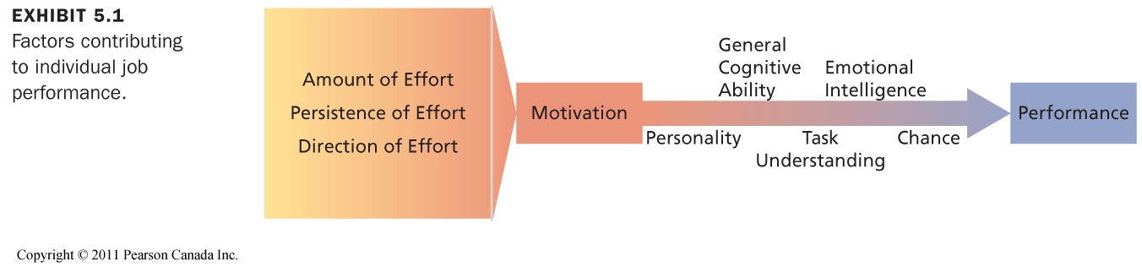
- Personality: The big five
- General Cognitive Ability: A person’s basic information processing capacities and cognitive resources ( verbal, numerical, spatial and reasoning)
- Task Understanding
- Emotional Intelligence (E.I.): Ability to understand and manage one’s own and other’s feelings and emotions
- Salovey & Mayer model:
    - Perception of emotions in oneself and others
    - Integration and assimilation of emotions
    - Knowledge and understanding of emotions
    - Management of emotions to attain goals
- Chance

- It is possible for performance to be low even when a person is highly motivated.
- We cannot consider motivation in isolation.
  - Not one-to-one because a number of other factors also influence performance.
- High motivation will not result in high performance if employees are deficient in important skills and abilities.

Expectancy Theory: Motivation is determined by the outcomes that people expect to get as a result of their actions on the job.

Expectancy: The probability that one will be able to act in a way that will lead to desired level of performance. (Effort/Performance Contingency) “I can do it if I try”
Instrumentality: The probability that a particular performance will be followed by a particular outcome. (Performance/Outcome Contingency) “ I can get it if I do it”

Valence: The expected value of outcomes, or the extent to which they are attractive or unattractive to you.
Positive valence = approach the outcome
Negative valence = avoid the outcome

Managerial Implications of Expectancy Theory

Boost expectancies
  - Ensure subordinates expect to achieve desirable first level outcomes
    - Proper equipment, appropriate training, fair and known performance review system
2. Clarify reward contingencies
  - Clarify the relationships between first level and second level outcomes
    - Clarify outcomes of actions, e.g. Company reward system
    - Challenging jobs lead to high instrumentalities for feelings of achievement, competence, etc.
3. Appreciate diverse needs
  - Analyze the specific needs of employees
McClelland’s Learned Needs Theory

- Nonhierarchical need theory of motivation.
- It outlines the conditions under which certain needs result in particular patterns of motivation.
- Once learned, needs become personal predispositions
- Needs are stable personality characteristics
- Focuses on the need for:
      - Achievement
      - Affiliation
      - Power
Need for Achievement: A strong desire to perform challenging tasks well.
- Individuals with a high nAch:
  - Prefer situations in which they can take personal responsibility for outcomes
  - Tend to set moderately difficult goals that provide for calculated risks.
  - Desire performance feedback.
Need for Affiliation: A strong desire to establish & maintain friendly, compatible interpersonal relationships.
- People with a high nAff have an ability to learn social networking quickly & a tendency to communicate frequently with others.
- Avoid conflict and competition with others.
Need for Power: A strong desire to influence others, making a significant impact or impression.
- People with a high nPow look for social settings in which they can be influential.
- Power can be used to serve the power seeker, other people, or the organization.
- We seek and do well in jobs that match our needs.
- People with high nAch:
  - Sales jobs or entrepreneurial positions
  - People with high nAff:
  - Social work, psychologist, or customer relations
  - People with nPow:
  - Management, or military, politics
Leadership Motive Pattern:
  - High in n-Power.
  - Low in n-Affiliation.
  - Medium in n-Achievement.
Entrepreneurship Motive Pattern:
  - High in n-Power.
  - High in n-Achievement.

Goal Setting Theory

Goal Setting: The process of choosing what goals to pursue, and deciding how to pursue them.
Goal: A Purpose or intention that helps direct attention and helps define the actions to be taken. Be specific, challenging, be committed and give feedback.
Motivational because:
- They direct attention toward goal-relevant activities.
- They lead to greater effort.
- They increase and prolong persistence.
- They lead to the discovery and use of task-relevant strategies for goal attainment.

February 11th, 2016

Chapter 6

Motivational Techniques:
  - Money
  - Job Design
    - Job enrichment
  - Management by Objectives
  - Alternative Working Schedule

Money as a Motivator

- Employees and managers seriously underestimate the importance of pay as a motivator.
  - Pay may be the most important motivator of performance.
- Pay is a good motivator if:
  - it can satisfy a variety of needs,
  - it is clearly tied to performance.
- The ability to earn money for outstanding performance is a competitive advantage for attracting, motivating, and retaining employees.

What is Job Design?

- The goal of job design is to identify the characteristics that make some tasks more motivating than others and to capture these characteristics in the design of jobs.
- Deciding what techniques, equipment, and procedures should be used to perform those tasks
- Job design may increase motivation and encourage good performance

Job Design: Early Approaches

- Scientific Management
  - There is “one best way” to perform any job
  - Simplification
  - Specialization
  - Extreme division of labour
  - Standardization of work
  - Best for unskilled workers

Disadvantages of the Scientific Method

- Repetitive, boring tasks – focuses on extrinsic motivation
- Meaningless, monotonous work
- High job dissatisfaction
- No opportunity to develop and acquire new skills

Job Scope Refers to

- . Breadth
  - Number of different activities performed on a job
  - Variety of tasks
AND
- 2. Depth
  - Degree of discretion or control a worker has over how work tasks are performed

JOB SCOPE AS A FUNCTION OF JOB DEPTH AND JOB BREADTH

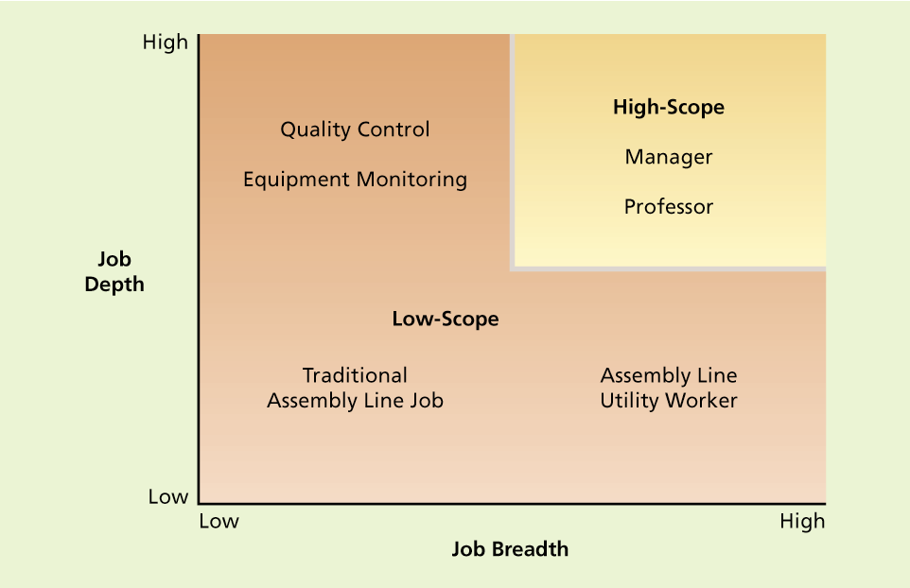

Need to look at job scope: breadth and depth of job.
Breadth: variety in tasks. Not routine.
Depth: degree of autonomy and control over one’s work. E.g., making decisions, planning, etc…
Low scope jobs: no breadth and no depth.
High scope jobs: high breadth and high depth.
Think about it in terms of motivation theories:
Need theories: high scope jobs can help fulfill more needs: see more people, good challenge, high esteem for self. nAch, nAff etc…
Expectancy theory: if the outcomes are attractive (e.g., enjoyment), it will increase motivational force.
Goal setting: difficult goals are more motivating.
High-scope jobs provide more intrinsic motivation than low-scope jobs.

Job Rotation

- Goal is to increase job scope
  - Employees are rotated to different tasks and jobs in an organization.
  - Can involve working in different functional areas and departments.
  - Can provide a variety of challenging assignments, develop new skills and expertise, and prepare employees for future roles.
The Job Characteristics Model

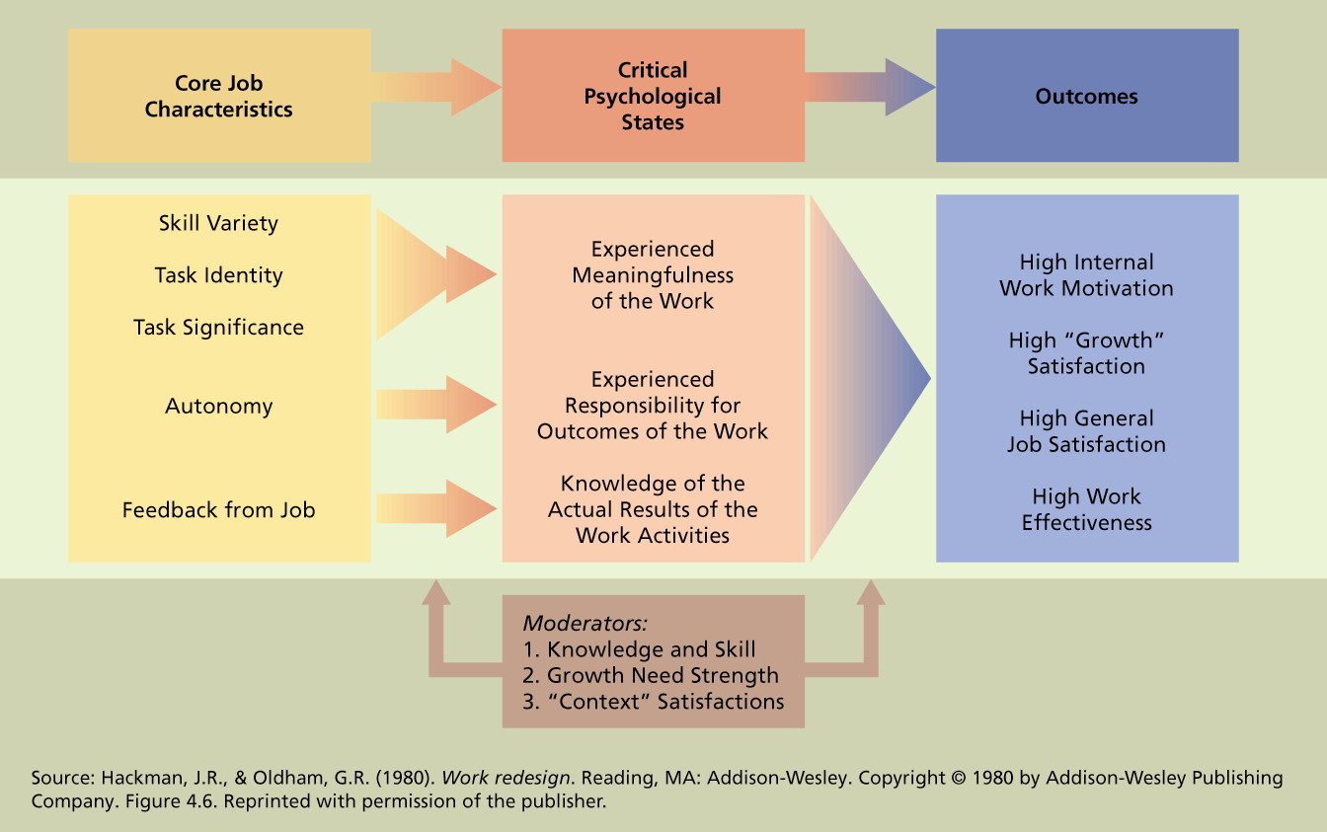

- The Job Characteristics Model proposes that there are several “core” job characteristics that have a psychological impact on workers.
- They attempted to identify exactly which job characteristics contribute to intrinsically motivating work and what the consequences of these characteristics are.
- According to this model, any job has five core dimensions that affect intrinsic motivation. The higher a job scores on each dimension, the higher the level o intrinsic motivation.
- The critical psychological states result in four key outcomes for employees and their organizations.
- When the five core dimensions are high, employees will be intrinsically motivated. They will also be motivated to perform at a high level. They will be more satisfied because they will have more opportunities for growth and development on the job. When employees enjoy performing their jobs, they will be less likely to be absent or quit.

Core Job Characteristics

- Skill Variety:
  - The opportunity to do a variety of job activities using various skills and talents.
  - High skill variety jobs are more intrinsically motivating
- Task Identity:
  - The extent to which a job involves performing a whole piece of work from its beginning to its end.
  - The higher the level of task identity, the more intrinsically motivated an employee is likely to be.
    - Group project
    - Art, toy designs,

- Task Significance:
- The extent to which a job has an impact on their lives or work of other people in or out of the organization.
  - Employees are more likely to enjoy performing their jobs when they think their jobs are important in the greater scheme of things.
  - Eg., waterboy
  - Major implicaitons for how you frame work to people to make them feel more important
- Autonomy:
  - The Freedom to schedule one’s own work activities and decide work procedures
  - degree of freedom, independence and discretion in scheduling and performing the work
- Feedback:
  - Information about the effectiveness of one’s work performance
    - (go back to goal setting)
  - degree to which you receive clear indications of your performance. At the high end, people receive almost constant report of their performance
Job Enrichment

The design of jobs to enhance intrinsic motivation, quality of working life and job involvement
- Combining tasks.
- Establishing internal client relationships
- Establishing external client relationship.
- Reducing supervision or reliance on others.
- Forming work teams.
- Making feedback more direct.

Potential Problems With Job Enrichment

- Poor diagnosis (job enlargement)
- Lack of desire or skill.
- Demand for rewards.
- Union resistance.
- Supervisory resistance.

Management by Objectives (MBO)

- An elaborate, systematic, ongoing program designed to facilitate goal establishment, goal accomplishment and employee development
- GOAL SETTING THEORY!!!
- Steps:
  - Organizational objectives are developed by top management.
  - Organizational objectives are translated into behavioural objectives for each individual.
  - Done by each manager participatively with the subordinate.
  - They are time-specific (i.e., deadlines) with measurable results.
  - Periodic meetings to review progress and take corrective measures.

Alternative Work Arrangements

- Flextime: Core time where you have to be there, with flexible bands that you can adjust around other life responsibilities (as long as #hours are done).
- Compressed work week: instead of the usual 5/40, people work 4/40.
- Job sharing: 2 people sharing the 40 hours in the same position.
- Work sharing: Instead of laying off people, you ask them to work less hours per week and share jobs.
- Telecommuting: working from home. Suited for people who are: Self-disciplined and self-directed, Trustworthy, Have tasks that allow some degree of autonomy

March 8th, 2016

Chapter 8

What is Organizational Culture?

- The shared beliefs, values, and assumptions that exist in an organization.
  - An organization’s style, atmosphere, or personality.
- These shared beliefs, values, and assumptions determine the norms that develop and the patterns of behavior that emerge from these norms.
CULTURE NORMS BEHAVIOR

- Language, values, attitudes, beliefs and customs that are shared within the organization
- It influences the way employees think, feel, and behave towards each other and towards people outside the organization.
- Feels like the style, atmosphere or “personality” of the organization.
- Way of life that is taken for granted
- It tends to be fairly stable over time and once established it can persist and provide social continuity.
- Affects organizational performance and employee satisfaction

Subculture

- Subcultures are smaller cultures that develop within a larger organizational culture that are based on differences in training, occupation, or departmental goals.
  - An organization can have several cultures (called subcultures).
- Effective organizations develop an “overarching” culture to manage differences between subcultures.

Strong Culture

When the beliefs, values and norms of an organizational culture are intense and pervasive (e.g. Disney, Westjet).
- Strongly supported and enforced by a majority of organizational members.
Has a great impact on the thoughts and behaviors of organizational members
- A strong culture provides great consensus concerning “what the organization is about” or what it stands for.
- Weak cultures are fragmented and have less impact on organizational members.
- But…
- An organization does not have to be big to have a strong culture.
- Strong cultures do not necessarily result in blind conformity.
- Strong cultures are associated with greater success and effectiveness.

Advantages of a Strong Culture

- Coordination
  - The overarching values and assumptions of strong cultures can facilitate communication and coordination.
- Conflict Resolution
  - Sharing core values is a powerful mechanism for resolving conflicts.
- Financial Success
  - Strong cultures contribute to financial success and organizational effectiveness when the culture supports the mission, strategy, and goals of the organization, and when its liabilities are avoided.

Liabilities of Strong Culture

- Resistance to change
  - can prove very resistant to change and can damage a firm’s ability to innovate.
- Culture clash
  - In a merger or acquisition: strong cultures mix badly
- Pathology
  - Values may support infighting /competition, having norms of secrecy or deception, blind obedience valued

Contributors to the Culture

- How are cultures built, maintained, and changed?
- Two key factors that contribute to the foundation and continuation of organizational cultures:
    - The founder’s role
    - Socialization
- Founder’s Role
    - Many cultures reflect the values of organization’s founder.
    - Top management strongly shapes an organization’s culture.
    - Sometimes, culture started by the founder can cause conflict when top management wishes to change direction.

Socialization Steps in Strong Cultures

- It is the consistency among these steps and their mutually reinforcing properties that make for a strong culture.
    - Disney company is a good example of a company that uses many of these steps.
- See page 13 of powerpoint for steps

Diagnosing a Culture

Symbols, rituals and stories.

- One way to learn about the culture is to examine the symbols, rituals and stories that characterize the organization’s way of life
- Symbols: corporate motto, mascot provide meaning and reinforce cultural values and what the company thinks is important
- From wikipedia…..
  - Motto: “To you from failing hands we throw the torch. Be yours to hold it high”
adopted from the “In Flanders field” poem written by John McCrae in 1915, the year before the Canadiens won their first Stanley cup (http://en.wikipedia.org/wiki/Montreal_Canadiens#Logo)
  - Logo: “C” & “H” which stands for Club & Hockey (the real name of the team). “Club de hockey Canadien"
  - Ken Dryden’s Mask
- Rituals: rituals and ceremonies such as parties and gatherings are expressive events that define and build the culture.
  - Every game begins with the national anthem
  - If they play a US team, they sing the anthem of the visiting team first
  - Retiring of Jersey numbers
- Stories: folklore and organizational stories about the past are told repeatedly across generations of employees to communicate informally about “how things work”.
  - Usually talk about issues regarding equality, security and control
  - Stories about “The Rocket” (known for his fiery passionate playing), Jean Beliveau, Ken Dryden

Stories: Common Themes

- Is the big boss human?
- Can the little person rise to the top?
- Will I get fired?
- Will the organization help me when I have to move?
- How will the boss react to mistakes?
- How will the organization deal with obstacles?

March 15th, 2016

Chapter 9

What is Leadership?

- The influence that individuals exert on the goal achievement of others in organizations:
  - Formal (assigned) roles (e.g., Vice-President of Sales)
  - Informal (emerged) roles (e.g., the “go-to person” for resolving a dispute with a supplier)

Approaches to Leadership

- Traits of effective leaders
- Emergent leadership: Who is likely to become a leader?
- What leaders do (specific behaviors).
- Situational factors:
- When to be “tough” & when to be friendly
- Transformational/ Transactional leadership

Search for Leadership Traits

- The trait perspective assumes that those who become good leaders possess special traits that distinguish them from others.
  - Traits are Individual characteristics such as physical attributes, intellectual ability, and personality.

Traits of an Effective Leader

- Intelligence
- Energy
- Self-confidence
- Dominance
- Motivation to Lead
- Honesty and Integrity
- Need for Achievement
- 3 of the Big 5:
  - Agreeableness, Openness to Experience, Conscientiousness

Limitations of Trait Approach

- Limited research support
- Traits Leadership?
- Situation not taken into account
- Does not tell us what leaders do to influence others successfully.

Emergent Leadership

- People who emerge as leaders in a group tend to be those who talk the most as long as they are perceived as having relevant expertise.
- The person who is liked the most in a group might emerge as a social-emotional leader.
  - A social-emotional leader is concerned with reducing tension, patching up disagreements, settling arguments, and maintaining morale.

Transactional Leadership

- Contingent Reward Leader: Assign people to tasks in return for reward/recognition (exchange).
- Active Management by Exception Leader: Actively monitor people’s behavior to avoid deviance. Punish when deviant.
- Passive Management by Exception Leader: Wait for deviance and consequence to occur before taking corrective measures.
- Laissez-Faire Leader: Avoid one’s leadership role and responsibilities, do not make decisions, delay action, do not use one’s authority when needed.

Transformational Leaders

- Transformational leaders change the beliefs and attitudes of followers to correspond with a vision and motivates them to achieve performance beyond expectations.

Dimensions of Transformational Leaders

- Idealized influence (charisma)
- Inspirational motivation
- Intellectual stimulation
- Individualized consideration

- Intellectual Stimulation:
  - People are stimulated to think about problems, issues, and strategies in new ways.
  - This contributes to the “new vision” aspect of transformational leadership.
  - It often involves creativity and novelty
  - Individualized Consideration:
  - Treat employees as distinct individuals
  - Indicate concern for their needs and personal development
  - A one-on-one attempt to meet the concerns and needs of the individual

- Inspirational Motivation:
  - communication of a VISION that is appealing and inspiring to followers.
  - Stimulates enthusiasm
    - challenge followers with high standards
    - communicate optimism about future goal attainment
    - provide meaning for the task at hand
  - They inspire followers using symbolic actions and persuasion.
  - Idealized Influence (Charisma):
  - The ability to command strong loyalty and devotion from followers and thus have the potential for strong influence among them.
  - The emotional aspect of transformational leadership
    - Making people feel pride and good about themselves when they are with you (GOOGLY EYES)
Situational Theories of Leadership

- ‘situation’ refers to the setting in which influence attempts occur.
- Basic premise = the effectiveness of a leadership style is contingent on the setting.
- Examples
  - Fiedler’s Contingency theory
  - House’s Path-goal Theory
    - (You are responsible only for this situational theory)

- To be effective, leadership must be adapted to the situation
- So contextual factors like:
  - Leader’s authority
  - Nature of the work itself
  - Attitudes of the subordinates
  - Characteristics of the external environment
- House’s Path-Goal Theory

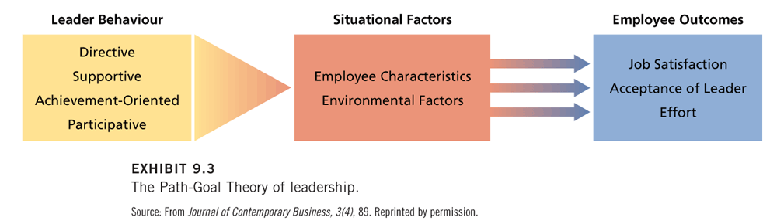

Participative Leadership

- Participative leadership = involving employees in making work-related decisions.
  - Leaders can vary in the extent to which they involve employees in decision making.
Advantages
- Increases motivation through goal acceptance and interest.
- Enhances quality when subordinates are knowledgeable and feel empowered.
- Increases acceptance through fairness.
Potential Problems
- Time and Energy
- Less Power
- Lack of Receptivity (distrust / poor work climate)
- Lack of Knowledge

Chapter 12

Ethics in Organizations

Systematic thinking about the moral consequences of decisions.
Moral consequences = harm to stakeholders.
40-90% of managers report being pressured to compromise ethical standards when making organizational decisions
Managers may see themselves as having
higher ethical standards than their
peers and sometimes their superiors.

Examples of Unethical Behavior

- Conflict of interest.
- Inappropriate gifts.
- Sexual harassment.
- Theft (e.g., stealing materials, unauthorized payments.)
- Dishonesty in reporting absenteeism, use of resources.
- Property damage.
- Violating employee privacy, releasing proprietary records
- Polluting the environment.
- False advertising.
- Withholding information about a product.
- Financial management procedures (e.g., creative accounting)
- Child labour
- Hazardous work conditions

What is an Ethical Dilemma?
A conflict between…
- One’s PERSONAL and PROFESSIONAL values
- Two values/ethical PRINCIPLES
- Two possible actions, each with reasons strongly FAVORABLE and UNFAVORABLE
- Two UNSATISFACTORY alternatives
- One’s VALUES/PRINCIPLES and one’s PERCEIVED ROLE
- The need to ACT and the need to REFLECT

It is not…

- Feelings
- Religion
- Following the Law
- Culturally accepted norms
- Science
Causes of Unethical Decisions and Behaviors

- Pressure from above.
- Feeling morally superior (self-serving bias).
- Temptation (easy gain).
- Role conflict (e.g., closing plant vs. polluting, “pushing” products).
- Competition.
- Bad organizational culture (values and norms)
- Industry culture.
- Strong economic value orientation.

March 24th, 2016

Chapter 11

What is decision making?

- The process of developing a commitment to some course of action.
- It is also a process of problem solving where there is a perceived gap between an existing state and a desired state.
- 3 important aspects of decision making:
  - It involves a choice among several action alternatives.
  - It is a process.
  - It involves a commitment of resources.

Well-structured Problem

- A problem for which the existing state is clear, the desired state is clear and how to get from one state to another is fairly obvious. These are simple, and their solutions arouse little controversy.
    - They are repetitive and familiar and they can be programmed.
Ill-structured Problem

A problem for which the existing and/or desired states are unclear, and the method of getting to the desired state(even if clarified) is unknown.

Rational decision making model

Perfect Rationality refers to a decision strategy that is completely informed, perfectly logical and oriented toward economic gain.

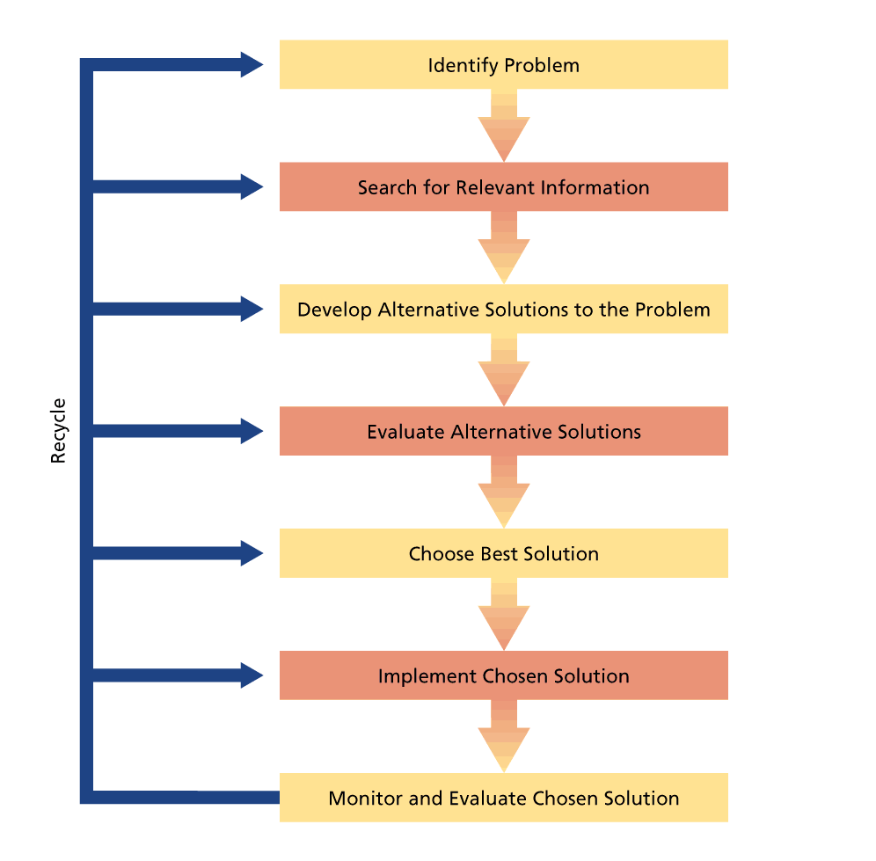

    - Identify and framing the problem
- FRAMING – Aspects of the presentation of information about a problem that are assumed by the decision maker
- These assumptions can be skewed because of cognitive biases we have
- Bounded rationality can lead to the following difficulties in problem identification:
- Perceptual defense.
- Problem defined in terms of functional specialty.
- Problem defined in terms of solution.
- Problem diagnosed in terms of symptoms.
- When a problem is identified, it is framed in some way.
- A $10,000 expenditure can be framed as a cost or an investment.
- Different decision frames can lead to very different decisions.
2. Information search
- Too Little Information
  - Sometimes, decision makers do not acquire enough information to make a good decision.
  - We remember vivid and recent events.
  - Confirmation bias
    - (when overly confident, seek out only information to confirm our decision.. results in “decision-based evidence making”)
  - Too Much Information
  - Information overload (more info than necessary)
  - Belief that More information = More satisfied
3. Evaluation and choice of alternatives
- Maximization: Choose the alternative with the greatest expected value.
Problems: People are poor statisticians, have cognitive biases, and bounded rationality.
- Satisficing: Establish an adequate level of acceptability for a solution to a problem and then screen solutions until one that exceeds this level is found.
- People are poor at revising estimates of probabilities and values as they acquire additional information.
- anchoring effect: decision makers do not adjust their estimates enough from some initial estimate that serves as an anchor.
- The perfectly rational decision maker can evaluate alternative solutions against a single criterion – economic gain.
- The decision maker who is bounded by reality might have to factor in other criteria such as political acceptability

Risky decision making

- Choosing between decision alternatives often involves an element of risk.
- Framing a problem as a choice between losses can contribute to a foolish level of risk taking
    - When people view a problem as a choice between losses, they tend to make risky decisions.
    - When people frame the alternatives as a choice between gains they tend to make conservative decisions.

Economic person Assumption

- Can gather information without costs.
- Is completely informed.
- Is perfectly logical.
- Has only one criterion for decision-making: Economic Gain!

Bounded Rationality

A decision strategy that relies on limited information and that reflects time constraints and political considerations.

Where decision making can go wrong…

- During problem identification and framing
- During information search
- During evaluation and choice

Cognitive Biases

- Definition: tendencies to acquire and process information in a particular way that is prone to error.
- They constitute assumptions and shortcuts that can improve decision-making efficiency, but they frequently lead to serious errors in judgment.
    - Perceptual Defense
    - Sampling Bias
    - Anchoring Effect
    - Availability Bias
    - Framing Bias
Examples of cognitive biases

- Anchoring effect: People do not adjust their estimates enough when they have been given an initially false estimate.
What is the length of the Mississippi River (in miles)? Is it more or less than 100 miles?
a. More
b. Less
What is your estimate of the length? _____ miles

- Availability Bias: People tend to make decisions based on the most easily accessible information in memory.
Consider the letter R.
Is R more likely to appear in:
(a) the first position?
(b) the third position?
- Framing bias: The way a problem is framed affects how people make a decision.
- Problems defined as:
  - Functional specialty: View the problem as being in the domain of their own specialty.
  - Solution: Jumping to conclusion
  - Symptoms: To understand the real problem, one must look at the causes, not at the symptoms.
Where it can go wrong…

- During problem identification and framing
- During information search
- During evaluation and choice

