Lab 5: Gel Filtration Chromatography Revisited and Electrophoretic Analysis of Lactate Dehydrogenase (LDH) Isozymes

CHEM 271-51L
Peter Faber
40032370
Performed 8/11/17
Submitted 22/11/17

QUESTIONS

1. Gel Filtration Chromatography
a) Calculate K_{d} for each protein standard and using these numbers generate a calibration curve. Using this curve determine the molecular mass of your unknown protein.

Table 1: Data provided for creation of calibration curve
Molecule | Elution Time (min) | K_{d} | Molecular mass (KDa) | Log(mass)
Blue dextran | 37.36 | 0 | 2000000 | 6.301
Catalase | 60.85 | 0.2795 | 232000 | 5.365
BSA | 68.18 | 0.3667 | 66000 | 4.820
Cytochrome C | 85.84 | 0.5789 | 13000 | 4.114
Vitamin B12 | 121.4 | 1 | 1350 | 3.130
Unknown | 64.23 | 0.3197 | 142807 | 1.732

b) If a monomer of this protein has a molecular mass of 36.5 KDa, what is its quaternary structure, based on your data? Explain your answer.
Because the protein mass approximately equals four of the monomer masses, it would be a tetramer.

2. Attach a copy of the gel record to this report. Be sure to indicate what sample is in each lane.

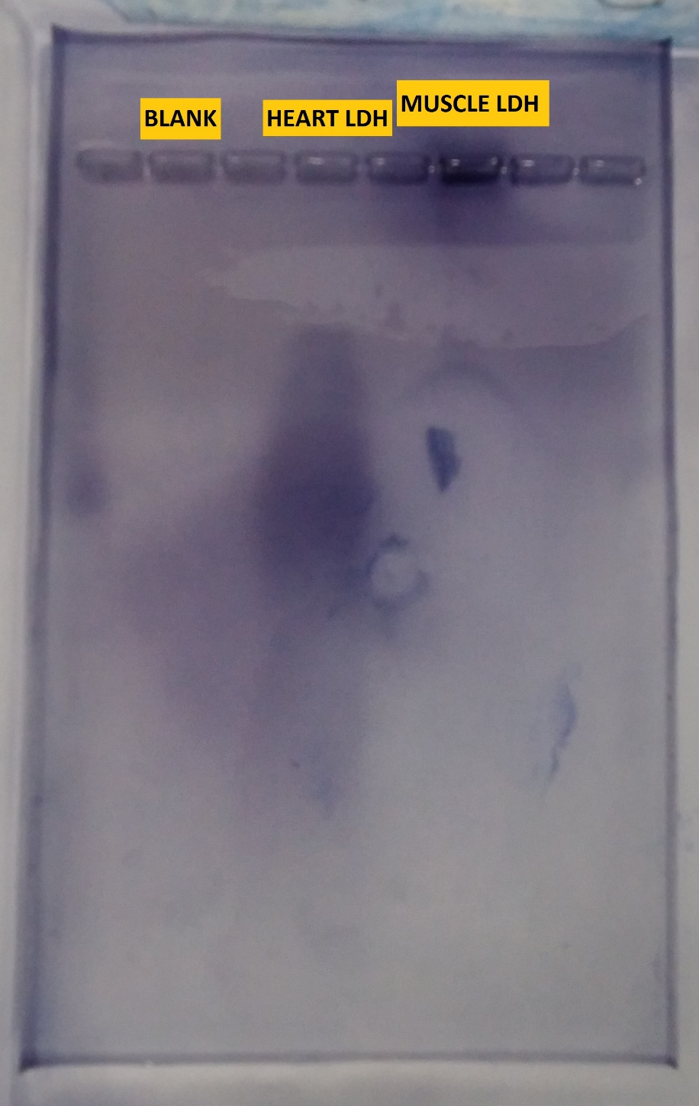

3. For this part you have to use Genbank.
a) Find the records for pig muscle and heart forms of LDH using Genbank. Blast the two sequences together and print out the alignment: attach it to this report.

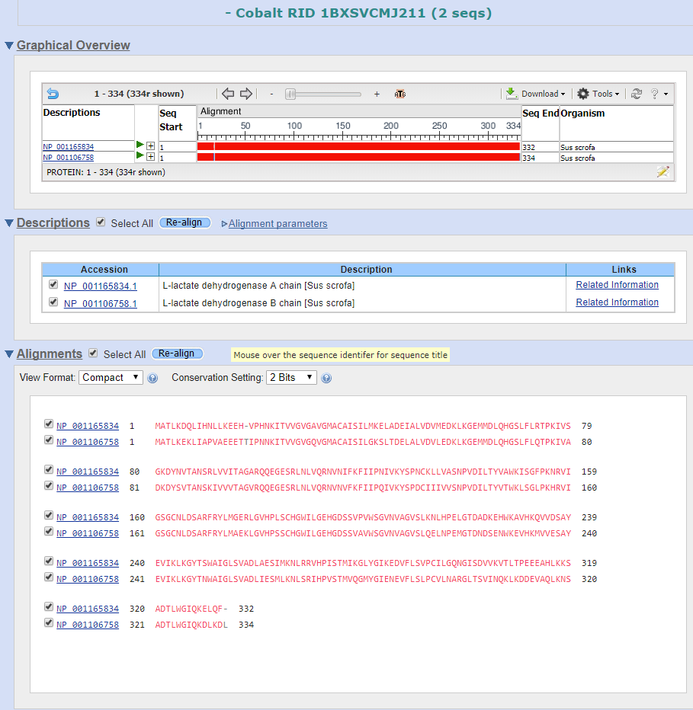

b) Using the alignment, what is the % identity between the two sequences?
The percent identity between the muscle and heart isozymes is 75%.

c) Now consider the amino acids that are different between the two sequences. At pH 8.6 (the pH of the buffer used to make the agarose gel) which of the two polypeptides (heart or muscle) will have more net negative charge? (You may assume that the pKa’s of the side chains are the same as those for the free amino acids.)
The manually estimated charges of heart and muscle isozyme are –11.7 and -2.8, respectively. Heart LDH is far more negatively charged.

d) Which isozyme would be expected to migrate farthest on the gel? Which of the samples on your gel actually migrated the farthest?
Isozymes traveled towards a positive terminal (1) at velocity $v=Ez/f$ (2), where negative charge, z, determined the distance gained. Heart LDH was most negative and should have traveled furthest. It did.

4. Predict what effects you would expect the following to have on the migration of LDH in the gel (compared to the gel you ran), and briefly explain why:
a) an increase in the agarose percentage to 1.2%.
Agarose makes up the mesh which proteins must navigate and determines the pore size by its concentration (2). As its percentage increases so does time needed to cross the gel. In a concentration 1.5x what was used (0.8%) the proteins would be expected to travel 2/3^{rds} the distance.

b) a decrease in the pH to 6.
A significant drop in pH would change the net charge of the proteins. At pH 6 the H isozyme is estimated to be -0.8, and the M isozyme 11.9. Movement of H would be markedly slower, and M would not move forward at all.

REFERENCES

- Powlowski, J., Kornblatt, M.J., Joyce, P., Turnbull, J., Ciortea, M. Chemistry 271 Laboratory and Tutorial Manual: Version 1.14; Concordia University: Montreal, QC, 2016: p 84
- Powlowski, J., Kornblatt, M.J., Joyce, P., Turnbull, J., Ciortea, M. Chemistry 271 Laboratory and Tutorial Manual: Version 1.14; Concordia University: Montreal, QC, 2016: p 83

