Lab #4: Basic Computer Organization
CEG2136C – Computer Architecture
Fall 2017
School of Engineering and Computer Science
Professor: Dr. Voicu Groza
University of Ottawa

Sajjad Kooliyat - 8640795
Rohan Sood - 8766597
Experiment Date:Wednesday, November 8th/November 15th/November 22nd/November 29th 2017
Submission Date: Monday December 4th, 2017

Introduction:
In this lab, students will analyse the structure of a basic computer, devise and design its control unit, and use opcodes to write simple programs in machine code. Students will also gain more experience working with the Quartus II software and the DE2-115 Altera development board.
Schematic Diagrams:
The controller used in our circuit
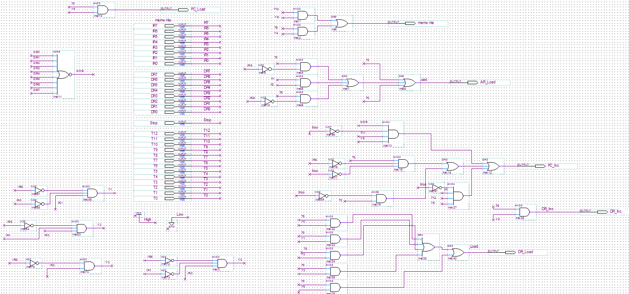
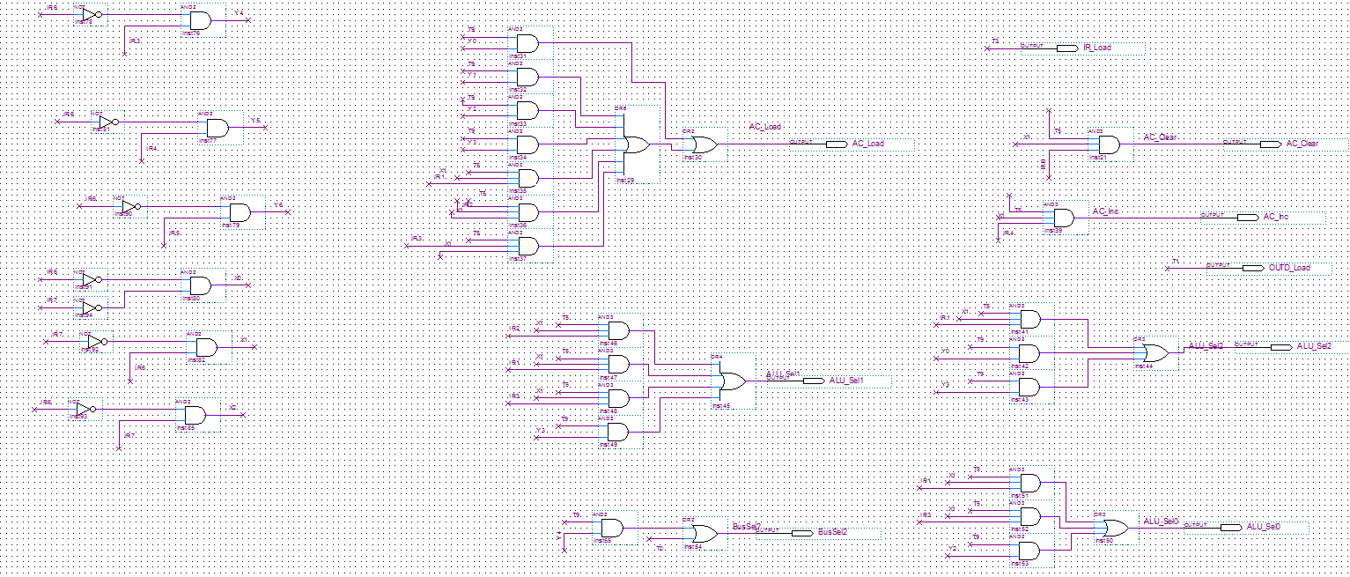
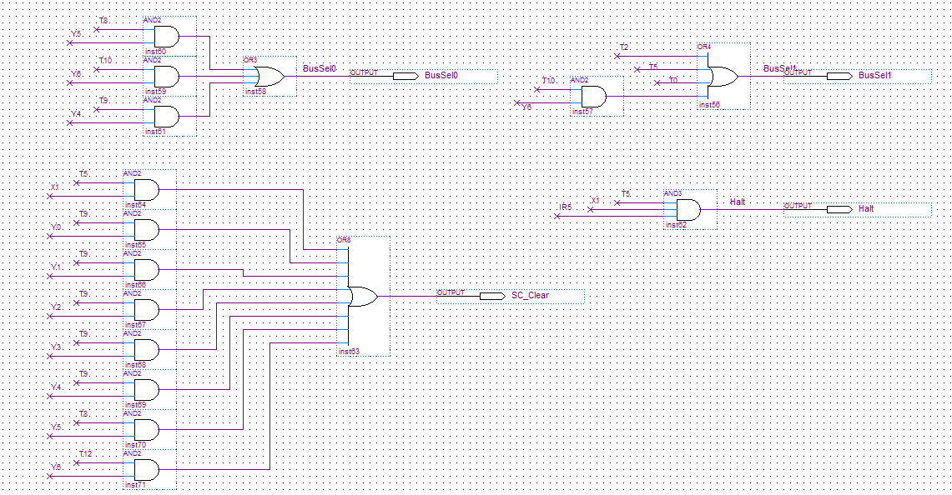

Memory Initialization files:
6.1 – Memory Initialization file
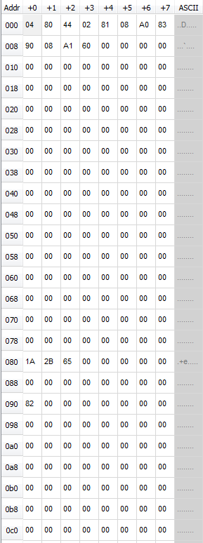

7.1 Memory Initialization File
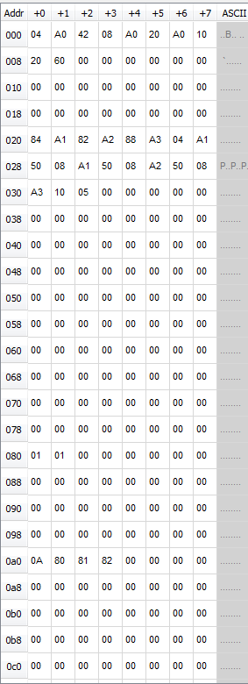

7.2 Memory Initialization File
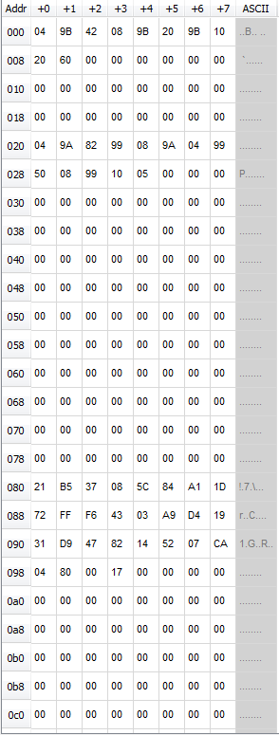

Waveform Data:
6.1 – Testing the Outputs for the A0 address
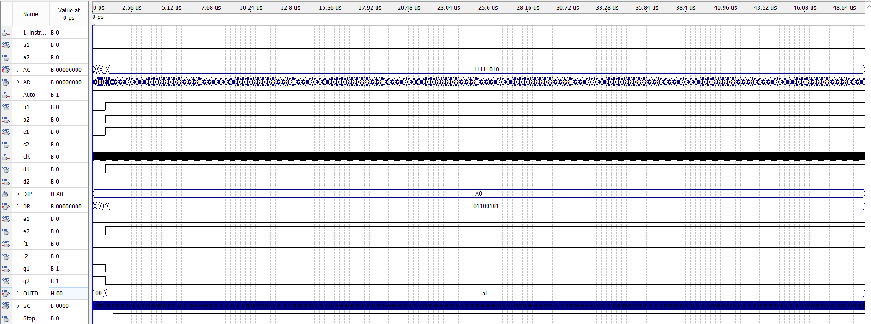
6.1 – Testing the output for the A1 address
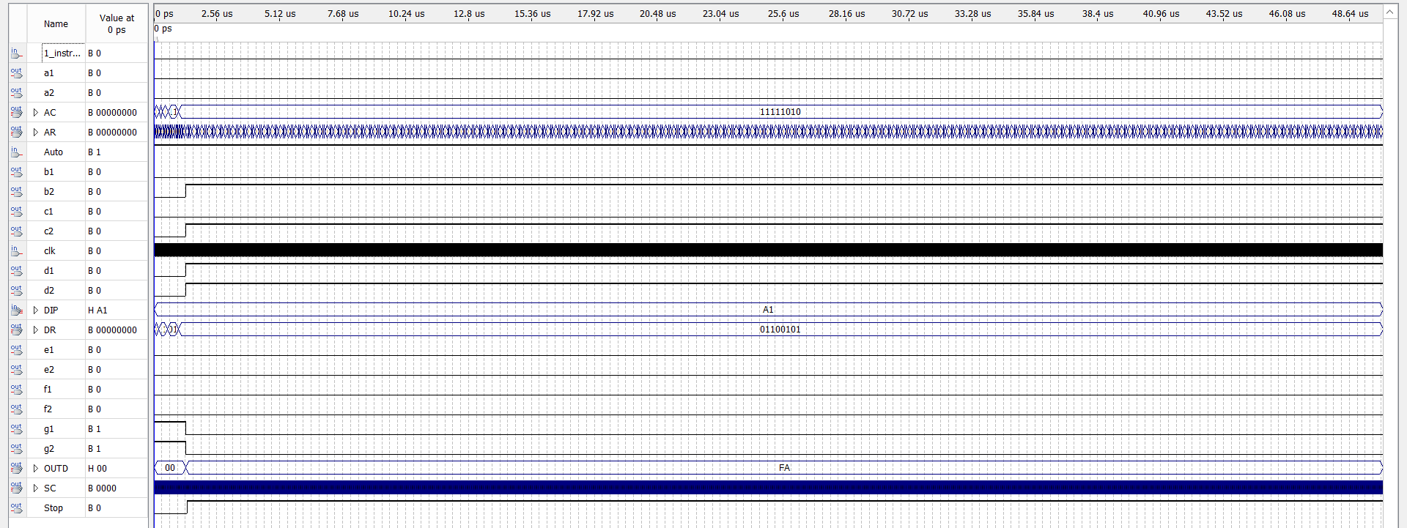

7.1 – Testing the output for the 84 address
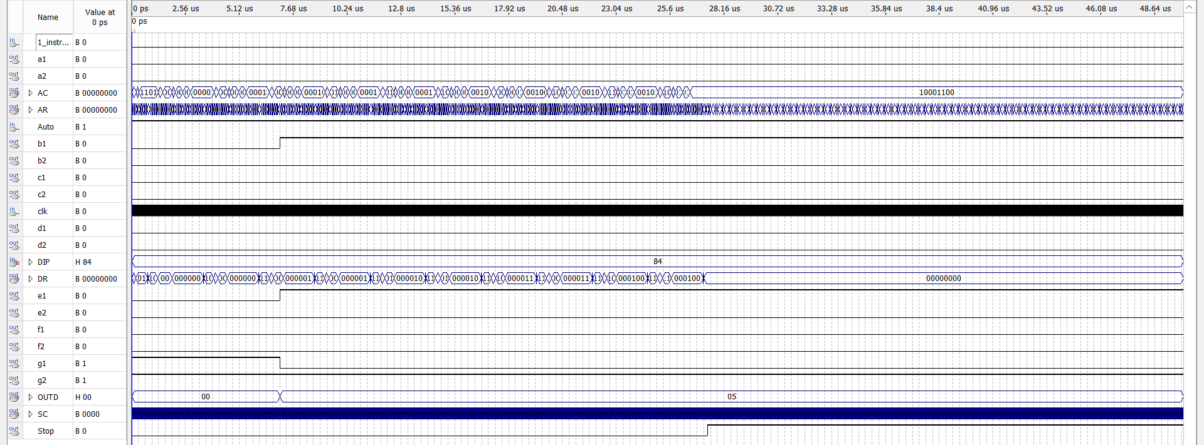
7.1 – Testing the output for the 85 address
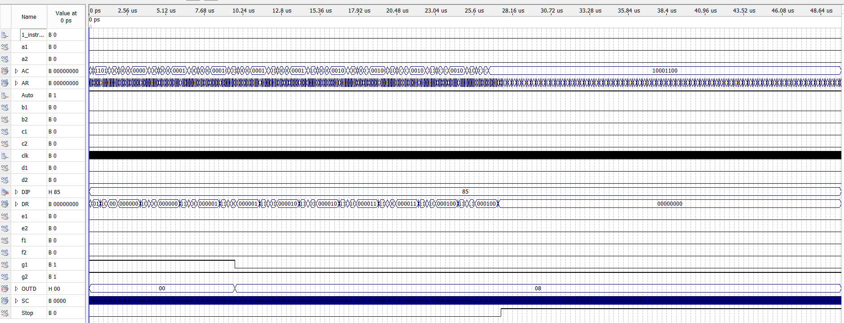

7.2 – Output for the 9A address 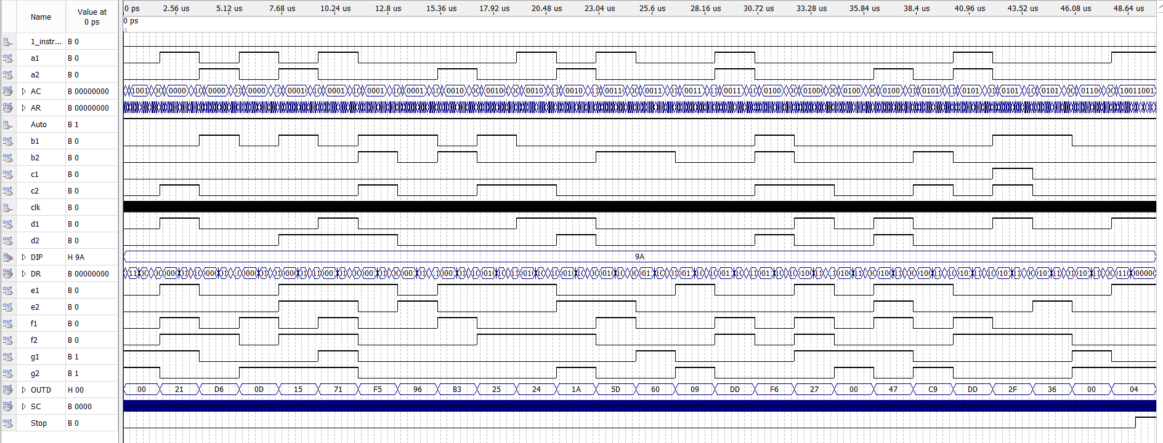
Altera-Board Outputs:
6.1 – Testing the Outputs for the A0 address
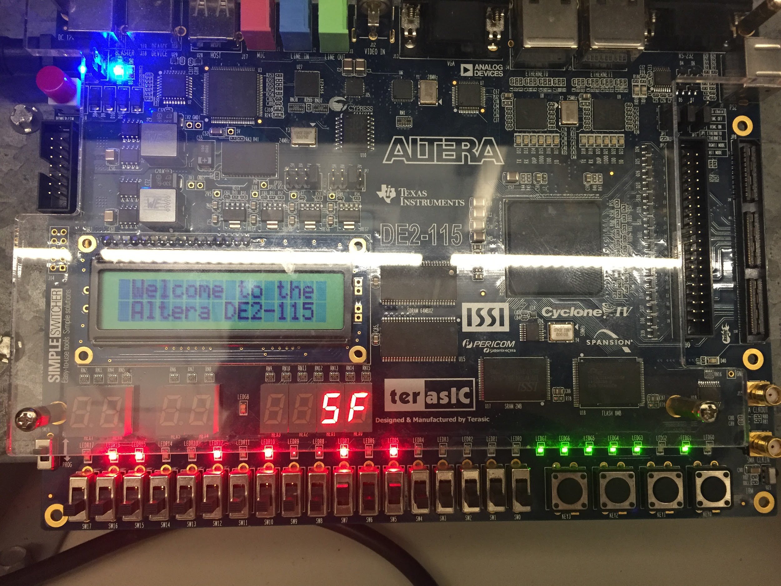

6.1 – Testing the output for the A1 address
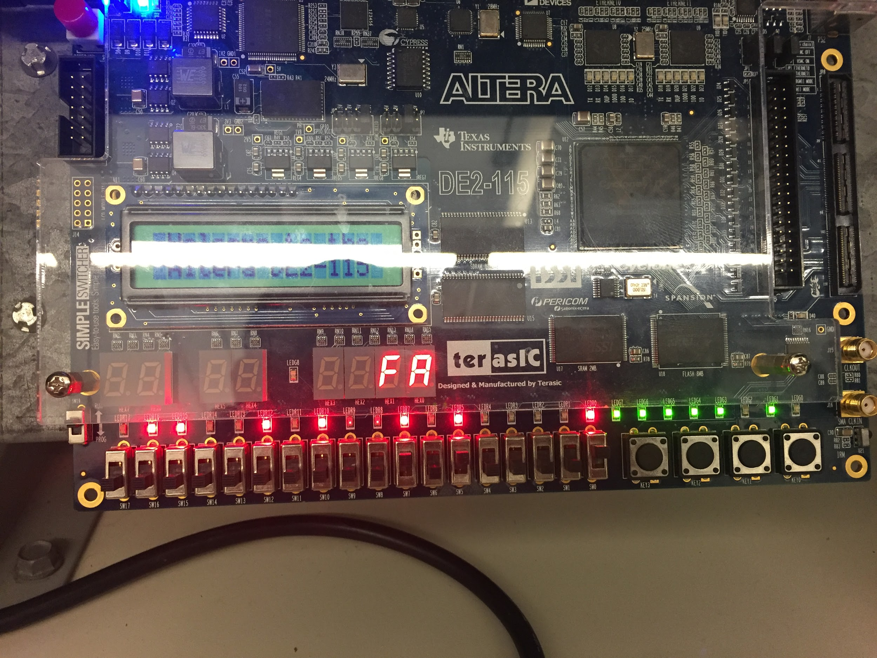

7.1 – Testing the output for the 84 address
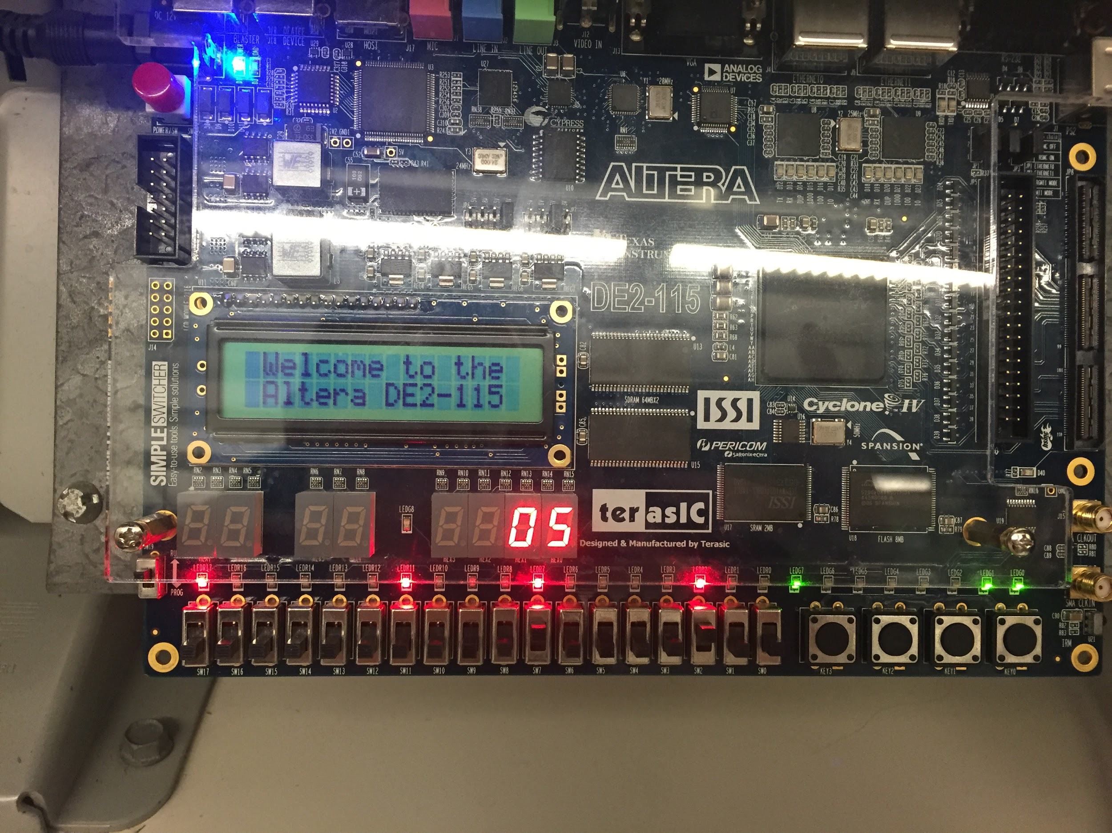
7.1 – Testing the output for the 85 address
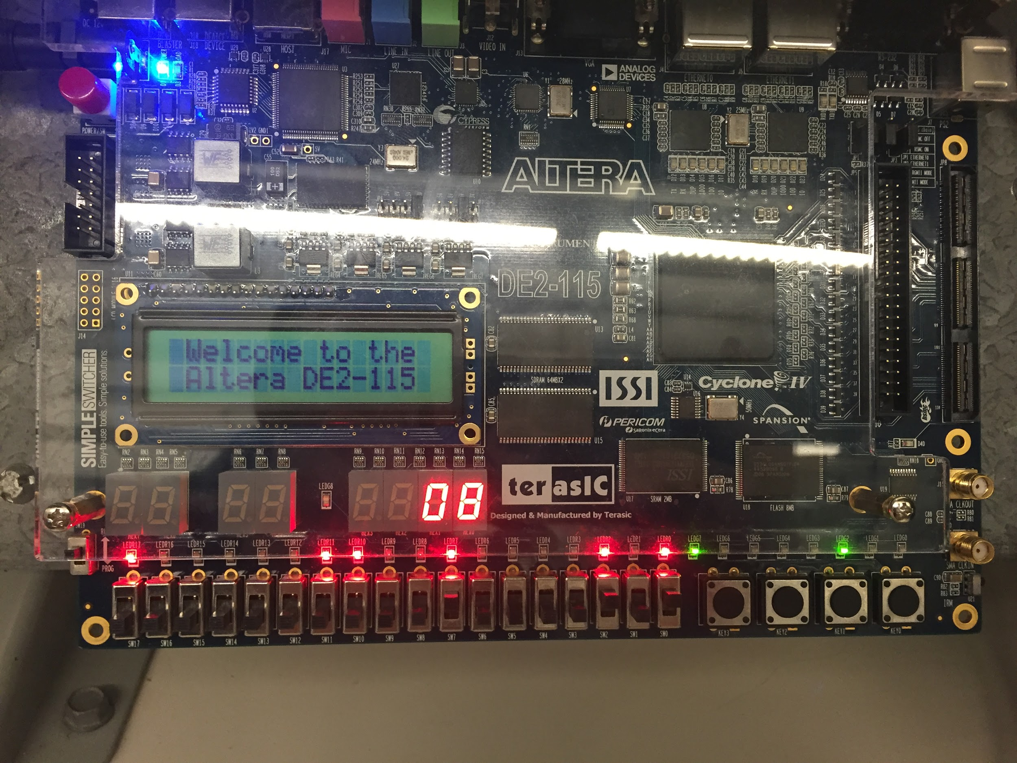

7.2 – Output for the 9A address
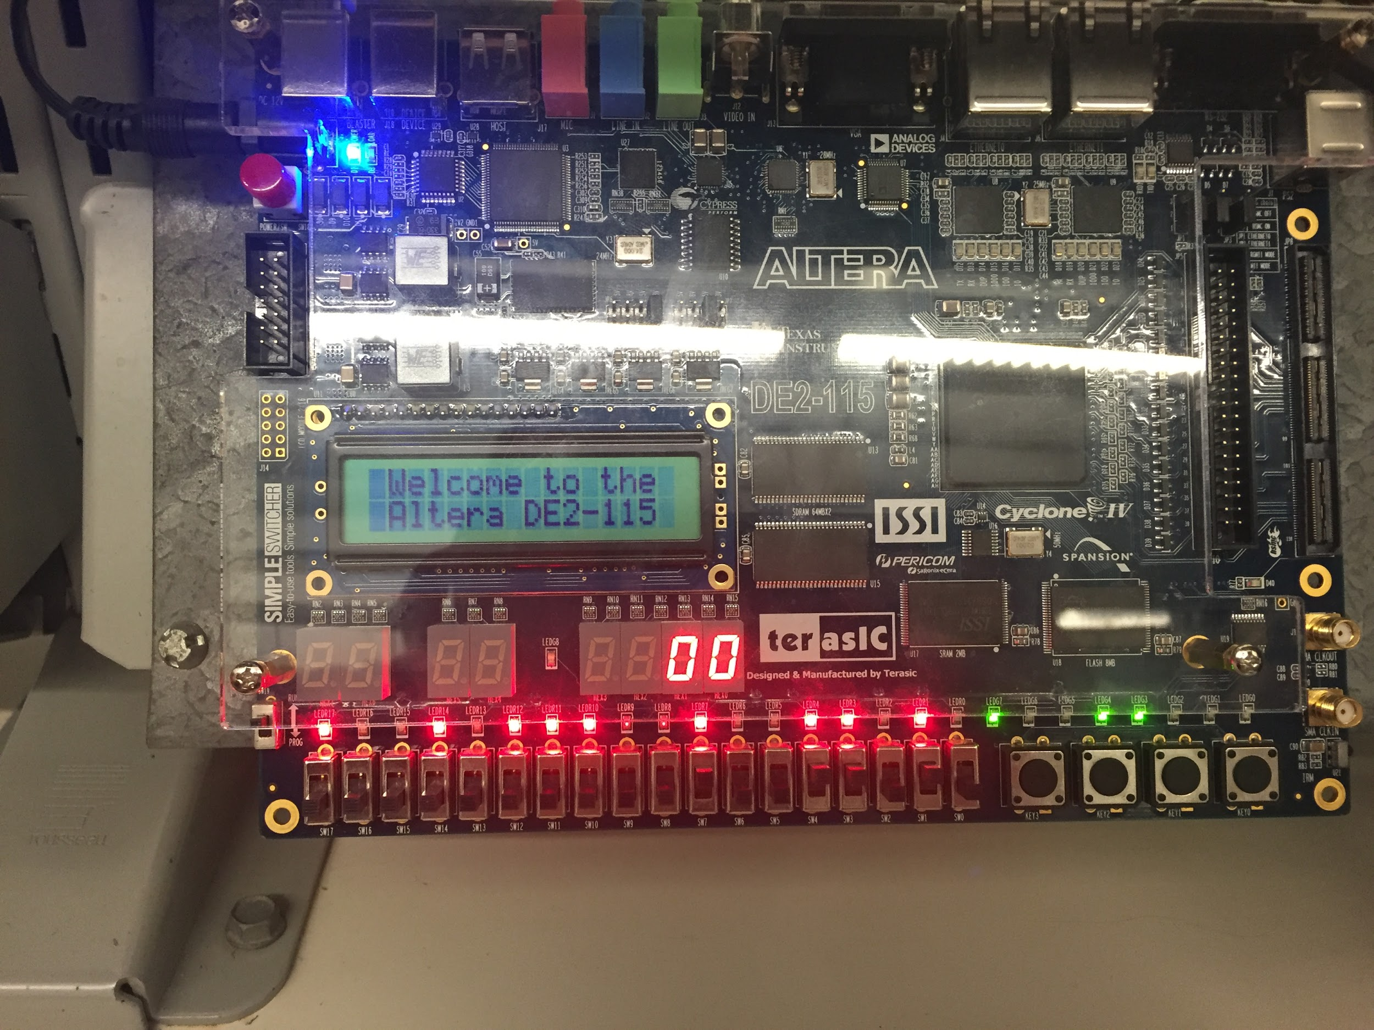

Discussion & Conclusions:
In this lab we created digital controllers which we designed in the prelab using Quartus II and coding in machine language. We first designed the circuits in Quartus and compiled them to make sure they were correct. Our group also created an memory initialization file where we inputted the machine code into Quartus which was simply from our prelab. Then we assigned pins to the inputs and outputs in the pin planner in order to simulate the controller on the Altera board. A problem occurred when we attempted to simulate on the Altera board, where the correct answers were not showing on the board even thought they were correct on the simulation. This is likely due to an hardware issue and we were not able to discover the issue even after the lab ended. In hindsight, our group should do the simulations on the Altera board ahead of time in order to make sure that our lab is done correctly.

Appendix (Pre-Lab) 

