BIO 1090 Final Notes

Lecture 13:
The three things it takes to make life are
- Information (genetics provides information about a cell and how it functions)- we need dynamic information
- Chemistry- need it to keep life
- Compartments- life is the chemistry of compartments
The Miller-Urey Experiment
- Chemical experiment that stimulated the conditions thought to be present on Earth which tested the chemical origin of life
- Used Water, Methane, Ammonia and Hydrogen to produce cyanide and formaldehyde
Main components of the cell theory
- The cell is the structural unit of life
- All organisms are composed of 1 or more cell types
- Cells can arise only by the division of a pre-existing cell
- The cell is the fundamental unit of life
The Basic Properties of Cells
- Highly complex and organized
- Activity controlled by a genetic program
- Can reproduce- makes copies of themselves
- Assimilate and utilize energy (source of all energy on earth is the sun)
- Carry out many chemical reactions through the use of enzymes which allow the reactions to occur without a large input of energy
- Engage in mechanical activities- have the ability to move and do this because they have a cytoskeleton
- Respond to stimuli through receptors embedded on the plasma membrane (e.g. leptin proteins interact with the receptors)
- Capable of self-regulation
- They evolve
Lecture 14:
Two types of cells on Earth:
- Prokaryotic
  - Bacteria
  - Structurally simpler
- Eukaryotic
  - Protista, fungi, plants, animals
  - Structurally more complex

Basic Properties of Cells:
- Cells are highly complex and organized
  - Contain a large number of parts
  - Organized with respect to time and space
  - Parts interact with little tolerance for error
  - Fidelity of interaction is maintained through control of regulation of parts (Provides precision in cellular activities
  - Cellular organization is very consistent (conserved throughout evolution)
- The nuclear pore complex enables movement of molecules into and out of the nucleus
- Cytoskeletal elements –actin filaments, microtubules, intermediate filaments
  - Contribute to cell shape and movement
  - Provide structural support
  - Support transport of material
- Some examples of different cell types in a human fetus are: red blood cells, muscle cells, fat cells, etc.
Viruses
- A virus is a non-cellular macromolecular package that can function and reproduce only within living cells
  - Outside of cells, a virus can exist as an inanimate particle- VIRION
  - A VIRION is composed of:
    - Small amount of DNA or RNA (encoding to a few hundred genes)
    - Protein capsule = capsid
Lecture 15:
Viruses:
- Viruses bind to a cell surface via specific proteins and enter into a cell- this defines the cell types the virus can infect and the host range
- WIDE HOST RANGE:
  - Rabies can infect cells in dogs, bats and humans
- NARROW HOST RANGE:
  - Humans cold and influenza viruses infect epithelial cells of the human respiratory system
- Once inside a cell, the virus hijacks cellular machinery to synthesize nucleic acids and proteins- assembles new virus particles
Two Main Types of Viral Infection:
- Lytic: production of virus particles will rupture and kill the cell (influenza)
- Non-Lytic or Integrative: viral DNA is inserted in the host genome DNA= Provirus; viral progeny bud at cell surface and the cell can survive, often with impaired function (e.g. HIV)
Function of Biological Membranes:
- Membrane is critical to how the cell works
- Forms a boundary between the cell and outside environment
- Define/ enclose compartment
- Control movement of material into/out of the cell
- Allow response to external stimuli
- Enable interactions between cells
- Provide scaffold for biochemical activities
- Plasma membrane bounds everything together
Fluid-Mosaic Model of Biological Membranes
- Fluid: individual molecules move
- Mosaic: diverse “particle” penetrate the lipid layer
Structure of the Biological Membrane:
- Biological membranes contain a hydrated lipid bilayer
- Fluid- Mosaic Model
  - Bilayer composed of amphipathic lipids (having both hydrophobic –non polar and hydrophilic- polar regions)
  - Proteins
    - Integral (transmembrane)
    - Peripheral
    - Lipid-anchored
- Components are mobile
- Anything bound by a membrane is a vesicle
- All membranes share common properties
  - 6nm thick (with associated water)
  - Stable
  - Flexible
  - Capable of self-assembly
- Different membranes contain different types of lipids and proteins
  - Membranes contain different functions in different cells
  - An example of differential membrane structure: the inner membrane of mitochondria contains a very high concentration of protein due to invagination
- Different areas of the plasma membrane perform different functions (e.g. epithelial cell)
- Biological membranes are asymmetrical
  - Two leaflets that have distinct lipid composition
  - In many plasma membranes, the outer leaflet contains glycolipids and glycoproteins (which are lipids and proteins with carbohydrate attached)
3 Classes of Membrane Proteins
- Integral: span the lipid bilayer
- Lipid Anchored: proteins attach to a lipid in the bilayer
- Peripheral: Associate with surfaces of the lipid bilayer
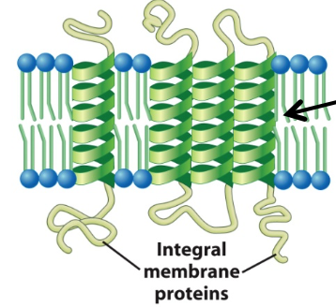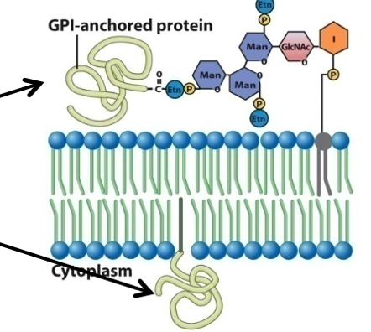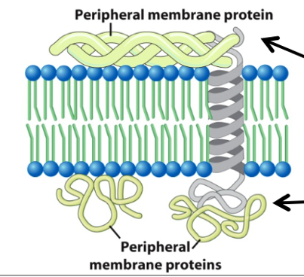

Fluidity is an important feature of biological membranes
- Membrane fluidity is determined by:
  - Nature of lipids in membrane
    - Unsaturated lipids increase fluidity
    - Saturated lipids reduce fluidity
  - Temperature:
    - Warming increased fluidity = liquid crystal
    - Cooling decreases fluidity = crystalline gel
Membrane Fluidity is Crucial to Cell Function
  - Balance between ordered (rigid) structure and disordered structure allows:
    - Mechanical support and flexibility
    - Dynamic interactions between membrane components (e.g. proteins can come together reversibly). Dynamic properties of the plasma membrane
      - Ruffles on the plasma membrane of a moving cell
      - A leukocyte ingesting a yeast cell
    - Membrane assembly and modification
  - Membrane fluidity must be maintained in response to changes in temperature, lipid composition of membranes can be changed
    - Desaturation of lipids
    - Exchange of lipid chains
Biological Membranes Are Dynamic
  - Lipids move easily, laterally, within leaflet
  - Lipid movement to other leaflet is slow
  - Membrane proteins diffuse within the bilayer
    - Movement of proteins is restricted
    - Some proteins do not move
    - Rapid movement is spatially limited
    - Long range diffusion is slow
    - Biochemical modification can dramatically alter protein mobility in the membrane (part of signal transduction)
- Cholesterol regulates membrane fluidity- alters packing and flexibility of lipids, if added to a liquid crystal membrane the fluidity will decrease. If added to a crystalline gel membrane the fluidity will decrease

Lecture 16:
Last Lecture:
- Viruses are infectious particles that commandeer the cell’s molecular machinery to propagate
- Membranes are composed of lipid bilayers
- Amphipathic phospholipids are main structural components of biological membranes
- Biological membranes are embedded with 3 different classes of proteins
- Fluid Mosaic Model describes membrane properties
- Cells with different functions have different membrane compositions
Lipid Rafts: Membrane Micro domains
- Lipid ‘rafts’ are small areas of the plasma membrane that are enriched in certain types of lipids (e.g. cholesterol)
- Rafts are relatively rigid
- Some membrane proteins accumulate in rafts
- May form ‘functional compartment’ (nature/ function of rafts is controversial)
Movement of Substances Across Cell Membranes
- Lipid bilayers DO NOT allow many compounds to pass through them freely
- Small, uncharged molecules cross membranes relatively easily (O₂, CO₂, NO, H₂O)
- Large/ polar/ charged compounds cannot easily cross lipid bilayers
- Specific mechanisms exist for the controlled transport of many substances across membranes
- 4 basic mechanisms for moving molecules across membranes:
  - Simple diffusion- nothing is assisting it, goes from high concentration to low concentration and it is only possible with small uncharged molecules
  - Diffusion though a channel- has to go through with protein and it goes from high concentration to low concentration
  - Facilitated diffusion- need assistance to go through membranes, foes from high concentration to low concentration
  - Active Transport- similar but goes from low concentration to high concentration
Simple Diffusion
- Very small uncharged molecules
- Down a concentration gradient (flow is downhill)
- High concentration to low concentration
- Examples: O₂, CO₂, NO, H₂O molecules
Diffusion Through a Channel
- Small, charged particles/ molecules (ions)
- Down a concentration gradient (flow is downhill)
- High concentration to low concentration
- Mediated by a channel
- Examples: Na+, K+, Ca2+, Cl-
  - Voltage gated K+ ion channel
    - It is selective
    - Driven by the different concentrations on each side of the membrane
    - It is gated; can be either open or closed
- Ion channels are formed by integral membrane proteins that line an aqueous pore
  - Channels are selective, allowing only one type of ion to pass
  - Ions move down concentration gradient- from high to low
  - Often channels are ‘gated’- can be open or closed
3 Types Of Gated Channels
- Voltage Gated Channels (e.g. K+ channel)
Channel responds to changes in charge across membrane
- Ligand Gated Channels (e.g. acetylcholine)
Channel responds to binding of specific molecule (a ligand)
- Mechano-Gated Channels (e.g. cation channels in inner ear)
Channel responds to physical force on membrane (stretch)
Facilitated Diffusion
- Compound binds specifically to integral membrane protein called a facilitative transporter
- Change in transporter conformation allows compound to be released on the other side of the membrane
- Compound moves down a concentration gradient
- Glucose Transporter: example of facilitated diffusion
Active Transport
- Compound binds specifically to integral membrane protein called an active transporter
- Change in transporter conformation allows compound to be released on other side of membrane
- Compound moves against a concentration gradient- low to high concentration gradient
- Requires input of ENERGY
- E.g. the Na+/ K+ ATPase maintains cellular [Na+] and [K+] using ATP
Lecture 17:
The Extracellular Matrix (ECM)- an organized network of material produced and secreted by cells
- Most cells have a glycocalyx
- Glycocalyx= assembly of carbohydrate groups attached to proteins and lipids on the outside of the plasma membrane
  - Mediates cell-cell and cell to ECM interaction
  - Provides mechanical protection
  - Serves as a barrier to some particles
  - Binds regulatory factors
- Many cells of multicellular organisms contact an extracellular matrix
- ECM serves many important functions:
  - sites for cell attachment
  - Physical support for cells
  - Contains regulatory factors (signals)
  - Separate/define tissues
- Components of the ECM are produced by cells and assemble into a network- proteins and glycoproteins
  - Proteins and glycoproteins (e.g. collagen, fibronectin, laminin)
  - Proteoglycans= proteins with chains of polysaccharides
Cells of Bacteria, Plants, and Fungi Have Walls
Plant Cell Walls:
- Composed of cellulose, hemicellulose, pectin and proteins- composed of cellulose micro fibrils embedded in a polysaccharide matrix
- Provide structural support to cell and to organism as a whole
- Protect cell from mechanical damage and pathogen attack
- Contain biochemical signals for cell
Main Functions of Intracellular Compartments
Compartment | Function
Cytosol | Protein synthesis, many metabolic pathways
Nucleus | Contains genome, DNA, RNA synthesis, ribosome assembly
Endoplasmic Reticulum | Synthesis of lipids, synthesis of proteins
Golgi Apparatus | Protein modification, packaging of proteins and lipids
Lysosomes | Degradation of cellular material
Endosomes | Sorting, recycling
Mitochondria | ATP synthesis, apoptosis
Chloroplasts | Photosynthesis, ATP synthesis
Peroxisomes | Oxidation of toxic molecules

Endosymbiotic Theory:
- Certain organelles such as mitochondria or chloroplasts were originally free-living bacteria that were taken inside another cell as endosymbionts
- Evidence to support this theory:
  - Mitochondria and chloroplast both have double membranes
  - Have their individual genomes
  - Both structures also have their own RNA and ribosomes
Mitochondria Have 2 Membranes:
- Outer Mitochondrial Membrane (OMM)
  - Contains many enzymes with diverse metabolic functions
  - Porins: large channels, when open the membrane is freely permeable (e.g. to ATP)
- Inner Mitochondrial Membrane
- High protein: lipid ratio (3:1)
- Double-layered folds = cristae
- Cristae: increase membrane surface area, contain machinery for aerobic respiration and ATP formation
- Rich in phospholipid called cardiolipin (characteristic of bacterial membranes)
Aqueous Compartments of Mitochondria
- Intermembrane space
- Matrix
  - High [protein]: gel-like consistency
  - Mitochondrial ribosomes
  - Mitochondrial DNA (mtDNA)
    - Encodes polypeptides that re integrated into the IMM, ribosomes and tRNA
Oxidative Phosphorylation: ATP Synthesis in the Mitochondria
- Step 1: Electron Transport and Proton Pumping: generates an electrochemical gradient
- High energy electrons (e⁻) pass from coenzymes (NADH and FADH₂) in the matrix carriers in IMM
- Series of electron carriers are present (respiratory enzyme complexes I, II, III, IV) known as the electron transport chain (ETC)
- The energy transfer at each of the complexes is used to pump H+ from the matrix into the intermembrane space
- Eventually, low energy electron is transferred to the terminal electron acceptor (O₂) to produce H₂O
- Step 2: Proton Movement down electrochemical gradient
  - The H+ protons which were transferred to the IMM do not move back easily- hence there is the controlled movement of protons back across the IMM
  - This is done via the ATP synthase
  - Potential energy in the electrochemical gradient across the IMM is converted to ATP in the matrix
Lecture 18:
Last Time:
- The extracellular matrix is important for cell function
- The Endosymbiont Theory suggests mitochondria and chloroplasts developed from ancestral bacteria
- Mitochondria have membranes and compartments that carry out oxidative phosphorylation
Apoptosis:
- Is a normal occurrence in which a coordinate sequence of events leads to death of a cell
- Mitochondria play an important role in programmed cell death (apoptosis)
- Apoptosis is characterized by:
  - Shrinkage of the cell
  - Blebbing of the plasma membrane
  - Fragmentation of DNA and nucleus
  - Loss of attachment to other cells
  - Engulfment by phagocytosis
The Intrinsic Pathway of Apoptosis:
- Internal stimuli such as genetic damage, hypoxia (lack of oxygen), or high concentrations of cytosolic Ca²⁺ cause apoptosis
- Proapoptotic proteins stimulate mitochondria to leak proteins such a cytochrome c
- The release of these apoptotic mitochondrial protein commits the cell to apoptosis
Release of cytochrome c and nuclear fragmentation during apoptosis caused by capases:
  - Capases: Proteases that are activated at an early stage of apoptosis and are responsible for the degradative events observed during cell death
    - Disrupt cell adhesion
    - Destroys LAMINS
    - Breaks down cytoskeleton
    - Activates DNase (genome breakdown)
Cytoplasmic Endomembrane System
- Early EM work revealed (within the cytoplasm)
  - Membrane bound organelles and vesicles
  - Extensive network of membranous canals and stacks of sacs known as cisternae
  - System is composed of: endoplasmic reticulum, golgi complex, lysosomes, vacuoles and endosomal transport vesicles
Secretory Cell (e.g. Mucin, a glycoprotein component of mucus)
- Synthesized in the rough endoplasmic reticulum
- Processed in the ER
- Further processed in the golgi complex
- Concentrated in vesicles
- Delivered to the plasma membrane
Technique: Using GFP to Track Cell Components
- The Green Fluorescent Protein from jellyfish can be genetically fused with a cellular protein
- The fusion protein can be expressed in cells
- The cellular: GFP fusion protein fluoresces and can be visualized under a microscope
- Observation of the fusion protein provides information about the endogenous protein
Vesicular Transport (Trafficking)
- Transport of material between compartments
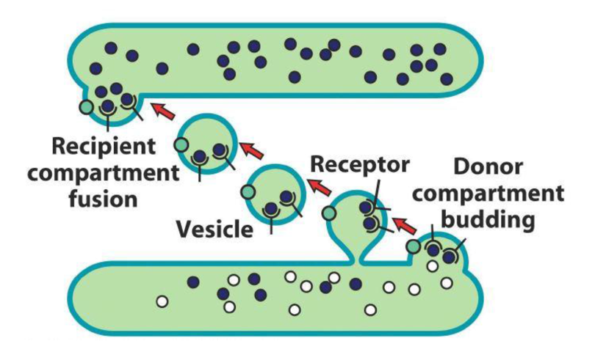
  - Organelle to the plasma membrane of vice versa
  - Organelle to organelle
- Utilizes transport vesicles (approx., 50-75nm)
  - Small, spherical, membrane enclosed organelles that bud off donor compartment and fuse with acceptor compartment
- Targeted Movement (directed)
  - Uses cytoskeleton and motor proteins
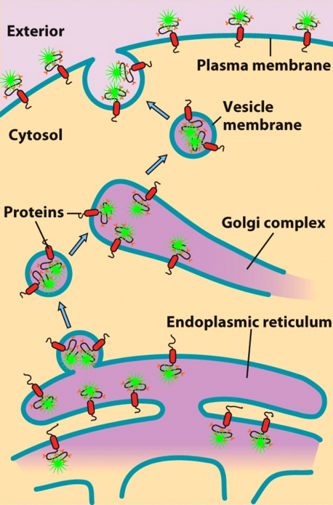
  - Sorting signals are recognized by receptors
Vesicular Transport: trafficking vesicles to a compartment
- Movement of Vesicle
  - Uses cytoskeleton and motor proteins
- Tethering Vesicle to Target Compartment
  - Via proteins called Rabs and Tethering Proteins to bring it closer to the compartment
- Docking of Vesicle to Target Compartment
  - Uses proteins called SNAREs to bind the vesicles to the membrane of the compartment
- Fusion of Vesicle and Target Membrane

Orientation of a protein with respect to the cytoplasm and the interior of membrane-bound compartments is maintained during its travel through the endomembrane system
- Some examples of vesicular transport are:
  - Organelle to the plasma membrane which is carried out by exocytosis (e.g. secretion of neurotransmitter)
  - Plasma Membrane to Organelle which is carried out by endocytosis
Lecture 19:
Last Time:
- Apoptosis eliminates redundant or damaged cells
- Internal signals activate the APOPTOSIS pathway through mitochondria
- CAPASES are PROTEASES which activate proteins that are involved in dismantling the cell
- The ENDOMEMBRANE system mediates exocytosis and endocytosis via VESICULAR TRANSPORT
- Protein traffic patterns cane be deciphered by using GFP fusion proteins
Endoplasmic Reticulum
- ER is an inter-connected network of membrane-enclosed tubules and flattened sacs (it is reticular)
- Interior is called the lumen which separate from the cytosol
- ER membrane is continuous with the outer membrane of the nucleus
Functions of the SMOOTH ER (SER)
- Production of steroid hormones (e.g. endocrine cells)
- Detoxification
  - E.g. liver cells- if you drink alcohol it will break down the toxins in the alcohol
  - Contains enzymes that modify foreign compounds (oxygenases, cytochrome P450)
- Sequestration (storage) of Ca²⁺ (in muscles it is called the sarcoplasmic reticulum)- flattened structure which stores calcium
Rough Endoplasmic Reticulum
- Contains ribosomes
  - There are no ribosomes in the lumen, but at some point the ribosomes interact with the cytosolic portion of the endoplasmic reticulum
- Functions of the Rough ER:
  - Protein synthesis, modification and transport for proteins targeted to the ER
  - Synthesis of membrane phospholipids
  - Glycosylation of proteins by the addition of carbohydrate chains
  - Protein folding
Protein Synthesis
- In the cytoplasm, ribosomes synthesize polypeptides from mRNA which is known as translation
Protein Translation
- ALL PROTEIN TRANSLATION BEGINS ON FREE RIBOSOMES
- Translation is completed in 1 or 2 ways:
- Translation completed on free ribosomes
  - Cytosolic proteins
  - Peripheral membrane proteins
  - These proteins can be targeted to nucleus, mitochondria, peroxisomes, chloroplasts
- Translation completed by ribosomes attached to ER membrane (rough ER)
Types of Proteins Synthesized in ROUGH ER:
- Secreted proteins (secreted through the plasma membrane)
- Integral membrane proteins
- Soluble proteins associated with inside (lumen) of the endomembrane system
  - E.g. proteins that function within the ER, Golgi and lysosomes
How is the Site of Translation Determined?
- Ribosomes are targeted to the ER membrane by a signal sequence
- Protein contains signal sequence
  - Located at its amino-terminus (N-terminus)
  - Contains several consecutive hydrophobic amino acids
- Signal Sequence directs synthesis to ER
- Protein moves through channel into ER = COTRANSLATIONAL IMPORT
Cotranslational Protein Import
After translation of signal sequence
- Signal Recognition Particle (SRP) binds to signal sequence- translation stops and the protein starts to be made at the end terminus
- Targeting of translation complex to ER [SRP/ribosome/new polypeptide]
  - SRP binds to SRP receptor
- SRP is released and ribosome binds TRANSLOCON
  - Protein synthesis resumes
- Polypeptide enters the ER (through the translocon) as it is translated
Once a protein is fully synthesized and properly folded it has 1 of 2 options:
- It is retained in the ER if that is where the protein functions
- It is transported from the ER to the Golgi complex for further modification and delivery to distal parts of the biosynthetic/ secretory pathway
- Once in the ER a protein is part of the biosynthetic/ secretory endomembrane system and may ultimately become part of the compartment or be secreted
  - E.g. ER, Golgi, Lysosome, Plasma Membrane
Transport from ER to Golgi Complex
- Exit Sites: membrane and ER lumen bud off to form Transport Vesicles
- ER-Golgi Intermediate Compartment (ERGIC)
  - Region between ER and Golgi complex
  - Transport Vesicles fuse to form larger vesicles and interconnected tubules= VESICULAR TUBULAR CLUSTERS (VTCs)
  - These then from the cis-Golgi network
- Material moves from ER to Golgi and then to the plasma membrane and other compartments
Lecture 20:
Last Time:
- The ER is a compartment of flattened sacs and tubules
- RER has ribosomes on the cytoplasmic membrane side; SER has no associated ribosomes
- RER and SER carry out many functions in the lumen
- Cotranslational import takes place in the RER
- The Golgi Complex is not directly connected to the ER; proteins enter via transport vesicles

Cotranslational Protein Import
- Synthesis of secretory and lysosomal proteins
- All protein translation begins in the cytosplasm
Synthesis of Integral Membrane Proteins On Membrane-Bound Ribosomes
- Synthesis of transmembrane proteins (except for those in mitochondria and chloroplasts)
  - Transmembrane protein means across the membrane which is the same thing as an integral protein
  - Anything that remains in the lumen of the ER are resident proteins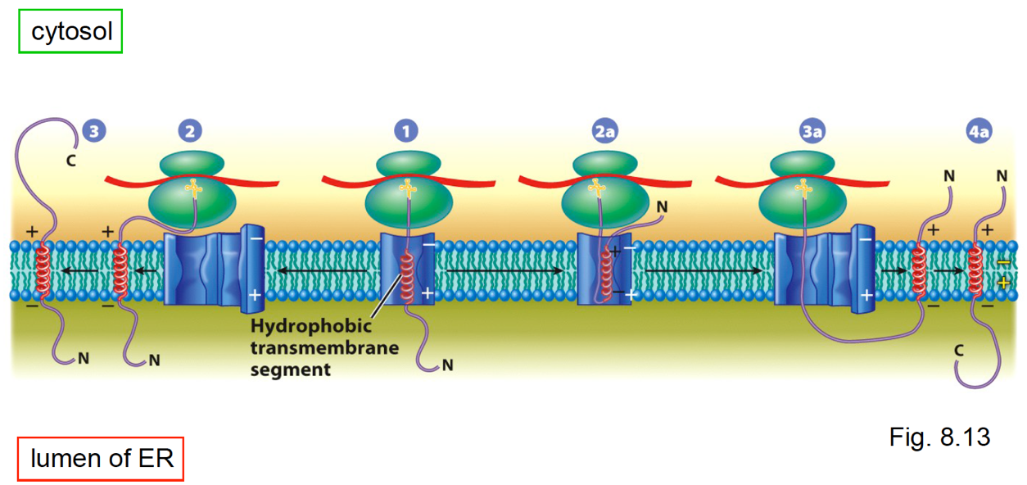
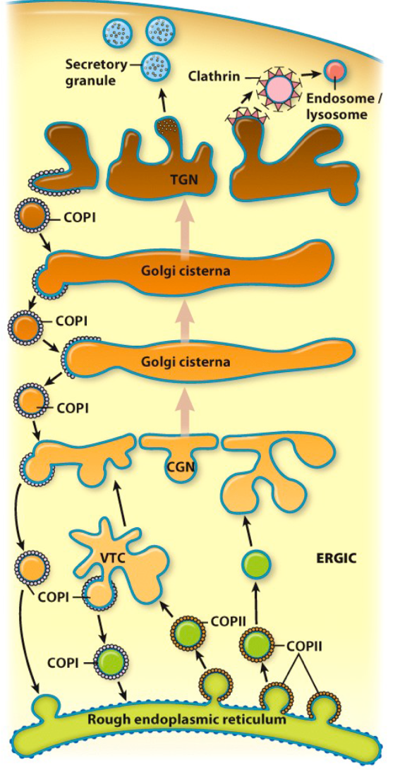
Transport from ER to Golgi Complex
- Membrane and ER lumen bud off to form TRANSPORT VESICLES
- ER-Golgi Intermediate Compartment (ERGIC)
  - Region between ER and Golgi complex
  - Transport vesicles fuse to form larger vesicles and interconnected tubules = Vesicular Tubular Clusters (VTCs)
  - These then from the ‘cis-Golgi network’ (CGN)
- Material moves from the ER to the Golgi and then to the plasma membrane and other compartments
  - [Proximal] ⇒ [Distal]
Cis- Golgi Network

The Structure of the Golgi Complex
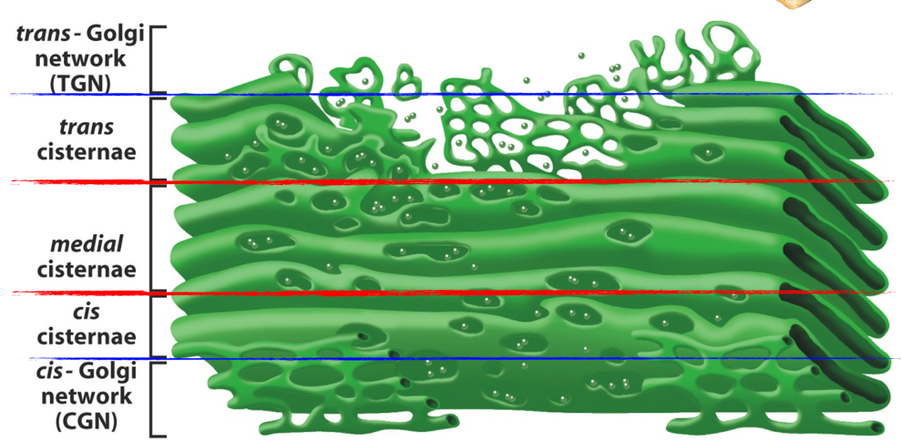
- Smooth, flattened, disk-like cisternae
  - ~ 0.5 – 1 micron in diameter
- ~ 8 or fewer cisternae/ stack
  - range from a few to several 1000 stacks
- Curved like a shallow bowl
- Shows Polarity:
  - Cis- medial- trans cisternae
  - Cisternae are biochemically unique
- Membrane is supported by protein ‘skeleton’ (actin, spectrin)
- Scaffold linked to motor proteins that direct movement of vesicles into and out of the Golgi
Why The Structural Differences?
CGN (Cis-Golgi Network)
- Acts as a “sorting station”
- i.e., sorts whether proteins should continue on to the next Golgi station or be shipped back to the ER

TGN (Trans-Golgi Network)
- Sorts protein into different types of vesicles
- Vesicles go to plasma membrane or other intracellular destinations (e.g. lysosomes)
Domains of Golgi Cisternae
- Proteins are modified “step wise” as they move through the Golgi
- Different cisternae of the Golgi contain different enzymes that modify proteins
Functions of Golgi Complex
- “PROCESSING PLANT” of the cell
- This is where the synthesis of complex polysaccharides occurs
- Also where the modification of proteins and lipids occurs
  - Glycosylation (glycoproteins and glycolipids)
  - Proteolytic modification (Proteolysis is the breaking down of proteins into simpler compounds)
- TRANSPORT and sorting of proteins
  - Fully processed proteins are exported from the trans cisterna, enter the trans-golgi network (TGN) and are then sorted and delivered to their final destinations such as:
    - Endosomes
    - Secretory Granules
    - Lysosomes
    - Plasma Membrane
Vesicular Transport= Trafficking
- Utilizes transport vesicles (coated vesicles)
  - ~50-100nm in diameter
  - Have protein-based “coat” on surface
  - Coat as 2 functions
    - Helps form the vesicle
    - Helps select cargo (which is the material inside/on vesicle)
- Vesicles bud of donor compartment
- Fuse with acceptor (or recipient) compartment
- Electron micrographs reveal dense protein coat (COPI and COPII) on vesicles
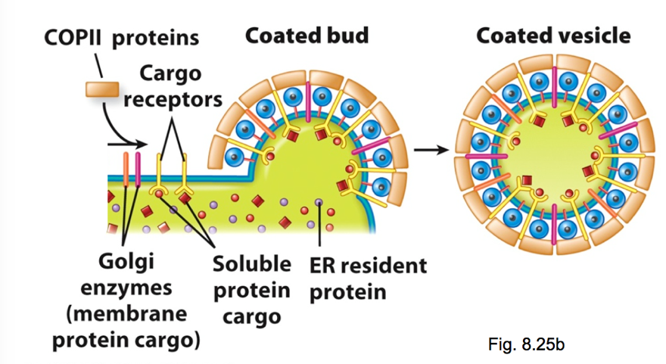
How do COPI and COPII proteins carry out functions (i) and (ii)?
- COPI and COPII proteins assemble on the cytosolic surface of donor membranes at sites where budding takes places
- Clathrin – coated vesicles move from TGN to other vesicles (e.g. lysosomes, endosomes, plant vacuoles)
- COPI- coated vesicles move in retrograde directions
- COPII- coated vesicles move in anterograde direction

Vesicular Transport: Overview
- Trafficking Vesicles to a Compartment
COP proteins help form the Transport Vesicle
- Movement of Vesicle
  - Uses cytoskeleton and motor proteins
COP proteins specify direction of Vesicle Movement
- Tethering vesicle to target compartment – via proteins called Rabs
- Docking of vesicle to target compartment- used proteins called SNAREs
- Fusion of vesicle and target membrane
Examples of Vesicular Transport
- ER to GOLGI
- ORGANELLE to PLASMA MEMBRANE
  - Both above are exams of exocytosis
      - Constitutive
      - Regulated
- PLASMA MEMBRANE to ORGANELLE = endocytosis
Lecture 21:
Lysosomes- Digestive Organelles
- 25nm- 1000nm
- Internal pH of 4.6 – H⁺-ATPase
- Hydrolytic enzymes- acid hydrolases
- Lysosomal membrane- is made up of glycosylated proteins
  - Protective lining next to the lumen
Lysosome Function
- AUTOPHAGY = organelle turnover (i.e., destruction of organelles and their replacement)
How?
- Lysosome fuses with ER- derived autophagic vacuole – forms autolysosome
- Contents enzymatically digested
  - Forms residual body (released by exocytosis and retained by lipofuscin granules)
- Degradation of internalized material (e.g. plasma membrane components or bacteria in phagocytic cells)
Plant Cell Vacuoles
- Fluid-filled and membrane bound
- Usually takes up ~90% of the cell’s volume
- Tonoplast: Vacuolar Membrane- contains active transport systems that generate high interior ion concentration
Function of Plant Vacuoles
- Intracellular digestion
  - Low pH, acid hydrolases (which is an enzyme that break macromolecules down)
- Storage
  - Solutes and Macromolecules
  - Chemical Storage (no excretory system)
  - Isolate Toxic compounds
  - Sequesters Pigments (e.g. anthocyanin)
- Mechanical support; Turgor Pressure
  - Gives rigidity to plant- supports soft tissues
  - Stretched cell wall during growth
Cytoskeleton/ Functions of Cytoskeleton
- The cytoskeleton is a dynamic network of interconnected filaments and tubules that extends throughout the cytosol (and some organelles) of eukaryotes
- Functions:
  - Structural Support
  - Spatial Organization within the cell
  - Intracellular transport
  - Contractility and motility
Microtubules (MT)
- Largest cytoskeletal element (25nm diameter)
- Polymer of proteins alpha and beta tubulin
- There are 2 major types of microtubules
  - Axonemal MT
    - Highly organized and stable
    - Part of structures (axoneme) involved in cell movement (e.g. cilia and flagella)

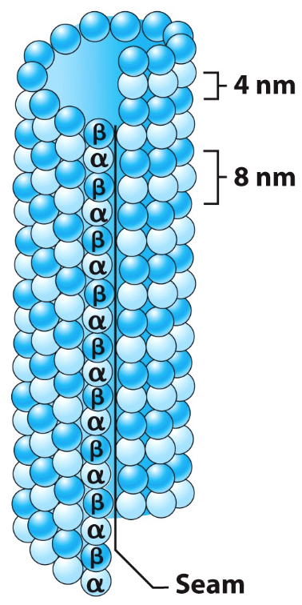
  - Cytoplasmic MT
    - Loosely organized and very dynamic
    - Located in the cytosol
Microtubules (MT) Structure:
- Alpha/ beta heterodimers form long protofilaments
- 13 protofilaments form longitudinal array to create a hollow cylinder
- heterodimers are aligned in same direction (head to tail)
- Also have structural polarity
  - MTs have fast-growing plus end and slow growing minus end
  - Structural polarity is important for MT growth/ shrinkage and direction of movement of material along MT
MTs Undergo Dynamic Assembly and Disassembly
- In vivo, this leads to the rapid turnover of most MTs within a cell (reaches its half-life in minutes)
  - This is known as dynamic instability
- Shrinkage can occur very rapidly at the “plus” end (termed catastrophe)
- Formation of MTs is regulated/controlled
- MTOC (Microtubule-Organizing Center) is the central site of MT assembly
  - The MTOC is where nucleation of microtubules begins
MAPs (Microtubule-Associated Proteins)
- Several different proteins that bind MTs
- Modulate assembly and function
- Mediate interactions with other cellular structures (e.g. vesicles/ organelles)
- Often stabilize MTs or stimulate assembly
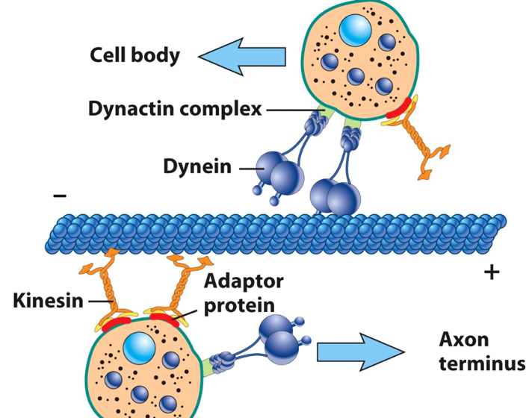
2 Classes of MAPs
- Motor MAPs
  - 2 main types: kinesin and dynein which power intracellular transport
  - use ATP to generate force
  - Can move material along the microtubule track
  - Can generate sliding force between microtubules
Kinesin: Plus end directed
Dynein: Minus end directed
- Non-Motor MAPs
  - Control MT organization in cytosol (e.g. TAU protein in neurons)
Intermediate Filaments (IF)
- Intermediate size of about 10-12nm in diameter
- Are Exclusive to multicellular animals
- Provide structural support and mechanical strength
- Are more stable in comparison to microtubules or microfilaments
- Fibrous proteins in which the central domain is α-Helical
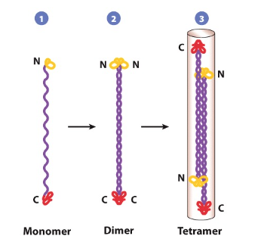
- Types of intermediate filaments are:
  - Keratins: epithelial cells
  - Neurofilaments: neurons
  - Lamins: Nucleus of all cells
Structure of Intermediate Filaments
- α-Helical domains wrap around each other forming a rope-like dimer (coiled-coil)
- Monomers are aligned in parallel; IF the dimers are POLAR molecules
- 2 dimers associate anti-parallel to make a tetramer- therefore the assembled filaments are NOT POLAR
Microfilaments (MF)
- Smallest Cytoskeletal element (~8nm)
- Polymer of actin protein
- Polypeptide = 42 kDa, binds ATP
  - Individual molecules are globular actin (G-actin)
    - G-Actin monomers have polar structure
    - Monomers are incorporated into the filament in the same orientation
  - The polymerized microfilament = F- actin
    - F-actin filament is polar: plus, and minus end
- Several well-characterized functions
  - Maintenance of cell shape
  - Cell movement
  - Cytokinesis
  - Muscle contraction
  - Vesicle Transport in plants
Lecture 22:
Last Time
- Autophagy used lysosomes to recycle used organelles
- Microtubules, intermediate filaments and microfilaments are the main structural components of the cytoskeleton
- Microtubules (MT) are polymers of alpha and beta tubulin that provide structural support and intracellular “tracks” (in animals)
- Vesicle movement along MTs is powered by Motor MAPs- Kinesin and Dynein
F-Actin Microfilament Assembly:
- G-Actin polymerizes reversibly (uses ATP)
- Then nucleation (slow process) occurs ( G-actin → dimers → Trimers → Short filaments)
- Elongation (Fast process)- monomers add to both end- usually faster at the positive end
- Polymerization/ Depolymerization and Structure/ Organization are regulated by actin binding proteins
- Filaments can be loose arrays/ networks or tight bundles/cables
- Examples of actin-binding proteins:
  - Nucleating proteins; e.g. Arp2/3
  - Monomer-polymerizing proteins; e.g. profilin
  - Filament-Depolymerizing proteins: e.g. cofilin
Directed Cell Motility
Coordinated activity of actin-binding proteins controls microfilament formation in lamellopodium to allow directed cell movement
MYOSIN: An actin associated motor protein
- Large family of proteins
- Most move toward the positive end of the microfilament
- Can be divided into 2 broad groups:
- Conventional Myosins
  - type II
  - Primary motors for muscle contractions
- Unconventional Myosins
  - Generate force and contribute to motility in non-muscle cells
  - Type I and types III- XVIII

Lecture 23:
Last Time
- Vesicle movement along MTs is powered by motor MAPs- Kinesin and Dynein
- Intermediate Filaments (IF) are non-polar and provide structural and mechanical support
- Intermediate Filaments are encoded by a “superfamily” of proteins with diverse functions in a variety of cells
- Microfilaments (MF) (a.k.a actin filaments or F-actin) are polar cytoskeleton components with important roles in cell structure and cell motility
- Growth of branched MF pushes against the plasma membrane to form lamellipodia and power cell movement
- Myosin is a motor protein that interacts with F-actin to facilitate cell movement (pulling) and vesicle transport (especially in plant cells)
Nucleus
- Functions
  - Storage, replication and repair of genetic material
  - Expression of genetic material
    - Transcription (mRNA, tRNA, rRNA
    - Splicing
  - Ribosome biosynthesis
- Structure
  - Nuclear envelope
    - Nuclear membrane, pores and lamina
  - Nuclear Contents
    - Chromatin, nucleoplasm, nucleolus
Nuclear Envelope (NE)
- 2 parallel phospholipid bilayers- separated by 10-50nm
- Outer Membrane (ONM) binds ribosomes and is continuous with rough endoplasmic reticulum
- Inner Membrane (INM) bears integral proteins and connected to nuclear lamina
Function of the Nuclear Envelope
- Separates content from cytoplasm
  - Separated transcription and translation
- Selective Barrier
  - Allows limited movement of molecules between nucleus and cytoplasm
- Supported by nuclear lamina
Nuclear Lamina
- Thin meshwork of filamentous proteins- forms meshwork next to the nucleoplasmic leaflet of the inner membrane
  - Lamins (Class V of intermediate filaments in animal cells)
  - Plants have nuclear lamina BUT it is not made of lamin proteins
- Bound to inner membrane of NE by integral membrane proteins
- Provides attachment sites for chromatin

Nuclear Pores
- Are gateways between cytoplasm and nucleoplasm
- There are ~3000 to 4000 pores per nucleus
- Pores occur where inner and outer membrane fuse
- Have a complex protein structure (Nuclear Pore Complex – NPC)
Nuclear Pore Complex
- Composed of nucleoporins (NUPs)
- Octagonal symmetry
- Projects into cytoplasm and nucleoplasm
- HUGE supramolecular complex (15-30 times the size of a ribosome)
NPC Function
- Passive diffusion of molecules smaller than 40 kDa
  - Rapid (100/min./ pore)
- Regulated movement of larger molecules
  - Slow (6/min./pore)
- Regulated movement of proteins into the nucleus requires a Nuclear Localization Signal (NLS)
  - NLS: a short stretch of positively charged amino acids within the protein sequence
Nuclear import and export are critical for cellular function
- Nucleocytoplasmic trafficking
  - Nucleotides
  - Structural Proteins
  - DNA packaging proteins (Histones)
  - Proteins for DNA replication, repair, transcription
  - Proteins for RNA processing and export
  - Proteins for ribosome synthesis and export
Function of the Nucleolus
- Ribosome Biogenesis
  - Synthesis of rRNA
  - rRNA processing
  - assembly of subunits (rRNA + proteins)
  - 40S and 60S subunits are exported to the cytoplasm

