Amazing Energy Reserves in Animals

The Anatomy of a Camel
- Hump consists of fat (tristearin C₅₇H₁₁₀O₆) and can weigh up to 80 lbs
- Extreme tolerance to water loss (up to 30-40% of their body weight)
- Minimize water losses by condensing water in the nostrils

Geese
- Canadian geese lose up to half of their body weight in fat
- Canadian geese can fly up to 3280 ft
- Bar-headed geese can fly up to 29500 ft and 65 km/h

Lipolysis
- Fat molecules are ~3 times as much ATP than per molecule of glucose
- Breakdown of lipids (Adipocyte)
- Hydrolysis of triglycerides into glycerol and free fatty acids
- Vesicles contain fatty acids
- Membrane transporters transport fatty acids at a high rate into circulation and into myocyte
- Undergo circulatory or cytosol transport (T)
- Entry into the mitochondria is through specific transporters and FFA undergo $β$-oxidation with each pass through the reaction spiral that yields acetyl-CoA
- Acetyl-CoA then enters the tricarboxylic acid cycle (TCA) producing reducing equivalents for production of ATP and the subsequent generation of CO₂
- $β$-oxidation produces more acetyl-CoA than glycogen
- Forks at the bottom are sarcomere (where muscle contraction occurs) contains actin and myosin which are motor proteins whose interactions produce movement, and in this particular case, muscle contraction.
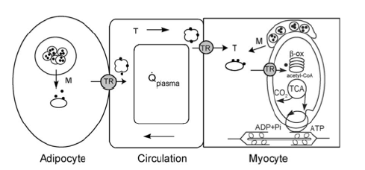

O₂ Transport in Hypoxic Environments
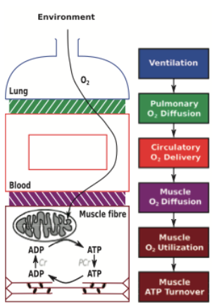

- Enhanced hypoxic ventilator response and
more effective breathing pattern

- Larger lungs increase the surface area for
diffusion

- Haemoglobin with a higher O₂ affinity
- Multiple cardiac specializations

- Even higher capillarity
- Mitochondria are redistributed closer to
capillaries

- Sometimes greater aerobic capacity in the
flight muscle

- Greater respiratory control by mitochondrial
creatine kinase

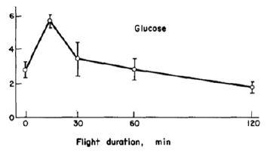

Locusts
- Decimate crops
- Can fly for long periods of time by tapping into their fat stores
- Fly for hours in swarms (millions – billions)
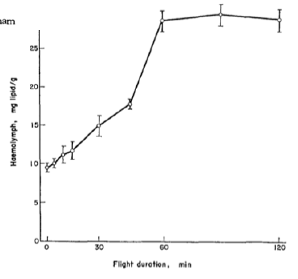
- They make carcass mats from the dead locusts and feed on them to fill energy stores to continues across the ocean
- Cannibalistic
- In the lab they tether them by the scruff and blow air on them to simulate a draft and monitor glucose/lipid levels
- Hemolymph is a fluid, analogous to the blood in vertebrates
Ketogenesis
- Process by which ketone bodies are produced as a result of fatty acid breakdown in the liver
- Can be converted to acetyl-CoA
- Ketones generate 38% more ATP than glucose


