Chapter 7

Consumers, Producers and Efficiency

From Individual Demand to Market Demand
In order to examine the underpinnings of the demand curve, we have to examine the behavior of consumers

Market demand is aggregation of the demands of all consumers

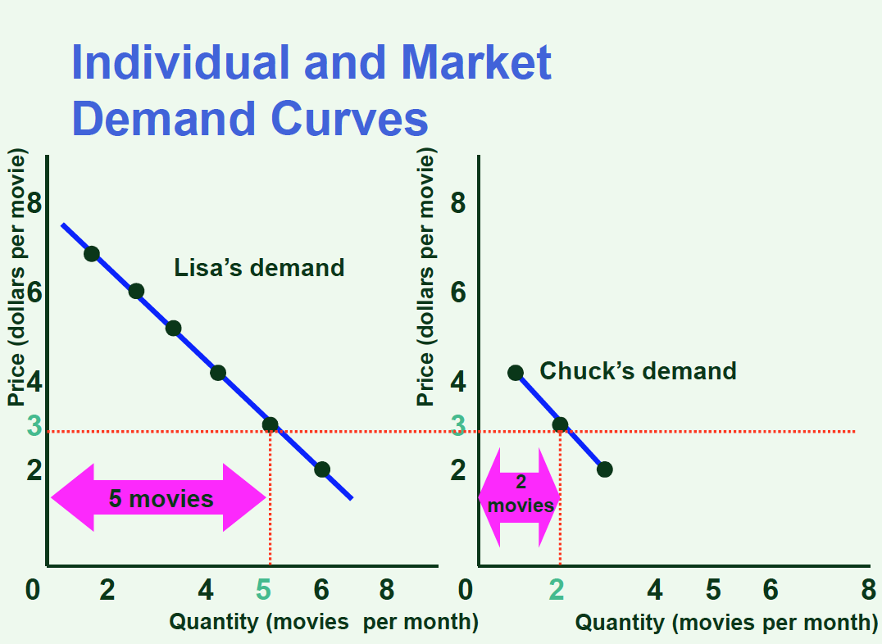
The market demand curve is the horizontal summation of all off the individuals’ demand curves
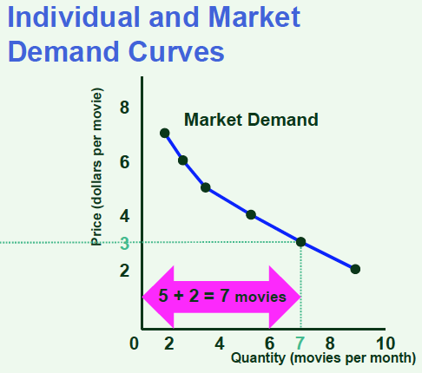

Consumer Surplus
- Definition: welfare economics
  - How the allocation of resources (input and hence output) affects economic well-being
  - Consider well-being of demanders (consumers) and of suppliers (firms)
- Think of price as a measure of the consumer’s willingness to pay given a quantity
  - This willingness to pay differs across individuals
  - The willingness to pay also tends to decline within an individual as his/her consumption level rises
- Consumer surplus is a measure of consumer well-being that reflects the payment rendered
- Consumer surplus = willingness to pay – requirement to pay
  - Requirement to pay = total revenue

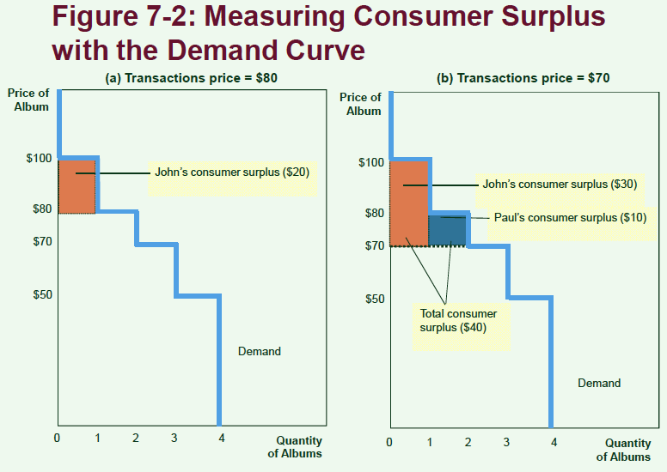

For each unit consumed, it is the height of the demand curve minus the height corresponding to the transaction price

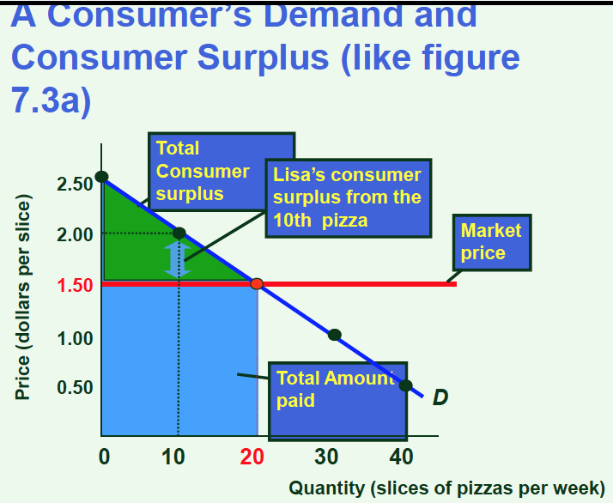

For all but the marginal unit, the consumer gets a ‘bonus’, and this quantity is counted in consumer welfare

- As the level of consumption rises, the level of consumer surplus diminishes
  - Consumer surplus at the margin (the very last unit produced) is 0
- A decrease in price will raise consumer surplus and thus make consumers better off
- An increase in price will have the opposite effect

Producer Surplus
- Producer surplus is the counterpart for consumer surplus on the supply side
- It is a measure of producer welfare
  - The benefit that firms receive from producing in the market
- Just as consumer surplus is related to the demand curve, producer surplus is derived from the supply curve
- Think of the price variable on the supply curve as the willingness to supply a given quantity
- Producer surplus = the actual price received – the willingness to produce (and sell)
- The area below the price yet above the supply curve measures the producer surplus in a market
- It is a measure of producer welfare, and it is 0 for the last unit produced and sold, and positive for all of the previously produced and sold units
- An increase in price received raises the level of producer surplus, while a decrease lowers it

Market Efficiency
Consumer surplus and producer surplus may be used to address the following question:
- Is the allocation of resources determined by free markets in any way desirable?
  - Some would say no, while others would say of course
- Recall: CS = willingness of demanders to pay – requirement to pay
- Recall: PS = price received by producers – willingness of suppliers to supply
- Total surplus or social surplus = CS + PS = (willingness of demanders to pay – requirement to pay) + (price received by producers – willingness of suppliers to supply)
  - The middle 2 terms cancel out
- TS = willingness of D to pay (value to buyers) – cost incurred by S
- Efficiency is the property of a resource allocation of maximizing the total surplus received by all members of society
  - Note how the welfare of consumers is weighted equally with the welfare of producers

3 Points Regarding Market Efficiency
- The S & D equilibrium allocates the supply of goods to the buyers who value them most highly, as measured by their willingness to pay as reflected in the D curve
- At the same time, the S & D equilibrium allocates the demand for goods to the sellers who can produce them at least cost, as reflected in the S curve
- The S & D equilibrium consists of the quantity of goods that maximizes the sum of consumer and producer surplus, and is therefore efficient

Laissez-faire Outcome
- According to free market economics, it is thought that in most cases, for most markets, the supply and demand equilibrium is efficient, or welfare maximizing
- Situation in which that condition does not apply are called ‘market failure’ by free market economists
- Situations in which that condition does not apply are called ‘the normal state of affairs’ by left-wing analysts

