Chapter 6

Application of Supply & Demand Analysis

Different Applications
- Price ceiling
  - Rent control
- Price floor
  - Minimum wage
  - Agricultural price supports
- Incidence of an excise tax

Price Ceiling
- Price ceiling is a regulated price designed to protect the interests of consumers
- The government dictates a maximum price for a commodity
- Example: rent control laws
  - Government decides that rents aren’t “fair”
  - It intervenes in the housing market to provide affordable housing
- If the price ceiling lies below the equilibrium rent, a situation of excess quantity demand for housing emerges
  - Price decreases, quantity supplied decreases
    - Developers stop building
    - Landlords cease to maintain units
  - Price decreases, quantity demanded increases
  - Shortage causes upward pressure on rents, on other perverse effects
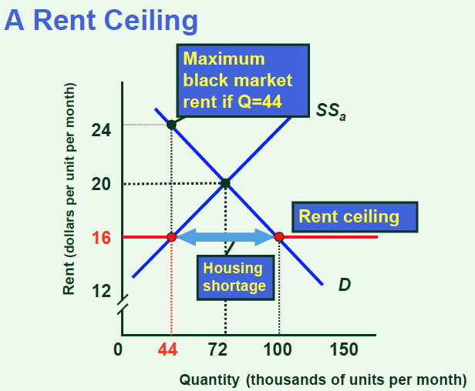

Price Floor
Price floor – the market generates a price which offends our sense of “social justice”
- The price is so low that producers can’t make a decent living
  - It is the consumers on the demand side who are exploiting the producers on the supply side
- Government comes to the rescue by imposing a price floor. It is a minimum bound on price
- Creates a situation of excess quantity supplied
  - Price increases, quantity supplied increases
  - Price increases, quantity demanded decreases
  - Big surpluses emerge, placing downward pressure on prices
  - Situation is unsustainable unless the surplus is removed from the market.
- A price floor is ineffective unless it is above the equilibrium price

Supply Management
- Alternative policy instrument to the price floor
  - Designed to support super-competitive prices in the dairy and poultry industries
- Here is how it functions
  - The industry chooses the price level such that high profits are guaranteed
  - This initially causes an increase in quantity supplied and a decrease in quantity demanded

