CHAPTER 8: DEVELOPING AND MANAGING PRODUCT AND SERVICES

Product: Any tangible good that can be offered to a market for attention, acquisition use or consumption that might satisfy a want or need

Service: Any activity or benefit (intangible) that can’t be dissociated from the person who provides it

Experiences: Represent what buying the product or service will do for the customer
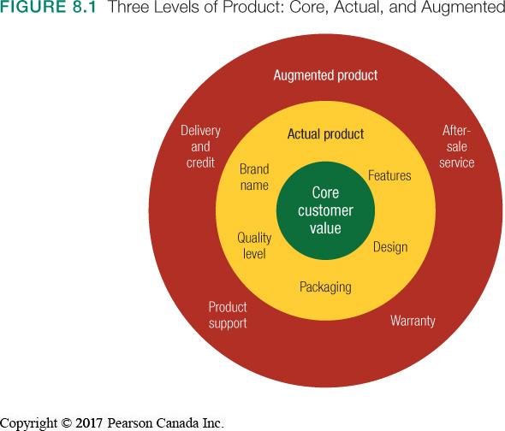
Levels of product or service (3):
- Core customer value
Value proposition (how the product will make you a better person)

- Actual product
Physical characteristic and use

- Augmented product
Additional customer service or benefit
(ex: Warranty, “If allergies/complaints call…”

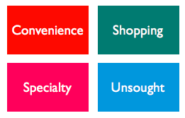
Consumer product categorization (4):
Convenience products: Consumer products and services that customer usually buys frequently, immediately and within minimum comparison and buying effort. (ex: toothpaste)
Shopping products: Consumer products and services that customer compares carefully on suitability, quality, price and style. (ex: clothes, furniture)
Specialty products: Consumer products and services with unique characteristics or brand identification for which a significant group of buyers is willing to make a special purchase with. (ex: Rolex watch, luxury goods)
Unsought products: Consumer products that the consumer does not know about or know about but does not normally think of buying. Aggressive advertising and personal selling. (ex: blood donation, life insurance)
Business product: a product bought by individuals and organizations for further processing or for use in conducting a business

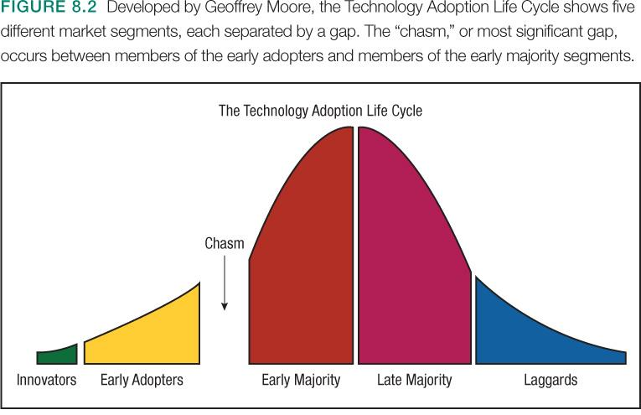
Diffusion of innovation theory: “Chasm” must be crossed for success, each group has very different beliefs and motivations
Innovators: Buy everything that is new [More educated]

Early Adaptors: Need a purpose

Early Majority: Ask themselves do I really need it? (compare prices)

Late Majority: Wait for everyone to have it to get the product

Laggards: Only buy new product when the old one breaks [Less educated]

Why do some products fail?
- Lack of differentiation
- Poor match between features and customer desires
- Overestimation of market size
- Incorrect positioning
- Price too high or too low
- Inadequate distribution
- Poor promotion
- Inferior product
- Bad timing

Success Factors
  - Understand consumers, markets, and competitors
  - Superior value to customers (superior to competition)

Product Development Process

- Idea generation: systematic search for new-product ideas
  - Internal (Employees and R&D)
  - External
    - Customers: questions, complaints, comments, new uses for products
    - Crowdsourcing: inviting broad communities of people into the new-product innovation process
- Idea screening: spot good ideas and drop poor ones
- Concept development and testing: develop idea into product concepts
  - - Description, drawing prototype
  - - Tested with a group of potential customers
  - - KEY: not yet in production
- Marketing strategy development: designing the marketing strategy
  - - How, when, where and to whom the product will be introduces?
- Business analysis: analyze the new products financial attractiveness

- Product development:
  - - passed the business test
  - - product testing
  - - getting ready for the market
- Test marketing: product and marketing program are introduced into realistic marketing settings (small and specific market)
- Commercialization: full scale introduction of new product
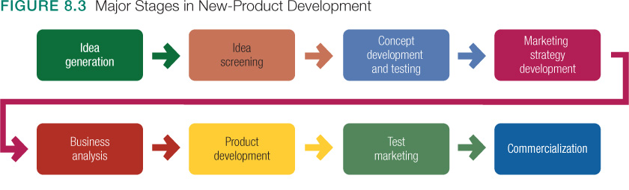
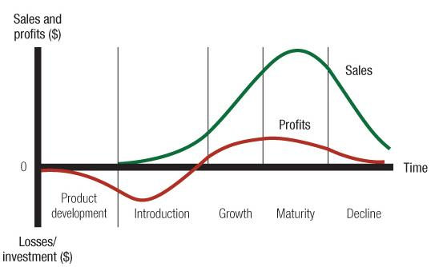
Product life cycle: Course of a product’s sales and profit over time (4 stages)
Stage 1 – introduction phase: The product is first launched into the market.
- Low sales
- High costs
- Negative profits
- Customers: innovators
- Price: skimming
- Promotion: inform, educate
- Marketing objective: create product awareness and trial
Stage 2 – Growth phase: Product sales start climbing quickly (want to stay here as long as possible because $$$)
- Rapidly increasing sales
- Avg costs
- Rising profits
- Customers: early adopters
- Price: penetration
- Promotion: stress differences
- Marketing objective: Maximize market share
Stage 3 – Maturity phase: Sales growth slows
- Peak sales
- Low costs
- High profits
- Customers: middle majority
- Price: match or beat competitors
- Promotion: reminder oriented
- Marketing objective: Maximize profit while defending market share
***Prevent decline in maturity stage by: modifying the target market, modify the product & modifying the marketing mix

Stage 4 – Decline phase: Product sales decline
- Declining sales
- Low costs
- Declining profits
- Customers: laggards
- Price: cut the price
- Promotion: reduced to minimal level
- Marketing objective: reduce expenditure and harvest
Alternatives product life cycles:
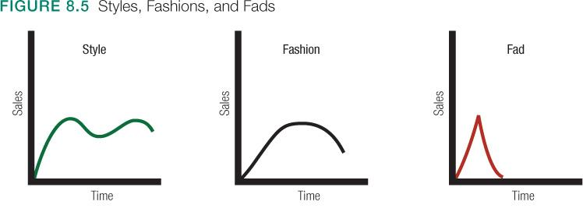
Service marketing: Services have 4 special characteristics
Intangibility: Can’t be seen, tasted, touched heard or felt
Inseparability: Can’t be dissociated from their provider
Variability: Quality of service depends on who provide them (and when, where, and how)
Perishability: Services cannot be stored for later sale or use

Individual product and Service Decisions:

Branding: a name, sign, symbol, design or a combination of these that identifies the products or services of one seller and differentiates them from competitors
*** Build brand story, because we identify with stories

Packaging: designing and producing the container or wrapper for the product

Labeling: The label identifies the product or brand (describes product attributes)

Product Support Services: Customer service is an element of product strategy

Product Line Decisions

Product line: a group of products that are closely related because they function in a similar manner, are sold to the same customer groups, are marketed through the same types of outlets, or fall within given price ranges

Product line length: the number of items in the product line

Can expand product line in two ways:
- Line filling: adding more items within the present range of the line
- Line stretching: lengthening product line beyond its current range

Product mix (product portfolio): the set of all product lines and items that a particular seller offers

Width: number of different product lines the company carries
Length: number of items a company carries within its product lines
Depth: number of versions offered of each product in the line
Consistency: refers to how closely related the various product lines are in end use, in production requirements, in distribution channels

CHAPTER 9: BRAND STRATEGY AND MANAGEMENT

Brand: Name, symbol, icon, design, or a combination of these, that identifies the maker or marketer of a product

Brand personality: Sum total of all the attributes of a brand and the emotions it inspires in the minds of customers

Brand equity: Amount of dollar attributed to the value of the brand, based on all intangible qualities that create that value

Brand Name Selection: descriptive, easy to pronounce/remember, distinctive

Brand Positioning: 3 levels
- Lowest level – can position the brand on product attributes
- Better positioned by associating its name with a desirable benefits
- Strongest brands are positioned on strong beliefs and values

Brand Sponsorship:

National/Manufacturer brand: Brand created and owned by the manufacturer of the product
(well-known and well established – take years and spend millions to create their own brand names)

Private/store brand: Brand names applied by the marketer to products manufactured for them under contract (ex: president’s choice for lowblaws)

Licensing: Buying and selling the rights to use a brand name, logo, character, icon or image.

Co-branding: Practice of using brand names of two different companies on the same product
(ex: aeroplan and TD Bank)

Brand Development

Line extension: extending an existing brand name to new forms, colors, sizes, ingredients, or flavors of an existing product category

Brand extension: extending existing brand name to new product categories
- Gives a new product instant recognition and faster acceptance
- Involves some risk
- May confuse the image of the main brand
- If a brand extension fails it may harm consumer attitudes toward other products carrying the name brand name

Multibrands: same manufacturer produces many different brands in the same product category
= Offers a new way to establish different features and appeal to different buying motives

  - ***Drawback – each brand may obtain only a small market share and none may be very profitable.
***Sales cannibalization – if you add an another line, you won’t have more customers, but instead existing customers will go from one line to another.

New brands: a company might believe that the power of its existing brand name is weakening and a new brand name is needed

Brand development strategy matrix

 | Product Category
Brand name |  | Existing | New
Brand name | Existing | Line extension | Brand extension
Brand name | New | Multibrand | New brand

CHAPTER 10: PRICING

Price: the amount of money charged for a product or service, or the sum of the values that customers exchange for the benefits of having or using the product or service.
***Price is the only element in the marketing mix that produces revenue.
***Price is the most flexible marketing mix element.

Major pricing strategies:
      - Consumer value-based pricing
      - Cost-based pricing
      - Competition-based pricing
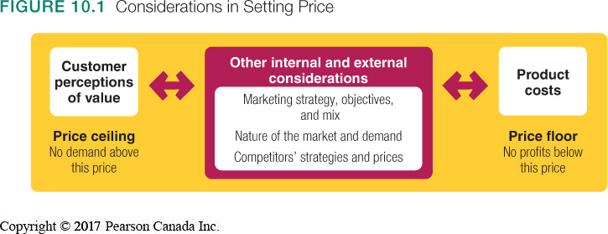

Consumer value-based pricing: setting price based on buyers’ perceptions of value rather than on the seller’s cost.

Good-value pricing: offering just the right combination of quality and good service at a fair price.

Everyday low pricing (EDLP): charging a constant everyday low price with few or no temporary price discounts (ex: Walmart)

High-low pricing: running frequent promotions to lower prices temporarily on selected items (ex: Winners)

Value-added pricing: attaching value-added features and services to differentiate a company’s offers and charging higher prices (=justifies the high prices).
(ex: in-theatre dinning)

Cost-based pricing: setting prices based on costs of production, distributing, and selling the product plus a fair rate of return for effort and risk.

Types of costs:
- Fixed costs (overhead): Do no vary with production or sales level.
- Variable costs: Vary directly with the level of production (ex: labour, raw materials, rent, electricity)
- Total cost = Fixed + Variable
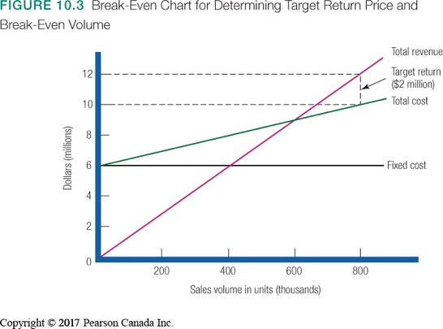
Cost-plus/mark-up pricing: adding a standard markup to the cost of the product
(% of profit you will make)

Break-even/target return pricing: setting price to break even on the costs of making and marketing a product, or setting price to make a target profit

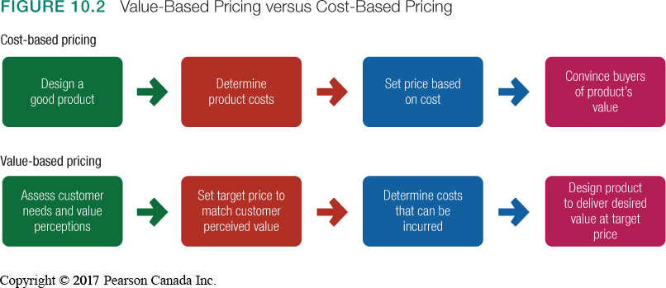

Competition-based pricing: Setting prices based on competitors’ strategies, costs, prices, and market offerings.

INTERNAL FACTORS (to consider when setting prices)

Marketing strategy/ Objective: Company must consider the firm/product goals and objectives

Marketing mix strategies: Pricing must coordinate with the other marketing mix elements
***Target costing: ideal selling price based then targets costs that will ensure that the price is met.

Organizational considerations:
  - Who should set the price?
  - Who can influence the prices?
(Small companies: Top management [VS] Large companies: Pricing departments)

EXTERNAL FACTORS (to consider when setting prices)

Market and demand: How do prices vary within different types pf markets?
Types of Markets
- Pure competition: so many competitor, marketing effort does not matter
- Monopolistic competition: many buyers and sellers trading over a range of prices
*KEY: Differentiated offers
- Oligopolistic competition: few competitors (ex: cell phone market, gas and oil)
- Pure monopoly: only one seller (ex: Hydroquebec, SAQ)

Demand: Demand curve is normally downward slopping, demand and price are inversely related.
(Higher price = lower demand)
***Price elasticity of demand

Economy: Recession VS inflation
Others: Government intervention and social concern

Types of pricing approaches (4):
- New-Product Pricing
- Product Mix Pricing
- Price Adjustment Strategies
- Price Changes

New product pricing strategies:

Market-skimming pricing: set a high initial price and then lower it (good strategy for technology products and high quality products)

Market-penetration pricing: set a low price for a new product to attract a large number of buyers and a large market share (sales promotion effort and economies of scale)

***Can be bad if people are used to low prices, and suddenly the price is high

Product mix pricing strategies:

Product line pricing: setting the prices between various products in a product line based on cost differences between the products, customer evaluations of different features and competitors’ prices (ex: MacBook, Air and Pro)

Optional-product pricing: the pricing of optional or accessory products along with a main product

Captive product pricing: setting a price for products that must be used along with a main product (ex: ink for printer, blades for razor)

By-product pricing: setting a price for by-products to make the main product’s price more competitive (ex: recycle the nespresso puds)
Product bundle pricing: combining several products and offering the bundle at a reduced price

Price adjustment strategies:

Discount: a straight reduction in price on purchases during a stated period of time (quantity and seasonal discounts)

Allowance: price reductions given for turning in an old item when buying a new one (ex: Lush – when you bring back your empty container, you get a free mask)

Segmented pricing: selling a product or service at two or more prices, where the difference in prices in not based on differences in costs
- Customer (ex: Children, students and senior reduction)
- Product-form (ex: Different room types in a hotel)
- Location-based (ex: Concert – front row vs high in the back)
- Time-based (ex: High/Low season, Early brids/Late evening)

Psychological pricing: beyond the economics, the price is used to say something about the product (Heuristics of higher prices = better quality)
***$1.99 is better than $2.00

Reference prices: prices that buyers carry in their minds and refer to when they look at a given product

Promotional pricing: temporarily pricing products below the list prices and sometimes even below cost, to increase short run sales

Geographical pricing: setting prices for different geographical locations (ex: Alaska or island, prices are higher because hard to reach)

FOB-origin pricing: customer pays the shipping, varies on the distance (high cost if you are far away)

Uniform-delivery pricing: a geographical pricing strategy in which the company charges the same price plus delivery to all customers regardless of their location (fixed delivery cost for everyone)

Zone pricing: a geographical pricing strategy in which the company sets up two or more zones. All customers within a zone pay the same total price; the more distant the one, the higher the price.

Dynamic pricing: adjusting prices continually to meet the characteristics and needs of individual customers and situations (ex: Ebay)

International prices: companies adjust prices to reflect local market conditions

CHAPTER 11: MARKETING CHANNELS

Place Decisions
Where should we distribute our products?
Who should distribute our products?
How intensively should we distribute our products?
How many intermediaries should there be between us and our final customers?

Value delivery network: the company, suppliers, distributors, and customers partner with each other to improve the performance of the entire system in delivering customer value.
- Upstream = manufacturers
- Downstream = the customers

Marketing (distribution) channel: interdependent organizations that help make a product or service available for use or consumption
***Intermediaries reduce the amount of work that must be done by both producers and consumers.
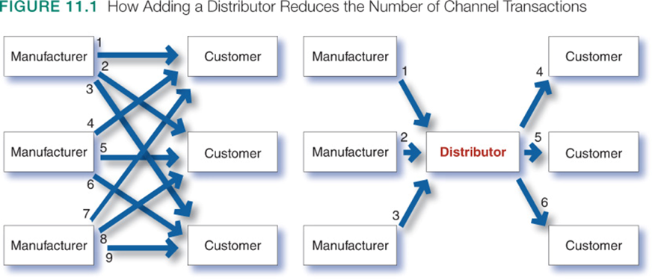

Types of channel partners
- Producers/Manufacturer
- Wholesaler
- Retailer

Manufacturer: The organization responsible for designing and producing a product.

Wholesaler: Sells products to those buying for resale (generally sell products to other intermediaries, mostly retailers).

Retailer: Sells goods to the consumer and takes ownership of the product.

Channel levels: The number of intermediary levels indicates the length of a channel.

Direct marketing channel: manufacturer deliver products to consumers directly from a producer; no intermediary
***Very few companies use a direct marketing channel

Indirect marketing channels: use one or more intermediaries (wholesaler and/or retailer) to reach final customers.

Conventional Distributions Systems: Each business is independently owned and no channel member has control over the other (seeks to maximize own gains)

Vertical marketing system (VMS): distribution channel structure producers, wholesalers, and retailers act as a unified system. One channel member owns the others, has contracts with them, or has so much power that they must all cooperate. (provides channel leadership)

Corporate VMS: combines successive stages of production and distribution under single ownership (= leadership is established through common ownership)

Administered VMS: coordinates successive stages of production and distribution through the size and power of one of the parties

Contractual VMS: independent firms at different levels of production and distribution join together through contracts [Most common form => franchise organization]
***Goal: achieve economies of scale

Franchise organization: system in which a channel member, called a franchisor, links several stages in the production-distribution process

Horizontal marketing system: Include two or more companies at one level that join together to follow a new marketing opportunity.
***Goal: combine resources to accomplish more than any one company could alone.

(Ex: Star Alliance = Air Canada, Lufthansa and United airlines)

Multichannel (hybrid) distribution systems: Hybrid marketing channels exist when a single firm sets up two or more marketing channels to reach one or more market segments (ex: clothing lines selling both in store and online)

Advantages
Expand sales and market coverage
Tailor products and services to specific needs of diverse customer segments

Challenges
Hard to control
Create channel conflict

Disintermediation: when established intermediary becomes unnecessary and is cut (popular with the advent of the Internet)

Channel conflict: disagreements among marketing channel members on goals and roles
(who should do what and for what rewards)

Horizontal conflict occurs among firms that perform the same function at the same level of the channel.

Vertical conflict occurs between different levels of the same channel.
(Ex: Disagreement over how profit margins are distributed)
Manage conflict and regain control of channels:
- Specify each channel member’s role
- Have a channel captain leader that has power to assign roles and manage conflicts
- Cooperation
- Vertical or Horizontal Marketing Systems

Marketing channel design: designing effective marketing channels by analyzing consumer needs, setting channel objectives, identifying major channel alternatives, and evaluating them

- Deciding on the number of marketing intermediaries:

Intensive distribution: stocking product in as many outlets as possible

Exclusive distribution: giving a limited number of dealers the exclusive right to distribute the product in their territories

Selective distribution: the use of more than one but fewer than all the intermediaries who are willing to carry the company’s products

- Evaluating alternatives involves:

Economic criteria: compares the likely sales, costs, and profitability of different channel alternatives

Control issues: using intermediaries usually means giving them some control over marketing. Some take more control than others – company generally prefers to keep as much control as possible

Adaptive criteria: channels usually involve long term commitments, yet the company wants to keep the channel flexible so that it can adapt to environmental changes

CHAPTER 13: COMMUNICATING CUSTOMER VALUE
(Advertising and public relations)

Promotion mix (marketing communications mix): Specific blend of advertising, public relations, personal selling, and direct-marketing tools Used to communicate customer value and build customer relationships.

Integrated marketing communications (IMC): coordinating the company’s communications channels to deliver a clear, consistent and compelling message about the organization and its products
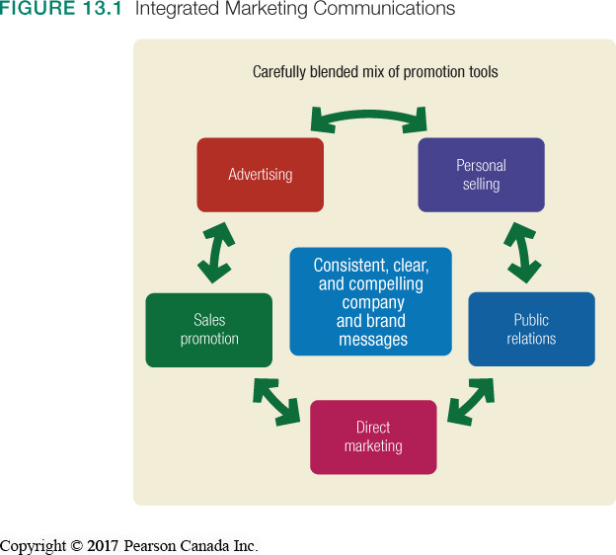

Promotion mix tools (5):

Advertising: any paid form of non personal presentation and promotion of ideas, goods, or services by an identified sponsor

PROS:
- Reaches masses at low cost per exposure
- Repeats message many times
- Creates consumer trust (view of advertised products as more legitimate)
CONS:
- Promotes impersonally, one-way
- Costs are high for some media types

Sales promotion: short-term incentives to encourage the purchase of sale of a product or service

PROS:
- Includes a wide assortment of tools
- Attracts consumer attention
- Offers strong incentives to purchase
- Dramatizes product offers
- Invites quick consumer response
CONS:
- Effects are short-lived

Personal selling: personal presentation by the firm’s sales force for the purpose of making sales and building customer relationships

PROS:
- Legitimizes credibility, very believable
- Reaches people who resist advertising
- Dramatizes a company or product
- Saves money when used proactively
CONS:
- Tends to be used as an afterthought

Public relations: building good relations with the company’s various publics by obtaining favorable publicity.
- building up a good corporate image
- handling unfavorable rumors, stories and events

PROS:
- Communicates personally two-ways
- Builds preferences, convictions, and actions
- Allows relationship building
CONS:
- Requires long-term commitment to sales force
- Most expensive promotion tool

Direct marketing: making direct connections with carefully targeted individual consumers

PROS:
- Communicates more directly with targeted customers
- Reaches customers with tailored message
- Creates interactivity
- Builds one-to-one relationships
CONS:
- Often perceived as junk-mail/spam

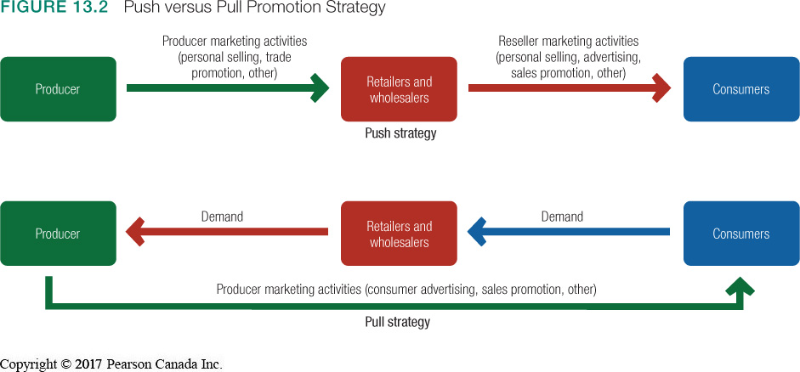

ADVERTISING

Advertising decisions:

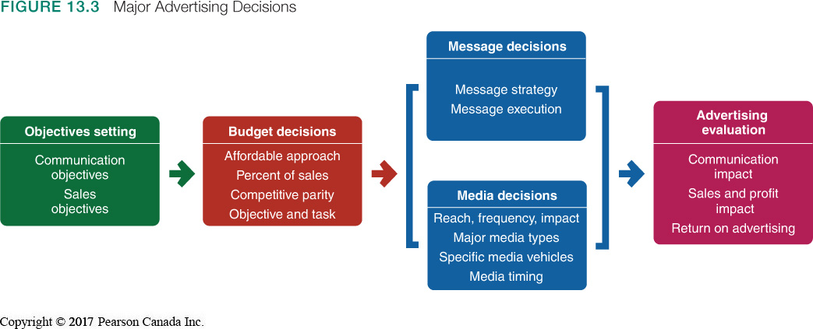

Advertising objectives: Specific communication task to be accomplished with a specific target audience during a specific period of time
- Inform
- Persuade
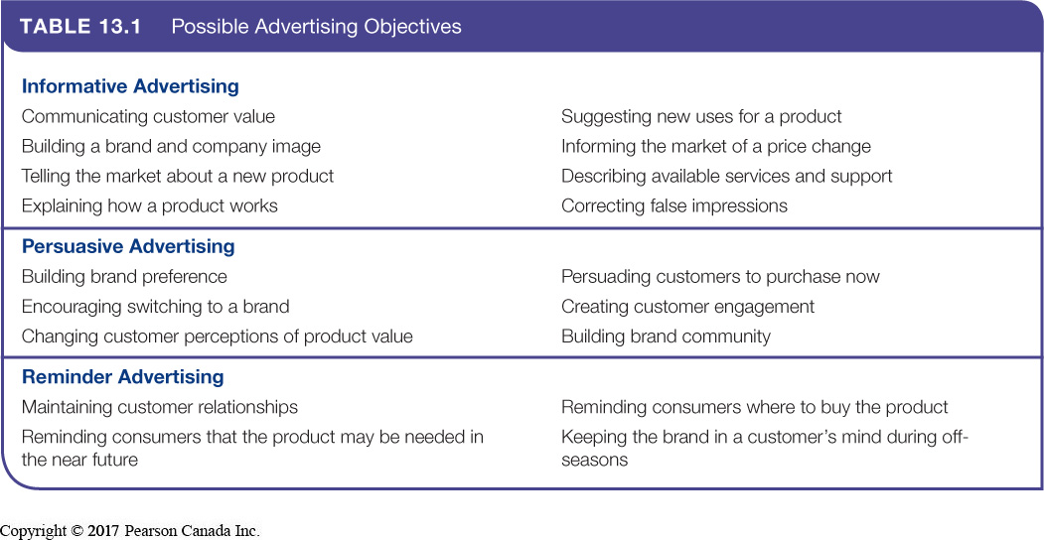
- Remind

Budget decisions:
- Affordable method: what is left over (small companies)
- Percentage-of-sales method
- Competitive-party method: react to competitor’s strategy
- Objective-and-task method: create awareness and increase sales [BEST METHOD]

Advertising strategy:

            - Creating the advertising message: breaking through

Consumer generated content: Consumers make the advertising

Advertainment: when advertisement is combined with entertainment (not necessarily focused on the brand)

Branded entertainment: integrates entertainment and advertising by embedding brands into a storyline of the movie, TV show, or other entertainment medium to create awereness

***Product placement: NOT PART OF THE STORY, but you can clearly identify the brand

Message strategy

  - Identifies benefits to be used as appeals
  - Develops a compelling creative concept
  - Meaningful, believable and distinctive

Message execution

- Slice of life: everyday routine
- Lifestyle: be fun, be healthy
- Fantasy: dreams = story telling
- Mood/image: emotions
- Musical
- Personality symbol: use famous people
- Technical expertise: doctors, etc
- Scientific evidence
- Testimonial evidence: satisfied customer

            - Selecting the advertising media

Media selection

  - Deciding on research, frequency, impact
  - Choosing media types
  - Selecting media vehicles
  - Deciding on media timing

Reach: % of people…
Frequency: # of times…
Impact of message
Media engagement
Consumer impressions and expressions
Choosing among major media types
  - Television, radio, newspaper, magazines, and OOH
Selecting media vehicles
  - Television, vehicles include networks

Deciding on media timing
  - Seasonality
  - Continuity – scheduling evenly within a given period
  - Pulsing – all year long, but more frequent during certain periods
How do we evaluate ad effectiveness?
- Measure pre- and post-communication effects
- Measure sales and profit effects
- Measure Return On Investment (ROI)
  - The net return on advertising investment divided by the costs of the advertising investment

PUBLIC RELATIONS

Public Relations: building strong relations with the company’s various stakeholders by
- Obtaining favourable publicity
- Communicating a trustworthy corporate image
- Managing unexpected occurrences, both positive and negative

***Used to promote products, people, places, ideas, activities, organizations and even nations

Public relation functions (6)

- Press relations: creating and placing newsworthy information in the news media to attract attention
- Product publicity: publicising specific products
- Public affairs: building and maintaining national or local community relations
- Lobbying: building and maintaining relations with legislators and government officials to influence legislation and regulation
- Investor relations: maintaining relationships with shareholders and others in the financial community
- Development: working with donors or members of not-for-profit organizations to gain financial or volunteer support

Why using public relations is important:
Public relations can have a strong impact on public awareness at a much lower cost than advertising can

Major public relation tools:
- News
- Speeches
- Special events
- Written materials
- Audiovisual materials
- Corporate identity materials (stationary)
- Public service activities
- Buzz (WOM) marketing
- Company website
CHAPTER 16: PERSONAL SELLING

Personal selling: Personal presentation by the firm’s sales force for the purpose of making sales and building customer relationships. Salesperson can take many roles:
- Order taker / order getter
- Creative selling
- Social selling
- Relationship building

What is the role of the salesforce?
Critical link between company and customers
Coordinating marketing and sales

Managing the Sales Force (6 major steps)

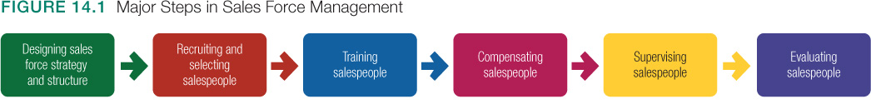

            - Designing a salesforce structure:

- Orientation:
  - Territorial
  - Product lines
  - Customer (per industry; big vs. smaller accounts)
  - Complex

- Size:
  - Larger force, larger sales and costs
  - Workload approach (backward)

- Personnel:
  - Outside sales (travel to call)
  - Inside sales (calls, contact offices)
  - Team selling (sales, marketing, tech, support)

            - Recruiting and selecting salespeople
- Intrinsically motivates
- Disciplines work style
- Relationship building
- Ability to close a sale

            - Training general skills and company specific approaches to selling:
- Seminars, sales meetings, and e-training form the basis of sales training programs
- Goal is to achieve understanding of company, product, customer and market knowledge
            - Compensation involves any combination of:
- Fixed amount: salary
- Variable amount: commissions or bonuses
- Expenses and fringe benefits

            - Supervision and motivation encourages and rewards “work smart” habits through:
- Analyzing and developing time efficiencies in all aspects of selling from prospective to closing
- Creating a positive organizational culture

            - Evaluating salespeople and sales force performance requires:
        - Regular sales, as well as call and expense reports
        - Clear standards for judging performance
        - Constructive feedback

Digital selling

Digital tools to supplement sales force management
- Social networking
- Time and costs saving
- Combination of proprietary systems and public portals such as YouTube
- Technology is a supplement

Personal selling process: Personal selling = managing relationships

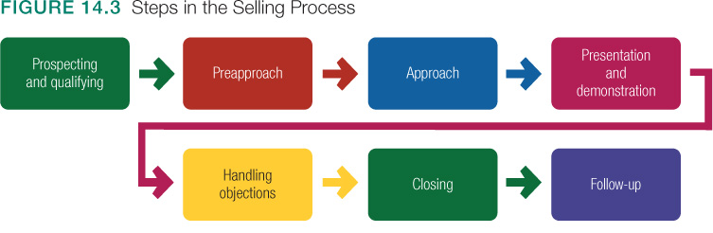

      - Prospecting: identifies qualified potential customers
      - Pre-approach: the process of learning as much as possible about a prospective customer before making a sales call
      - Approach: salesperson meets the customer for the first time
      - Presentation: salesperson tells the value story to the buyer, showing how the company offer solves the customer’s problem
      - Handling objections: the process where salespeople seek out, clarifies and overcomes any customer objections to buying
      - Closing: salespeople asks the customer for any order
      - Follow-up: salesperson follows up after sale to ensure customer satisfaction and repeat business

Building profitable relationships is key goal
- Listening to customers
- Understanding their needs
- Coordinating entire company efforts to create value

CHAPTER 14: SALES PROMOTION

Sales promotions: A short-term incentive to encourage purchases or sales of a product or service [BUY NOW]

Targeted towards:
  - Final buyers consumer promotions
  - Retailers and wholesalers trade promotions
  - Business customs business promotions
  - Sales force sales force promotions

Sales promotions objectives

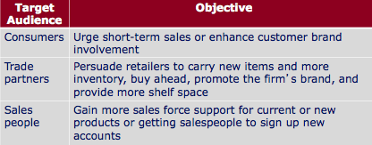

Types of sales promotions for consumer (12)

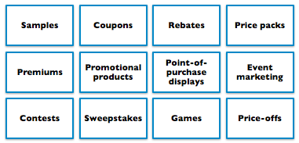
      - Samples: offer a trial amount of a product
      - Price-off: % off
      - Coupons: give buyers a saving when they purchase specified products
      - Rebates: price reduction occurs after the purchase
      - Price packs: are directly marked down by the manufacturer (ex: 2 for 1, extra 20% of soap)
      - Premiums: goods offered either for free or at a low price (ex: toys in happy meal)
      - Promotional products: articles imprinted with company name (ex: hotels’ commodities)
      - Point-of-purchase promotions (POP): include displays and demonstrations that take place at point of sale
      - Contests, sweepstakes and games: give consumers the chance to win something by luck or through extra effort (ex: roll the rim, McDonalds’ monopoly games)
      - Event marketing (event sponsorship): creating a brand-marketing event or serving as a sole or participating sponsor of events created by others (ex: RedBull sports’ events)

Trade promotions: Sales promotion tools used to persuade companies to carry their brand, give it shelf space and promote it in advertising

Can use business tools as for consumer promotions
- Discount on list price
- Allowance
- Free goods
- Push money speciality advertising items

Business promotions: Sales promotion tools used to generate business leads, stimulate purchases, reward customers and motivate salespeople
- Conventions
- Trade shows
- Sales contests

Develop the sales promotion program:
*Size of incentive
*Conditions of participation
*Promotion and distribution of program
*Length of program
*Evaluation of the program

CHAPTER 15: DIRECT, ONLINE, SOCIAL MEDIA AND MOBILE MARKETING

Direct marketing/digital marketing: Involve engaging directly with carefully targeted individual consumers and customer communities
***Companies obtain an immediate response and build lasting customer relationship

Direct marketing of offers and content to the need of narrowly defined segments and individual buyers
- Marketing channel without intermediaries
- Part of promotion mix
- The fastest-growing form of marketing

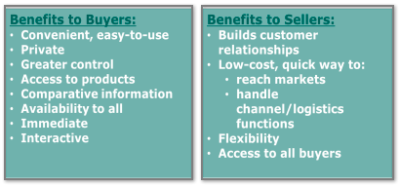
Benefits of direct and digital marketing to buyers and sellers

Digital and social media marketing: Digital and social media is the fastest growing form of direct marketing.

***Uses both offline (brick and mortar stores, catalogues) and online (digital, online, social media, and mobile) channels to conduct marketing

What are online marketing components?
- Marketing websites
- Branded community websites
- Online advertising
- Email marketing
- Blogs and online forum
- Online videos

Social media marketing: Online communities where people congregate, socialize, and exchange views and information

Advantages:
  - Targeted and personal
  - Interactive
  - Immediate and timely
  - Cost effective
  - Engagement and social sharing capabilities
Disadvantage:
  - Still experimental – difficult to measure results
  - Largely user controlled – campaigns can backfire

Mobile marketing: Marketing promotions, messages, and other content delivered to on-the-go consumers through mobile phones

Aims to:
- Stimulate buying
- Make shopping easier
- Enrich the brand experience

Traditional direct marketing:
- Direct mail marketing
- Catalogue marketing
- Telemarketing
- Direct-response TV marketing (home shopping channel)
- Kiosk marketing

Issues in direct and digital marketing:
- Irritation, unfairness, deception and fraud
- Consumer privacy concerns

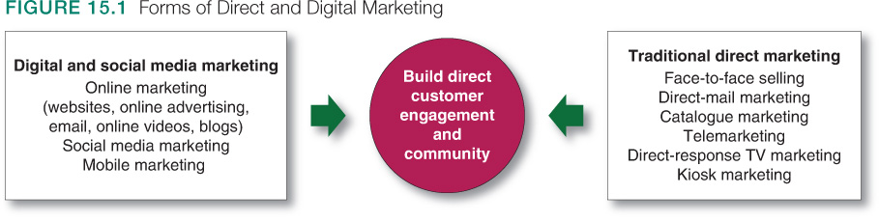

CHAPTER 16: THE GLOBAL MARKETPLACE

Global Marketing: Global firm that operates in more than one country & gains R&D, production, marketing and financial advantages in its costs and reputation that are not available to purely domestic competitors

Marketing decisions:

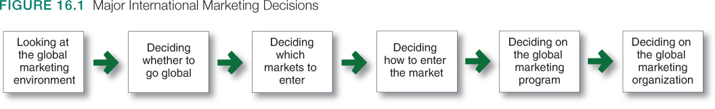

Global marketing environment:
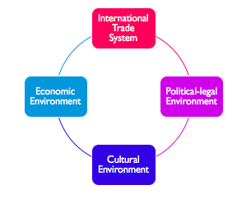

International trade system: when selling to another country, a firm may face restrictions on a trade between nations
- Tariffs from the gov.
- Quotas
- Nontarrif trade barriers

The world trade organization
- Promotes world trade
- Reassess trade barriers
- Imposes trade sanctions
- Mediates trade disputes

Regional Free Trade Zones:
- European Union
- North American Free Trade Agreement (NAFTA)
- Trans-Pacific Partnerships

International economic environment
Two factors reflect the country’s attractiveness as a market:

Industrial structure
  - Subsistence economies: live of agriculture
  - Raw material exporting: rich in one natural source but poor in other ways (ex: Columbia coffee beans)
  - Emerging economies: industrializing economies
  - Industrial economies

Income distribution
  - Industrialized nations: may have a wide range of income
  - Subsistence economies: mostly households very low family incomes
  - Emerging economics: may be attractive markets for all kinds of goods

International political legal environment:
- Country’s attitude toward international buying
- Government bureaucracy
- Political stability
- Monetary regulations
- The need to adapt to local cultural values and traditions rather than imposing their own

How do you decide which markets to enter?

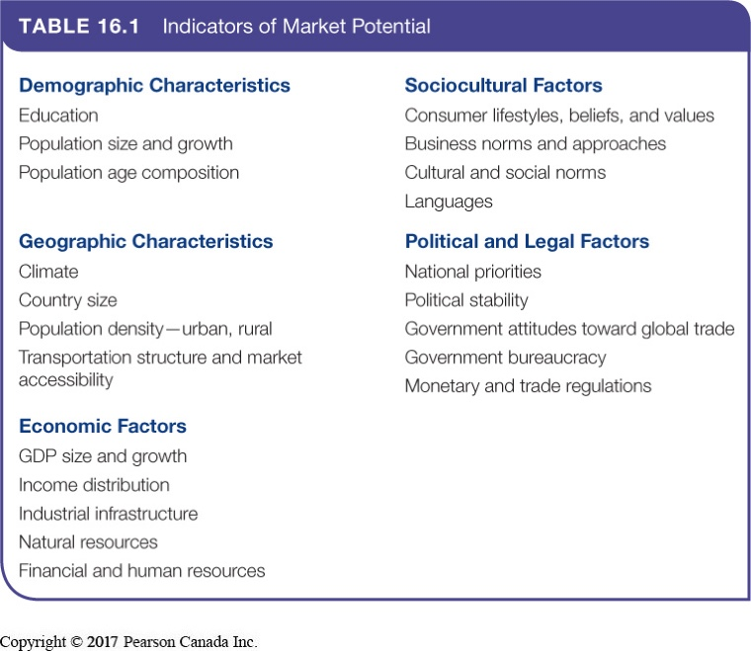

Market entry strategies:

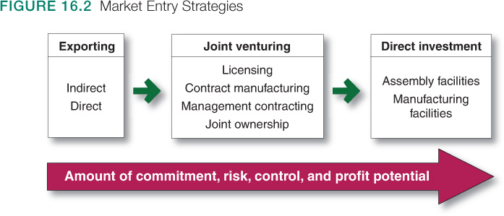

- Exporting: Company produces its goods in the home country and sells them in a foreign market
- Simplest way to enter a foreign market
- Indirect exporting
  - Working through independent international marketing intermediaries
- Direct exporting
  - Handling their own exports

- Joint venture: Company joins with a host country partner to sell or market abroad their products
- Licensing & joint ownership

- Direct investment: Developing a foreign-based assembly or manufacturing facility
- Labor
- Logistics
- Control
- Government incentives
- Lower costs
- Raw materials

Deciding on global marketing program

- Standardized global marketing
- Using the same marketing strategy approaches and marketing mix worldwide

- Adapted global marketing
- Adjusting the marketing strategy and mix elements to each target market
- Involves higher costs with the goal of producing a larger market share and return

CHAPTER 3: SUSTAINABLE MARKETING SOCIAL RESPONSIBILITY AND ETHICS

Sustainable marketing: Socially and environmentally responsible marketing (business) that makes the needs of customers while preserving the ability of future generations to meet their needs

Major social and ethical criticism of marketing:
- High prices
- Deceptive practices
- High-pressure selling
- Shoddy, harmful or unsafe products
- Planned obsolescence
- Poor service to disadvantaged consumers

High pricing or high cost of distribution

Complaints:
- Prices are too high due to high costs of:
  - Distribution
  - Advertising and promotion
  - Excessive mark-ups

Response:
- Intermediaries are important and offer value
- Advertising informs buyers of availability and merits of a brand
- Consumer’s don’t understand the cost of doing business

Deceptive Practices

Complaints:
Pricing: falsely advertising “wholesale” or “factory” prices or large reductions from phony high retail list prices

Promotion: misrepresenting a product’s features or performance, or luring consumers to store for out-of-stock items

Packaging: exaggerating package contents through design, misleading labeling, or size

Response:
- Legislation to protect consumers from deceptive practices (Competition Act)
- Guidelines to prevent “greenwashing” (Competition Bureau)
- Industry self-regulation through Advertising Standards of Canada

High pressure selling

Complaints: Salespeople use high-pressure selling that persuade people to buy goods they had no intention of buying.

Response: Most selling involves building long-term relationships and valued customers.

Shoddy, harmful or unsafe products

Complaints: Products have poor quality, provide little benefit, and can be harmful.

Reponses: Good marketers realize there is no value in marketing shoddy, harmful, or unsafe products.

Planned Obsolescence

Complaints:
- Using inferior materials and components
- Continuous changing of acceptable styles
- Delaying features until follow-up version

Response:
- Planned obsolescence is really the result of competitive market forces leading to ever-improving goods and services.
- Customer customers like style changes and want the latest innovations

Marketing’s impact on society as a whole:
- False wants and too much materialism
- Overselling private goods
- Creating cultural pollution

Marketing’s impact on other businesses:
- Acquisition and shrinking of competitors
- Creating barriers to entry
- Unfair practices such as predatory pricing

Consumer activism: Organized movement to improve the rights and power of buyers in relation to sellers

Traditional seller’s rights:
- Introduce any product, any size and style
- Charge any price for the product
- Spend any amount to promote the product
- Use any product message
- Use any buying incentive schemes

Traditional Buyers’ rights:
- Not buy a product that is offered for sale
- Expect the product to be safe
- Expect the product to perform as claimed

Consumer advocates call for more rights in order to:
- Be well informed about aspects of the product
- Be protected from bad products and practices
- Influence products to improve “quality of life”
- Preserve the world for future generations of consumers

Environmentalism: An organized movement to protect and improve peoples living environment
- 1960s-1970s: concerned consumers and environmental groups
- 1970s-1980s: driven by government, resulting in environmental laws
- Firms accepting more responsibility and are adopting environmental sustainability

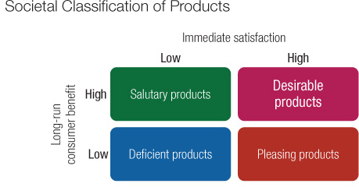
Societal marketing:
Consumers wants and interests
The company’s requirements
Society’s long-term interests

Marketing ethics: To guide their staff, firms develop corporate marketing ethics policies which cover:
- Distributor relations
- Advertising standards
- Customer service
- Pricing
- Product development
- General ethical standards

