Bio 1090 - Midterm
Structure of DNA
- Nucleotides comprised of: phosphate group, 5 carbon sugar, 1 of 4 nitrogenous bases
- 5’ end: phosphate group, 3’ end: hydroxyl group
- nucleotide chains connected by phosphodiester bonds

Structure of chromosomes
Euk. – nonchromatin nuclear constituents, non-histone proteins, highly basic proteins (histones), DNA, RNA
1st lvl condensation – packaging DNA as a negative supercoil into nucleosomes (produces 11nm fiber). DNA wrapped around a nucleosome core of 8 histone proteins and anchored by a 9th
2nd lvl condensation – additional folding/supercoiling of 11nm fibre to produce 30 nm fibre (driven by nucleosomal interactions). Structure – solenoid or zig-zag
3rd lvl condensation – attachment of 30 nm fibre at many positions to a non-histone protein scaffold

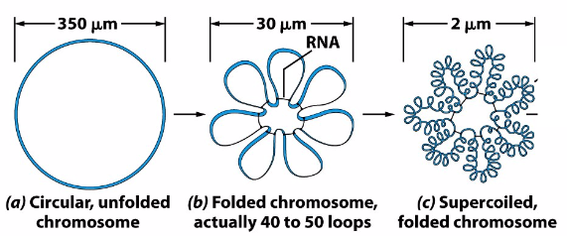
prok. -
*DNA found in mitochondria and chloroplasts exists in circular chromosomes, resemble prok

Function of Centromeres and telomeres
Telomeres – protect chromosome ends (form stable end t-loop)
1. Resist degradation by DNases
2. Prevent fusion of chromosomal ends
3. Facilitate replication of the ends of the linear DNA
Cancer cells can reactivate telomerase --> immortal
Centromeres – provide point of attachment of chromosomes to microtubules in the mitotic spindle
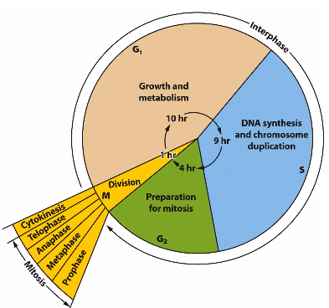
Cell cycle
Interphase:
G1 – growth and metabolism
S – DNA synthesis/chromosome duplication (DNA rep)
G2 – prep for mitosis
Mitosis (prophase, metaphase, anaphase, telophase) + Cytokinesis:
M – division (chromosome movements and cytokinesis)
*cells not actively cycling may exit cycle, from G1 they enter state called G0 (cells said to quiescent)
*there is no ‘clock’ for euk cells (30 mins to several months)
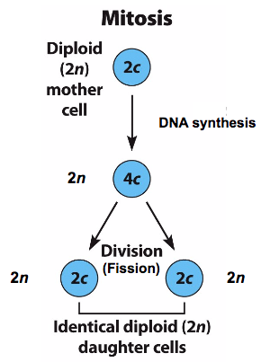
Mitosis – cellular organelles and cytoplasmic contents are divided equally btwn daughter cells

n – haploid chromosome number
c – DNA content

Phases:
Interphase – duplicate chromosomes (sister chromatids), joined at centromere by cohesion (centrosome is duplicated)
Prophase – initiation of spindle formation, condensation of duplicated chromosomes, fragmented of ER and golgi, nucleolus disappear, nuclear membranes break down, spindle microtubules invade nuclear space
Prometaphase – chromosomal microtubules attach to kinetochores, chromosomes move towards the equator of the spindle
Metaphase – duplicated chromosomes aligned midway btwn the spindle poles equatorial plate (metaphase plate)
Anaphase – centromeres split and chromatids separate, chromosomes move towards opposite spindle poles, spindle poles move further apart
Telophase – chromosomes cluster at opposite spindle pole, chromosomes become dispersed and decondense, nuclear envelope assembles around chromosomes, golgi and ER reform, daughter cells form by cytokinesis (membrane forms btwn)
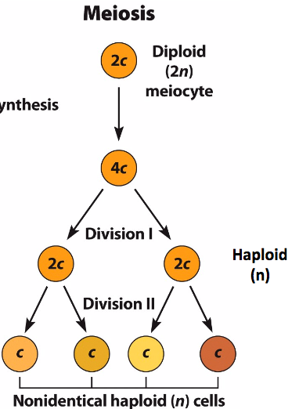
Meiosis
Meiosis I:
- produces 2 haploid daughter cells that are genetically distinct
Prophase I – chromosomes condense, homologous chromosomes pair, synapsis (pairing of homologous chromosomes; often facilitated by formation of a synaptonemal complex), crossing over (the breakage of chromatids and the exchange of the broken pieces btwn homologous chromosomes), homologous chromosomes start to pull apart but remain joined at cross over junctions (chiasmata), paired chromosomes condense further and become attached to spindle fibers
Metaphase I – paired chromosomes align on equatorial plane
Anaphase I – homologous chromosomes disjoin and move to opposite poles of the cell (chromosome disjunction occurs btwn metaphase and anaphase)
Telophase I – chromosome movement is completed and new nuclei begin to form

Meiosis II:
- produces 4 non-identical haploid daughter cells
Prophase II – chromosomes (w/ 2 sister chromatids) condense and become attached to spindle fibres
Metaphase II – chromosomes align on equatorial plane
Anaphase II – sister chromatids disjoin and move to opposite poles in cell (chromatid disjunction occurs btwn metaphase and anaphase)
Telophase II – chromosomes condense and new nuclei begin to form
Cytokinesis – haploid daughter cells are separated by cytoplasmic membranes
Spermatogenesis – Oogenesis -
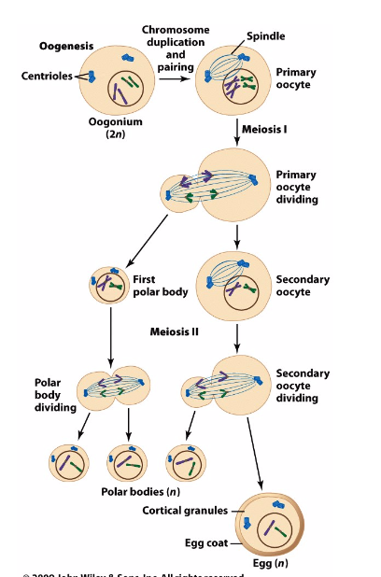
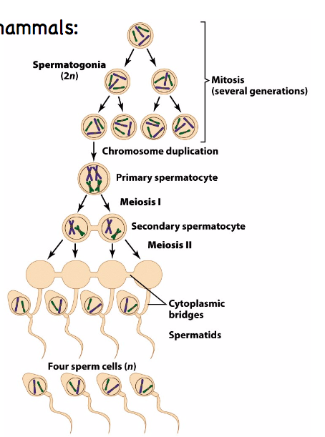
*meiosis 1 begins in the fetal ovary but arrests at prophase 1

*for ovulation, egg matures to metaphase II and is released into fallopian tube. At time of fertilization the oocyte is still 2c and meiosis II is completed (expulsion of the second polar body) after fertilization

Mendel’s principles
Principle of dominance – in a heterozygote, one allele may conceal the presence of another
Principle of segregation – neither allele is typically changed by coexisting with the other heterozygote; 2 different alleles segregate from each other during the formation of gametes
Principle of independent assortment – alleles of different genes assort/segregate independently of each other

Genetic consequence of being inbred
- increases the frequency of homozygotes and decreases the frequency of heterozygotes
- subjects inbred individuals to diseases caused by rare recessive alleles
- can be used in selective breeding, use to establish new/desirable trait (bred true)

Chromosomal basis –
Principle of Segregation Principle of Independent Assortment
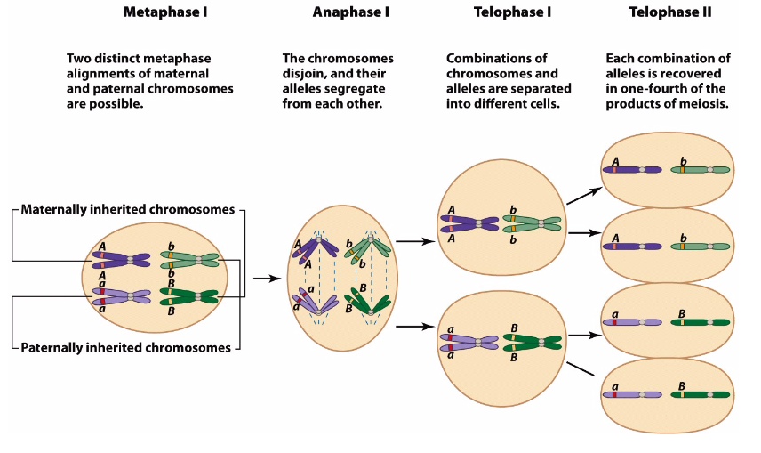
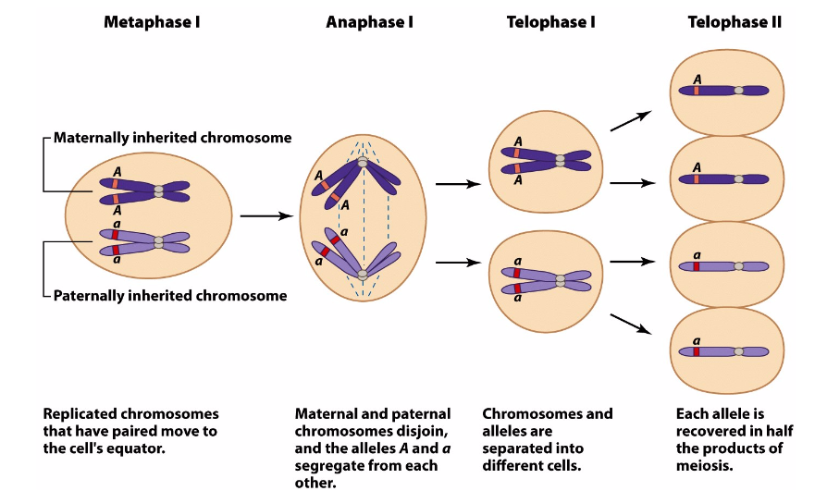

Rules of probability
Multiplicative rule – if the events A and B are independent, the probability that they occur together is the product of their individual probabilities
P(A) x P(B)
Additive rule – if the events of A and B are independent, the probability that at least one of them occurs is the sum of their individual probabilities of occurrence minus the probability of their joint occurrence
P(A) + P(B) – [P(A) x P(B)]
Additive rule (continued? - if the events of A and B are independent and don’t occur together, the probability that at least one of them occurs is the sum of their individual probabilities
P(A) + P(B)
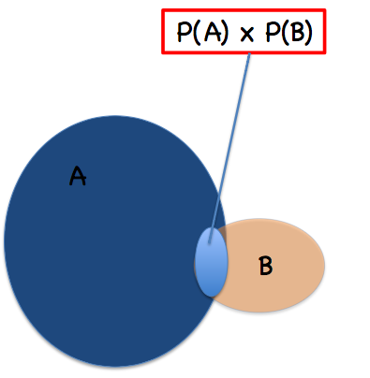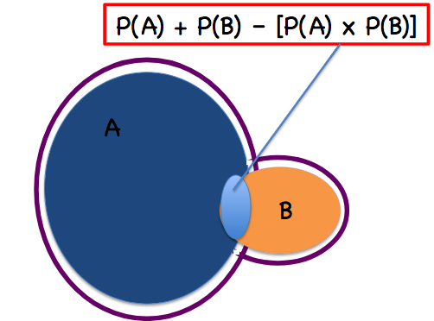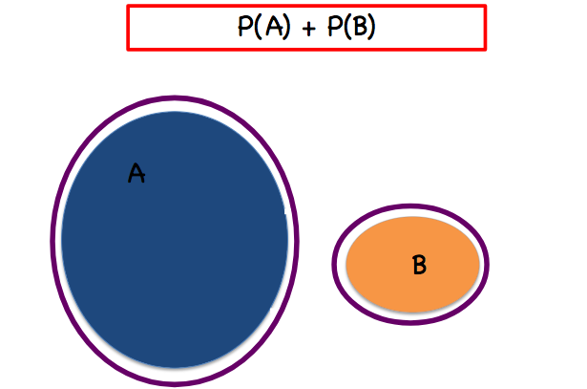

Recessive and Dominant traits in pedigrees
Dominant mode of inheritance –
- every individual has at least 1 affected parent
- trait is manifested in at least 1 individual in every generation once trait appears
- spontaneous appearance of a dominant allele extremely rare
Recessive mode of inheritance –
- trait suddenly appears in a pedigree
- ‘skips’ a generation
- in the absence of evidence to the contrary, assume that unrelated individuals marrying into the family do not carry the recessive allele

Binomial probability equation
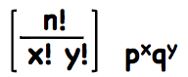
n - total # progeny
x - # progeny that fall into class P
y - # progeny that fall into class Q
p – probabilities of occurrence for class P
q – probabilities of occurrence for class Q
*only 2 classes therefore p = 1 - q

Pseudoautosomal regions of sex chromosomes
- some genes are present on both x and y chromosome (mostly in terminal regions); these genes do not follow x or y linked patterns of inheritance (called pseudoautosomal genes)
- exhibit autosomal pattern of inheritance
- crossing over dominantly occurs in these regions (ex: females can inherit an allele originally present on the y chromosome of father)

X-linked genes - males are hemizygous for x-linked genes
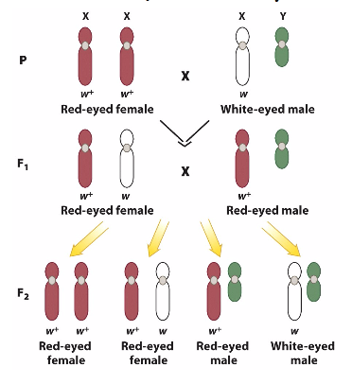
Testing that eye colour is x-linked:
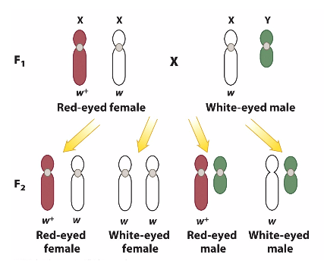
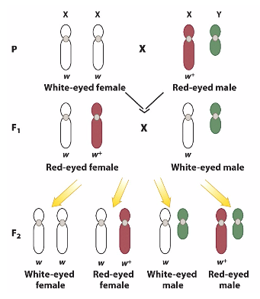

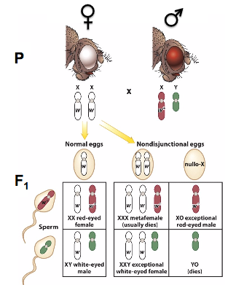

Non-disjunction – Bridge’s model accounts for results of exceptions to rule; some rare white-eyed females and red-eyed males produced due to abnormal numbers of chromosomes in gametes and ultimately in zygotes

*recessive x-linked traits are relatively easy to identify bc they show up immediately in hemizygous males

Ex:
Calculating the risk of inheriting an x-linked disorder (red-green colour blindness)
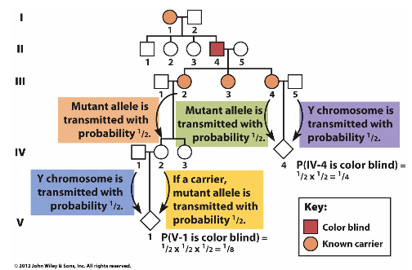

Dosage Compensation – different mechanisms adjust for the unequal dosage of x-linked genes in males and female animals
EX: mammals (inactivating 1 of the 2 X chromosomes in females), drosophila (hyper activating the single X chromosome in males), c. elegans (each of the 2 X chromosomes has reduced activity that are collectively equal to the single X in males)
barr body – inactive X chromosome (highly condensed)
ex: x inactivation is random therefore the ‘clone’ of a calico cat has different fur colouring/pattern

Gene expression
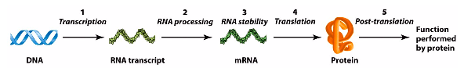

Genes encode one of several types of RNA Difference btwn DNA and RNA molecules
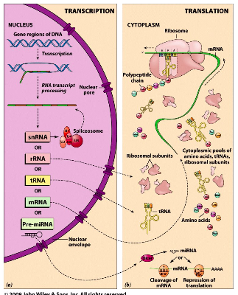
- RNA uses the pyrimidine uracil instead of
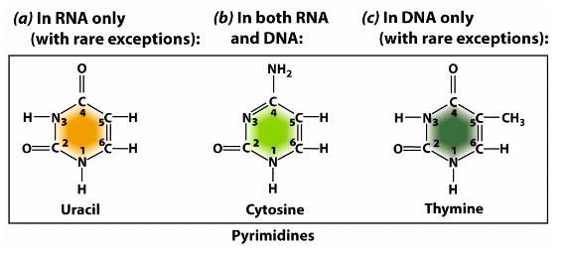
thymine
- The RNA pentose sugar = ribose (not a
deoxyribose like DNA)
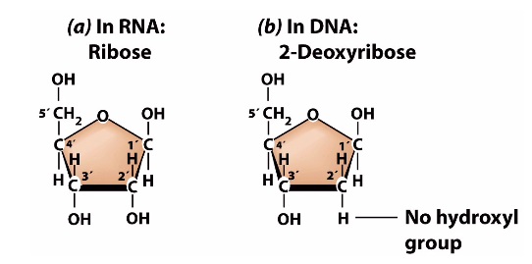

General features of RNA synthesis from a DNA template:
DNA: template strand 3’CGTAT…5’
Non-template strand 5’GCATA…3’ mRNA: 5’GCAUA…3’ (RNA sense strand)

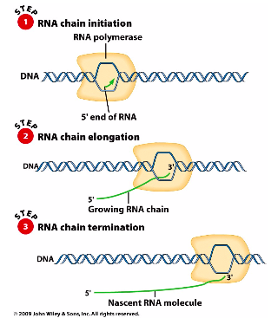
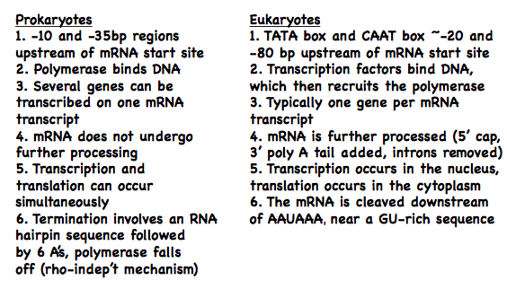
Transcription – prok vs euk
Differences in the initiation, elongation, termination and processing of transcripts

DNA sequences position the RNA polymerase to begin transcription at the beginning of a gene and cause it to dissociate at the end of the gene

Summary of Transcription and Stop Sequences:
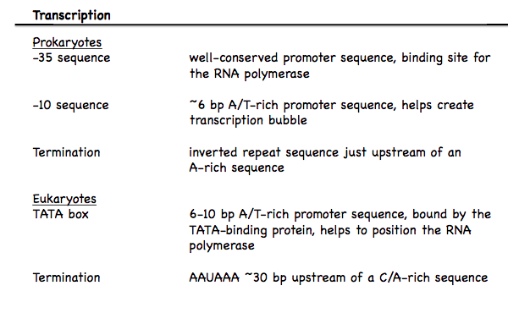

Pre-mRNA in Euk and mature mRNA
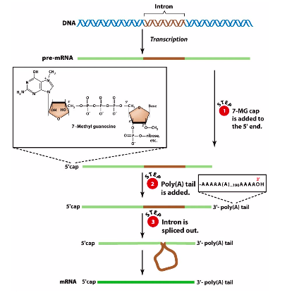
Introns and splicing:
Introns
- Non-coding sequences located btwn exons
- Removed from pre-mRNA and not present in mature RNA
Exons
- Both coding and non-coding sequences

*non-coding sequences are untranslated and referred to as the 5’ or 3’ untranslated region

Ribosome composition
Ribosome structure in E. coli:

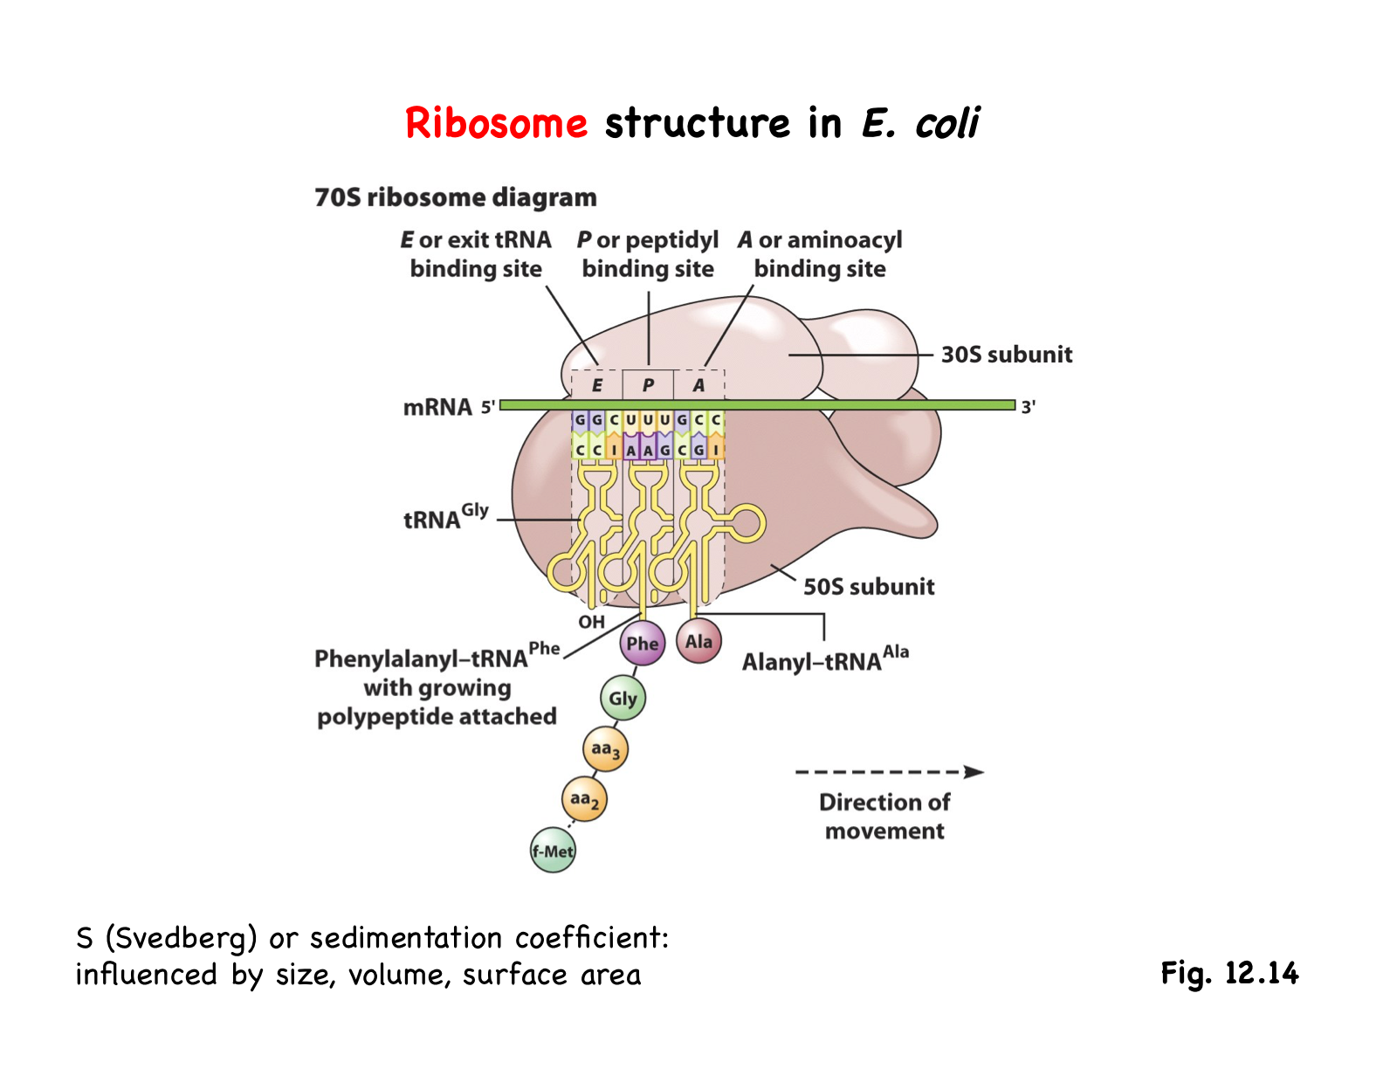
prok – ribosomal protein, rRNA, subunit (50s
and 30s)
20 nm, 70s ribosome

euk - ribosomal protein, rRNA, subunit (60s
and 40s)
24nm, 80s ribosome

Shine-Dalgarno sequence –
- in prok an RNA sequence helps position the ribosome near the 5’ end to begin translation at the beginning of a coding sequence or open reading frame
Kozak sequence –
- optimal core sequence context for a start codon
- GCCRCCAUGG (R = A or G)
- Underlined nucleotides = most important influence efficiency of translation by at least 10-fold if changed
- in euk a cap-binding protein helps position the ribosome at the 5’ end of the mRNA and the ribosome scans progressively to locate an AUG. The RNA sequence around the AUG influences where translation begins

Steps of Translation
Initiation –
- ribosome attaches to the mRNA and 1st tRNA so translation can begin
- initiation complex: involves a ribosome, mRNA, and tRNA (carrying 1st aa – Met)
EUK:
  - tRNA (carrying Met) attaches to the small ribosomal subunit
  - bind to the 5' end of the mRNA (recognize the 5' GTP cap)
  - run along mRNA (3' direction) stopping at start codon (often 1st AUG)
  - kozak sequence - optimal core sequence context for start codon
  - large ribosomal subunit joins initiation complex
PROK:
  - small ribosomal subunit doesn't travel 5' to 3' end
  - attaches directly to sequences in the mRNA -- Shine-Dalgarno sequences identify start codons (come just before start codon)
  - genes transcribed in groups, one bacterial mRNA can contain coding seq for several genes (transcription and translation can occur simultaneously)
Elongation –
- 1st met carrying tRNA starts in P site of ribosome, next aa brought to A site by next tRNA
- peptide bonds form, connect aa to each other
- met forms the N-terminus, other amino acid is the C-terminus
- mRNA pulled through ribosome by codon, allows empty tRNA to leave via E site and exposes new codon to A site (cycle repeats)
Termination –
- release factor 1 bind to the UAAG termination codon in the A site of ribosome and tRNA (Phe) leaves E site
- release of nascent polypeptide and RF-1, transfer of tRNA (Gly) from the P site to E site
- dissociation of the mRNA-tRNA-ribosome complex

Point mutations
Original: AGA – arginine
Nonsense stop codon: TGA
Missense (conservative) Lysine: AAA (non-conserved) Serine: AGT
Silent arginine: AGG

Insertions and deletions
- Frameshift; Changes remainder of polypeptide sequence

Expanding triplet repeats
- Usually <40 copies of the triplet repeat are stably inherited
- Larger # of copies = unstable and prone to expansion
- Ex: fragile x syndrome (CGG), Huntington disease (CAG)
- The expanding triplet repeat disease can show increase severity and/or earlier onset from one generation to the next
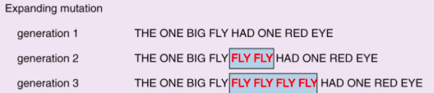

Mutations in non-coding regions
- Prevent or reduce transcription
- Prevent or reduce translation
Ex: mRNA unstable, ribosomes can’t bind, mutation of the start codon, nuclear export of mRNA is compromised

Nucleotide expansion in non-coding regions:
Myotonic dystrophy type 1 – CTG expansion in the untranslated region (UTR) of an mRNA transcribed from chromosome 19 encoding an enzyme (kinase)
Myotonic dystrophy type 2 – CCGT expansion in an intron of a gene on chromosome 3 encoding a zinc finger transcription factor
*in both cases the mRNA may become too large for efficient export to cytoplasm

Alleles behaving as dominant or recessive
- Recessive mutations almost always involve a loss of gene function
  - Complete loss of function – (null allele)
  - Partial loss of function – (hypomorphic allele)

- Loss of function mutations usually recessive since for most genes one functional copy is enough to confer a normal (wild type) phenotype
Dominant mutations - can involve a loss of function or a gain of gene function
Loss of function mutations – for those genes for which one functional copy is not enough (state called haploinsufficiency)
Dominant negative mutation – a loss of function mutation that interferes with the normal function of the w^+ allele
Gain of function mutation – enhances the normal function of the gene or causes expression of the gene in a novel cell type

Interaction of alleles
Incomplete dominance
- Phenotype of the heterozygote is midway btwn the phenotypes of the 2 homozygotes
- One allele is partially dominant over the other
- Ex: red flower (WW) X white flower (ww) pink flower (Ww)
Codominance
- The heterozygote expresses the phenotypes of both homozygotes
- Neither allele is dominant
- Ex: blood type

Allelic Series – describes the dominance hierarchy
Dominance hierarchy: Allelic series:
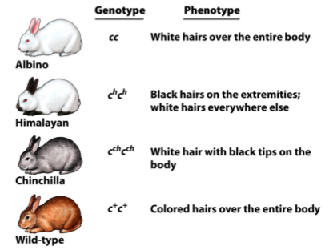
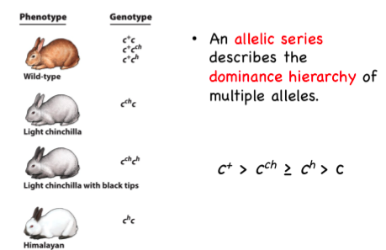

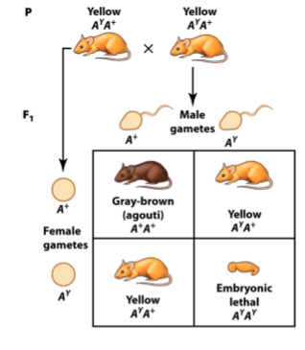
A^Y –
a dominant visible allele that is also a recessive lethal (involved in at least 2 different developmental processes)

* a gene is said to be pleiotropic if it influences multiple aspects of an individual’s phenotype

Complementation test
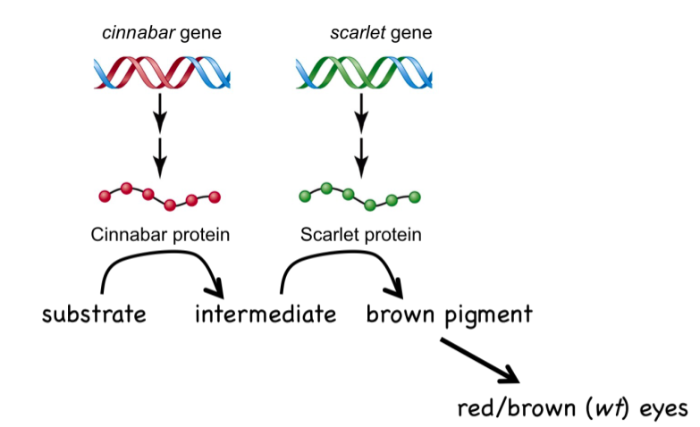
multiple genes can contribute to a phenotype: Complementing Alleles:
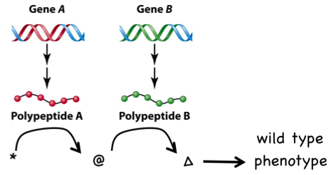
- Comp. test - tests for allelism
- cross 2 individuals that share identical/similar mutant phenotypes
- If the mutations are in alleles of the same gene, the F1 will display the mutant phenotype
- If the mutations are in alleles of different genes, the F1 will NOT display the mutant phenotype
- Complementation is the production of a wild type phenotype when two haploid genomes bearing different recessive mutations are united in the same cell
- Failure to complement - indicates that the parents carried mutations in the same gene.

Ex: white feather colour is recessive:
- White strain A crossed with white strain B produce all white offspring
(a a X a' a' -> a a') mutations in same gene

- White strain A crossed with white strain C produces all black & brown offspring.
(aa b⁺b⁺ X a⁺a⁺ bb) -> a⁺a b⁺b) mutations in different genes

Cloning and cell differentiation
- Cloning by nuclear transfer argues against gene loss
- Ability to clone a sheep tells us that the genome in differentiated cells doesn’t change

Enhancers
- Regulate where and when genes are expressed
- Additional regulatory sequences of those genes that have restricted and specific expression patterns
- Like promoters, enhancers contain binding sites for transcription factors; each enhancer contains binding sites for both transcription activators and repressors
- Tissue specific enhancers create additional regulatory regions of a gene that can make defining the physical boundaries of a gene difficult

Proteins that regulate transcription
Basal transcription factors – proteins that bind to specific sequences within the promoter to facilitate RNA polymerase binding. Basal factors are expressed in most, if not all cells
Regulatory transcription factors – proteins that bind to sequence elements in promoters or enhancers, thereby facilitating (or repressing) the function of the basal transcription factors and RNA polymerase. – expressed themselves in more restricted, tissue-specific patterns
Chromatin compaction
- Chromosomes not uniformly condensed:
Euchromatin – lightly packed, contains actively transcribed genes
Heterochromatin – tightly packed form of DNA
- DNA compaction is regulated and is an additional level of control over gene expression
- Many regulatory proteins modify histone tails, thereby making the chromatin more/less accessible to basal transcription factors
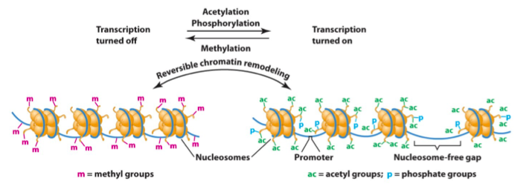
- Level of chromatin compaction during interphase is regulated by histone modifications

