Corporate Governance: Whom Does the Corporation Serve??
- OECD suggests a ‘stakeholder’ approach to governance
- Who are stakeholders?
  - Any group or individual who is affected by or can affect the achievement of an organization’s objectives (Freeman: 1984)
- A stakeholder approach means operating in a socially responsible way – in other words, business has a responsibility beyond profit maximization
Pluralism
- A condition in which there is diffusion of power among society’s many groups and organizations – a wide decentralization and diversity of power concentration
- Strengths
  - Prevents concentration of power
  - Maximizes freedom
  - Disperses individual allegiances
  - Creates diversified loyalties
  - Provides safeguards
- Weaknesses
  - Pursuit of self-interest
  - Proliferates organizations with similar goals
  - Forces conflicts
  - Promotes inefficiency

Stakeholders
Individuals and groups with a multitude of interests, expectations, and demands as to what business should provide to society
Shareholder Viewpoint vs. Stakeholder Viewpoint
- Shareholder Viewpoint:
  - A business exists to make money – greatest efficiency is achieved through profit maximization
  - > profits, > taxes paid to government for use in dealing with social issues
  - Property rights theory (corporation owned by shareholders)
- Stakeholder Viewpoint:
  - Business has a responsibility to do more than maximize profits
  - Business has caused several problems so it has a responsibility to fix them
  - Social institution theory (society provides the very existence of business through legal frameworks)
Stakeholders – A Complex Landscape
Who are our stakeholders?
Management must identify generic stakeholder groups and specific subgroups
What are our stakeholders’ stakes?
  - The nature/legitimacy of a group’s stakes
  - The power of a group’s stakes
  - The specific groups within generic groups
What opportunities and challenges do stakeholders present?
- Productive working relationships with stakeholders
- Challenges and action on how the firm handles stakeholders
What strategies or actions to take?
  - Deal directly or indirectly with stakeholders?
  - Take the offence or the defence in dealing with stakeholders?
  - Accommodate, negotiate, manipulate, or resist stakeholder overtures?
  - Employ a combination of the above or singular strategies?

Identifying key stakeholders
  - One who can exert and sustain a positive or negative affect on the organization
  - Those stakeholders having high interest and high power to influence would be perceived as key
Who Are Business Stakeholders?
Primary and Secondary Stakeholders
- Primary stakeholders are those that have a direct interest in the organization and its success
- Secondary stakeholders are those that have a public or special interest in the organization
Core, Strategic, and Environmental Stakeholders
- Core stakeholders are essential to the firm’s survival
- Strategic stakeholders are directly affected by threats and opportunities the organization faces
- Environmental stakeholders are all others in the organization's environment
The Business Stakeholders
- Legitimacy is the perceived validity of the stakeholder’s claim to a stake
- Power is the ability of a stakeholder to produce an effect
- Urgency is the degree a stakeholder’s claim demands immediate attention
Identifying Stakeholders
  - Power, legitimacy and urgency – any party possessing at least one of these attributes is a stakeholder
    - Latent stakeholder possesses only one attribute
    - Expectant stakeholder possesses two attributes
    - Definitive stakeholder would possess all three attributes
How Canadians Govern Themselves
- Canada is a democracy, a constitutional monarchy and a federal state, with 10 largely self-governing provinces and three territories
- Nova Scotia was the first part of Canada to secure a representative government (in 1758)
How Canadians Govern Themselves
- The Constitution
  - The Constitution Act, 1982 did not give Canada a new constitution
  - What we have now is the old constitution with a very few small deletions and four immensely important additions:
    - The establishment of 4 legal formulas for amending the constitution
    - The first three amending formulas place certain parts of the written constitution beyond the power of Parliament or any provincial legislature to touch
    - The setting out of the Canadian Charter of Rights and Freedoms
    - The giving to provinces, wide powers over their own natural resources
Canadian Charter of Rights and Freedoms
Specific Rights and Freedoms
- Democratic rights
- Fundamental freedoms
- Mobility rights
- Legal rights
- Equality rights
- Official language rights
- Minority language education rights
Canadian Federalism
- Canada:
  - governed by a system of parliamentary democracy with powers divided among the various levels of government that constitute our federalist state
- Federalism:
  - is a system of political organization in which the activities of state are divided between at least two levels of government in such a way that each level has certain areas in which it is empowered to make final decisions
- The Canadian Federation:
  - the federal government
  - 10 provincial and three territorial governments
  - a number of regional and local municipalities
How Canadians Govern Themselves
Some Examples of Federal Government Exclusive National Powers:
- Direct and indirect taxation
- Regulation of trade and commerce
- “the public debt and property”
- Grants to individuals or provinces (family allowance, hospital insurance/medicare, higher education, etc.)
- The post office
- Census and statistics
- Defence
- Navigation and shipping
- The fisheries
- Money and banking
- Interest
- Bankruptcy
- Weights and measures
- Patents
- Copyrights
- Criminal law and procedure in criminal cases
- General Law of marriage and divorce
Some Examples of Provincial Legislation Powers:
  - Direct taxation in the province for provincial purposes
  - Natural resources
  - Prisons (except for federal penitentiaries)
  - Charitable institutions
  - Hospitals (except marine hospitals)
  - Municipal institutions
  - Licenses for provincial and municipal revenue purposes
  - Incorporation of provincial companies
  - Solemnization of marriage, property and civil rights in the province
  - The creation of courts and the administration of justice, fines and penalties for breaking the law
  - Matters of a merely local or private nature in the province
  - Education
Some Areas of Cross-Over
- Both Parliament and provincial legislatures have power over agriculture and immigration, and over certain aspects of natural resources – if their laws conflict, the national law prevails
- Although Parliament cannot transfer any of its powers to a provincial legislature, nor a provincial legislature any of its powers to Parliament, Parliament can delegate the administration of a federal Act to provincial agencies, and a provincial legislature can delegate the administration of a provincial Act to a federal agency
The Canadian Political Landscape
- Canada is a constitutional monarchy, a federation and a parliamentary democracy
- Her Majesty Queen Elizabeth II is the Queen of Canada and our constitutional head of state
- She delegates her duties, which are mainly ceremonial, to her representatives in Canada: the Governor General and the provincial lieutenant-governors
- Formally the Prime Minister and cabinet advise the queen, but practically cabinet holds the power and determines the policy for proposed legislation
`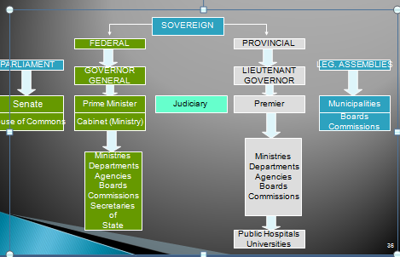
The Canadian Federal Government
- Canada governs through the “Westminster Model” of Government
- Three Branches of Government:
  - Legislative -- The House of Commons & The Senate
  - Executive -- Prime Minister, Cabinet and the Public Service
  - Judicial -- independent of Cabinet, Parliament or of any other state institution
Legislative Process
Stages of a Bill (before becoming law)
- Introduction
- First Reading
- Second Reading (most important – principle and object of the bill are debated and either accepted, rejected, or amended)
  - Six months hoist
  - Reasoned amendment
  - Referral to a committee
- Third Reading
- Senate
- Royal Assent
The Legislative Process -- A Closer Perspective
Part 1: The Cabinet
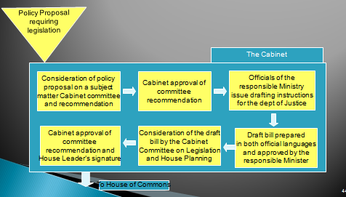
The Legislative Process -- A Closer Perspective
Part 2: Parliament
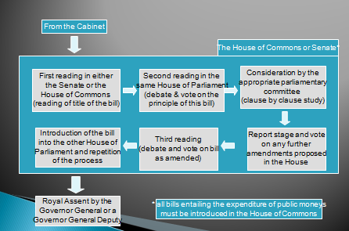
Legislative Process
Private Bills
- Matters of particular interest or benefit to a person or persons, including corporations
Parliamentary Committees
(composed of members from all parties)
Standing Committees
- Focus on a substantive sphere of government policy (e.g., Public Accounts Committee)
Special Committees
- Examine specific issues (e.g., pensions, child care)
Legislative Committees
- Examine specific government bills after they have passed second reading
Committee of the Whole
- All members from either the Commons or the Senate
The Canadian Federal Government
The Executive Branch
- The Prime Minister, Cabinet and the Public Service comprise the Executive Branch of Government
  - PM selects Cabinet Ministers from amongst elected members of his/her party - ministers then formally appointed by the Governor General
  - PM and Cabinet Ministers make all majority policy decisions
  - PM establishes Committees of Cabinet to handle streams of policy issues
  - PM also recommends various appointments to the Governor General -- ministers, lieutenant-governors, speakers of the senate, chief justices, senators, deputy ministers
  - PM also recommends a Governor General for the Queen’s appointment!
- The Public Service is the third and largest component of the Executive Branch of government
- Public servants work to “translate the declarations and definitions of public policy into action” devising options for actions from which Ministers decide on a course of action
- The Judiciary - the third branch of government
  - The Canadian system is inherited from the common law tradition of England
  - The basis of the constitutional, criminal and civil law of the entire country except Quebec which has its own civil code
  - The judgements of the Supreme Court of Canada are binding on all other courts
  - Judges of the Supreme Court (nine, three of whom must come from the Quebec bar) are appointed by the Governor General on the advice of the federal Cabinet and hold office until they reach age 75
- The Judiciary
  - The Constitution provides that almost all our courts shall be provincial, but it also provides that the judges of all these courts from county courts up shall be appointed by the federal government
  - Judges of the provincial “superior courts” (all provincial supreme courts and the provincial courts of appeal) can only be removed on address to the Governor General by both Houses of Parliament (the same applies to judges of the Supreme Court of Canada and the Federal Court)
  - Judges of the county courts can only be removed if one or more judges of the Supreme Court of Canada, or the Federal Court, or any provincial superior court, report after inquiry that demonstrates guilt of misbehaviour, or inability or incapacity to perform their duties
Sources of Legislation
- The public
- The government
- The public service
- Parliament
- The Judiciary
Public Policy
- Whatever governments choose to do or not do (Dye: 1972)
- A course of action or inaction chosen by public authorities to address a problem, expressed in the body of laws, regulations, decisions and actions of government*
The Public Policy Process*
Steps:
- Problem identification/definition
- Setting the agenda
- Formulating the policy
- Implementing the policy
- Evaluating the policy
The Public Policy Process vs. The Market Process
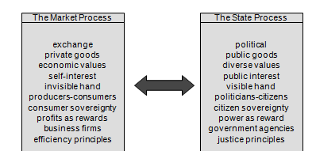

Lecture 4 the Civil Society Segment
Canadian Business in its Social-
Civil Society: Key Terms
- Community
- Reciprocity-based value system
- Trust & Collaboration
- Social arrangements
- Social capital
- Civic engagement
Civil Society (Social Segment)
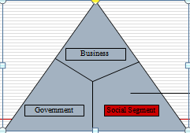
- The community, volunteer sector, civic sector, civil society

What is ‘civil society’?
- Also referred to as the ‘third segment’
  - Nonprofit
  - Not-for-profit
  - Voluntary
  - Independent
  - “Community”
- The totality of voluntary civic and social organizations and institutions
- “locality” and “common interests”
- Shared characteristics, values, interests, goals that provokes a sense of belonging:
  - Closeness
  - Warmth
  - Protection
  - engagement
- Can be occupational (physicians, accountants)
- Can occur within organizations:
  - Professors
  - Accountants
  - Auditors
  - HR “community”
  - Finance “community”
  - Senior Management “community”
- Can be based on
  - Skills, gender, age, ethnicity or some combination of these
Civil Society (Social Segment) – Who is included?
- The community, but also:
  - United Way
  - Foundations (Maytree, Atkinson)
  - Imagine Canada (formerly the Canadian Centre for Philanthropy)
  - Kids Help Phone
  - Caledon Institute
  - Planned Parenthood
  - Sun Youth
  - Charities
Civil Society (Social Segment) – What characterizes the segment?
- Activities mainly instituted through forms of reciprocal relationships or solidarity
- Based on “good neighborliness” and social trust
- Its value system is reciprocity-based:
  - Engagement
  - Commitment
  - Trust
  - Obligation
  - Cooperation
  - Collaboration
- Overall Characteristics:
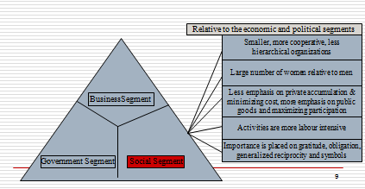
The contemporary civil society segment
- Now features:
  - Involved communities
  - NGOs/Interest Groups/Associations that are “issue-oriented”
  - Knowledge groups/Institutes/Think Tanks
    - Civic entrepreneurs linking community and economic development
The Dynamics of the Civil Society Segment
- The dynamics of this sector are somewhat different from the other two sectors:
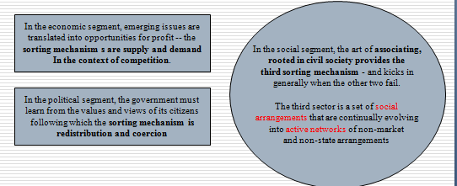
Social Capital -- Some Perspectives
- Social Capital is generally defined as the relationships, networks and norms that facilitate collective action (Alfred LeBlanc, ISUMA, Spring 2001)
- Social Capital directs attention to the relationships that shape the realization of human capital’s potential for the individual and collectively (Tom Schuller, ISUMA, Spring 2001)
- Social Capital is defined as norms, networks and other related forms of social connection (Edward Glaeser, ISUMA, Spring, 2001)
- The central idea of social capital is that networks and the associated norms of reciprocity have value (Robert Putman, ISUMA, Spring 2001)
Social Capital vs. Human Capital
- Social capital is not human capital. The differences can be expressed as follows:
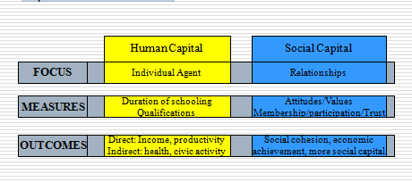
- Highly formal forms:
  - Parent-teacher association, a national organization of any sort, a labour union (where each is formally organized with a chairperson, a president and membership dues)
- Highly informal forms:
  - a group of people gathering at a bar every Thursday evening
- Densely interlaced or comparatively invisible
  - a group of steelworkers who work together every day at the factory, go bowling together on Saturday, and the same Church every Sunday vs. the nodding acquaintance you have with the person you occasionally see waiting in line at the supermarket
Five Roles of Civil Society
- Monitoring through which policy is kept ‘honest’
- Advocacy through which policy options can be supported or not supported
- Innovator through which different ways of doing things are developed and demonstrated
- Service provider through which a particular need is fulfilled
- Capacity builder through which support is provided to other civil society organizations
The Civil Society Segment -- Likely Contributions
- Alternative service delivery models based on inter-sectoral partnerships
- employment generation and recognition
- valuing and conceptualizing the importance of “community”
- Civic engagement
Video: The Sum is Greater
- Which aspects of civil society were apparent in this video?
  - Strategic Partnerships
  - Trust
  - Collaboration
  - Networks
  - Reciprocity
  - Norms and values
- What is the relationship between civil society and business?
  - They need each other
  - Working together and complementing each other both can be more effective
Civil Society – An important but complex segment with complex issues
- Segment fragmentation
- Funding
- Attracting and retaining volunteers and strong non-profit board members
1. Segment Fragmentation
- >161,000 incorporated non-profit organizations plus thousands of unincorporated community groups:
  - Different issues
  - Different missions
  - Highly diversified and incongruent
  - Varying management capacity and ability
- Challenges due to fragmentation – for the smaller organizations:
  - Being heard by government and industry
  - Getting on the government or business agenda
  - Partnering with government and business
2. Funding
- A finite amount of money to be shared amongst the fragmented third segment
- Changes in government policy intended to foster improved stewardship has had a negative impact on the third segment
- Project-based funding model:
  - Overhead costs not funded, but more reporting requirements
  - Funding targeted on specific issues that causes “mission drift”
3. Attracting and Retaining Volunteers
- Age demographics:
  - By 2011 the potential exists for every person aged 55-64 there will be only one person aged 15-24
  - More people available to do volunteer and charitable work, but also more demand for third segment services
- Changing volunteer paradigms
  - Employee volunteerism
  - Episodic volunteerism
  - Virtual volunteerism
  - Cross-national volunteering
  - VolunTourism
Reflection: Might “Civil Society” and/or “Community” be in decline?
  - Putnam (2000):
    - People disengaged from “civic life”
      - Fewer voters, political activity, newspaper readership, participation in local associations – the result: a decline in social capital, community relations and social cohesion – a weakening of the “social glue” in society
    - The Cause(s):
      - Changes in family structure
      - Suburban sprawl
      - Time pressures
      - Electronic entertainment
      - technology
Bourdieu: Four Types of Personal Capital
- Each person in society will possess differing amounts of:
  - Social capital (who you know)
  - Economic capital (what you have)
  - Cultural capital (legitimate knowledge: what you know)
  - Symbolic capital (your status in the eyes of others)

Lecture 5 – The Ethics of Business
HOW DO WE DEFINE “BUSINESS ETHICS”?
“…the study of business situations, activities, and decisions where issues of right and wrong are addressed.”
“… rules, standards, codes or principles which provide guidelines for morally right behaviour and truthfulness in specific situations.”
- Business Ethics:
  - “the application to business activity of ethics, the study of morals or principles of what is right or wrong in human behaviour” (Edmund Marshall, “Business and Society”, Routledge, 1993)
  - “…concerned with the beliefs that determine what is acceptable (and what is not) in business” (Wheelen, Hunger and
  - Wicks, “Concepts in Strategic Management”, Canadian Edition, Pearson Prentice Hall, 2005)
  - “applies a group’s standards of right and wrong to the decisions and actions of business organizations, managers, and employees” (Marian Burk Wood, “Business Ethics in Uncertain Times”, Prentice Hall, 2004)
Common Themes EMERGING FROM DEFINITIONS OF BUSINESS ETHICS
- Right and wrong
- Moral standards
- Value judgements
Value judgements
- Subjective evaluations of what is considered important, based on how managers intuitively feel about the goodness or rightness of various goals
MORAL STANDARDS
- The means by which individuals judge their actions and the actions of others based upon accepted behaviour in society
INFLUENCES ON ETHICAL BEHAVIOUR
- Individual morals
- National and ethnic cultures
- Government legislation and regulation
- The legal system
- Religion
- Colleagues or peers
- Education
- Media
- Corporate mission, vision, and values statements
- Union contracts
- Competitive behaviour
- Activist or advocacy groups
- Business or industry organizations
- Professional associations
THE THEORETICAL BASIS FOR ETHICAL CONDUCT: THE MOST CITED PRINCIPLES OF ETHICAL ANALYSIS
- Self-Interest Ethic (Ethical Egoism)
  - Individuals or businesses set their own standards for judging the ethical implications of their actions
- Personal Virtues Ethic
  - An individual’s or business’ behaviour is based upon being a good person or corporate citizen with traits such as courage, honesty
- Ethic of Caring
  - Gives attention to specific individuals or stakeholders harmed or disadvantaged and their particular circumstances
- Government Requirements Ethic
  - The acceptance of a code of laws as the governing rules of society that determines what is acceptable behaviour
- Utilitarian Ethic
  - Focuses on the distribution of benefits and harms to all stakeholders with the view to doing the greatest good for the greatest number
- Universal Rules Ethic
  - Ensures that managers or businesses have the same moral obligations in morally similar situations
- Individual Rights Ethic
  - Reliance on a list of agred-upon rights for everyone that will be upheld by everyone and that becomes the basis for deciding what is right, just and fair
- Economic Efficiency Ethic
  - Judges the moral implications of a decision by its economic consequences and provides the moral justification for a market system
- ETHIC OF JUSTICE
  - Ethical decisions are based on the primacy of justice
    - Procedural
      - the impartial application of rules or procedures
    - Corrective
      - Appropriate compensation for wrongdoings that are suffered
    - Retributive
      - The punishment should fit the offence
    - Distributive
      - Concern for how all stakeholders are treated
Business Ethics
Two Key Branches of Ethics
- Descriptive ethics involves describing, characterizing and studying morality
  - “What is”
- Normative ethics involves supplying and justifying moral systems
  - “What should be”
ETHICS – THREE DIFFERENT KINDS
- Social Ethics
  - Standards learned primarily from an awareness of the climate of opinion – developed during a person’s upbringing, in home and school, and extended through social contacts and through the news media
  - Also expressed in the legal framework of a society through legal codes and statutes determined by political processes
- Transcendental Ethics
  - Absolute concepts of right and wrong which transcend all human societies
  - Prompted by the realization of the weakness of social ethics in not being applicable to relations between different societies
- Tactical Ethics
  - Ethics practiced out of convenience, and in pursuit of ulterior motives, most commonly in the improvement and optimization of self-interest
  - Based not on the concepts of what is right in a social or absolute context, but on other considerations, as often as not what is advantageous for the individual
Making Ethical Judgments
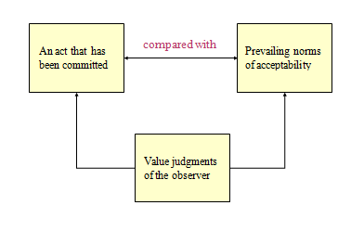
Making ethical judgements: Deciding what is ethical
- Ethical dilemmas:
  - Situations where a decision must be made between two equally valid but mutually exclusive courses of action
  - What approaches exist to help make defensible ethical decisions
  - Otto Bremer: Four Questions
  - Josephson: Bell, Book, Candle
  - Nash
  - Pagano
Otto Bremer: 4 ethics Questions
- What is (descriptive ethics)?
  - What is actually going on in an ethical sense (what is the real situation)
- What ought to be (normative ethics)?
  - What managers should do
- How do we get from What Is to What Ought to Be?
  - How is the gap closed? May actually not be able to fully close the gap!
- What is Our Motivation?
  - What is the motive for being ethical?
Making ethical decisions – Josephson’s “bell, book, candle” approach
Three tests:
- “Listen for the bells warning you of an ethical decision (the ‘bell’);
- Check to see if there are any laws, regulations or rules which restrict your choices (the ‘book’); and,
- How will your decision look in the light – could a reasonable, fair-minded person conclude you acted improperly? (the candle).”[1]
Nash: Some Plainly Worded Questions
- Have you defined the problem accurately?
- How would you define the problem if you stood on the other side of the fence?
- How did this situation occur in the first place?
- To whom and to what do you give your loyalty as a person and as a member of the corporation?
- What is your intention in making this decision?
- How does this intention compare with the probable results
- Whom could your decision or action injure?
- Can you discuss the problem with the affected parties before you make your decision?
- Are you confident that your position will be as valid over a long period of time as it seems now?
- Could you disclose without qualm your decision or action to your boss, your CEO, the Board of Directors, your family, society as a whole?
- What is the symbolic potential of your action if understood? If misunderstood?
- Under what conditions would you allow exceptions to your stand?
The Pagano Model
- Is it legal?
- The benefit cost test (the greatest good for the greatest number?)
- The categorical imperative (Do you want this action to be a universal standard?)
- The light of day test (What if your actions appeared on TV?)
- Do unto others (Do you want the same to happen to you?)
- The ventilation test (Get a second opinion from someone with no investment in the outcome)
IMPORTANCE OF BUSINESS ETHICS
- Business ethics helps business understand how to deal with:
  - The uneasiness of many public stakeholders with the growing power and influence of business in society
  - Providing significant contributions to society
  - Mitigate business malpractices with the potential to inflict harm on individuals, communities, and the environment
  - Increasingly complex demands to be ethical
  - Formalizing business ethics, given that few business people receive formal ethics training or education
  - Ethical violations that continue to occur in business, across countries
  - How to assess the benefits and problems associated with different ways of managing ethics in organizations
  - Issues that transcend the traditional framework of business studies and confront some of the most important questions faced by society
Ethical Perspectives and Challenges
- Ethical decisions make good business sense but can be complicated by:
- Globalization – managers from diverse cultures and backgrounds doing business in different geographic locations governed by different laws and customs
- Accountabilities – In 2008 Greece’s GDP was about the same as Wal-Mart’s revenues (US$4 billion): but the stakeholders affected by Wal-Mart decisions have comparatively little influence on the company compared to shareholders
- Technology – internet technology for sales, research, distribution, promotion: what type of information is being collected and for what purposes?
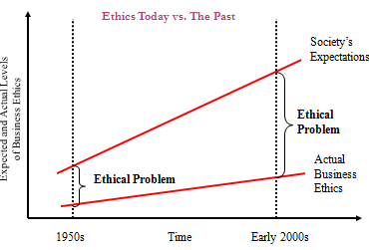
Improving Ethical Climate


