Organizational Behaviour

Chapter 1 – what is organizational behaviour

Frederick Taylor – scientific management
Elton Mayo (Hawthorne Studies) – Human relations movement wanting more purpose

Groupthink: no one wants to challenge anyone: “Behaviour that support conformity and harmony at the expense of other team priorities”

Motivation is not based on money $

Relationship conflict is never good
Task Conflict challenges people in managed ways

Rule of 1/8: about 12% of organizations actually and fully apply the insights of OB

Chapter 2 – Job performance

How we define job performance is important

Reward job performance
- We want to have measurement tools in place to measure job performance
- Minimum hourly wage + (payout – penalty)
  - Incentives: 85%> = all payout, 84-80% = 75% of payout, 80%< = no payout

How do we define job performance in order to motivate the best possible behaviours and generate the best possible organizational outcome?
- Results objective measures of outcomes (WEP)
- Behaviour specific behaviours employees engage in (Rideau & Friel)

Results based job performance
- Pros:
  - Easy to access, Objective and comparable,
- Cons:
  - Don’t capture “beyond bottom line”, Not always controllable, No info for improvement / no “why”

Job performance (behaviour)
- Volitional employee behaviours that contribute either positively, or negatively to the accomplishment of organizational goals
- Total Behaviour Performance
  - Task performance, Citizenship Behaviours, Counter-productive behaviours

In-role Extra-role

Task performance – three subtypes
- Routine
- Adapt (thoughtful responses to unpredictable tasks)
- Creative (novel and useful ideas)

Citizenship behaviours
- Voluntary behaviours that contribute to achieve organizational goals
- Subtypes
  - Helping, courtesy, sportsmanship, voice, civic virtue, boosterism

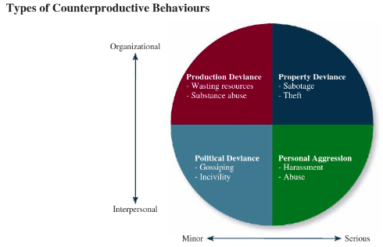
Counter-productive behaviour:
- Employee behaviours that intentionally hinder organizational goal accomplishments
- Intentional (ex: voluntarily)
- Interpersonal or organizational

- On purpose (intentional) – person should change
- On purpose (non-intentional) – organization should change

Surveillance and theft
- Surveillance of employees weak negative but non-significant relations with CWBs
- Surveillance of employees strong but they feel interpersonal so they are not doing amazing

Important takeaways
- Breaking down into types = greater insight
- Change look at multiple performance outcomes

JOB PERFORMANCE TOOLS
Management by objectives:
- Is not results based performance
  - Agreed upon goals
  - Proper application of goal setting theory
  - Change, environmental pressures
BARS
- Behaviourally Anchored Rating Scales
- Assesses behaviours
- Can capture the “how”
- “Quantify it to measure”
360 Degree Feedback
- Multiple stakeholders
- Limitations
  - Time, Difficulty, Tension/Relationships
- Always need to justify necessity given the limitations! In context
- More simplified than BARS

Job Appraisals
- Some best practices
  - Give employees heads up
  - Make sure to stick to schedule
  - Meet in a neutral, comfortable and PRIVATE location
  - Give employee a voice
  - Come with the good and bad
  - Come with results / goals in mind
  - Ask what employee needs to improve performance
  - Make sure tools accurately reflect what is expected

Recap
- The importance of defining performance
- Job performance is multifaceted
- Well-executed measurement tools
- Job appraisals: ambivalence and best practices

Mini case study – Revisiting performance
- Employees are caught stealing over $1 million but the union protects them. The company puts in cameras but it makes it worse, what do you do?
  - Why are people steeling? (intentional or not)
  - Confidential interviews
  - Find creative ways to stop motivation of theft

Chapter 3

Organizational commitment
- Employee retention
- Employee engagement

Why is commitment important?
- Turnover is expensive
- Unengaged employees are expensive

Types of commitment
- Affective
  - Staying in an organization due to emotions (ex: love job, love coworkers, love clients)
  - Not always, but often linked to our relationships to others
  - Social network approach
  - I want to
- Continuance
  - People stay because of resource or cost reasons
  - Stay because no alternatives (no other option)
    - Likely to not engage and go above & beyond
  - Invested so much time into the organization that you don’t want to leave (McDonald’s)
    - Embeddedness has no link to emotions
    - May not want to leave people of the connections you’ve made
    - Community resources (ex: wife doesn’t want to move, kid’s schools)
  - I have to
- Normative
  - “They need me”
  - Obligation to stay
  - Organization’s commitment into their employees
  - Not very controllable
  - I ought to
- Dynamic & complex
- “Focus of commitment” – elements that inspire the desire to remain

4 primary responses in organization
- Positive
  - Voice, Loyalty
- Negative
  - Neglect, Exit

Withdrawal = Low engagement
- Physically and Psychological withdrawals

Q&A
Best commitment?
- Affective
  - Able to strategically encourage
  - Reliable and consistent negative correlation with withdrawal behaviours
  - Positively correlated with the “good” responses
What is the impact of continuance commitment on employee behaviour?
- It depends on the reason for why it is continuance
- Generally bad (based on a few alternatives)
- Embeddedness (not always bad)

Chapter 4

Personality, cultural values, and ability
- Personality – the structures and propensities inside people that explain their characteristic patterns of thought, emotion, and behaviour. Personality captures what people are like
- Traits – recurring regularities or trends in people’s responses to their environment
  - responsible, easygoing, polite, reserved = traits to summarize a personality
- Cultural values – shared beliefs about desirable end states or modes of conduct in a given culture
  - capturing what cultures are like
- Ability – relatively stable capabilities of people for performing a particular range of related

The Big Five
- Conscientiousness – dependable, organized, reliable, ambitious, hard-working, and preserving
  - Accomplishment striving
- Agreeableness
  - Communion striving
- Neuroticism – nervous, moody, emotional, insecure, jealous, unstable
  - Negative affectivity
- Openness to experience
- Extraversion – sociable, talkative, passionate, assertive, bold, dominant
  - Status striving, Positive affectivity

Individualism-collectivism
- The degree to which a culture has loosely knit social framework (I) or a tight social framework (C)

Power distance
- The degree to which a culture prefers equal power distribution (low) or an unequal power distribution (high)

Uncertainty avoidance
- The degree to which a culture tolerates situations (low) or feels threatened by them (high)

Masculinity-femininity
- The degree to which a culture values stereotypically male or female traits

Ethnocentrism
- Propensity to view one’s own cultural values as “right” and other cultures as “wrong”

Cognitive ability
- Capabilities related to the acquisition and application of knowledge in problem solving
  - Make decisions, solve problems

Verbal ability
- Various capabilities associated with understanding and expressing oral and written communication

Quantitative ability (two types of mathematical capabilities)
- Number facility – capability to do simple math operations (PEDMAS)
- Mathematical reasoning – ability to choose and apply formulas to solve problems that involve numbers

Reasoning ability
- A diverse set of of abilities associated with sensing and solving problems using insight, rules, and logic

Emotional intelligence
- A set of abilities related to the understanding and use of emotions that affect social functioning
- Self-awareness – ability of an individual to understand the types of emotions he/she is experiencing, the willingness to acknowledge them, and the capability to express them naturally
- Other awareness – ability to recognize and understand the emotions that other people are feeling
- Emotion regulation – ability to recover quickly from emotional experience
- Use of emotions – the degree to which people can harness emotions and employ them to improve their chances of being successful in whatever they are seeking to do

Sensory ability
- Capabilities associated with vision and hearing. Near-far, night vision, colour perception

Situational strength
- The degree to which situations have clear behavioural expectations, incentives, or instructions that make differences between individuals less important

Trait activation
- The degree to which situations provide cues the expression of a given personality trait

Chapter 5

Job satisfaction is a pleasurable emotional state resulting from the appraisal of one’s job or job experience. (what you think about your job and how you feel about it)

Value fulfillment
- Value-percept theory: job dissatisfaction depends on whether an employee perceives his or her job supplies the things he or she values most
  - What does he want to make?
  - How important is salary to him?
  - How satisfied is he with other aspects of his job?

Commonly assessed work values
- Pay, Promotions, Supervision, Co-workers, The work itself

Job descriptive index
- Strengths
  - Simple questions and easy to use
  - Tracks 5 “most commonly assessed” factors
  - Scoring includes level
  - Publically available benchmarks
  - Compare across time
- Limitations
  - Doesn’t tell you why

Job characteristics theory
- Assumption: If the job itself is so important to people, lets focus on building better jobs
- Job design
  - Structuring the methods and relationship of jobs in order to satisfy organizational requirements
- Job enrichment
  - Designing jobs in a way to increase satisfaction with work
    - 5 characteristics: Variety, Identity, Significance, Autonomy, Feedback (from the job itself)
- Structuring the methods and relationship of jobs in order to satisfy organizational requirements as well as the social and personal requirements of the job holder

Moods and emotions
- Assumption: our attitudes towards our job fluctuate with our feelings
- Mood: states of feelings, mild intensity, last for a while, not directed towards anything
- Emotions: informal feelings, can be short, directed towards something
- Affective events theory: how workplace events can generate emotional reactions that impact work behaviours and satisfaction
  - Ex: You get an obnoxious email from a client complaining about the service you provided
  - Ex: Your boss praises your hard work

Chapter 6

Workplace stress
- 27% (high [because of work]), 27% (none), 46% (less)
- 20 billion dollars annual spending on stress-related illnesses
- ¾ short term disabilities are stress

Stress is the psychological response to demands when there is something at stake for the individual, and when coping with these demands, would tax or exceed the individual’s capacity or resources

Overall capacity
- Feeling positive/upbeat, ability to think clearly, ability to work effectively, ability to regulate behaviour
v
- Stress is the psychological response to those “red” demands. Start to feel less upbeat, weakened abilities

Stressor Stress Strain
Demands that cause Reduction in blue space Visible effects of stress
a stress response
(red dots)

Transactional theory of stress
- Primary appraisal
  - Evaluation of significance
  - Does this demand cause me to feel stressed?
    - How significant is this demand?
    - How threatening is this demand?
    - How big is the red dot you?
- Secondary appraisal
  - Evaluation and application of coping methods
  - How do I cope with this stressor?

Types of stressor
- Hindrance stressors
  - Appraised as thwarting progress towards growth, achievement, goals
  - Ex: role conflict, role overload, work family conflict, breakups
    - Professor: tension between teaching and research, working 50+ hours
- Challenge stressors
  - Appraised as opportunities for growth, achievement, goals
  - Optimistic behind red dot; help grow blue circle or shrink future red dots
  - Work responsibility, time pressure, family-time demands, personal development

Types of strain
- Physiological strain
  - Stomach aches, headaches, problems sleeping, muscle tension
- Psychological strain
  - Depression, anxiety, burnout
        - Emotional, mental, and physical exhaustion that results from trying to cope with demands on an ongoing basis
        - Blue circle never fully replenished
- Behavioural strain
  - Smoking, drinking, over eating

How do employees cope?
- Problem vs. Emotion-focused
  - Problem = addressed stressor
  - Emotion = manages emotional reactions
- Behavioural vs. cognitive coping
  - Behavioural = some sort of activity
  - Cognitive = thoughts, change our appraisals
- Coping does not mean constructive or healthy

How can organizations help their employees manage stress?
- Eliminate/reduce the stressor
- Help employees manage and rethink stress
- Help employees reduce strain

Transactional theory of stress
- Why is the appraisal approach important/useful?
- “It depends”
  - person
  - nature of the demand
- **Interpretation more important than event**
- Notable limitations of the transactional theory of stress
  - Doesn’t capture “non-conscious” stressors
    - Sometimes it’s difficult to know why we are stressed
    - Doesn’t capture physiological views of stress
  - Doesn’t say a lot about “recovery periods” (getting back to the blue circle)

Individual differences in stress
- Type-A personality:
  - Time urgency
  - Competitiveness
  - Impatient – get things done
  - Strong achievement oriented
- Social support
  - Helps manage emotions
  - As a buffer – there is a weaker link between stressors and stress and strain

Chapter 7

Motivation
- A set if energetic forces that determine the direction, intensity, and persistence of an employee’s work effort
  - Direction: are you working on what you should be working on?
  - Intensity: are you working hard or hardly working?
  - Persistence: will you keep working even when things get tough? Till you are done? …etc

Extrinsic motivation
- Motivation derived by some contingency that depends on task performance
  - Ex: pay, bigger office, public recognition, bragging rights
Intrinsic Motivation
- Performing the task is its own reward
  - Ex: enjoyment, sense of accomplishment

Expectancy theory
- The cognitive process that employees go through to make choices among different voluntary responses
- People are motivated to act is they believe their actions will result in certain desired outcomes
Effort Performance Outcome
  - Belief 1: Expectancy – If I exert the effort, will I perform well?
  - Belief 2: Instrumentality – If I perform well, what outcome will I receive?
  - Belief 3: Valence – will the outcomes be satisfying/ valuable?

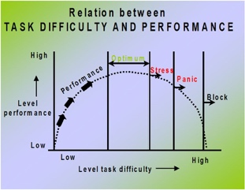
Goal setting theory
- Primary driver of effort
- STRETCH: Goals must be specific, and difficult but not impossible instead of being easy or “do your best” goals
- Can enhance intrinsic motivation, but usually combined with extrinsic motivation
- Goals should come with a warning sign
- These goals aim to achieve higher levels of performance

Goals Gone Wild – reading
- Goals can be too narrow
  - Ignore “non-goals”
  - Inappropriate time horizons
  - Even when we try to incorporate multiple tasks – tendency to choose easier goals
- When goals are too challenging (and rewards/stakes high)
  - Risk taking
  - Unethical behaviour

Equity theory
- Motivation doesn’t just depend on your own beliefs and circumstances but also on what happens to other people
  - Employees make mental ledger of outcomes/inputs to others’ outcomes/inputs
- Equity distress = tension as a result of inequity (anger, envy)
  - Happens when you compare your outcome to others and your ratio is lower
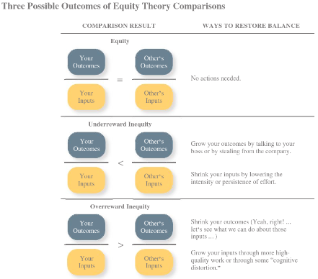
- Cognitive distortion: re-evaluation of the inputs an employee brings to a job, often occurring in response to equity distress

Psychological Empowerment
- An energy rooted in the belief that tasks are contributing to some larger purpose
- A form of intrinsic motivation

Chapter 8 – Trust, justice and ethics

Moral disengagement
- Internal strategies we apply to convince ourselves that our unethical behaviours are not in fact unethical
- Does not drive all unethical behaviour (ex: lack of moral awareness_) particularly relevant in corruption
- Moral justification: justify unethical behaviour using moral pretences (ex: torture)
- Euphemistic labelling: give unethical behaviour a non-threatening label
- Advantageous comparison: rely on the contrast principle to rationalize the “least bad” unethical behaviour
  - Contrast principle: I smoked one cigarette but brad smoked 5
- Misrepresenting harmful consequences: rationalizing harm
- Displacement of responsibility: rationalize unethical behaviour as someone else’s responsibility
- Dehumanizing “the enemy”: reframe whomever we are hurting as not deserving ethical treatment

Chapter 9 – Learning and decision making

Decision fatigue
- Making decisions is taxing (think “red” dots)
- Optimal amount for choosing is 6

Bounded rationality
- Should identify the problem thoroughly
  - Do: boil down to something manageable
- Should exhaustive lists
  - Do: few solutions
- Should evaluate alternatives together
  - Do: evaluate individually
- Should use accurate information
  - Do: distorted information/biased
- 2 impacts:
  - Se filter information to make it more accessible (cognitive strategies)
  - Satisficing

Framing
- Different decisions based on how question is phrased
  - Ex: loss vs. gain
- Thiokol example: risk of losing important sponsorship result in “loss frame”

Availability bias
- Information that is easier to remember weighs more heavily on our decision
  - Ex: are you more afraid of flying or riding in a car?
- Subtype: recency effect: looks at more recent events
- Thiokol example: most recent tests were “ok”

Anchoring bias
- Piece of information/decision in mind becomes anchor
  - Ex: first offer in negotiation
- Thiokol example: already planned to launch (should we still go?)

Representativeness bias
- Tendency to assess likelihood of event by comparing it to similar events and assuming it will be similar
- Thiokol example: more successes than failures

Conformation bias
- Tendency to look for information that already confirms our perceptions
- Thiokol example: scientists looked at flawed data, and didn’t challenge the data/didn’t see the problem

Commitment escalation
- Continuing down failing course of action
- Sunk Cost Fallacy
- Thiokol example: already sunk a lot of money; planning to launch, public support, NASA support

Fundamental attribution error
- Other’s faults something internal
  - Think the person is lazy, unreliable, low work ethic
- Our faults something external
  - Traffic jam, emergency, alarm malfunctioned
- Moderators
  - Consensus
    - Other people also showing similar attributes
  - Distinctiveness
    - Whether or not someone acts similarly but in different context
  - Consistency
    - Does this person act the same way in other scenarios

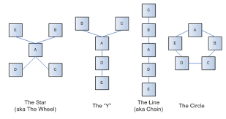
What to do afterwards?
- Implement a formalized decision making system (protocol)
- Differentiate the people making the problem from the people testing the problem
- Teams meet and discuss findings/ideas
- One astronaut has final say

Chapter 10 – the communication process

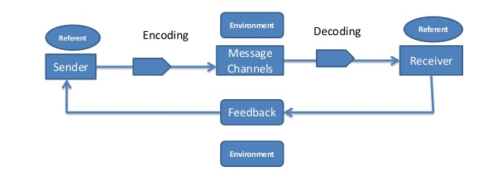
Moderators of this model
- Communication competence
- Noise
- Information richness
  - Amount and depth of information
  - Email tone misinterpreted 50% of time
- Gender differences
- Privacy

Communication networks
- Who speaks to whom (who shares the info to whom)
- Formal = determined by organization roles
- Informal = determined by friendship networks

Chapter 12

What is Power?
- The ability to influence the behaviour of other and resist unwanted influence in return

Sources of power
- Legitimate power
  - Based on authority or position
- Reward power
  - Based on the control of resources or benefits
- Coercive power
  - Based on the ability to hand out punishment
- Expert power
  - Power based on expertise or knowledge
- Referent power
  - Attractiveness or charisma of the leader (ex: Drake, Selena Gomez)

Contingences of power
- Substitutability
  - The degree to which people have alternative in accessing the resources that a leader controls
- Discretion
  - The degree to which managers have the right to make decisions on their own
- Centrality
  - How important a person’s job is and how many people depend on that person to accomplish their tasks
- Visibility
  - How others are a leader and the resources that leader can provide

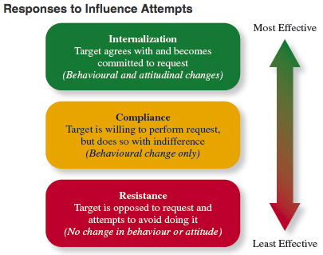

Influence strategies
- Influence: “The use of behaviours to cause behavioural or attitudinal change in others”
- No bases of power
- Can’t use bases of power effectively
- Don’t want to use bases of power

Influence tactics
- Rational persuasion
  - The use of logical arguments and hard facts to show someone that a request is worthwhile
- Consultation
  - An influence tactic whereby the target is allowed to participate in deciding how to carry out or implement a request
- Inspirational appeal (values)
  - Appeal to one’s values and ideals, thereby creating an emotional or attitudinal reaction
- Collaboration (offer help)
  - Target is allowed to participate in deciding how to carry out or implement a request
- Ingratiation (flattery)
  - The use of favours, compliments, or friendly behaviour to make the target feel better about the influencer
- Personal appeals (based on friendship)
  - Requestor asks for something based on personal friendship or loyalty
- Exchange tactic (reciprocity)
  - Requestor offers a reward in return for performing a request
- Apprising (why will it benefit them)
  - The requestor clearly explains why performing the request will benefit the target personally
- Pressure (threats and demands)
  - Requestor attempts to use coercive power through threats and demands
- Coalitions
  - Influencer enlists other people to help influence the target

Bargaining tactics
- Distributive bargaining (win/lose)
  - A situation in which whatever gains one person makes, the other person must “lose”
    - Ex: negotiating the price of a car
- Integrative bargaining (win/win)
  - A situation in which both parties can achieve their interests
    - Ex: negotiating a job position
- To determine which one, depends on situation and personal style
- How do we take a negotiation to an integrative negotiation?
  - “Sell me this pen” = need to understand what the other party’s interests
  - Move from a compromise to collaboration



