- Definition of Ecology
  - The scientific interactions between organisms and their environment
    - E.g. sidewalk and corn field

- Organisms are important part of one another’s environment
  - The scientific study of interactions that determine the distribution (geographic location) and abundance of organisms.
    - Why organisms happen to be one area when they are not in another?
    - Why some organism are more successful in some area in terms of population ?

  - Other meanings in public usage
    - Differs from environmental activism and environmental science (solution to environmental problems)
    - Environmental science is an interdisciplinary field that incorporates concepts from the natural sciences (including ecology) and the social sciences
      - Focused on how people affect the environment and how we can address the environmental problems

General Misconceptions
  - Balance of nature – natural systems are stable and tend to return to original preferred state after disturbance
    - Not always the case
    - Communities and ecosystems are dynamic (always changing)
    - We would end up with different end point after disturbance
    - Some predictable patterns but we cannot always predict the exact outcome ; random factor
  - Each species has a distinct role to play in maintaining that balance
    - Not necessarily
    - Many species are similar
    - A lot of redundancy in ecosystem and community; even if we loose one species, nothing would happen to the whole system
    - Some species are a lot more important than others in terms of how the system functions
    - The different species in an area often respond in different ways to changing conditions.

- 7 Ecological Maxims (guiding principles)
  - Organism interact and are interconnected (interaction)
    - Connections could be relatively weak because the communities are complex
    - Organism interact with on another and with their physical environment. As a result, events in nature are connected, and what affects one organism or place can effect others as well.
  - Everything goes somewhere
    - any production, energy, and release of nutrients all end up in somewhere
    - there is no “away” into which waste materials disappear.
  - No population can increase in size forever
    - What is the limit imposed on the population ?
    - There are limits to the growth and resources use of every population, including humans.
  - Finite energy and resources result in tradeoffs
    - Any decision that organisms might make has another consequence.
    - E.g. Super organisms that outcompete others must have some way that is overcompensated and weak in another area.
    - An organism’s energy and resources are finite, and increasing inputs into one function (such as reproduction) results in a trade-off in which there is a loss for other functions (such as growth)
  - Organisms evolve
    - Adaptation and Natural selection
      - Adaptation: a characteristic that improves survival or reproduction
        - The process that makes organisms better suited to their habitat
      - Natural selection: individuals with certain adaptations tend to survive and reproduce at a higher rate than other individuals.
      - If the adaptation is heritable, the frequency of the characteristic may increase in a population over time.
    - E.g. antibiotic resistance
      - Bacteria that is resistance to one will not be resistance to the one anymore
      - Natural selection can cause the frequency of antibiotic resistance in bacteria to increase over time
    - Organisms evolve or change over time – it is a mistake to view them as static. Evolution is an ongoing process because organisms continually face new challenges from changes in both the living and nonliving components of their environment.
  - Communities and ecosystems change over time
    - They change over time; not static
    - We are often biased by our own time scale on which we operate.
    - Ecosystems change over time. When we look at the world as we know it, it is easy to forget how past events may have affected our present, and how our present actions may affect the future.
  - Spatial scale matters
    - How we organize the ecological system
    - E.g. physiology ecologist often study at the level of organism and advance to population, community, ecosystem and finally biosphere
      - How we define each of these level
      - How this hierarchy system constructed
      - Usually people are specialized in one specific area
    - Organism < population < community < ecosystem < biosphere
      - Population: group of individuals of same species that are living and interacting in a particular area.
      - Community: association of population of different species in the same area.
    - Spatial definition could be complicated because of migrations, so their boundaries are hard to define.
      - Metapopulation : consists of a group of spatially separated populations of the same species which interact at some level.
        - Address the connection between different populations
    - Abiotic and biotic environmental conditions can change dramatically from one place to another, some across very short distances. This variation matters because organisms are simultaneously influenced by processes acting at multiple spatial scales, from local to regional to global.

- Ecosystem
  - Ecological studies often include both the biotic (living components), and abiotic (physical components) of natural systems.
  - Ecosystem : community of organisms + the physical environment
  - Landscapes : areas with substantial differences, typically including multiple ecosystems.
  - All the world’s ecosystems comprise the biosphere
    - All living organism on Earth + the environments in which they live
  - Ecosystem processes
    - Producers capture energy from an external source (e.g. the sun) and use it to produce food
    - Consumers get energy by eating other organisms or their remains.
      - Herbivores, carnivores, decomposers
    - Net primary productivity (NPP) : energy captured by producers minus the amount lost as heat in cellular respiration
      - Changes in NPP can have large effects on ecosystem function, and NPP varies greatly from one ecosystem to another

- How ecosystem work
- 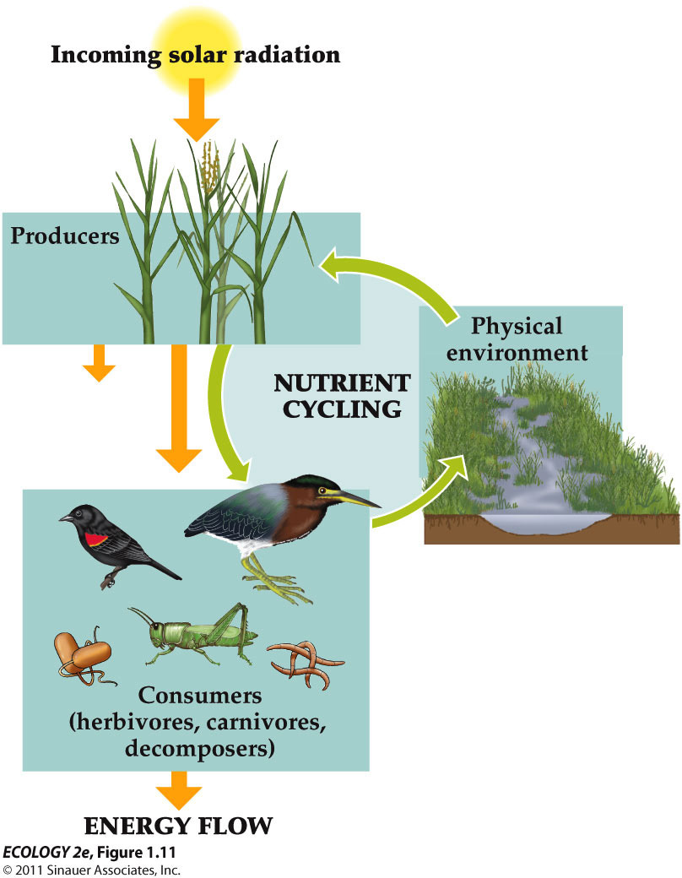
  - Each unit of energy captured by producers is eventually lost from the ecosystem as heat. As a result, energy moves through ecosystem in a single direction only – it cannot be recycled!
  - But nutrients (N or P) are continuously recycled from the physical environment to organisms and back again – this is the nutrient cycle

- Ecological Experiments
- 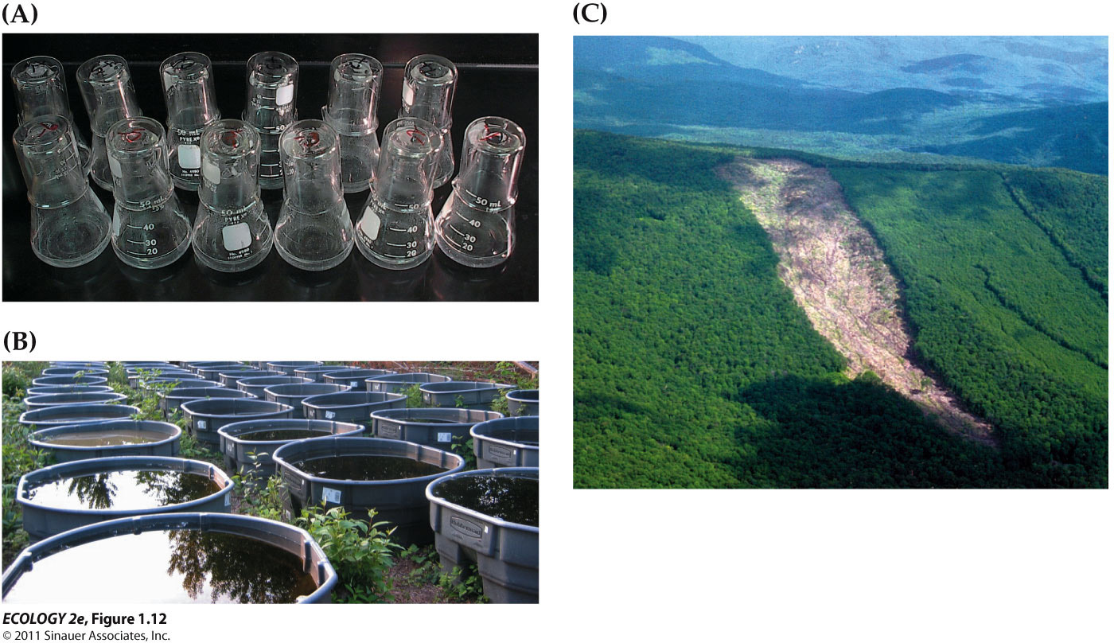
  - A – laboratory experiment (controlled)
  - B - Small-scale field experiments conducted in natural or artificial environment (Semi-controlled)
  - C – large-scale experiments that alter major components of an ecosystem (cannot be controlled)

  - Design and Analysis
    - Assignments of treatments and control
    - Replication (perform more than once)
      - Natural variation among groups
      - If more replications, less likely that the results are due to a variation that wasn't measured or controlled in the study
    - Random assignment of treatments
      - To avoid any bias
      - To limit the effects of unmeasured variable
    - Statistical Analyses (statistical vs. biological significance)

    - E.g. A plot sprayed with insecticide (right) is shown surround by several control plots
      - Goldenrods (yellow, on right) are taller and more abundant in this insecticide-treated plot than in control plots.

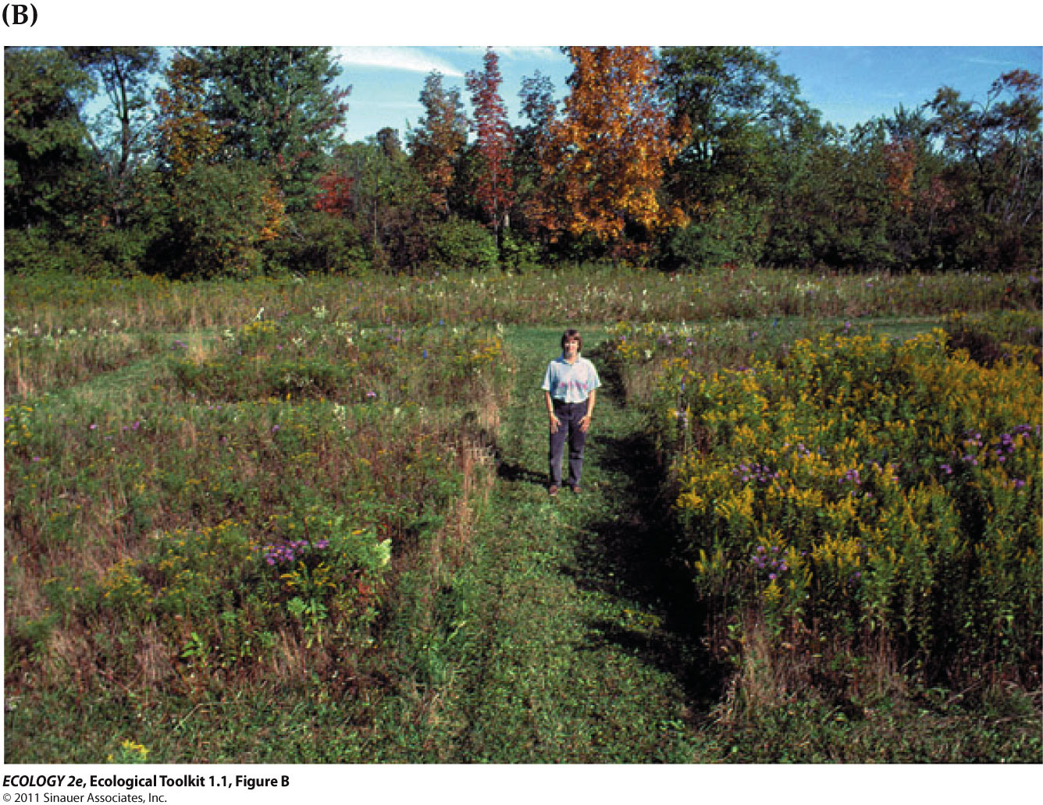
      - 30 of the plots in this field were selected at random (15 insecticide-treated and 15 controls)

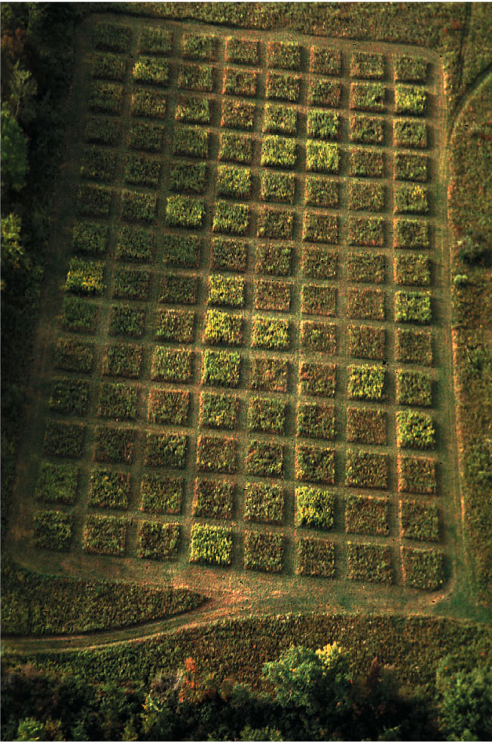

- Scientific Method
- - Scientists use a series of steps called the scientific method
  - Make observations and ask questions
  - Use previous knowledge or intuition to develop hypotheses.
  - Evaluate hypotheses by experimentation, observational studies, or quantitative models.
  - Use the results to modify the hypotheses, pose new questions, or draw conclusions about the natural world

- This process is iterative (repeating) and self-correcting.
  - Constantly develop new questions.

- CASE STUDY : deformity and decline in amphibian populations
- - High incidence of deformities in amphibians
- - Declining populations of amphibians worldwide
- 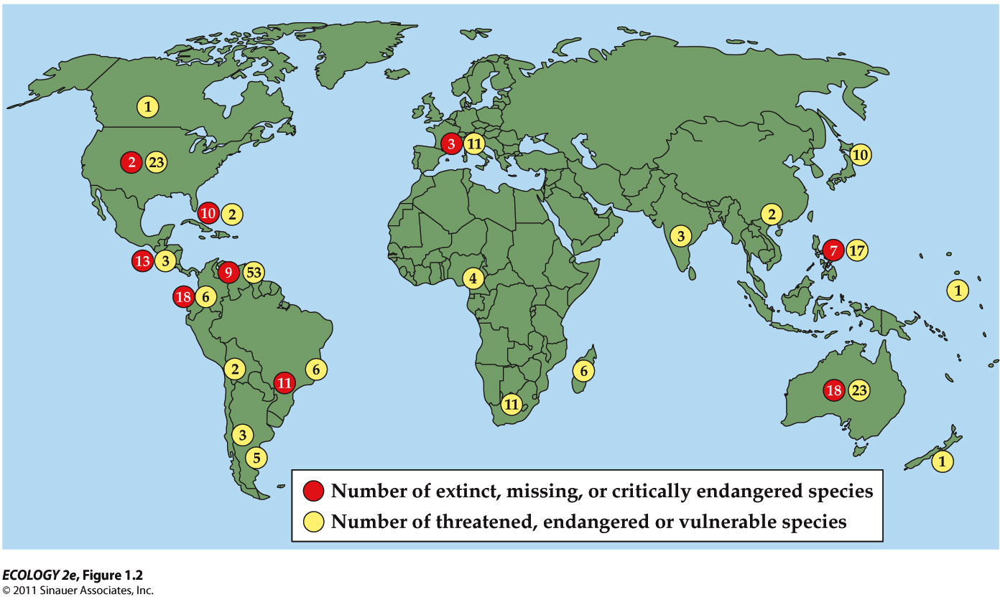
  - In many regions of the world, amphibian species face increased risk of extinction.
  - Amphibians are “biological indicators” of environmental problems because of 3 reasons!
    - Skin is permeable ; pollutant molecules can pass through easily
    - Eggs have no protective shell
    - Highly exposed to the environment
    - They spend part of life on land and part in water
    - exposed to pollutants and UV in both environments

  - Observation of Pacific tree frogs suggested that a parasite can cause deformities.
  - Small glass beads implanted in tadpoles to mimic the effect of cysts of Ribeiroia ondatrae,(type of parasite) a trematode flatworm, also produced deformities
  - Further studies:
    - Deformities of Pacific tree frogs occurred only in ponds which also had an aquatic snail, Planorbella tenuis, the intermediate host of the parasite.

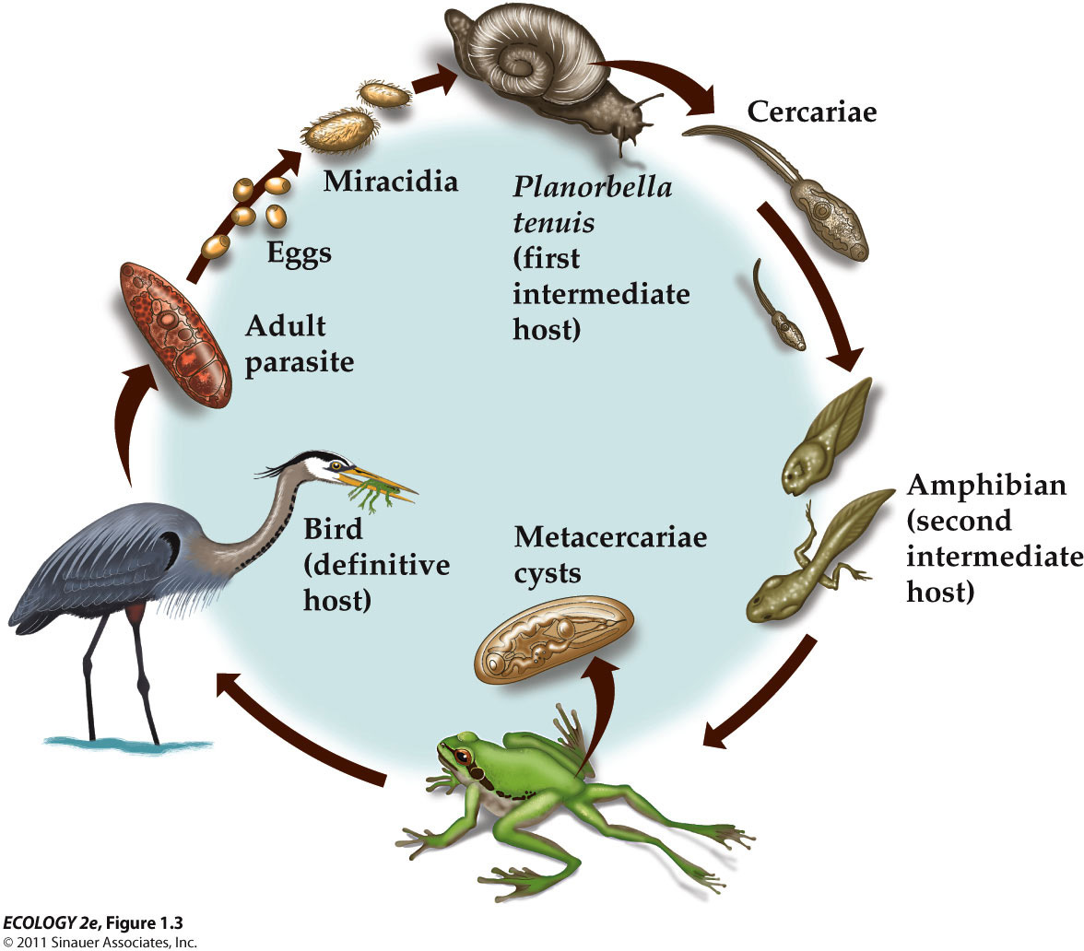
  - The life cycle of Ribeioroia utilizes three different kinds of hosts: snails, larval amphibians or fish, and birds or mammals. Many other parasites have similar complex life cycles. Some parasites, like Ribeiroia, can alter the appearance or behavior of their second intermediate host, making that host more vulnerable to predation by their final or definitive host.
    - In the snail, the parasite undergoes asexual reproduction to produce free-swimming cercariae.
    - The cercariae infect tadpoles and form cysts around their developing limb buds.
    - The cysts interfere with normal limb development, causing limb deformities.
    - The limb deformities make the amphibian more vulnerable to capture by predatory birds.
    - The parasite matures to adulthood in the bird’s body and reproduces sexually.
    - Eggs in the bird’s faces are released into water, where they hatch into free-swimming miracidia that infect the snail.
    - Cycle repeated

- - A controlled experiment (effect of parasites on deformity of frogs)
  - Tree frog eggs were exposedto Ribeiroia parasites in the lab.
  - Four treatments
    - 0 (control), 16, 32, or 48 Ribeiroia parasites.
  - Results
    - The percentage of deformed frogs increased as the number of parasites the tadpoles were exposed to increased
    - Tadpole survival rate decreased to a lower of 40% as the number of parasites increased.

  - Synthetic pesticide use began in 1930s; use has increased dramatically.
  - Amphibian exposure to pesticides has also increased.
  - Any action (increased use of pesticides) can have unanticipated side effect (more frequent deformities in amphibians).

- - A field experiment (pesticide & parasite; which has greater effect?)
  - Six ponds, three with pesticide contamination
  - six cages in each pond, three with mesh size that allowed parasite to enter

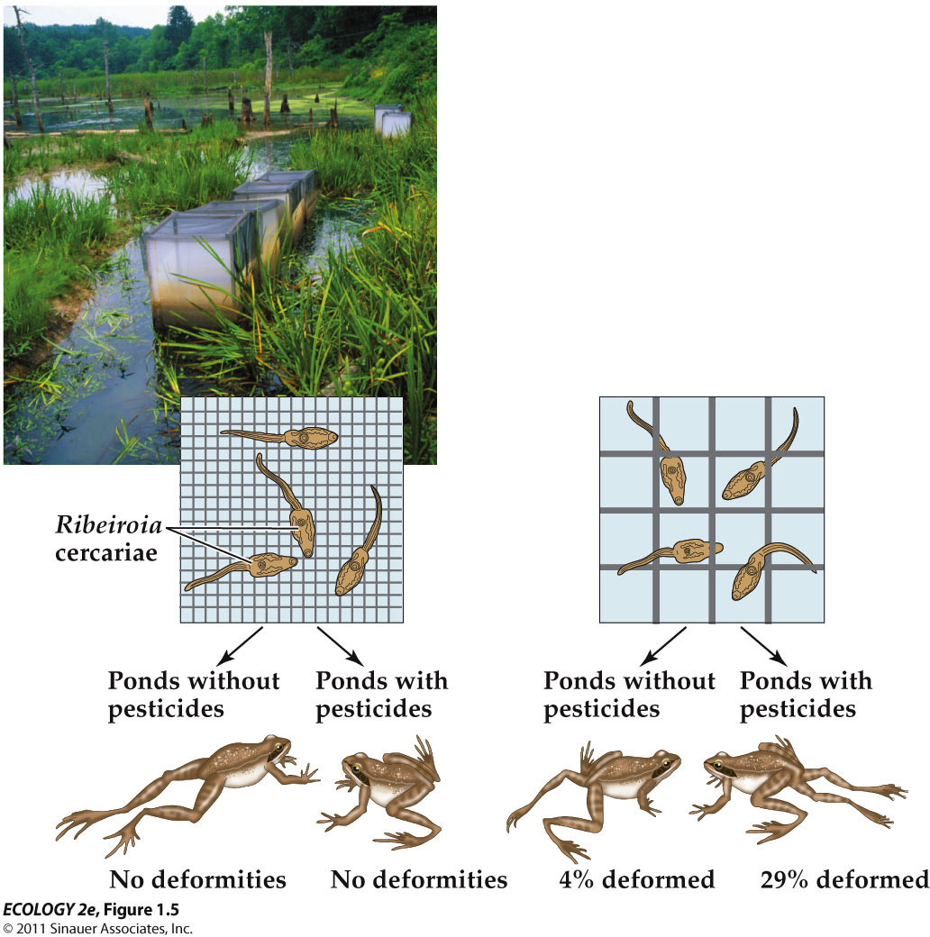
    - interaction between two factors :pesticide and parasite
      - having two together will bring a greater effect
    - hypothesis : pesticides decrease the ability of frogs to resist infection by parasites.

- - Another lab experiment – (immune suppression and cyst formation)
- Tadpoles reared in presence of pesticides had fewer white blood cells (indicating a suppressed immune system) and a higher rate of Ribeiroia cyst formation
  - Whether pesticide level is high or low, it affects both on suppression of immune system and Ribeiroia cyst formation

  - Fertilizer use may also be a factor
    - Fertilizer in runoff to ponds increases algal growth
    - Snails that harbor Ribeiroia parasites eat algae.
    - Greater number of snails result in greater numbers of Ribeiroia parasites.
  - All the organism involved , responding to different environmental effects

  - Some studies have suggested that a range of factors may be responsible amphibian declines.
    - The relative importance of factors such as habitat loss, parasites, pollution, UV exposure , and others are still being investigated.
    - Skerrat et al. (2007) argued that some declines may be due to pathogens such as a chytrid fungus that causes a lethal skin disease, and has spread rapidly in recent years.
      - But climate change and altered conditions may be favoring growth and transmission of disease organisms.
    - Hatch and Blaustein (2003) studied the effects of UV light and nitrate on Pacific tree frog tadpoles.
      - At high elevation sites, neither factor alone had any affect. But together, the two factors reduced tadpole survival.
      - At low elevation sites, this effect was not seen.

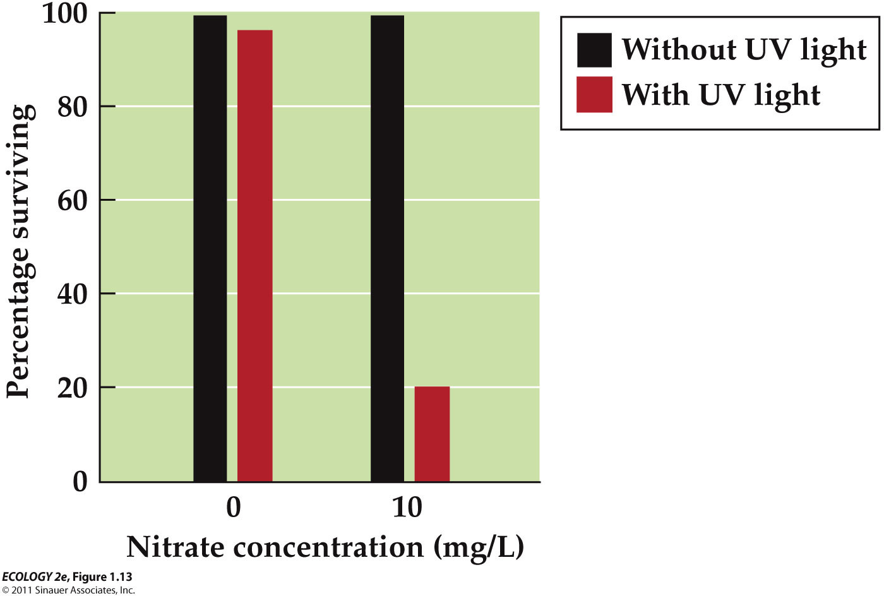
      - Results
        - UV doesn't affect on its own.
        - When it is with nitrate, it reduces the survival rate.
    - Stuart et al. (2004) analyzed studies on 435 species:
      - Habitat loss was the primary cause for 183 species; overexploitation (overharvesting) for 50 species.
      - The cause for the remaining 207 species was poorly understood.

Definition of the physical environment
  - The ultimate determinant of where organisms can live, the resources that are available to them, and the rate at which their populations can grow

The physical environment is important in two ways
  - Looking globally, we are going to find certain regions that have characteristic species adapted to these environments over many million years
    - Historically, what has been responses to species, being restricted certain regions globally
  - Regional global patterns

CASE STUDY : Climatic Variation and Salmon Abundance
  - Potential causes of salmon declines in the North Pacific Ocean
    - Dam construction
      - Interfere salmons’ migration
    - Sediment from logging operations
    - Water pollution
    - Overharvesting
  - But the conditions of oceans (change in marine environment), where salmon spend most time as adults have also been implicated.
    - Hare and Francis (1994) studied fish harvest records and showed alternating periods of high and low production associated with climatic variation in the North Pacific

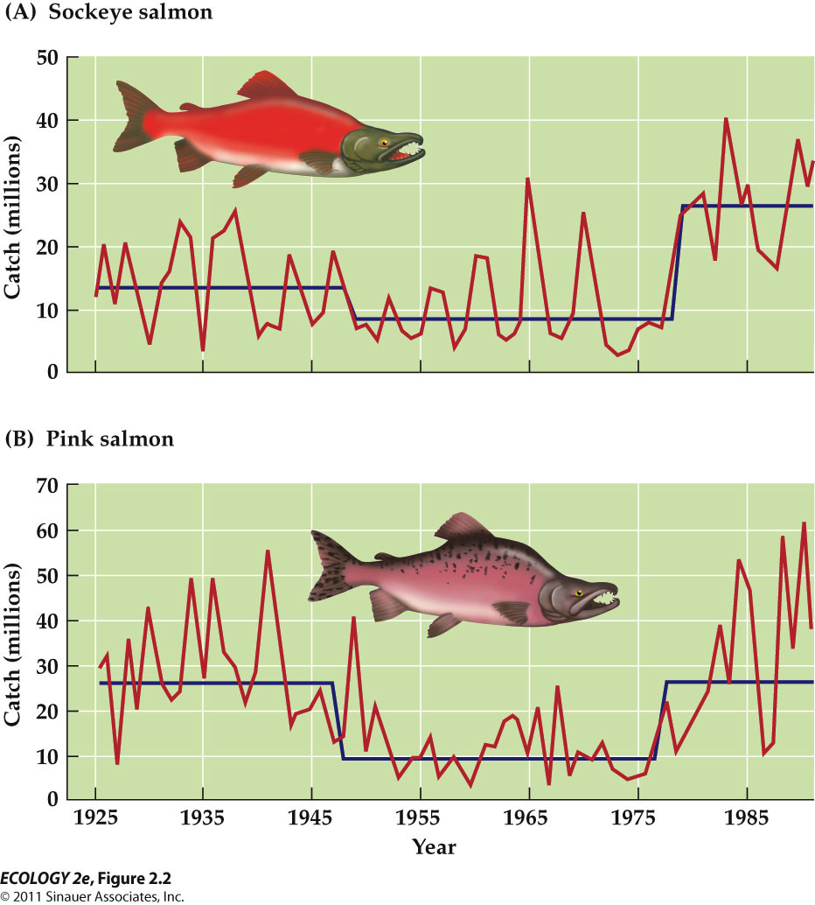
    - Abrupt drops and increases in production of salmons
      - Blue line represents the long-term trends
      - Both salmons going down in the 1940s and going up again in the 1970s
    - Mantua et al. (1997): Periods of high salmon production in Alaska corresponded with periods of low production in Oregon and Washington.
      - High salmon production in North, then low in South. Vice versa
      - They also found a correlation between salmon production shifts and sea surface temperatures.

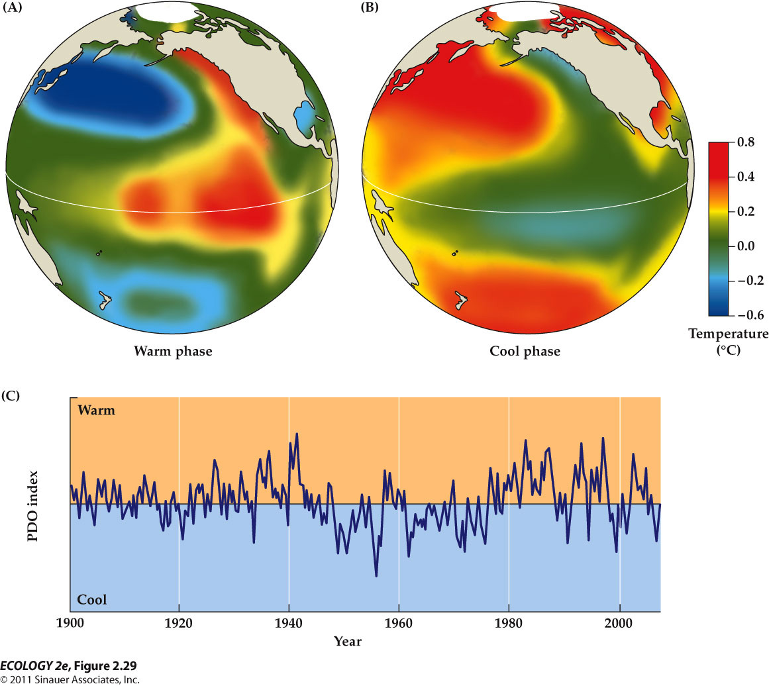
    - Difference in ocean surface temperatures from the average during the warm phase (left) and cool phase (right)
      - Salmon production was high in the North and low in the South during warm phase.
      - Salmon production was high in the South and low in the North during cool phase.

- The Physical Environment
  - ultimately determines where organism can live, and the resources that are available.
    - What limits where species live is the physical environment !
  - Thus, the understanding the physical environment is key to understanding all ecological phenomena.

CLIMATE

Weather vs. Climate
  - Weather : current conditions – temperature precipitation, humidity, cloud coverage
    - Any given year conditions we see that are unusual are more associated with weather !
  - Climate : long-term description of weather, based on averages and variation measured over decades.

- - Climate controls where and how organism live
  - Climate determines the geographic distribution of organisms
  - Climate is characterized by average conditions;
  - BUT extreme conditions are also important to organisms because they can contribute to mortality.
    - What limits the distribution of organisms

Climatic Variation
  - Includes daily and seasonal cycles, as well as yearly and decadal cycles
  - Long-term climate change result from changes in the intensity and distribution of solar radiation.
  - Current climate change is due to increased CO₂ and other gases in the atmosphere because of human activities.

- - Global energy balance drives the climatic system
  - The sun is the ultimate source of energy that drives the global climate system.
  - Energy gains from solar radiation must be offset by energy losses if Earth’s temperature is to remain the same.

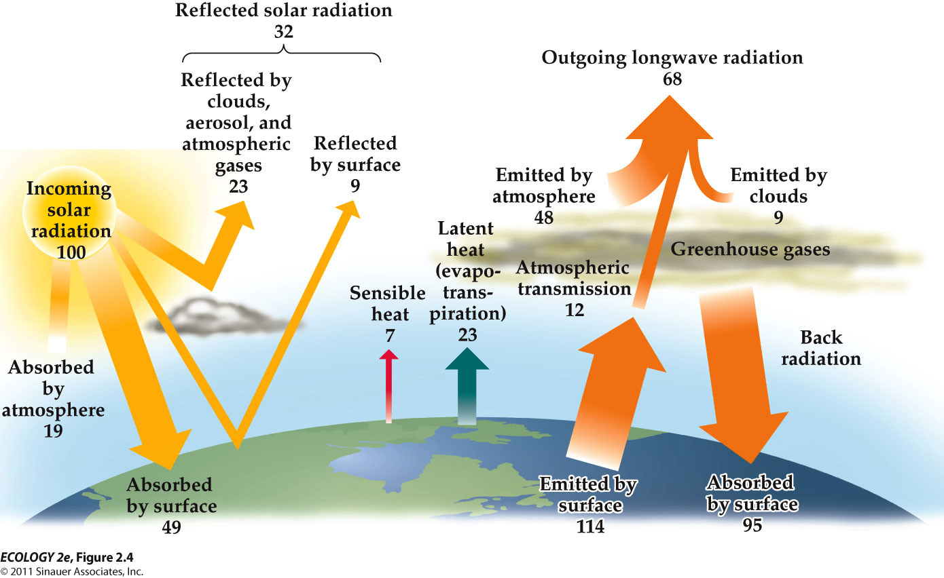
  - **In general, know what the energy is doing and the size of arrows
    - Don't worry about the numbers
  - Incoming solar radiation
    - Only half of the radiation is absorbed by the surface of the earth
    - Rest are either absorbed by the atmosphere or reflected by clouds, surfaces, etc.
    - In general, 1/3 being reflected, ½ being absorbed, rest remained in atmosphere
  - Without the energy lost, earth will get warmer and warmer.
  - What goes back out into space (regulating earth temperature)
    - Latent heat (evapotranspiration) – produces cooling effect (loosing heat)
    - Sensible heat – convection (by the movement of air or water) and conduction (by direct contact)
    - A lot of radiation emitted by surface is reabsorbed by surface again because of greenhouse gas effect
  - The atmosphere contains greenhouse gases that absorb and reradiate the infrared radiation emitted by Earth.
    - These gases include:
      - Water vapor (H₂O).
      - Carbon dioxide (CO₂).
      - Methane (CH₄) & Nitrous oxide (N₂O)
        - not concentrated but strong forcing effect
    - Although this greenhouse gases seem to be harmful to us(results of overproduction), we rely on these gases because they keep us somewhat warm.
      - Without greenhouse gases, Earth’s climate would be about 33°C cooler.

- ATMOSPHERIC AND OCEANIC CIRCULATION

- Latitudinal differences in solar radiation at Earth’s surface
  - distance to the Sun doesn't matter to the temperature on the earth
  - The angles of the sun’s ray affects the intensity of the solar radiation that strikes Earth’s surface
    - Angles
      - At equator, radiation spread relative small area
      - At both poles, radiation spread much larger areas
        - more heating (energy) in the equator – warmer
    - Atmosphere
      - At equator, ray pass through the atmosphere at sharpest angle
        - Less energy absorbed by atmosphere
      - At poles, ray pass through the atmosphere at more weak angle, cutting thru longer path of the atmosphere
        - More energy absorbed by atmosphere
    - Therefore, the equator is warmer than the poles
    - This affect not only temperature but also rainfalls and wind circulation all around globe

- Surface heating and uplift of air
  - Solar radiation heats Earth’s surface, which emits infrared radiation to the atmosphere, warming the air above it.
    - Warm air is less dense than cool air, and it rises—this is called uplift. (hot air balloon – less dense so rises)
    - Air pressure decreases with altitude, so the rising air expands and cools.
      - We will observe clouds forming and rain
- 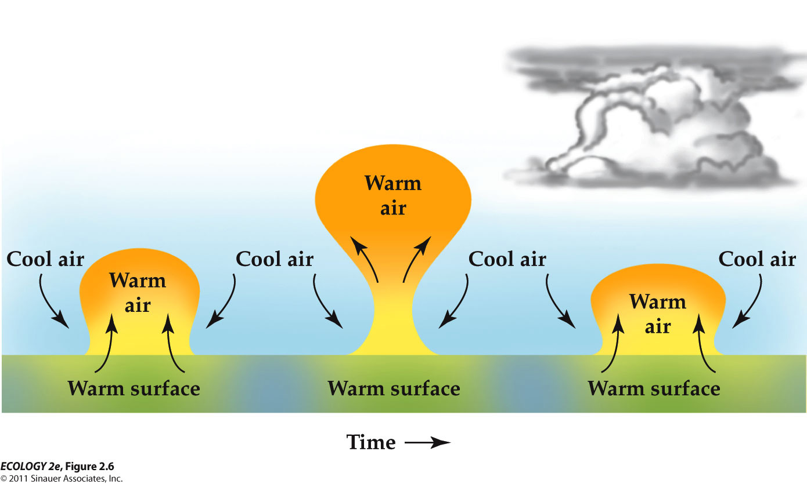
  - Warm air is less dense than cool air, so the air above the warm surface rises.
  - As the warm air rises, it expands and cools
  - Eventually, the air cools enough to form clouds
  - This is why a lot of rain occurring at the equator
    - Hot air on the surface is translated into clouds and rain
  - Tropical regions (equator) receive the most solar radiation and the most precipitation.
  - Uplift of air in the tropics results in a low atmospheric pressure zone and air rises until they reach the stratosphere.
  - When air masses reach the troposphere-stratosphere boundary, air flows towards the poles

- 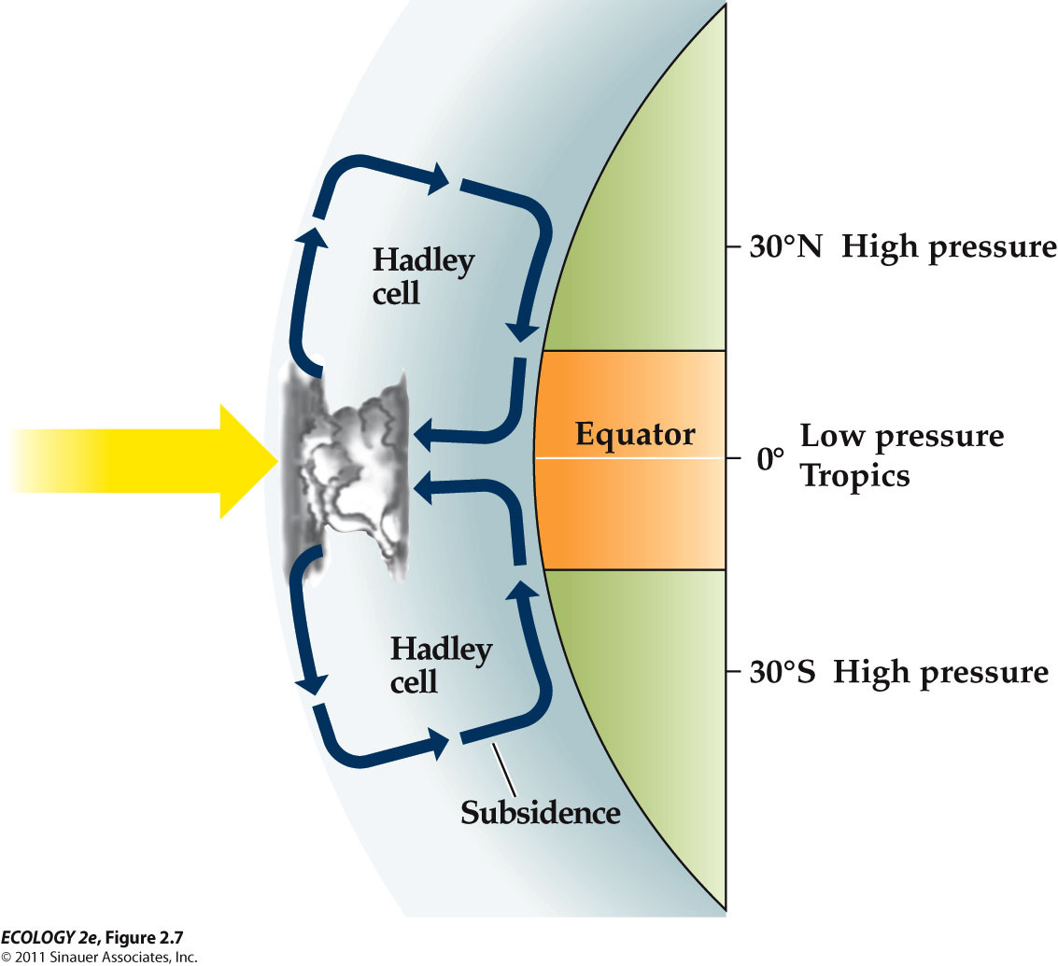
  - The sun heats Earth’s surface most intensely at the equator.
  - This heating leads to the uplift of air, creating a large band of low atmospheric pressure.
  - Subsidence of air creates a band of high atmospheric pressure.
    - Subsidence occurs when dense air starts to fall
    - Subsidence inhibit the formation of clouds.
  - Hadley Cells – weather cells, formed by the uplift of warm air at the equator.
  - When air is rising, it decreases the air pressure – rainy weather
  - When air is falling, it increases the pressure – sunny weather
- 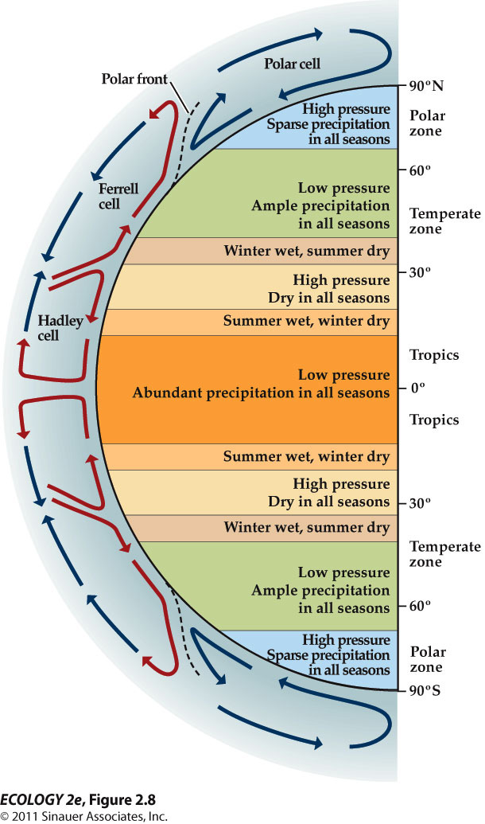
  - The differential heating of Earth’s surface by solar radiation gives rise to atmospheric circulation cells, which determine Earth’s major climatic zone.
    - Desert regions (north and south of equator) associated with high pressure region
    - Tropics tend to be wet and low pressure region
  - The polar cell is formed subsidence of cold air at the poles.
  - The Ferrell cell is driven by the movement of the Hadley and polar cells.
    - Always pushed on the opposite direction.

- - Atmospheric circulation cells create surface wind pattern.
- 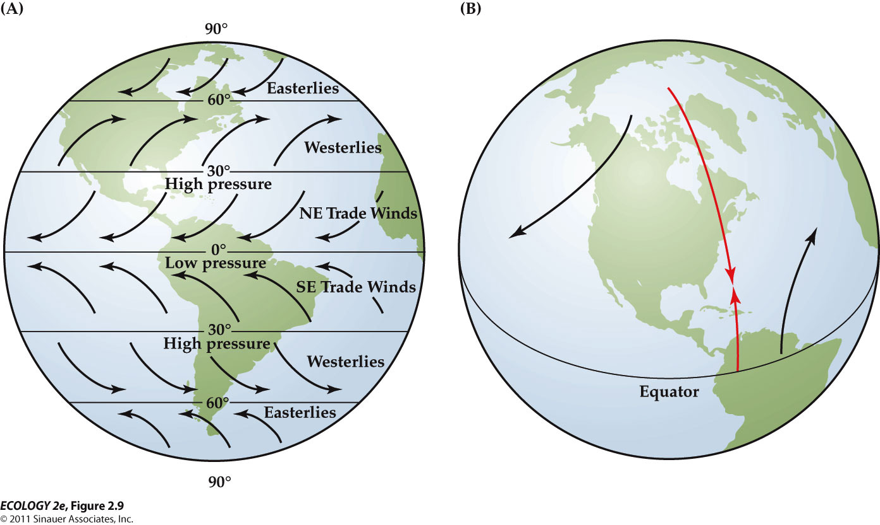
  - Areas of high and low pressure created by the circulation cells result in air movements called prevailing winds.
  - The winds appear to be deflected due to the rotation of the Earth – the Coriolis effect
    - Moving air at Earth’s surface appears to be deflected to the right in the Northern Hemisphere and to the left in the Southern Hemisphere.

  - Water has a higher heat capacity than land—it can absorb and store more energy without changing temperature.
    - Summer: Air over oceans is cooler and denser, so air subsides and high pressures develop over the oceans.
      - Land heats up a lot faster than ocean.
    - Winter: Air over continents is cooler and denser; high pressure develops over continents.
      - Land cools off a lot faster than ocean.
  - These are known as semipermanent high and low pressure cells.
    - They change seasonally.
    - Caused by heat capacity between water and land
  - The difference heat capacity between the oceans and the continents lead to seasonal changes in atmospheric pressure cells that influence prevailing wind patterns.
    - In summer, ocean water is cooler than land at the same latitude, so areas of high pressure from above the ocean
    - In winter, the land is cooler than ocean water, so areas of high pressure from above the continent.

  - Major ocean surface currents are driven by surface winds, so patterns are similar.
  - Speed of ocean currents is about 2%–3% of the wind speed.
  - Ocean currents affect climate.
    - E.g. The warm Gulf Stream warms the climate of Great Britain and Scandinavia.
    - At the same latitude, Labrador is much cooler because of the cold Labrador Current.

  - Where warm tropical surface currents reach polar areas, the water cools, ice forms, the water becomes more saline and more dense and sinks (downwelling).
  - Upwelling is where deep ocean water rises to the surface.
  - Upwelling occurs where prevailing winds blow parallel to a coastline. Surface water flows away from the coast and deeper, colder ocean water rises up to replace it.
  - Upwellings influence coastal climates.

- Upwelling
- 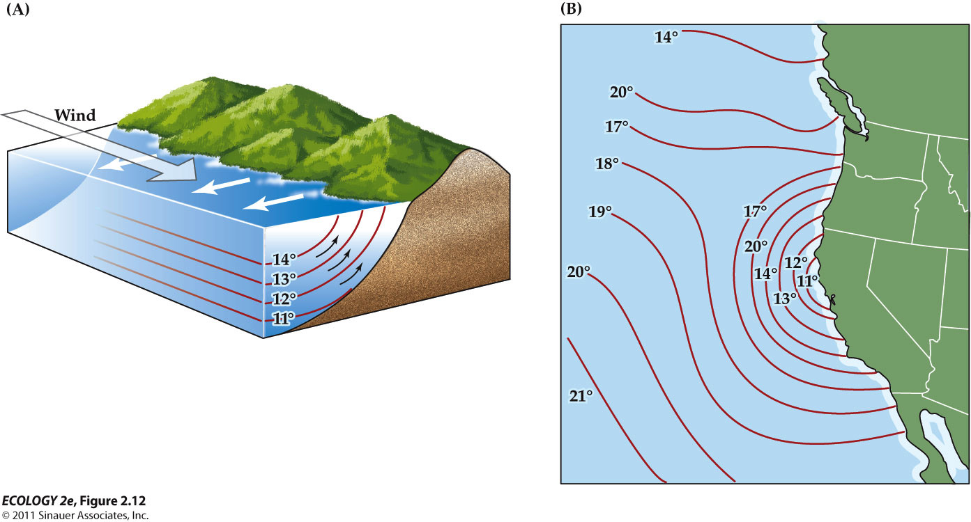
  - Wind blowing parallel to the coast causes surface water to flow away from the coast, pulling deep water upward to replace it.
    - A prevailing wind blows parallel to the coast.
    - The wind, along with the Coriolis effect, creates a surface current flowing away from the coast
    - Deep, cool water rises to replace the surface water.

  - Upwellings bring nutrients from the deep sediments to the photic zone (the layer of surface water where there is enough light to support photosynthesis) – where light penetrates and phytoplankton grow.
  - This provides food for zooplankton and their consumers. These areas are the most productive in the open ocean.

Maritime vs. continental
  - Coastal areas have a maritime climate: Little daily and seasonal variation in temperature, and high humidity.
    - Oceans have more heat capacity
  - Areas in the center of large continents have continental climates: Much greater variation in daily and seasonal temperatures.
  - Monthly Average Temperatures in a Continental and a Maritime Climate

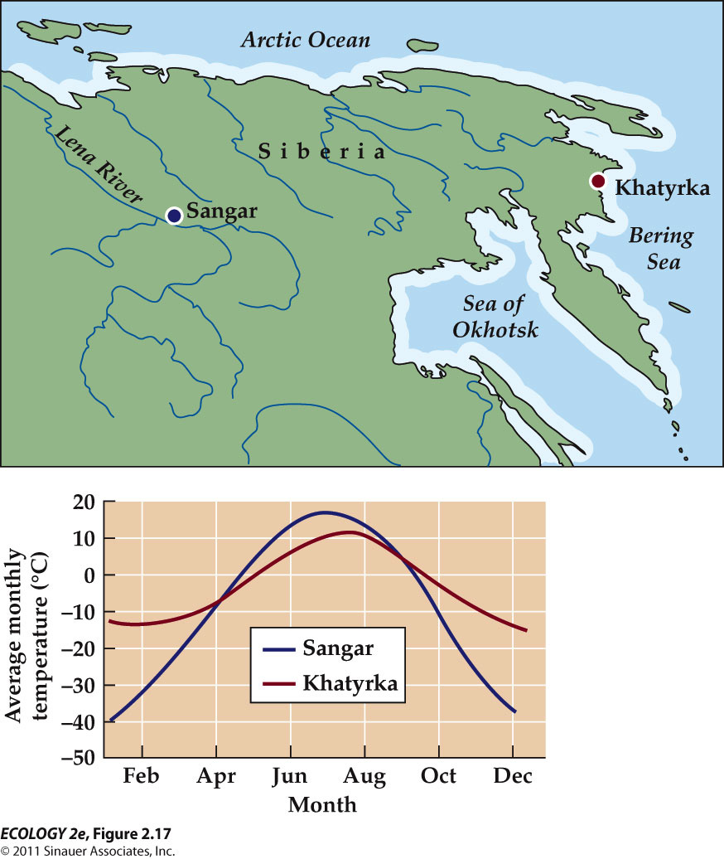
    - The difference in seasonal temperature variation between two locations in Siberia at about the same latitude and elevation illustrates the effect of the high heat capacity of ocean water

Annual seasonal temperature variation

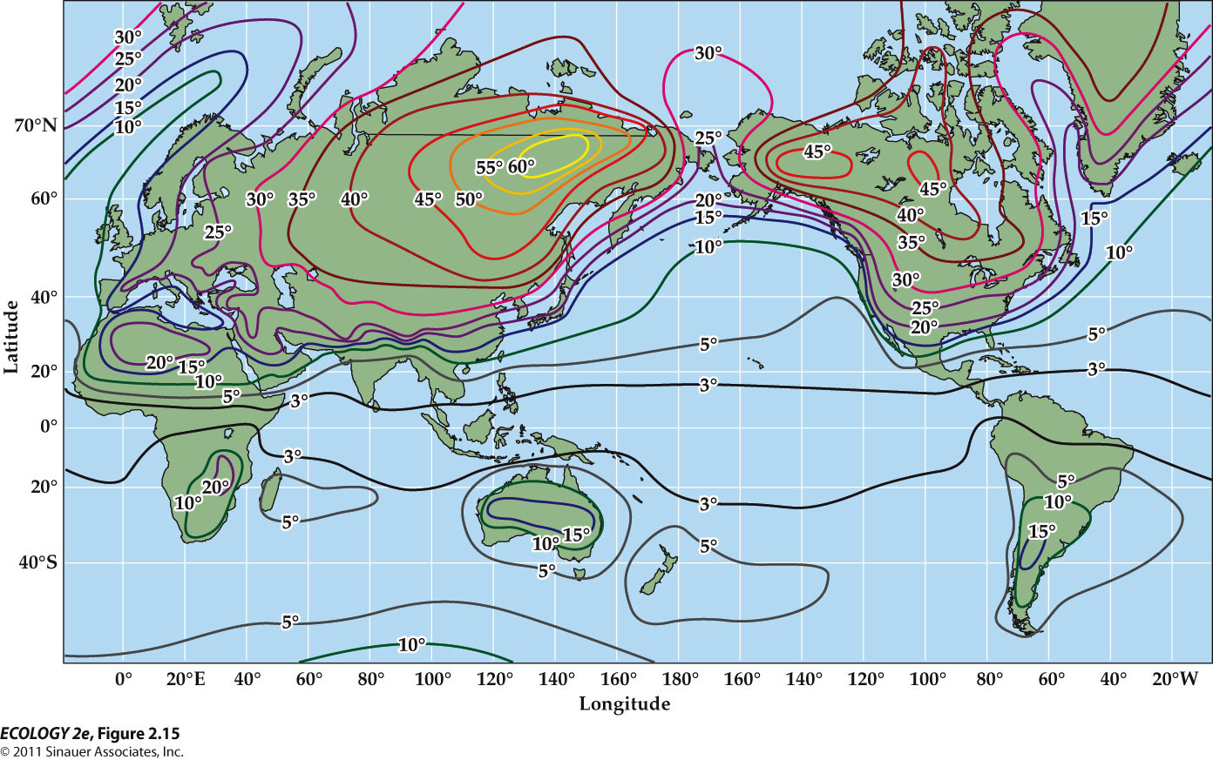
  - Air temperatures over land show greater seasonal variation than those over the oceans.

Precipitation
- 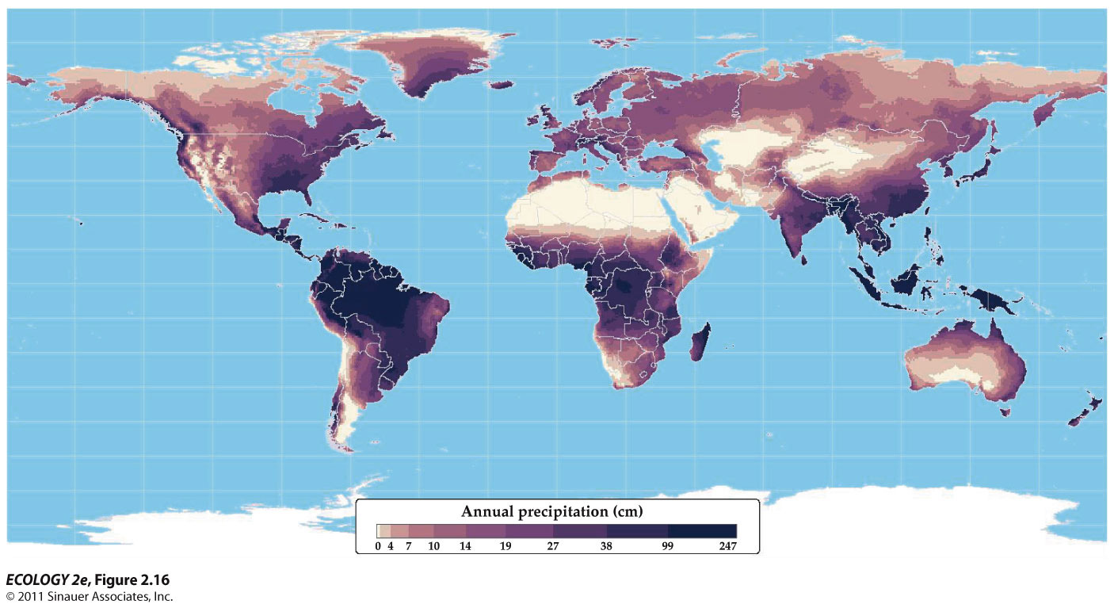
  - Hardely cells at the equator – have high precipitation because of low pressure
  - 30 degrees North and South from the equator – very dry because of high pressure
    - e.g. Sahara desert – very dry 30 degree N from the equator
    - North America
      - High pressure and low pressure – semi-permanent zone results in lots of precipitation

- Mountains influence wind patterns and gradients in temperature and precipitation
  - On mountain slopes, vegetation shifts reflect climate changes as temperature decreases, and precipitation and wind speed increases with elevation.
  - When air masses meet mountain rages, they are forced upwards, cooling and releasing precipitation.
  - North–south trending mountain ranges create a rain shadow: The slope facing prevailing winds (windward) has high precipitation, while the leeward slope gets little precipitation.
  - The Rain-Shadow effect

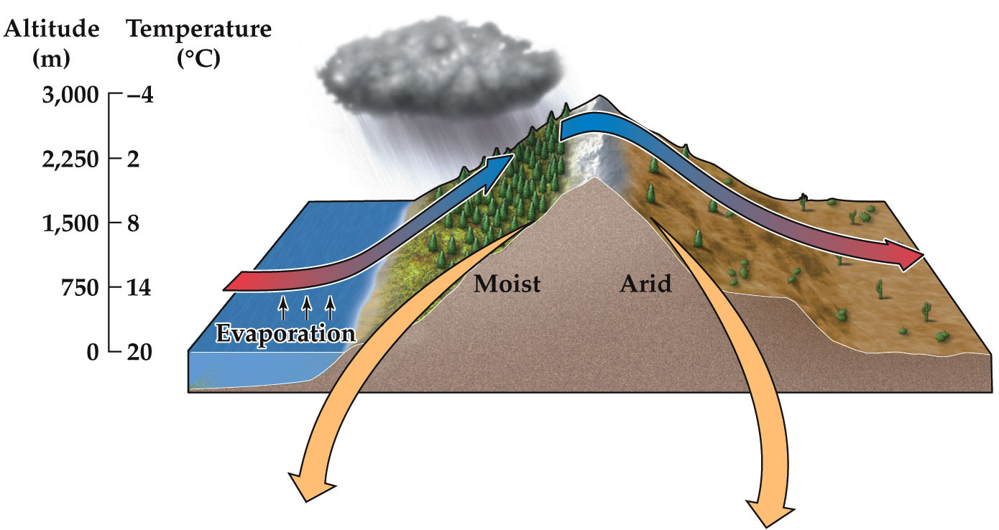
    - Precipitation tends to be greater on the windward slope of a mountain range than on the leeward slope
      - A moving air mass picks up moisture over the ocean
      - On the windward slope (left side), the air rises and cools, releasing most of its moisture as precipitation.
      - On the leeward slope (right), the dry air descends and warms, and there is little precipitation.

- Vegetation affect climate via surface energy exchange
  - Vegetation can also influence climate
  - Albedo – capacity of a land surface to reflect solar radiation – is influenced by vegetation type, soils, and topography.
    - reflection of sun
      - High albedo = snow, a lot of reflection
      - Little albedo = dark , absorbing a lot of radiation
    - e.g. a coniferous forest has darker color and lower albedo than bare soil (lighter color) or a dormant grass land.
  - Loss or change in vegetation can affect climate
    - Deforestation increases albedo of the land surface : less absorption of solar radiation and less heating
    - Lower heat gain is offset by less cooling by evapotranspiration, due to loss of leaf area.
      - Decreased evapotranspiration results in less moisture in the atmosphere and less precipitation
    - Deforestation in the tropics can lead to a warmer, dryer regional climate.
  - The Effects of Deforestation - Influence of Vegetation on Climate

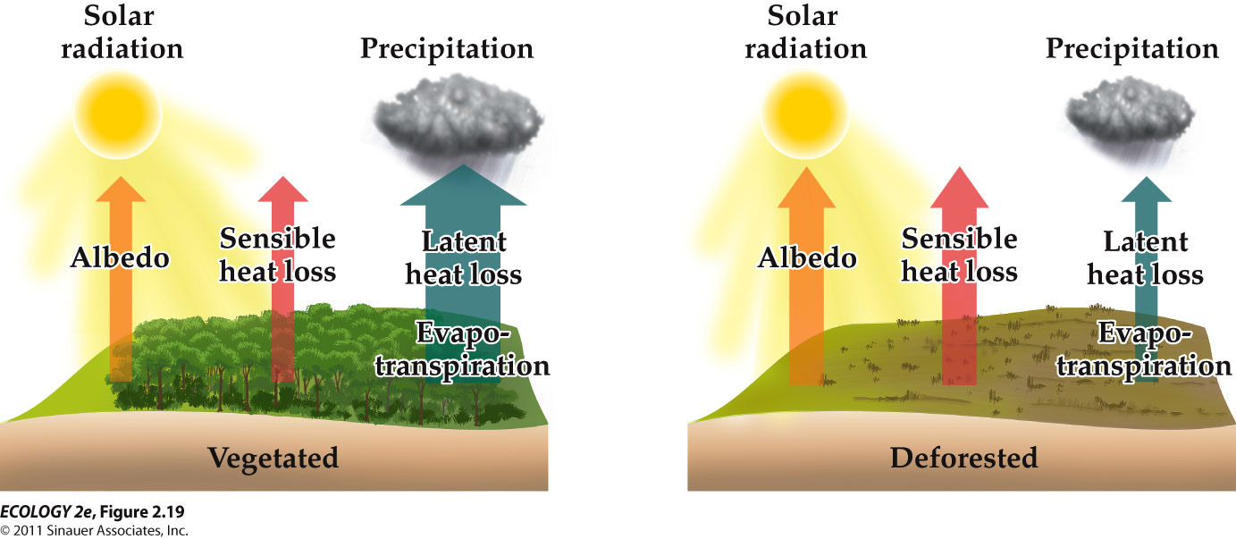
    - Vegetated
      - Lower sensible heat loss because roughness of tree slows down air current
      - Large latent heat loss results in lots of precipitation
      - Relatively cool because it is loosing heat through evapotranspiration
      - More return of moisture
    - deforested
      - Albedo – removing trees increases the albedo of the land surface, lowering its absorption of solar radiation
        - Increased albedo
      - Sensible heat – the change in surface roughness increases sensible heat loss by convection (wind)
      - The cooling effects are more than offset by the warming effects of decreased latent heat loss by evapotranspiration
        - Small latent heat loss
      - Reduced evapotranspiration also reduces the return of moisture to the atmosphere and reduces precipitation rates.

Climatic Variation over Time
- - seasonality results from the annual orbit of Earth around the sun
  - Earth is tilted at an angle of 23.5° relative to the sun’s direct rays.
  - The angle and intensity of the sun’s rays striking any point on Earth vary as Earth orbits the sun, resulting in seasonal variation in climate.
  - As Earth orbits the sun over the course of a year, its orientation relative to the sun changes due to the tilt of its axis of rotation. The resulting changes in the intensity of the solar radiation create seasonal climatic variation.
  - Because of tile of the Earth, at the equator, the area that is getting heat the most shifts northward or southward across the year.
    - Its seasonality is marked by changes in precipitation, rather than by changes in temperatures.
    - These seasonal changes in precipitation are associated with the movement of the zone of maximum solar radiation, known as the Intertropical Convergence Zone (ITCZ), between Northern Southern hemisphere.
      - Zone of maximum solar radiation = zone of maximum warm air uplift and precipitation.

- - Seasonal changes in aquatic environments are associated with changes in water temperature and density
  - In temperate-zone lakes, stratification (building of layers) changes with the seasons.
  - In summer, the warm epilimnion lies over the colder hypolimnion. The thermocline is the zone of transition.
  - Complete mixing (turnover) occurs in spring and fall when water temperature and density become uniform with depth.
  - Lake stratification

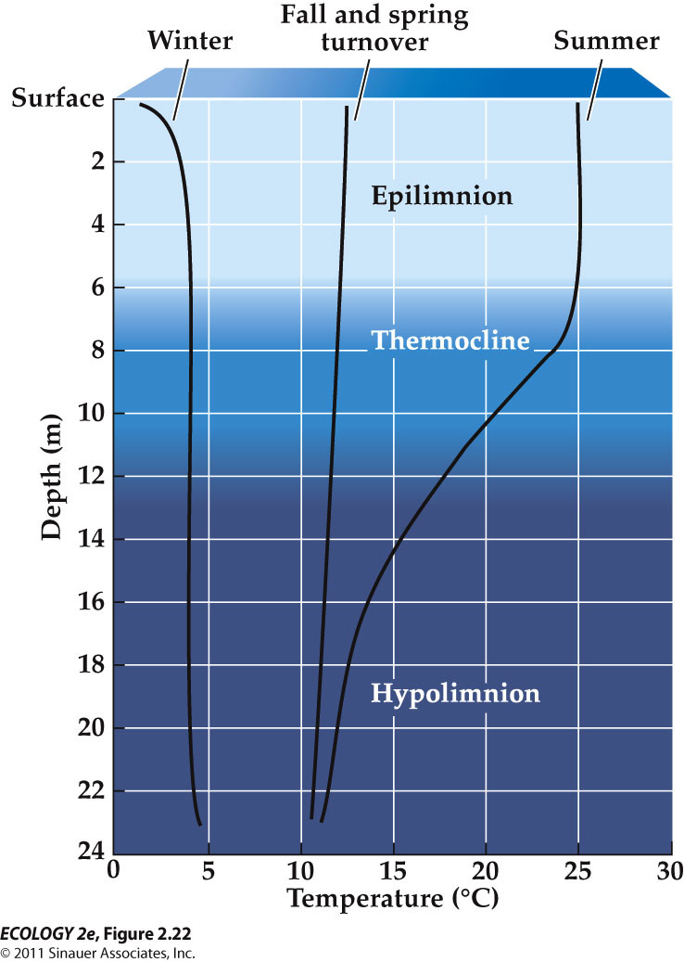
    - results from the effects of temperature on water density
    - Seasonal changes in water temperature result in the turnover of water that mixes little during summer and winter.
    - During turnover, temperature equalizes across the water column, so the density becomes same, leading water to mix. This time many nutrients are upwelling to the surface.

- - Climatic variation over years and decades result from changes in atmospheric pressure cells.
  - El Niño events, or the El Niño Southern Oscillation (ENSO), are longer-scale climate variations that occur every 3 to 8 years and last about 18 months.
    - Unusually warm ocean temperature
  - The positions of high- and low-pressure systems over equatorial Pacific switch, and the trade winds weaken.
  - Upwelling of deep ocean water off the coast of South America ceases, resulting in much lower fish harvests.
  - Huge effect on climate globally

- Long-term climate change
  - Long-Term Record of Average Global Temperature

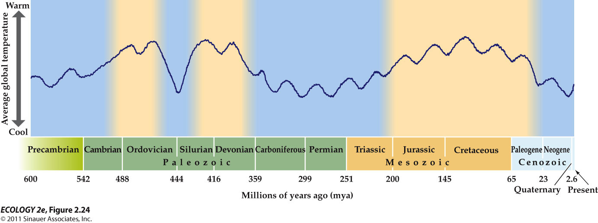
    - Over the past 500 million years, Earth’s climate has alternated between warm and cool cycles. Warmer periods are associated with higher concentrations of greenhouse gases.
    - Related to the greenhouse gases (fluctuations)
  - Glaciation
    - Earth is currently in a cool phase characterized by formation of glaciers (glacial maxima), followed by warm periods with glacial melting (interglacial periods).
    - These glacial–interglacial cycles occur at frequencies of about 100,000 years.
    - We are currently in an interglacial period; these have lasted about 23,000 years in the past.
    - The last glacial maximum was about 18,000 years ago.
    - The glacial–interglacial cycles have been explained by regular changes in the shape of Earth’s orbit and the tilt of its axis—Milankovitch cycles.
      - The intensity of solar radiation reaching Earth changes, resulting in climatic change.

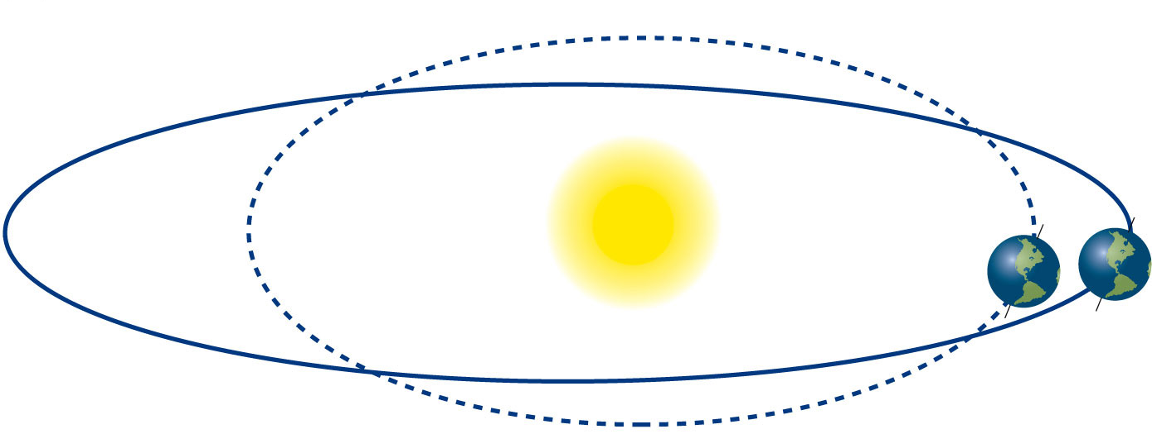
    - The shape of Earth’s orbit changes in 100,000-year cycles.
    - The angle of axis tilt changes in cycles of about 41,000 years.
    - Earth’s orientation relative to other celestial objects changes in cycles of about 22,000 years.
    - **don't worry about the details
      - tilt, location, space are changing

The Biosphere is the zone of life on Earth
  - Restricted to the surface of Earth

- - Biomes are large-scale biological communities shaped by the physical environment, particularly climate.
  - Biomes are categorized by dominant plant forms, not taxonomic relationships (classification of relatedness)
    - Animals are mobile (migration), so they can avoid location conditions by going to different areas.
      - Much more adopted at surviving within certain larger climate area, by choosing favorable microclimate
      - Less visible such as microorganisms
    - Plants occupy sites for a long time (stuck) and are good indicators of the physical environment, reflecting climatic conditions and disturbances.
      - Plants must be able to cope with its environmental extremes and its biological pressures.
    - Terrestrial biomes are characterized by growth forms of the dominant plants, such as leaf deciduousness (seasonal shedding of leaves) or succulence (development of fleshy water storage tissues).
      - Adaptation to the local climate

Plant Growth Forms (dominant groups)
  - The growth form of a plant is an evolutionary response to the environment, particularly climate and soil fertility.

- How do plants have the alternate growth forms ?
  - Plants have taken many forms in response to selection pressures such as aridity (dry), extreme temperatures, intense solar radiation, grazing, and crowding (occurs when conditions are optimal).
  - Similar growth forms can be found on different continents, even though the plants are not genetically related.
  - Convergence: Evolution of similar growth forms among distantly related species in response to similar selection pressures.
    - We do not talk about the groups of related plant necessarily.

- Terrestrial Biomes reflect global patterns of precipitation and temperature
  - Temperature has direct physiological effects on plant growth form.
    - Extreme conditions
  - Precipitation and temperature act together to influence water availability and water loss by plants.
  - Water availability and soil temperature determine the supply of nutrients in the soil.
    - Nutrient transformation in the soil is governed by microorganisms which are response to soil temperatures and water availability
    - When soil gets warm, more decomposition which release nutrients back into soil
    - Indirect relationship between precipitation and temperature in mediating nutrient availability
  - Biomes vary with mean annual temperature and precipitation.

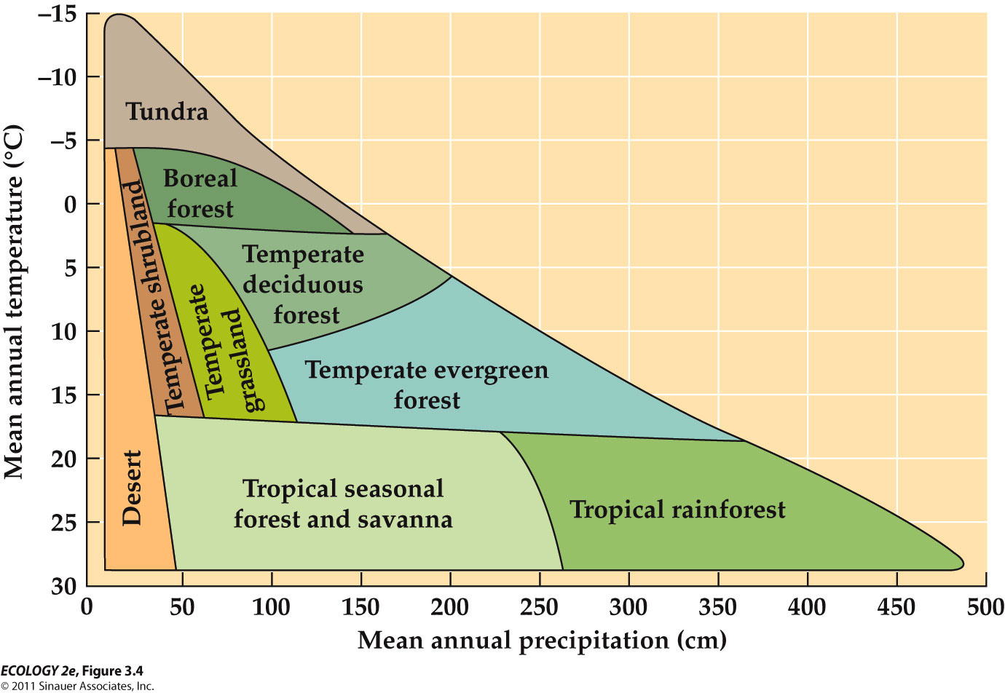
    - OVERSIMPIFIED : This does not account for seasonal variation !!
      - “temperate grassland” which is very common only appear in small area.

- Global Biome Distributions
  - Human activities influence the distribution of biomes
    - Land use change : conversion of land to agriculture, logging, resource extraction, urban development
  - The potential and actual distributions of biomes are markedly different.

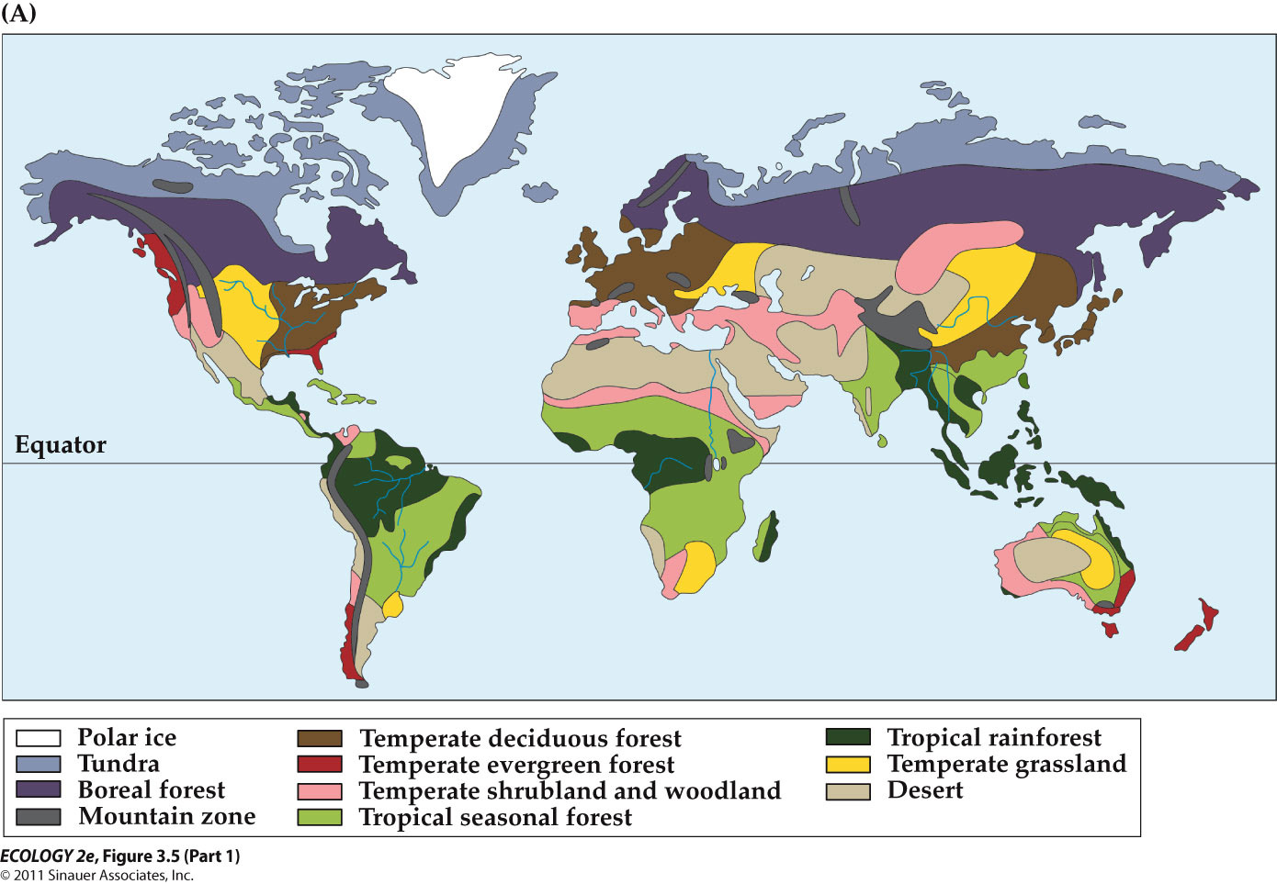
    - potential global distribution of biomes (ideal)

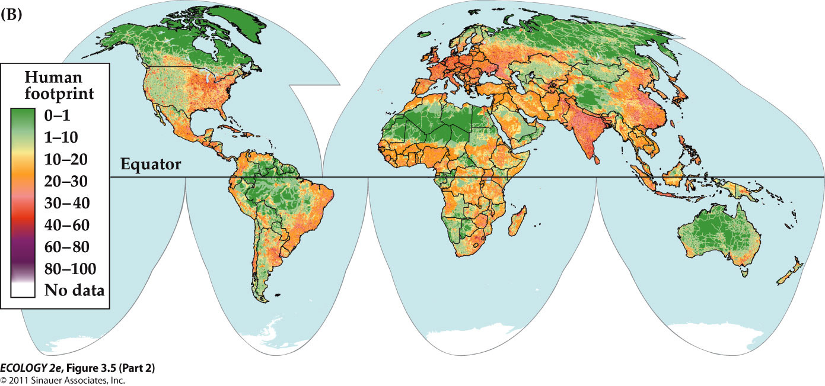
    - alteration of terrestrial biomes by human activities (actual)
      - most green areas are inhabitable
      - most biomes are affected by human activities

- 9 Major Terrestrial biomes
  - Climate diagrams show the characteristic seasonal patterns of temperature and precipitation at a representative location.

1. Tropical Rainforests

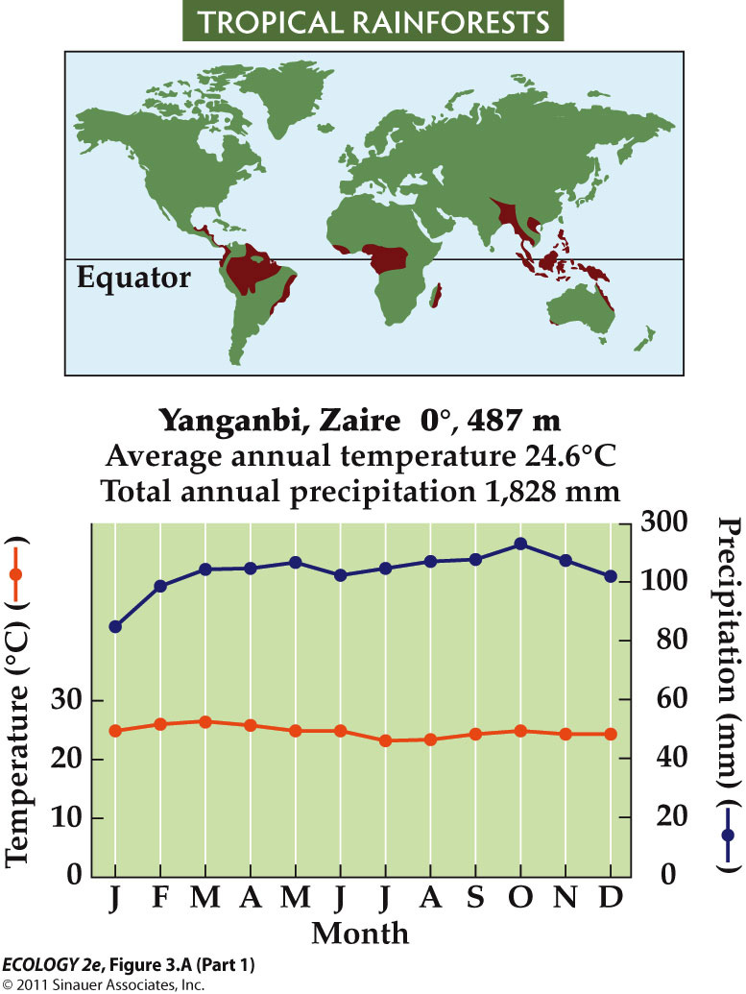
  - Warm, seasonally invariant temperature
  - Most precipitation spread evenly throughout the year.
  - High biomass, high diversity—about 50% of Earth’s species.
  - Light is a key factor—plants must grow very tall above their neighbors or adjust to low light levels.
    - Ideal for plant growth, so very competitive environment
  - Emergents (very tall) rise above the canopy.
  - Lianas (woody vines) and epiphytes (plants grow on the branches) use the trees for support.
  - Understory trees grow in the shade of the canopy, and shrubs and forbs occupy the forest floor.
    - Shrubs and forbs must rely on light flecks (sun flecks) that move across the forest floor during the day for photosynthesis

  - Tropical rainforests are disappearing due to logging and conversion to pasture and croplands.
  - About half of the tropical rainforest biome has been altered.
  - Recovery of rainforests is uncertain: Soils are nutrient-poor, and recovery of nutrient supplies may take a very long time.

- Tropical Seasonal Forests and Savannas

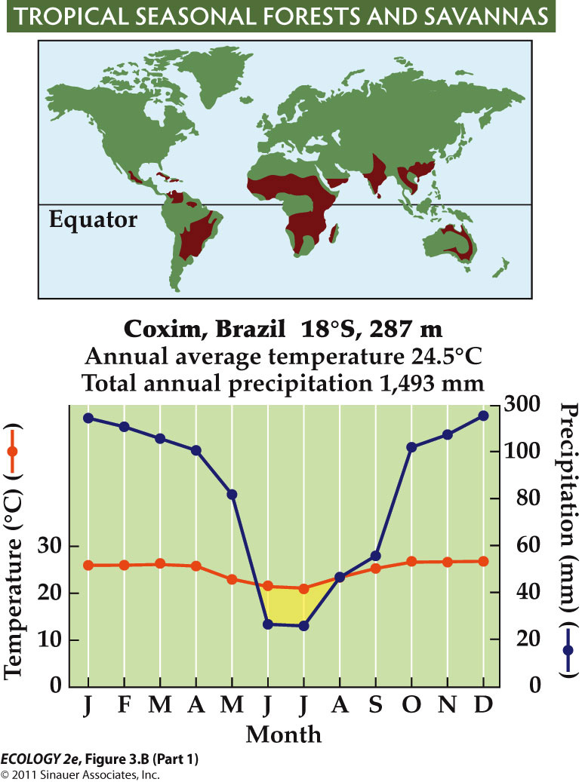
  - wet and dry seasons associated with shifts in the ITCZ.
  - Shorter trees, deciduous (loosing leafs) in dry seasons
  - more grasses and shrubs because they are no longer shaded by those big canopy
  - Yellow area = period of water shortages

  - Fires (disturbance) promote establishment of savannas; some are set by humans.
  - In Africa, large herbivores—wildebeests, zebras, elephants, and antelopes—also influence the balance of grass and trees.
    - Eat a lot of trees and grasses
  - On the Orinoco River floodplain, seasonal flooding promotes savannas.

  - Less than half of seasonal tropical forests and savannas remain.
  - Human population growth in this biome has had a major influence.
  - Large tracts have been converted to cropland and pasture.

- Hot Desserts

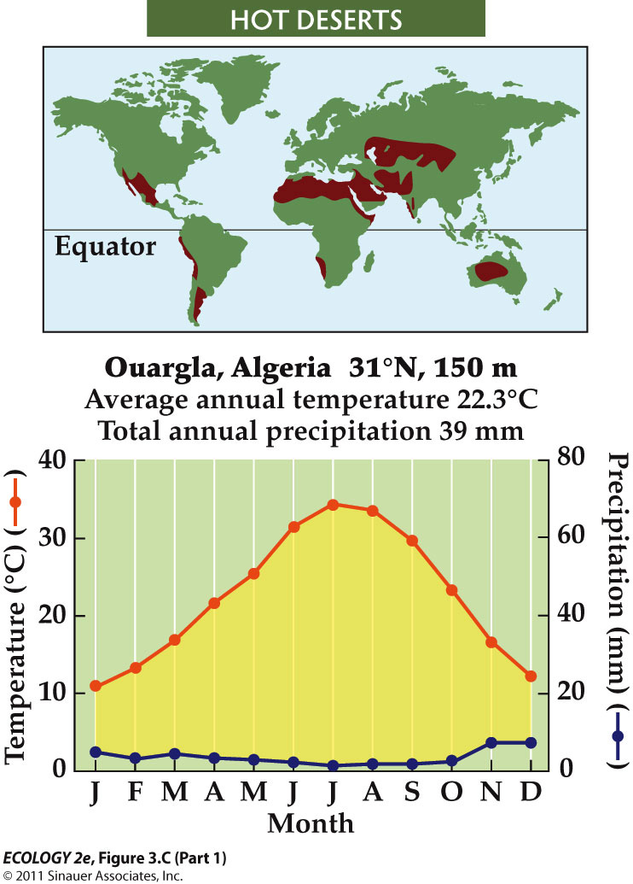
  - High temperatures, low moisture (high pressure)
  - Sparse (thinly dispersed) vegetation and animal populations
  - Low water availability constrains plant abundance and influence form
  - Corresponding to the descending air of Hadley cells

  - Many plants have succulent stems that store water.
  - Convergence of this form is shown by cacti (Western Hemisphere) and euphorbs (Eastern Hemisphere).
    - Convergence - Very distantly related plants assumed to be same form

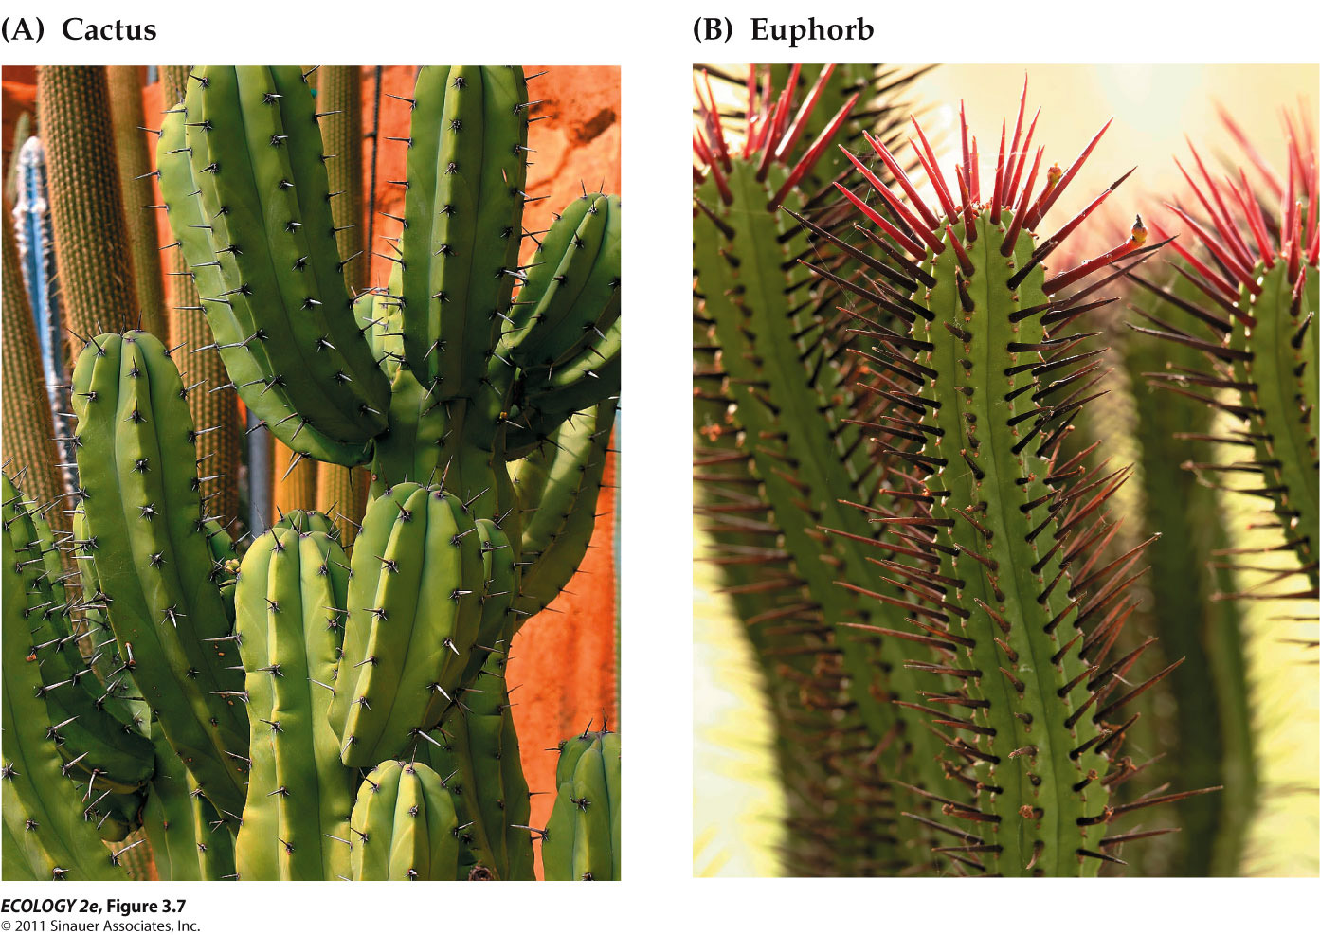

  - Humans use deserts for agriculture and livestock grazing.
  - Agriculture depends on irrigation, and results in soil salinization (high level of salts).
  - Long-term droughts and unsustainable grazing can result in desertification—loss of plant cover and soil erosion.

4. Temperate Grasslands
- 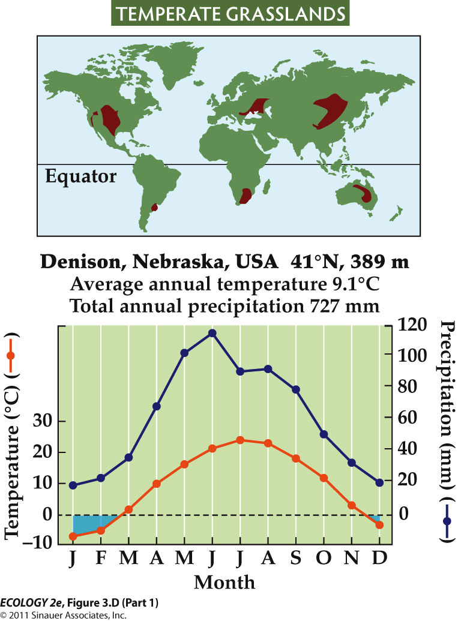
  - Warm, moist summers and cold, dry winters.
  - Subfreezing periods
  - Grasses dominate; maintained by frequent fires and large herbivores such as bison
    - These disturbances prevent the establishment of trees and thus maintain the dominance of grasses.

  - Grasses grow more roots than stems and leaves, to cope with dry conditions.
  - This results in accumulation of organic matter and high soil fertility.
  - Most fertile grasslands of central North America and Eurasia have been converted to agriculture.

  - In arid grasslands, grazing by domesticated animals can exceed capacity for regrowth, leading to grassland degradation and desertification.
  - Irrigation in some areas causes salinization.

5. Temperate Shrublands and Woodlands

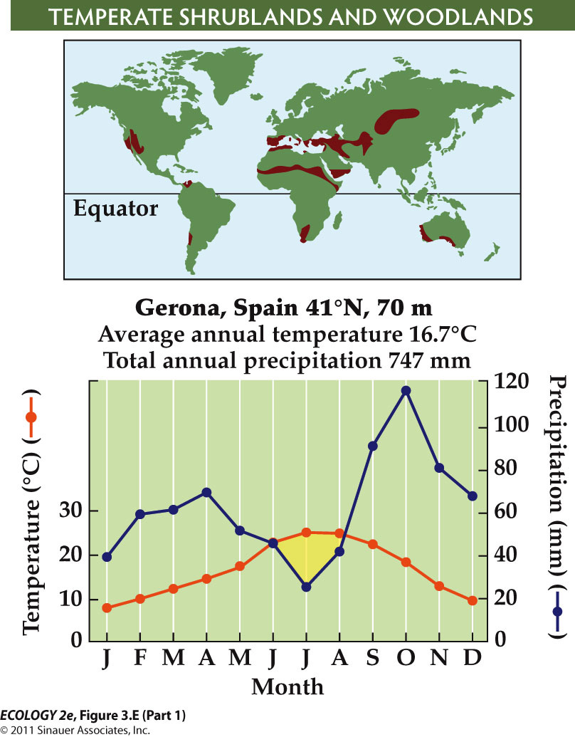
  - Mediterranean-type climate
    - Asynchrony between precipitation and the summer growing season
    - Relatively mild temperature
  - Evergreen leaves allow plants to be active during cooler, wetter periods.
  - They also lower nutrient requirements—the plants don’t have to develop new leaves every year.
  - Sclerophyllous leaves—tough and leathery—deter herbivores and prevent wilting.

  - After fires, shrubs sprout (to germinate seeds) from underground storage organs, or produce seeds that sprout and grow quickly.
    - Fire is also important in maintaining them.
    - Without regular fires at 30–40-year intervals, shrublands may be replaced by forests.

6. Temperate Deciduous Forests

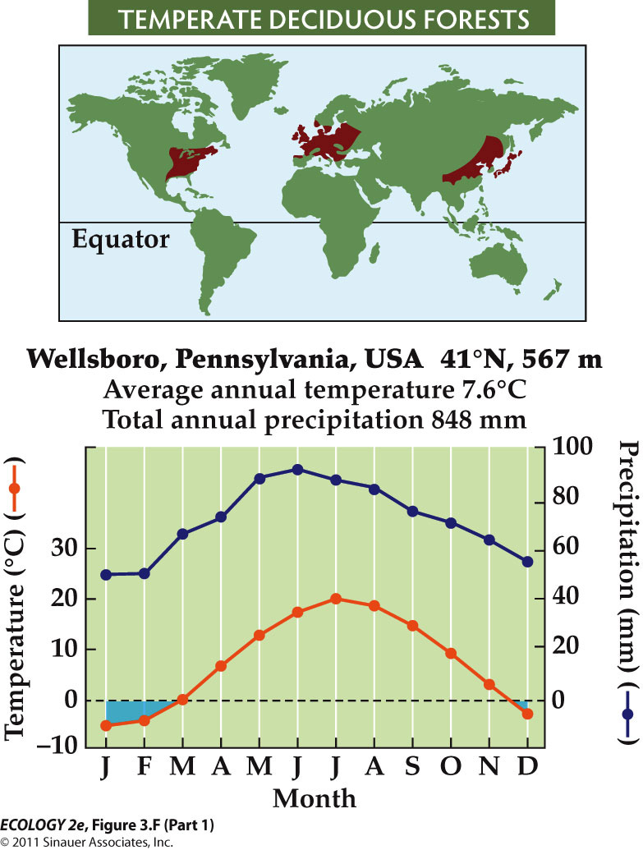
  - Cold winter, wetter than grassland
  - Deciduous leaves in response to extended periods of freezing
  - Need fertile soils and enough water to support tree growth

  - Fertile soils and climate make this biome good for agriculture. Very little old-growth temperate forest remains.
  - As agriculture has shifted to the tropics, temperate forests have regrown.
  - Shifts in species composition are due to nutrient depletion by agriculture and invasive species, causing damage such as chestnut blight (devastating disease of American chestnut tree) and ash tree disease

- 7. Temperate Evergreen Forests
- 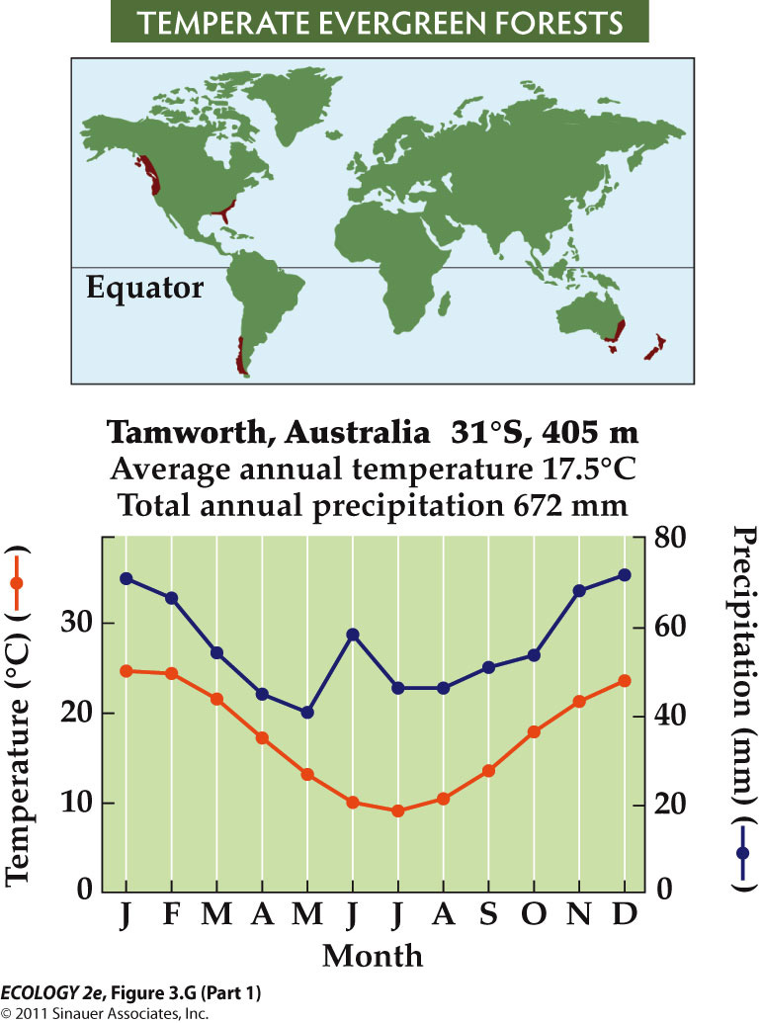
  - Includes temperate rainforests, but spans a wide range of environmental conditions
  - Commonly found on nutrient-poor soils

  - Evergreen trees are used for wood and paper pulp, and this biome has been logged extensively.
  - Very little old-growth temperate evergreen forest remains.
  - In some areas, trees have been replaced with non-native species in uniformly aged stands.

  - Suppression of fires in western North America has increased the density of forest stands, which results in more intense fires when they do occur.
  - It also increases the spread of insect pests and pathogens.
  - Air pollution has damaged some temperate evergreen forests.

- 8. Boreal Forests (Taiga)
- 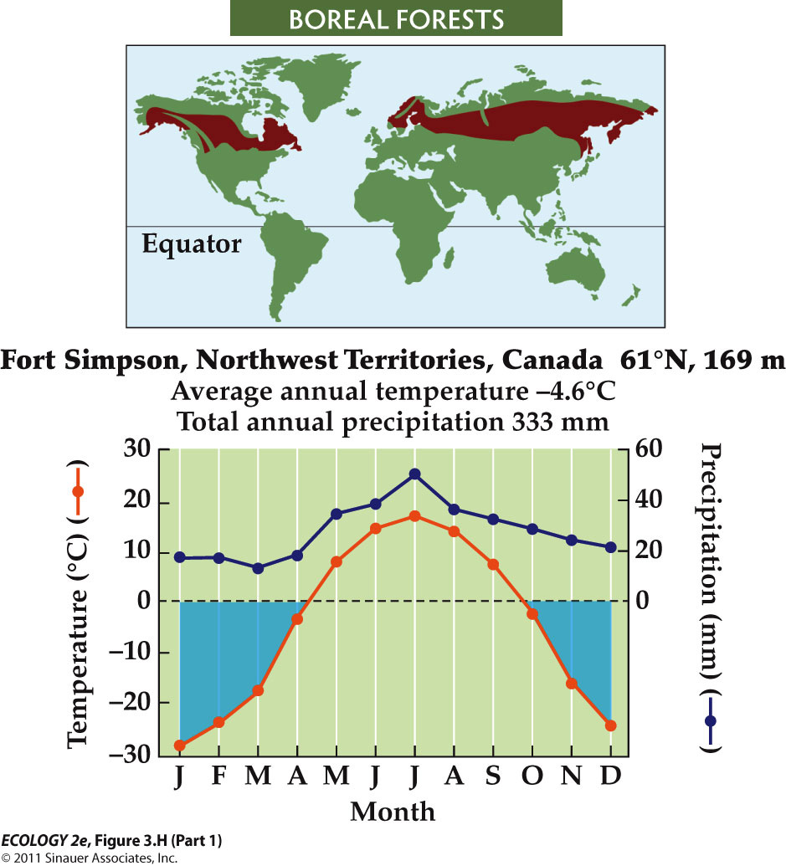
  - Long, severe winters.
  - Permafrost (soil that remains frozen year-round) prevents drainage and results in saturated soils. (wet soil)
  - Trees are conifers—pines, spruces, larches
    - Tolerate cold conditions much better

  - Cold, wet conditions in boreal soils limit decomposition, so soils have high organic matter.
    - The large store of organic matter in the soil makes boreal forests an important component of the global carbon cycle.
      - Enhancing atmospheric [greenhouse gas], thus positive feedback
  - In summer droughts, forest fires can be set by lightning, and can burn both trees and soil(organic). In low-lying areas, extensive peat bogs form.
    - Fire is very important in regeneration of this system.

  - Boreal forests have not been as affected by human activities.
  - Logging, and oil and gas development, occur in some regions. Impacts will increase as energy demands increase.
  - Climate warming may increase soil decomposition rates, releasing stored carbon and creating a positive feedback to warming

- 9. Tundra
- 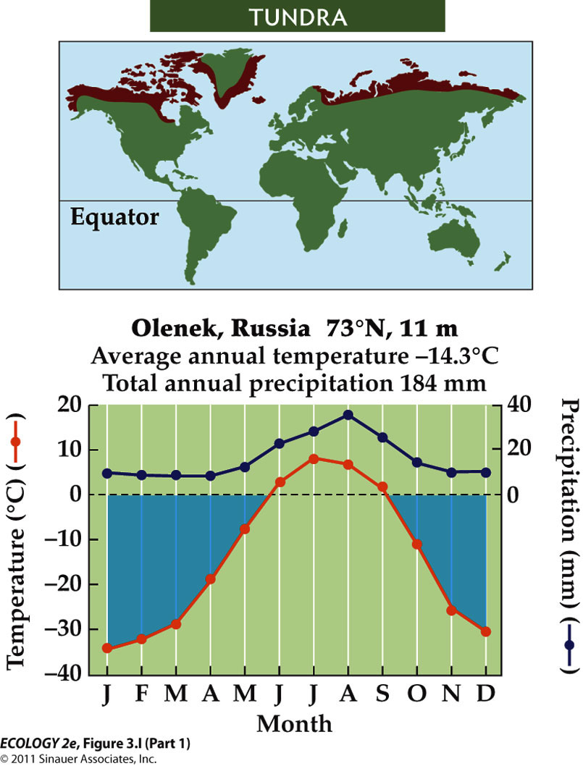
  - Where growing season length and temperatures decrease, trees cease to be the dominant vegetation (the tree line marks the boreal to tundra transition)
  - Characterized by sedges, grasses, forbs and low growing shrubs

  - Human influence is increasing as exploration and development of energy resources increases.
  - The Arctic has experienced significant climate change, with warming almost double the global average.
    - Very sensitive to temperature changes

- Biological communities in mountains occur in elevational bands
  - On mountains, temperature and precipitation change with elevation, resulting in zones similar to biomes.
  - Smaller scale variations are associated with slope aspect, proximity to streams, and prevailing winds.

- Freshwater Biological Zones
- Streams and Rivers
  - Streams and rivers are lotic (flowing water) systems.
  - Benthic organisms are bottom dwellers, and include many kinds of invertebrates.
  - Some feed on detritus (dead organic matter- dead leaves or organisms), others are predators.
  - Some live in the hyporheic zone—the substratum below and adjacent to the stream.

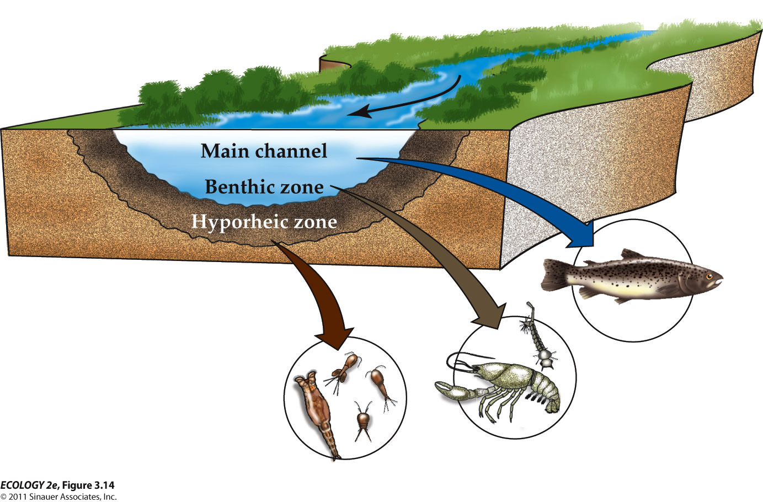

Lakes
  - Lakes and still waters (lentic) occur where depressions in the landscape fill with water.
  - The littoral zone is near shore zone where the photic zone (the surface layer of water where there is enough light for photosynthesis) reaches the lake bottom. Macrophytes (weeds) occur in this zone.
  - Pelagic zone: Open water; dominated by plankton (small and microscopic organisms suspended in the water).

  - Plankton
    - Phytoplankton are photosynthetic, restricted to the upper layers through which light penetrates (photic zone).
    - Zooplankton are non-photosynthetic protists and tiny animals.

Marine Biological Zones
  - Estuaries – where rivers flow into oceans
    - Mixing of fresh and salt water
  - Salt marshes – shallow coastal wetlands dominated by grasses and rushes
  - Mangrove forests – mudflats dominated by salt-tolerant trees
  - Sandy shores

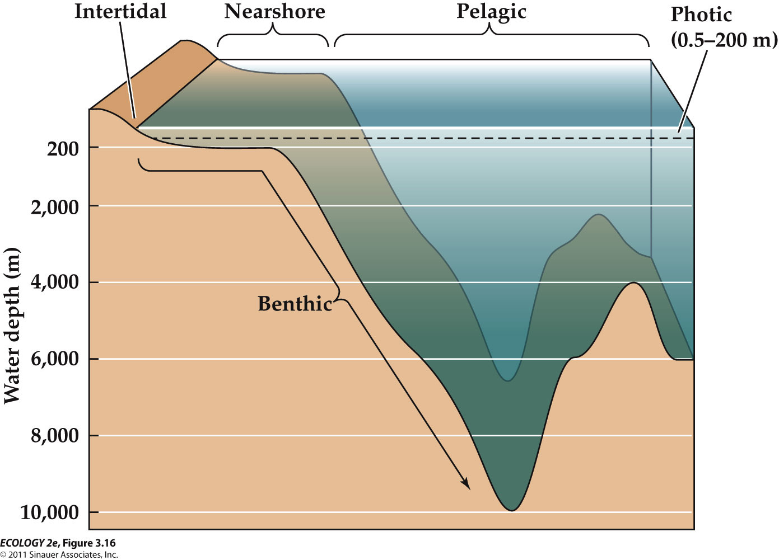
  - Pelagic zone: Open ocean beyond the continental shelves.
  - The photic zone, which supports the highest densities of organisms, extends to about 200 m depth.
  - Below the photic zone,
    - energy is supplied by falling detritus.
    - temperatures drop and pressure increases.
  - Crustaceans such as copepods graze on the rain of falling detritus from the photic zone.
  - Crustaceans, cephalopods, and fishes are the predators of the deep sea.

Globally, human have strong influence on oceans – pollution and fishery

Oceans are exposed to great extent to humans !
- RESPOND TO ENVIROMENTAL VARIATION

- Species distributions reflect environmental influences on energy acquisition and physiological tolerances

- The physical environment influences an organism’s ecological success in two ways:
  - 1. Availability of energy and resources—impacts growth and reproduction.
  - 2. Extreme conditions (temperature, water supply, chemical concentrations) can exceed tolerance limits and impact survival.
  - These two influences (the availability of energy and resources & physical tolerance limits) are not mutually exclusive.
    - Energy supply can influence an organism’s ability to tolerate environmental extremes.
      - Organisms that have very low availability to resources will have less ability to tolerate the environmental extremes.
  - The actual geographic distribution of a species is also related to other factors, such as disturbance and competition.

- - Abundance Across Environmental Gradients
- 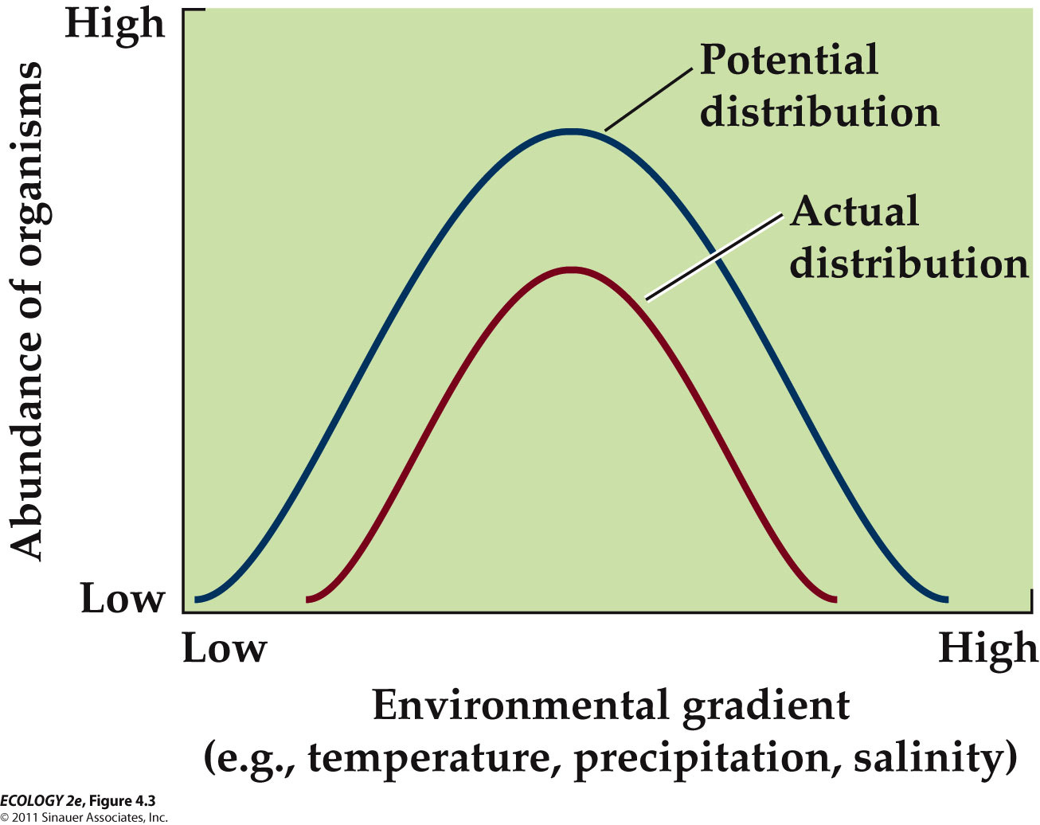
  - The abundance of an organisms reaches a theoretical maximum at some optimal value across an environmental gradient and drops off at either end at values that constraint the potential geographic distribution of the organism.
  - The actual disturbance curve (smaller) is likely to differ from the potential abundance curve due to biological interactions such as competition.

- - Because plants don’t move they are good indicators of the physical environment.
  - E.g. aspen distribution can be predicted based on climate.
    - Low temperatures and drought affect reproduction and survival.

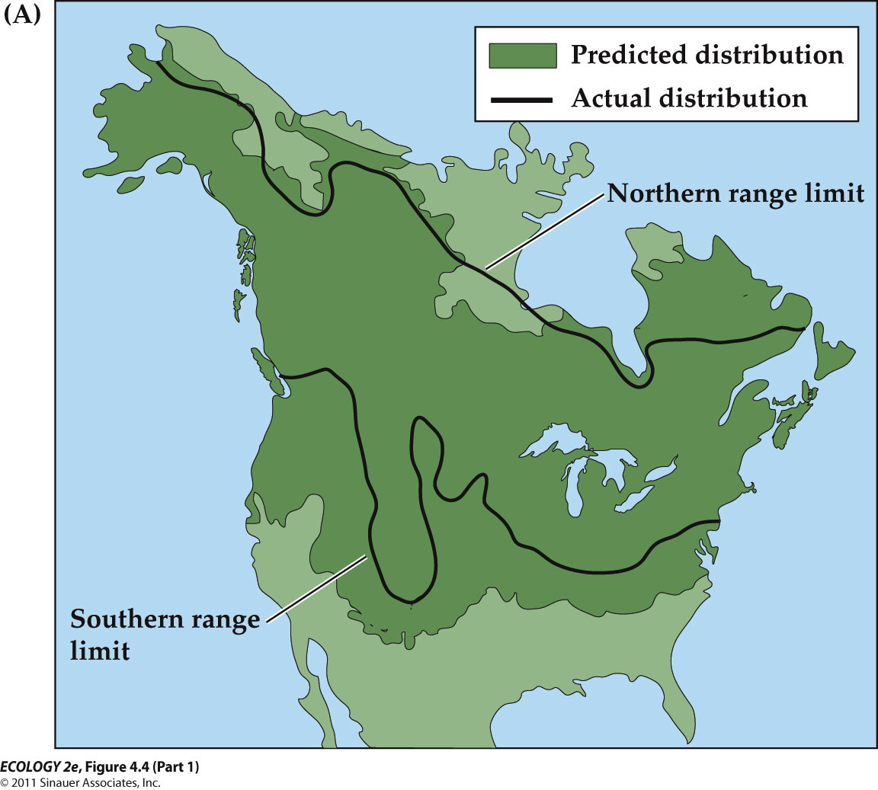
    - Fairly broad range of distribution
    - The climatic factors that limit its distribution include the effects of low temperatures on its reproductive success and the effects of drought and low temperatures on its survival.
    - Predicted vs. actual distribution
      - P : based upon drought and temperature tolerance
      - A : based on observations
      - Fairly good correspondence between two

- Individuals respond to environmental variation through acclimatization
  - Physiological Ecology
    - the study of interactions between organisms and the physical environments that influence their survival and persistence.
  - Physiological processes have optimal conditions for functioning.
  - Deviations from the optimum reduce the rate of the process.
  - Stress—environmental change results in decreased rates of physiological processes, lowering the potential for survival, growth, or reproduction.
    - Lowering photosynthetic or metabolic rates

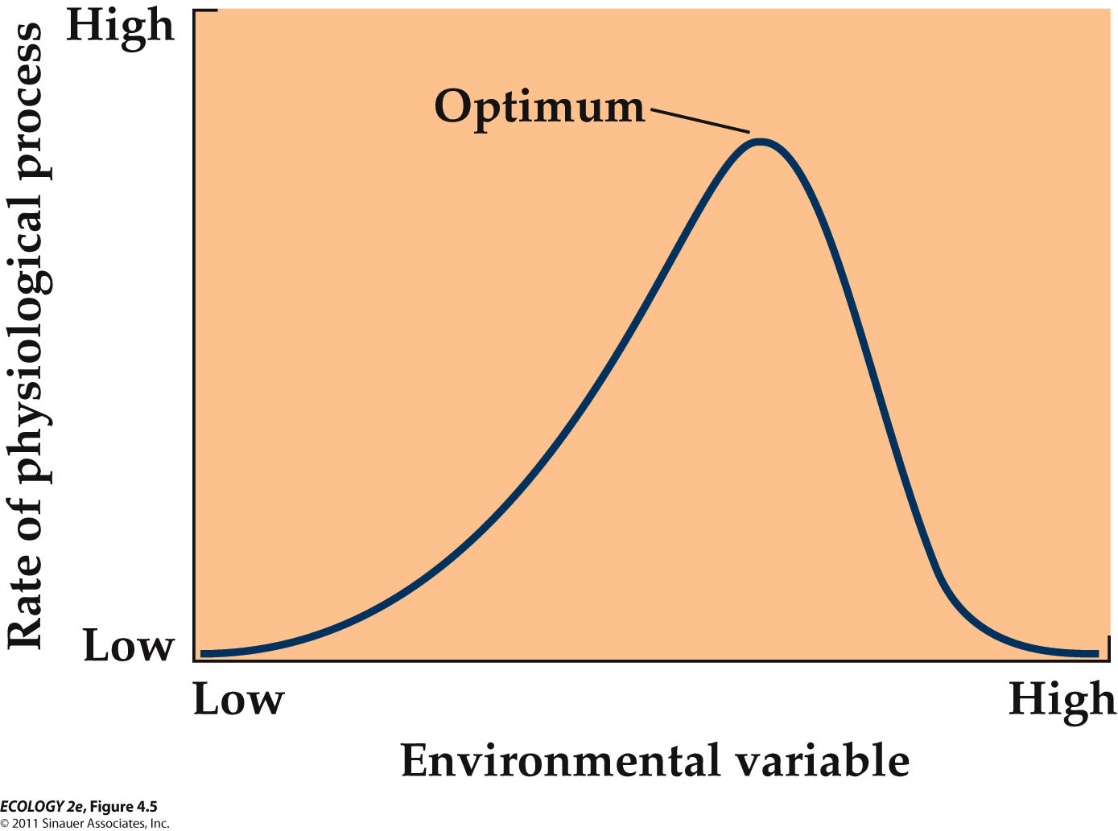
    - The rates of physiological processes are greatest under a set of optimal environmental conditions (optimal temperatures, optimal water availability). Deviation from the optimum cause a decrease in the rates of physiological process

  - Acclimatization: Adjusting to stress through behavior or physiology.
    - It is usually a short-term, reversible process.
    - E.g. Acclimatization to high elevations involves higher breathing rates, greater production of red blood cells, and higher pulmonary blood pressure.
      - When mountaineers try to climb the mountain Everest, they don't go straight to the peak ; they stay at the base camp of high altitude for acclimatization.

- Individuals respond to environmental variation through adaptation
  - Over time, natural selection can result in adaptation of a population to environmental stress.
  - Individuals with traits that enable them to cope with stress are favored.
  - Over time, these genetic traits become more frequent in the population.
    - Ones surviving best will produce more offspring.
    - E.g. the rabbit has big ears to cool down its at the hot area.

- - Organismal Responses to stress (Acclimatization and Adaptation)

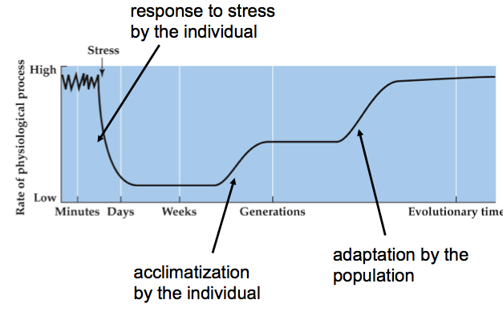
    - The rate of a physiological process deceases when an organism is exposed to a stressful environment.
    - Over time, the organism may respond to the stress through acclimatization, compensating for the effect of the stress.
      - Limitations in acclimatization
    - Over several generations, a population may undergo adaptation to the stress, and the physiological process may return to its pre-stress rate.
  - Acclimatization and adaptation require investments of energy and resources, representing possible trade-offs with other functions that can also affect survival and reproduction.
    - Always consequences for changing physiology
    - Something that works well in one environment would not work in another environment.
  - Ecotypes: Populations with adaptations to unique environments.
    - E.g. In plants, same species : one population lives in a field while the other lives in the forest, shades, etc. They have different adaptations over time.
    - E.g. heavy metal tolerance on mine tailing
    - Ecotypes can eventually become separate species as populations diverge and become reproductively isolated.
      - Speciation

VARIATION IN TEMPERATURE

- Temperature
  - Environmental temperatures vary greatly throughout the biosphere.
  - Survival and functioning of organisms is strongly tied to their internal temperature.
    - Very critical
  - Some archaea and bacteria in hot springs can function at 90°C.
  - Lower limits are determined by temperature at which water freezes in cells (–2 to –5°C).

- - Temperature Range for life on Earth (internal body temperature)
  - Even though they are extreme cases such as living at 90 °C, most organisms live in a similar temperature range
    - endotherms – relatively constrained
    - ectotherms – less constrained

- Temperature controls physiological activity

- - Enzymes
  - Metabolic reactions are catalyzed by enzymes, which have narrow temperature ranges for optimal function.
    - High temperature destroys enzymes function (denatured).
  - Bacteria in hot springs - enzymes stable to 100°C; Antarctic fish and crustaceans -enzymes function at –2°C; soil microbes - active at temperatures as low as –5°C.
  - Some species produce different forms of enzymes (isozymes) with different temperature optima that allow acclimatization to changing conditions.
    - Isozymes – basically have same function but different forms that able to tolerate different temperature ranges

- - Cell Membranes
  - Temperature also affects the properties of cell membranes, which are composed of two layers of lipid molecules.
  - At low temperatures, these lipids can solidify, embedded proteins can’t function, and the cells leak metabolites.
  - Plants that thrive at low temperatures have higher proportions of unsaturated lipids (with double bonds – kinks in their tails) in their cell membranes.
    - Remains fluid at lower temperature

Organisms influence their temperature by modifying energy balance

- Animal modification of energy balance
  - Ectotherms: Regulate body temperature through energy exchange with the external environment. (limited controls)
  - Endotherms: Rely primarily on internal heat generation—mostly birds and mammals. Although it is costly being endotherms :
    - can maintain internal temperatures near optimum for metabolic functions.
    - Can extend geographic range (climate range)
  - Some other organisms that generate heat internally include bees, some fish, such as tuna, and even some plants.
    - E.g. Skunk cabbage warms its flowers using metabolically generated heat in early spring
    - E.g. Japanese honeybees use internal heat generation as a defense against hornets that attack bee colonies.

- - Temperature regulation and tolerance in ectotherms
  - Ectotherm surface area-to-volume ratio of the body is an important factor in exchanging energy with the environment.
    - A larger surface area allows greater heat exchange (large surface area to volume ratio is preferred), but makes it harder to maintain internal temperature.
  - Small aquatic ectotherms remain the same temperature as the water.
    - Able to exchange with water
  - Some large ectotherms can maintain higher body temperature:
    - Skipjack tuna (predator) use muscle activity and heat exchange between blood vessels to maintain a body temperature 14°C warmer than the surrounding seawater.

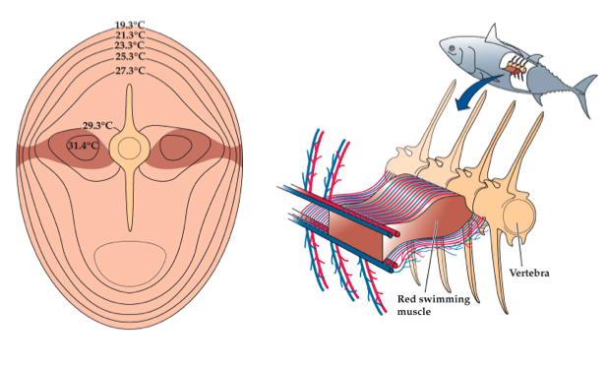
      - Heat generated in the red swimming muscles warms blood flowing through them, which is carried toward the body surface in veins. Those veins run parallel to arteries carrying cool oxygenated blood from the gills, warming that blood before it reaches the swimming muscle.
        - The core temperature (where red swimming muscles are) remain warmer than that of the surround water.
  - Many terrestrial ectotherms can move around to adjust temperature.
    - Many insects and reptiles bask in the sun to warm up after a cold night. Because this increases risk from predators, many are camouflaged and can change coloration to match backgrounds.
    - A smaller surface area relative to volume decreases the animal’s ability to gain or lose heat.
      - As body size increases, surface area-to-volume ratio decreases, and large ectotherms are thus improbable.
      - This led to speculation that large dinosaurs may have had some degree of endothermy.
  - Ectotherms in temperate and polar regions must avoid or tolerate freezing.
    - Avoidance behavior includes seasonal migration to lower latitudes or to microsites that are above freezing (e.g., burrows in soil).
    - Tolerance to freezing involves minimizing damage associated with ice formation in cells.
      - Ice formation will puncture cell membrane and disrupt metabolic function
    - Some insects have high concentrations of glycerol, a chemical that lowers the freezing point of body fluids.
  - Generally, vertebrates generally do not tolerate freezing temperatures because of their large size and greater physiological complexity.
    - One exception – frozen frogs (case study from the textbook)
      - Even though they froze in solid, they will re-animate when they are warmed up.
        - Can even freeze them down -50 and revive them again
      - Cryonics is the preservation of bodies by freezing, in hope that they can be brought back to life in the future.
        - Sounds Farfetched (improbable in nature)
      - Two frog species live in the Arctic tundra and can survive winter in a semi-frozen state.
        - They overwinter in shallow burrows, with no heartbeat, no blood circulation, and no breathing.
      - In most organisms, freezing results in tissue damage as ice crystals perforate cell membranes and organelles.
      - However, in animals that withstand freezing, the freezing water is limited to the space outside the cells. (not freezing within their cells)
        - Ice-nucleating proteins outside cells serve as sites of slow, controlled ice formation.
        - Additional solutes, such as glucose and glycerol are made inside the cells to lower the freezing point.

- Temperature regulation and tolerance in endotherms.
  - Endotherms can remain active at subfreezing temperatures.
  - The cost of being endothermic is a high demand for energy (food) to support metabolic heat production.
  - Metabolic rates are associated with external temperature and rate of heat loss.
    - Rate of heat loss is related to body size and surface area-to-volume ratio.
    - Small endotherms with large surface area-to-volume ratio have higher metabolic rates, and require more energy and higher feeding rates than large endotherms.
      - High surface area to volume ratio – constantly loosing heat !
  - Thermoneutral zone: The range of environmental temperatures over which a constant basal metabolic rate can be maintained.
  - Lower critical temperature: When heat loss is greater than metabolic production; body temperature drops and metabolic heat generation increases.

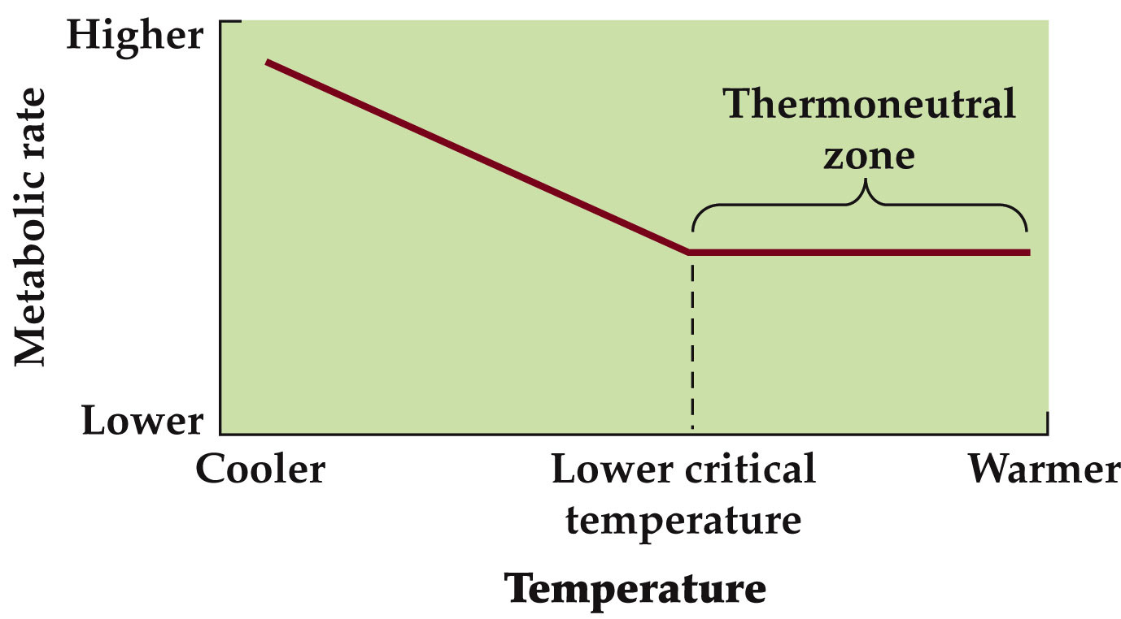
    - Always try to find lowering metabolic rate, to reduce energy consumption
    - Metabolic rates in endotherms vary with environmental temperatures.
      - When the environmental temperature drops below the lower critical temperature, the metabolic rate begins to increase in order to generate more heat
      - The resting metabolic rate remains the same as long as the environmental temperature is within the themoneutral zone.
  - The thermoneutral zones and lower critical temperatures of endotherms vary with their habitats.
    - Mammals in the Arctic have lower critical temperatures than mammals in tropical regions.
      - The rate of metabolic activity increases more rapidly below the lower critical temperature in tropical mammals as compared to Arctic mammals.
  - Why organisms have differences in lower critical temperatures and metabolic rate change?
    - Evolution of endothermy required insulation—feathers, fur, and fat. Insulation limits conductive and convective heat loss.
      - Conduction – direct contact
      - Convection – up and down movement of gases or liquid
        - E.g. wind currents
      - Fur and feathers provide a layer of still air adjacent to the skin. Some animals grow thicker fur for winter.
        - Air is very good insulator

  - Some organisms can survive periods of extreme heat or cold by entering a state of dormancy, in which little or no metabolic activity occurs.
  - Small mammals have thin fur and not much fat for energy storage, but high demand for metabolic energy below the lower critical temperature.
  - They survive in cold climates by entering a dormant state called torpor.
    - Lowering body temperature and basal metabolic rates, therefore conserves energy.
  - Energy reserves are needed to come out of torpor. Small endotherms may undergo daily torpor to survive cold nights.
  - Longer periods of torpor, or hibernation, are possible for animals that can store enough energy.
    - During torpor, metabolic rate decreases, substantially lowering energy demand.

- Heat stress in animals
  - Some organisms use behavioral changes to control exchange of energy with the environment.
    - E.g. elephants swim and spray water onto their backs with their trunks to cool their bodies.
    - E.g. moving into the shade reduces the amount of solar radiation received.
  - Evaporative heat loss in animals includes :
    - sweating in humans, panting in dogs and other animals, and licking of the body by some marsupials.
  - Ectotherms in hot environments can gain too much heat from the environment and body temperature can reach lethal levels.

- VARIATION IN WATER AVAILABILITY
  - Arid conditions are a widespread challenge for organisms.
    - Some tolerate dry conditions by going into suspended animation.
    - Many microorganisms do this, as do some multicellular organisms.
    - Desiccation-tolerant organisms can lose 80%–90% of their water.
      - Club moss and water bear
  - Generally, invertebrates have a higher tolerance for water loss than vertebrates.
    - With in vertebrates, amphibians have a higher tolerance for, but lower resistance to, water loss than mammals and birds

  - Reptiles are very successful in dry environments.
    - They have thick skin with layers of dead cells, fatty coatings, and plates or scales.
  - Mammals and birds have thick skin plus fur or feathers to minimize water loss.
    - Sweat glands in mammals are a trade-off between water loss resistance and evaporative cooling.
  - In some cases, your ability to resist water loss to your external covering can make big difference in an arid environment.

- Plant modification of energy balance
- - Energy exchange in Terrestrial plants
- 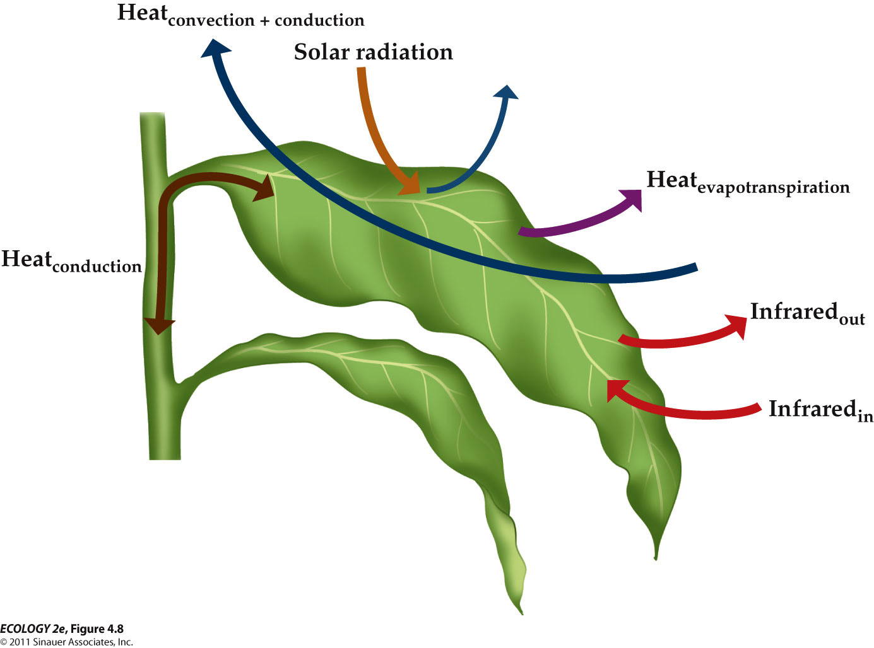
  - the temperature of a plant is determined by the balance between inputs of energy from and outputs of energy to the environment.
  - Conduction—transfer of energy from warmer to cooler molecules.
  - Convection—heat energy is carried by moving water or air.

  - Plants can adjust energy inputs and outputs.
  - Transpiration (evaporation) rates can be controlled by specialized guard cells surrounding leaf openings called stomates.
    - Variation in degree of opening and number of stomates controls the rate of transpiration and thus leaf temperature.

  - BUT, If soil water is limited (in dry environment), transpirational cooling is not a good mechanism.
    - Some plants shed their leaves during dry seasons.
  - Other mechanisms include pubescence—hairs on leaf surfaces that reflect solar energy. (lowering the amount of solar radiation absorption)
    - But hairs also reduce conductive heat loss
    - a trade-off between opposing heat exchange mechanisms.

  - Pubescence was studied in three Encelia species (plants in the daisy family).
    - Desert species with high pubescence were compared with non-pubescent species from wetter, cooler habitats.
    - Plants of all three species were grown in both locations (common gardens).
    - Results
      - In the cool, moist location, the three species showed few differences in leaf temperature and stomatal opening.
      - In the desert, species with no hairs maintained leaf temperature by transpiration; the pubescent species leaves reflected about twice as much solar radiation.
      - The desert species (E. farinosa) also has smaller, more pubescent leaves in summer than in winter, representing acclimatization to hot summer temperatures.
        - Higher reflection in summer / lower in winter

  - If air temperature is lower than leaf temperature, heat can be lost by convection.
    - Convective heat loss is related to speed of air moving across a leaf surface.
  - Boundary layer: A zone of turbulent flow due to friction, next to the leaf surface.

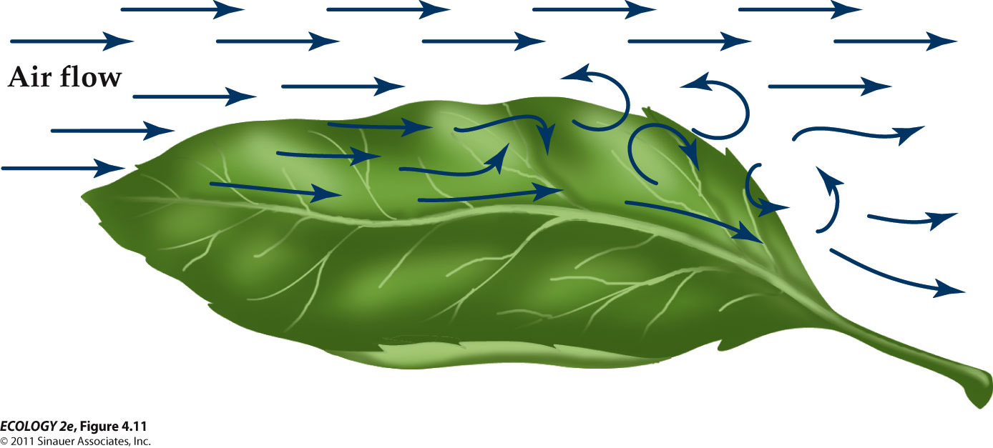
    - The boundary layer lowers convective heat loss.
    - Boundary layer thickness is related to leaf size and surface roughness.
    - Small, smooth leaves have thin boundary layers and lose more heat than large or rough leaves.
  - In cold, windy environments, convection is the main heat loss mechanism.
    - Most alpine plants hug the ground surface to avoid high wind velocities.
    - Some have a layer of insulating hair to lower convective heat loss.

- SOURCES OF ENERGY

  - Autotrophs: Assimilate radiant energy from sunlight (photosynthesis), or from inorganic compounds (chemosynthesis).
    - The energy is converted into chemical energy stored in the bonds of organic molecules.
  - Heterotrophs: Obtain their energy by consuming organic compounds from other organisms.
    - This energy originated with organic compounds synthesized by autotrophs.
    - Some heterotrophs consume non-living organic matter. (detritovores)
    - Parasites and herbivores consume live hosts, but do not necessarily kill them.
      - Many parasites don't benefit for killing others.
    - Predators capture and consume live prey animals.

  - Not clear distinction between autotrophs and heterotrophs
    - Some plants are holoparasites: They have no photosynthetic pigments and get energy from other plants (they are actually heterotrophs).
      - E.g. Dodder is a holoparasite that is an agricultural pest and can significantly reduce biomass in the host plant.
        - Increasing amounts of dodder biomass result in decreasing growth of its host plant.
        - 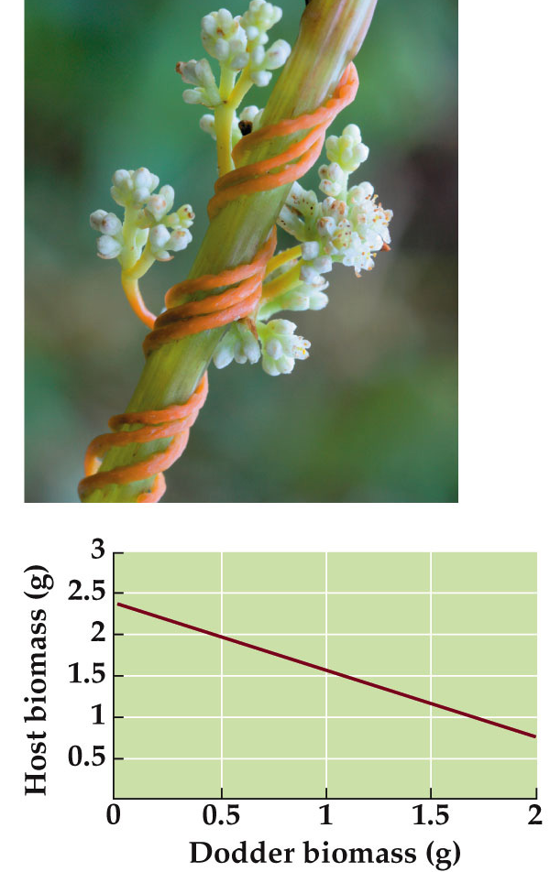
    - Mistletoe is a hemiparasite—it is photosynthetic, but obtains nutrients, water, and some of its energy from the host plant.

  - Sea slugs have functional chloroplasts that are taken up from the algae that the slug eats.
    - Associated with the chloroplasts in its digestive system.
    - The chloroplast can supply enough energy to the sea slug to maintain it for several month without food.

- AUTOTROPHY

  - Photosynthesis - (most autotrophs): sunlight provides the energy to take up CO₂ and synthesize organic compounds.
  - Chemosynthesis (chemolithotrophy): Energy from inorganic compounds is used to produce carbohydrates.
    - Chemosynthesis is important in nutrient cycling bacteria, and in some ecosystems
      - such as hydrothermal vent communities (bottom of oceans).
        - No sun light penetrating the bottom of oceans
    - Nitrifying bacteria
      - Convert ammonium into nitrate and oxide it to nitrate
      - Important in nitrogen cycling and plant nutrition
    - Sulfur bacteria
      - Volcanic deposits, sulfur hot spring, acidic mine wastes

- - Photosynthesis is the powerhouse for life on Earth
  - Most of the biologically available energy on Earth is derived from photosynthesis.
  - Photosynthetic organisms include some archaea, bacteria, and protists, and most algae and plants.
  - Two major steps
    - Light reaction—light is harvested and used to split water and provide electrons to make ATP and NADPH.
    - Dark reaction—CO₂ is fixed in the Calvin cycle, and carbohydrates are synthesized.
      - Does not have to happen in the dark necessarily ; can happen in a day time
      - Do not directly rely on light energy
  - Photosynthetic rate determines the supply of energy, which in turn influences growth and reproduction.
  - Environmental controls on photosynthetic rate are an important topic in physiological ecology.
  - Light response curves show the influence of light levels on photosynthetic rate.
    - Light compensation point: Where CO₂ uptake is balanced by CO₂ loss by respiration.
      - When leaf is in darkness, it does not photosynthesize at all; it does respire.
      - Enough light to balance the respiration
    - Saturation point: When photosynthesis no longer increases as light increases.

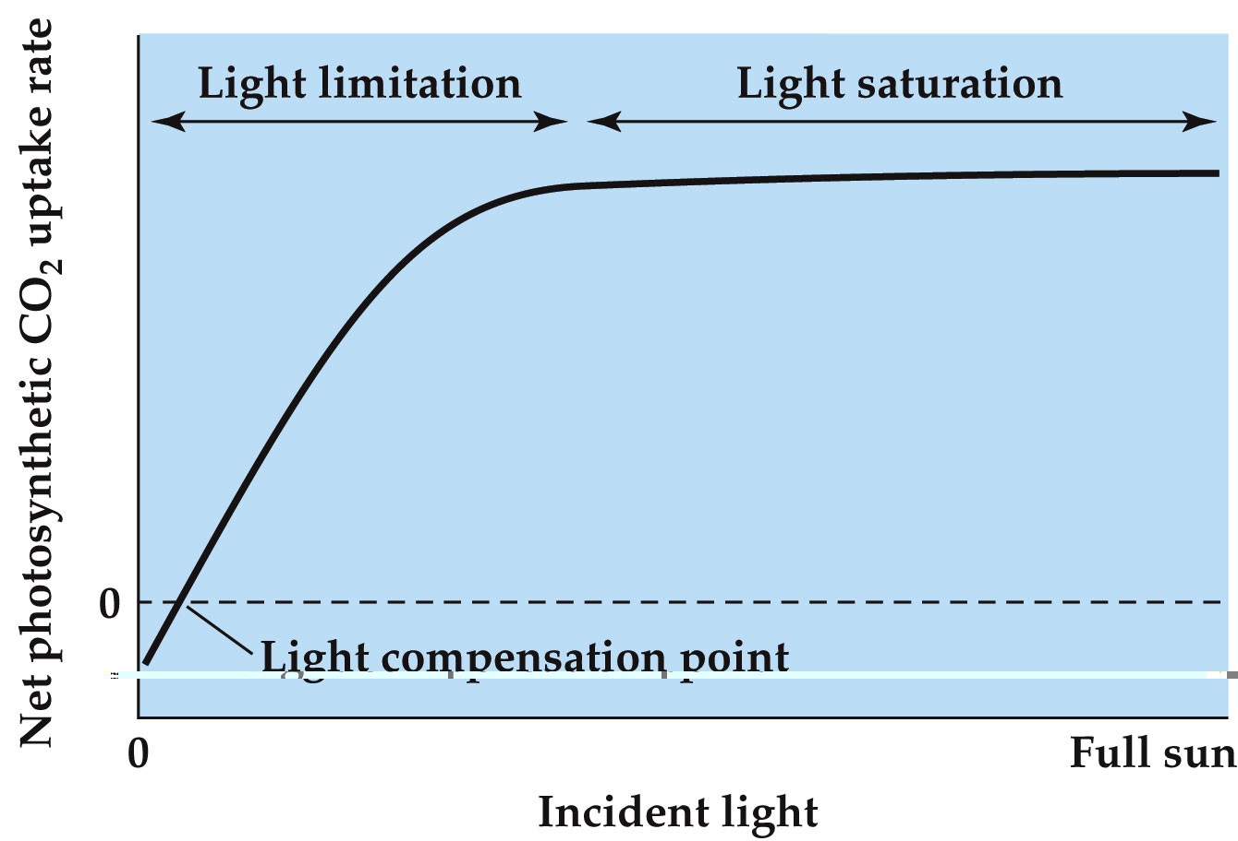
    - Net photosynthesis = photosynthesis – respiration
  - Plants can acclimatize to changing light intensities with shifts in light response curves.
    - Shifts in light saturation point involve morphological and physiological changes.

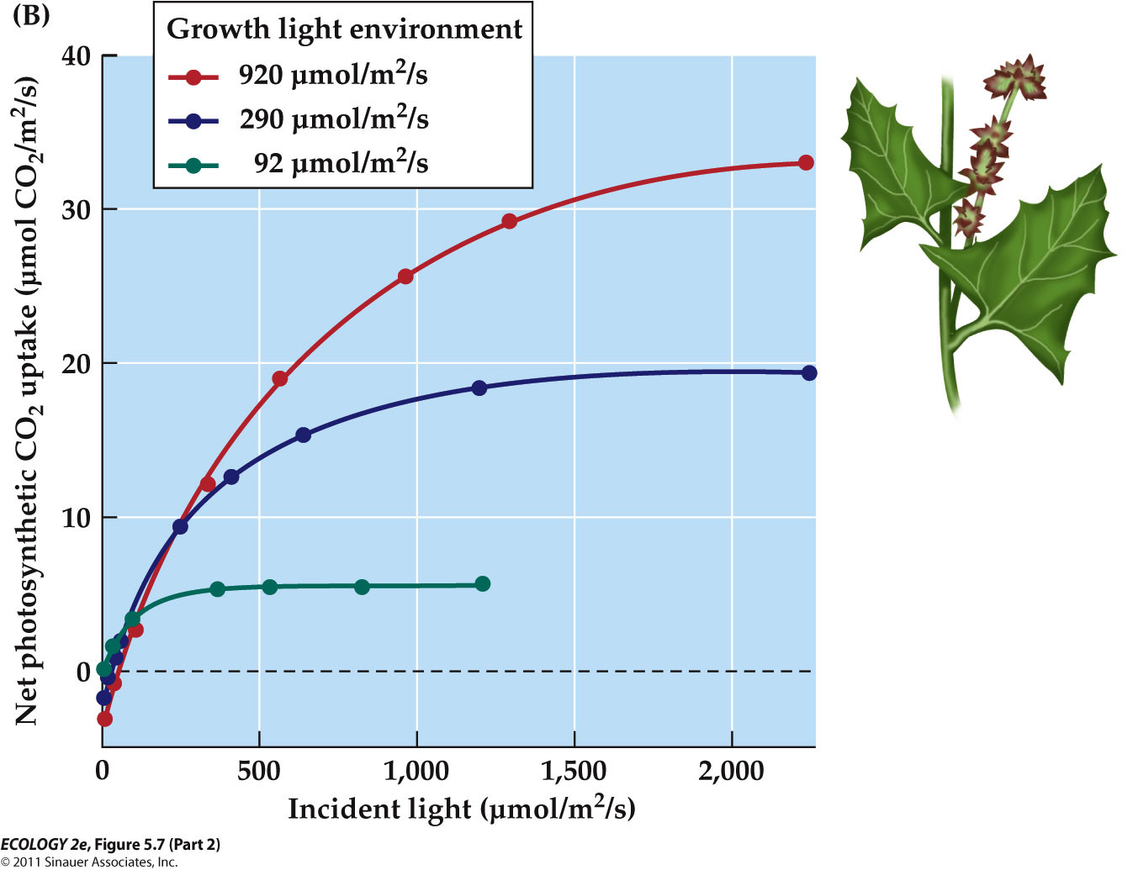
    - Same species growing in 3 different light intensities
      - One that grows under low light become saturated at very low level of light. Low net photosynthesis
  - Leaves at high light intensity may have thicker leaves and more chloroplasts.

  - Water availability influences CO₂ supply in terrestrial plants.
  - Low water availability causes stomates to close, restricting CO₂ uptake.
  - This is a trade-off: Water conservation versus energy gain.
    - Photosynthesis vs. cooling of the leaf
  - Closing stomates increases chance of light damage
    - If the Calvin cycle isn’t operating, energy accumulates in the light-harvesting arrays and can damage membranes.
    - Plants have various mechanisms to dissipate this energy, including carotenoids, to release the energy as heat.

  - Plants from different climate zones have enzyme forms with different optimal temperatures that allow them to operate in that climate.
    - The temperature at which plants reach their maximum photosynthetic rates correspond to the range of environmental temperature in the specie’s native habitat.
      - Artic plants – have low optimal temperature for photosynthesis
      - Desert plants – have high temperature for photosynthesis
    - Plants that acclimatize to changes in temperatures synthesize different forms of photosynthetic enzymes with different temperature optima.

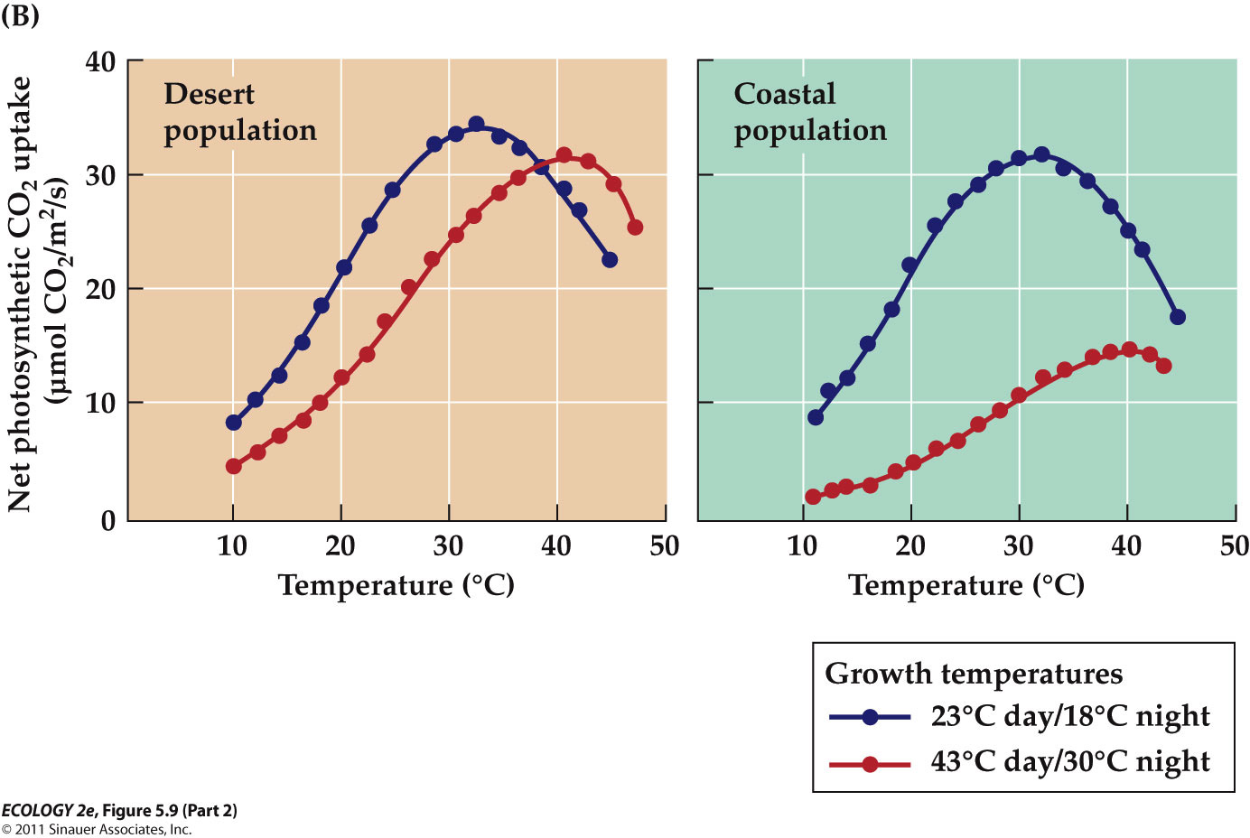
      - Plants shifts to their optima
      - Coastal – although they shift to their optimum, their overall photosynthetic rates drop, as a result of temperature effects on their membrane properties.

  - Nutrients can also affect photosynthesis:
    - Most nitrogen in plants is associated with rubisco (most abundant enzyme that need a lot of nitrogen) and other photosynthetic enzymes.
    - Thus, higher nitrogen levels in a leaf are correlated with higher photosynthetic rates.
    - Why don't all plants allocate more nitrogen to their leaves to increase their photosynthetic capacity ?
      - Nitrogen supply is low, relative to demand for growth and metabolism.
      - Increasing nitrogen content of leaves increases the risk that herbivores will eat them, as plant-eating animals are also nitrogen-starved.

Photosynthetic Pathway

- - Photorespiration lowers the efficiency of photosynthesis
  - Some metabolic processes decrease photosynthetic efficiency.
  - Rubisco can catalyze two competing reactions:
    - Carboxylase reaction: Photosynthesis.
    - Oxygenase reaction: O₂ is taken up, carbon compounds are broken down, and CO₂ is released (photorespiration).
      - Photorespiration (reverse of photosynthesis)

  - Does photorespiration have any benefits?
    - Experiments with Arabidopsis thaliana plants with a mutation that knocks out photorespiration:
      - These plants die under normal light and CO₂ conditions.
      - Hypothesis: Photorespiration may protect plants from damage at high light levels.
      - Altered tobacco plants with high rates of photorespiration showed less light damage than plants with normal or lowered photorespiration rates (Kozaki and Takeba 1996).
  - But photorespiration is not advantageous if CO₂ is low and temperatures high.
    - Such conditions existed 7 million years ago, when C₄ photosynthesis first appeared.

- - C₄ photosynthesis lowers photorespiratory energy loss
  - The C₄ photosynthetic pathway reduces photorespiration, and evolved independently several times.
    - Not just from one common ancestor
  - Many grass species use this pathway, including corn, sugarcane, and sorghum. It involves biochemical and morphological specialization.

  - C₄ separates CO₂ uptake and the Calvin cycle in different parts of the leaf.
    - CO₂ is taken up in the mesophyll by PEPcase, which has greater affinity for CO₂, and does not take up O₂. (lacks oxygenase activity)
    - CO₂ concentration is increased in bundle sheath cells where rubisco is operating in the Calvin cycle, which reduces O₂ uptake by rubisco.

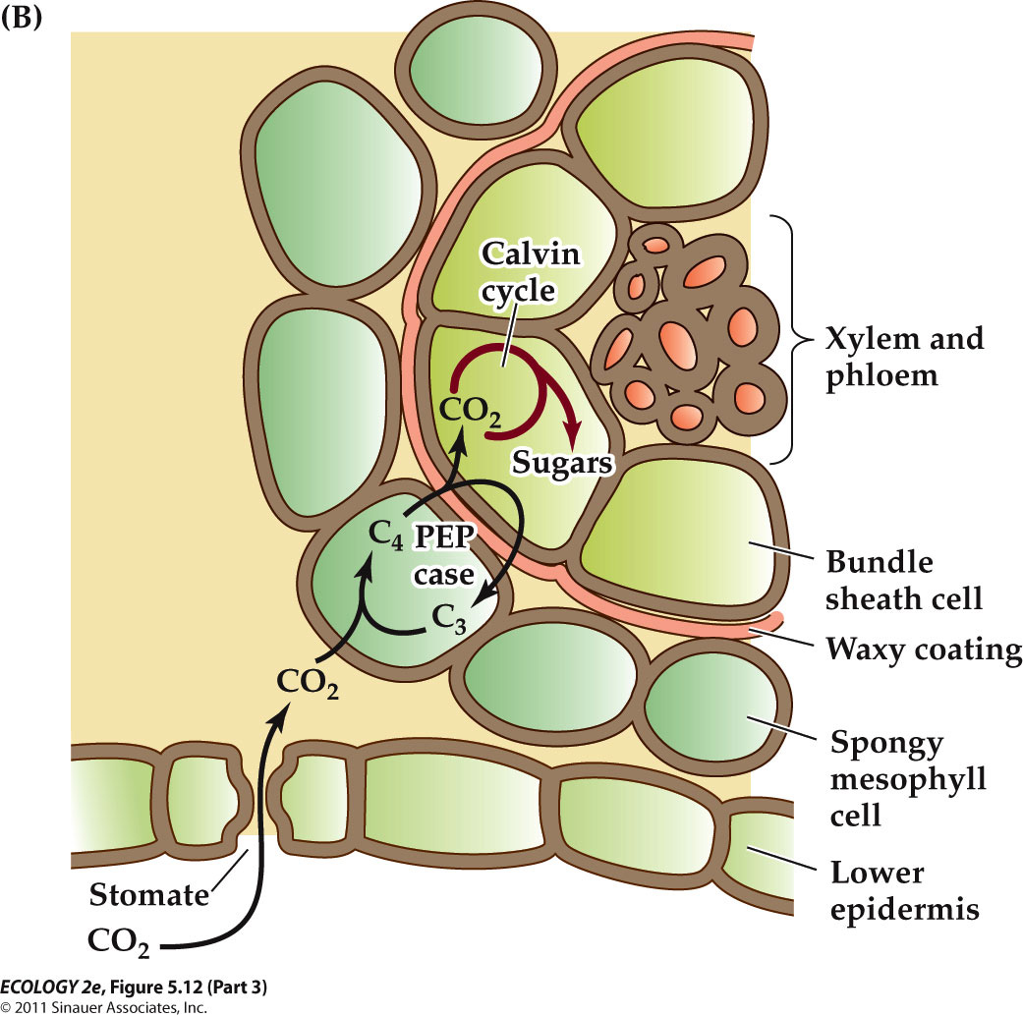
    - The spatial separation of CO₂ uptake and the Calvin cycle effectively minimizes photorespiration.
    - Waxy coating prevents from CO₂ diffusing out
    - The high concentration of CO₂ in the bundle sheath limits the amount of oxygen taken up by rubisco
    - Able to open stromata without having high photorespiration rate.

  - More ATP is required for the C₄ pathway, but higher photosynthetic efficiency gives these plants an advantage at high temperatures.
  - Transpiration losses are minimized because PEPcase can take up CO₂ even when stomates are not fully open.

  - If photosynthetic rates determine ecological success, climatic patterns should predict regions where C₄ plants will dominate.
  - There is a close correlation between temperature and the proportion of C₄ species in the community.

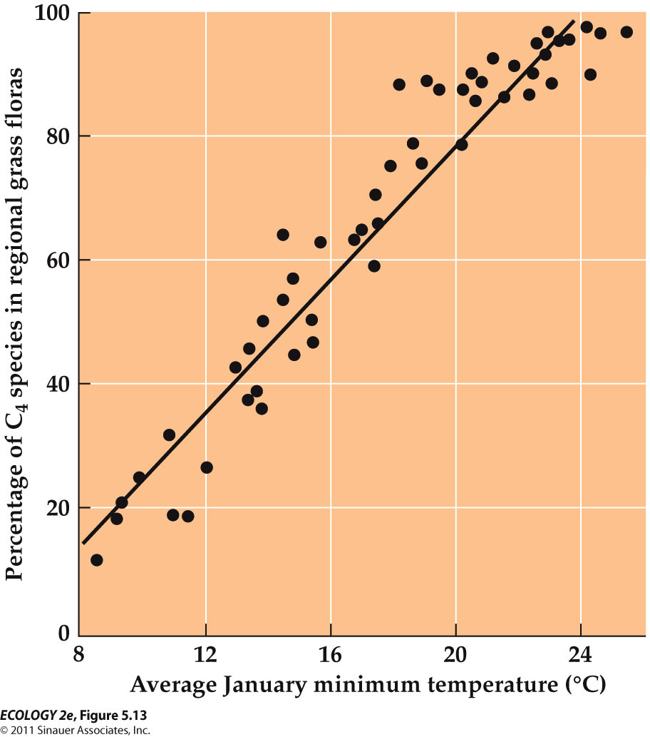
    - The increasing proportions of C4 plants with higher minimum growing-season temperatures suggest that C4 photosynthesis is especially beneficial at high temperatures.
    - The decreasing proportions of C4 plants with lower minimum growing-season temperatures are associated with the cold sensitivity of a key C4 enzyme.

- - CAM photosynthesis enhances water conservation.
  - Crassulacean acid metabolism (CAM) minimizes water loss.
  - CO₂ uptake and the Calvin cycle are separated temporally.
  - CAM plants open their stomates at night when it’s cooler and humidity is higher, and close them during the day.
  - C3 vs. C4 vs. CAM

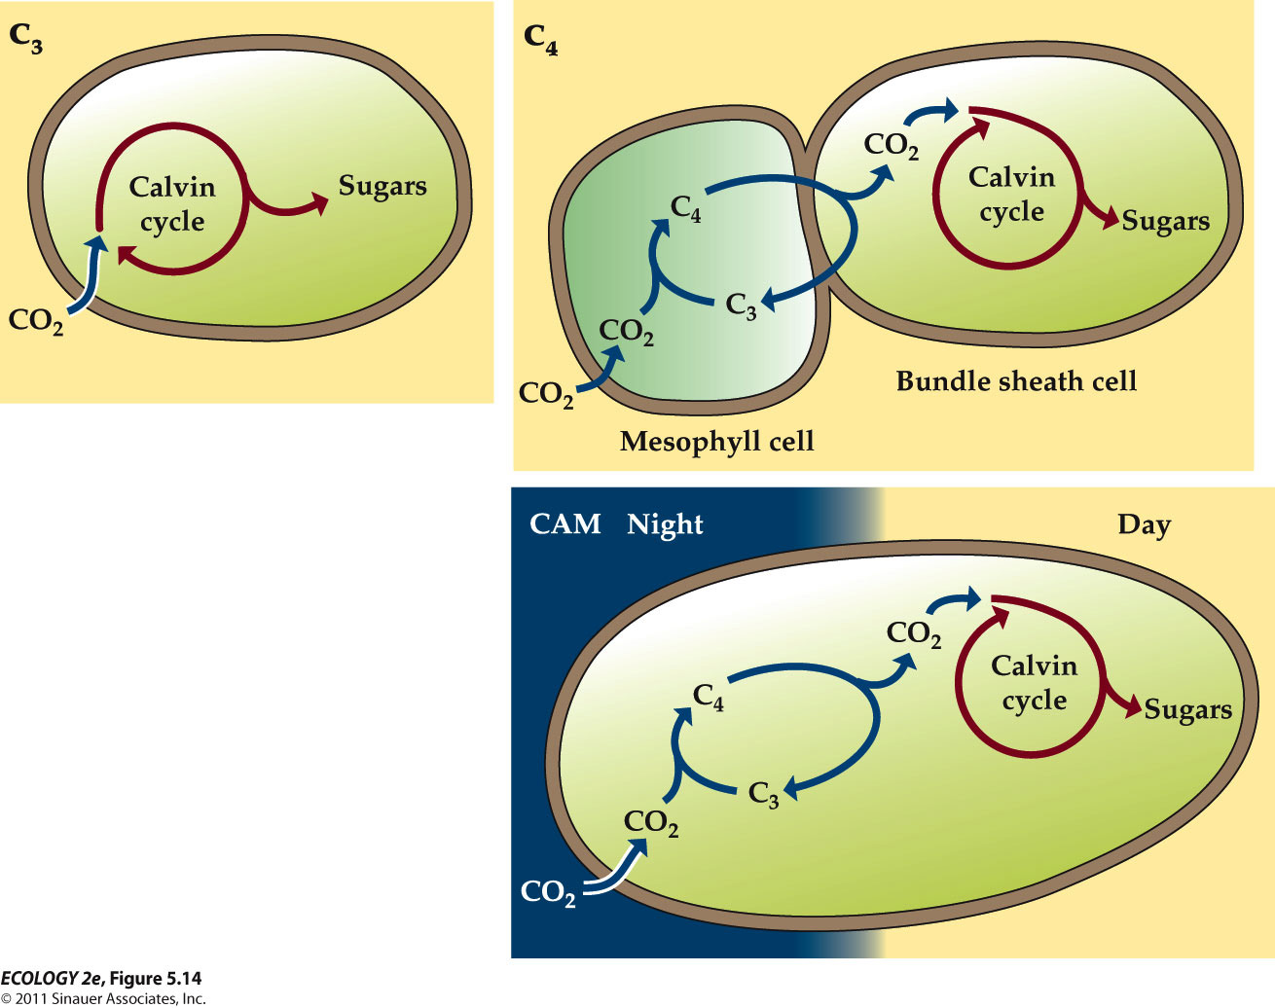
    - C3 takes CO2 in and directly puts it into Calvin cycle.
    - C4 photosynthesis separate CO2 uptake and the Calvin cycle spatially.
    - CAM plants separate these two step separately by only opening stomates at night.
      - Night – CO2 uptake
      - Day – Calvin cycle

  - CAM plants are often succulent, with thick, fleshy leaves or stems.
    - They need big vacuoles to store not only water also C4 compounds
  - They are common in arid environments.
  - Some occur in the humid tropics—mostly epiphytes that grow on tree branches and have less access to water.
    - These epiphytes have less access to water
  - E.g. pineapple, Cacti etc.

HETEROTROPHY

-Food sources differ in their chemistry and availability
  - Heterotrophs consume energy-rich organic compounds (food) and convert them into usable chemical energy (ATP).
  - The energy gain depends on two factors
    - the chemistry of the food
      - some are energy rich, others not
    - how much effort is need to find and ingest the food.
  - Examples :
    - Soil microorganisms that feed on detritus invest little energy to find food, but the food has low energy content.
      - Have to invest a lot of energy to break down those materials
    - A cheetah hunting a gazelle invests a lot of energy to find, chase, and kill its prey, but it gets an energy-rich meal.
    - Soil microorganism <-> cheetah (exact opposite)

- - Heterotrophs obtain food using diverse strategies
  - Feeding methods are accordingly very diverse among heterotrophs.
    - Try to maximize the net energy gain by getting high energy sources with minimum amount of efforts.
  - Multicellular animals have evolved specialized tissues and organs for absorption, digestion, transport, and excretion.
  - They have tremendous diversity in morphological and physiological feeding adaptations. (specializations)
    - Differences in the morphology of insect mouth parts reflect different strategies for effectively capturing and consuming the food types they prefer.
    - Bird bill morphology is associated with the feeding behavior of the species and enhances the capture of its preferred food resources.
  - Toolmaking
    - Humans view toolmaking as something that differentiates us from other animals.
    - But toolmaking in chimpanzees has been known since the 1920s.
      - Jane Goodall observed chimps in the wild using plant stems to retrieve termites from a mound.
    - Some birds also make tools.
      - Crows on South Pacific islands use tools to snag insects from decomposing trees (Hunt 1996).
      - The crows make two different kinds of tools from plant materials.

- Optimal foraging theory address behavioral choices that enhance the rate of energy pain
  - Food availability can vary greatly over time and space.
    - If energy is in short supply, animals should invest in obtaining the highest-quality food that is the shortest distance away.
  - Optimal foraging theory: Animals will maximize the amount of energy gained per unit time, energy, and risk involved in finding food.
    - It assumes that evolution acts on the behavior of animals to maximize their energy gain.
    - Profitability of a food item (P) depends on how much energy (E) the animal gets from the food relative to the amount of time (t) it spends finding and obtaining the food:

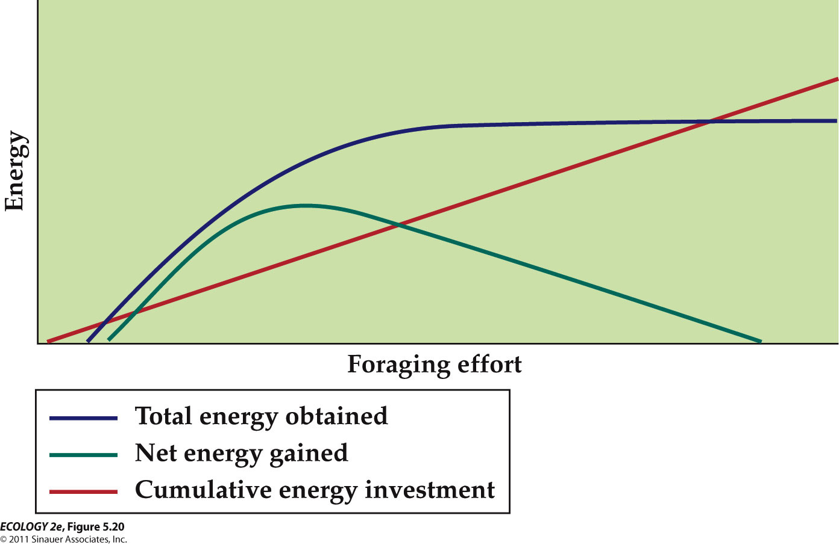
    - The benefit (net energy gain) obtained from the effort invested in foraging is related to the energy gain from the food acquired minus the cumulative energy invested in acquiring that food (effort).
    - An animal’s success in acquiring food increases with the effort it invests; but at some point, more effort results in no more benefit, and the net energy obtained begins to decrease.

  - Tests of optimal foraging theory
    - In a study of Parus major (lab experiment), proportions of prey types and encounter rates were varied.
      - The time it took birds to subdue and consume the prey (handling time) was measured.
      - The model correctly predicted consumption rates of large mealworms as profitability of prey items varied

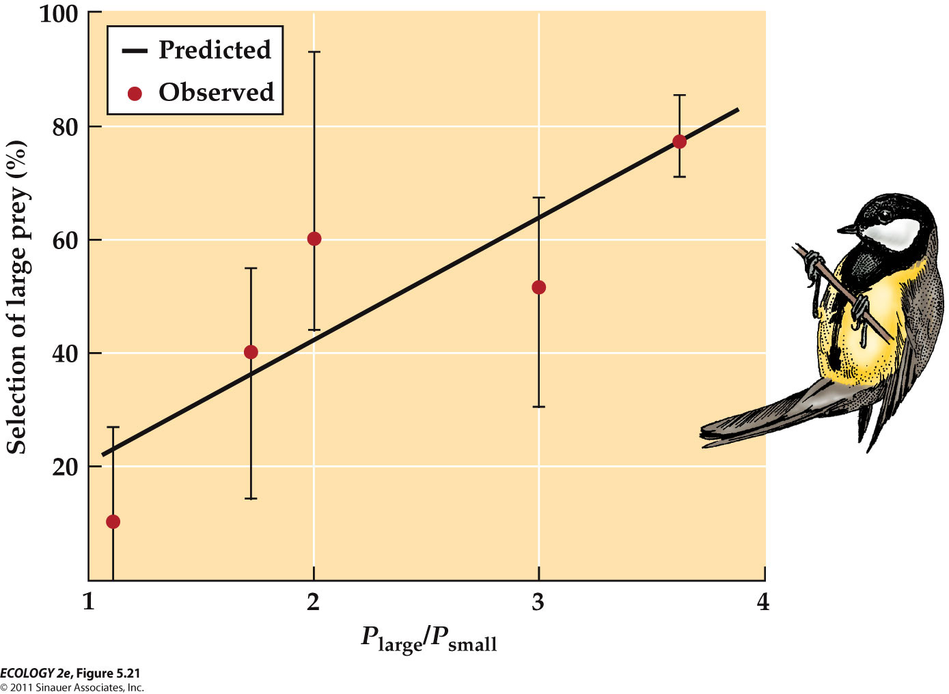
      - The selection of the large prey decreased as predicted, when the profitability of large prey relative to the profitability of small prey decreased.
        - More you profit getting larger ones, more you going to select larger.
      - As the profitability of the large mealworms increased, the birds selected those prey at higher frequencies.

    - A field study of Eurasian oystercatchers (Meire and Ervynck 1986) showed that the birds select prey items in a specific size range.
      - Small bivalves don’t have enough energy to offset the energy needed to find and open them.
      - Largest bivalves are too difficult to

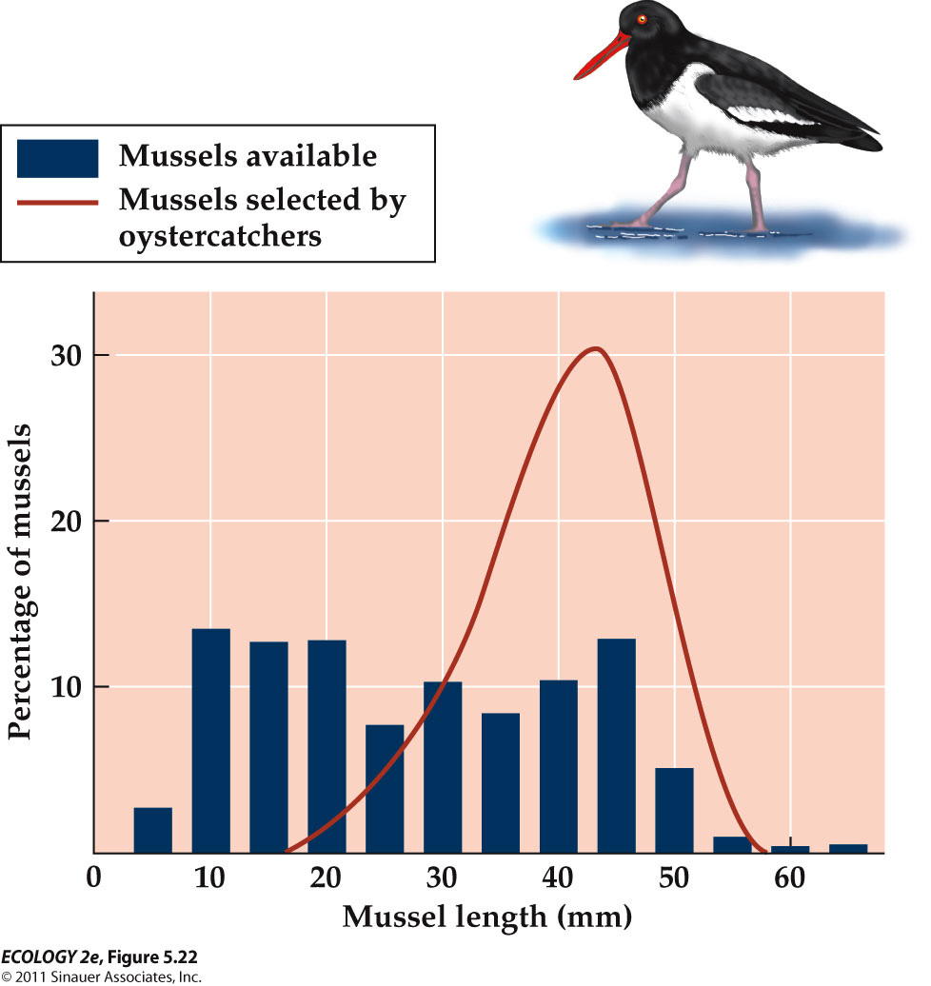
      - oystercatchers selected mussels in the optimal size range, despite the greater abundance of smaller mussels.
    - Northwestern crows (Corvus caurinus) pick up shellfish, then fly up and drop them on rocks to crack them open.
      - Richardson and Verbeek (1986) estimated the size of clams that provide the most benefit, based on energy content, abundance of size classes, and handling time needed.

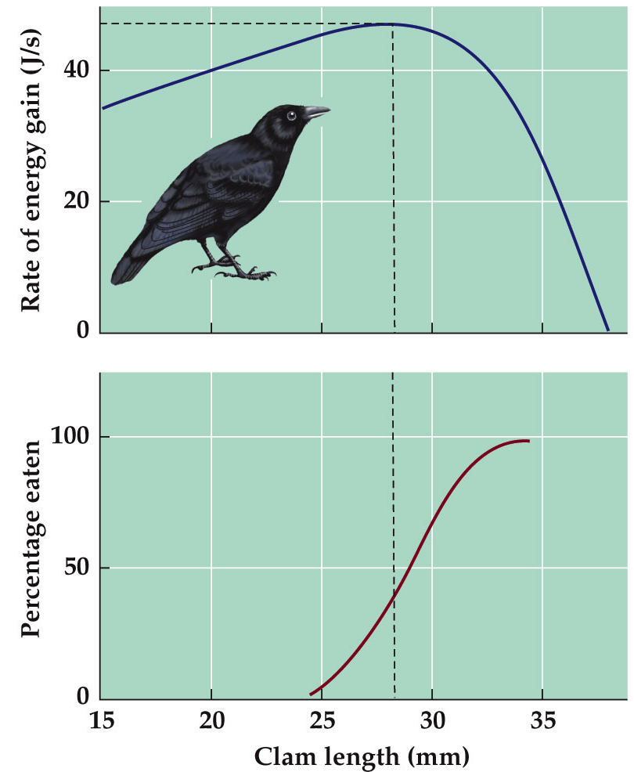

  - Optimal foraging theory considers habitat to be heterogeneous—patches have different amounts of food.
    - To optimize energy gain, an animal should remain in a patch with the highest food density, until it becomes equal to nearby patches.
  - Marginal value theorem (Charnov 1976):
    - An animal should stay in a patch until the rate of energy gain has declined to match the average rate for the whole habitat (giving up time).
    - Giving up time is also influenced by distance between patches.

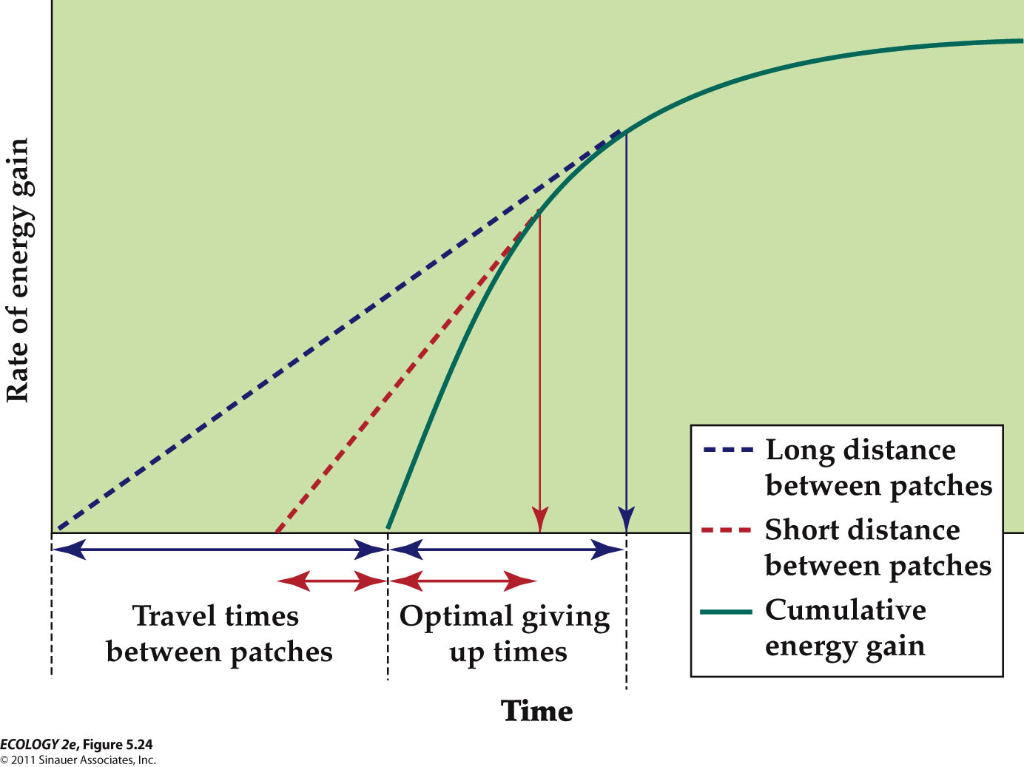
    - A foraging animal will encounter patches containing varying amounts of food. The animal’s rate of energy gain in a patch initially high, but decreases as the animal depletes the food supply. The time the animal spends in a patch should optimize its rate of energy gain per unit of time spent foraging.
      - In case of short distances between patches, giving up time and travel times between patches are shorter.
      - In case of long distances between patches, giving up time and travel time between patches are longer.
    - The longer the travel time between food patches, the longer an animal should spend in a patch.

  - Cowie (1977) tested this in lab experiments with Parus major.
    - A “forest” of wooden dowels contained food “patches” of plastic cups containing mealworms.
    - “Travel time” was manipulated by covering food cups, and adjusting ease of mealworm removal.
    - Results matched predictions made by the theorem very well.
      - The average amount of time the birds spent in a patch was longer when travel times between patches were longer.

  - Munger (1984) tested the theorem in a natural setting, using horned lizards.
    - The lizards eat ants that occur in patches of varying densities.
    - The rate of ant consumption at the giving up time was compared with overall consumption rate.
    - Again, results matched the predictions
      - When they have a habitat that has lots of ants, they give up even with lots of ants because they know they can find more ants in close areas.
      - When living in a habitat with low ants, they will not give up until they find some ants.

  - Optimal foraging theory does not apply as well to animals that feed on mobile prey.
    - Nice theory, but it does not hold many real life examples.
  - The assumption that energy is in short supply, and this dictates foraging behavior, may not always hold.
  - Resources other than energy can be important, such as nitrogen or sodium content of the food

Evolution could happen on much more rapid time scale.

Humans provide very selective pressure globally that can cause changes to organisms.

CASE STUDY : Trophy Hunting and Inadvertent Evolution
  - Bighorn sheep populations have been reduced by 90% by hunting, habitat loss, and introduction of domesticated cattle.
  - Hunting is now restricted; permits for a large “trophy ram” cost over $100,000.
    - BUT trophy hunting removes the largest and strongest males—the ones that would sire many healthy offspring.
      - In one population, 10% of males were removed by hunting each year, the average size of males and their horns decreased over 30 years of study.

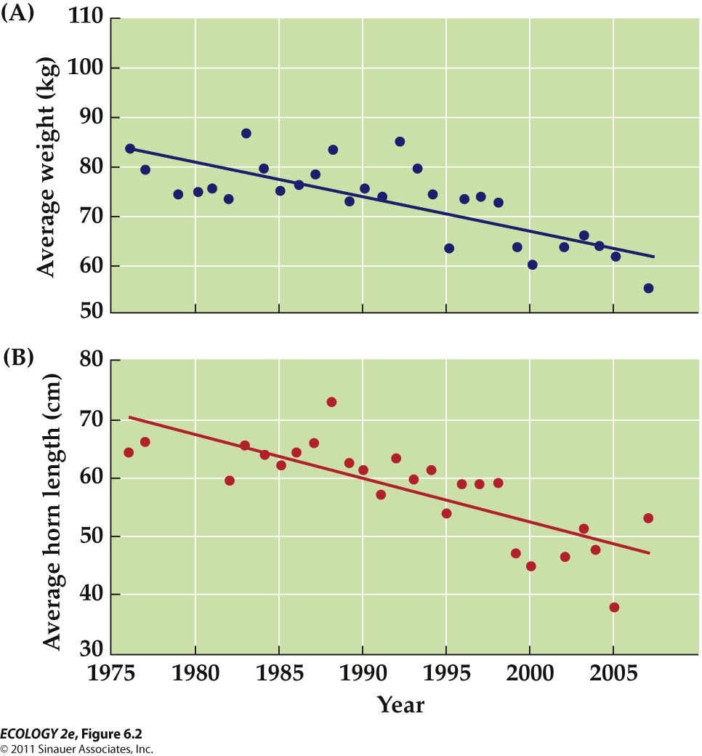
    - Over 30 years of trophy hunting, the average body weight of rams decreased , and the average length of their horns decreased.

  - This is also being observed in other species:
    - African elephants are poached for ivory; the proportion of the population that have tusks is decreasing.
    - Rock shrimp are all born male, and become females when they are large enough to carry eggs. Commercial harvesting takes the largest individuals, which are all females.
      - Genes for switching sex at a smaller size became more common, resulting in more females, but smaller females lay fewer eggs.

WHAT IS EVOLUTION ?
- - Evolution can be viewed as genetic change (frequencies of different allels) over time or as a process of descent with modification.
  - Biological evolution is change in organisms over time.
  - Evolution can be defined more broadly as descent with modification.
    - As a population accumulates differences over time and a new species forms, it is different from its ancestors.
    - But the new species has many of the same characteristics as its ancestors, and resembles them.

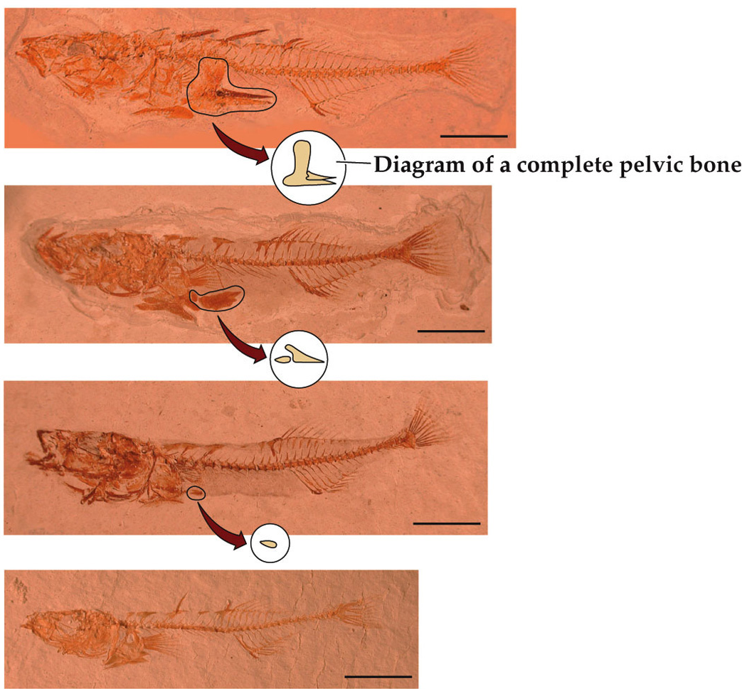
    - Descent with modification : example - changes in pelvic bone
      - Body structure relatively similar but pelvic bone became reduced over time

  - Charles Darwin used the phrase “descent with modification.”
    - He proposed that populations change over time through natural selection:
      - Individuals with certain heritable traits survive and reproduce more successfully than other individuals.

- MECHANISMS OF EVOLUTION

  - Natural selection, genetic drift, and gene flow can cause allele frequencies in a population to change over time.

- Mutation generates the raw material for evolution
  - Phenotype: Observable characteristics that are determined by the genotype.
  - Therefore, individuals differ from one another in part because they have different alleles for genes.

  - Different alleles arise by mutation: Change in DNA.
    - Mutations can result from copying errors during cell division, mechanical damage, exposure to chemicals (mutagens) or high-energy radiation.
  - Formation of new alleles is critical to evolution.
    - If mutation did not produce new alleles, all members of a population would have identical genotypes and evolution could not occur.

  - Mutations are actually very rare.
    - In a generation, one mutation would occur in every 10,000 to 1,000,000 copies of a gene.
      - Some are lethal, some are harmless
    - In one generation, mutation acting alone causes virtually no change in allele frequencies of a population.

  - Recombination also produces different genotypes within a population.
    - Offspring have combinations of alleles that differ from those of their parents.

- Natural selection increases the frequencies of advantageous alleles
  - Some individuals have heritable phenotypes that give them an advantage in survival or reproduction, causing them to leave more offspring than other individuals.
  - 3 types of natural selection
    - Directional selection: Individuals at one phenotypic extreme (e.g., large size) are favored.
      - E.g. Drought favored large beak size in medium ground finches

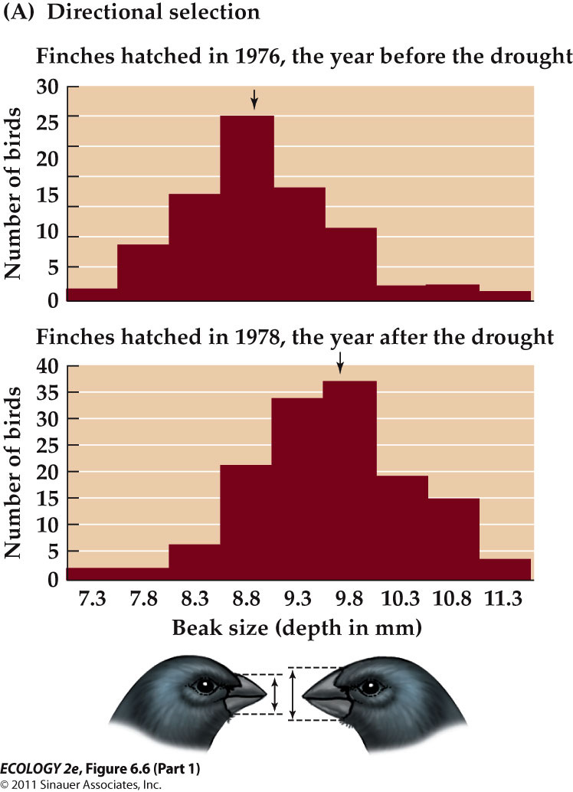
      - The mean beak size increased in 2 years after drought (shifts to the right)
        - As a result of drought, most of the available seeds were large and hard to crack, so birds with large beaks, which could more easily crack those seeds, had an advantage over birds with smaller beaks

    - Stabilizing selection: Individuals with an intermediate phenotype are favored.
      - E.g. Parasitic wasps select for small gall size of Eurosta flies; while birds select for large gall size.

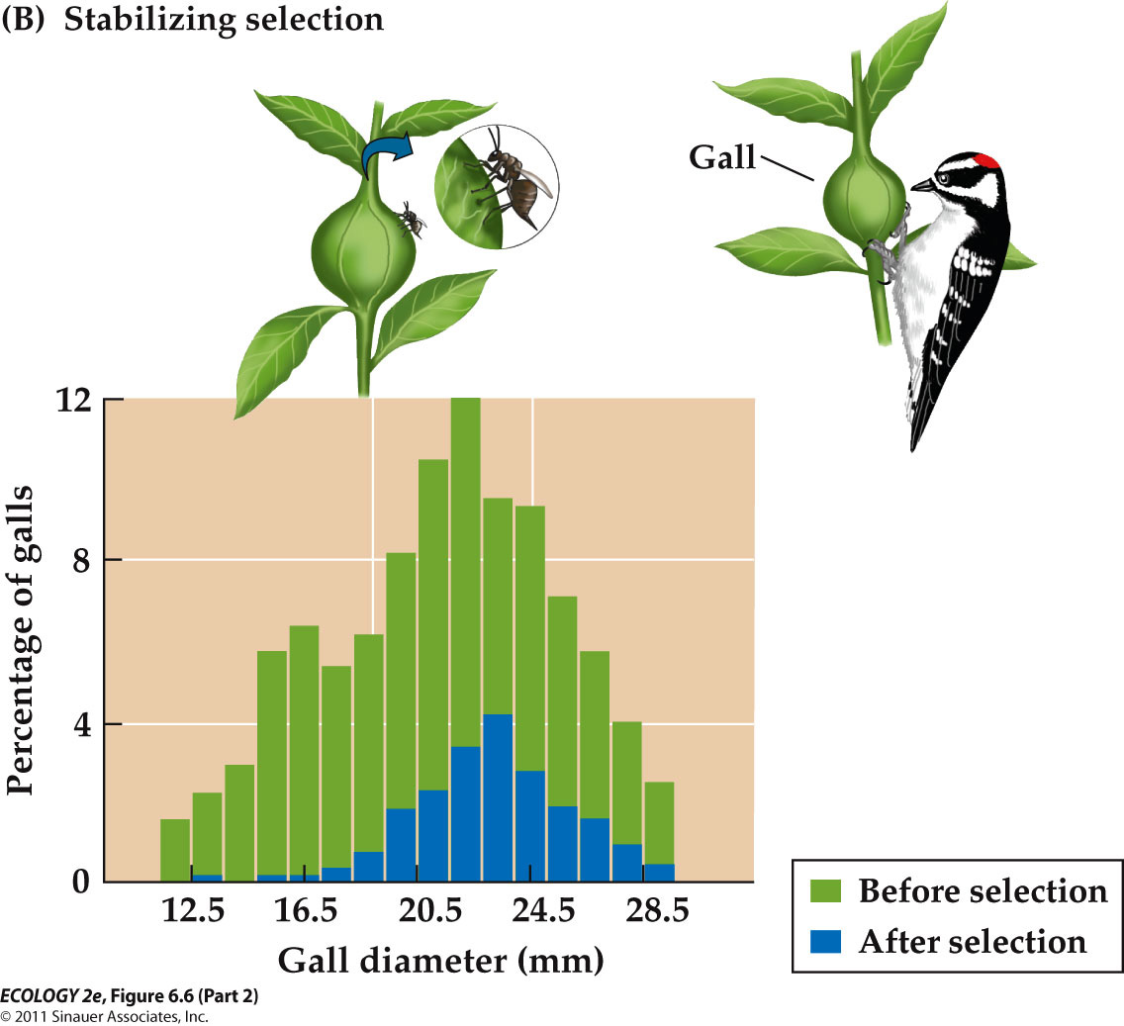
      - Wasps that parasitize by larvae select against small galls
      - Birds that eat fly larvae select against large galls
      - Overall, larvae in galls of intermediate size have an advantage.
    - Disruptive selection: Individuals at both phenotypic extremes are favored.
      - E.g. African seedcrackers (birds) have two food sources—hard seeds that large beaks are needed to crack, and smaller, softer seeds that smaller beaks are more suited to.

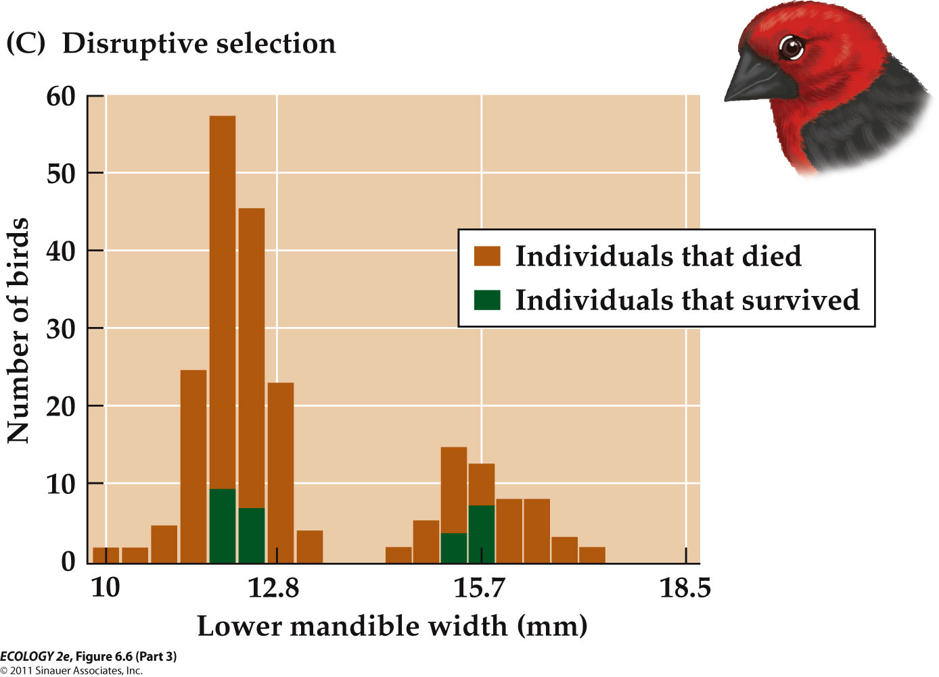
      - Individuals with mandible sizes that are either relatively small or large have an advantage.

- - Genetic drift results from chance events
  - Genetic drift occurs when chance events (random) determine which alleles are passed to the next generation.
    - It is significant only for small populations.
  - Genetic drift has 4 effects on small populations:
    - 1. It acts by chance alone, thus causing allele frequencies to fluctuate at random. Some may disappear, other may reach 100% frequency (fixation).

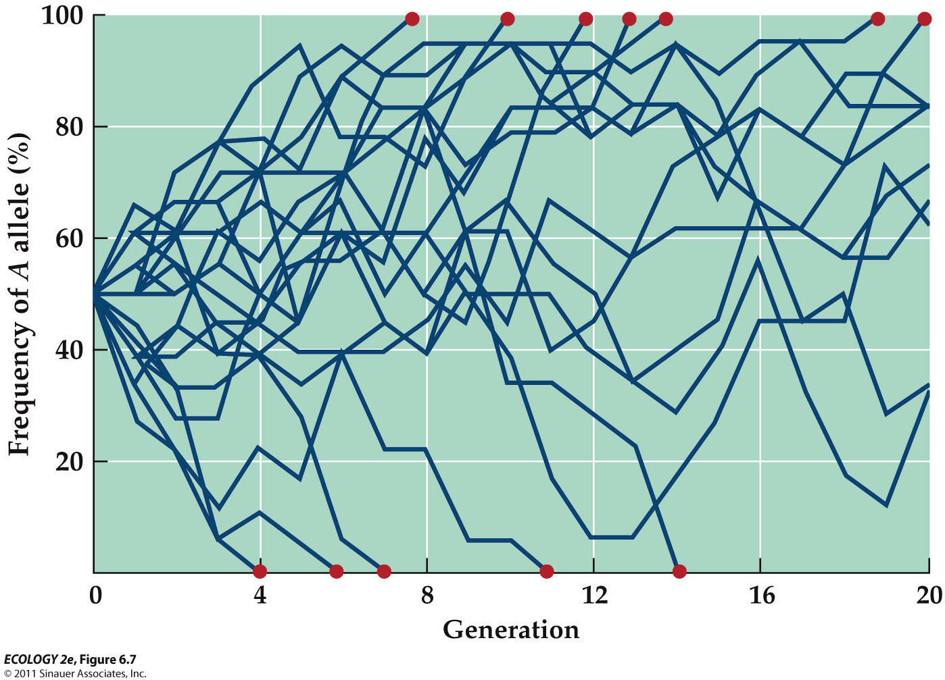
      - Initially, start with 50% alleles frequency.
      - Some fixed at 0 or 100% - loosing genetic variation
    - 2. Because some alleles are lost, genetic variation of the population is reduced.
    - 3. Genetic drift can increase the frequency of a harmful allele.
      - Genetic drift acts on alleles that neither harm nor benefit organism.
      - Natural selection reduces the frequency of a harmful allele.
      - BUT, If the population size is very small and the allele has only slightly deleterious effects, genetic drift can “overrule” the effects of natural selection, causing the harmful alleles to increase or decrease in frequency by chance alone.
    - 4. Differences between populations can increase.

    - 2. and 3. can have dire(bad) consequences.
      - Loss of genetic variation reduces the ability of the population to respond to changing environmental conditions.
      - Increase of harmful alleles can reduce survival and reproduction.
        - Both increasing the risk of extinction
      - These effects are important for species that are near extinction.

    - Greater prairie chicken populations in Illinois have been reduced by loss of habitat to farmland.
      - In 1993, population was <50. DNA from this population compared with museum specimens from the 1930s showed a decrease in genetic variation.
      - 50% of eggs failed to hatch, suggesting fixation of harmful alleles

- - Gene flow is the transfer of alleles between populations
  - Gene flow: Alleles move between populations via movement of individuals or gametes.
  - Gene flow has two effects:
    - Populations become more similar.
    - New alleles can be introduced into a population.

  - In the 1960s, new alleles that provide resistance to insecticides arose by mutation in mosquitoes in Africa or Asia.
    - Mosquitos with the new alleles were blown by winds or transported by humans to new locations.
    - If mosquitoes in those new locations are exposed to insecticides, natural selection causes the frequency of the resistance alleles to increases rapidly.

ADAPTATIVE EVOLUTION

- Adaptations result from natural selection
  - Natural selection is the only evolutionary mechanism that consistently causes adaptive evolution.
  - Adaptations are features of organisms that improve their ability to survive and reproduce.
  - Adaptation is quite variable.
  - Natural selection is not a random process.
    - By consistently favoring individuals with certain alleles, natural selection causes adaptive evolution—traits that confer advantages tend to increase in frequency over time.
  - Example: Soapberry bugs feed on fruits by piercing them with a needle-like beak.
    - Feeding is most efficient if beak size matches fruit size.
    - In populations with different food sources, Carroll and Boyd (1992) predicted that beak size would evolve to adapt to fruits of introduced tree species.

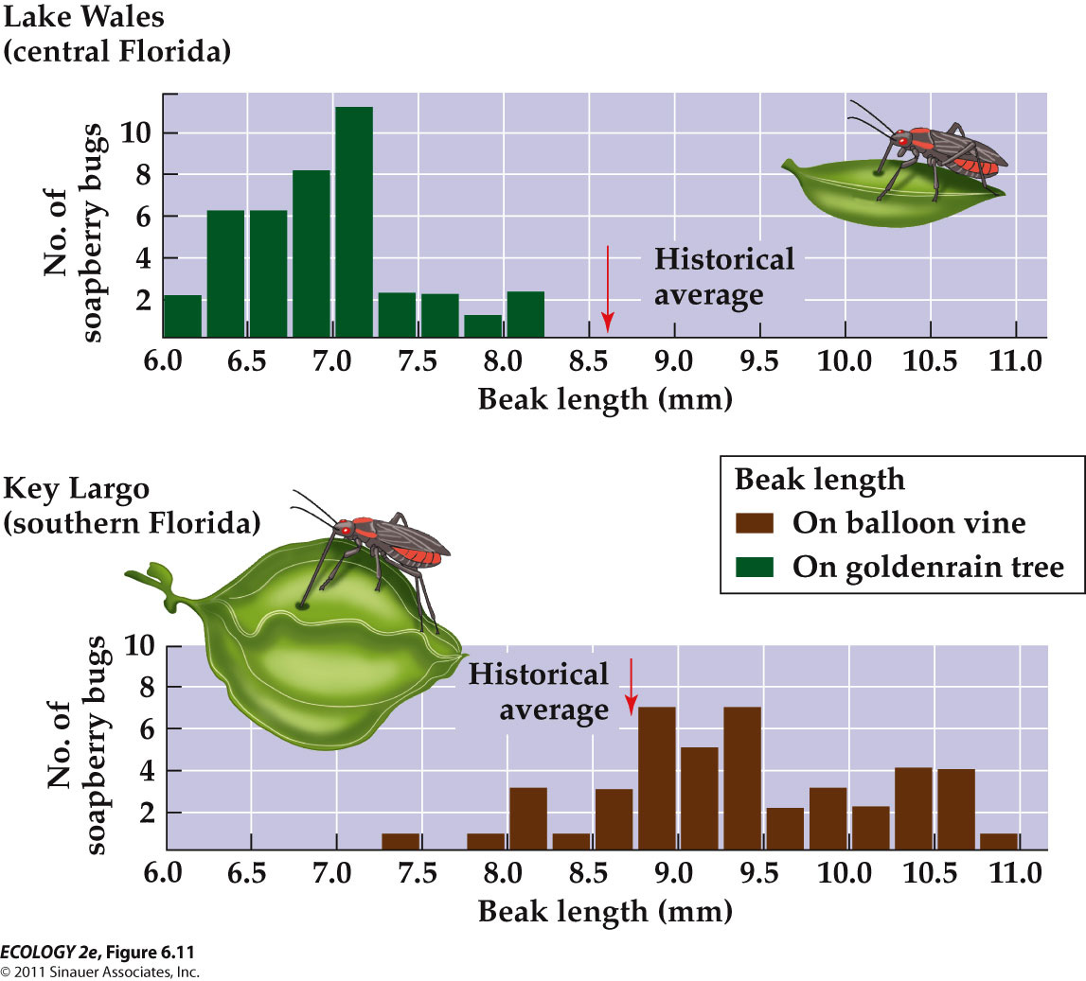
    - (bottom)the historical average is very close to what we observed.
    - (top) the historical average is very greater than what we observed.
      - Adaptive evolution in which a characteristic of the organism (beak size) evolved to match an aspect of its environment (fruit size) more closely.
    - Beak length is a heritable trait, so the observed changes must have been due to changes in allele frequencies.
    - The goldenrain tree was introduced to Florida about 35 years ago, so natural selection caused adaptive evolution in a relatively short times.

- - Adaptive evolution can occur rapidly
  - There are many examples of rapid adaptive evolution:
    - Antibiotic resistance in bacteria. (in days to months)
    - Insecticide resistance in insects. (in months to years)
      - because their generation times can be very rapid
    - Drab coloration in guppies, which makes them harder for predators to see. (several years)
    - Increased beak size in Geospiza finches. (several years)

  - Rapid adaptive evolution can happen on a continental scale.
    - Clines are patterns of change in a characteristic over a geographic region.
  - E.g. In Drosophila, the Adh^{S} allele of the alcohol dehydrogenase gene decreases in frequency as latitude increases.
    - Adh^{S} is less effective in colder temperatures, so natural selection resulted in this cline with latitude.
    - In the past 20 years in Australia, the Adh^{S} cline has shifted about 4° latitude south, as mean temperature has increased 0.5°C.
    - This shift indicates an adaptive change in allele frequency in response to climate change.

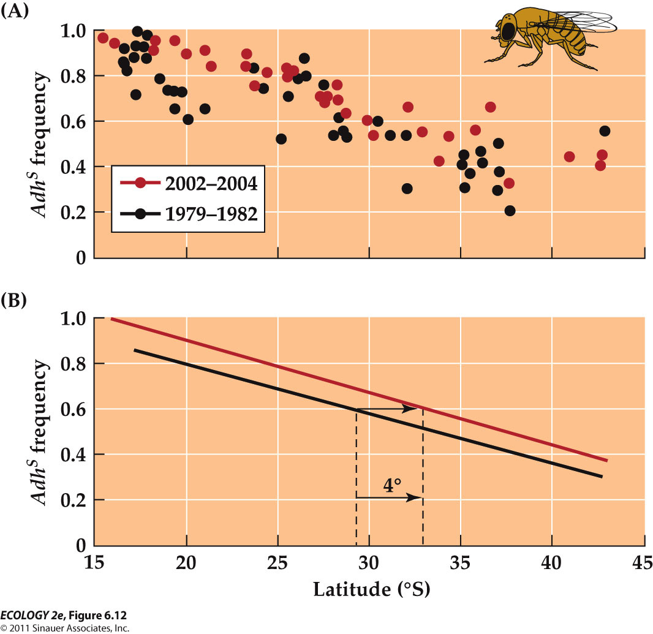
    - The frequency of the alleles has increased at all latitudes over a 20-year period as the climate has warmed.
  - Rapid evolutionary changes that are correlated with global warming have been observed in worldwide population of fruit fly species.

  - Evolutionary response to climate change has also been documented in other insects, mammals, and plants.
  - Hundreds of other species have altered the timing of life events such as delaying the onset of winter dormancy or reproducing earlier in the spring.
    - Response to climate change

- - Gene flow can limit local adaptation to local conditions.
  - Adaptive evolution can occur in a population if the natural selection forces are strong enough to overcome gene flow.
  - Example: Bentgrass populations
    - 2 genotypes
      - one that can grow on heavy metal sites & one that cannot.
    - Bentgrass can grow in soils that are contaminated with heavy metals.
    - At former mine sites, the tolerant genotypes were dominant, but also occurred in populations growing in normal soils.
    - Bentgrass is wind-pollinated, so alleles are easily carried to other populations.
    - Plants at the mine site also received pollen (alleles) from the population on normal soils, but allele frequencies didn’t change—at the mine site there was very strong selection against plants without tolerance to heavy metals( they survive poorly on mine soils).
    - Natural selection was strong enough to overcome the effects of ongoing gene flow.

- - Adaptations are not perfect
  - Natural selection does not result in a perfect match between organisms and their environments; environments are constantly changing, and there are constraints on adaptive evolution:
    - Lack of genetic variation : If there is no beneficial allele, adaptive evolution at that gene cannot occur.
      - Example: Initially, mosquito populations lacked alleles for pesticide resistance, so the pesticides were effective.
      - Advantageous alleles arise by chance, not “on demand.”
    - Evolutionary history : Natural selection works on traits that already exist.
      - Organisms have certain characteristics and lack others because of their ancestry.
      - Example: Dolphins evolved from terrestrial mammals; they have lungs and cannot “breathe” underwater.
    - Ecological trade-offs : The ability to perform one function may reduce the ability to perform another function.
      - E.g. Female red deer that reproduced died at a higher rate than female red deer that did not reproduce.
        - Reproductive costs
  - Adaptations represent compromises in the abilities of organisms to perform different and sometimes conflicting functions.

THE EVOLUTIONARY HISTORY OF LIFE

- the diversity of life results from speciation
  - Species: Groups of organisms whose members have similar characteristics and can interbreed.
  - Speciation: The process by which one species splits into two or more species. (cannot interbreed)
    - Speciation most commonly occurs when a barrier prevents gene flow between two or more populations of a species.
    - Barriers can be geographic (mountains, lakes …) or ecological (e.g. when some members of an insect population begin to feed on a new host plant).
    - The populations then diverge genetically over time.

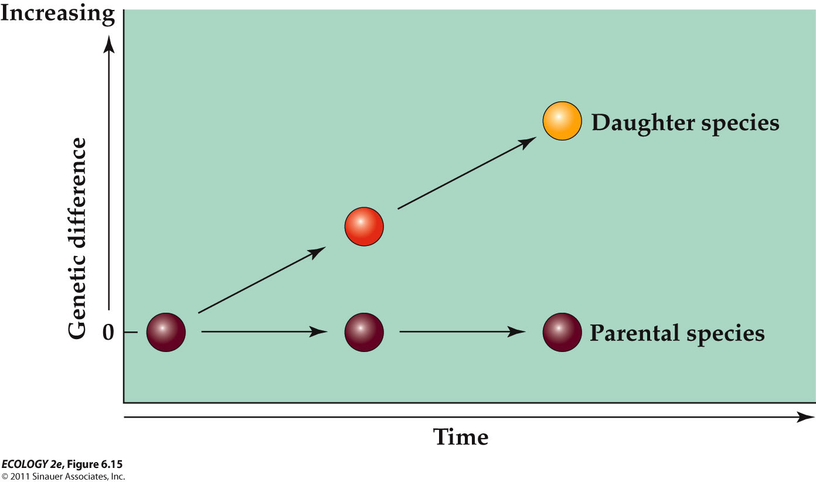
    - The key step in speciation occurs when a population accumulates so many genetic differences that they cannot produce viable, fertile offspring if they mate with the parental species.

  - Reproductive barriers can arise as a by-product of natural selection.
    - Example: Experiments with two populations of fruit flies selected to grow on different food sources.
      - After 40 generations, most matings occurred between flies feeding on the same food source.

  - In some cases, a trait favored by selection is the same trait that drives speciation.
    - Example: Mosquitofish in pools with fish predators have evolved a body shape (nice and smooth) for high-speed escape swimming.
      - Female mosquitofish prefer to mate with males that have the same body shape (nice and smooth) as they do.
      - Natural selection favors different body shapes in mosquitofish, depending on the presence or absence of predators.
      - The different body shapes drive the early stages of speciation through their effects on mate choice.

  - Genetic drift can also lead to evolution of reproductive barriers.
    - But gene flow slows down or prevents speciation.
    - Because populations that exchange many alleles tend to remain genetically similar to another, making it less likely that
  - Populations that exchange alleles tend to remain genetically similar, reproductive barriers will evolve.

  - The rise of new species in one group can lead to increased diversity of other groups.
    - Example: When apples were introduced into North America, some apple maggot fly populations switched to eating apples. These populations are probably forming a new species.
      - Populations of parasitic wasps that feed on apple maggot flies have also diverged and become reproductively isolated from the parent species.

- JOINT EFFECTS OF ECOLOGY AND EVOLUTION

- - Evolution can alter ecological interactions.
  - If a predator evolves a new way to capture prey, prey species may go extinct, decline, migrate to other areas, or evolve new ways to cope with the more efficient predator.

  - About 2 million years ago, 70% of marine species were lost in the western Atlantic.
    - This event affected the behavior of predatory snails because their predators and competitors were reduced.
    - In experiments on modern snails, edge drilling increased when densities of competitor species were increased.
      - Take less time to penetrate the shell but the snail risks amputation of its feeding organ.

  - Human actions can alter the course of evolution. Habitat fragmentation leaves isolated patches, which can affect evolutionary processes.

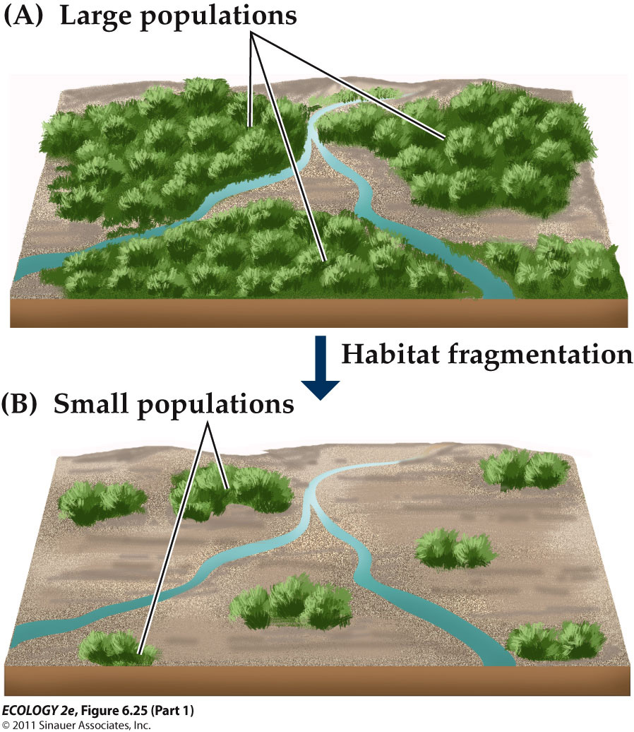
    - Prior to habitat fragmentation, there are many individuals in the species’ populations, and the distance between populations are short.
    - When human activities remove large portions of the species’ habitat, its population sizes shrink, and the distances between populations increases, causing evolutionary changes that decrease its potential for adaptive evolution and increase risk of extinction.

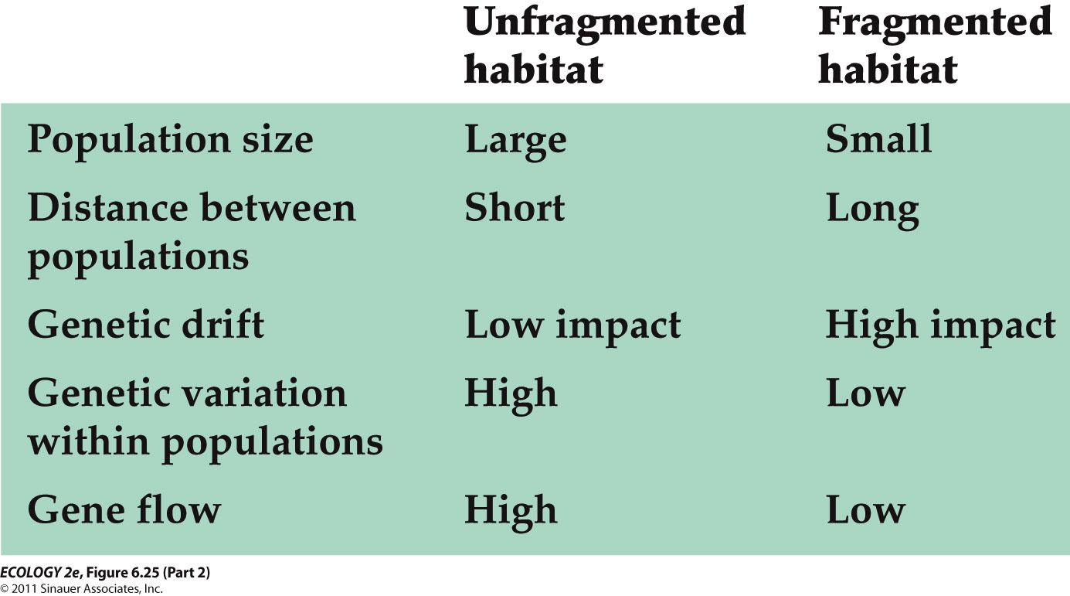

  - An organism’s life history is a record of events relating to its growth, development, reproduction, and survival.
  - Life history characteristics include:
    - Age and size at sexual maturity.
    - Amount and timing of reproduction.
    - Survival and mortality rates.

CASE STUDY : Nemo Grows Up
  - In real life, two to six clownfish spend their entire adult lives within one sea anemone, but those clownfish are not usually related to one another.
  - The largest fish is a female; the next largest is the breeding male. The remaining fish are immature nonbreeders.
  - There is a strict pecking order in the group, based on body size.
  - If the female dies, the breeding male changes sex to become a female, and the next largest nonbreeder increases in size and becomes the new breeding male.
  - Hatchlings move out of the anemone, and juveniles (kids) must find a new anemone to inhabit.

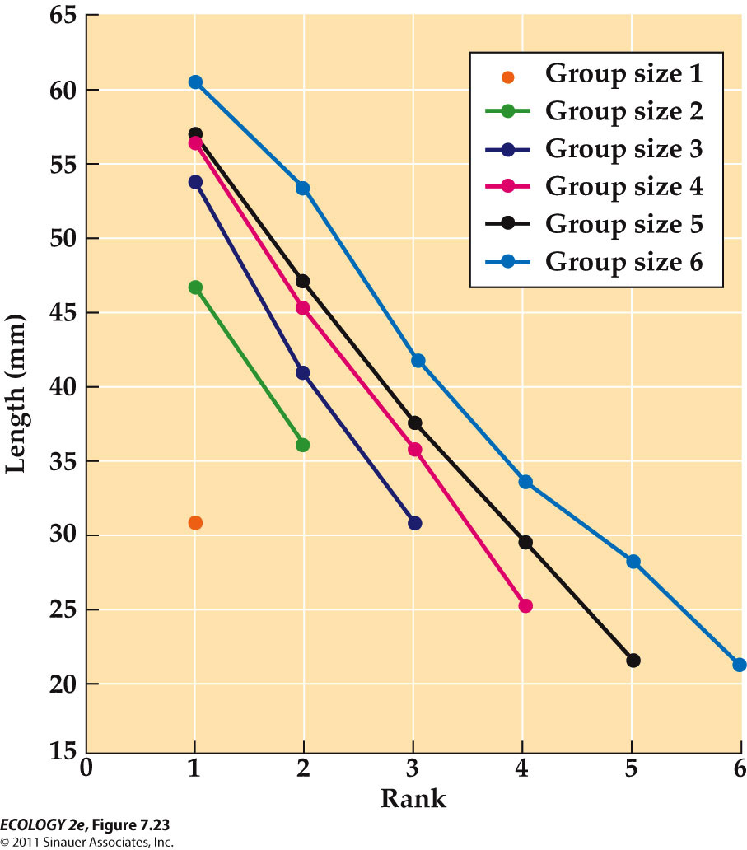
    - Clownfish within a anemore regulate their growth to maintain a hierarchy in which each fish belongs to a distinct size class. Anemore may be home to between one and six fish, and the size of each fish is determined by the fish’s rank and the size of the group in which it lives.
  - But how do they maintain the strict hierarchy within the anemone?
    - Experiments with clownfish show that hierarchy is maintained by regulating growth rates (Buston 2003).
    - If two fish become similar in size, a fight results and one is expelled from the anemone.
  - Why do the clownfish maintain the hierarchy?
    - They are completely dependent on protection by the sea anemone. They are easy prey outside the anemone.
  - Conflicts result in expulsion and death, probably without having reproduced.
    - So there is strong selection pressure to avoid conflict. Sea anemones are a scarce resource for clownfish.
    - Growth regulation mechanisms have evolved because individuals that avoid growing to a size that necessitates conflict are more likely to survive and reproduce.

  - Sequential hemaphroditism: Change in sex during the course of the life cycle.
    - Timing should take advantage of high reproductive potential of different sexes at different sizes.

LIFE HISTORY DIVERSITY

- - Individuals with species differ in their life histories.

  - Individuals within a species show variation in life history traits due to genetic variation or environmental conditions.
  - The life history strategy of a species is the overall pattern in average timing and nature of life history events.
    - It is shaped by the way the organism divides its time and energy between growth, reproduction, and survival.

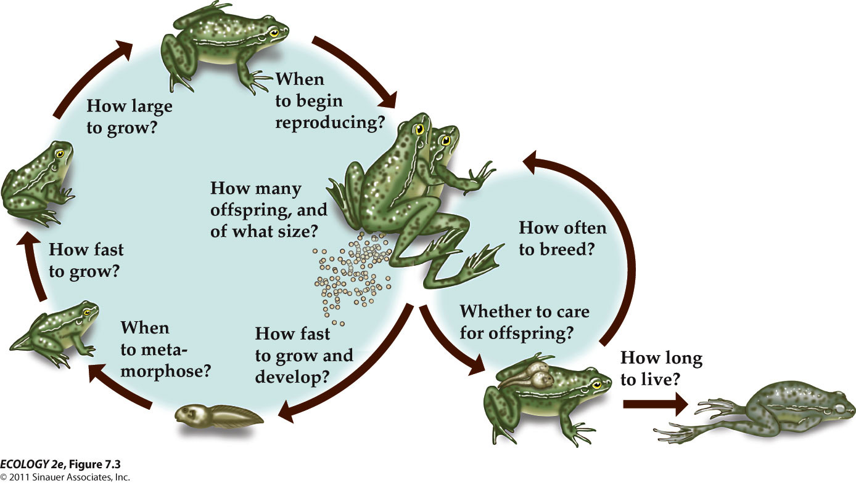

- Genetic Differences
  - Some life history traits are determined genetically.
  - Natural selection favors individuals whose life history traits result in their having a better chance of surviving and reproducing.
  - Ideal or optimal life histories maximize fitness (genetic contribution to future generations).
    - But none are perfect; all organisms face constraints and ecological trade-offs.
      - An increase in the performance of one function (such as reproduction) can reduce the performance of another (such as growth or survival).

Environmental Differences
  - Phenotypic plasticity: One genotype may produce different phenotypes under different environmental conditions.
    - For example, growth and development may be faster in higher temperatures.
    - If low phenotypic plasticity, same phenotype under growth condition; no change

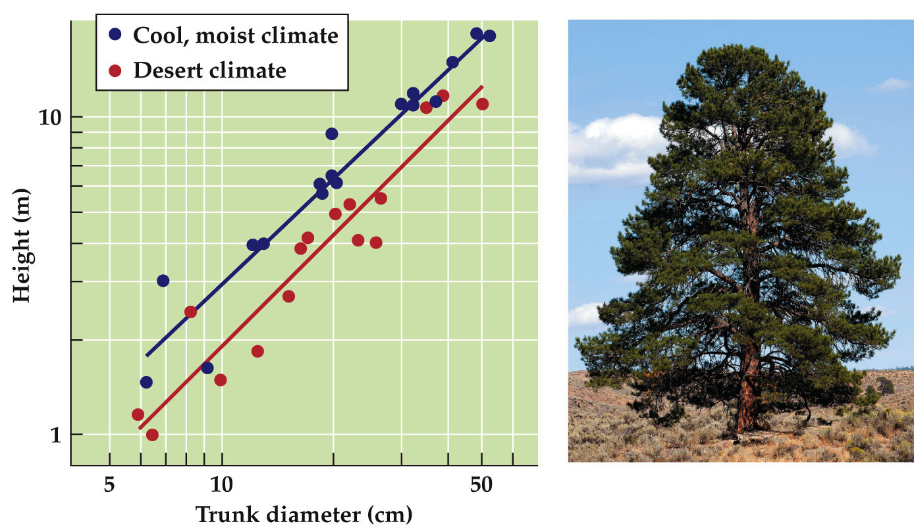
    - Changes in life history traits can cause change in adult morphology
      - The pine trees in cool, moist climate (taller) allocate more resources to leaf production than do trees in desert climates. (wider diameter)
  - Phenotypic plasticity may result in a continuous range of sizes; or discrete types called morphs.
    - Polyphenism—a single genotype produces several distinct morphs.
    - E.g. Spadefoot toad tadpoles have small omnivore morphs and larger carnivore morphs.

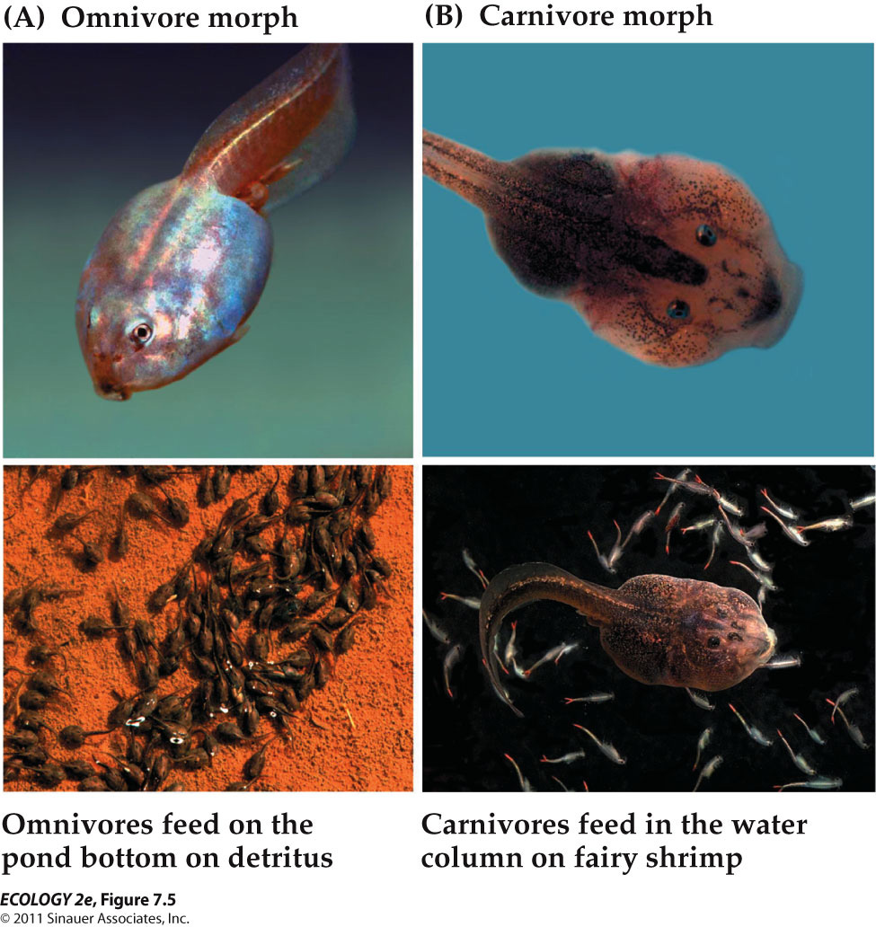
    - These tadpoles can develop into smaller headed omnivores or large-headed carnivores, depending on the food they consume early in development.
      - Carnivore tadpoles grow faster and metamorphose earlier. They are favored in ephemeral ponds that dry up quickly.
      - Omnivores grow more slowly and are favored in ponds that last longer; they metamorphose in more favorable conditions and have more chance of survival.

  - Different body morphology results from different growth rates of body parts in both the Ponderosa pines and spadefoot toads.
  - Allometry: Different body parts grow at different rates, resulting in differences in shape or proportion.
    - Opposite of allometry : isometric

- Modes of reproduction is a basic life history trait

  - Asexual reproduction: Simple cell division (binary fission)—all prokaryotes and many protists.
  - Some multicellular organisms reproduce both sexually and asexually (e.g., corals).

  - Sexual Reproduction
    - Benefits of sexual reproduction: Recombination promotes genetic variation and increased ability to respond to environmental challenges.
    - Disadvantages: An individual transmits only half of its genome to the next generation; population growth rate is slower.

    - Isogamy: Gametes are equal in size.
      - e.g. the green alga Chlamydomonas reinhardii
    - Anisogamy: Gametes of different sizes.
      - Usually the egg is much larger and contains nutritional material.
      - Most multicellular organisms produce anisogametes

- - Life cycles are often complex

  - Some species have direct development—the fertilized egg develops into a juvenile without passing through a larval stage.
    - Most vertebrates have simple life cycles without abrupt transitions.
  - BUT complex life cycles are common in insects, marine invertebrates, amphibians, and in some plants, algae, protists and fishes.
  - Complex life cycles have at least two stages, with different body forms and that live in different habitats.
    - Metamorphosis: Abrupt transition in form between the larval and juvenile stages.
    - 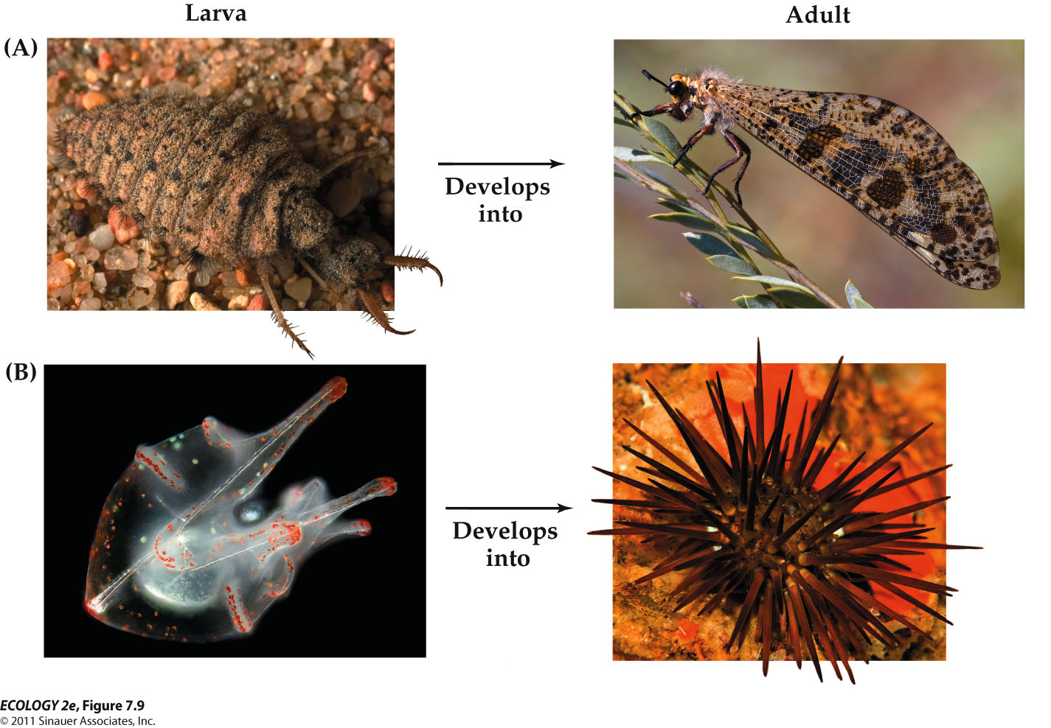
    - These species undergo metamorphosis.

- LIFE HISTORY CONTINUA

  - Classification schemes for reproductive patterns place the patterns on continua with extremes at each end.

- - Some organisms reproduce only once while others reproduce multiple times.
  - One way of classifying the reproductive diversity of organisms is by the number of reproductive events in an individual’s lifetime.
    - Semelparous species reproduce only once.
      - Annual plants
      - Agave – vegetative growth can last up to 25 years (but also produces clones asexually)
    - Iteroparous species can reproduce multiple times.
      - Trees such as pines and spruces.
      - Most large mammals.

- - Live fast and die young or slow and steady wins the race ?
  - r-selection and K-selection describe two ends of a reproductive strategy continuum.
  - r-selection - (“live fast, die young”)
    - r is the intrinsic rate of increase of a population.
    - r-selection: For high population growth rates; an advantage in newly disturbed habitats and uncrowded condition.
    - Short life spans, rapid development, early maturation, low parental investment, high reproduction rates.
    - Most insects, small vertebrates such as mice, weedy plant species.
  - K-selection - (“slow and steady”)
    - K is the carrying capacity for a population.
    - K-selection: For slower growth rates in populations that are at or near K; this is an advantage in crowded conditions; efficient reproduction is favored.
    - Long-lived, develop slowly, late maturation, invest heavily in each offspring, low reproduction rates.
    - Large mammals, reptiles such as tortoises and crocodiles, and long-lived plants such as oak and maple trees.’

- - Plant life histories can be classified based on habitat characteristics
  - One classification scheme for plant life histories is based on stress and disturbance (Grime 1977).
    - Stress—any abiotic factor that limits growth.
      - Extreme temperatures, shading, low nutrient levels, water shortages, etc.
    - Disturbance—any process that destroys plant biomass.
      - Fire, outbreaks of herbivorous
  - Four habitat types possible:
    - Low stress, low disturbance.
      - Competitive plants with superior ability to acquire light, minerals, water, and space—have a selective advantage.
    - High stress, low disturbance.
      - Stress-tolerant plants with phenotypic plasticity, slow rates of water and nutrient use—not palatable to herbivores.
    - Low stress, high disturbance.
      - Ruderal plants with short life span, rapid growth rates, heavy investment in seed production.
      - Can exploit habitats after disturbance has removed competitors.
      - Seeds can survive a long time until conditions are right for rapid germination and growth.
    - High stress, high disturbance—not suitable for plant growth.

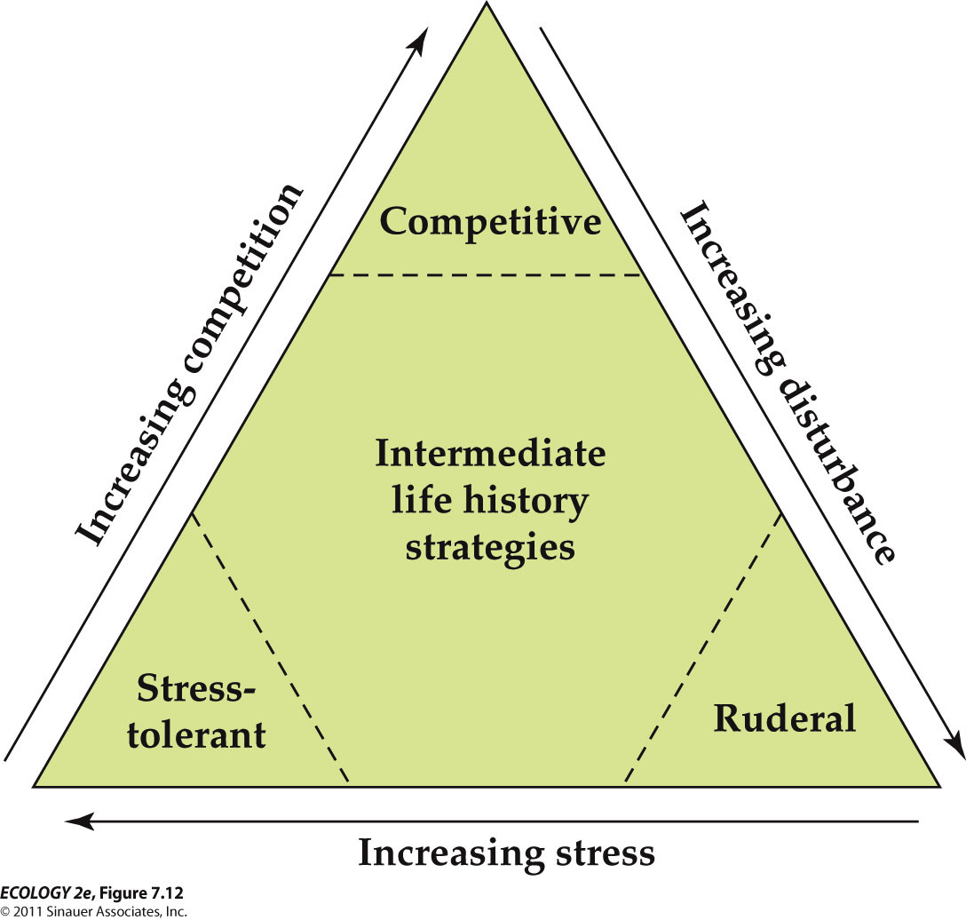

- TRADE-OFFS

  - Trade-offs: Organisms allocate limited energy or resources to one function at the expense of another.

- - There is a trade-off between number and size of offspring

  - Trade-offs between size and number of offspring:
    - The larger the investment in each individual offspring, the fewer offspring can be produced.
  - Investments: Energy, resources, and loss of time for other activities such as foraging.

- Lack clutch size
  - “Lack clutch size”: Maximum number of offspring a parent can successfully raise to maturity.
    - Named for David Lack (1947) who noticed that bird’s clutch size increases with latitude; longer daylight hours may allow parents more time to forage and feed more offspring.

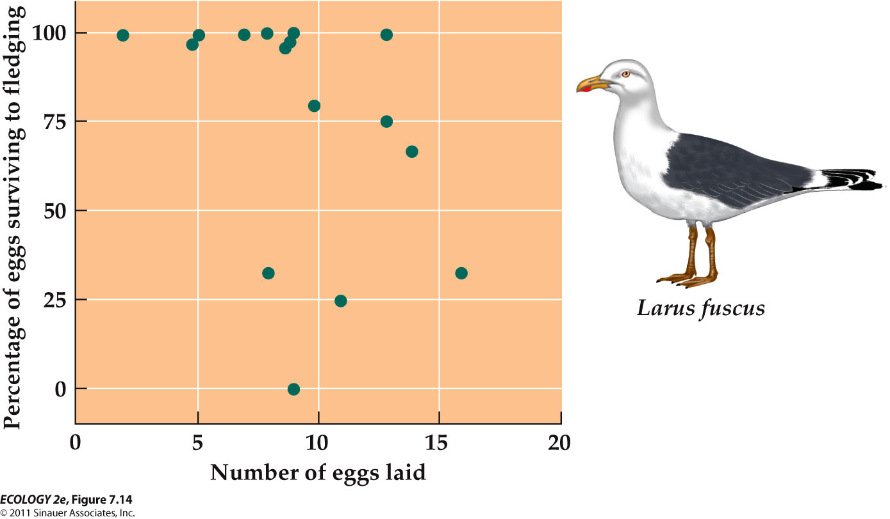
      - Experimental manipulation of clutch size in lesser black-backed gulls showed that in larger clutches, offspring have less chance of survival.

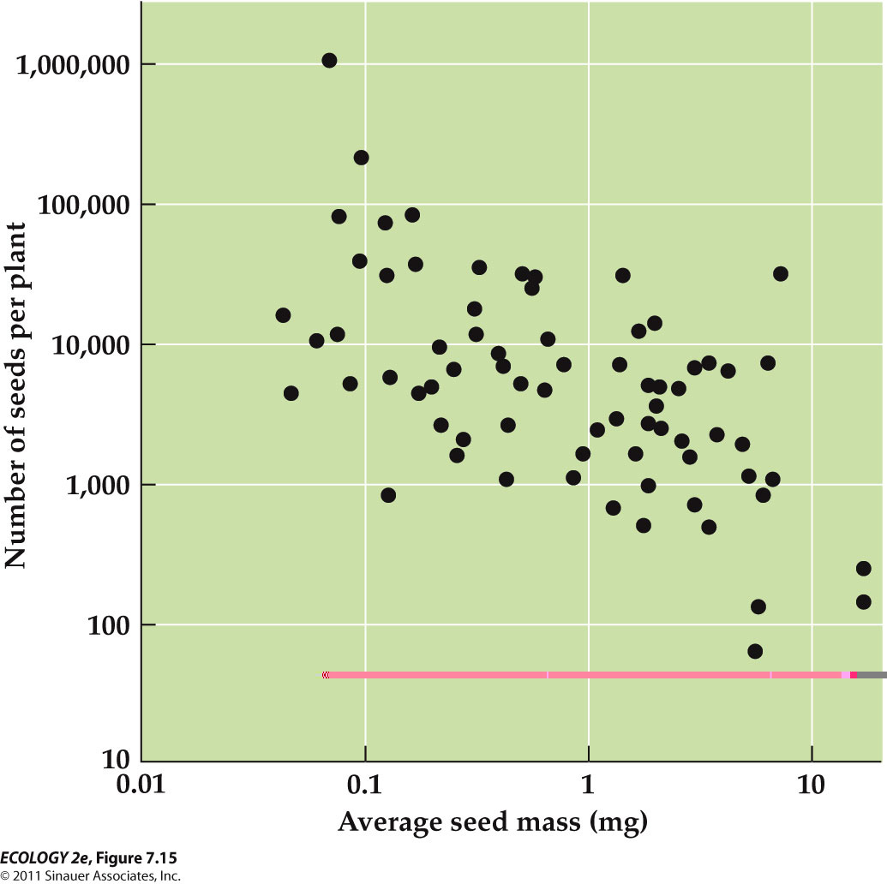
      - In species without parental care, resources are invested in propagules (eggs or seeds). Size of the propagule is a trade-off with the number produced.
        - Heavier the seed, less number of seeds

- Size – number trade-offs in organisms without parental care

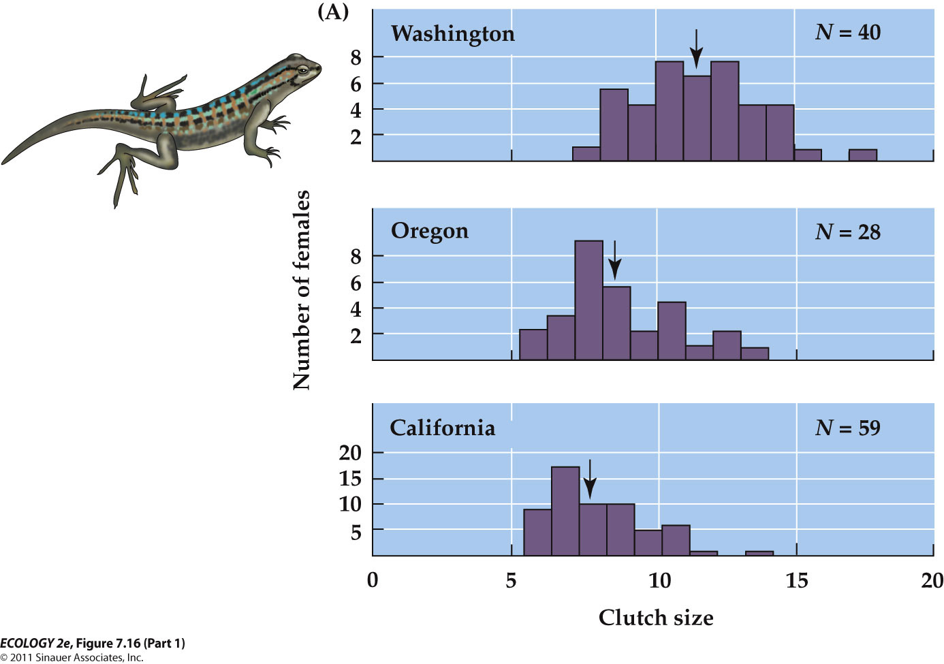
  - The lizards in northern populations produced larger clutches and smaller eggs those in southern populations.
  - Experiments by Sinervo (1990) on lizard eggs showed that smaller eggs developed faster and produced smaller hatchlings, but small hatchlings were not able to sprint as fast to escape predators.
  - Selection may favor early hatching in northern populations, because of shorter growing seasons. Faster sprinting speed may be favored in southern populations where there are more predators.

- - There is a trade-off between current and future reproduction

- Age at sexual maturity
  - Trade-offs between current and future reproduction
    - For an iteroparous organism, the earlier it reproduces, the more times it can reproduce over its lifetime.
      - But the number of offspring produced often increases with size and age of the organism.

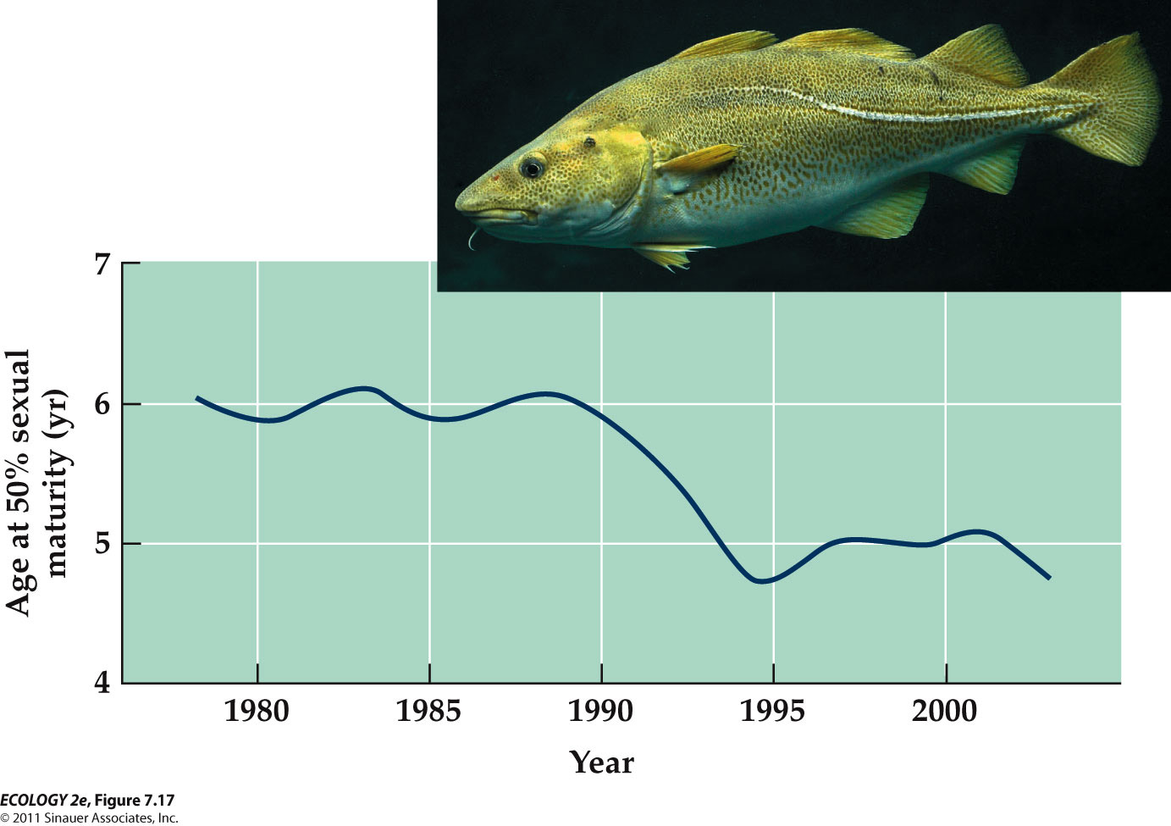
    - Atlantic cod females produce more eggs as they grow larger. Commercial fishing removes older, larger fish, favoring fish that reproduce earlier at smaller sizes (evolutionary change).

  - It may be advantageous to delay reproduction and invest more energy in growth and survival in order to increase lifetime reproductive output.
    - Example: A fish with a 5-year lifespan can increase its total reproductive output by delaying maturation by one year.
  - If adult survival rates are low, future reproduction may never occur, so early reproduction rather than growth would be favored.
  - If adult survival rates are high with long life spans, or fecundity increases with body size, it makes sense to allocate energy to growth rather than reproduction.

Senescence
  - Senescence: Decline in physiological function with age.
  - Onset can set an upper age limit for reproduction.
  - Semelparous species undergo very rapid senescence and death following reproduction.
  - In some large social mammals, such as humans and elephants, senescence is long.
  - But, post-reproductive individuals contribute to the group’s welfare by parental and grandparental care and other ways.

  - Senescence may occur earlier in populations with high mortality rates or predation.
    - In guppy populations with high mortality rates, they may be investing less energy in immune system development, resulting in higher rates of senescence due to disease

- LIFE CYCLE EVOLUTION
  - As selection pressures change, different morphologies and behaviors are adaptive at different life cycle stages.

- -Small size has benefits and drawbacks
  - Small early life stages can be vulnerable to predation and competition for food.
  - But small size can allow early stages to do things that adult stages can’t.
  - Organisms have various mechanisms to protect the small life stages.

- Parental investment
  - Provisioning eggs or embryos—yolk and protective coverings for eggs, nutrient-rich endosperm in plant seeds.
  - Parental care—invest time and energy to feed and protect offspring.

- Dispersal and Dormancy

  - small offspring are well-suited for dispersal.
  - Dispersal can reduce competition among close relatives, allow colonization of new areas, and allow escape from areas with diseases or high predation.
    - Sessile organisms such as plants, fungi, and marine invertebrates disperse as pollen, seeds, spores, gametes, or larvae.

  - Dormancy: State of suspended growth and development in which an organism can survive unfavorable conditions.
    - Small seeds, spores, eggs, and embryos are best suited to dormancy—less metabolic energy is needed to stay alive.
    - But some larger animals also enter dormancy.

- - Complex life cycles may result from stage-specific selection pressures
  - Complex life cycles may result from stage-specific selection pressures, and help minimize the drawbacks of small, vulnerable early stages.

- Larval Formation and adaptation
  - Functional specialization of stages is a common feature of complex life cycles.
  - In many insects the larval stage stays in a small area, such as on a single plant.
  - The larvae are specialized for feeding and growth. The adult is specialized for dispersal and reproduction.

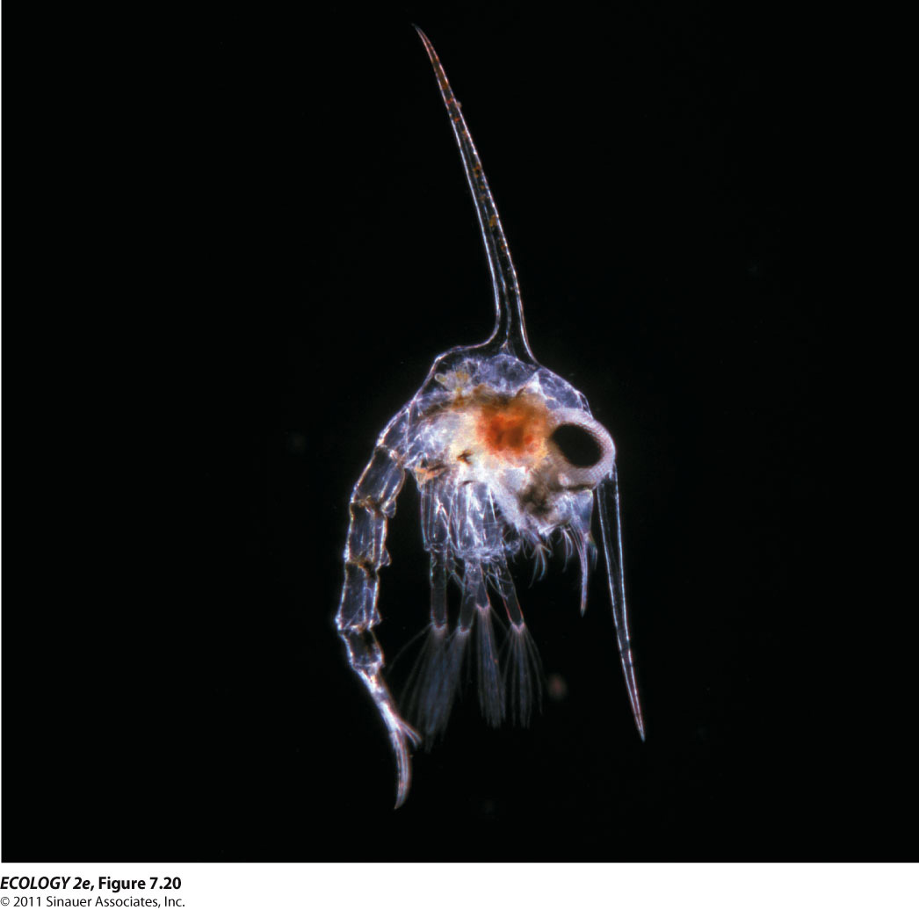
  - In marine invertebrates, larvae are specialized for both feeding and dispersal in ocean currents. Many larvae have specialized ciliated bands for feeding, or they may also have spines, or other structures to deter predators.

Timing of life cycle shifts
  - Even in species with gradual morphological change, individuals may have different ecological roles depending on size and age—niche shift.
    - The ecological niche is the physical and biological conditions that an organism needs to grow, survive, and reproduce.
  - Niche shifts should occur when the organism reaches a size at which conditions are more favorable in the adult habitat than in the larval habitat
  - In the Nassau grouper, small juvenile fish hide in algae clumps; larger ones stay in rocky habitats.
    - Dahlgren and Eggleston (2000) found that smaller juveniles are very vulnerable to predators in the rocky habitats, but larger ones were not.
    - Niche shift was timed to maximize growth and survival.
  - If the larval habitat is very favorable, metamorphosis may be delayed or eliminated.
    - Some salamanders mature sexually while retaining larval morphology and habitat (paedomorphic).
    - Mole salamander have both aquatic paedomorphic adults and terrestrial metamorphic adults in the same population.

POPULATION

  - Population: Group of interacting individuals of the same species living in a particular area.
    - Interactions within populations include sexual reproduction and competition.
  - Populations are dynamic—distribution and abundance can change over time and space. Understanding the factors that influence these dynamics helps us manage populations for harvest or conservation.
  - Distribution: Geographic area where individuals of a species occur.
  - Abundance: Number of individuals in a given area.
    - Abundance can be reported as population size (# of individuals), or density (# of individuals per unit area).
    - Example: On a 20-hectare island there are 2,500 lizards. Population density = 125/hectare

  - Sometimes the total area occupied by a population is not known.
    - E.g. It is often difficult to know how far organisms or their gametes can travel.
    - When the area isn’t fully known, an area is delimited (determine the limits) based on best available knowledge of the species.

- - Abundances change over time and space
  - the number of individuals in a population change over time.
  - Abundances also differ from one place to another
  - E.g. changes in abundances of the beetle
    - All the sites experienced roughly the same climatic conditions
    - Nevertheless, insect abundances varied considerably from one site to another and from one year to the next

- Dispersal links populations
  - Species vary in their ability to disperse.
    - In plants, dispersal occurs by seed movement. The distance moved can be very small.
    - Other species, such as whales, can move thousands of kilometers in a year.
  - Some populations exist in isolated patches that are spatially isolated from one another but linked by dispersal.
    - This can result from physical features of the environment, or human activities that subdivide populations.
    - Example: Heathlands in England have been fragmented by human development.
      - Greatly reduced the extent of these plants
      - More patches (breaking a single large populations to a series of much smaller populations) over time

- - What are individuals ?
  - For some species, it’s hard to determine what an individual is.

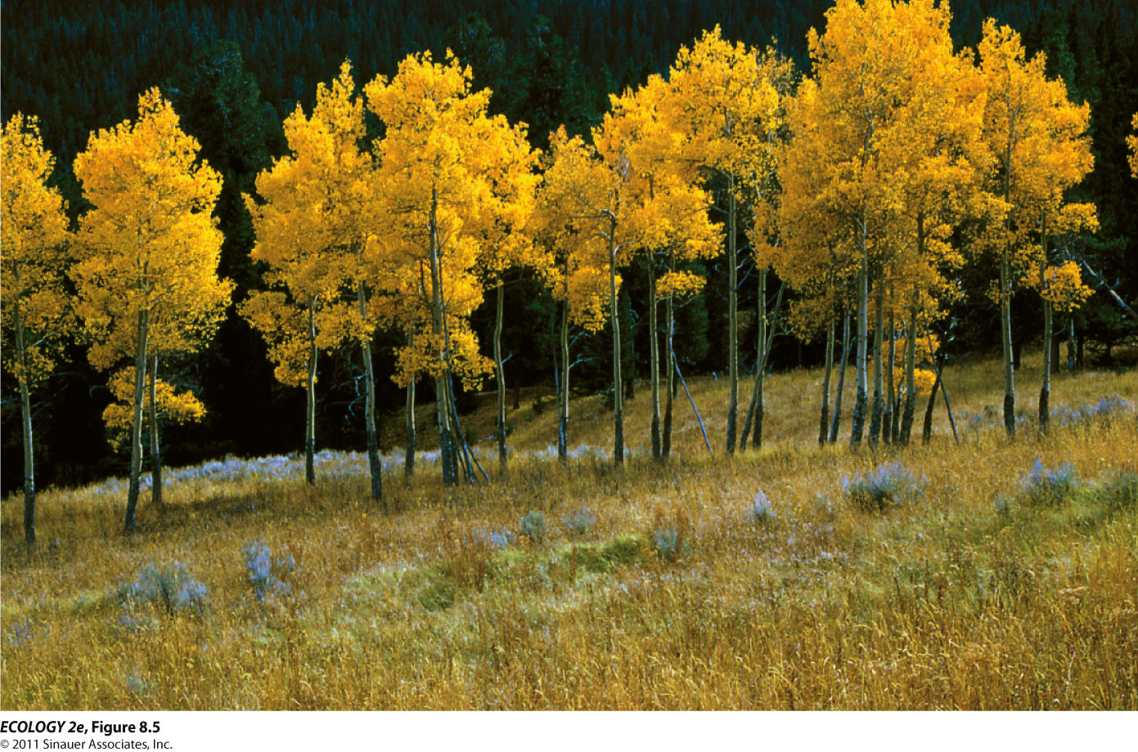
    - Although there are 20 different genetic individuals, each of these aspens is actually part of “one” tree, having been produced asexually from the root buds of a single genetic individual.
    - Clones = genetically identical copies of itself

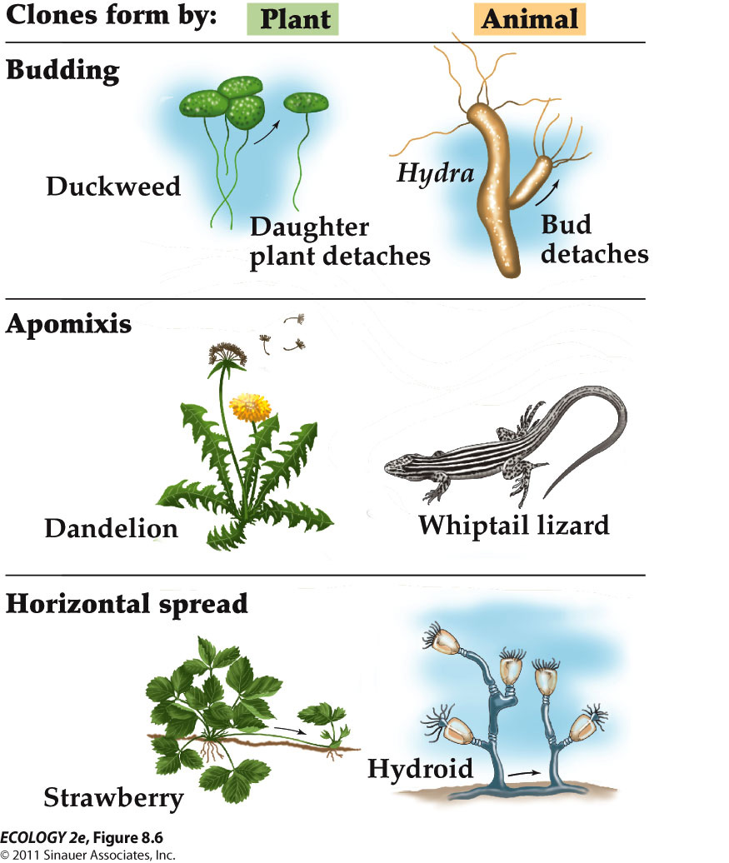
    - Examples of clones
      - Budding (detatch from the parent)
      - Apomixes (produced from unfertilized egg)
      - Horizontal spread (produced as organism grows

  - Individuals can be defined as products of a single fertilization: The aspen grove would be a single genetic individual, or genet.
    - If members of a genet are independent physiologically and they need to compete for resources, each member is called a ramet.
    - E.g. in strawberries, a rooted plant is considered a rament because it can persist even if it is not connected to the rest of its genet.

DISTRIBUTION AND ABUNDANCE

  - The distributions and abundances of organisms are limited by habitat suitability, historical factors, and dispersal.

- - Habitat suitability limits distribution and abundance
- Abiotic features of the environment
  - Abiotic features: Moisture, temperature, pH, sunlight, nutrients, etc.
  - Some species can tolerate broad ranges of physical conditions, others have narrow ranges.
  - distribution of two drought-tolerant plants
    - Creosote bush is very tolerant of dry conditions and occurs widely in North American deserts.
    - Saguaro cactus can tolerate dry conditions, but not cold temperatures and has a more limited distribution

Biotic features of the environment
  - Biotic features : Organisms are affected by herbivores, predators, competitors, parasites, and pathogens.
    - E.g. In Australia, an introduced cactus became a pest species, spreading over vast areas.
    - A moth that feeds on cactus was then released, and distribution and abundance of the cactus has been greatly reduced

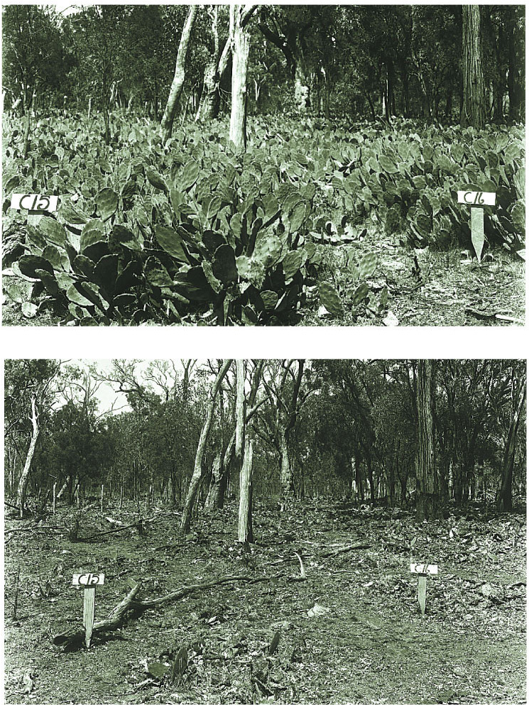
    - Herbivores can limit plant distribution

Interactions between abiotic and biotic features
  - Abiotic and biotic features can interact to determine distribution and abundance.
    - E.g. The range of the barnacle Semibalanus balanoides is restricted by temperature. But competition from other species precludes (prevent) it from some areas with suitable temperatures.

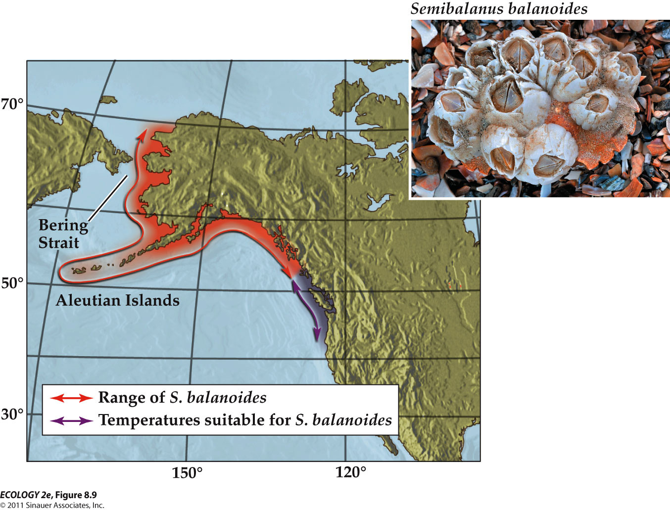
    - Competition with other barnacles prevents this species from living in the region around Vancouver although temperatures are suitable.

- Disturbance
  - Some species distributions depend on disturbance—events that kill or damage some individuals, creating opportunities for other individuals to grow and reproduce.
  - E.g. Some species persist only where there are periodic fires

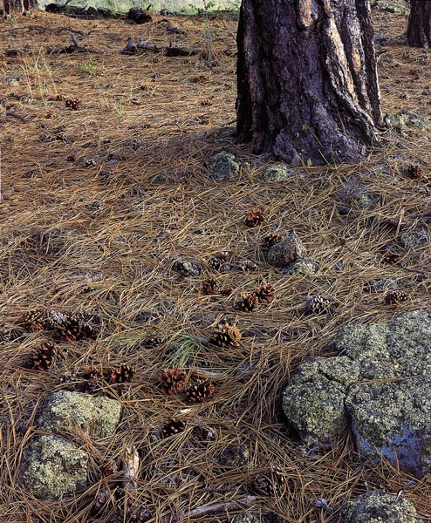
  - Respond to fire or encourage fire

- - History and dispersal limit distribution and abundance
- Historical factors (evolution and continental drift)
  - Evolutionary history and geologic events affect modern distribution of species.
    - Example: Polar bears evolved from brown bears in the Arctic. They are not found in Antarctica because of an inability to disperse through tropical regions.
  - Continental drift explains the distributions of some species.
    - Wallace (1860) observed very different animal species on the Philippines and New Guinea, even though they are close together.

- Dispersal limitation
  - Dispersal limitation can prevent species from reaching areas of suitable habitat.
    - Example: The Hawaiian Islands have only one native mammal, the hoary bat, which was able to fly there. No other land mammals have been able to disperse Hawaii.
    - and polar bears example above
  - Dispersal limitation has also been shown in plant species:

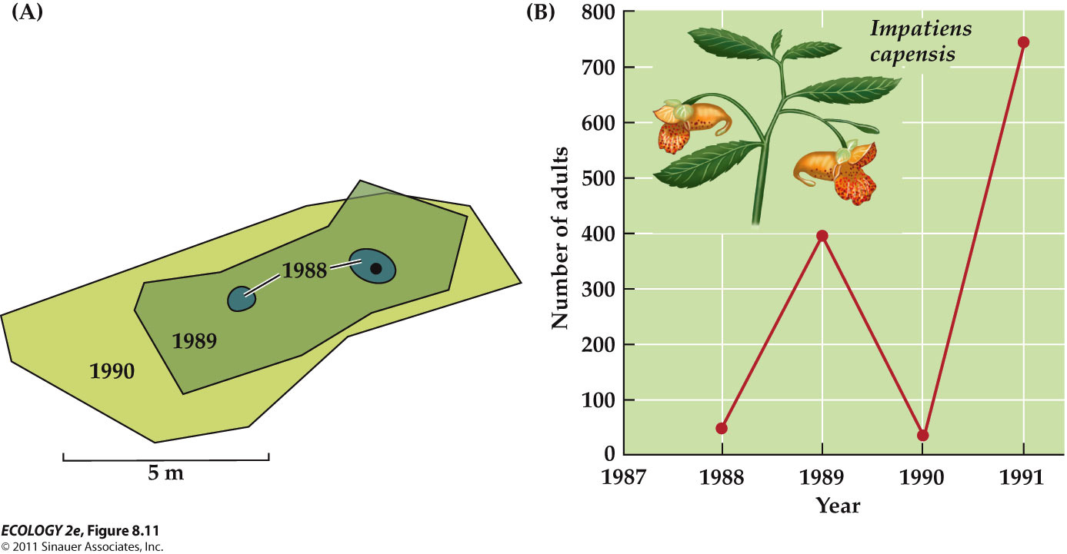
    - Preventing populations from expanding to nearby areas of apparently suitable habitat

- Dispersal and density
  - Dispersal can also affect population density, and vice versa.
    - E.g. Many species of aphids produce winged forms (capable of dispersing) in response to crowding.

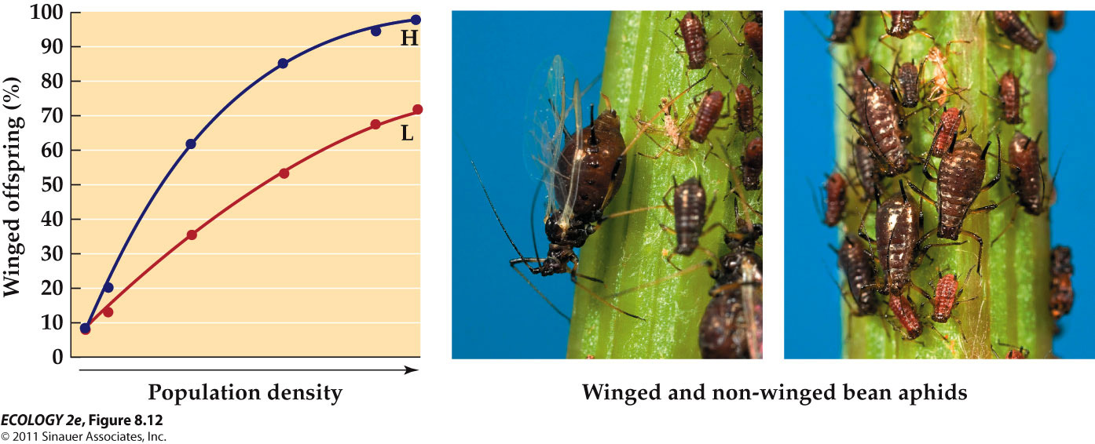
      - The percentage of offspring that develop wings increases as the density of aphids increases.
    - E.g. Desert pupfish live in pools that are sometimes connected after heavy rains.
      - Experiments suggest that dispersal may result in better chances for survival and reproduction than staying in crowded pools with limited food.

- GEOGRAPHIC RANGE

  - Geographic range—the entire geographic region over which a species is found.
  - Many species have a patchy distribution of populations across their geographic range.
  - There is also great variation in species ranges:
    - Many tropical plants have small ranges. In 1978, 90 new species were discovered, restricted to a single mountain ridge in Ecuador.
    - Other species, such as the coyote, have very large geographic ranges
      - Some species are found on several continents.
      - Few species are found on all continents except humans, Norway rats, and the bacterium E. coli.
  - Geographic range includes areas occupied during all life stages.
    - Some species, such as monarch butterflies, migrate long distances between summer and winter habitats.
    - For some species, it is difficult to find all the life stages and the ranges they inhabit.
  - Not all habitat within a range is suitable, resulting in patchy distributions.
    - This can operate at different spatial scales.
      - At large scales, climate may dictate locations of populations.
      - At small scales, soils, topography, other species, etc., can determine patchiness.
    - Patchiness at different scales is illustrated by the shrub Clematis fremontii.
      - It is restricted to areas of dry, rocky soil with few trees, called barrens or glades.
      - The glades occur (open area) on outcrops of limestone on south- or west-facing slopes.
  - Abundance can vary throughout a species’ range.
    - This species tolerate a broader range of habitats, but their abundance still vary throughout their geographic range.
      - E.g. Density of red kangaroos varies throughout their range in Australia, including areas of high density, and areas where they are absent.

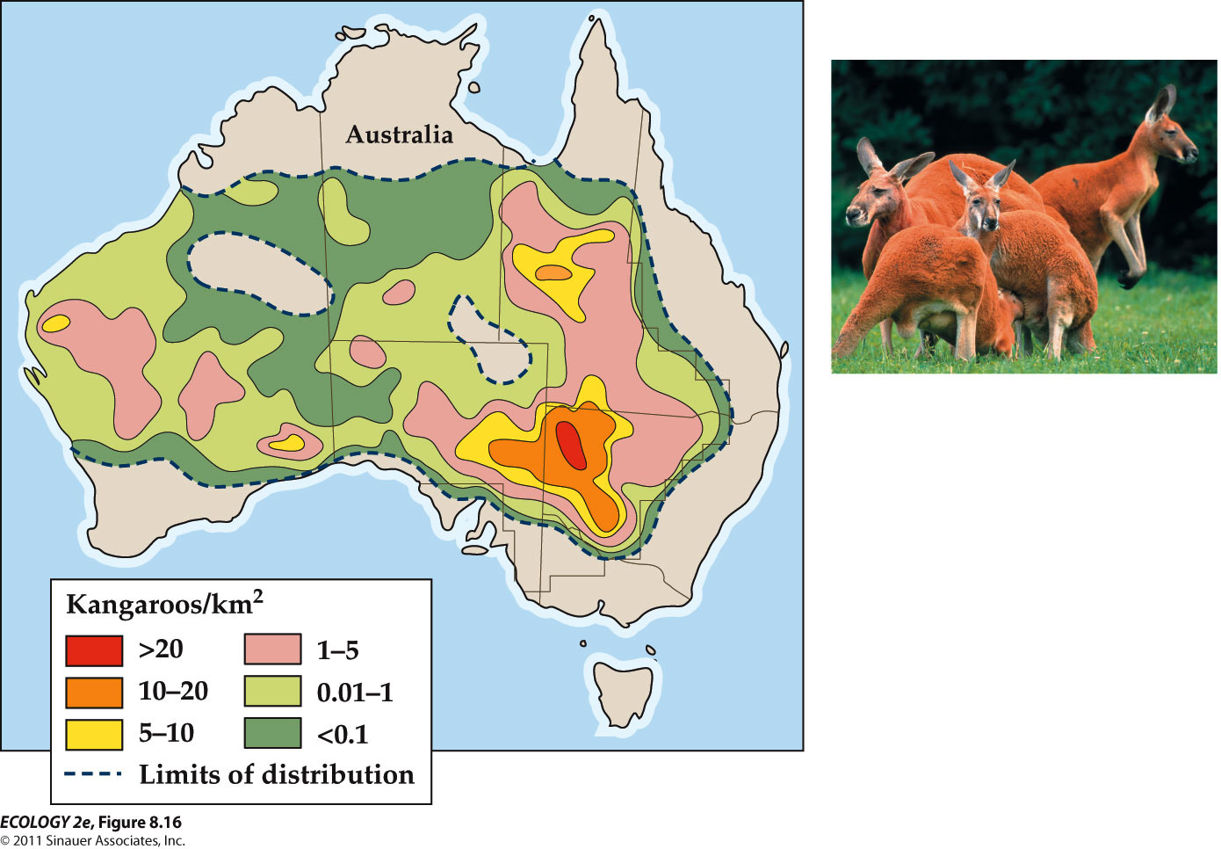
  - For some species, population density is greatest in the center of the range.
    - E.g. This occurs in many North American species, including indigo buntings and other animals and plants.

DISPERSION WITHIN POPUPLATIONS

  - Dispersion: Spatial arrangement of individuals within a population:
  - The dispersion of individuals within a population depends on the location of essential resources, competition, dispersal, and behavioral interactions.
    - Regular—individuals are evenly spaced.
    - Random—individuals scattered randomly.
    - Clumped—the most common pattern.
  - Dispersion patterns often result from the distribution of resources.
    - Random or clumped dispersion can also result from short dispersal distances.
    - Competition appears to result in the regular dispersion of some species
    - 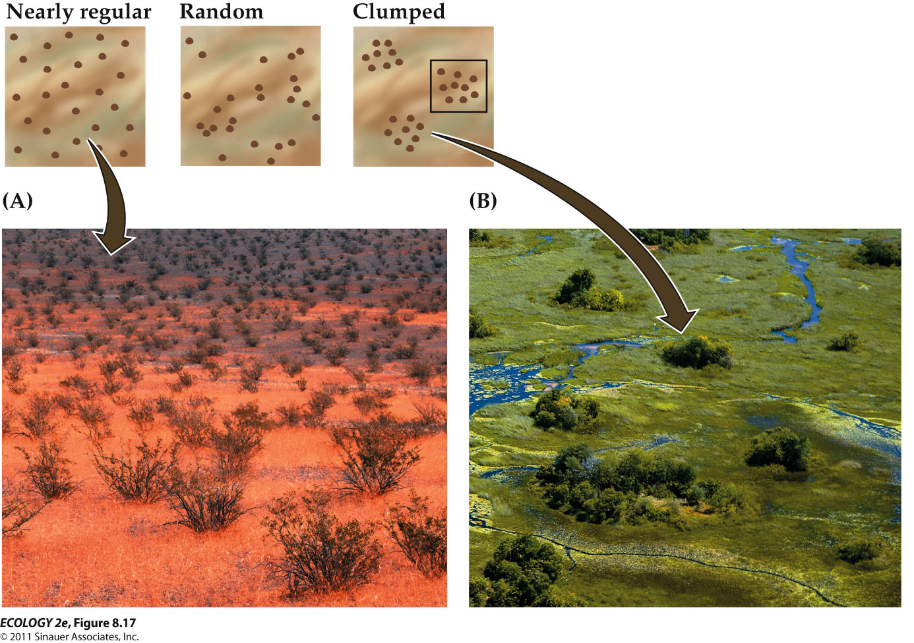
      - regular dispersion – individuals compete for limited water supplies
      - random dispersion
      - clumped – majority

- individuals behavior affects dispersion within populations
  - Interactions can also influence dispersion
    - Individuals may repel or attract others.
    - E.g. Seychelles warblers are territorial (a breeding pair defends its territory against other birds of the species), which results in a regular dispersion.
      - But some territories provide better resources than others

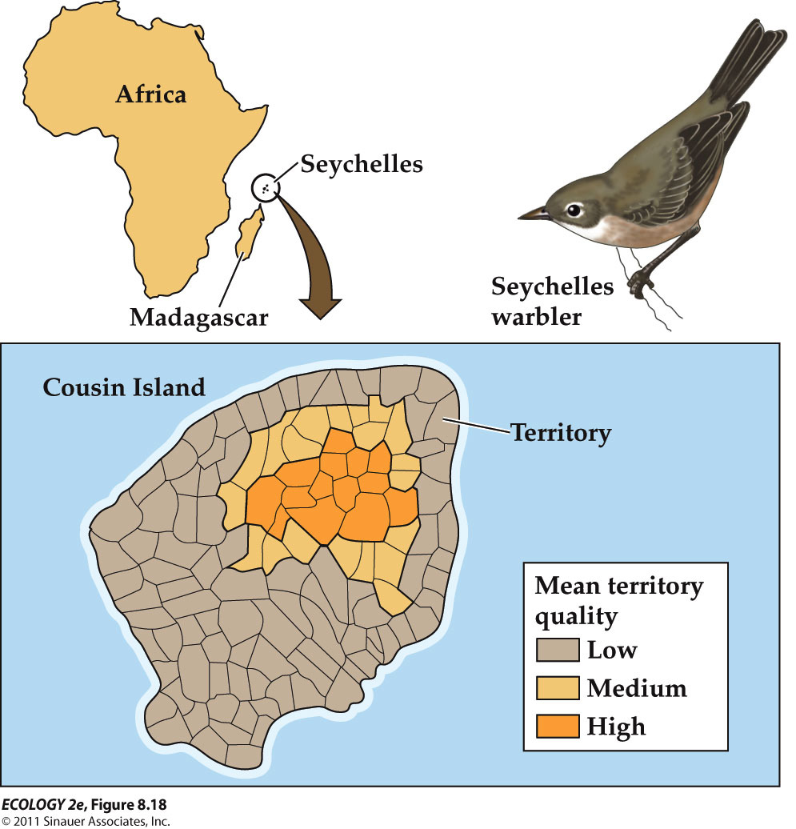
  - In high quality territories, cooperative breeding occurs—young birds postpone breeding and instead help their parents raise more offspring.
    - The high quality sites attract more birds and can result in clumped dispersions
    - Cooperative breeding is advantageous when high-quality territories are scarce.
    - A young bird will survive and produce more offspring over its lifetime if it stays to help the parents, and delays breeding.
    - HOWEVER, If high-quality territories are abundant, cooperative breeding is not favored.
      - Cooperative breeding can result can from a lack of territories.
        - Cooperative breeding was first observed when high-quality territory began to be in short supply.

- ESTIMATING ABUNDANCES AND DISTRIBUTIONS

  - Population abundances and distributions can be estimated with area-based counts, distance methods, mark–recapture studies, and niche modeling.
  - Complete counts of individual organisms in a population are often difficult or impossible.
  - Several methods are used to estimate the actual abundance or absolute population size.
    - Relative population size: Number of individuals in one time period or place relative to the number in another.
    - Estimates are based on data presumed to be related to absolute population size.
      - Examples: Number of cougar tracks in a given area, or number of fish caught per unit of effort.
    - Interpretation of relative population size can be tricky.
      - Example: Number of cougar tracks is related to population density, but also activity levels of individuals.

- Area-based counts
  - Used most often to estimate abundance of immobile organisms
  - Quadrats: Sampling areas of specific size, such as 1 m².
    - Individuals are counted in several quadrats; the counts are averaged to estimate population size.
    - E.g. 40, 10, 70, 80, and 50 chinch bugs are counted in five 10 cm by 10 cm (0.01 m²) quadrats.

Distance methods
  - Distances of individuals from a line or point are converted into estimates of abundance.
  - Line transects: Observer travels along line and counts individuals and their distance from the line.

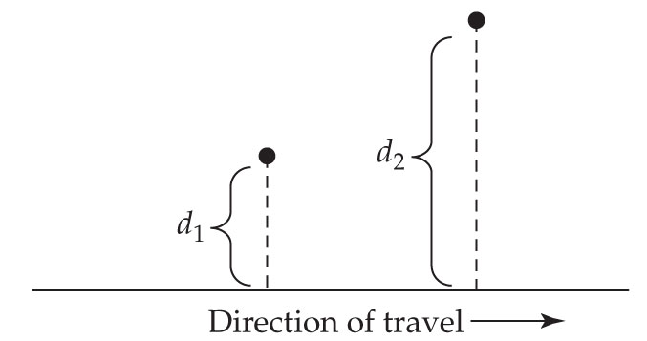

- Mark–recapture studies
  - Used for mobile organisms
  - A subset of individuals is captured and marked or tagged, then released.
  - At a later date, individuals are captured again, and the ratio of marked to unmarked individuals is used to estimate population size.
    - E.g. 23 butterflies are captured and marked (M). Later, 15 butterflies are captured (C), 4 of them marked (R for recaptured).
    - To estimate total population size (N):

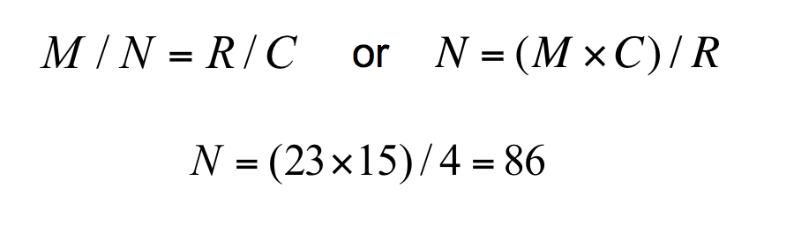

  - Long-term data sets can help solve applied problems
    - E.g. Outbreak of a new disease in 1993 in New Mexico was caused by a new strain of hantavirus, carried by the deer mouse.
    - Deer mouse specimens indicated the virus had been present for 10 years. Why was there an outbreak?
    - Deer mouse populations had been studied at Sevilleta National Wildlife Refuge since 1989.
    - Densities of several species had increased between 1992 and 1993. High rainfall had led to more plant growth, providing more food for rodents.
    - High mouse densities increase the chances of contact with humans.

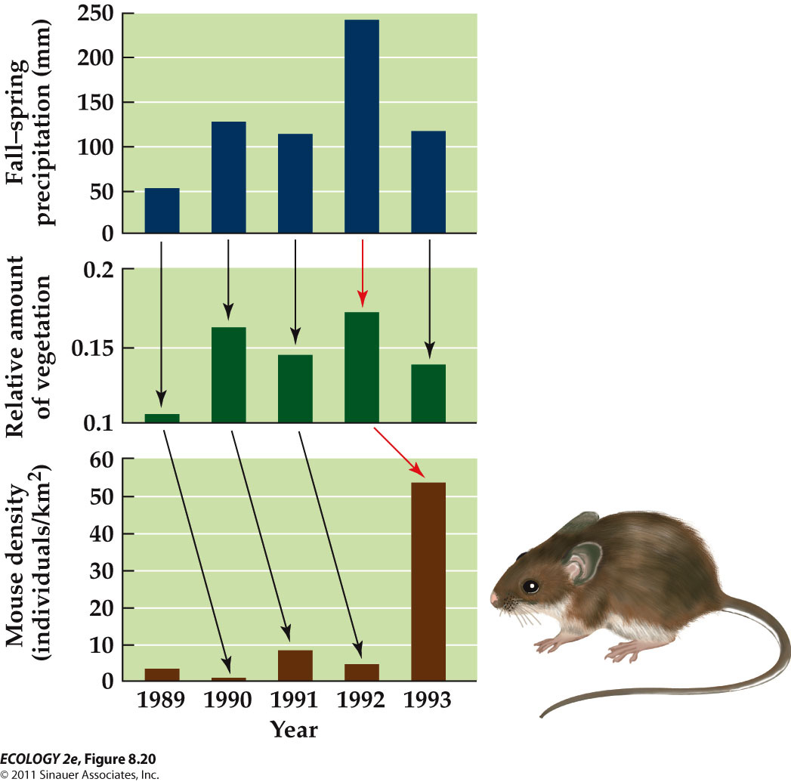
      - High levels of fall-spring precipitation were correlated with increased plant growth in the spring
      - Increased plant growth was correlated with increased densities of the mouse 1993 – year of the outbreak

- - Niche models can be used to predict where species can be found
  - The geographic ranges of many species are not well known.
  - Ecologists often wish to predict the future distribution of a species:
    - Pests or disease carriers.
    - Changing distributions as a result of global warming.

  - Niche Modeling
    - Ecological niche: Physical and biological conditions that a species needs to grow, survive, and reproduce.
    - A niche model predicts a species’ distribution based on conditions at locations the species is known to occupy.
    - E.g. Niche model for chameleons in Madagascar:
      - Environmental data were recorded for 1x1 km² “grid cells.”
      - “Habitat rules” for each species described environmental conditions where it was most likely to be found.
      - A computer program (GARP) compared grid cell data with habitat rules for each species. Predictions of species occurrences were correct 75–85% of the time.
      - In areas where predictions were not correct, researchers found seven previously unknown chameleon species.

CASE STUDY : Human population growth
  - Humans have a large impact on the global environment: Our population has grown explosively, along with our use of energy and resources.
  - Human population reached 6.8 billion in 2010, more than double the number of people in 1960.
  - Our use of energy and resources has grown even more rapidly. From 1860 to 1991, human population quadrupled in size, and energy consumption increased 93-fold.
  - For thousands of years our population grew relatively slowly, reaching 1 billion for the first time in 1825. Now we are adding 1 billion people every 13 years.

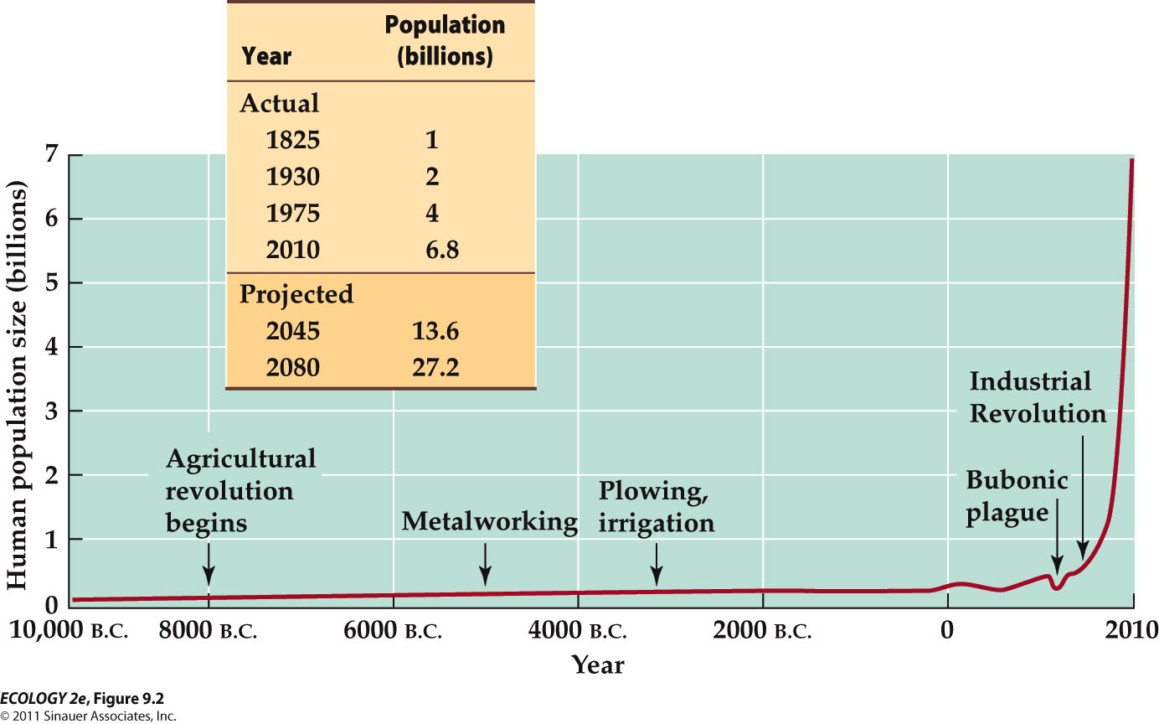

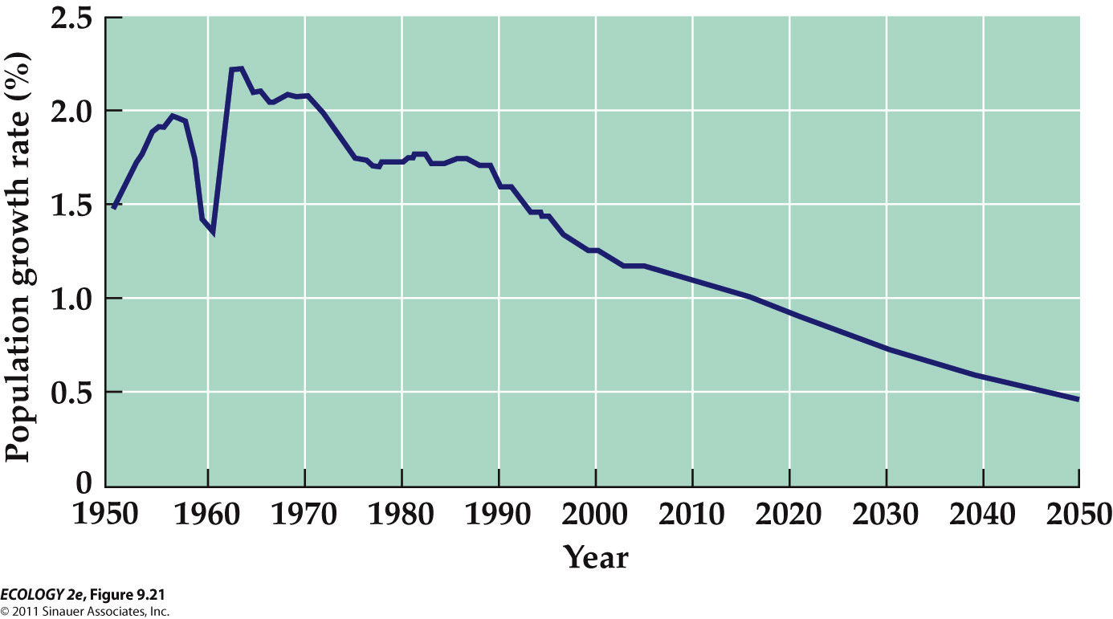
  - Growth rate has slowed recently, to about 1.18% per year, and continues to slow.
  - By 2080, it is predicted there will be roughly 9–10 billion people on Earth.
  - Is 10 billion above the carrying capacity of the human population?
    - Many people have tried to estimate human carrying capacity.
    - Researchers must make assumptions about how people would live and how technology would influence our future.
    - Estimates range from fewer than 1 billion to more than 1,000 billion.
  - Ecological footprint: Total area of productive ecosystems required to support a population.
    - Uses data on agricultural productivity, production of goods, resource use, population size, and pollution.
    - The area required to support these activities is then estimated.
  - In 2006:
    - 11.9 billion hectares of productive land available globally.
    - Average ecological footprint: 2.6 hectares.
    - Suggests a carrying capacity of 4.6 billion.
    - Population: 6.6 billion, a 40% overshoot of carrying capacity.
  - If everyone in the world used resources at the same rate as:
    - U.S. citizens in 2006, carrying capacity would be 1.3 billion people.
    - Indian citizens in 2006, carrying capacity would be 14 billion people.

INTRODUCTION

  - One of the ecological maxims is: “No population can increase in size forever.”
    - The limits imposed by a finite planet restrict a feature of all species
      - A capacity for rapid population growth.
  - Ecologists try to understand the factors that limit or promote population growth.

LIFE TABLES
  - A life table is a summary of how survival and reproductive rates vary with age.
    - Information about births and deaths is essential to predict future population size.
    - Life table data for the grass Poa annua were collected by marking 843 naturally germinating seedlings and then following their fates over time

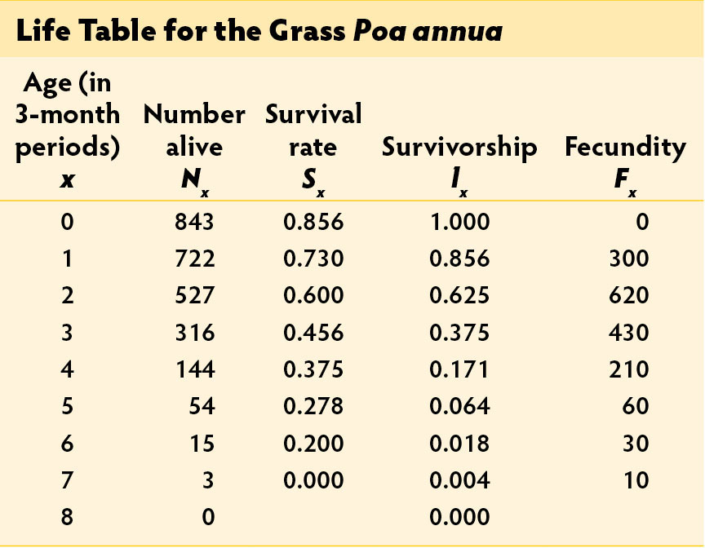
      - Sx = survival rate: Chance that an individual of age x will survive to age x + 1.
      - lx = survivorship: Proportion of individuals that survive from birth to age x.
      - Fx = fecundity: Average number of offspring a female will have at age x.
  - Birth and death rates can vary greatly between individuals of different ages.
    - Gambians’ survivorship depends on the season of birth.
    - Gambians born during the “hungry season” (when food stored from the previous year is depleted) had lower survivorship than those born at other times of the year.

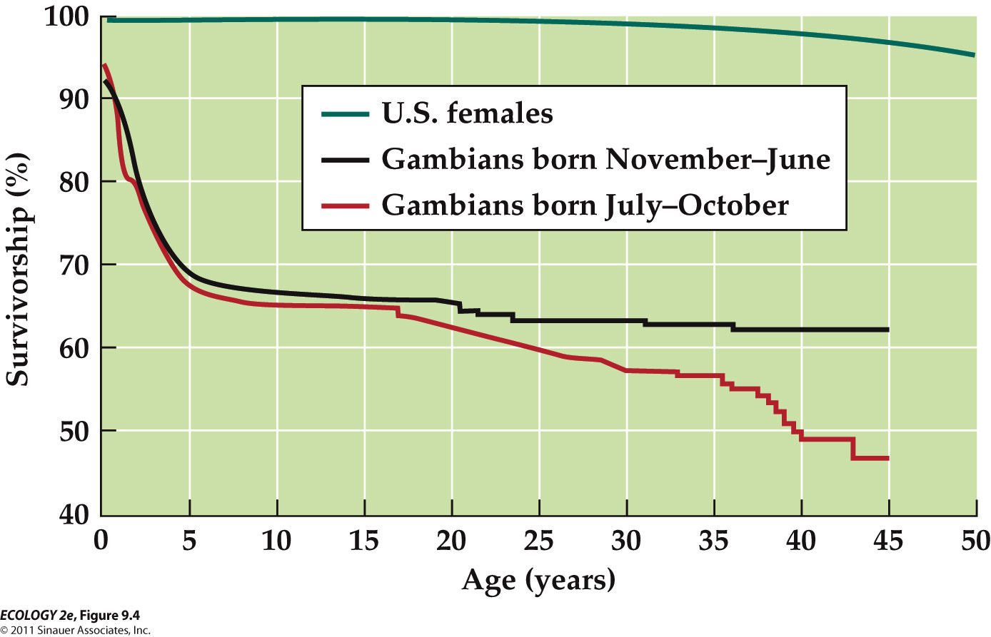
    - In Gambia, many people die young age and more people die when they are born between July and October

  - In some species, age is not important,
    - E.g. in many plants, reproduction is more dependent on size (related to growth conditions) than age.
  - Life tables can also be based on size or life cycle stage.

  - Survivorship curve: Plot of the number of individuals from a hypothetical cohort that will survive to reach different ages.
  - Survivorship curves can be classified into 3 general types.
    - Type I: Most individuals survive to old age (Dall sheep, humans).

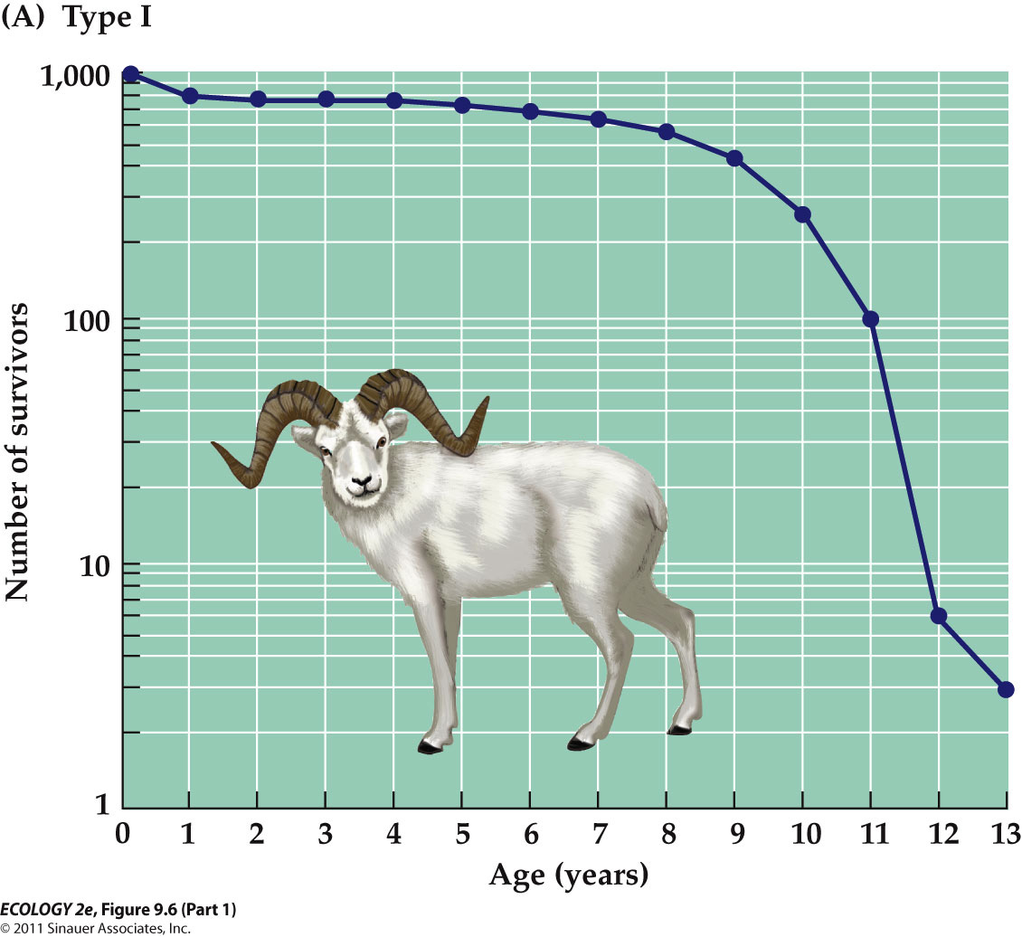
    - Type II: The chance of surviving remains constant throughout the lifetime (some birds).

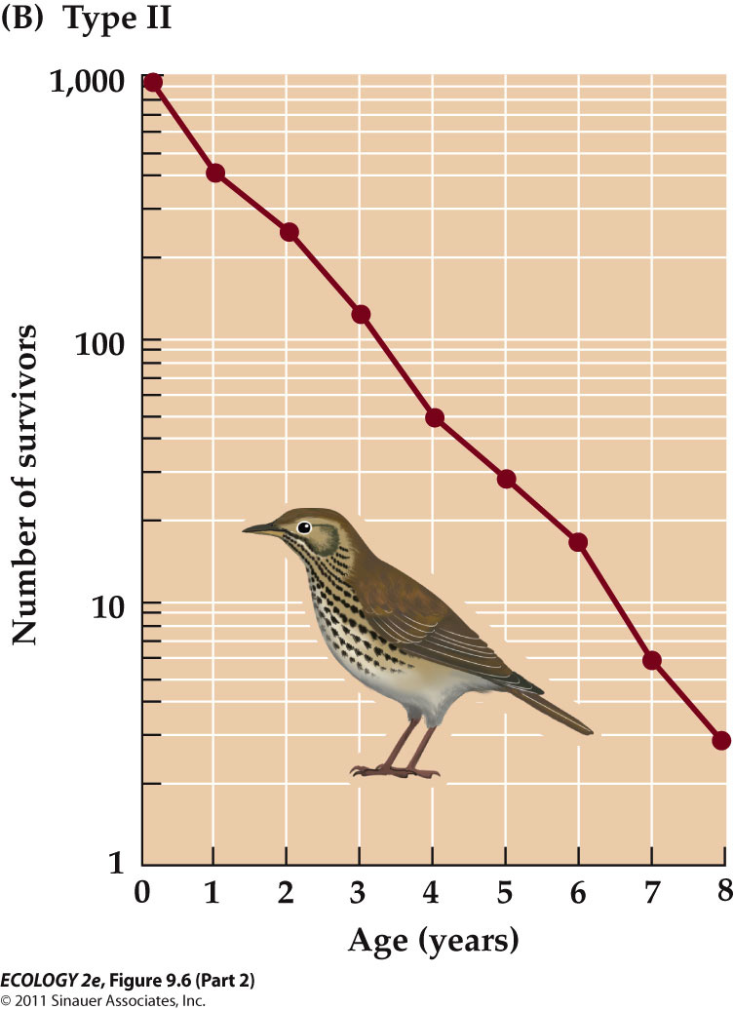
    - Type III: High death rates for young, those that reach adulthood survive well (species that produce a lot of offspring).

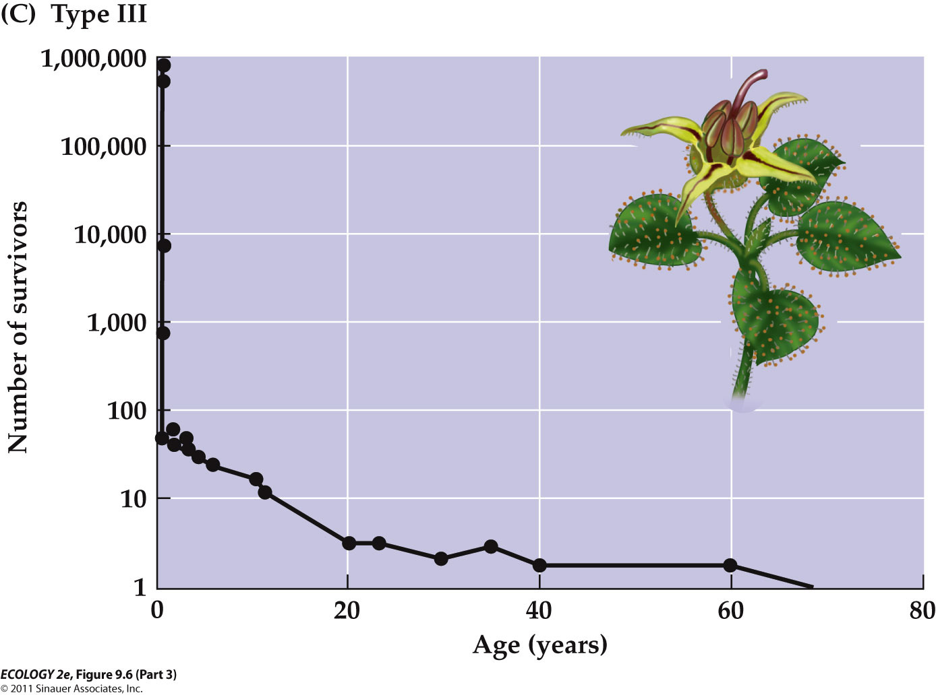

AGE STRUCTURE

  - A population can be characterized by its age structure—the proportion of the population in each age class.
  - Age structure influences how fast a population will grow.
    - If there are many people of reproductive age (15 to 30), it will grow rapidly.
    - A population with many people older than 55 will grow more slowly.

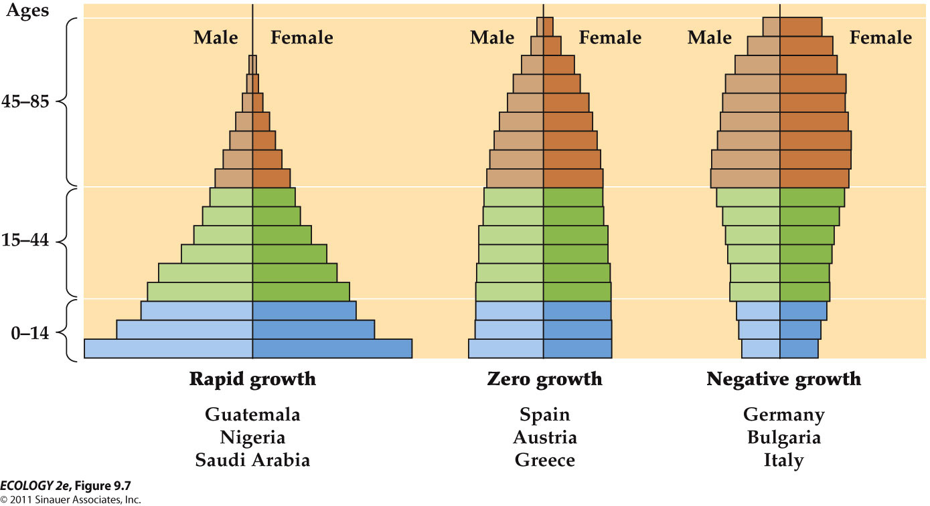
    - The general shapes of age structures that are typical of human populations with rapid, zero, and negative growth rates.

  - Life table can be used to predict age structure and population size.

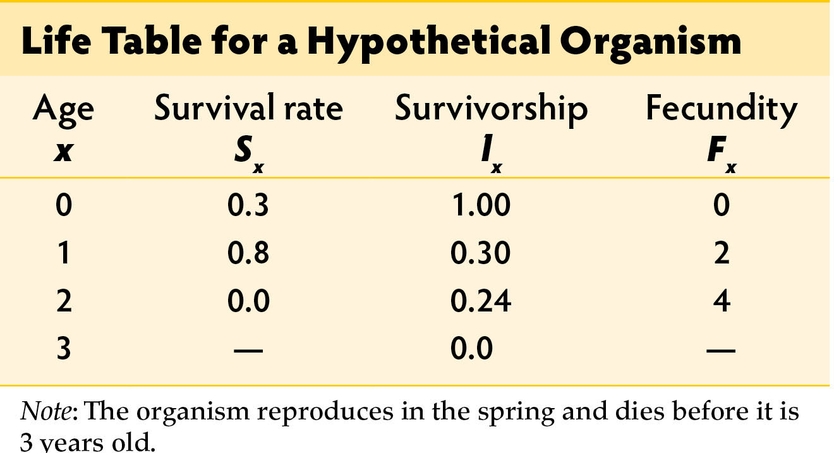
    - If the population starts with 100 individuals:
      - Age class 0 (n₀) = 20 individuals.
      - Age class 1 (n₁) = 30.
      - Age class 2 (n₂) = 50.
    - To predict population size for the following year, calculate:
      - The # of individuals that will survive to the next time period.
      - The # of offspring those survivors will produce in the next time period.
- 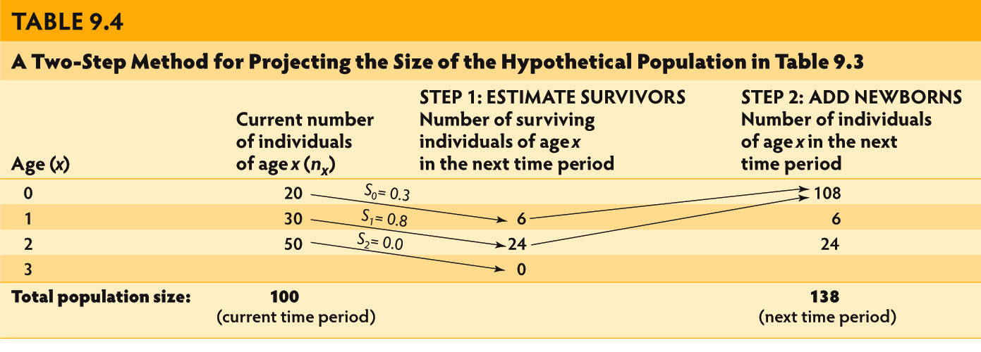
  - Growth rate (λ): Ratio of population size in year t + 1 (N_{t+1}) to population size in year t (N_{t}).
  - If survival or fecundity (ability to reproduce) rates change, population growth rate will change.
    - Example: If F₁ changes from 2 to 5.07 (and other values stay the same), λ increases to 2.0.
  - Age distribution would also change.

  - Environment factors can alter survival or fecundity and thus change population growth rates.
  - Knowledge of these factors helps develop management practices to decrease pest populations or increase an endangered population.
    - Example: Early efforts to protect endangered Loggerhead sea turtles focused on egg and hatchling stages.
    - But life table data indicated that the best way to increase growth rates was to increase survival rates of juveniles and adults.
    - These studies resulted in laws requiring Turtle Excluder Devices (TEDs) in shrimp nets to increase adult survival.
    - The number of turtles killed in nets declined by about 44%, but it will be decades before we know whether TED regulations helped increase turtle populations.

EXPONENTIAL GROWTH

  - Populations can grow rapidly whenever individuals leave an average of more than one offspring over substantial periods of time
  - Geometric growth and exponential growth can lead to rapid increases in population size.

- Populations grow geometrically when reproduction occurs at regular time intervals.
  - Geometric growth: If a population reproduces in synchrony at discrete time periods (regular time intervals) and growth rate doesn’t change (constant proportion) over time.
    - The population increases by a constant proportion: The number of individuals added is larger with each time period.

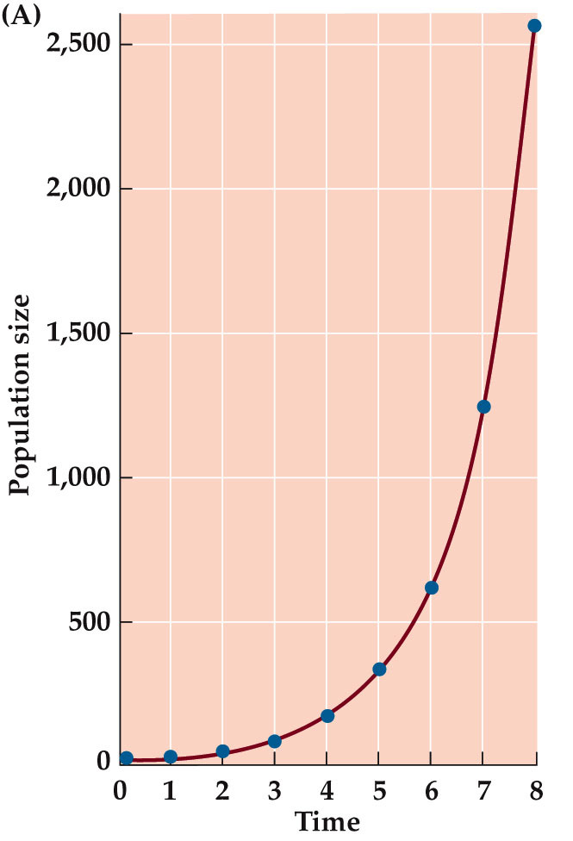
    - Geometric growth results in a J-shaped set of points. (the blue points)
  - Geometric growth:
    - λ = geometric growth rate or per capita finite rate of increase.

- Populations grow exponentially when reproduction occurs continuously.
  - Exponential growth: When individuals reproduce continuously, and generations can overlap.
    - Exponential growth results in a J-shaped curve (red line)

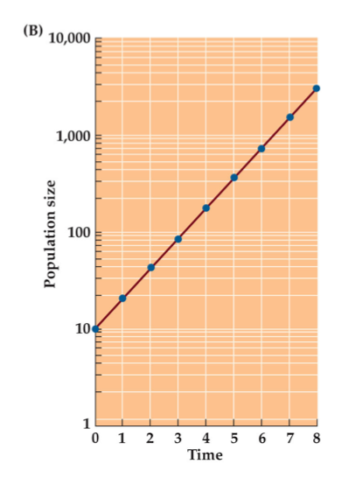
  - If a population is growing geometrically or exponentially, a plot of the natural logarithm of population size versus time will result in a straight line.
  - Exponential growth is described by:
    - the rate of change in population size at each instant in time
    - r = exponential population growth rate or per capita intrinsic rate of increase.

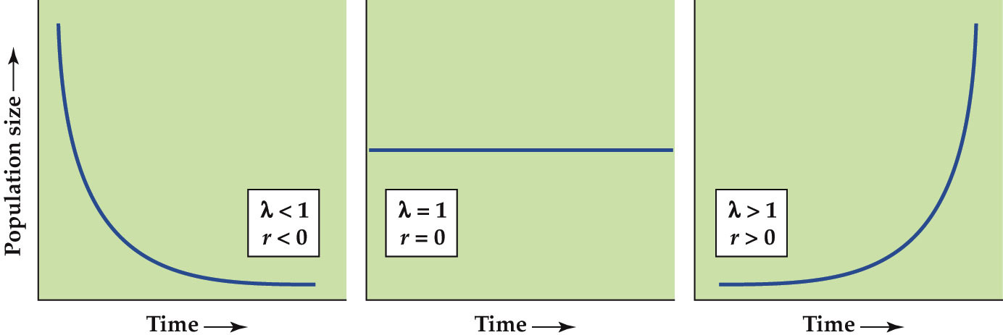

  - Growth rate (r or λ) can be estimated in several ways.
    - Life table data can be used to predict future population size, the predicted population size is plotted versus time, and growth rate (λ) is estimated from the graph.
    - E.g. Human population
      - The current growth rate is 1.11%, so r = 0.0117.
      - If 2010 is time t = 0 and N(0) = 6.8 billion, population size in one year N(1) = 6.8 × e^{0.0117}, or 6.88 billion.
      - If r remained constant, population would be over 80 billion in 215 years.
    - Populations of some species, such as wild ginger, have observed λ values close to 1.
    - 25 reindeer were introduced to Saint Paul Island off the coast of Alaska in 1911. After 27 years, the population had increased to 2,046 individuals.
      - λ = 1.18 for this population
    - Much higher growth rates have been observed in many species, including western grey kangaroos (λ = 1.9), field voles (λ = 24), and rice weevils (λ = 10¹⁷).
    - Some bacteria double in number every 30 minutes, resulting in an annual growth rate of λ = 10^{5,274}.

  - In natural populations, favorable conditions result in exponential growth, but it cannot continue indefinitely.
  - There are limits to population growth.

EFFECTS OF DENSITY

  - Population size can be determined by density-dependent and density-independent factors.
  - Under ideal conditions, λ > 1 for all populations.
  - But conditions rarely remain ideal and λ fluctuates over time.

- - Density-independent factors can determine population size
  - Density-independent factors
    - Effects on birth and death rates are independent of the number of individuals in the population. (no death and birth rate changes)
    - Temperature and precipitation, catastrophes such as floods or hurricanes
    - E.g. In the insect Thrips imaginis, population size fluctuation is correlated with temperature and rainfall.

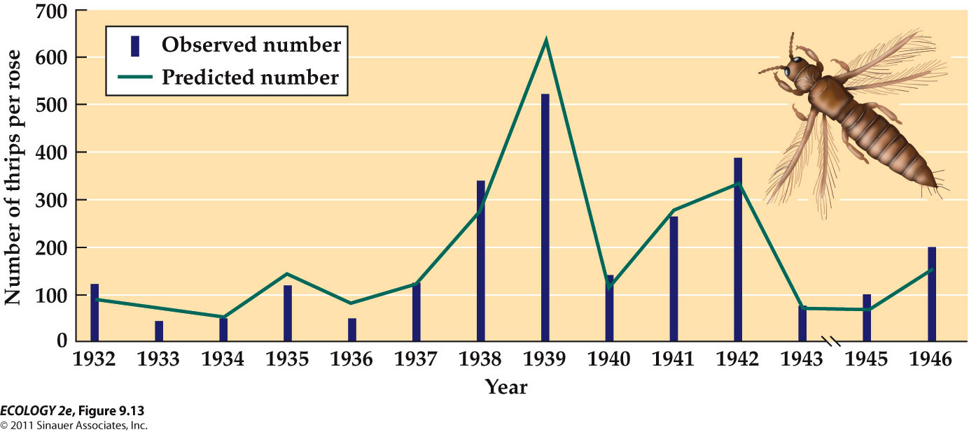
      - Weather can influence population size

- - Density-dependent factors regulate population size
  - density-dependent factors
    - Birth, death, and dispersal rates change as the density of the population changes.
    - As density increases, birth rates often decrease, death rates increase, and dispersal (emigration) increases, all of which tend to decrease population size.

  - Comparing density-dependent and density-independent

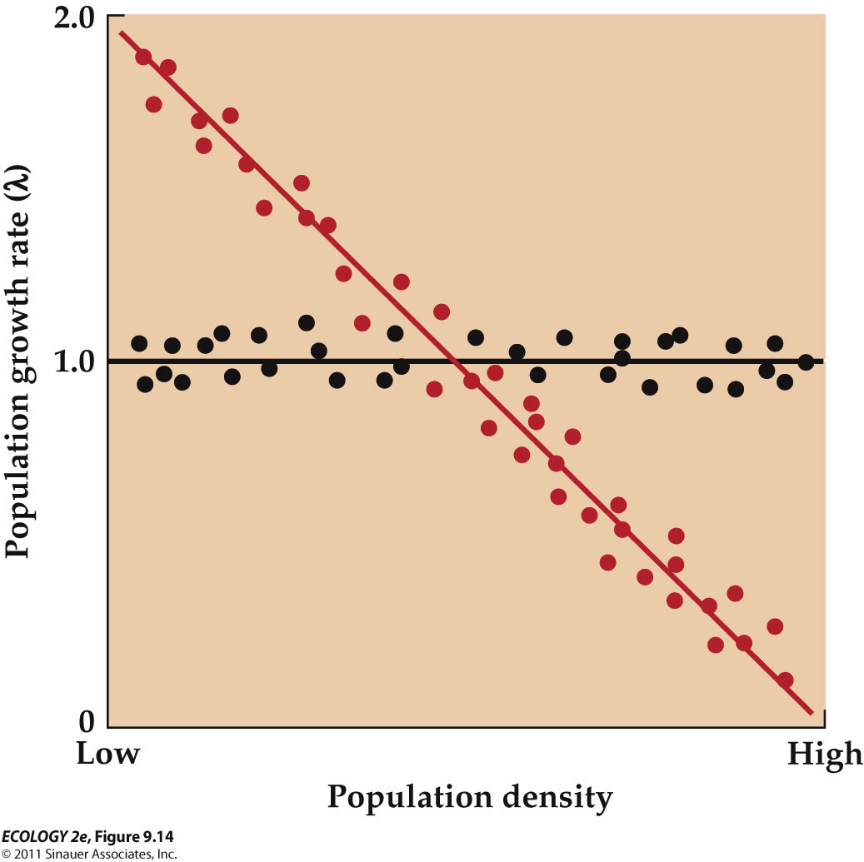
    - In density-independence, population growth rates are not a function of density. (black)
    - In density-dependence, population growth rates change as population density changes. (red)

  - Population regulation: Density-dependent factors cause population to increase when density is low and decrease when density is high.
  - Ultimately, food, space, or other resources are in short supply and population size decreases.
  - BUT, Density-independent factors can have large effects on population size, but do not regulate population size (such as by changing growth rates)

  - Density-dependence has been documented in natural populations.
    - E.g. In song sparrows, the number of eggs laid per female decreased with density, as did the number of young that survived (Arcese and Smith 1988).
    - 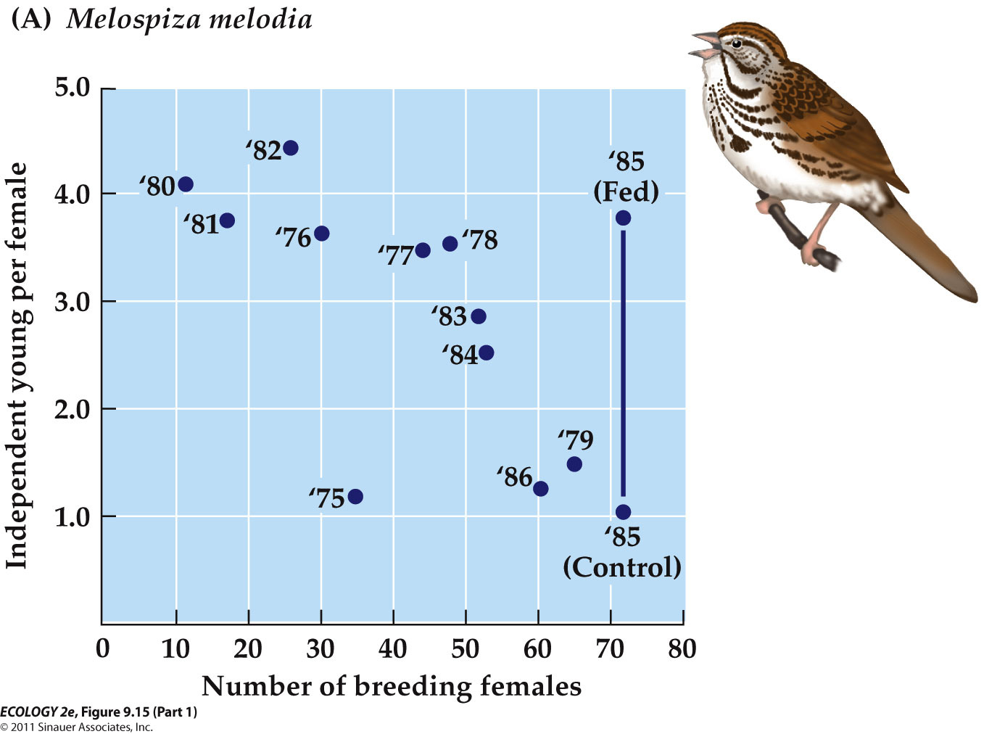
  - Density-dependent mortality has been observed in many populations.
    - E.g. Yoda et al. (1963) planted soybeans at various densities and found that at the highest densities, many seedlings had died by 93 days of age.

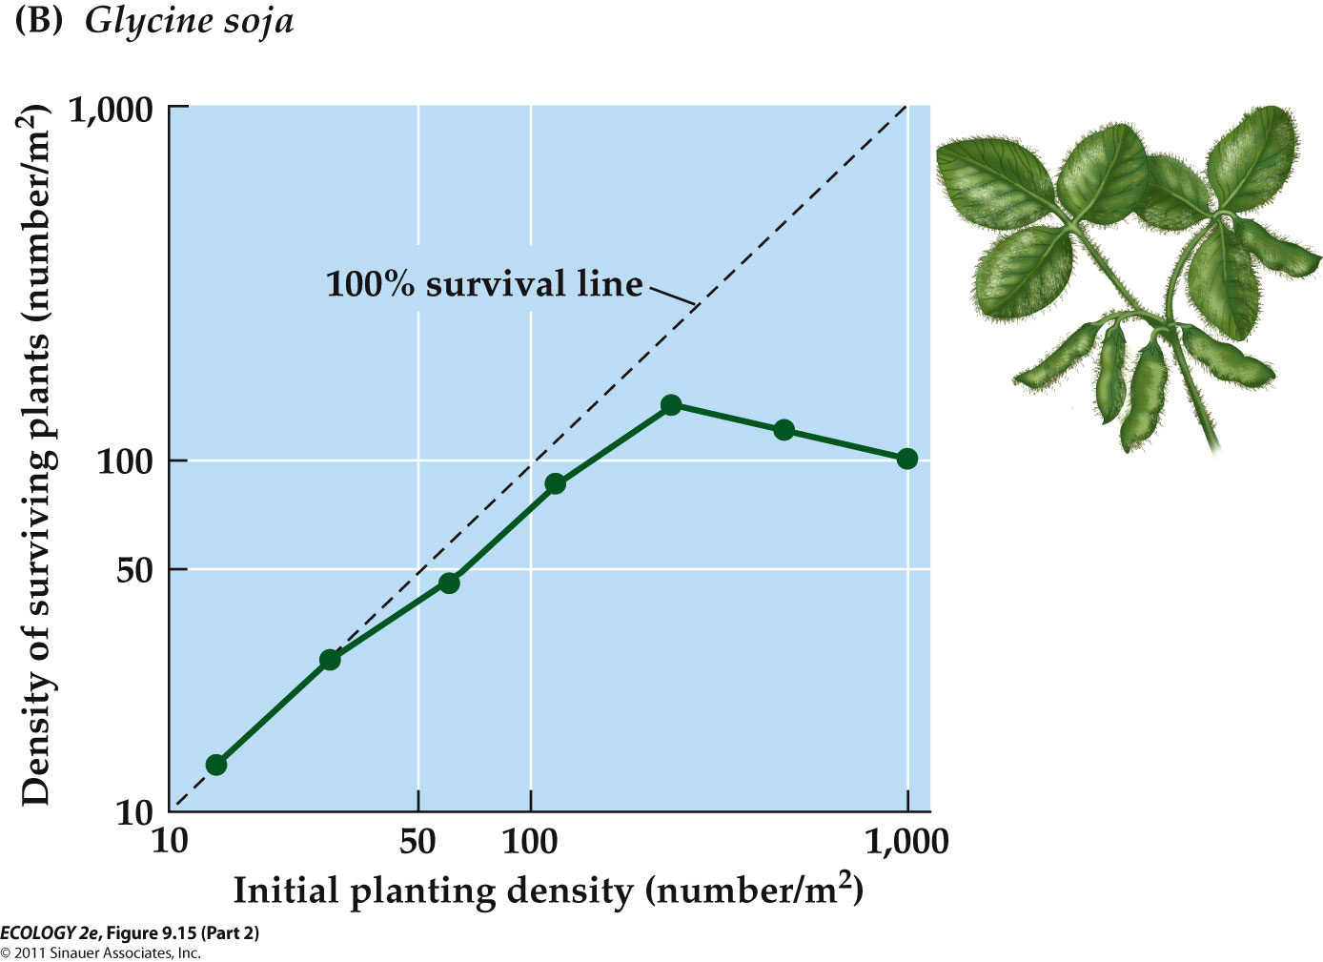

LOGISITC GROWTH

  - Logistic growth: Population increases rapidly, then stabilizes at the carrying capacity (maximum population size that can be supported indefinitely by the environment).
    - E.g. an S-shaped growth curve in a natural population

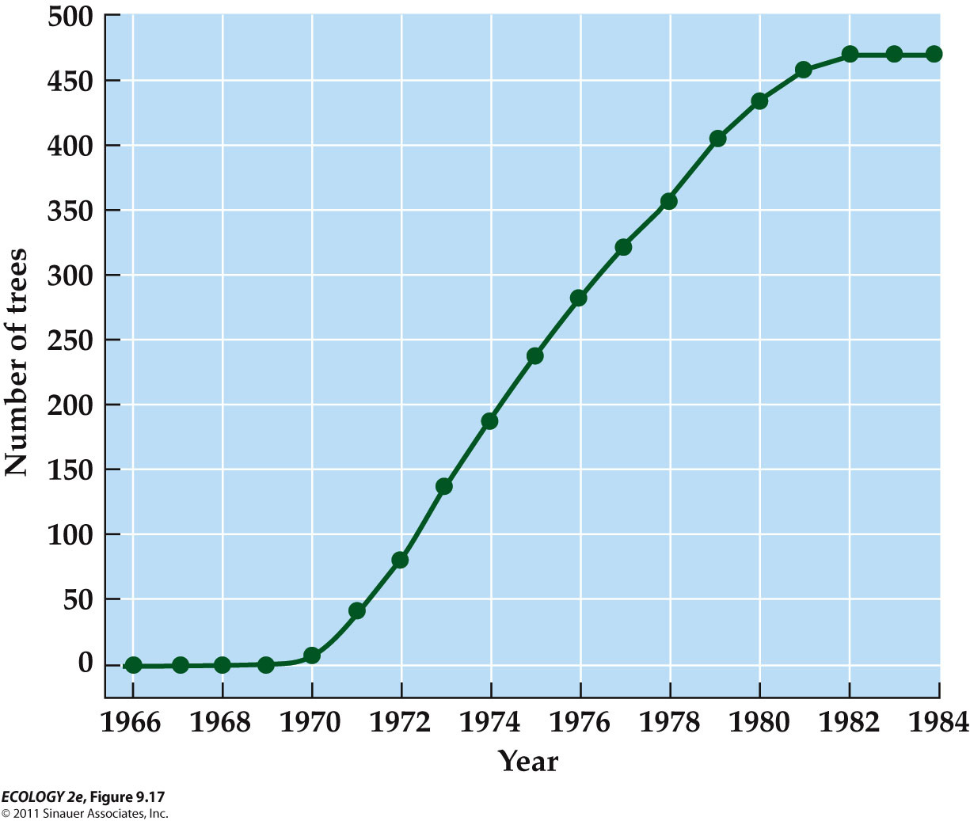
    - The willow population increased rapidly in number at first and then stabilized at about 475 trees.
  - The growth rate decreases as population nears carrying capacity because resources begin to run short.
  - At carrying capacity, the growth rate is zero, so population size does not change.

  - The logistic equation assumes that r declines as N increases:
    - N = population density
    - r = per capita growth rate
    - K = carrying capacity

  - Logistic VS. Exponential Growth

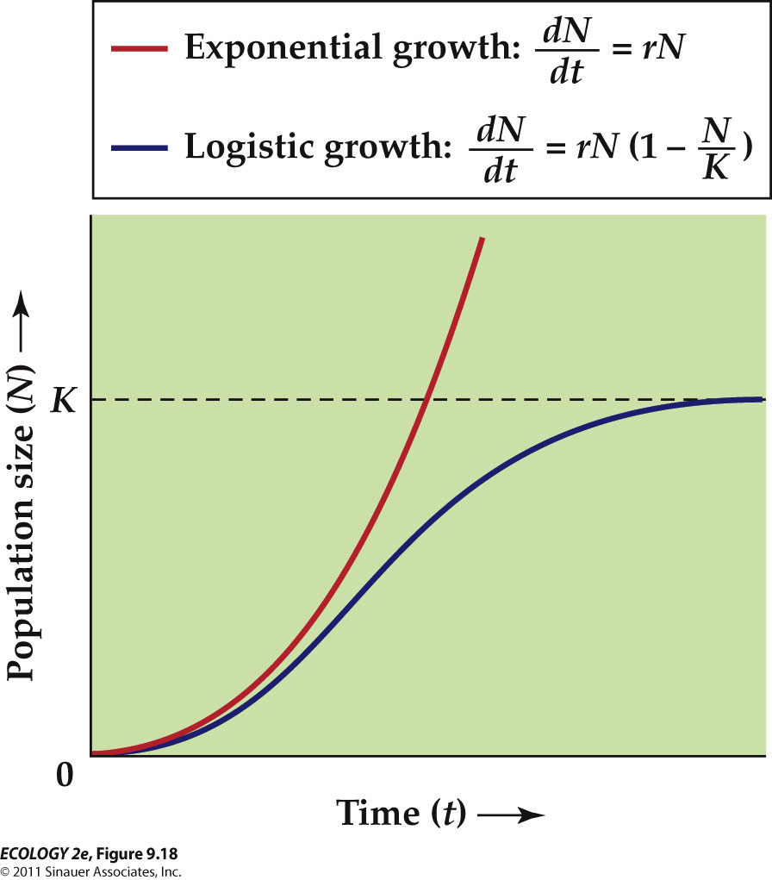
    - Eventually, a population that grows logistically levels off at the carrying capacity, K.

  - When densities are low, logistic growth is similar to exponential growth.
  - As density increases, growth rate approaches zero as population nears K.

  - When N is small, (1 – N/K) is close to 1, and the population increases at a rate close to r.

  - Population dynamics: The ways in which populations change in abundance over time.
  - Population size changes as a result of four processes: Birth, death, immigration, and emigration.
    - N_{t} = Population size at time t
    - B = Number of births
    - D = Number of deaths
    - I = Number of immigrants
    - E = Number of emigrants

PATTERNS OF POPULATION GROWTH

  - Populations exhibit a wide range of growth patterns, including exponential growth, logistic growth, fluctuations, and regular cycles.
    - These four patterns are not mutually exclusive. A single population can experience each of them at different times.

- Exponential growth can occur when conditions are favorable
  - Exponential Growth : Population increases by a constant proportion at each point in time.
  - When conditions are favorable, a population can increase exponentially for a limited time. (cannot continue indefinitely)
  - When a species reaches a new area, exponential growth can occur if conditions are favorable.
  - The population may grow exponentially until density-dependent factors regulate its numbers.
  - The example of how dispersal can lead to exponential growth

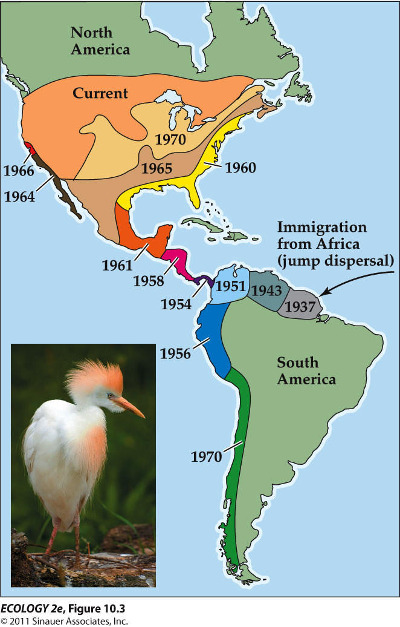
    - Species such as the cattle egret colonize new regions by long-distance or jump dispersal events.
    - Local populations then expand by short-distance dispersal events.

- In logistic growth, the population approaches an equilibrium
  - These populations first increase, then fluctuate by a small amount around the carrying capacity.
  - Plots of real populations rarely match the logistic curve exactly.
  - “Logistic growth” is used broadly to indicate any population that increases initially, then levels off at the carrying capacity.

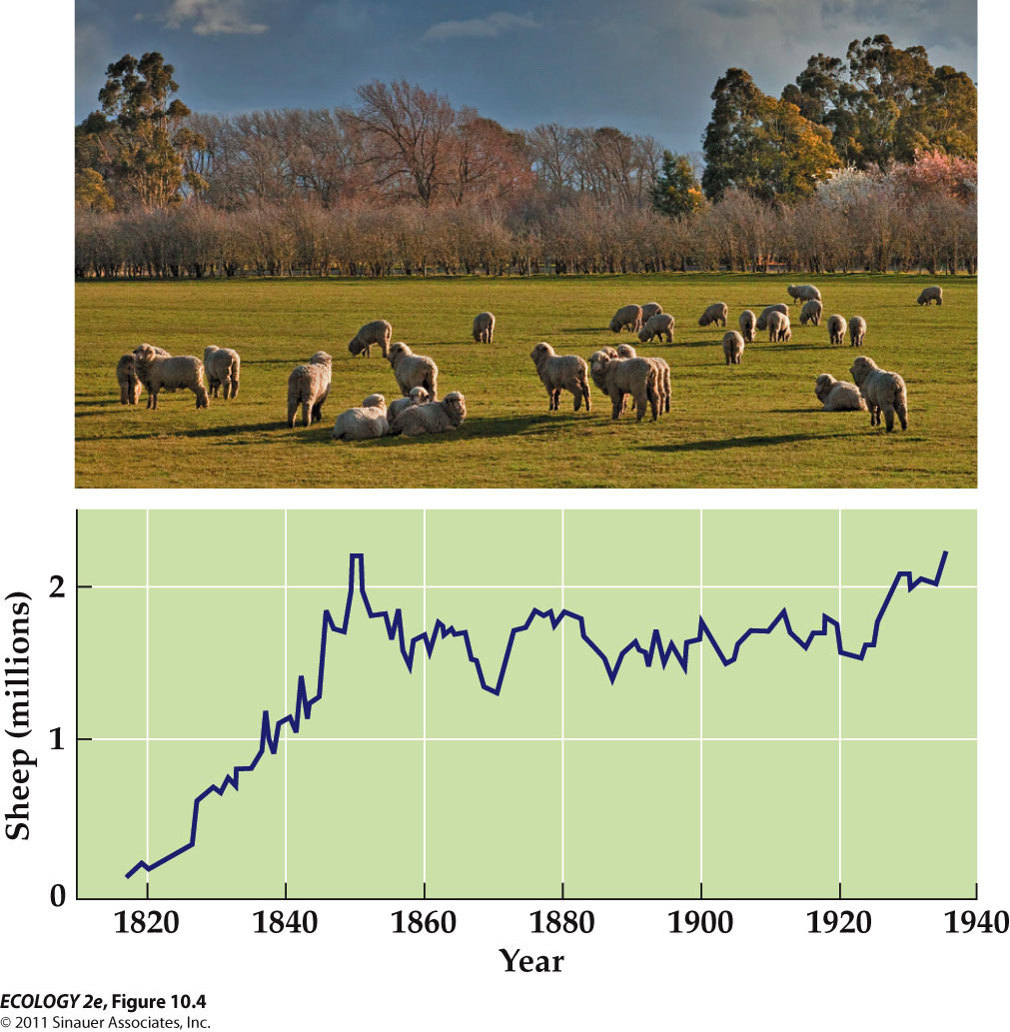
    - The curve of real population growth can roughly resemble a logistic curve.
  - For K (carrying capacity) to be constant, birth rates and death rates must be constant over time at any given density.
    - This rarely happens in nature. Birth and death rates do vary over time, thus we expect carrying capacity to fluctuate.

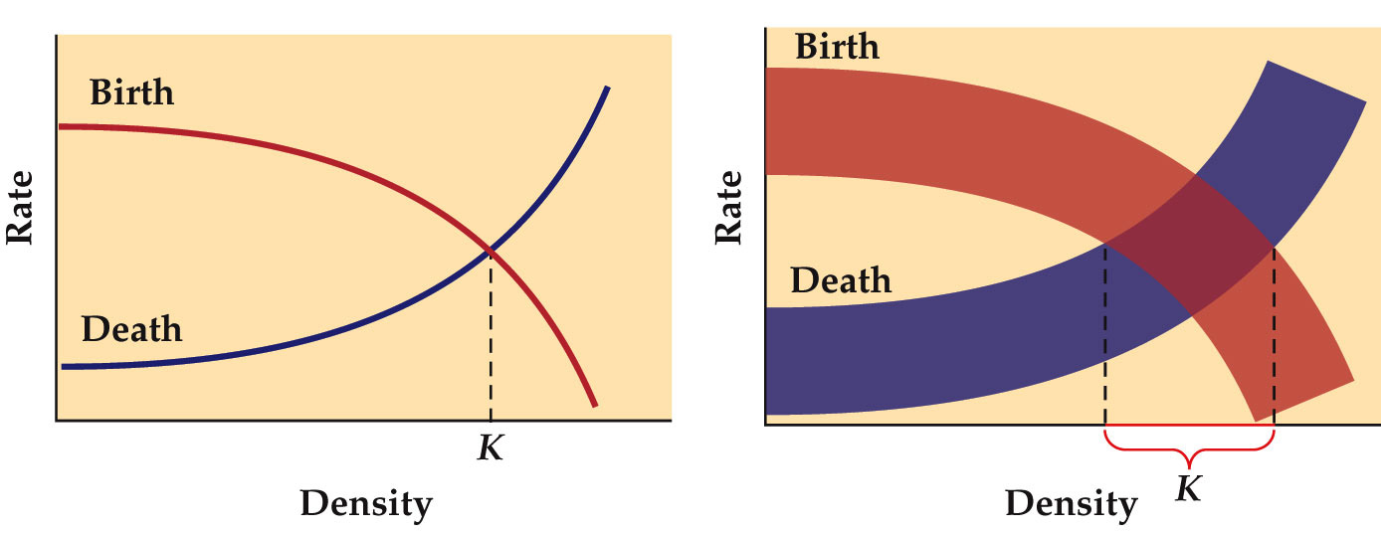
    - Why we expect carrying capacity to fluctuate
      - Broad band values due to a lot of variations

- - All population fluctuate in size
  - In all populations, numbers rise and fall over time.
  - Fluctuations can be deviations from
    - a growth pattern, e.g., the Tasmanian sheep population
    - or erratic (unpredictable)- In Lake Erie phytoplankton populations, fluctuating abundance could reflect changes in environmental factors such as nutrient supplies, temperature, or predator abundance.

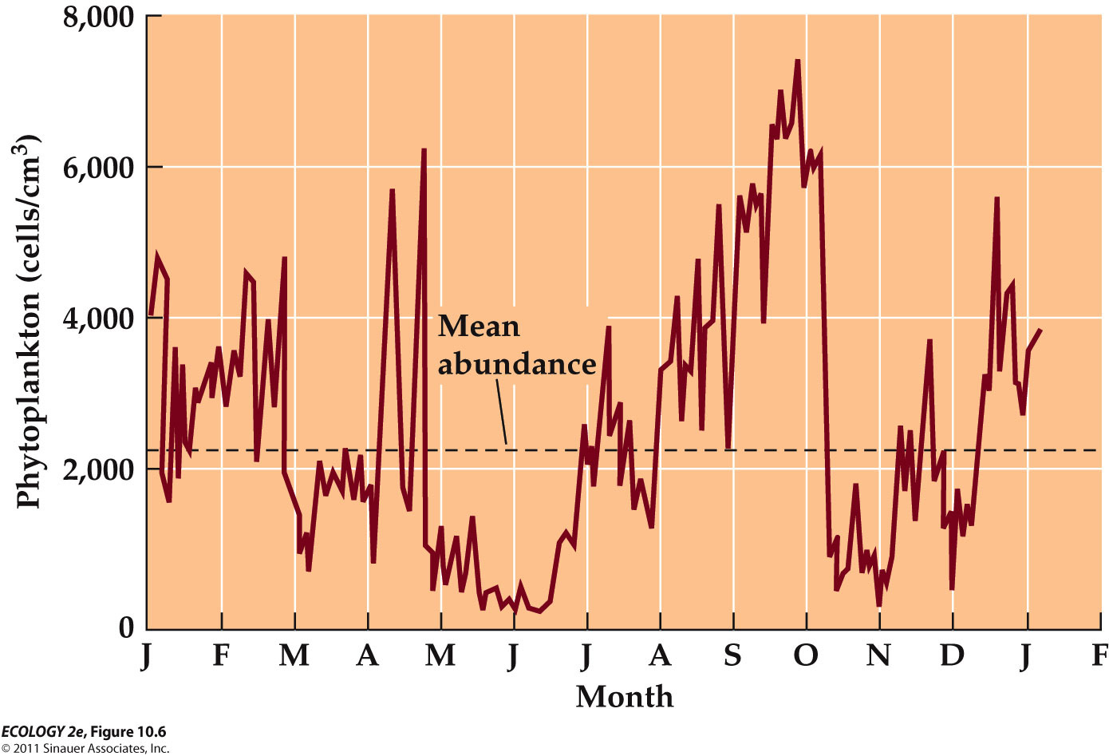
      - Population fluctuations – erratic (dramatic) change in Lake Erie
  - population outbreak - # of individuals increases rapidly
    - e.g. An ongoing outbreak of the mountain pine beetle has killed hundreds of millions of trees across British Columbia. This has altered forest composition, and CO₂ is released as the trees decay—17.6 megatons every year.

- - Some species exhibit population cylce
  - Poplulation cycles
    - Some populations have alternating periods of high and low abundance at regular intervals.
  - E.g. Populations of small rodents, such as lemmings and voles, typically reach a peak every 3–5 years.
  - 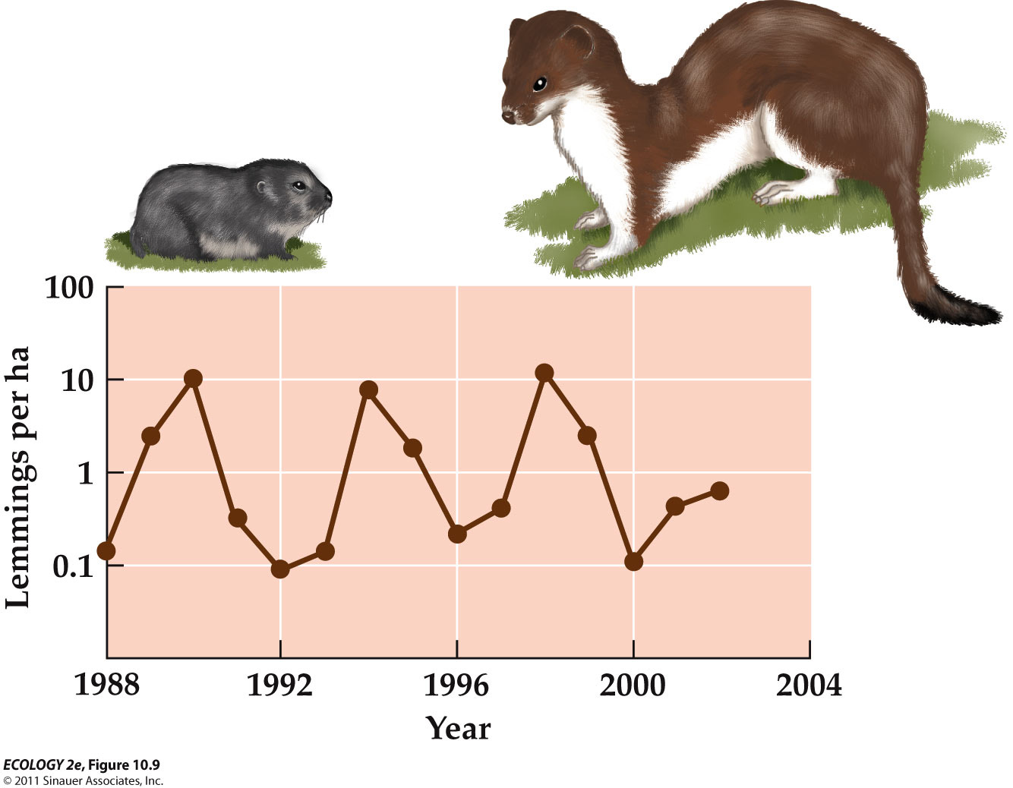
    - The lemming abundance tends to rise and fall every 4 years due to predation (stroat) and food supply.
  - Different factors may drive population cycles in rodents.
    - For collared lemmings in Greenland, field studies and modeling indicated that the 4-year cycle is driven by predators, such as the stoat.
    - In other studies, predator removal had no effect on population cycles. Factors driving population cycles may vary by place/species.
  - Some population cycles may stop if certain environmental factors change.
    - Warmer winter temperatures affect snow conditions at high latitudes, making it more difficult for lemmings to feed and avoid predators. Their populations have stopped cycling every 3 to 4 years.

DELAYED DENSITY DEPENDENCE

  - Definition : Delays in the effect that density has on population size.

- - The effect of population density os often delayed in time
  - Commonly, the number of individuals born in a given time period is influenced by population densities that were present several time periods ago.
  - Delayed density dependence can cause populations to fluctuate in size.
  - E.g. A predator reproduces more slowly than its prey.
    - If predator population is small, prey population may increase. Then the predators will increase but with a time lag.
    - Many predators may reduce the prey population, and then the predator population will decease again.
  - The logistic equation can be modified to include time lags

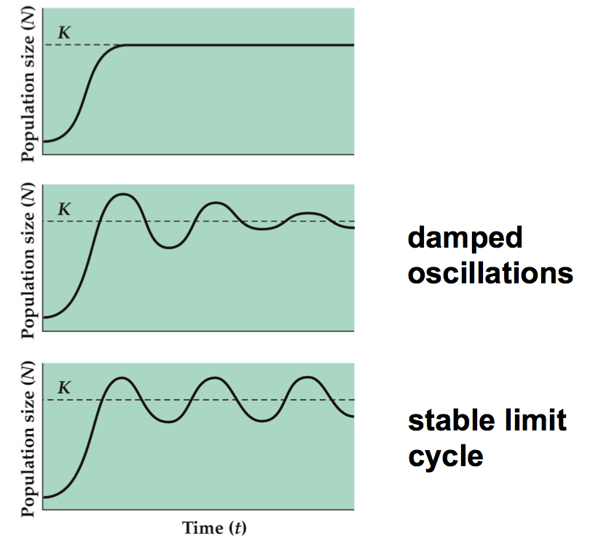
    - Damped oscillations – the deviations from the carrying capacity gradually get smaller over time
    - Stalbe limit cycle – fluctuate indefinitely about the carrying capacity, K

  - A. J. Nicholson studied density dependence in sheep blowflies using laboratory experiments.
    - In the first experiment, adults were given unlimited food, but larvae were restricted to 50 g of liver per day.

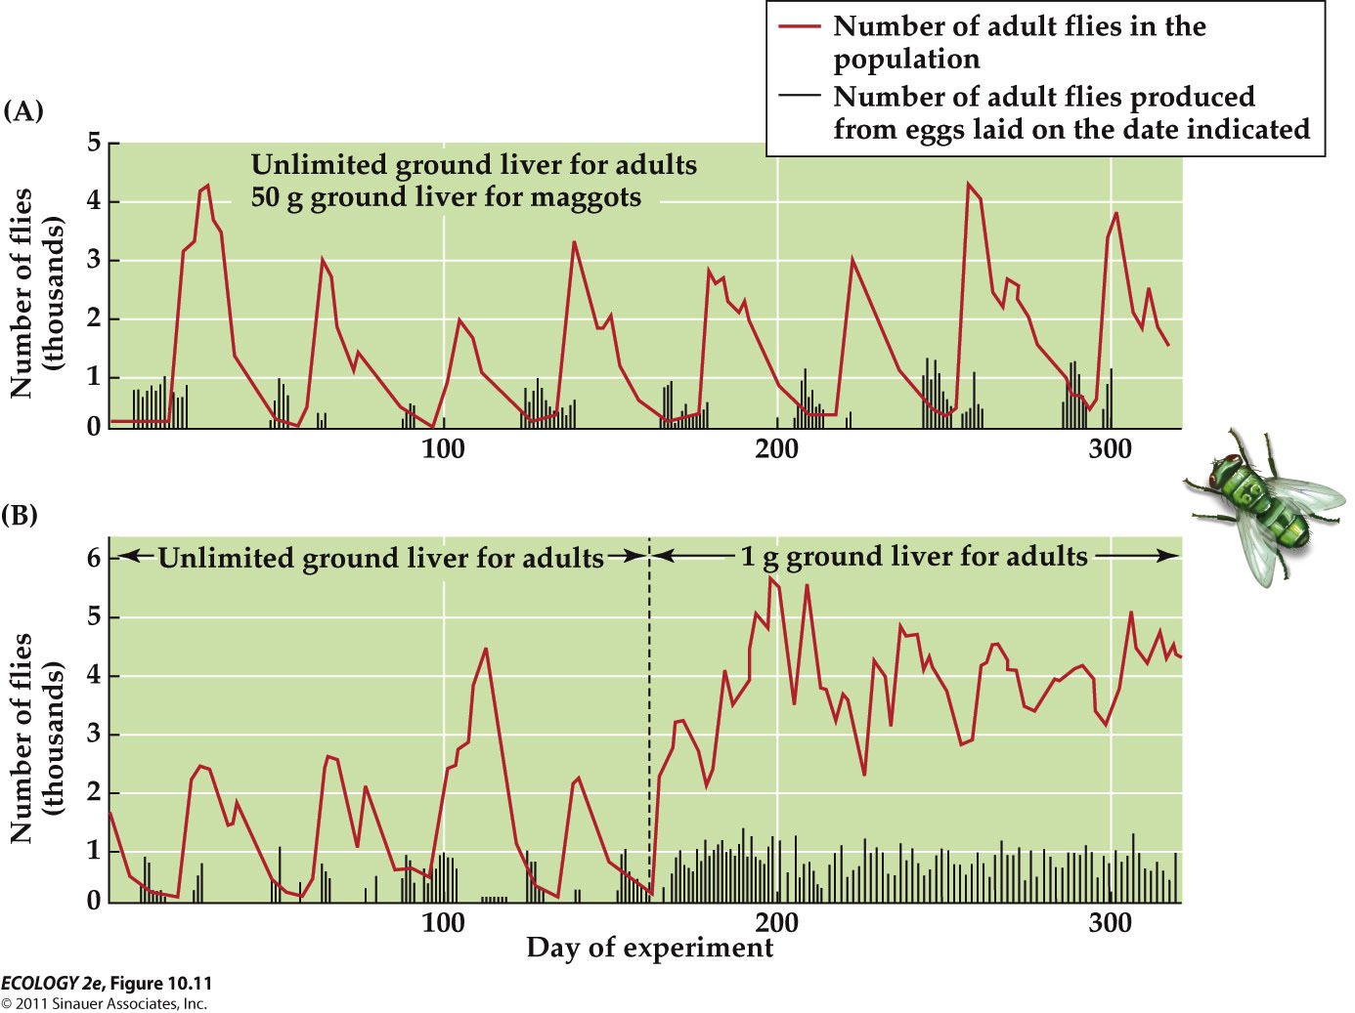
      - With abundant food, females laid enormous numbers of eggs, but when the eggs hatched, most larvae died because of lack of food. This resulted in an adult population size that fluctuated dramatically.
    - In the second experiment, both adults and larvae were given limited food.
      - The adult population size no longer showed repeated fluctuations.

POPULATION EXTINCTION

  - The risk of extinction increases greatly in small populations.
  - Fluctuations in growth rate, population size, and chance events can affect a population’s risk of extinction.

- - Flunctuations in the population growth rate can incrased the risk of extinction.
  - The geometric growth equation can include random variation in the finite rate of increase (λ).
    - Random variation in environmental conditions can cause λ to change from year to year (good years and bad years for growth)

  - Computer simulations for three populations allowed λ to fluctuate at random.
    - Two of the populations recovered from low numbers, but one went extinct.
    - Fluctuations increase the risk of extinction, and the degree of fluctuation is important.

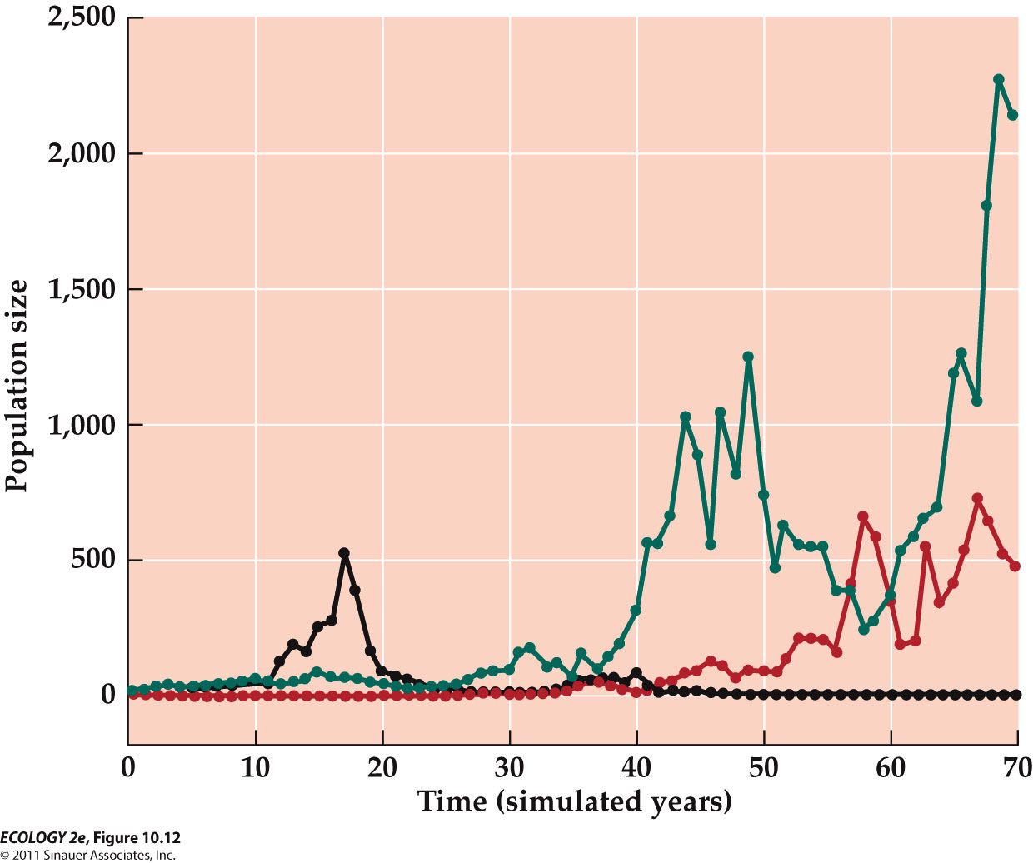
    - The range of variation in λ is measured by the standard deviation (σ).
      - σ = 0.2, 0.3% of populations went extinct in 70 years.
      - σ = 0.4, 17% of populations went extinct.
      - σ = 0.8, 53% of the populations went extinct.
    - When variable environmental conditions result in large fluctuations in growth rate, the risk of extinction increases.

- Small populations are at much greater risk of extinction than large populations
  - Small populations are at greatest risk.
    - If the simulations are repeated using larger initial population sizes, there are fewer extinctions.
  - These patterns have been observed in real populations.
    - In bird populations on the Channel Islands in California, 39% of populations with less than 10 breeding pairs went extinct.
    - No extinctions occurred in populations with over 1,000 breeding pairs (Jones and Diamond 1976).

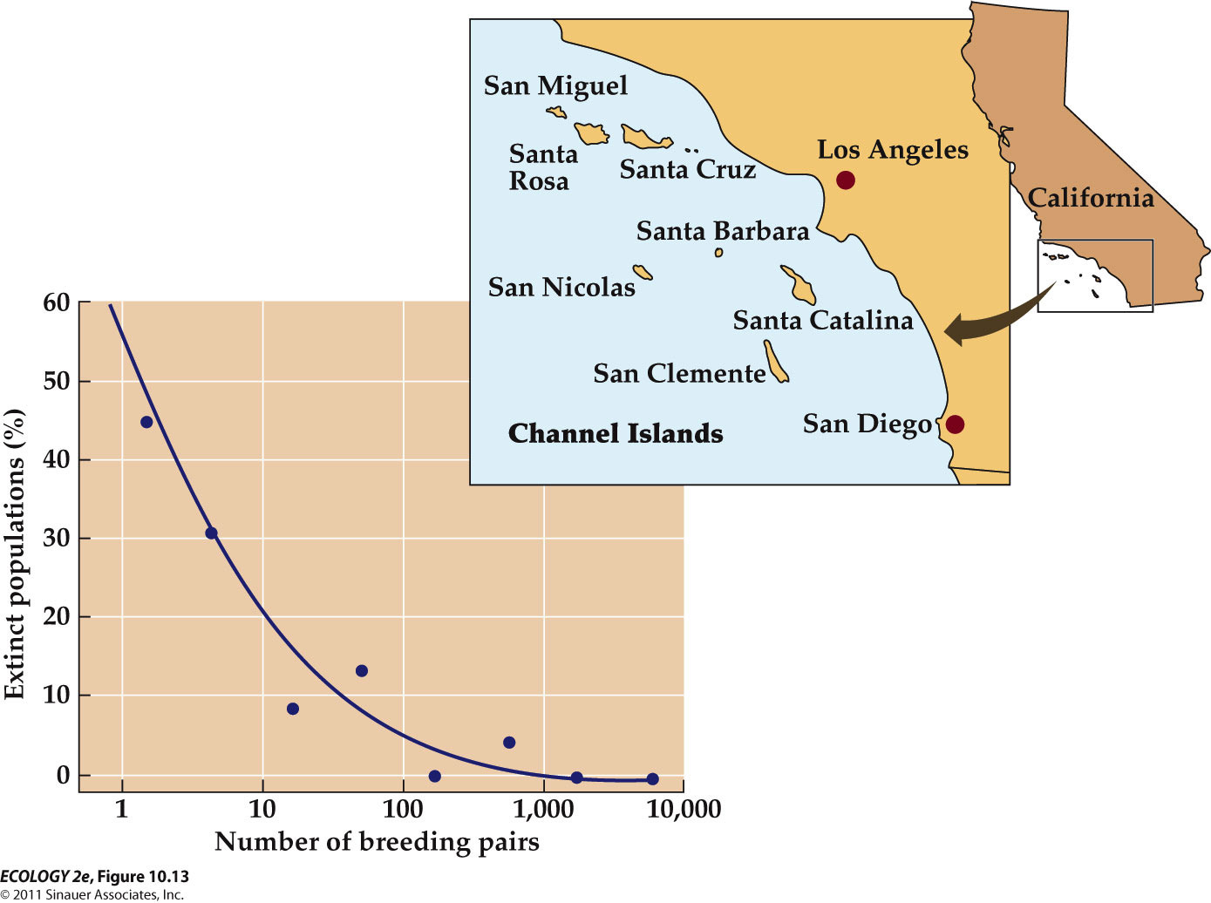
      - The percentage of popuplations that went extinct declined rapidly as the number of breeding pairs in the population increased.

- - Chance events can drive small populations to extinct.

  - Chance events—genetic, demographic, and environmental events—can play a role the extinction of small populations.

- Threats from genetic factors
  - Genetic drift—chance events influence which alleles are passed on to the next generation.
    - Allele frequencies can change at random from one generation to the next and genetic variation is reduced.
  - Genetic drift and inbreeding reduced fertility of male lions in a Tanzanian population which was reduced to only a few males in 1962.
    - Population size has since increased, but testing shows all individuals are descended from 15 lions.
    - The population has low genetic variation and a high frequency of sperm abnormalities.

Threats from demogrphic factors
  - Demographic stochasticity—chance events affect survival and reproduction of individuals.
    - Example: In a population of ten individuals, a storm wipes out six.
    - The 40% survival rate may be much lower than the average rate for that species.

  - Allee effects: At low densities, individuals have difficulty finding mates, so growth rate decreases as population density decreases.
    - Allee effects can reduce small population size even further.

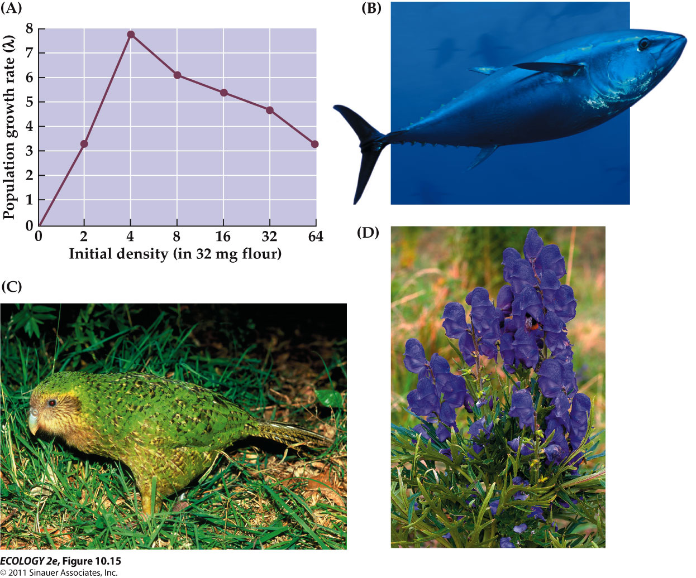
      - Population growth rates reached their lowest point at the lowest initial density

Threats from environmental variation
  - Environmental stochasticity: Unpredictable changes in the environment that can cause extinction of small populations.
    - Yellowstone grizzly bear population is at risk of extinction from random environmental variation, if the number of females drops to 30–40.

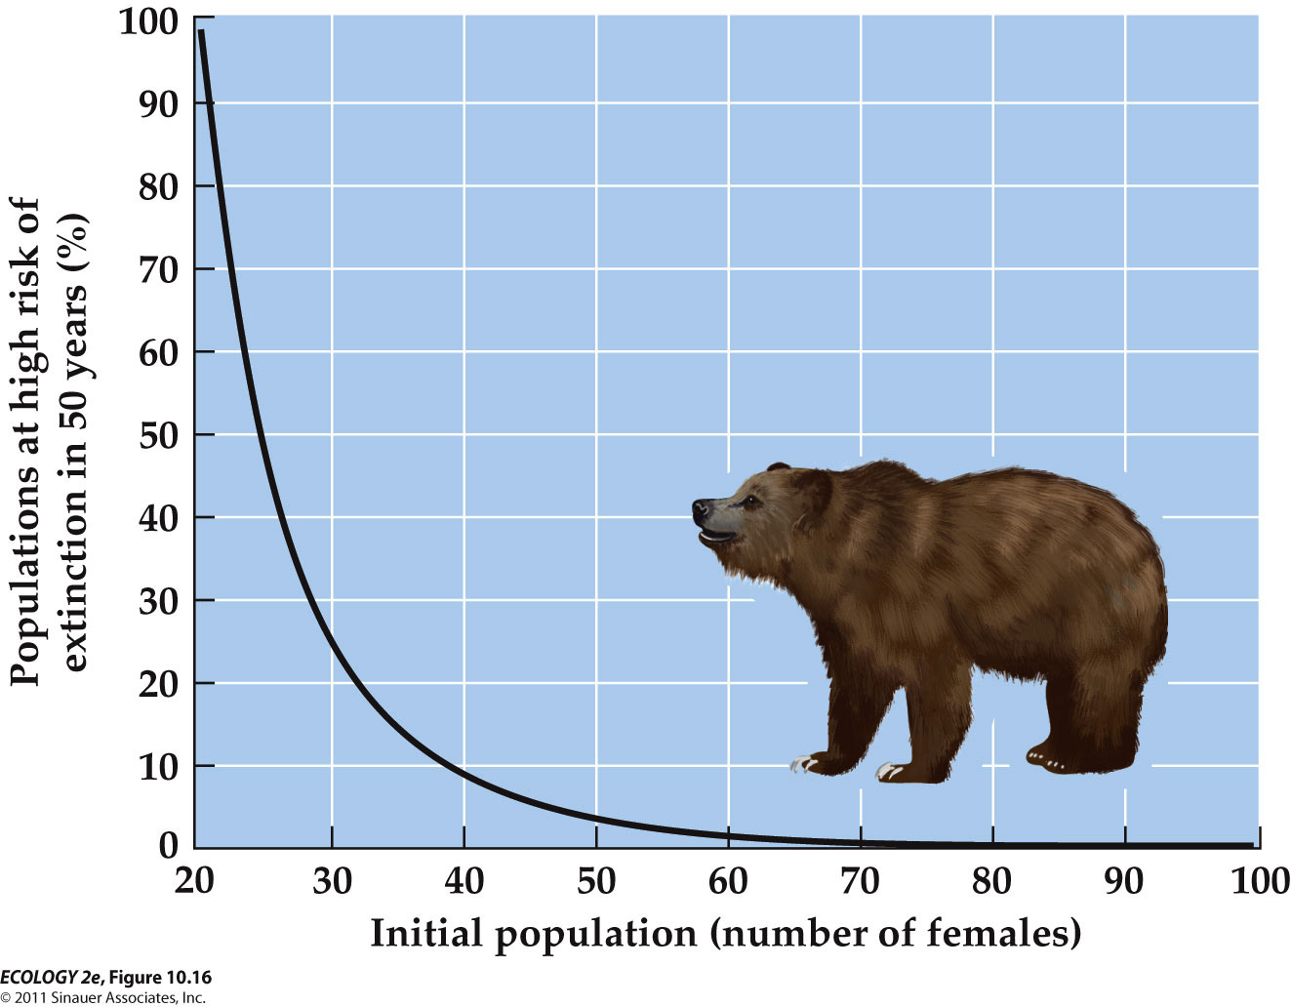
  - Environmental stochasticity—change in average birth or death rates from year to year because of random changes in environmental conditions.
  - Demographic stochasticity—birth and death rates are constant, but the actual fates of individuals differ.
  - Natural catastrophes (floods, fires, etc.) can eliminate or greatly reduce even large populations, and play a role in extinctions.
    - Heath hens were reduced to one population of 50 on Martha’s Vineyard when a series of bad weather, fires, diseases, and predators drove the population to extinction.

- METAPOPULATIONS

  - For many species, suitable habitat exists as a series of spatially isolated patches, resulting in isolated populations.
  - Metapopulation: A set of spatially isolated populations linked by dispersal of individuals or gametes.
    - Characterized by repeated extinctions and colonizations of the small individual populations, but the metapopulation persists because this includes populations that are going extinct and new pouplations established by colonization.

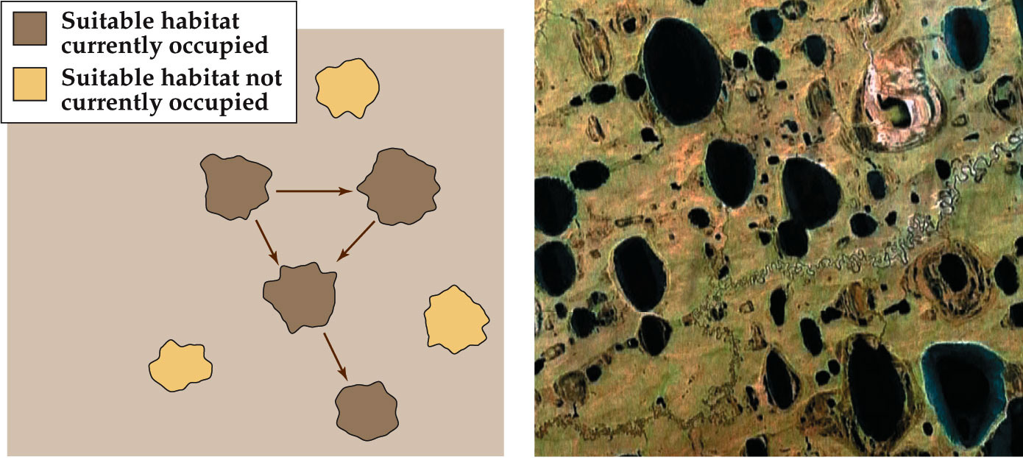
    - membes of the species occasionally disperse from one patch of suitable habitat to another.

  - Extinction and colonization of patches (Levins 1969, 1970):
    - Some patches will be occupied as long as colonization rate is greater than extinction rate; otherwise, all populations in the metapopulation will become extinct.
    - Levins’ research impacts key issues:
      - Factors that influence patch colonization and extinction.
      - Importance of the spatial arrangement of patches.
      - How the landscape between patches affects dispersal.
      - Whether empty patches are suitable habitat.

- A metapopulation can go extinct even when suitable habitat remains
  - Habitat fragmentation: Large tracts of habitat are converted to isolated patches, resulting in a metapopulation structure.
    - As patches get smaller and more isolated, colonization decreases and extinction rate increases.
  - E.g. The northern spotted owl lives in patches of old-growth forests in the Pacific Northwest.
    - Lande (1988) estimated that the metapopulation would collapse if logging reduced suitable patches to <20%. The owl was listed as threatened in 1990.

- Extinction and colonization rates often vary among patches
  - Research on skipper butterflies in the United Kingdom highlighted two important features of metapopulations:
    - Isolation by distance—when patches are too far apart.
    - Patch size—small patches may be hard to find and have high extinction rates.

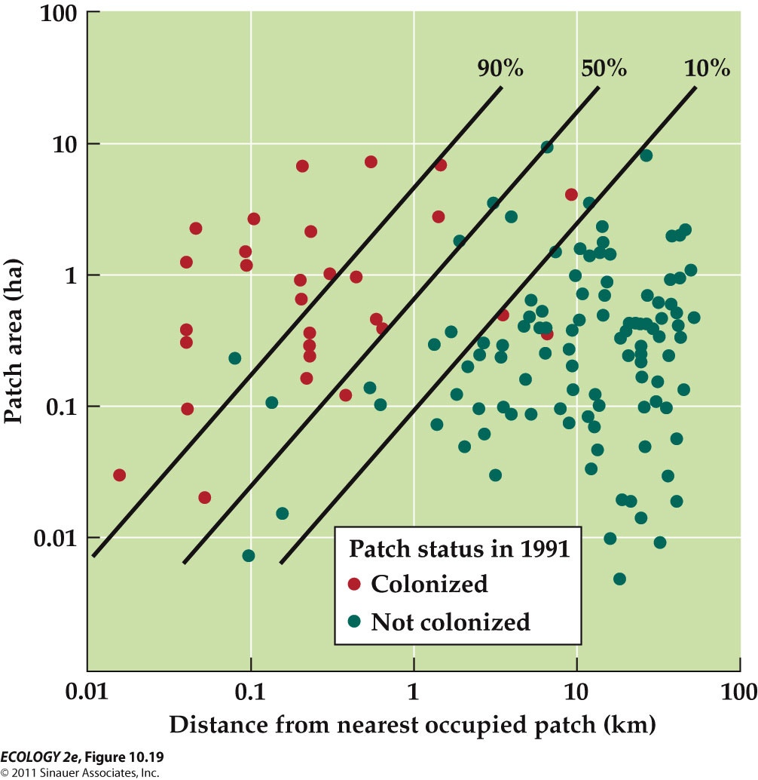
      - Patches that had the largest area and were closest to occupied patches were most likely to be colonized.
  - Isolation by distance can affect the chance of extinction—a patch that is near an occupied patch may receive immigrants repeatedly.
    - High rates of immigration that protect a population from extinction is known as the rescue effect.

  - Nonrandom factors can also influence colonization and extinction.
    - A metapopulation of pool frogs is found in some ponds along the Baltic coast in Sweden.
    - Over time, some ponds fill in with sediments and vegetation, shrinking pond size and increasing extinction rates.

- CASE STUDY : A Sea in Touble

  - The comb jelly Mnemiopsis leidyi was introduced accidentally into the Black Sea in the 1980s.

  - The Black Sea ecosystem was already in trouble—nutrients inputs had caused eutrophication.
    - Phytoplankton abundance had increased, water clarity decreased, oxygen concentrations dropped, and fish had experienced massive die-offs.

  - Mnemiopsis is a voracious predator of zooplankton, fish eggs, and young fish.
    - It continues to feed even when completely full, then regurgitates (Bring swallowed food up again to the mouth) prey organisms stuck in balls of mucus.
    - An individual Mnemiopsis can produce up to 8,000 offspring just 13 days after its own birth.

  - In 1989, Mnemiopsis populations exploded: Biomass in the Black Sea was estimated at 800 million tons.
  - Feeding by Mnemiopsis caused zooplankton populations to crash, which caused phytoplankton populations to increase even more.
  - Huge numbers of dead phytoplankton and Mnemiopsis provided food for bacterial decomposers, which use oxygen.
  - Oxygen levels then decreased, harming fish populations, and commercial fishing was impacted.
  - Native predators and parasites failed to regulate Mnemiopsis populations.

  - By 1999, the Black Sea showed signs of recovery.
    - Nutrient inputs had been reduced and phytoplankton abundance decreased.

  - Another comb jelly had arrived, Beroe, which feeds almost exclusively on Mnemiopsis. Within 2 years, Mnemiopsis numbers plummeted.(drop)
  - The Mnemiopsis decline led to a rebound in zooplankton abundance and increase in native jellyfish species.
  - There was also an increase in anchovy catches for commercial fishermen.

  - Events in the Black Sea ecosystem illustrate two types of causation in ecological communities:
    - Bottom-up control—increased nutrient inputs caused eutrophication and increased phytoplankton biomass, decreased oxygen, fish die-offs, etc.
    - Top-down control—top predators control the abundance of populations.

  - Overfishing was also a factor in the Black Sea: Decline of top predator fish leads to increase in plankton-eating fish, which decreases zooplankton populations, and then phytoplankton abundance increases.

  - Competition: An interaction between individuals in which each is harmed by their shared use of a limiting resource
  - Competition occurs between species that share the use of a resource that limits the growth, survival, or reproduction of each species

  - Two types of competition
    - Interspecific competition: Interaction between two species in which each is harmed when they both use the same limiting resource.
    - Intraspecific competition: Between individuals of a single species.

COMPETITION FOR RESOURCES

  - Resources are features of the environment required for growth, survival, or reproduction, and which can be consumed to the point of depletion.
  - Examples of resources
    - Food.
    - Light for plants.
    - Water in terrestrial habitats.
    - Space, especially for sessile organisms.
    - For mobile animals, space for refuge, nesting, etc.
  - Species are also influenced by physical factors (abiotic) that are not consumed, such as temperature, pH, salinity.
    - These factors are not considered to be resources.

  - Competition reduces availability of resources.
    - Experiments with two diatom species by Tilman et al. (1981) showed that when each species was grown alone, a stable population size was reached.
    - When grown together, they competed for silica, and one species drove the other to extinction.

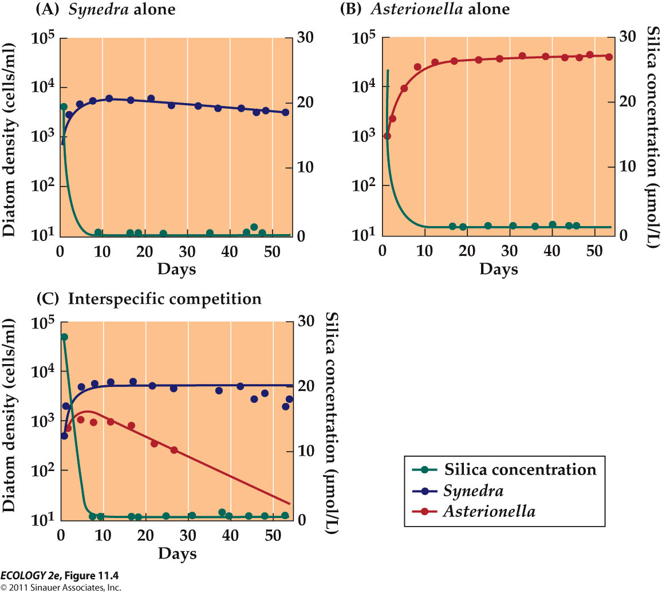

  - Competition can intensify when resources are scarce.
    - Competition among plants should increase in nutrient-poor soils.
    - Wilson and Tilman (1993) studied grass plants that were transplanted into fertilized and unfertilized plots.
    - Each plot type had three treatments:
      - 1. Neighbors left intact (belowground and aboveground competition).
      - 2. Neighbor roots left intact but neighbor shoots tied back (belowground competition).
      - 3. Neighbor roots and shoots both removed (no competition).
    - Belowground competition (treatment 2) was most intense in nitrogen-limited plots. Aboveground competition for light increased when light levels were low.

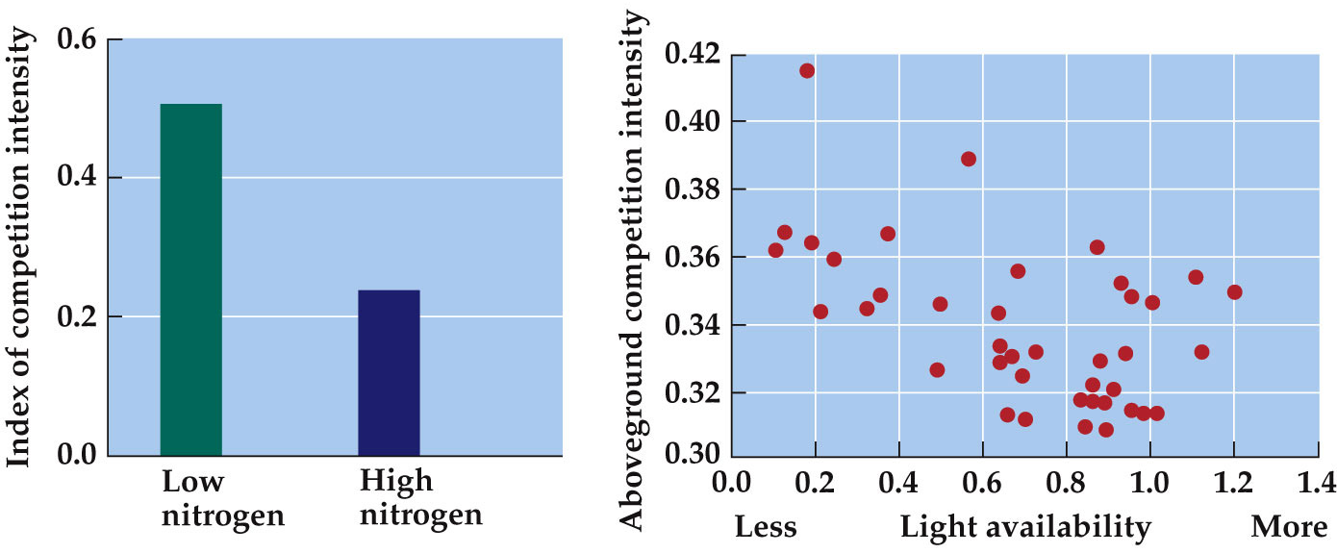
      - Resource availability affects the intensity of competition.

  - How important is competition ?
    - Connell (1983) found that competition was important for 50% of 215 species in 72 studies.
    - Gurevitch et al. (1992) analyzed the magnitude of competition in 93 species in 46 studies
      - Competition had significant effects on a wide range of organisms.

  - Potential biases: Researchers may not publish studies that show no significant effects, and a tendency for investigators to study species they suspect will show competition.
  - Still, they document that competition is common, though not ubiquitous.

GENERAL FEATURES OF COMPETITION

  - Competition, whether direct or indirect, can limit the distributions and abundances of competing species.
    - Exploitation Competition—Species compete indirectly: Individuals reduce the availability of a resource as they use it.
    - Interference competition: Species compete directly for access to a resource.
  - Individuals may perform antagonistic (opposite) actions that directly interfere with the ability of their competitors to use a limiting resources.
    - E.g. when two predators fight over a prey item, or
    - E.g. voles aggressively exclude other voles from preferred habitat.
    - Interference competition in sessile species
      - The acorn barnacle crushes or smothers nearby individuals of another barnacle species as it grows, and directly excludes the other species from portions of a rocky intertidal zone.

  - Interference competition in plants:
    - Allelopathy: Plants of one species release toxins that harm other species.
    - Individuals of one species grow on or shade other species, reducing their access to light.
  - For a resource in short supply, competition will reduce the amount available to each species.
    - The effects of competition are often unequal, or asymmetrical, and one species is harmed more than the other.
    - Example: When one species drives another to extinction.

  - Competition can occur between distantly related species.
    - In experiments with rodents and ants that eat the same seeds, Brown and Davidson (1977) set up plots with four treatments, as follows:
      - 1. Rodents excluded: Ant colonies increased by 71%.
      - 2. Ants excluded: Rodents increased in number and biomass.
      - 3. Both rodents and ants excluded: Seed density increased 450%.
      - 4. Undisturbed control plots.

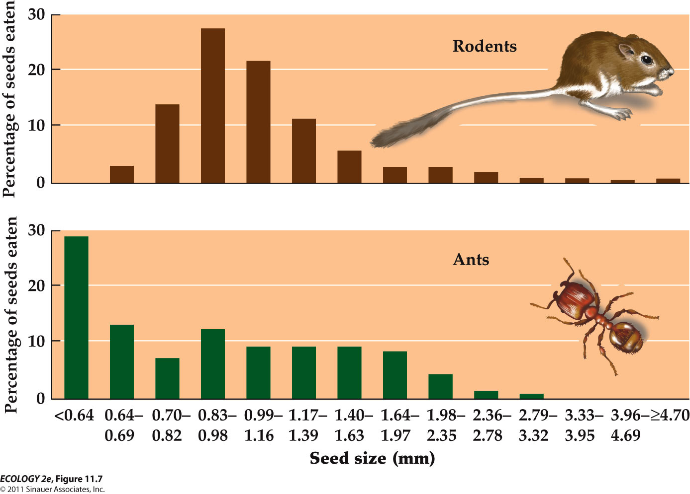
      - There is extensive overlap in the sizes of seeds eaten by ants and by rodents. Removal experiments showed that these two

distantly related groups compete for this food source.

  - Competition can influence species distributions.
    - Connell (1961) examined factors that influence the distribution, survival, and reproduction of two barnacle species on the coast of Scotland.
      - Distribution of larvae of the two species overlapped.
      - Adult distributions did not overlap:
        - Chthamalus were found only near the top of the intertidal zone.
        - Semibalanus were found throughout the rest of the intertidal zone.

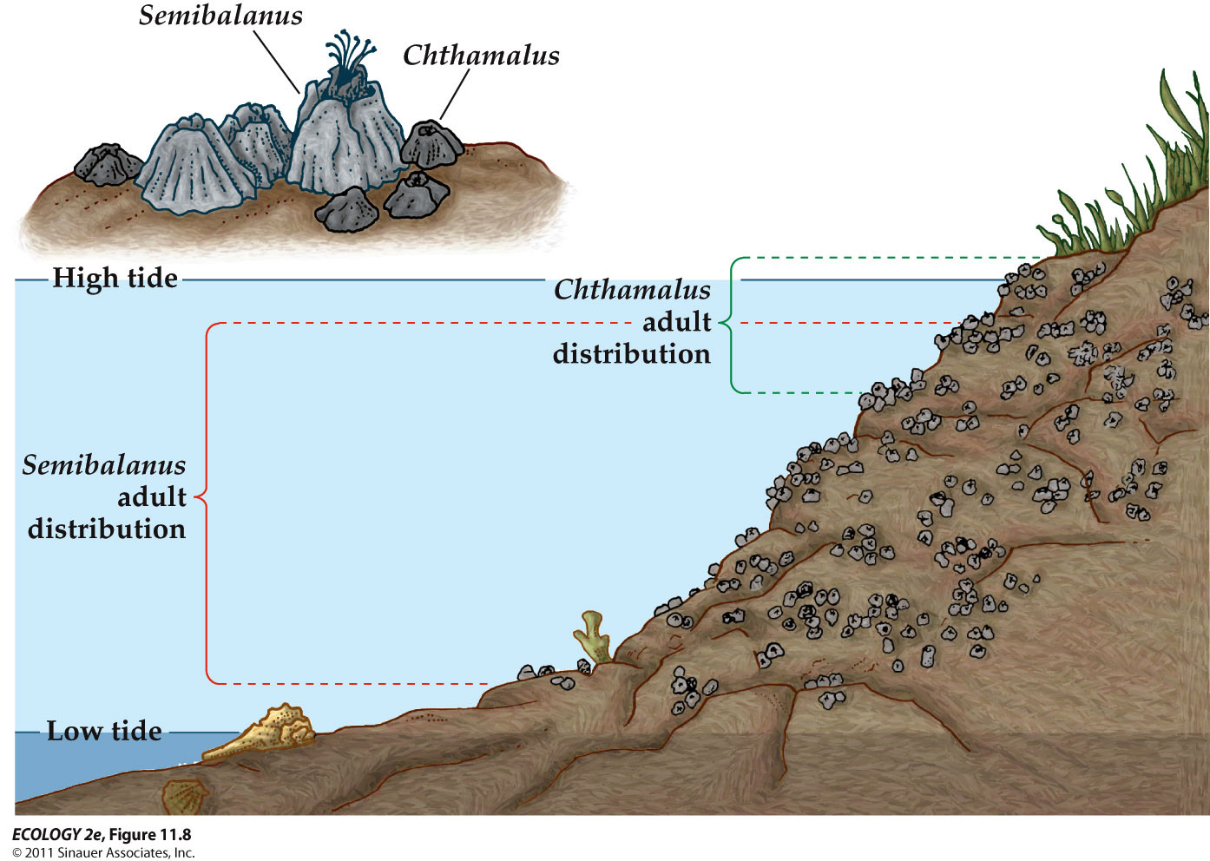
      - Chthamalus is excluded from the lower portions of the intertidal zone by competition with Semibalanus.
      - Semibalanus is excluded from the top of the intertidal zone by its sensitivity to desiccation (extreme dryness).
    - Using removal experiments, Connell found that Semibalanus excluded Chthamalus from all but the top of the zone.
    - Semibalanus smothered, removed, or crushed the other species.
    - However, Semibalanus dried out and survived poorly at the top of the intertidal zone.

  - A “natural experiment” is a situation in nature that is similar in effect to a controlled removal experiment.
    - Patterson (1980, 1981) studied chipmunk species in mountain forests and found:
    - When a species lived alone on a mountain, it occupied a wider range of habitats than when it lived with a competitor species.

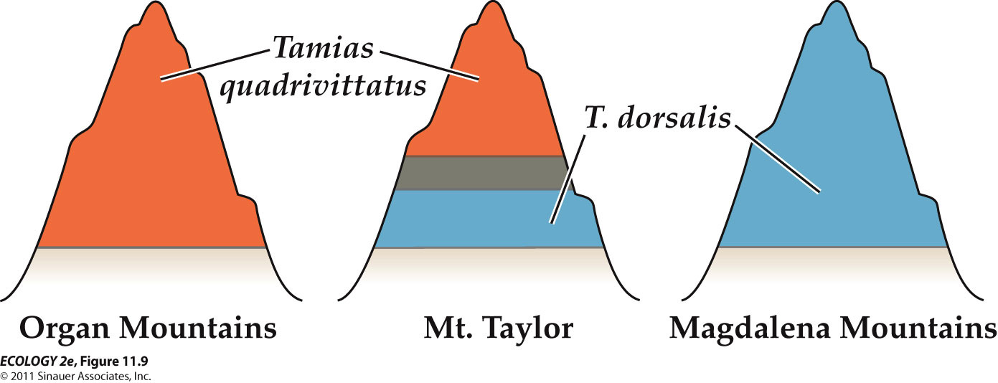

- COMPETITIVE EXCLUSION

  - Competing species are more likely to coexist when they use resources in different ways.
  - If the ecological niches (the physiological and biological conditions that the species needs to grow, survive and reproduce) of competing species are very similar, the superior competitor may drive the other species to extinction.
    - In the 1930s, Gause did experiments on competition using three species of Paramecium.
    - Populations of all three species reached a stable carrying capacity when grown alone.
    - When paired, some species drove others to extinction.

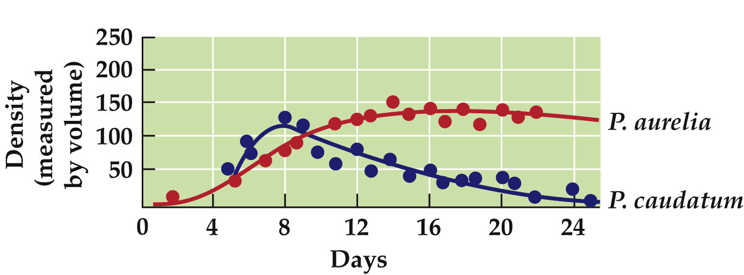
      - When grown together, P. caudatum went extinct.

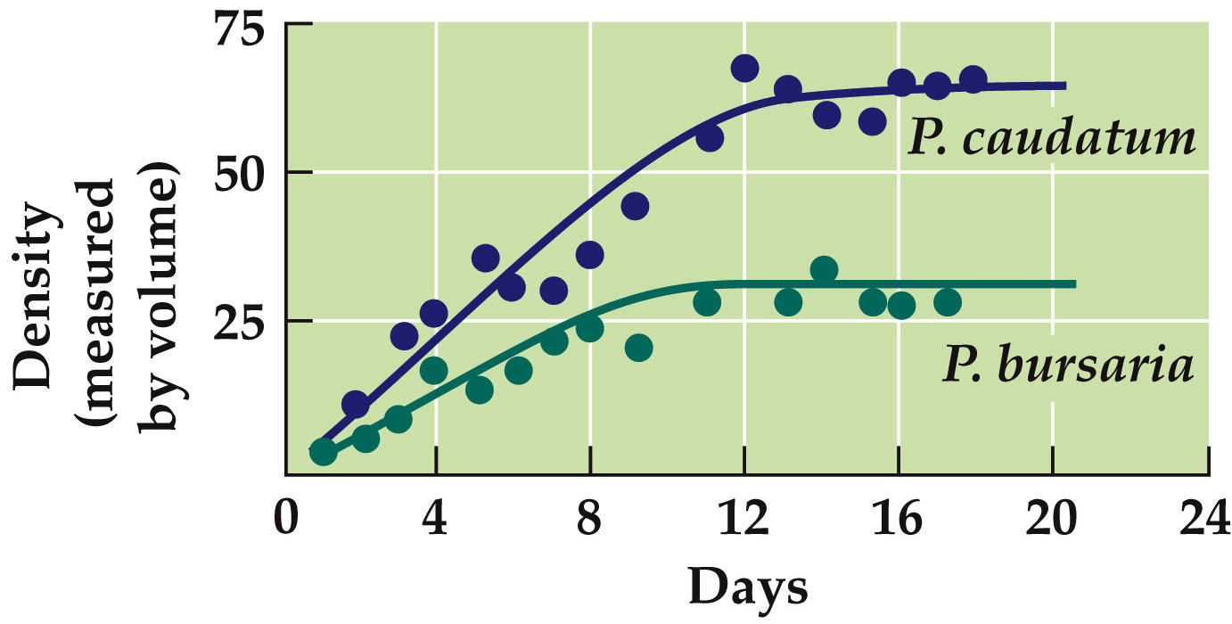
      - When grown together, both species persisted.
    - P. caudatum and P. bursaria were able to coexist despite competition, but the carrying capacity of both species was lowered.
    - P. caudatum usually ate floating bacteria, while P. bursaria usually fed on yeast cells that settled to the bottom.

  - Experiments on these and many other species led to the competitive exclusion principle:
    - Two species that use a limiting resource in the same way cannot coexist.

  - Resource partitioning: Species using a limited resource in different ways.
    - Stomp et al. (2004) studied two cyanobacteria species (BS1 and BS2) in the Baltic Sea.
      - BS1 absorbs green wavelengths most efficiently
      - BS2 absorbs red most efficiently.
    - Each species could survive when grown alone in either wavelength.
    - When grown together, one drove the other to extinction, depending on the wavelength used.
    - Under white light (all wavelengths) they both persisted.

    - Stomp et al. then studied cyanobacteria in lakes and oceans:
      - Only red cyanobacteria were found in clear waters,
      - only green cyanobacteria were found in turbid waters,
      - both were found in intermediate waters.
    - THEREFORE, the species are able to coexist because they are partitioning the light resource.

- - Competition can be modeled by modifying he logistic equation
  - The Lotka–Volterra competition model:
    - N₁ = population density of species 1.
    - r₁ = intrinsic rate of increase of species 1.
    - K₁ = carrying capacity of species 1.
    - α and β = competition coefficients—constants that describe effect of one species on the other.

  - The Lotka–Volterra model can be used to predict the outcome of competition:
    - Determine the conditions under which population size of each species stops changing over time.

    - Coexistence occurs when:
      - If α and β are equal, and close to 1, the species are equally strong competitors, and have similar effects on each other.
    - E.g. 1 If α = β = 0.95:
      - Coexistence is predicted only within a narrow range of values for the carrying capacities, K₁ and K₂.
    - E.g. 2 If α = β = 0.1:
      - Coexistence is predicted within a much broader range of carrying capacities.

- ALTERING THE OUTCOME OF COMPETITION

  - The outcome of competition can be altered by environmental conditions, species interactions, disturbance, and evolution.

- - Environmental conditions can result in competitive reversal—the inferior competitor in one habitat becomes the superior competitor in another.
  - Presence of herbivores can lead to competitive reversals.
    - When ragwort flea beetles (herbivore) were introduced to western Oregon, the biomass of ragwort, an invasive species, decreased, and its competitor species increased.
    - In the absence of the flea beetles, ragwort is a superior competitor.

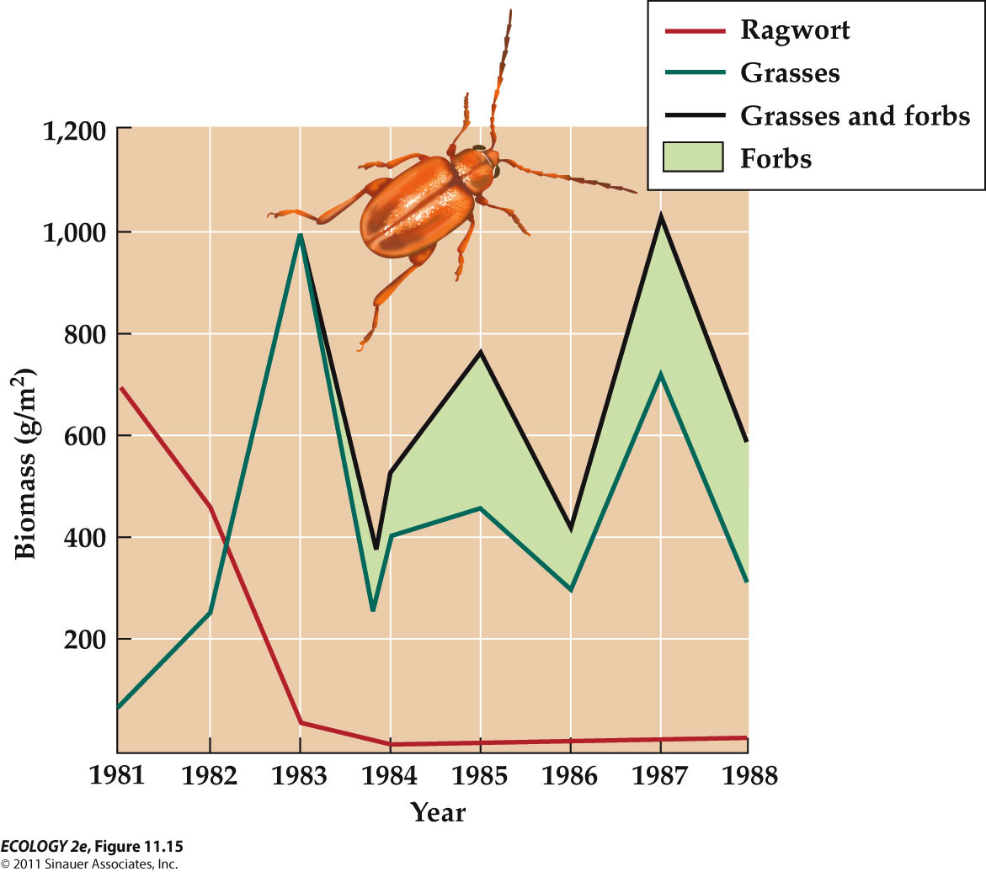

- - Disturbances such as fires or storms can kill or damage some individuals, while creating opportunities for others.
  - Forest plants that need sunlight are found only where disturbance has opened the tree canopy.
    - As trees recolonize and create shade, these plants cannot persist in the patch.
    - Such species are called fugitive species because they must disperse from one place to another as conditions change.
  - E.g. The brown alga called sea palm coexists with mussels, a superior competitor, in the rocky intertidal zone.
    - Large waves sometimes remove the mussels, creating temporary openings for the alga.

- - Competition can cause evolutionary change, and evolution can alter the outcome of competition.
  - This interplay has been observed in many studies.
  - Pimentel et al. grew houseflies and green blowflies together in chambers on the same food.
    - Initially, houseflies appeared to be the superior competitors, rapidly increasing in density.
    - Over time, the situation reversed, and eventually the houseflies went extinct.

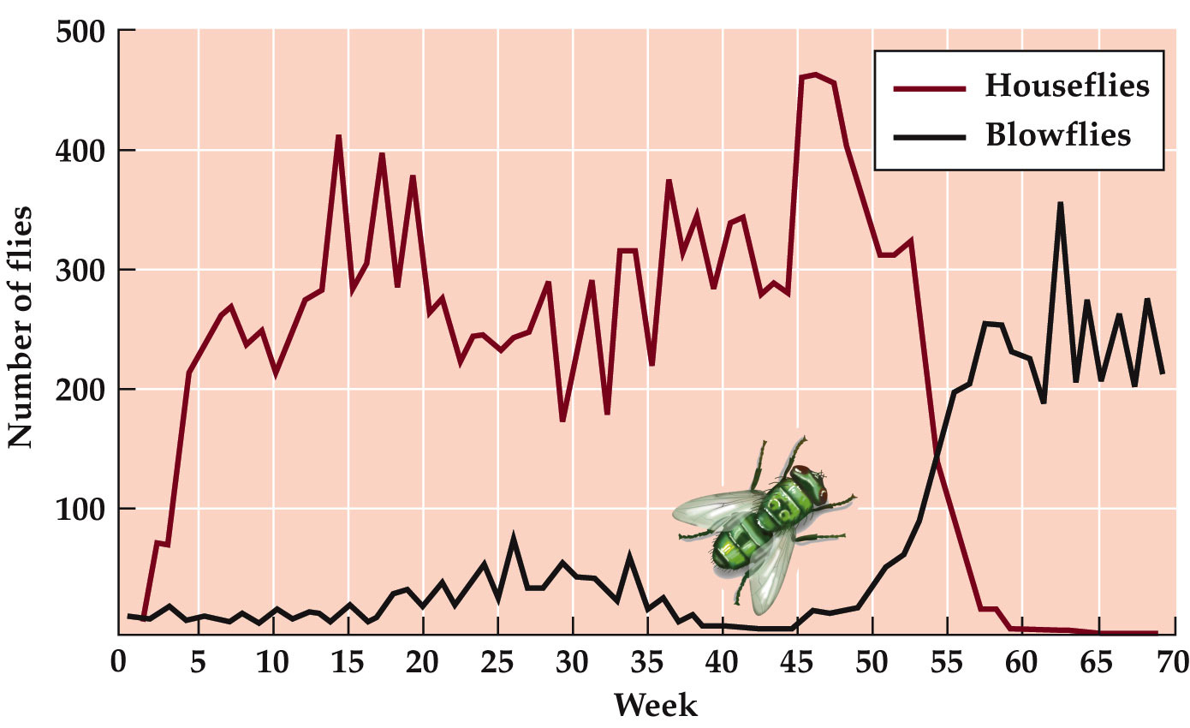
    - Individuals were also tested for signs of evolutionary change.
      - Blowflies raised in competition with houseflies had evolved to become superior competitors and always outcompeted the houseflies.
      - The underlying mechanisms of this and the associated genetic changes are unknown.

  - Natural selection can influence the morphology of competing species and result in character displacement.
    - The phenotypes of competing species become more different over time.

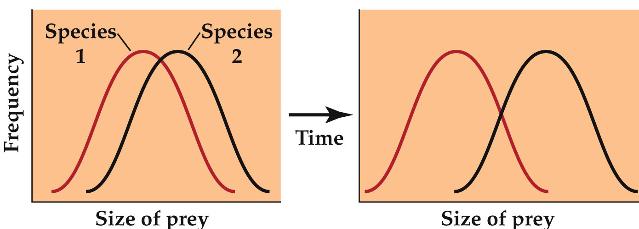
      - When they fist come together, the two species catch prey of about the same size.
      - BTUT after living tighter, for some time, the two species often catch prey of different sizes
  - E.g. In two species of Galápagos finches, beak sizes, and hence sizes of the seeds eaten, are different on islands with both species.
  - On islands with only one of the species, beak sizes are similar.

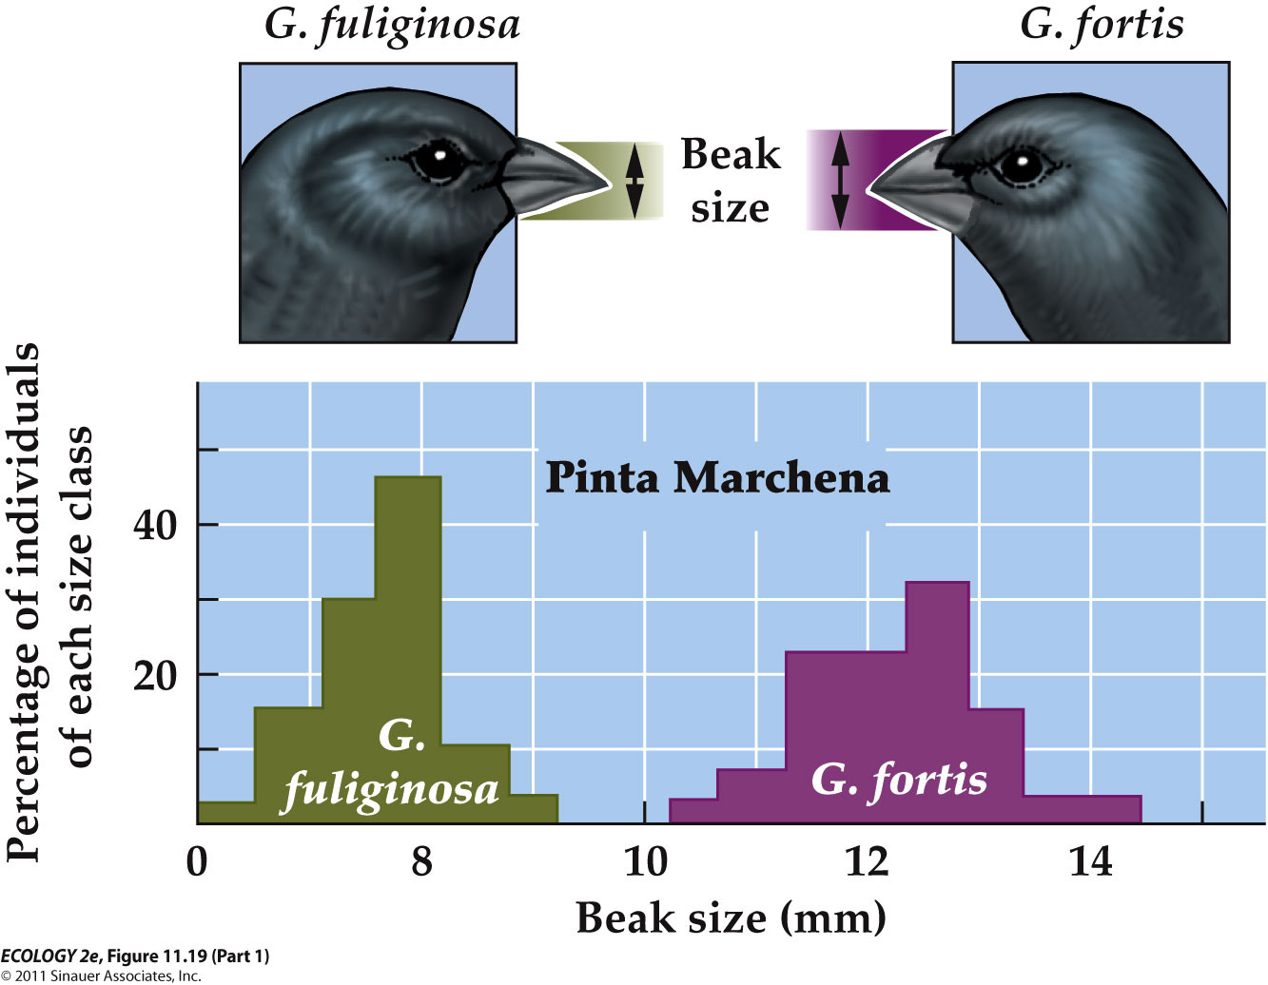

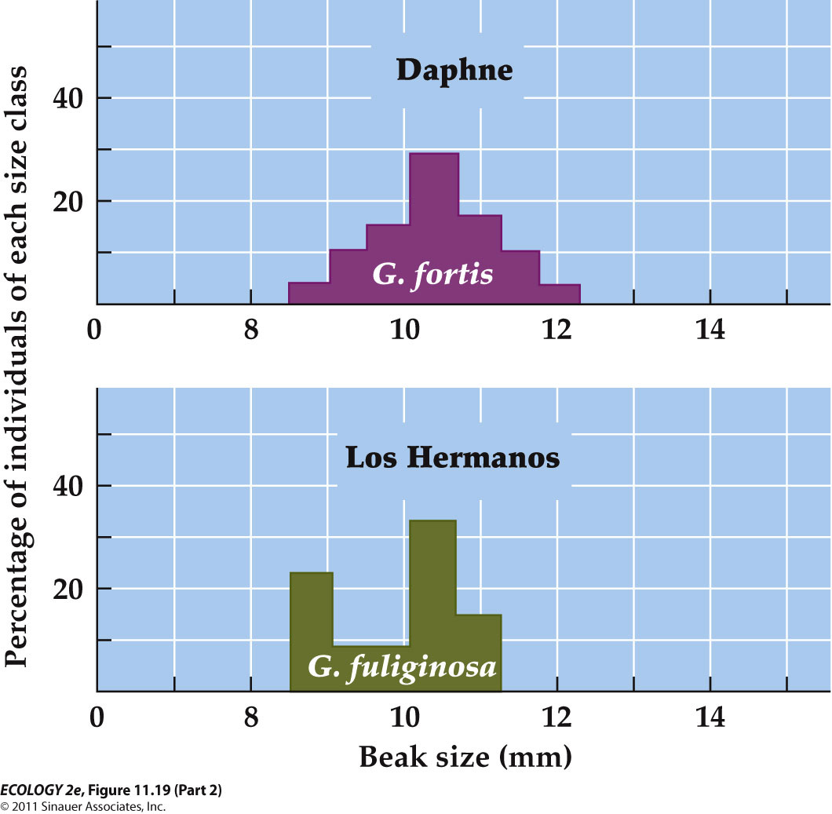
    - Beak size influence the sizes of the seeds the bird can eat.
    - The beak sizes of the two species differ considerably when they both live in the same island.
    - HOWEVER, when the two species live apart on different islands, they have similar beak sizes.

CASE STUDY : Why do some plants eat animals? COMPETITON !

  - Competition among plants can be intense where soil nutrients are scarce.
  - Many carnivorous plants may be an adaptation to low-nutrient environments.

  - Brewer (2003) removed noncarnivorous competitor plants from around pitcher plants .
    - found that pitcher plant growth rates increased.

  - Some pitcher plants were also covered, to prevent prey capture, BUT prey exclusion did not reduce the growth rate as expected.

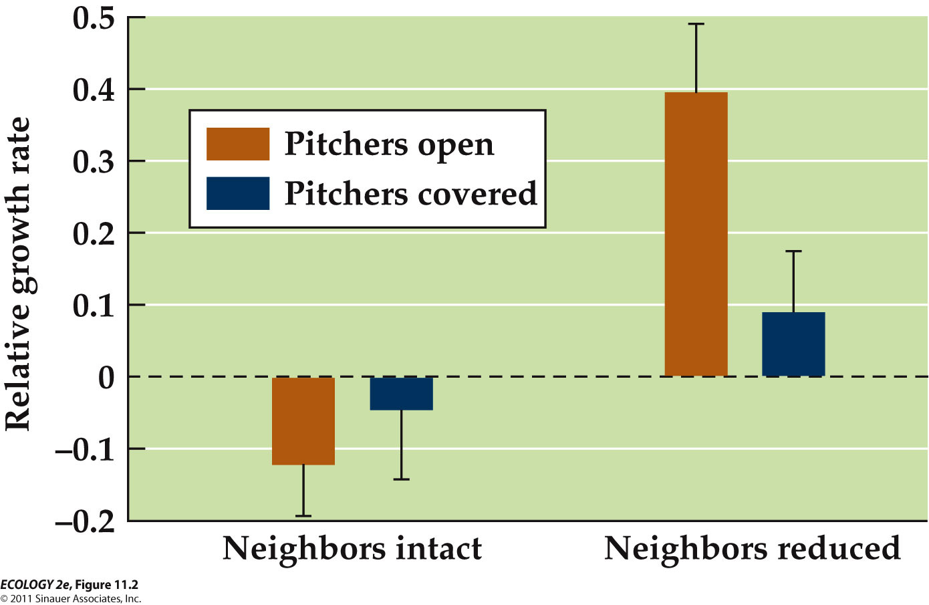

  - In the experiments on pitcher plants, the results suggested little competition for soil nutrients between them and noncarnivorous neighbors.

  - Competition for light was more important.
    - When shaded by neighbors, pitcher height increased at the expense of pitcher volume.
    - When neighbors were removed, pitcher plant growth rate increased, but only if they were able to capture animal prey.

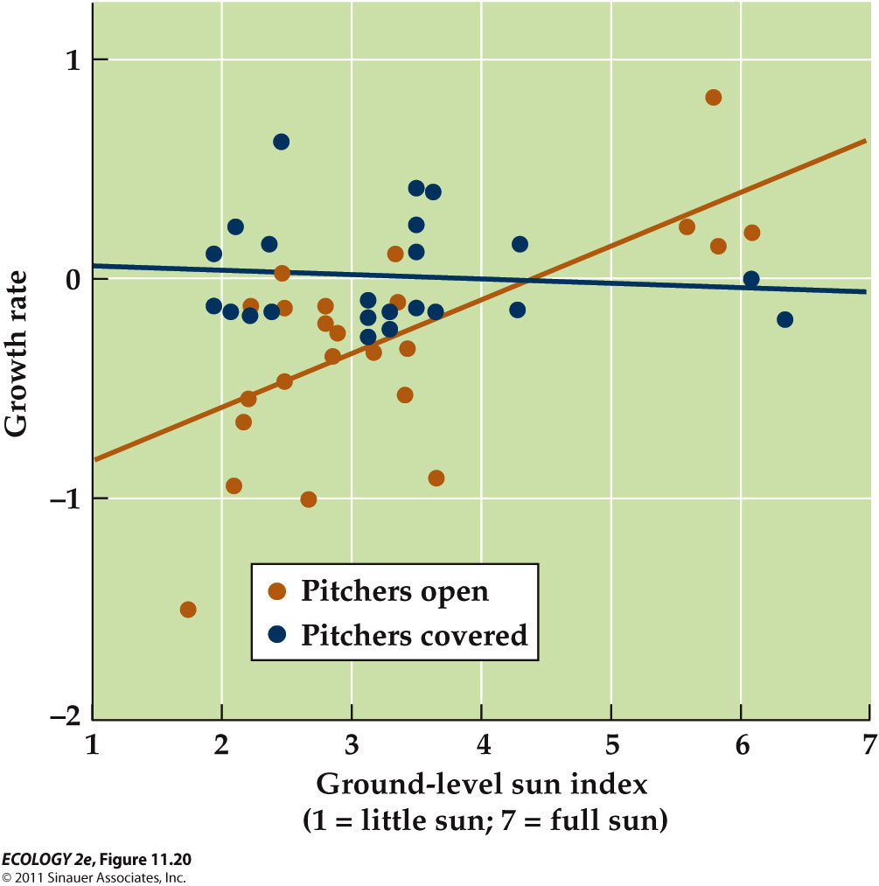
  - Pitcher plants compete with neighbors for light but avoid competition for soil nutrients by eating animal prey.

  - In low light, they grow little and require few nutrients, thus prey deprivation (loss) has little effect.
  - In high light, they grow more and require nutrients, thus prey deprivation matters

