Nutrition Notes #2
Lecture 1 – Intro to Nutrition

Human Nutrition: The actions of nutrients within food in the body including digestion, adsorption, transportation, metabolism and excretion.

Energy Yielding Nutrients: Lipids – Carbs – Proteins
Non-Energy Yielding Nutrients: Vitamins – Water – Minerals

Food: Combination of essential nutrients that must be supplied to the human body because we cannot synthesize them. Food contains non-nutrients like phytochemicals that are plant derived chemicals.

Pro nutrition attitude does not always align itself with behavior.

Lecture 2 – DRI, Food Guide, Food Groups

Dietary Reference Intake (DRI): quantitative reference values estimating nutrient intake for planning and assessing diets for healthy people. DRIs are used by nutrition experts and the food industry.
- Amount of nutrients to prevent deficiency disease in healthy people.
- Amount of nutrients to reduce the risk of chronic disease.
- Upper level of safety for nutrients.

DRI – Most Nutrients | DRI – Energy and Macronutrients
Estimated Average Requirement (EAR)  - Nutrient req. that meets 50% of population needs.  - Based on diagnostic tests | Estimated Energy Requirements (EER) (individual estimate)  - Number of calories to maintain energy balance  - Factors: Gender/Age/Activity/Weight (KG), Height (meters)
Recommended Dietary Allowance (RDA)  - Gold standard of DRIs.  - Meets 97-98% of pop. needs  - EAR x 1.2 = RDA or EAR + 2 S.D. | Acceptable Macronutrient Distribution Ranges (AMDRs)  - Range of carbs, fat and protein intake that provide adequate amounts of energy to reduce risk of diet related chronic disease.  - 45-65% Carbs  - 20-35% fat  - 10-35% protein
Adequate Intake (AI)
- Healthy group of people in a particular life stage
- Exceeds EAR, below UL
- Potassium AI = 3500mg/day.
- Used for nutrients that are hard to measure
Upper Intake Level (UL)
- Highest level of daily nutrient intake to be safe
- Avoid – especially with supplements

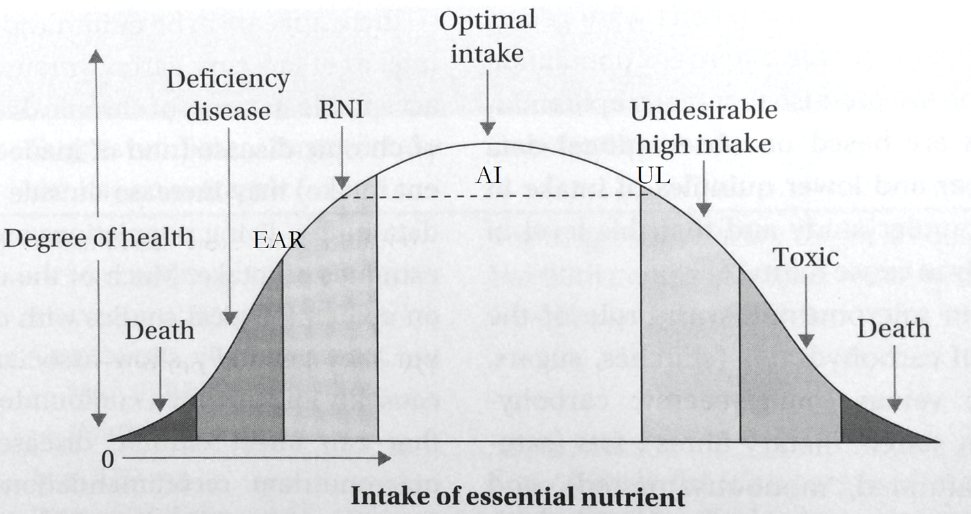

Personal Nutrient Intake Levels: Nutrient recommendations vary depending on your country. Differences between countries indicate cultural differences and interpretations of scientific studies.

Nutrition Facts Table: The table lists 13 core nutrients per serving in grams. % daily values are based on a 2,000-calorie diet. Excellent source of “x” nutrient must be at least 20% of daily value.

Major Food Groups

 | Nutrients | Sources
Grains | - Carbohydrates  - Fiber  - Vitamins  - Magnesium  - Iron | - Wheats  - Oats  - Corn  - Rice  - Buckwheat
Milk and Alternatives | - Calcium  - Vitamins (A, D)  - Protein  - Magnesium  - Phosphorus  - Potassium  - Zinc | - Milk  - Cheese
Meat and Alternatives | - Protein  - Vitamins (B6,12)  - Iron  - Zinc  - Alternative, Fiber  - Magnesium  - Potassium | - Meat  - Fish  - Poultry  - Eggs  - Legumes (beans, peas, lentils, peanuts)  - Nuts, seeds
Vegetables and Fruit | - Carbohydrates  - Fibers  - Vitamins (A,C,K)  - Magnesium  - Potassium | - 100% Fruit, vegetable juice  - Vegetables  - Fruits

Lecture 3 Notes – Atoms Organ systems – Digestive System – Circulation of Nutrients

What is matter?
- Made up of elements that take up space and have mass
- Atom is smallest unit of matter
- Organisms are composed of matter
- The human body is composed of matter representing 23 or more different elements but trillions of atoms.
- 92 natural elements.

Atoms vs. Molecules vs. Compounds

 | Definition | Examples
Atoms | - Bond to each other to form molecules  - Come together to form chemical bonds | - H₂ – 2 atoms
Molecules | - Groups of atoms bonded in specific configurations | - H₂O – 3 atoms  - CO₂ – 3 atoms  - C₆H₁₂O₆ (glucose)
Compounds | - Molecules containing 2 or more elements are also compounds | - H₂O  - C₁₈H₃₀O₂

Atoms: Atoms are composed of subatomic particles, neutrons and electrons. Made up of 3 subatomic particles, protons, neutrons, electrons.

Electrons: Form cloud around nucleus. Distribution of electrons within the shells determines how an atom chemically behaves. Valence electrons are electrons that are on the outermost shell, the valence shell. The valence shell is full when it has 8 orbiting electrons. Full shells = chemically inert. Hydrogen only needs 2 in its valence shell.

Chemistry Golden Rule #1: Atoms with incomplete shells can share or transfer electrons with certain other atoms via chemical bonds.

Electronegativity: Ability of an atom to attract shared electrons.

Chemical Bonds
Covalent Bond | - Atoms sharing electrons
Ionic Bond | - Transfer of electrons from one atom to another

Solution: Evenly distributed mixture of two or more compounds.
- Primary component = solvent
- Lesser component = solute

Aqueous solution: Water is the solvent. Like beer, water, blood, fluid within/between cells etc.

Blood: Composed of plasma and cells. Plasma contains nutrients from your diet and water (90%). Cells include red blood cells (45% of blood) which carry oxygen and CO₂ and white blood cells (<1% of blood).
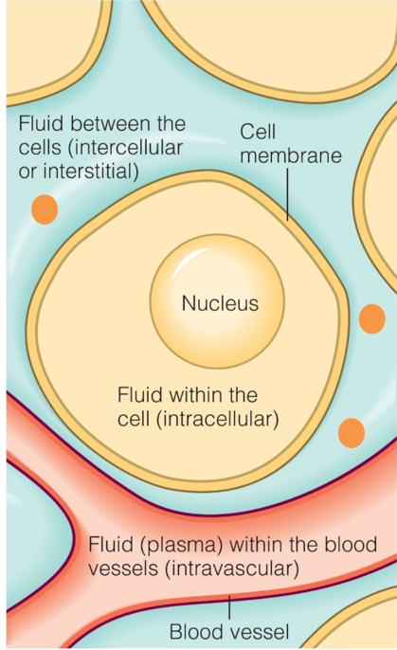
Liquid around the cells contain nutrients from digested food.

Golden Chemistry Rule #2: Oxygen atom is very electronegative. In a water molecule, the electrons between both elements are attracted to oxygen causing a partial negative charge around the oxygen atom and a positive charge around hydrogen atoms. Molecules like this are called polar molecules. In result, weak hydrogen bonds are formed.
- Molecules that dissolve in water include glucose, proteins and salt because they are all polar molecules.
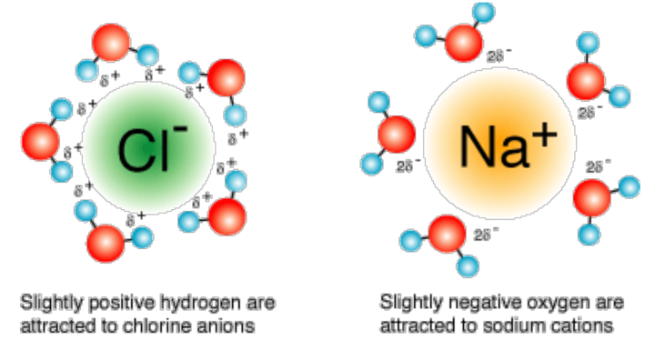

Solubility of Solutes: How easily some solutes dissolves to form a solution. Simple sugars (carbs) dissolve in water unlike fats that do not.

Starch: Starch molecules are long chains of glucose molecules linked together. Glucose is a polar molecule. Starch does not dissolve in room temperature water. In heated water, starch unfolds and form hydrogen bonds with water. This is why corn starch thickens sauces.
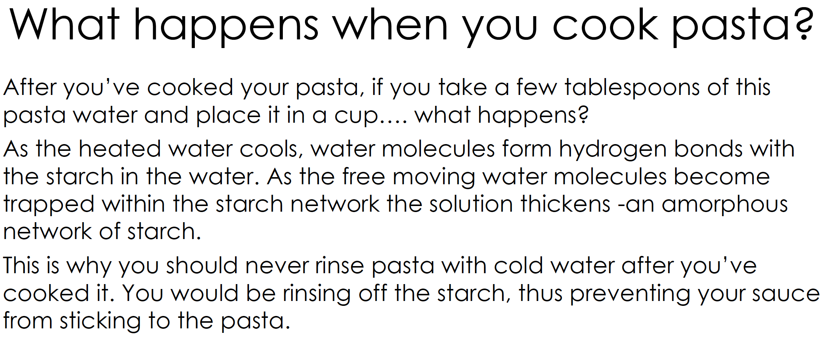

Enzymes: An enzyme is a molecule that can only function under specific three-dimensional shapes. They are the catalyst for digestion.

pH scale: Scale to determine the level of acidity or basic level of a substance from 0 (acidic) -14 (base). pH concertation is 10 times greater or lesser per interval. A change in pH will alter the shape of an enzyme thus not being able to function anymore. Change in pH is crucial to activate enzymes to facilitate digestion, whether in the mouth 6.4, stomach 1.0 or SI 8.0.
- Concentration of H+ ions increase more acidic.
- Water is neutral with = H+ and OH- ions.
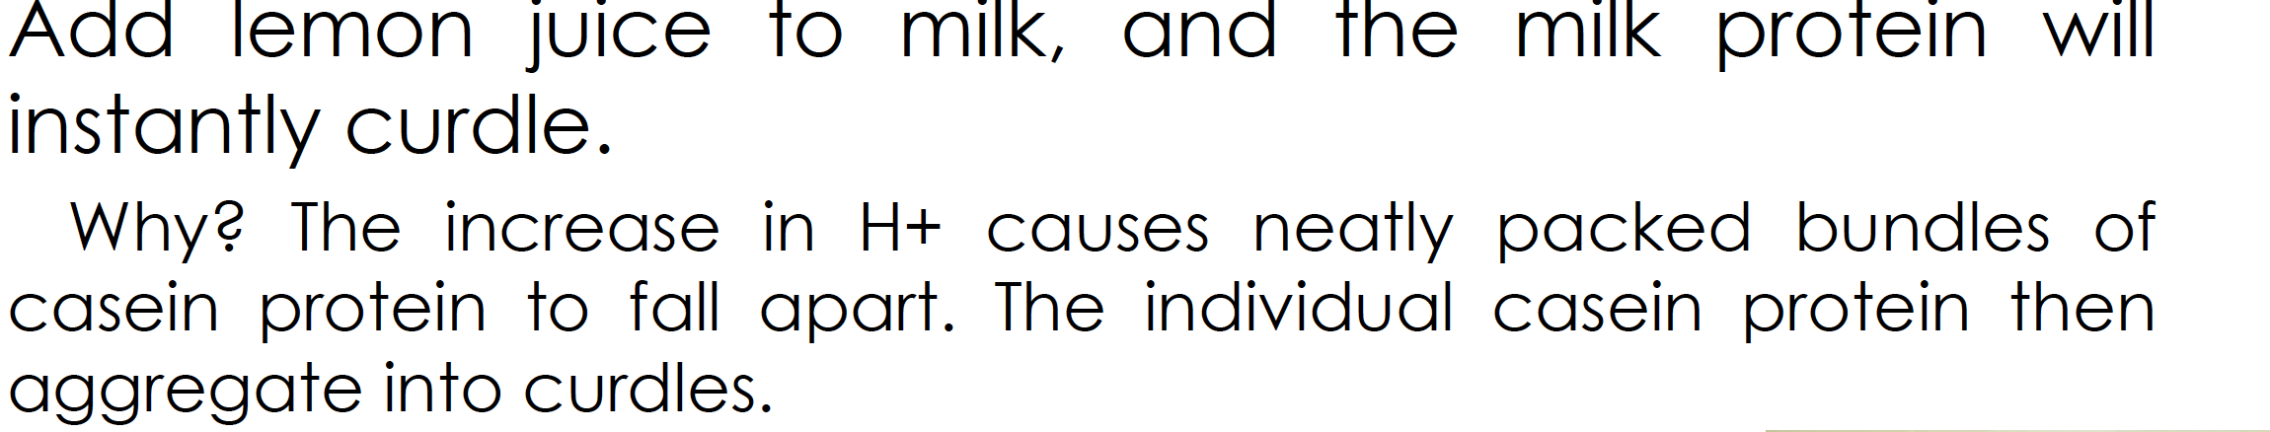
Four Types of Tissue
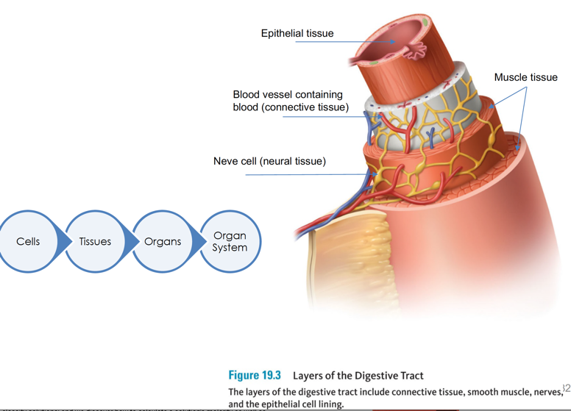
Epithelial tissue: Protect most of the inner layer of the digestive tract. Relies on connective tissue for blood flow. They release enzymes, hormones and mucus.

Digestive System
 | Activity
Digestion | - Mechanical and chemical breakdown of food.  - Chewing, stomach churning = mechanical.  - Enzymatic breakdown occurs in duodenum of small intestine.
Absorption | - Transfer of nutrients from gastrointestinal tract into blood/lymph vessels (Villus image).
Elimination | - Solid waste is removed from body. Substances in large intestine will be eliminated.

Gastrointestinal Tract
 | Activity
Mouth | - Mechanical digestion begins.
Salivary Glands | - Secrete saliva (starch-digesting enzymes) (chemical)
Pharynx | - Passage of food esophagus
Epiglottis | - Protects airway for swallow
Esophageal sphincter | - Passage from mouth esophagus AND esophagus stomach.  - Prevents backflow for both ways.
Stomach | - Acid, enzyme, fluid. Food chyme.  - Mechanical and chemical digestion.  - Muscular traction churns food.
Pyloric sphincter | - Passage stomach small intestine.  - Prevents backflow from small intestine.
Liver | - Creates bile to digest fats.
Gallbladder | - Stores bile until needed.
Bile Duct | - Conducts bile, gallbladder small intestine.
Small Intestine | - Duodenum (short), jejunum (most digestion), ileum.  - Secretes enzymes digesting all energy-yielding nutrients to basic building blocks  - Cells of wall absorb nutrients into blood and lymph.
Pancreas | - Enzymes are delivered to lumen of S.I. to digest all energy-yielding nutrients and releases bicarbonate to neutralize acid chyme that enters S.I
Pancreatic duct | - Conducts pancreatic juice, pancreas S.I.
Ileocecal valve (sphincter) | - Passage from ileum large intestine, prevents backflow
Appendix | - Stores lymph cells
Large Intestine | - Reabsorbs water, minerals  - Mingling with gut bacteria  - Passes waste (fiber, bacteria, unabsorbed nutrients) w/ water to rectum.
Rectum | - Stores waste prior to elimination in anus.

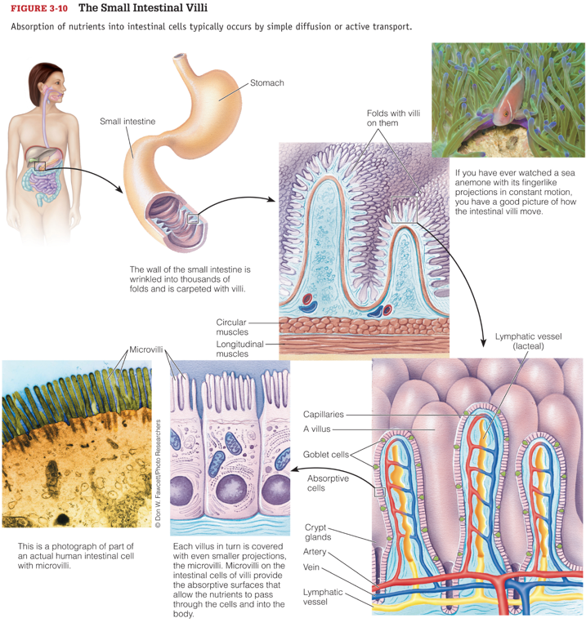
Foods that thrive in large intestine
- Probiotic – contains live bacterial cultures, some thrive in colon (yogurt, fermented dairy products)
- Prebiotic foods – fiber-rich, may stimulate growth of microbial population in colon

Cardiovascular system (heart, blood, blood vessels)
- Water soluble nutrients enter bloodstream through capillaries contained within each villus.
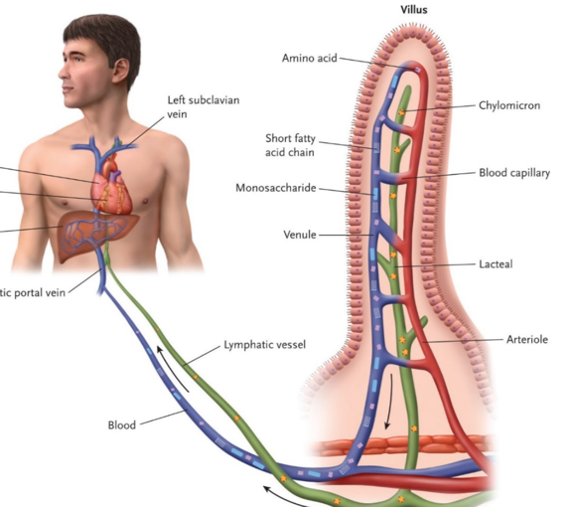
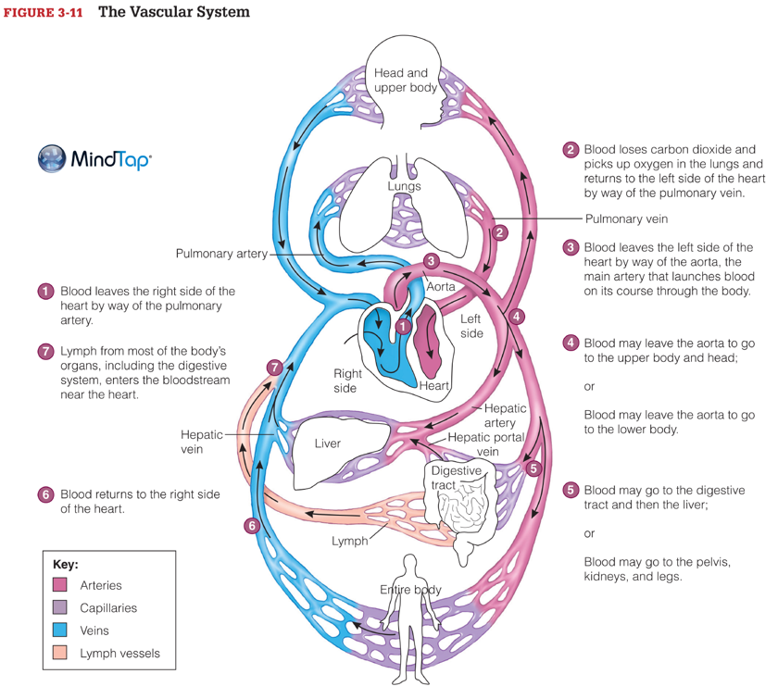

Blood Vessels: Network of tubes through which blood moves. From the heart the blood flows through arteries arterioles capillaries venules veins.
- Artery: Blood vessel that takes oxygenated blood from heart to rest of the body.
- Arterioles: Small blood vessel that branches from an artery to a capillary.
- Capillaries: Blood vessels between arterioles and venules. Where gas + nutrient exchange between blood and cells occur.
- Venules: Small vein collecting blood from capillary.
- Vein: Blood vessels that carry blood towards the heart (deoxygenated)

Papercut: Receiving a papercut releases blood enriched with nutrients.

Lecture 4 – Intro to carbs – Calories – Simple/Complex Carbs – Digestion/Absorption of Carbs – Carb DRIs and disease

Intro to carbs
Plants take CO₂ from the air and use sun’s energy to make glucose. Plants then break down glucose for energy to power growth, reproduction and repair. Humans eat plants and break down the glucose to power our own growth, reproduction and repair.

Calories vs. calories vs. kcal, 1000 calories = 1 Calorie = 1 kcal
Type | Use
calorie | - Heat energy  - 1 calorie = +1 Celsius of 1 gram of water
Calorie | - Units for measurement of energy content in food  - 1 Calorie = 1000 grams of water +1 Celsius
kcal | - Units for measurement of energy content in food  - 1 kcal = 1000 grams of water +1 Celsius

Breaking down C-H bonds results in the release of energy in the form of heat. The amount of heat released tells us how much energy is contained within 1 gram of each nutrient.

Bomb Calorimeter: When food is burned, energy is released in the form of heat in kcal.
- Carbs = 4 kilocalories/gram
- Protein = 4 kilocalories/gram
- Lipid = 9 kilocalories/gram

Fat dissolves in ether.
To analyze how much of these nutrients do we absorb you analyze stool.

Nutritive Sweeteners: simple sugars that add calories to food. All carbs (except insoluble fiber) contributes energy. (4kcal/g).
- Sugar alcohols: sorbitol, xylitol, mannitol

Non-nutritive sweeteners: synthetic compounds that are intensely sweet tasting compared to sugar but supply no energy per serving. Made from chemically modified sucrose to escape digestion and absorption.
- NutraSweet/Splenda.

Fiber (plant cell walls): The body can’t digest fiber.
Type | Properties | Sources | Health
Soluble | - Dissolve in water  - Form gels/thickening abilities  - Fermentable, good for bacteria in colon | - Pectin extracted from fruit  - Plant gums  - Seaweed | - Slows gastric emptying  - Slows glucose uptake  - Traps cholesterol for L.I  - Improves bowel health  - Reduced risk CVD, #2 diabetes.
Insoluble | - Don’t dissolve in water  - Don’t form gels  - Not fermented in L.I  - Promote bowel movement | - Husk of grains  - Seed coat of legumes  - Leafy greens | - Prevent diverticula by large soft mass that applies pressure to inner walls.

Carbohydrates
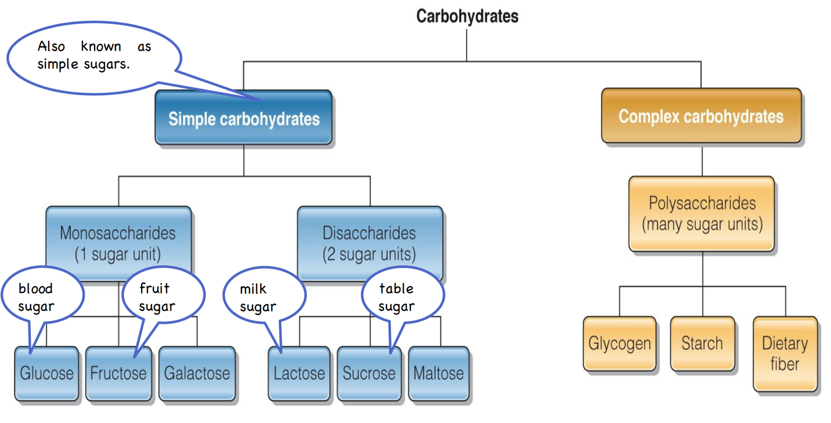

Monosaccharides | Use
Glucose (Blood sugar) | - Mild sweetness  - Most important  - Needed to drive ATP  - RBC, brain and nervous system rely on glucose for energy
Fructose (Fruit Sugar) | - Very sweet
Galactose | - Slightly sweet
(Arrangement of atoms differ for each monosaccharide)

Disaccharides | Use | Enzyme | Result
Lactose | - Milk sugar  - Breast milk – very high amount of lactose | Lactase | Galactose + Glucose
Sucrose | - Table sugar  - Found in fruit, vegetables, grains | Sucrase | Fructose + Glucose
Maltose  By-product of digestion of food. I.e. via digested starch. |  | Maltase | Glucose + Glucose

Lactose intolerance: Inability to digest lactose completely. Individuals who are lactose intolerant do not produce enough lactase to breakdown lactose. In result, bacteria in large intestine breaks down lactose producing gas and diarrhea. Infants produce large amount of lactase. 75% of elderly become lactose intolerant.
Extreme amount of added sugar is toxic.

Complex Carbohydrates: Made of many, units of glucose linked together in straight or branched chains.
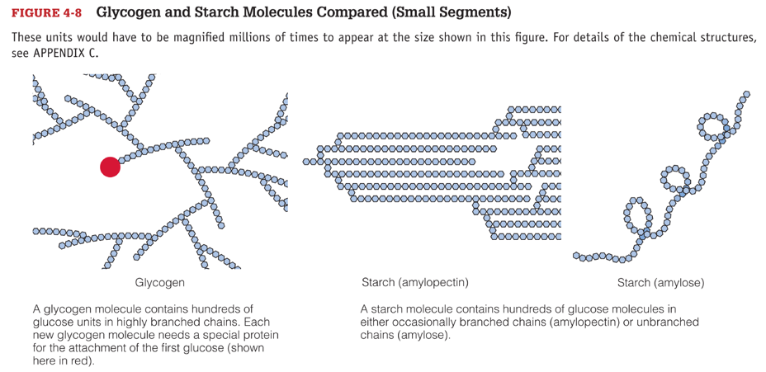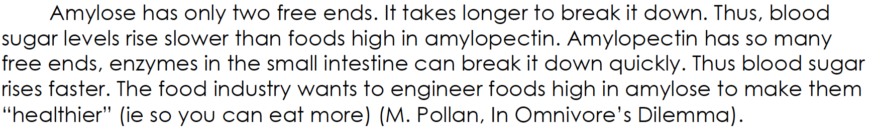
- Plants store glucose in form of starch
  - Grains
  - Legumes
  - Vegetables

Glycogen: Store glycogen in liver and muscle cells. When we exercise, our muscle cells break down glycogen to release glucose for energy.
Glucagon: Glucagon triggers liver to metabolize fat and glycogen stores to release glucose.

Starch Digestion
 | Starch | Enzyme | Result
Mouth and salivary glands | Starch | Amylase | Small polysaccharides, maltose
Stomach | Stomach halts starch digestion
Small intestine and pancreas | Starch | Pancreatic amylase | Small polysaccharides, maltose

Fiber Digestion
 | Activity
Mouth | - Mechanical crushes and tears fibers with food and mixes with saliva
Stomach | - Fiber is not digested, delays gastric emptying
Small Intestine | - “ “. Delays absorption of nutrients
Large Intestine | - Most fiber passes intact but some fiber is digested via bacterial enzymes to make short-chain fatty acids.

To learn more and get OneNote, visit www.onenote.com.

