Chandler
- Primary claim: successful firms capitalize on economies of scale and scope, create management structure and invest in research and development
- Secondary claims:
  - Once a firm loses the opportunity to be a first mover, It is difficult to regain competitive advantage
  - Entrepreneurial companies that do not make investments to create organizational capabilities cannot achieve long-term success.
  - Growth through unrelated diversification is a poor corporate strategy
  - Business ownership patters have diminished the likelihood of many firms’ long-term success
- Separation of top & middle managers (due to unrelated diversification): this happens when
  - Top managers have little knowledge and experience with the technological processes and markets of divisions or subsidiaries they had acquired
  - Large number of acquired businesses created an extraordinary overload in decision making at the corporate office
- Market pressures
  - Need short-term thinking
- Economies of scope: using same or similar inputs in production to make more products
- First mover: the organization that makes the necessary investment to dominate the industry
- Economies of scale: doing things at a bigger scale reduces costs
- National and international marketing and distribution functions must be created for firms to benefit from scale and scope
- Research and development: new technologies, improving quality (innovation)
- Diversification: related vs unrelated
- Bigger is better
  - Ability to act as a small company, allows them to put themselves in many different markets around the world
- Vertical integration

Greiner

Major Claims
- Organizations grow through a series of revolution and evolution phases that are a function of the age and the size of the organization
- Management practices that work well in one phase bring on a crisis in the next

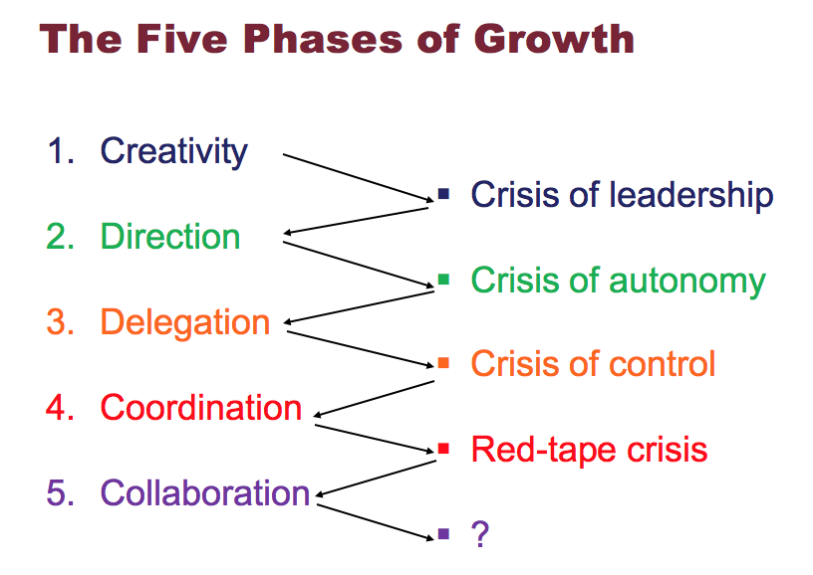

- Creativity
- Characteristics
  - New employees
  - Growth through stability
  - Entrepreneurs are hands on
  - Small number of employees
  - Incentive to work= be part ownership of the company
  - Frequent informal communication
  - Long working hours
  - Decisions are sensitive to the marketplace
  - Founding of company focus is on making and selling new product
- Issue leads to crisis
  - No efficiencies
  - Informal communication
  - Lack of dedication to organization
  - Unwanted management responsibilities
  - The company is growing therefore you need someone to manage all parts and entrepreneurs don’t want to manage/can’t manage alone………
- Crisis= LEADERSHIP (trying to find a new leader to facilitate the process)
- Solutions
  - Strong managers with knowledge and skills
  - As the company grows, creativity becomes the problem because you need a larger knowledge and more employees
  - Management wants to lead the company like before, so conflict between leaders intensify……..
- Direction (find manager)
- Characteristics
  - Growth through efficiency
  - People at the top are giving directions to people at bottom
  - Job assignments are becoming increasingly specialized
  - Accounting systems for inventory and purchasing, incentives, budgets, and work standards are adopted
  - New manager assumes most responsibility for direction
  - Lower level supervisors are treated more as functional specialists rather than autonomous decision makers (Establish hierarchy everyone works for the manager)
  - Formal communication
  - High and low level of management= roles are more strictly defined
- Issues lead to crisis
  - Not enough for diverse and complex organizations
  - The centralized hierarchy
- Crisis: AUTONOMY (Top manager makes all decisions but doesn’t actually know what’s going on… employees do. Employees feel torn between taking initiatives and following procedures, workers feel too controlled)
- Solutions
  - Move to delegation (when responsibilities are passed down)
  - Difficult to top and lower management
- Delegation (people at top are now making more general decisions, whereas people at the bottom are getting responsibilities)
- Characteristics
  - Managers of different divisions are making own decisions
  - Top and bottom management are disconnected (not communicating as much)
  - Greater responsibilities are given to managers
  - Profit centers and bonuses are used to motivate employees
  - Top level executives limit managing
  - Decentralization
  - Expansion
- Issues leads to crisis
  - Top management have a sense of losing control
  - Panicking so they have to put in measures to help them regain control
- Crisis: CONTROL (managers have a greater authority and are able to penetrate larger markets. Managers seek to regain control of the whole company want to return to centralized management)

- Solution
  - Top management seeks to regain control
  - Return to centralized management
- Coordination
- Characteristics
  - Top managers implement set of procedures to coordinate what all employees are doing
  - Try to make it as fair as possible
  - Everyone’s constantly being reviewed and evaluated
  - Use of formal systems to achieve greater coordination
  - Decentralized units are merged into product groups
  - Head quarters coordinates everyone
  - Formal planning
  - Hiring
  - Product group is traded as investment
- Issues leads to crisis
  - Product groups
- Crisis: REDTAPE (Departments don’t mix to help one another. Less innovation, lack of communication between everyone. Middle or lower level managers feel like the head offices are stopping them at every term)
- Solutions:
  - Emphasis of spontaneity
- Collaboration
- Characteristics:
  - Encourage experimenting with new practices
  - Educational programs to train managers
  - More flexible and behavioural approach to management
  - Self control and self discipline instead of formal control
  - Use teams to solve problems
  - Bringing back intimacy
  - Reducing staff at headquarters
  - Social relationships: communication, rewards or team bonuses, not as many rules
  - Matrix type structure: resources are deployed where they are needed
  - Skill improvement
FOCUS ON FIXING THE PROBLEM no crisis

Secondary Claims

- Organizations should not try to skip phases
- Top managers whose style is no longer appropriate should remove themselves
- Growth is not inevitable

Collins & Porras

- Vision: provides guidance about what core to preserve, and what future to stimulate progress towards

Core Ideology: enduring character of the organization and is the source of guidance and inspiration, it is the glue that holds the organization together as it grows, diversifies and expands globally. It is the consistent identity of the organization that transcends the product or market life cycles.
- Discovering the core:
  - Needs to be authentic
  - Meaningful and inspirational
  - Attracts people who are compatible with the companies core values
- Core Values:
  - Beliefs about what is important
  - Small set of timeless guiding principles
  - Company should not change core values in response to market change
  - Have intrinsic value to those within the organization
  - 3-5 values
  - Require no external justification
- Core Purpose:
  - Reason for existing
  - 100 year test
  - Can never be fulfilled
  - Not a goal or a business strategy, it is to guide and inspire

Envisioned Future: what we aspire to be
- Audacious goal:
  - 10-30 years
  - BHAG = big hairy audacious goal
    - Engages people, reaches out and grabs them
    - Tangible, energizing, highly focused
    - Should not be a sure bet
    - 50-70% success rate
  - Unifying focal point
  - Catalyst for team spirit
  - Clear finish line
- Goal Achievement:
  - Vivid description
  - What it will be like to achieve BHAG
  - Picture people can carry around with them
  - Passion, emotion, conviction = essential

Barney

Major claim
- A firm will have a sustained competitive advantage if its resources and capabilities are valuable, rare, imitable and organized in a way that allows it to exploit potential opportunities
- A firm will be successful if it has resources with the right attributes and characteristics
- The most careful and complete analysis of firms’ competitive environments cannot, by itself, explain their success
- Strategists also need to analyze the competitive implications of firms’ internal strengths and weaknesses
Resources and capabilities:
- Financial, physical, human, organizational assets used by the firm to develop, manufacture and deliver products and services to its customers.
  - Financial: debt, equity, retained earnings
  - Physical: machines, manufacturing facilities, buildings
  - Human: experience, knowledge, judgment and wisdom
  - Organizational: history, relationships, trust, culture, formal reporting structure , patents

4 important questions about resources and capabilities
- Value
- Beneficial to market. Used daily.
- Does a firms’ resources and capabilities enable it to exploit an opportunity and/or neutralize a threat
- Rareness
- Hard to come across anywhere else
- How many competing firms already possess these resources and capabilities
- Imitability
- Can’t be imitated by anyone. Very unique.
- Do firm’s without a resource or capability face a cost disadvantage in obtaining it comparing to firms that already possess it?
- Copy or substitute
- Factors that make it hard to imitate:
  - History
    - Valuable and rare resources acquired or developed through unique historical circumstances can be a source of sustained competitive advantage
  - Numerous small decisions
    - A firms competitive advantage seems to depend on numerous small decisions rather than big ones through which a firms resources and capabilities are developed and exploited
    - Hard to imitate small decisions because they’re almost invisible
  - Socially complex resources
    - Reputation
    - Trust
    - Friendship
    - Teamwork
    - Culture
- Organized
- Allows it to exploit potential opportunities
- Is a firm organized to exploit the full competitive potential of its resources and capabilities?
- Alone, this won’t do much for the firm. You need money and assets.

- SWOT: a company must ensure that they are focusing on their external opportunities and threats without leaving out their internal strengths and weaknesses

Tannenbaum & Schmidt

Continuum of leadership: shows the relationship between the level of freedom that a manager chooses to give to a team and the level of authority used by the manager.
- When teams freedom increases, manager’s authority decreases.

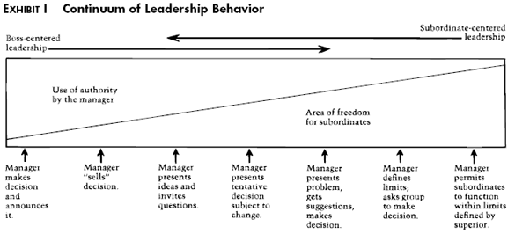

- Manager is always responsible for all decisions even is subordinates make decisions
- You can tell how democratic a manager is by the number of significant decisions given to subordinates and if they follow through with these decisions.
- Roles of manager: member or authority figure (this depends on where they are on continuum)

Factors when deciding how to manage
- FORCES IN THE MANAGER
- Manager’s personality will influence behaviour in a given situation.
- His value system (how they feel about individuals making decisions), confidence in non-managers, own leadership inclinations (directive vs team role, how they feel about giving orders), and feelings of security in an uncertain situation.
- FORCES IN THE SUBORDINATES
- Managers can permit more freedom to non managers when
  - Subordinates have high needs for independence
  - They have readiness to assume responsibility
  - High tolerance for ambiguity
  - Interest and feeling of importance towards problems (identify with organizations problem and goals)
  - Expect to share decision making
- FORCES IN THE SITUATION
- Type of organizations
  - Value and traditions
- Group effectiveness
  - Manager must asses the groups effectiveness before giving them responsibilities
- The problem itself
  - Nature of problem will determine the degree of authority
- The pressure of time
  - The more immediate decision is needed, the less other subordinates involvement is needed
- Long run strategy
  - Shift thinking from tactics to large scale strategy
- Objectives to be obtained

Mintzberg

- Talks about the importance of managers and the need to understand it properly and thoroughly before attempting to train and develop more managers
The nature of managerial work
- The managers job is a mixture of regular programmed jobs and unprogrammed jobs/tasks
- A manager is both a generalist and a specialist
- Manages rely on information from all sources but show a preference from that which is orally transmitted
- Managerial work is made up of activities that are characterized by brevity, variety, and fragmentation
- Management work is more an art than a science and is reliant on intuitive processes and a feel for what is right
- Management work is becoming more complex
3 categories of manager roles/expectations
- INTERPERSONAL: managing through people
- Monitor
  - Collecting info
  - Constantly observing what’s going on
  - Finding things out by asking people
  - Also receive info
- Disseminator
  - Passing information to non managers who otherwise have no access to it
- Spokesperson
  - Transmits info from within the organization to outsiders
- INFORMATIONAL: managing by information
- Figurehead
  - Head of organization
  - Must perform some ceremonial duties
- Leader
  - Motivate, hire, train employees
  - Responsible for the work of its people
- Liaison
  - Making contacts outside the organization
- DECISIONAL: managing through action
- Entrepreneur
  - Seeks to improve organization and adapt it to changing conditions
  - Look at what competitors do
- Disturbance-handler
  - Responds to pressure and problems that arise
- Resource-allocator
  - Deciding who will get what delegation
- Negotiator
  - Negotiates decisions (discussion aimed at reaching an agreement)

Becoming a more effective manager
- Be aware of the roles you prefer. Stretch beyond those you’re most comfortable with, depending on what the situation demands
- Reduce workload by giving subordinates the information they need to be more self-sufficient
- Avoid superficial decision making by taking advantage of expert analysts
- Force yourself to do things you believe are important

MYTH: managers plan, organize, coordinate, control

French and Raven

Types of Social power based on perception of the other
- REWARD POWER
- Power of the manager to give some type of reward to an employee as means to influence the employee to act
- Ability to mediate rewards and to remove negative consequences
- COERCIVE POWER
- The ability of a manager to apply a force to an employee to follow an order by threatening the employee with a punishment if the employee does not comply with the order
- Ability to mediate punishments (police, judge, teacher)
- LEGITIMATE POWER
- Based on the perception that people have the formal right to make demands and to expect compliance and obedience from others
- To direct behaviour
- Ex: if the class is getting loud, professor can tell u to stfu
- REFERENT POWER
- The influence one has on others from being well liked or respected
- Power of the other over our desire to associate
- EXPERT POWER
- Based on ones perception that the other has some special knowledge or expertise
- Ex: my mechanic telling me to increase my calcium wont believe him

- Stay within your expertise if not it will diminish your actual powers

Kaplan and Norton

The balanced scorecard: performance measurement system/tool

4 perspectives
- CUSTOMER PERSPECTIVE
- What matters most to customers
- How to customers see us
- If customers are not satisfied they will eventually find other suppliers that meet their needs
- Concerned about time, quality, performance, service, cost (goals should revolve around these primarily)
- INTERNAL BUSINESS PERSPECTIVE
- How can we produce to meet customer expectations
- What must we excel in?
- Cycle time (length of a particular process, ex: time to manufacture of product or deliver a product) quality, employee skills and productivity, company should also identify core competencies (what the company does really well
- FINANCIAL PERSPECTIVE
- How can we ensure profitability for shareholders
- How do we look to shareholders
- These measure indicate whether or not the company’s strategy, implementation and execution are contributing to the bottom line
- Return on investments, market share
- INNOVATION AND LEARNING PERSPECTIVE
- How can we make continual improvements?
- Can we continue to improve and create value?
- Skills, improvement, training, knowledge, best in brand, leadership

- For every perspective, you should have a goal, measure, target, due-date to better each perspective

Handy

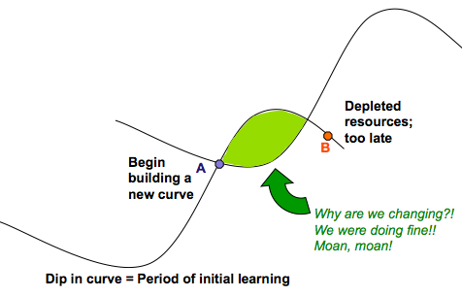

Sigmoid curve: the secret to constant growth is to start a new sigmoid curve before the first one begins to diminish. When a company is left at point B, new people will be able to lift the organization to the second curve.
- We are looking for renewal
- New product, new way of doing things
- Why do this at point A?
  - 2nd curve needs a lot of preparation
  - A = when things are doing well so we have enough resources to start the renewal
  - Difficult to launch from B because the resources are limited here, not doing so well, may have layoffs.
- Green section
  - Time of turbulence
  - Found a second curve at A but ppl who r leading first curve think it’s a waste of time because our first curve is good enough we are doing well, whats the point of doing something else.
  - People working on first curve are not the same ppl who bring on the 2nd curve
  - It takes new people
- Not easy for company to know where they are at on the first curve

Discipline of the second curve proceed by guess and assumption
- Always assume that you are near the peak of the first curve, at point A, and should therefore be starting to prepare for second curve
- If assumption turns out to be wrong, nothing has been lost. Only the exploration phase of the second curve has been done
- No major commitments will have been done until curve 2 overtakes curve 1 which wont happen if curve 1 is on the rise
- New curve could be
  - Product
  - Service
  - Division
  - Anything that helps company maintain an advantage
- The new generation should manage the second curve
- Don’t abandon first curve too early

Paradox of time
- By the time you know where you need to go, it is already too late
- The curvilinear logic everything in life follows sigmoid curve, has ups and downs, and nothing lasts forever

Paradox of success
- What got you where you are wont keep you were you are
- Curvilinear logic

Herzberg

2-Factor Theory
- Employees dissatisfied and unmotivated(Hygiene Factors)Employees not dissatisfied but unmotivated(Motivational Factors)Employees not dissatisfied and motivated

HYGIENE FACTORS (Dissatisfaction)
- Company policy and administration, supervision, relationship with supervisor, working conditions, salary, relationship with peers, personal life, relationship with subordinates, status, security
  - ALL OF THESE are the primary cause of unhappiness on the job based on human nature

MOTIVATION FACTORS (primary source of satisfaction)
- Achievement, growth, responsibility, advancement, recognition.

JOB ENRICHMENT (VERTICAL JOB LOADING)
- Increase accountability of individuals for own work
- Giving additional authority
- Job freedom
- Provides opportunity for psychological growth
- Adding meaningful tasks
- Herzberg prefers this over job enlargement because of all these reasons.

JOB ENLARGEMENT (HORIZONTAL JOB LOADING)
- Widening the range of jobs at the same level in the organization and adding them to existing jobs.
- Making job bigger, adding more tasks, not responsibilities
- More of the same things to do

NEGATIVE KITA
- Leads to movement, not motivation
- Negative (physical): using violence
- Negative (psychological): talking down on people.

POSITIVE KITA
- Pull rather than push
- Bonuses, vacation days, reduce time spent at work

- Herzberg concludes that the opposite of satisfaction is not dissatisfaction, but is NO satisfaction. The opposite of dissatisfaction is NO dissatisfaction. In other words, the absence of satisfaction is not the same thing as being dissatisfied.

TEXTBOOK NOTES

Finding a claim:
- The major conclusion of a piece of writing that the author is trying to persuade you to accept
  - Explicitly (stated clearly) or implicitly (find it yourself) stated
  - Likely locations are: beginning, title, headline, near the end
  - Key words: therefore, thus, in summary, I believe that, clearly…..
    - Clear, short and right on spot.
- Uncontestable claims
  - A vary thorough text (consistent with own experiences, independent facts, agreed amongst exports and strongly supported)
    - Facts are independent of interpretation
    - EX: technical and mathematical claims
- Contestable claims
  - A very questionable text
    - Opinions, un-scaled facts, new ideas, provocative and persuasive
    - Not commonly accepted knowledge can’t stand on it’s own

Finding evidence
- Evidence can consist of stats, details of past events and quotes
- Any statement that is a response to the question “why is this true”
- Argument is a claim + evidence
- 6 qualities of good evidence
- Sufficiency:
- How much is enough (multiple and back up)
- Author is guilty of hasty generalization if evidence is not sufficient to support the claim
- Precision
- Comes from numbers and quotes
- Don’t overuse ambiguous words
- Precision= accuracy
- Accuracy
- Shouldn’t be bias (independent source of info) broadness
- To proceed do your own research to verify accuracy or use proxies (trivial errors, grammar, spelling mistakes, inaccurate quotes or lack of precision)
- Authority
- Training, credentials, experience of others
- When writers cite business scholars lends authority to arguments
- Current sources have more authority than old ones
- Fallacy of false appeal to authority: accepting testimony to someone who has no expertise in the relevant area
- Fallacy of argumentum ad populum = translates to appeal to the people
  - The bandwagon effect (doing something just because everyone else is)
- Representativeness
- Variety in source should match variety in population
- Evidence must appeal to the WHOLE population
- Can also have fallacy of hasty generalizations
- Clarity of expression
- Qualitative and quantitative data should be interpreted
- Significance of data should be clearly stated

Underlying assumptions
- Logical link that fills the gap between evidence and claim. Implicit or explicit principles that form the bases of our beliefs + reasoning. Tell us whether evidence provided for claim is relevant
- 2 types:
  - Reality/descriptive assumption:
    - Our beliefs about what events have taken place, what exists or how things work in the world. The way things really are.
    - Beliefs become “taken for granted”
  - Value assumptions
    - Values: our ideals, standards of right and wrong, the way we ought to be.
    - Learned as children “you should keep your promises”
    - Values may conflict. They may be ranked differently by different people

