Topic 1-Cell Features
Slide 4- What is a Cell? Mid 1600s
- Basic building blocks of all living things- minimal self-reproducing unit, and is the vehicle for transmission of the genetic information in all living species. Contains DNA.
- The human body is composed of trillions of cells.
- Cells provide structure for the body, take in nutrients from food, and carry out specialized functions.
  - Robert Hooke set the foundation for the cell theory- the first to look at cells and observe them. He looked at corks first- small room= cellulae-cells.
  - Robert Hooke coined the term ‘cell’
Slide 5- How did we go from looking at corks to cells that are organized in a similar fashion
- In 200 years, the world was able to progress from looking just at cells into organizing them.
Are there any life forms that do not have any cells?
No, there are no life forms that do not have any cells. Even in the case of viruses, they still need a host.

Slide 6- Cell Theory- mid 1800s
- All organisms are composed of one or more cells
- The cell is the basic structural and functional unit of all living organisms (Schwann, 1839)
- Cells arise only from division of pre-existing cells (Virchow, 1855)
- Cell Theory: the microscope 1600s progressed with the progression of microscopes.
- All living things are made up of cells.
- A cell is the smallest unit in a living thing.
- All cells come from other cells.
- All living things are made up of cells.

Slide 7- Cell features
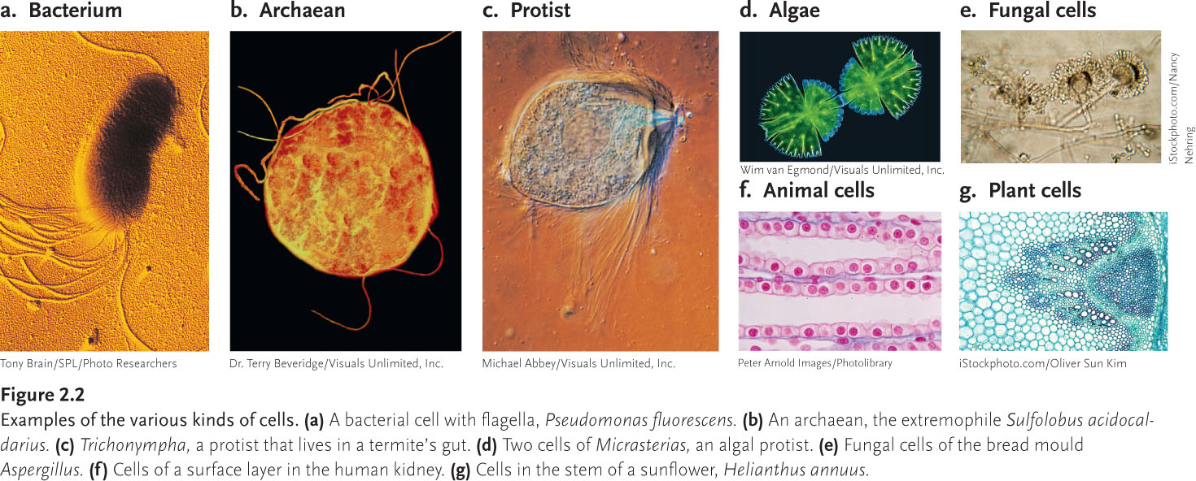
Common Characteristics | Diversity
- Cell membrane  - Cytoplasm  - Components  - Basic chemistry- amino acids, nucleic acids, proteins, lipids  - Metabolism (ATP)- to produce, use or get rid of waste  - Genetic material- DNA- same way of storing and using genetic material | - Wide range of sizes (nm to m)  - Simple or complex shapes; related to function  - General or very specialized role  - Different way to use and produce energy as well as getting rid of waste  - Specific locations in which they can thrive and grow

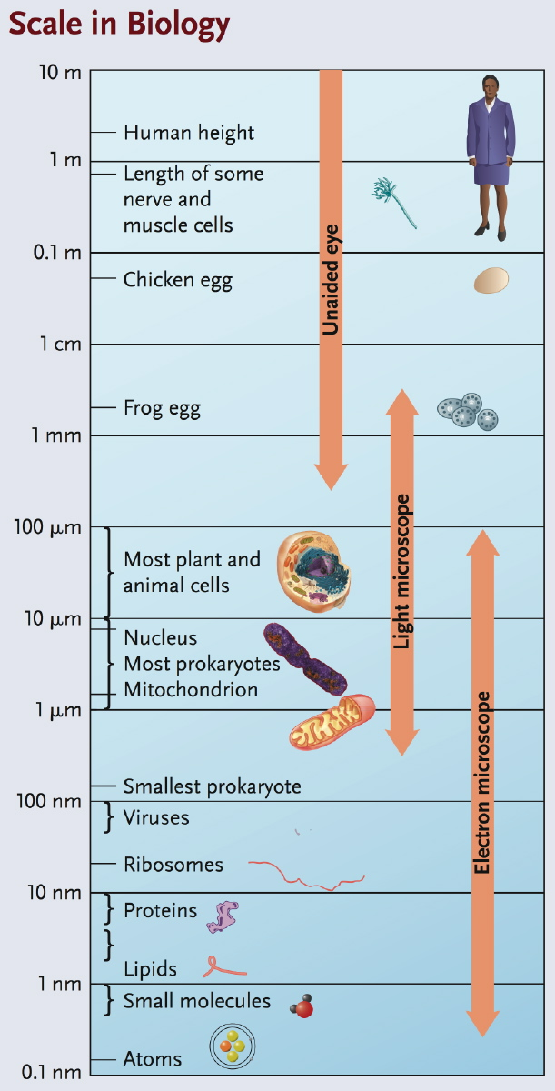
Slide 8- Cell size and scale
- What are the different scales/sizes for cells and organelles?

- Relevant units:
1µm = 10⁻⁶m
1nm = 10⁻⁹m
- Typical cell sizes:
Prokaryote: 1-5 µm
Eukaryotes 10-100 µm
- Why are cells small?

Slide 10- How do you look at cells?

Slide 11- But why are cells small?
- SA: V ratios
- Rates of diffusion
- Adequate concentrations or synthetic capacity
- The bigger the surface area, the harder it is to manage the biological and physiological processes.
- Cells are so little, so they can maximize their ratio of surface area to volume. Smaller cells have a higher ratio which allow more molecules and ions move across the cell membrane per unit of cytoplasmic volume. Cells are so small because they need to be able to get the nutrients in and the waste out quickly.
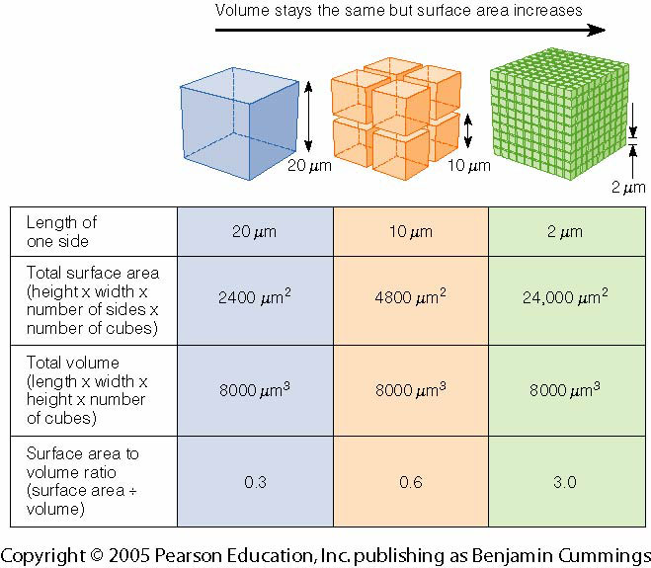

Slide 12- What next?
Cells can remain individual (for example in blood) or assemble together to form functional tissues and organs
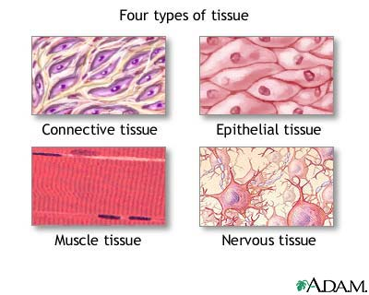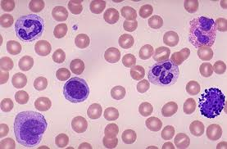
Blood cell

Slide 13- The Tree of Life: 3 domains
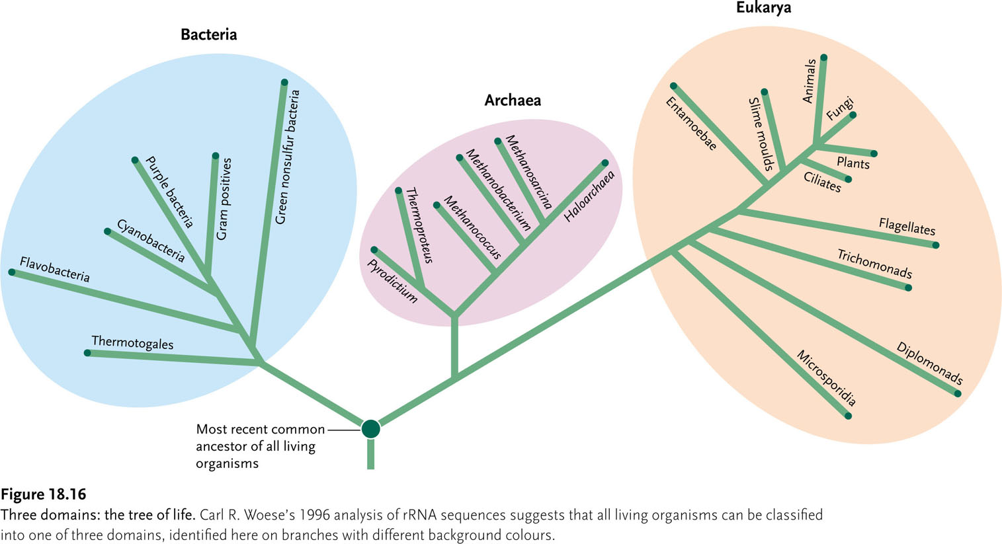

Unicellular vs. multicellular
Bacteria and archaea (prokaryotes) vs. eukaryote (animals, fungi, and plants)
What elements of organisms can we use to classify them in phylogenetic trees?
  - Sequencing of the RNA-ones which build the ribosomes
  - Type and number of flagella
  - Proteins and markers on the cell membrane- phospholipids on the cell membrane are especially important in determining the location of organisms on the tree of life
Slide 14: Prokarya; bacteria and archea
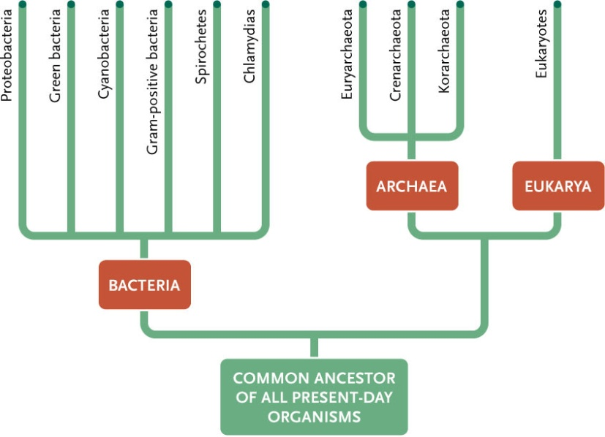
Fig. 20.15
prokaryotes
Archaea:
rRNA, membrane phospholipids: more similar to eukarya

Slide 15: Protists, fungi, plants, and animals

What are the different types or classes of organisms?
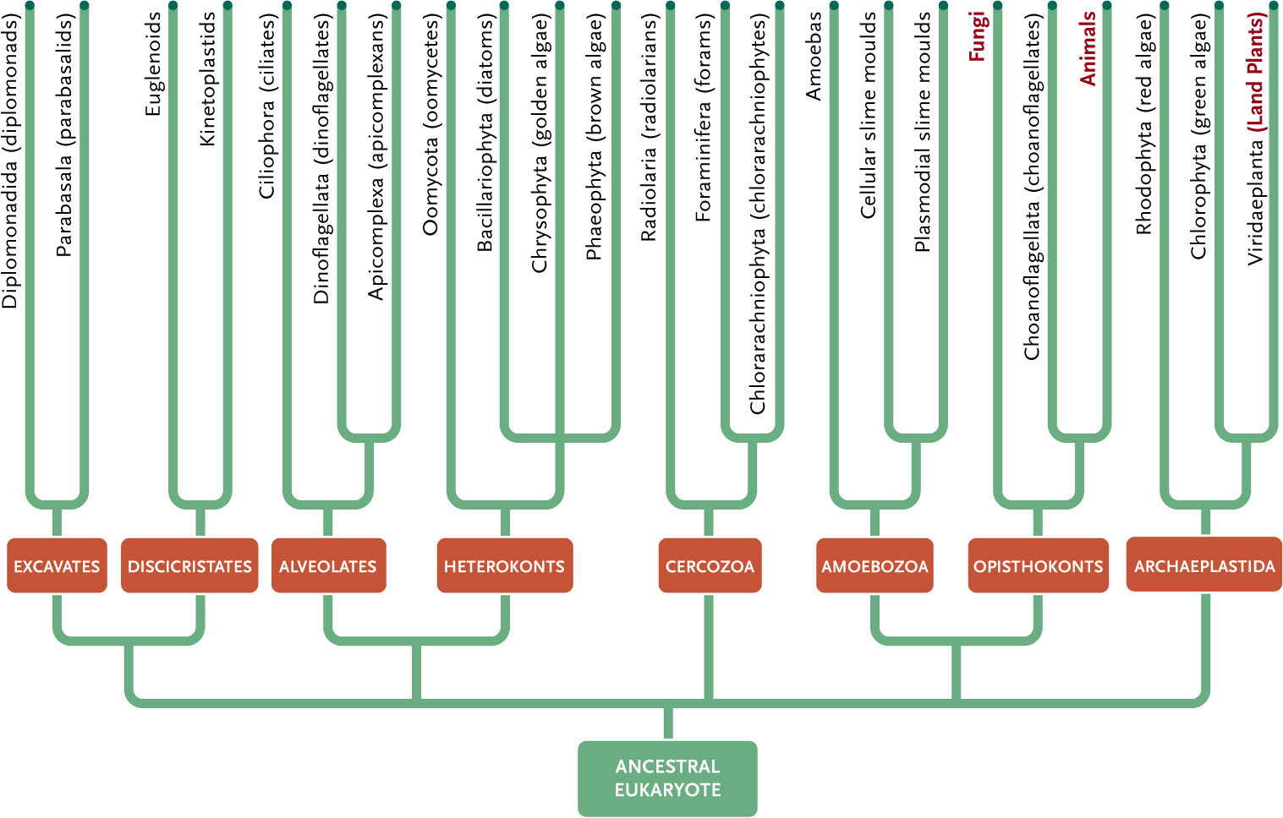

Slide 16: Two main types of cells: Dealing with size
What are the main groups or types of cells and how do they differ?
  - Cells are divided into two main classes, initially defined by whether they contain a nucleus or not.
  - Prokaryotic cells (bacteria) lack a nuclear envelope;
  - Eukaryotic cells have a nucleus in which the genetic material is separated from the cytoplasm.
  - Prokaryotic cells are generally smaller and simpler than eukaryotic cells- genomes are less complex and they do not contain cytoplasmic organelles or a cytoskeleton
  - Nuclear envelope (separating DNA from rest of intracellular components)
  - Membranous compartments with specific roles (ER, mitochondria, etc.)
  - All eukaryotic cells have some sort of energy-transforming unit (mitochondria, chloroplasts).

Prokaryotes
- Unicellular
- Bacteria
- Archaea

Eukaryotes
- Unicellular (protists)
- Multicellular
  - Plants
  - Fungi
  - Animals
Slide 17: Prokaryotes and Eukaryotes
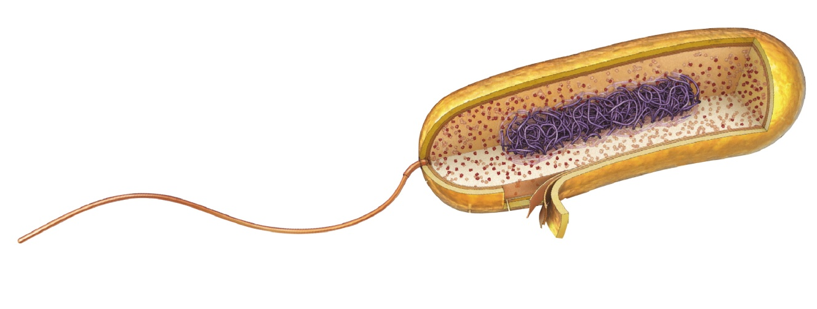
Prokaryotes
- Stay small (1 – 5 μm)
- Keep it simple
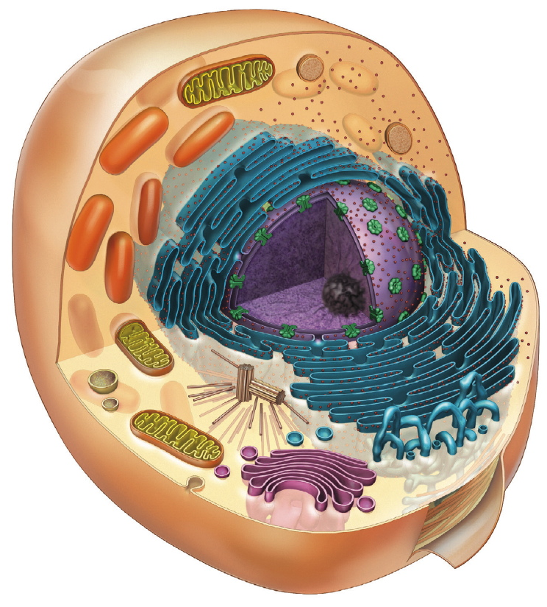
- Highly adaptable (extremophiles)
- Small genomes (10⁶ bp), plasmids- circular genes
- Adapt very quickly to extreme conditions due to their size and the way they are constructed
Eukaryotes
- Larger (10 – 100 μm or larger)
- Elaborate membranes allow compartments to organize cellular functions
- Transport systems
- Larger genomes (10⁶ to 10⁹ bp), linear, w. associated proteins
- Unable to change quickly to new environments because it is a complex system

Slide 18- Typical bacteria: Escherichia coli
- Small, rod-shaped eubacterial cell normally lives in the gut of humans and other vertebrates
- Optimized to cope with variable chemical conditions and to reproduce rapidly
- Genetic instructions are contained in a single, circular molecule of DNA
- In molecular terms, we have more knowledge of the woekings of E.Coli than of any other living organism.
- Understanding of the fundamental mechanisms of life- DNA replication or decoding fir synthesis of specific proteins- have come from studies of E.coli.
  - Useful because they have a known genome and a known structure.
  - No internal compartment- no nucleus, no organelles. The cell’s DNA is lying in the cell, exposed. Therefore, the DNA is more vulnerable. However, it is easy to reproduce the cell. During reproduction, it can be easily transferred to other organisms. Transcription and translation (can be done simultaneously) will be faster because there is no need to exit or enter the cell.
  - All cells have a plasma membrane. However, prokaryotes can have an additional layer- a capsule, which can be slimy- glycocalyx.
  - The glycocalyx is there for extra protection.

Slide 19- Typical animal eukaryotic cell
  - Image produced by TEM
  - Scanning electron microscopy- bombarding it with electrons,
  - Transmission- interior of the sample
Slide 20- Typical plant cell
- Plant cells have a large vacuole- distinguishes it from animal cells.
Slide 21- Things you can already organize

Slide 22- Eukaryotic cell organelles
- Subcellular compartments within the cytosol surrounded by a membrane
- Single subcellular compartment without a membrane: Ribosomes
- Their functions are varied, and depend on the cell’s role

What is a cell made of? Define the different features, organelles and explain the roles/functions for each
- The Universal Features of Cells on Earth
  - The parent organism hands down information specifying, in extraordinary detail, the characteristics that the offspring shall have. This phenomenon of heredity is a central part of the definition of life: distinguishes life from other processes.
  - The living organism must consume free energy to create and maintain its organization; but the free energy drives a hugely complex system of chemical processes that is specified by the heredity information.
  - Most living organisms are single cells; others such as ourselves are multicellular in which groups of cells perform specialized functions and are linked by intricate systems of communication.
  - The organism has been generated by cell division from a single cell. Therefore, a cell is the vehicle for the heredity information that defines the species.
  - And specified by this information, the cell includes the machinery to gather raw materials from the environment, and to construct out of them a new cell in its own image, complete with a new copy of the hereditary information
- All Cells Store Their Hereditary Information in the Same Linear Chemical Code (DNA)
- Living organisms reproduce themselves by transmitting genetic information to their progeny.
- The individual cell is the minimal self-reproducing unit, and is the vehicle for transmission of the genetic information in all living species.
- All living cells on Earth, without any known exception, store their hereditary information in the form of double-stranded molecules of DNA—long unbranched paired polymer chains, formed always of the same four types of monomers—A, T, C, G.

- All Cells Replicate Their Hereditary Information by Templated Polymerization
- Each monomer in a single DNA strand—that is, each nucleotide—consists of two parts: a sugar (deoxyribose) with a phosphate group attached to it, and a base, which may be either adenine (A), guanine (G), cytosine (C) or thymine (T)
- Each sugar is linked to the next via the phosphate group, creating a polymer chain composed of a repetitive sugar-phosphate backbone with a series of bases protruding from it. The DNA polymer is extended by adding monomers at one end.
- DNA is not synthesized as a free strand in isolation, but on a template formed by a preexisting DNA strand.
- The bases protruding from the existing strand bind to bases of the strand being synthesized, according to a strict rule defined by the complementary structures of the bases: A binds to T, and C binds to G. This base-pairing holds fresh monomers in place and thereby controls the selection of which one of the four monomers shall be added to the growing strand next. In this way, a double-stranded structure is created, consisting of two exactly complementary sequences of As, Cs, Ts, and Gs. The two strands twist around each other, forming a double helix (Print Figure 1-2)
- The bonds between the base pairs are weak compared with the sugar-phosphate links, and this allows the two DNA strands to be pulled apart without breakage of their backbones.
- Each strand then can serve as a template, in the way just described, for the synthesis of a fresh DNA strand complementary to itself—a fresh copy, that is, of the hereditary information
- The basics of DNA replication are universal: DNA is the information store, and templated polymerization is the way in which this information is copied throughout the living world.

- All Cells Transcribe Portions of Their Hereditary Information into the Same Intermediary Form (RNA)
- The process begins with a templated polymerization called transcription, in which segments of the DNA sequence are used as templates to guide the synthesis of shorter molecules of the closely related polymer ribonucleic acid, or RNA. Later, in the more complex process of translation, many of these RNA molecules serve to direct the synthesis of polymers of a radically different chemical class—the proteins
- In RNA, there is ribose instead of deoxyribose, and one of the bases is slightly different- Uracil (U) instead of thymine (T);
- but the other three bases—A, C, and G—are the same, and all four bases pair with their complementary counterparts in DNA—the A, U, C, and G of RNA with the T, A, G, and C of DNA.
- During transcription, RNA monomers are lined up and selected for polymerization on a template strand of DNA in the same way that DNA monomers are selected during replication. The outcome is therefore a polymer molecule whose sequence of nucleotides faithfully represents a part of the cell's genetic information, even though written in a slightly different alphabet, consisting of RNA monomers instead of DNA monomers.
- The cell's archive of genetic information in the form of DNA is fixed and sacrosanct, the RNA transcripts are mass-produced and disposable
- The primary role of most of these transcripts is to serve as intermediates in the transfer of genetic information: they serve as messenger RNA (mRNA) to guide the synthesis of proteins according to the genetic instructions stored in the DNA.

- All Cells Use Proteins as Catalysts
- Protein molecules, like DNA and RNA, are long unbranched polymer chains
- The monomers of protein, the amino acids, are quite different from those of DNA and RNA, and there are 20 types, instead of 4.
- Each amino acid is built around the same core structure through which it can be linked in a standard way to any other amino acid in the set; attached to this core is a side group that gives each amino acid a distinctive chemical character.
- Each amino acid is built around the same core structure through which it can be linked in a standard way to any other amino acid in the set; attached to this core is a side group that gives each amino acid a distinctive chemical character.
- Protein molecules, or polypeptides, fold into a precise three dimensional form with reactive sites on its surface.
- Amino acid polymers bind with high specificity to other molecules and act as enzymes to catalyze reactions in which covalent bonds are made and broken. In this way they direct the vast majority of chemical processes in the cell
- Proteins- —maintaining structures, generating movements, sensing signals, and so on
- Proteins, above all, are the molecules that put the cell's genetic information into action.
- polynucleotides specify the amino acid sequences of proteins.
- Polynucleotides (nucleotide polymers) and proteins (amino acid polymers) provide the sequence information and the catalytic functions that serve—through a complex set of chemical reactions—to bring about the synthesis of more polynucleotides and proteins of the same types.
- All Cells Translate RNA into Protein in the Same Way
- The information in the sequence of a messenger RNA molecule is read out in groups of three nucleotides at a time: each triplet of nucleotides, or codon, specifies (codes for) a single amino acid in a corresponding protein.
- The code is read out by a special class of small RNA molecules, the transfer RNAs (tRNAs).
- Each type of tRNA becomes attached at one end to a specific amino acid, and displays at its other end a specific sequence of three nucleotides—an anticodon—that enables it to recognize, through base-pairing, a particular codon or subset of codons in mRNA
- For synthesis of protein, a succession of tRNA molecules charged with their appropriate amino acids have to be brought together with an mRNA molecule and matched up by base-pairing through their anticodons with each of its successive codons. The amino acids then have to be linked together to extend the growing protein chain, and the tRNAs, relieved of their burdens, have to be released. Process carried out by the ribosome.
- The Fragment of Genetic Information Corresponding to One Protein Is One Gene
- Segments of the entire DNA sequence are therefore transcribed into separate mRNA molecules, with each segment coding for a different protein.
- A gene is defined as the segment of DNA sequence corresponding to a single protein
- In all cells, the expression of individual genes is regulated: instead of manufacturing its full repertoire of possible proteins at full tilt all the time, the cell adjusts the rate of transcription and translation of different genes independently, according to need.
- The quantity and organization of the regulatory and other noncoding DNA vary widely from one class of organisms to another, but the basic strategy is universal.
- The genome of the cell—that is, the total of its genetic information as embodied in its complete DNA sequence—dictates not only the nature of the cell's proteins, but also when and where they are to be made.

- Life Requires Free Energy
- This consumption of free energy is fundamental to life.
- free energy is required for the propagation of information
- The cell therefore requires free energy, which has to be imported somehow from its surroundings, to replicate its genetic information faithfully.
- The same principle applies to the synthesis of most of the molecules in cells.
- In the production of RNAs or proteins, the existing genetic information dictates the sequence of the new molecule through a process of molecular matching, and free energy is required to drive forward the many chemical reactions that construct the monomers from raw materials and link them together correctly.
- All Cells Function as Biochemical Factories Dealing with the Same Basic Molecular Building Blocks
- all cells have to contain and manipulate a similar collection of small molecules, including simple sugars, nucleotides, and amino acids, as well as other substances that are universally required for their synthesis.
- Many of the details of the cell’s small molecule transactions differ

All Cells Are Enclosed in a Plasma Membrane Across Which Nutrients and Waste Materials Must Pass
- each one is bounded by a membrane—the plasma membrane.
- These have a hydrophilic (water-loving, phosphate) head group and a hydrophobic (water-avoiding, hydrocarbon) tail. At an interface between oil and water, they arrange themselves as a single sheet with their head groups facing the water and their tail groups facing the oil. When immersed in water, they aggregate to form bilayers enclosing aqueous compartments.
- hydrocarbon polymers (-CH₂-CH₂-CH₂-)
- All cells have specialized proteins embedded in their membrane that serve to transport specific molecules from one side to the other
- There are membrane transport proteins
- by specifying the set of proteins that the cell is to manufacture, the genetic information recorded in the DNA sequence dictates the entire chemistry of the cell; and not only its chemistry, but also its form and its behavior, for these too are chiefly constructed and controlled by the cell's proteins.

- A Living Cell Can Exist with Fewer Than 500 Genes
- Mycoplasma genitalum- a parasite in mammals, only 477 genes in its genome of 580,070 nucleotide pairs

Learning Objective: Understand the different types of microscopy and their requirements for use in cell biology
https://www.youtube.com/watch?v=b4WOsYktdn4

Looking at cells with different microscopes: http://www.ncbi.nlm.nih.gov/books/NBK26880/
- A typical animal cell is 10–20 μm in diameter
- Cell doctrine by Schleiden and Schwann in 1838, marks the formal birth of cell biology.
- Animal cells are colorless and translucent

Living Cells Are Seen Clearly in a Phase-Contrast or a Differential-Interference-Contrast Microscope
- The possibility that some components of the cell may be lost or distorted during specimen preparation has always challenged microscopists.
- The only certain way to avoid the problem is to examine cells while they are alive, without fixing or freezing.
- In the dark-field microscope, the illuminating rays of light are directed from the side so that only scattered light enters the microscope lenses. Consequently, the cell appears as a bright object against a dark background.
- With a normal bright-field microscope, the image is obtained by the simple transmission of light through a cell in culture.
- Phase-contrast, differential-interference-contrast, and dark-field micros-copy make it possible to watch the movements involved in such processes as mitosis and cell migration.

Images Can Be Enhanced and Analyzed by Electronic Techniqueshttps://www.ncbi.nlm.nih.gov/books/NBK26880/

Tissues Are Usually Fixed and Sectioned for Microscopy
- To make a permanent preparation that can be stained and viewed at leisure in the microscope, one first must treat cells with a fixative so as to immobilize, kill, and preserve them.
- In chemical terms, fixation makes cells permeable to staining reagents and cross-links their macromolecules so that they are stabilized and locked in position. Early fixatives included: organic solvents, new ones include reactive aldehydes, particularly formaldehyde and glutaraldehyde.
- After fixation, therefore, the tissues are usually cut into very thin slices, or sections, with a microtome, a machine with a sharp blade that operates like a meat slicer (Figure 9-10). The sections (typically 1–10 μm thick) are then laid flat on the surface of a glass microscope slide.
- Once sections have been cut, by whatever method, the next step is usually to stain them.

Different Components of the Cell Can Be Selectively Stained
- Some of the dyes were found to stain biological tissues and, unexpectedly, often showed a preference for particular parts of the cell—the nucleus or mitochondria, for example—making these internal structures clearly visible.

Specific Molecules Can Be Located in Cells by Fluorescence Microscopy
- The fluorescent dyes used for staining cells are detected by a fluorescence microscope.
- monitor changes in the concentration and location of specific molecules inside living cells

Antibodies Can Be Used to Detect Specific Molecules
- The precise antigen specificity of antibodies makes them powerful tools for the cell biologist.
- When labeled with fluorescent dyes, they are invaluable for locating specific molecules in cells by fluorescence microscopy

Summary
Many light-microscope techniques are available for observing cells. Cells that have been fixed and stained can be studied in a conventional light microscope, while antibodies coupled to fluorescent dyes can be used to locate specific molecules in cells in a fluorescence microscope. Living cells can be seen with phase-contrast, differential-interference-contrast, dark-field, or bright-field microscopes. All forms of light microscopy are facilitated by electronic image-processing techniques, which enhance sensitivity and refine the image. Confocal microscopy and image deconvolution both provide thin optical sections and can be used to reconstruct three-dimensional images.
Determining the detailed structure of the membranes and organelles in cells requires the higher resolution attainable in a transmission electron microscope. Specific macromolecules can be localized with colloidal gold linked to antibodies. Three-dimensional views of the surfaces of cells and tissues are obtained by scanning electron microscopy. The shapes of isolated macromolecules that have been shadowed with a heavy metal or outlined by negative staining can also be readily determined by electron microscopy. Using computational methods, multiple images and views from different directions are combined to produce detailed reconstructions of macromolecules and molecular complexes through a technique known as electron-microscope tomography.

- Diversity and tree of life: http://www.ncbi.nlm.nih.gov/books/NBK26866/

Cells Can Be Powered by a Variety of Free Energy Sources
- feeding on other living things or the organic chemicals they produce; such organisms are called organotrophic
- those that harvest the energy of sunlight (phototrophic)and those that capture their energy from energy-rich systems of inorganic chemicals in the environment (lithotrophic (feeding on rock))
- Phototrophic organisms include many types of bacteria, as well as algae and plants. the oxygen in the Earth's atmosphere is a by-product of their biosynthetic activities.
- Lithotrophs- microscopic, mostly live in extreme habitats such as deep in the ocean, buried in the Earth’s crust, or in various other inhospitable environments. Lithotrophs can be either aerobic or anaerobic- resembling a strategy of surviving in the early atmosphere which contained little oxygen. The most extreme location that they can be found at is the hot hydrothermal vents.

Some Cells Fix Nitrogen and Carbon Dioxide for Others
- We animals depend on plants for our supplies of organic carbon and nitrogen compounds.
- Plants in turn, although they can fix carbon dioxide from the atmosphere, lack the ability to fix atmospheric nitrogen, and they depend in part on nitrogen-fixing bacteria to supply their need for nitrogen compounds

The Greatest Biochemical Diversity Is Seen Among Prokaryotic Cells
- Living organisms can be classified on the basis of cell structure into two groups: the eukaryotes and prokaryotes.
- Eukaryotes have a nucleus to house their DNA, whereas the Prokaryotes do not. Eukaryotes include plants, fungi, and animals. Prokaryotes include bacteria and archaea.
- Prokaryotic cells are small and simple in appearance. They live as independent individuals rather than as multicellular organisms. Can be spherical or rod-shaped, few micrometers in linear dimension. Tough protective coat, called a cell wall, beneth which a plasma membrane encloses a single cytoplasmic compartment containing DNA, RNA, proteins, and the many small molecules needed for life.
- Prokaryotes live in a variety of ecological niches, and they are astonishingly varied in biochemical capabilities-more than eujaryotic cells.

The Tree of Life Has Three Primary Branches: Bacteria, Archaea, and Eukaryotes
- Genome analysis has transformed the problem, giving us a simpler, more direct, and more powerful way to determine evolutionary relationships.
- Because DNA is subject to random changes that accumulate over long periods of time (as we shall see shortly), the number of differences between the DNA sequences of two organisms can be used to provide a direct, objective, quantitative indication of the evolutionary distance between them.
- There are three domains of life: bacteria (eubacteria), archaea (archaebacterial) and eukaryotes- based on comparisons of the nucleotide sequence of a ribosomal RNA subunits in the different species.
- Archaea live in bogs, sewage farms, ocean depths, salt brines and acid springs. Archaea resemble eukaryotes in their machinery for handling genetic information. But are closer to eubacteria in metabolism and energy conversion.

Some Genes Evolve Rapidly; Others Are Highly Conserved
- Alteration of the nucleotide sequence- creating mutations. Daughter cells are not quite identical to one another or to their parent.
- Mutations are rarely a change for the better, they are almost always the cause of serious damage.
- Through endless repetition of this cycle of error and trial—of mutation and natural selection—organisms evolve: their genetic specifications change, giving them new ways to exploit the environment more effectively, to survive in competition with others, and to reproduce successfully.

Most Bacteria and Archaea Have 1000–4000 Genes
- Small size implies a large ratio of surface area to volume, thereby helping to maximize the uptake of nutrients across the plasma membrane and boosting a cell's reproductive rate- helps with natural selection.

New Genes Are Generated from Preexisting Genes
- no gene is ever entirely new. Innovation can, however, occur in several ways:
- Intragenic mutation: an existing gene can be modified by mutations in its DNA sequence.
- Gene duplication: an existing gene can be duplicated so as to create a pair of closely related genes within a single cell.
- Segment shuffling: two or more existing genes can be broken and rejoined to make a hybrid gene consisting of DNA segments that originally belonged to separate genes.
- Horizontal (intercellular) transfer: a piece of DNA can be transferred from the genome of one cell to that of another—even to that of another species. This process is in contrast with the usual vertical transfer of genetic information from parent to progeny.

Gene Duplications Give Rise to Families of Related Genes Within a Single Cell
- genes in two separate species that derive from the same ancestral gene in the last common ancestor of those two species—are said to be orthologs.
- Related genes that have resulted from a gene duplication event within a single genome—and are likely to have diverged in their function—are said to be paralogs.
- Genes that are related by descent in either way are called homologs, a general term used to cover both types of relationship

Genes Can Be Transferred Between Organisms, Both in the Laboratory and in Nature
- Procaryotes also provide examples of the horizontal transfer of genes from one species of cell to another
- OLD BIO NOTES

Horizontal Exchanges of Genetic Information Within a Species Are Brought About by Sex
- It has been suggested that the genomes of present-day eubacteria, archaea, and eucaryotes originated not by divergent lines of descent from a single genome in a single ancestral type of cell, but rather as three independent anthologies of genes that have survived from the pool of genes in a primordial community of diverse cells in which genes were frequently exchanged
- horizontal gene transfers leave a characteristic imprint: they result in individuals who are related more closely to one set of relatives with respect to some genes, and more closely to another set of relatives with respect to others.

The Function of a Gene Can Often Be Deduced from Its Sequence
- Since gene sequence determines gene function, one can frequently make a good guess at the function of the new gene: it is likely to be similar to that of the already-known homologs.
- It is possible to decipher a great deal of the biology of an organism simply by analyzing the DNA sequence of its genome and using the information we already have about the functions of genes in other organism that have been more intensively studied.
More Than 200 Gene Families Are Common to All Three Primary Branches of the Tree of Life
- Lineage specific gene loss and horizontal gene transfer, in some cases between evolutionary distant species, have been major factors of evolution, at least in the prokaryotic world.
- Some gene that were initially shared will have changed beyond recognition by current methods.
- Only a small proportion of ancestral gene families have been universally retained in a recognizable form.

Mutations Reveal the Functions of Genes
- The analysis of gene functions depends heavily on two complementary approaches: genetics and biochemistry.
- Genetics starts with the study of mutants: we either find or make an organism in which a gene is altered, and examine the effects on the organism's structure and performance
- Biochemistry examines the functions of molecules: we extract molecules from an organism and then study their chemical activities.
- By putting genetics and biochemistry together and examining the chemical abnormalities in a mutant organism, it is possible to find those molecules whose production depends on a given gene.

- Origin and Evolution of Cells- How did life evolve into organisms and cells? (Review from BIO1130 and/or BIO1109)
Origin and evolution of cells: http://www.ncbi.nlm.nih.gov/books/NBK9841/
  - Life emerged at least 3.8 billion years ago, approximately 750 million years after Earth was formed.
  - 1920s, simple organic molecules could form and spontaneously polymerize into macromolecules under conditions thought to exist in primitive Earth’s atmosphere
  - Earth’s early atmosphere (CO2 and N2) provides a reducing conditions in which organic molecules, when given a source of energy, can form spontaneously.
  - The spontaneous formation of organic molecules was first demonstrated experimentally in the 1950s, when Stanley Miller. Next step is the formation of macromolecules.
  - the critical characteristic of the macromolecule from which life evolved must have been the ability to replicate itself. Only a macromolecule capable of directing the synthesis of new copies of itself would have been capable of reproduction and further evolution
  - Between nucleic acids and proteins, only nucleic acids are capable of directing their own self- replicating- RNA is capable of catalyzing a number of chemical reactions, including the polymerization of nucleotides. RNA is thus uniquely able both to serve as a template and catalyze its own replication.
  - RNA is generally believed to have been the initial genetic system, and an early stage of chemical evolution is thought to have been based on self-replicating RNA molecules—a period of evolution known as the RNA world. Ordered interactions between RNA and amino acids then evolved into the present-day genetic code, and DNA eventually replaced RNA as the genetic material.

The Evolution of Metabolism
- The mechanisms used by cells for the generation of ATP are thought to have evolved in three stages, corresponding to the evolution of glycolysis, photosynthesis, and oxidative metabolism
Present- Day Prokaryotes
- divided into two groups—the archaebacteria and the eubacteria—which diverged early in evolution.
- Video – Tour of the cell: https://www.youtube.com/watch?v=1Z9pqST72is&list=TLxSfHo2_yogzBEYECTfFTNVUGO-sbqvAu

Learning Objectives
- Organelles (Eukaryotes) : http://www.ncbi.nlm.nih.gov/books/NBK21743/
- The internal architecture of cells and central metabolic pathways are similar in all plants, animals, and unicellular eukaryotic organisms (e.g., yeast). All eukaryotic cells contain a membrane-limited nucleus and numerous other organelles in their cytosol.
- Lysosomes, which are found only in animal cells, have an acidic interior and contain various hydrolases. These degradative enzymes break down some cellular components that are no longer functional or needed by the cell and some ingested materials (see Figure 5-44).
- Plant cells contain one or more large vacuoles, which often fill much of the cell. The vacuole is a storage site for ions and nutrients. Osmotic flow of water into the vacuole generates turgor pressure that pushes the plasma membrane against the cell wall.
- Peroxisomes are small organelles containing enzymes that oxidize various organic compounds, generating hydrogen peroxide. This toxic substance is converted to water and oxygen by catalase, also present in large amounts in these organelles. Oxidation of fatty acids in peroxisomes produces acetyl groups, used in biosynthetic reactions, but no ATP.
- The mitochondrion is bounded by two membranes, with the inner one extensively folded. Enzymes in the inner mitochondrial membrane and central matrix carry out the terminal stages of sugar and lipid oxidation coupled to ATP synthesis.
- Chloroplasts, the sites of photosynthesis, are surrounded by an inner and outer membrane; a complex system of thylakoid membranes in their interior contains the pigments and enzymes that absorb light and produce ATP.
- Secretory proteins and membrane proteins are synthesized on the rough endoplasmic reticulum, a network of interconnected membrane vesicles studded with ribosomes. These proteins then move to the Golgi complex, where they are sorted and processed (see Figure 5-48).
- The nucleus is surrounded by an inner and outer membrane. These contain numerous pores through which materials pass between the nucleus and cytosol. The outer nuclear membrane is continuous with the rough endoplasmic reticulum.
- The cytosol, the protein-rich fraction remaining after removal of all organelles, contains numerous soluble enzymes and three major types of protein filaments: actin microfilaments, microtubules, and intermediate filaments. In all animal and plant cells, these filaments form a complex network, the cytoskeleton, that gives the cell structural stability and contributes to cell movement.
Prokaryotes : http://www.ncbi.nlm.nih.gov/books/NBK21665/
- Cells are surrounded by water-impermeable membranes.
- Cells then, in order to maintain their integrity, need to be surrounded by an environment through which water cannot flow. A membrane composed of fatty molecules serves this purpose- a membrane composed of fatty molecules serves this purpose
- In spite of the rigidity provided by cholesterol, membranes composed of fat are not very strong, so numerous mechanisms for strengthening the borders of cells have evolved- in plants, there is a cell wall, in animals the proteins attached to their exterior surfaces provide some stability
- Membranes serve functions other than segregation- energy storage is one of their functions
- Explain the theory of the cell and the theory of endosymbiosis – can you provide some examples?
Endosymbiosis : http://www.ncbi.nlm.nih.gov/pmc/articles/PMC368163/?tool=pmcentrez
- Endosymbiosis is a specific type of symbiosis in which one—typically microbial—partner lives within its host and represents the most intimate contact between interacting organisms

