Brittney Dagenais
Devoir 4
8201359

Model Summary^{b}
Model | R | R Square | Adjusted R Square | Std. Error of the Estimate
1 | .817ª | .668 | .665 | 2.231
a. Predictors: (Constant), mollets
b. Dependent Variable: blessure

Coefficientsª
Model |  | Unstandardized Coefficients |  | Standardized Coefficients | t | Sig.
 |  | B | Std. Error | Beta | t | Sig.
1 | (Constant) | 153.510 | 1.181 |  | 129.968 | .000
1 | mollets | .544 | .039 | .817 | 14.045 | .000
a. Dependent Variable: blessure

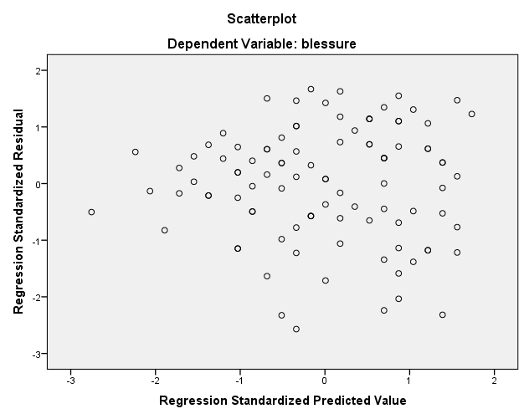
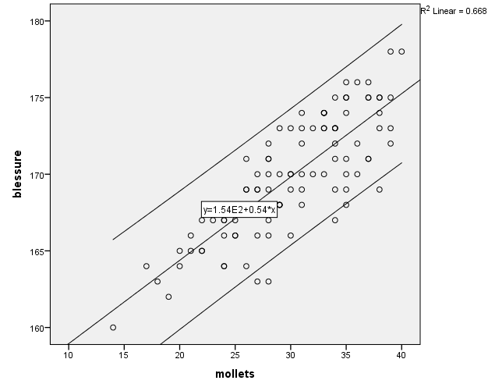
Model Summary^{b}
Model | R | R Square | Adjusted R Square | Std. Error of the Estimate
1 | .823ª | .677 | .674 | 2.200
a. Predictors: (Constant), abdos
b. Dependent Variable: blessure

Coefficientsª
Model |  | Unstandardized Coefficients |  | Standardized Coefficients | t | Sig.
 |  | B | Std. Error | Beta | t | Sig.
1 | (Constant) | 159.768 | .733 |  | 217.961 | .000
1 | abdos | .362 | .025 | .823 | 14.347 | .000
a. Dependent Variable: blessure

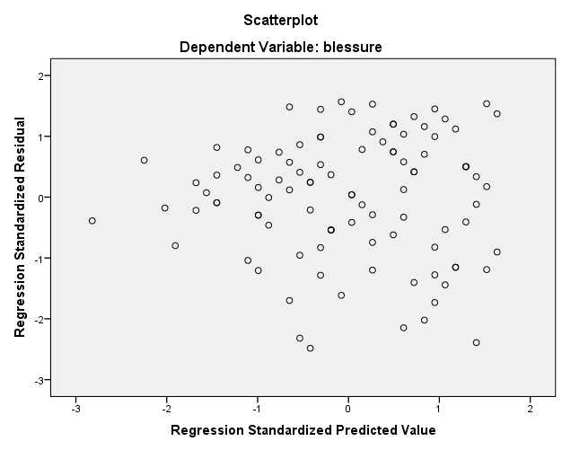
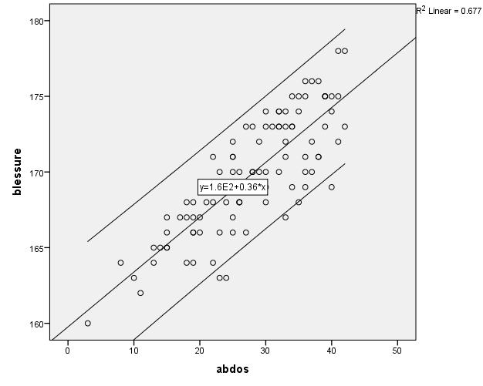
Model Summary^{b}
Model | R | R Square | Adjusted R Square | Std. Error of the Estimate
1 | .823ª | .677 | .674 | 2.200
a. Predictors: (Constant), avant_bras
b. Dependent Variable: blessure

Coefficientsª
Model |  | Unstandardized Coefficients |  | Standardized Coefficients | t | Sig.
 |  | B | Std. Error | Beta | t | Sig.
1 | (Constant) | 159.406 | .757 |  | 210.537 | .000
1 | avant_bras | .362 | .025 | .823 | 14.347 | .000
a. Dependent Variable: blessure



