Digital Circuit Design I
COEN 212 – FI X

Experiment #5
Analysis and Design of Counters

Performed on November 24, 2016

Submitted on December 1, 2016

Objective
The objectives of the experiment are to further increase skills in connecting digital circuits, testing and debugging sequential designs. We will also gain experience in the analysis and design of sequential circuits. Finally, the experiment will allows us to obtain an understanding of the design and functionality of various sequential digital counter circuits.

Introduction
This experiment deals with the analysis and design of counters. A sequential circuit that counts the same pattern every cycle is known as a counter. A counter that follows the binary sequence is called a binary counter. In this experiment, an up-down counter was designed, where the circuit counts up in binary when the input is high and counts down in binary when the input is low.

Analysis of Sequential Circuits:
- Label all inputs and outputs on the logic circuit diagram
- Determine the flip-flop inputs in terms of the system inputs and the present state outputs from each flip-flop
- Generate a state transition table
- Generate a state transition diagram

Design of Sequential Circuits:
- Derive a state transition diagram
- Generate a state transition table
- Derive the Boolean equation for each input of every flip-flop and minimize by using a K-map
- Determine the outputs as a function of flip-flop present state variables and system inputs and minimize by using a K-map
- Draw the circuit diagram

The detailed methodology is found in the Laboratory Manual for Digital System Design I.

Results
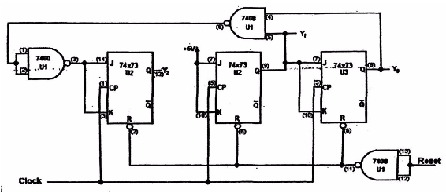
Present |  |  | Next
Y₂ | Y₁ | Y₀ | Y₂ | Y₁ | Y₀
0 | 0 | 0 | 0 | 1 | 0
0 | 0 | 1 | 0 | 1 | 1
0 | 1 | 0 | 0 | 0 | 1
0 | 1 | 1 | 1 | 0 | 0
1 | 0 | 0 | 1 | 1 | 0
1 | 0 | 1 | 1 | 1 | 1
1 | 1 | 0 | 1 | 0 | 1
1 | 1 | 1 | 0 | 0 | 0
PART 1

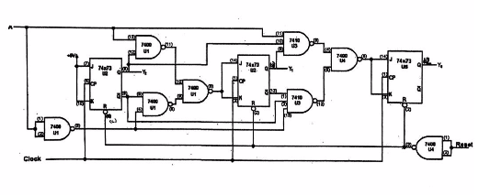
Input | Present |  |  | Next
A | Y₂ | Y₁ | Y₀ | Y₂ | Y₁ | Y₀
0 | 0 | 0 | 0 | 1 | 1 | 0
0 | 0 | 0 | 1 | 1 | 1 | 1
0 | 0 | 1 | 0 | 1 | 0 | 1
0 | 0 | 1 | 1 | 1 | 0 | 0
0 | 1 | 0 | 0 | 1 | 0 | 0
0 | 1 | 0 | 1 | 0 | 0 | 1
0 | 1 | 1 | 0 | 0 | 1 | 0
0 | 1 | 1 | 1 | 0 | 1 | 1
1 | 0 | 0 | 0 | 1 | 0 | 0
1 | 0 | 0 | 1 | 1 | 0 | 1
1 | 0 | 1 | 0 | 1 | 1 | 0
1 | 0 | 1 | 1 | 1 | 1 | 1
1 | 1 | 0 | 0 | 0 | 1 | 1
1 | 1 | 0 | 1 | 0 | 1 | 0
1 | 1 | 1 | 0 | 0 | 0 | 0
1 | 1 | 1 | 1 | 0 | 0 | 1
PART 2

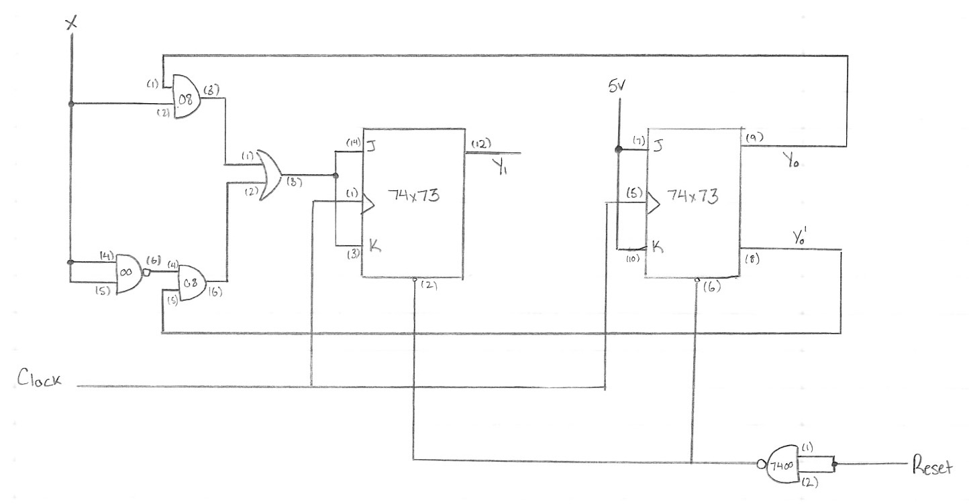

Input | Present |  | Next
X | Y₁ | Y₀ | Y₁ | Y₀
0 | 0 | 0 | 0 | 0
0 | 0 | 1 | 1 | 0
0 | 1 | 0 | 0 | 1
0 | 1 | 1 | 1 | 1
1 | 0 | 0 | 0 | 0
1 | 0 | 1 | 1 | 0
1 | 1 | 0 | 0 | 1
1 | 1 | 1 | 1 | 1
PART 3

Discussion
The first sequential circuit build had a counter pattern of 0246 when Y₀ is 0 and the most significant bit. When Y₀ is 1 and the most significant bit, the counter pattern would be 1357. This circuit is a 3-bit counter, meaning that three JK Flip-Flops were used. It is designed with the least chips possible and uses NAND gates to ensure time, energy and cost efficiency.

The second sequential circuit built was an up-down counter. When the input is 0 and Y₀ is the most significant bit, the circuit counts down from 7. When the input is 1 and Y₀ is the most significant bit, the circuit counts up to 7. The circuit is a 3-bit up-down counter, meaning that three JK Flip-Flops were used. The circuit’s use of NAND gates ensures time, energy and cost efficiency.

The third sequential circuit built was a 2-bit up-down counter. When the input is 0, it counters down from 3. When the input is 1, it counts up to 3. The circuit used only 2 JK Flip-Flops, yet could have been more efficient had it been designed simply using NAND gates.

Conclusion
Overall, all of the circuits were designed and built properly by following the procedures outlined in the introduction. The final circuit was initially designed incorrectly, forcing me to redesign it and build it during the lab period. Aside from that, there were not many issues with the methodology, however it is important to test the circuits modularly in order to avoid eventual errors when the circuit is complete. Assuring that all state diagrams and K-maps are correct is a crucial component to the overall functionality of the circuit. The lab is considered a success due to all of the circuits functioning as expected and building them within the expected timeframe.

References
Al-Khalili, A. J., Taillefer, C. “Lab Manual for Digital System Design I COEN 212”. Lab
handbook. Concordia University, Montreal, Quebec, 2001. Print.

