HSS 2305
PRETEST : Chapter 8
Multiple choices
1) Fundamental to the life cycle of all animal viruses, is hijacking of host’s cellular membrane system. One of the challenge is how to enter a cell. Which way can a virus enter a eukaryotic cell?
a) by fusion with the plasma membrane, for enveloped viruses
b) by being ingested into vesicles named lysosomes, for naked viruses
c) by creating viroplasm
d) by restructuring RER
2) Endocytosis is:
a) the same as secretory pathway
b) the same as phagocytosis
c) a way to incorporate fluids into a cell
d) a maturation of early endosome to late endosome
3) Distinguish between an early endosome (EE) and a late endosome(LE)?
a) in EE: lower pH in LE: higher pH
b) EE: peripheral LE: near the nucleus
c) EE: near the nucleus LE: peripheral
d) a and b are good
4) Which of these statements is correct according to the general concept on the endomembrane system?
a) only the Golgi apparatus is a cell compartment
b) cell organelles are stable structures
c) cytoskeleton is part of the endomembrane system
d) the nucleus is part of the compartmentalized system
5) Which is true about mitochondria and/or peroxisomes?
a) mitochondria are part of the endomembrane system
b) mitochondrial proteins may come from cytoplasm
c) peroxisomes are involved in the production of ATP
d) mitochondrial proteins, unlike those of peroxisomes, come from cytoplasm
6) A donor membrane compartment can be located at the level of:
a) the nucleus
b) the mitochondrion
c) the ribosome
d) the RER
7) How does a cell sort different proteins destined for different sites into different bound-membrane carriers?
a) by the involvement of RER
b) by the involvement of Golgi complex
c) by the production of clathrin-coated vesicle
d) none of these
8) Here a list of statements according to the time a lysosome enzyme is produced in the RER and the time it is located into a clathrin-coated vesicle:
1) phosphorylation of mannose residues occurs in the Cis Golgi
2) separation of lysosomal enzyme from secretory proteins occurs in the Cis Golgi
3) MPRs bind to lysosomal enzyme at the level of the TGN
4) a clathrin-coated vesicle starts to be formed at the level of the TGN
Which combination of statements is correct?
a) all these statements are correct
b) only 1 is correct
c) only 2 and 4 are correct
d) all these statements are false
9) In a clathrin-coated vesicle, which constitutes a structural scaffold?
a) an adaptor called GGA
b) the cytosolic tail of the MPR
c) the lysosomal enzyme in itself
d) a lattice of protein clathrin
10) In a clathrin-coated vesicle, the adaptor GGA
a) can bind to a clathrin subunit
b) can bind to the cytosolic tail of one MPR
c) to the lysosomal enzyme itself
d) a and b are good
11) During transportation of lysosomal enzymes, when is a clathrin coat depolymerized?
a) after it has fused with a lysosome
b) after it has fused with a CURL (late endosome)
c) after the clathrin-coat vesicle has budded from the TGN
d) it is never depolymerized
12) Here a list of statements on housekeeping receptors and signaling receptors
1) a housekeeping receptor aims at delivering a hormone to a cell
2) after delivering a growth factor, a signaling receptor is destroyed
3) LDL receptors are signaling receptors
4) endocytosis leads to the recycling of a housekeeping receptor
Which combination is true?
a) 2, 4
b) 1, 2, 4
c) 1, 3
d) 3, 4
13) In the endocytic pathway, what is the difference between an endosome and a transport vesicle?
a) an endosome has a single membrane while a transport vesicle has a double one
b) an endosome always carries hormones unlike the transport vesicle
c) an endosome is a distribution center unlike the transport vesicle
d) an endosome has a high pH unlike the transport vesicle
14) In a LDL, which component binds specifically to a LDL receptor?
a) the fatty acid chains
b) the apolipoprotein
c) the phospholipid monolayer
d) the unesterified cholesterol
15) What happens once a LDL particle has been delivered to a late endosome or a lysosome, during the endocytic pathway of cholesterol?
a) its protein component is esterified
b) its cholesterol core is deesterified
c) the phospholipid monomolecular layer is esterified
d) none of these situations
16) Which is true among these statements?
a) lysosomal enzymes work better in a near-neutral pH
b) with the help of lysosomes, a human liver cell recycles half of its macromolecules each week.
c) phagocytosis aims at ingesting transferrin
d) lysosome arise by budding of the Cis face of Golgi apparatus
17) What is the good association according to the disease and its lacking/inactive lysosomal enzyme?
a) Tay-Sach disease sphingomyelinase
b) Niamann-Pick disease hexosaminidase A
c) Gaucher’s disease glucocerebrosidase
d) Niemann-Pick disease glucocerebrosidase
18) Which is true according to Tay-Sach disease?
a) it strikes especially young adult
b) the brain becomes impaired by the accumulation of ganglioside G_{m2}
c) it is still hard today to lower the incidence
d) it strikes especially Afro-American people
19) Which is true according to Gaucher’s disease?
a) infants accumulate glucocerebroside lipids in their macrophage lysosomes
b) it cannot be diagnosed prenatally
c) it can cause spleen enlargement
d) a and c are good
20) Which is true according to the I-cell disorder?
a) lysosomal enzymes are not produced at all
b) lysosomes are bloated with gangliosides G_{M2} only
c) lysosomal enzymes are produced but not targeted to lysosomes
d) the disease is due to a deficiency N-acetylglucosamine phoshotransferase which role is to bind MPR to a mannose residue

21) Here a list of statements on atherosclerosis:
1) it can be initiated by altering LDL particles in presence of oxygen free radicals
2) in its early development, endothelial cells of an artery are injured
3) macrophage foam cells appear only after the age of 40
4) macrophage foam cells’ development is preceded by proliferation of smooth muscle cells
Which combination is correct?
a) 1, 2, 3
b) 2, 3
c) 1, 2
d) all statements are correct

True or false
1) If we compare RER to Golgi complex, RER would have the recipient compartment while Golgi complex would have the donor compartment: _____
2) We can see a phenomenon of budding at the level of a donor compartment and a phenomenon of fusion at the level of a recipient compartment: _____
3) Usually, materials are synthesized in the RER but Golgi complex can also synthesize substances such as hormones: _____
4) A secretory pathway is very similar to a biosynthetic pathway: _____
5) The constitutive secretion aims at discharging substances, such as extracellular matrix components, to the outside of a cell, which has produced it: _____
6) According to the electron micrograph of a pancreatic acinar cell, the letter A Indicates silver grains: _____
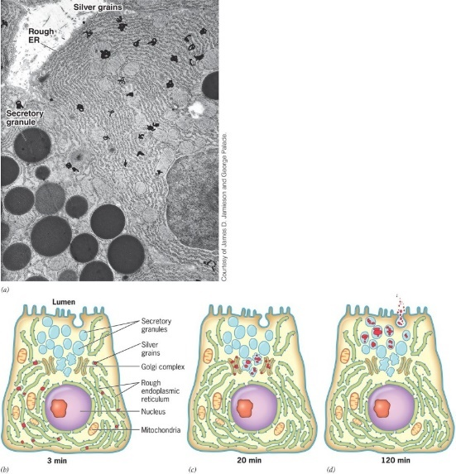
A
7) Lysosomal enzymes are considered as soluble proteins while MPRs are considered as integral proteins: _____
8) This is a low pH (around 5) that causes the MPRs to dissociate from the lysosomal enzymes, in a late endosome : _____
9) A lysosomal enzyme loses its phosphate group before its transport vesicle fuses with a lysosome: _____
10) A lysosome digests only materials that have been incorporated into a cell by phagocytosis: _____
11) A peroxisome can be digested by a lysosome and be recycled by the cell: _____
12) A receptor-down regulation aims at reducing the sensitivity of the cell to furthur stimulation by a hormone: _____
13) In a late endosome, growth factors are internalized into intraluminal vesicles: _____
14) Generally, an early endosome matures into a late endosome: _____
15) A receptor-mediated endocytosis provides animal cells with exogenous cholesterol: _____
16) HDL contains an apolipoprotein A-I: _____
17) In the Niemann-Pick type C disease, a protein required for transferring cholesterol out of a lysosome is missing: _____
18) Unlike LDL, HDL particles carry cholesterol from cells to liver: _____
19) Statins are drugs used to lower HDL level: _____

