BOOK NOTES

3.1 The marketplace – trading

- Matching mechanisms are a form of market in that they bring together suppliers & demanders

- The importance of the marketplace springs from its role as an allocating mechanism
- Elevated prices effectively send a signal to suppliers that the buyers in the market place a high value on the product being traded; conversely when prices are low

- Marketplace is central to the economy we live in
- Not only does it facilitate trade, it also provides a means of earning a livelihood
- Price for a good is inevitably linked to the qty of a good; price & qty are diff sides of the same coin

3.2 The market’s building blocks

- Demand is the qty of a good or service that buyers wish to purchase at each possible price, w/ all other influences on demand remaining unchanged
- .:. it reflects a multitude of values, not a single value
- .:. a full description of the qty of a good or service that buyers would purchase at various prices

- Homogeneous good same product no matter which supplier brings it to the market (ex: cubit foot of natural gas)
- Heterogeneous good varies in size & qty (ex: Airbnb accommodations)

- Supply is the qty of a good or service that sellers are willing to sell at each possible prices, w/ all other influences on supply remaining unchanged

- While the words demand & supply refer to the complete schedules of demand & supply, the terms qty demanded & qty supplied each define a single value of demand or supply at a particular price

- Qty demanded defines the amount purchased at a particular price
- Qty supplied refers to the amount supplied at a particular price

- Ex: qty demanded exceeded the qty supplied at the going price of tickets (when tickets sold out for the hockey game)

Other things equal – ceteris paribus

- The demand & supply schedules rest on the assumption that all other influences on supply & demand remain the same as we move up & down the possible price values

Market equilib

- The equilib price equilibrates the market. It is the price at which qty demanded equals the qty supplied
- Excess supply exists when the qty supplied exceeds the qty demanded at the going price
- Excess demand exists when the qty demanded exceeds the qty supplied at the going price

- Excess supply means that there are suppliers willing to supply at a lower price, & this willingness exerts continual downward pressure on any price above the price that equates demand & supply

- In excess demand, suppliers could force the price upward, knowing that buyers will continue to buy at a price at which the suppliers are willing to sell
- Such upward pressure would continue until excess demand is eliminated

- Qty traded always corresponds to the short side of the market
- The short side of the market determines outcomes at prices other than the equilib

3.3 Demand & supply curves

- The demand curve is a graphical expression of the relationship b/w price & qty demanded, w/ other influences remaining unchanged
- The supply curve is a graphical expression of the relationship b/w price & qty supplied, w/ other influences remaining unchanged

3.4 Non-price influences on demand

- These other influences fall into several broad categories: prices of related goods, the incomes of buyers, buyer tastes, & expectations about the future

The prices of related goods – oil & gas, Kindle & paperbacks

- Substitute goods: when a price reduction/rise for a related product reduces/increases the demand for a primary product, it is a substitute for the primary product
- Complementary goods: when a price reduction/rise for a related product increases/reduces the demand for a primary product, it is a complement for the primary product
- Ex: electricity is a substitute for gas in the power market, whereas a gas furnace is a complement for gas as a fuel

Buyer incomes – which goods to buy

- Demand for most goods increases in response to income increases
- HH incomes may increase either b/c there are more HHs in the economy or b/c the incomes of the existing HHs grow
- An inferior good is one whose demand falls in response to higher incomes
- A normal good is one whose demand increases in response to higher incomes

- The distribution of income can be an important determinant of the demand for many commodities & services

Expectations – betting on the future

- If HHs expected that the price of natural gas was going to stay relatively low for many years, then they would be tempted to purchase a gas burning furnace rather than an oil burning furnace
- .:. the prices that are expected to prevail in the future also determine current demand
- Expectations are particularly important in stock markets

Shifts in demand

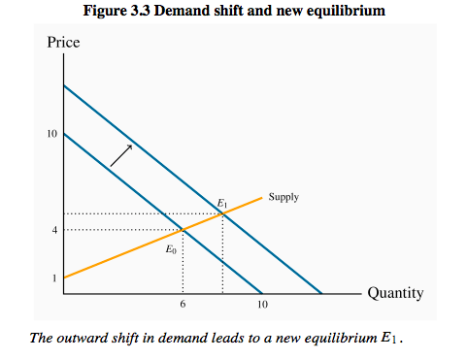

- The new equilib reflects a change in qty supplied & a change in demand

- Variations in price are what equilibrate the market
- That’s why we use price & qty in diagrams
- By focusing primarily upon the price, we see the self-correcting mechanism by which the market reacts to excess supply or excess demand

- Comparative static analysis compares an initial equilibrium w/ a new equilibrium, where the difference is due to a change in 1 of the other things that lie behind the demand or supply curve
- .:. we compare 1 outcome w/ another, w/out being concerned too much about the transition from an initial equilibrium to a new equilibrium

3.5 Non-price influences on supply

- Only the more efficient producers can make a profit at a low price

- Other influences that underlie supply curves: technology, input costs, prices of competing goods, expectations, & # of suppliers

Technology – computers & fracking

- A technological advance may involve an idea that allows more output to be produced w/ the same inputs, or an equal output w/ fewer inputs
- Ex: Just in time technology
- Development of fracking means that companies involved in gas recovery can now do so at a lower cost
- Hence they are willing to supply any given qty at a lower price

Input costs – green power

- Ex: a wage negotiation that grants workers a substantial pay raise will increase the cost of production
- .:. leftward shift of supply
- Green energy is expensive .:. if used the supply curve will shift left

Competing products – Airbnb versus hotels

- If competing products improve in quality or fall in price, a supplier may be forced to follow suit
- The arrival of new products in the marketplace also impacts the willingness of suppliers to supply goods at a given price

Shifts in supply

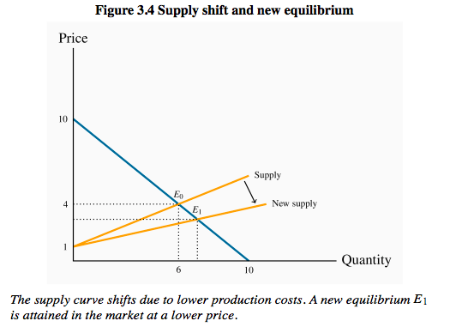

3.6 Simultaneous supply & demand impacts

- Vertical curves mean that a fixed # of homeowners decide to put their homes on the market, & these suppliers just take wtv price results in the market
- HH incomes increased & mortgage rates fell .:. demand curve goes right

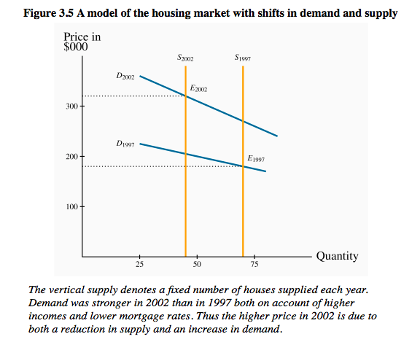

3.7 Market interventions – govs & interest groups

- Price controls are gov rules or laws that inhibit the formation of market-determined prices
- Quotas are physical restrictions on output
- Price controls come in the form of either floors or ceilings
- Price floors are frequently accompanied by marketing boards

Price ceilings – rental boards

- Ceilings mean that suppliers cannot legally charge more than a specific price
- Limits on apartment rents are 1 form of ceiling
- Prob w/ price ceilings = leave demand unsatisfied & .:. must be accompanied by some other allocation mechanism

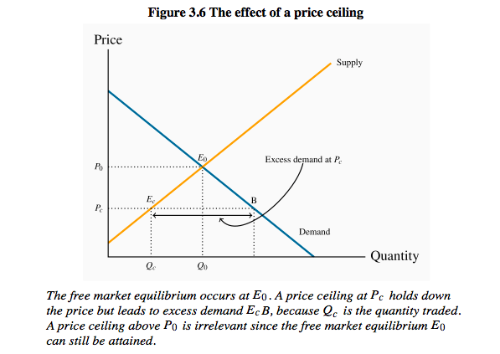

- Landlords tend not to repair or maintain their rental units in good condition if they cannot obtain the rent they believe they are entitled to
- Residential rental stock deteriorates
- Builders realize that more money is to be made in building condos than rental units
- .:. frequent consequence is thus a reduction in supply & a reduced quality
- These outcomes are examples of what we call the law of unintended consequences

Price floors – minimum wages

- Seen as a way of protecting the well-being of low-skilled workers
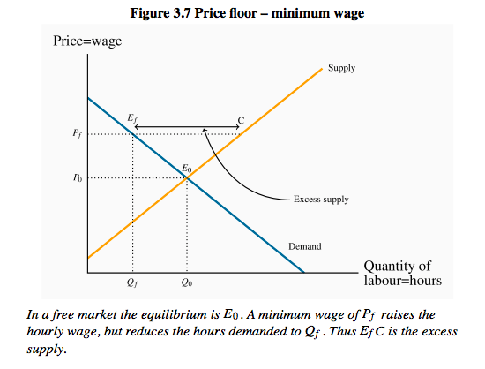

- Note the similarity b/w the outcomes defined in the floor & ceiling cases: the qty actually traded is the lesser of the supply qty & demand qty at the going price: The short side dominates
- This is the trade off that govs face: w/ a view to increasing the purchasing power of generally low-skilled individuals, a minimum wage is set, hoping that the negative impact on employment will be small

Quotas – agricultural supply

- It is a means of keeping prices higher than the free-market equilibrium price
- As an alternative to imposing a price floor, the gov can generate a high price by restricting supply

- Agricultural markets abound w/ examples
- In these markets, farmers can supply only what they are permitted by the quota they hold, & there is usually a market for these quotas
- Canadian cheese importers must pay for the right to import cheese from abroad
- The impact of all of these restrictions is to raise the domestic price above the free market price

- Fig 3.8, from the standpoint of farmers, a higher price might be beneficial, even if they get to supply a smaller qty, provided the amount of rev they get as a result is as great as the rev in the free market
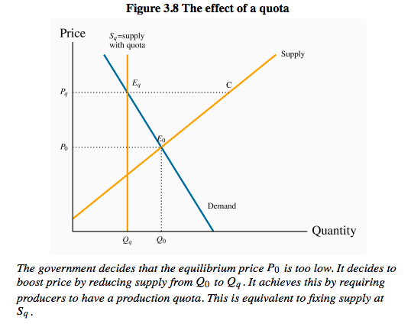

Marketing boards – milk & maple syrup

- A marketing board is a means of insuring that a quota or price floor can be maintained
- Quotas are frequent in the agriculture sector of the economy
- This system of quotas is necessary to eliminate the excess supply that would emerge at the above-equilibrium price P_{q}

3.8 Individual & market functions

- Markets are made up of many individual participants on the demand & supply side

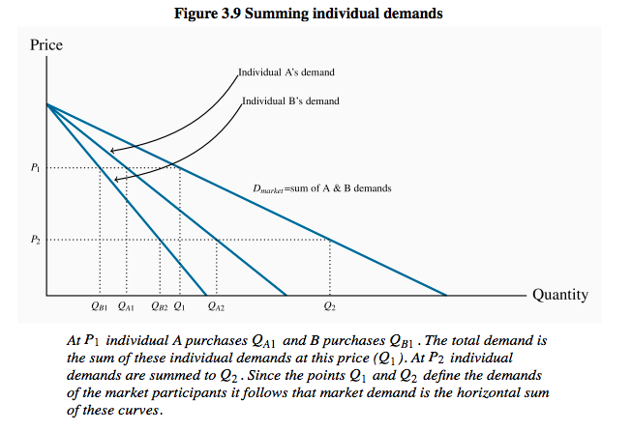

- The market demand indicates how much they buy together at any price
- Market demand: the horizontal sum of individual demands

3.9 Useful techniques – demand & supply equations

- A straight line is represented completely by the intercept & slope

REVIEW QUESTIONS

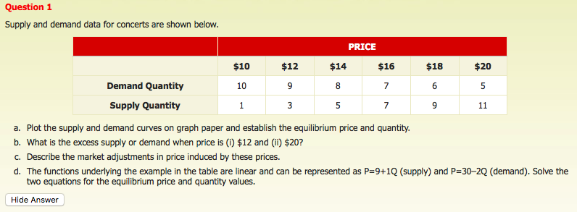
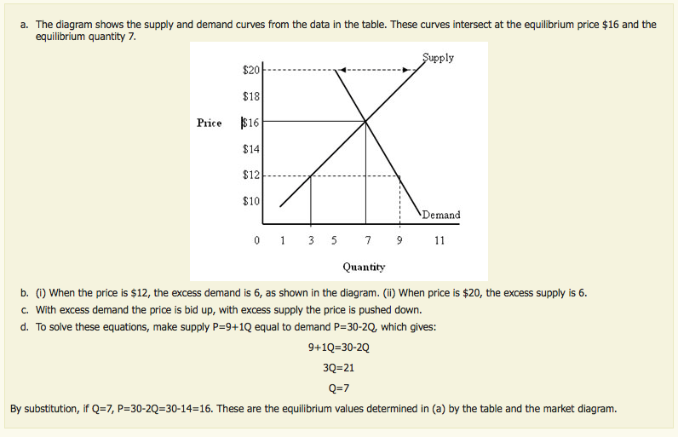

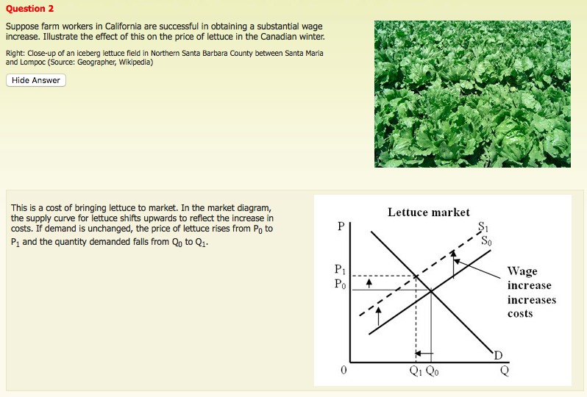

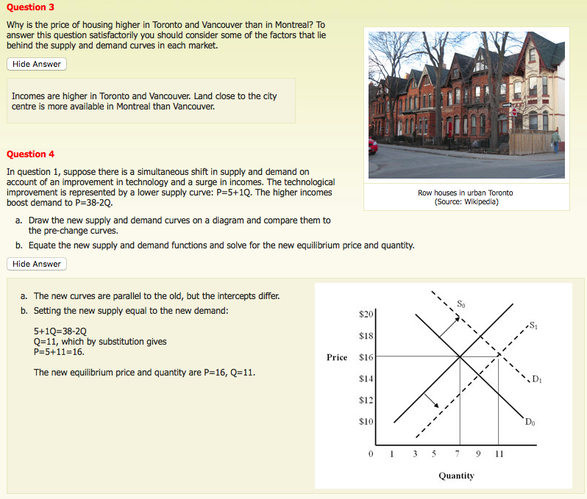

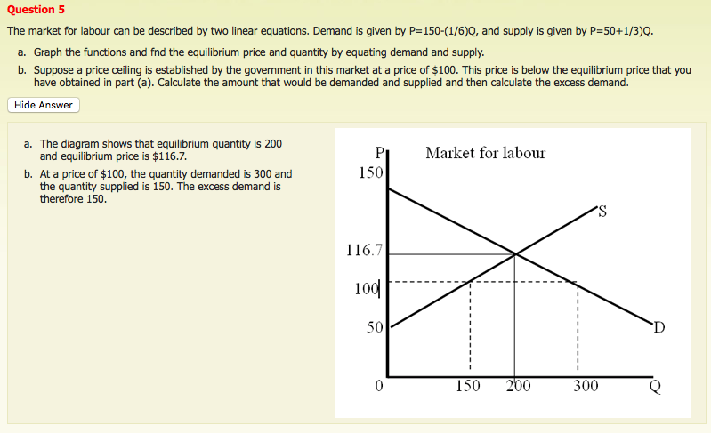

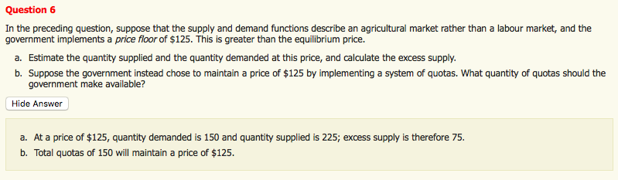

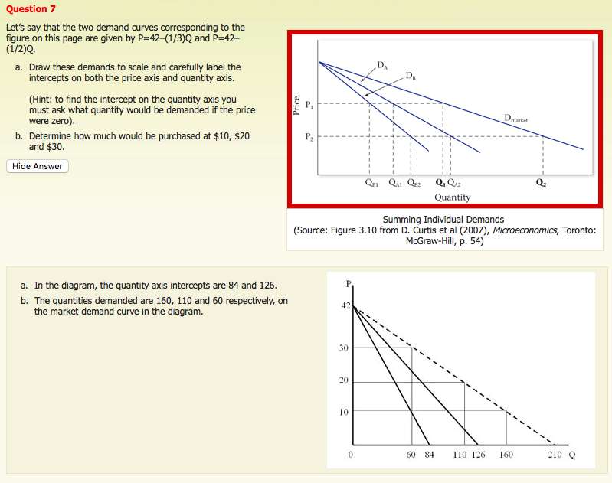

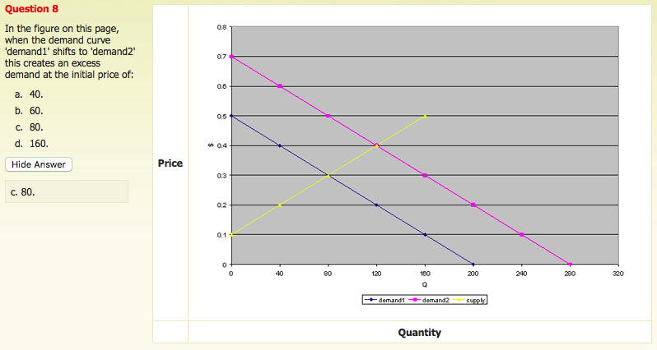

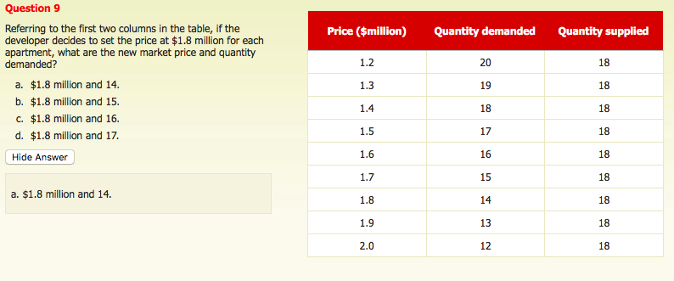

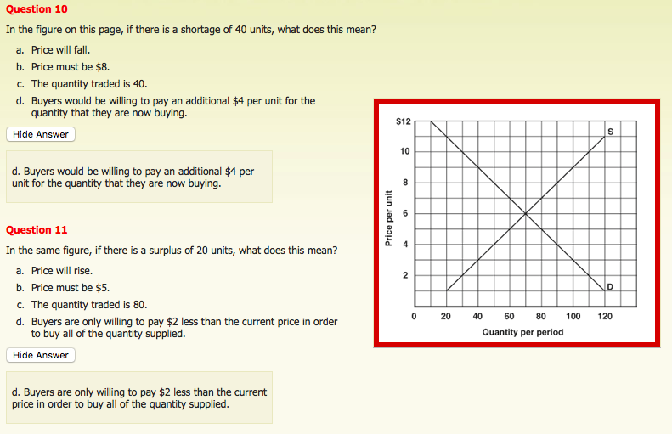

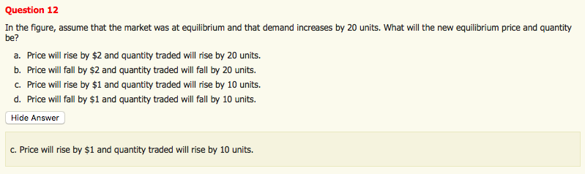

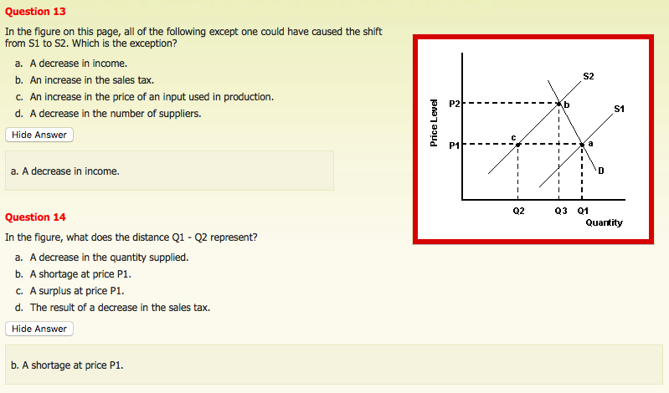

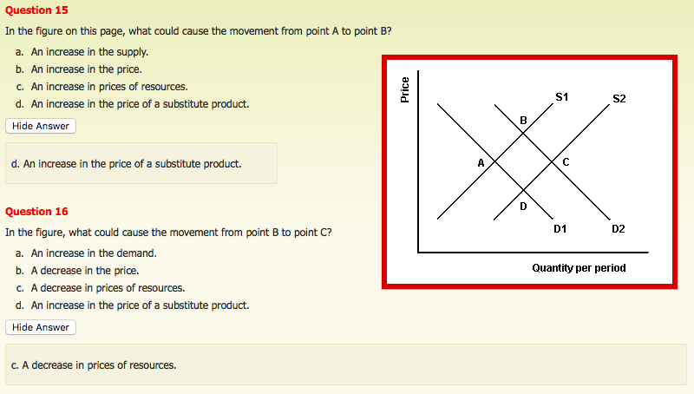

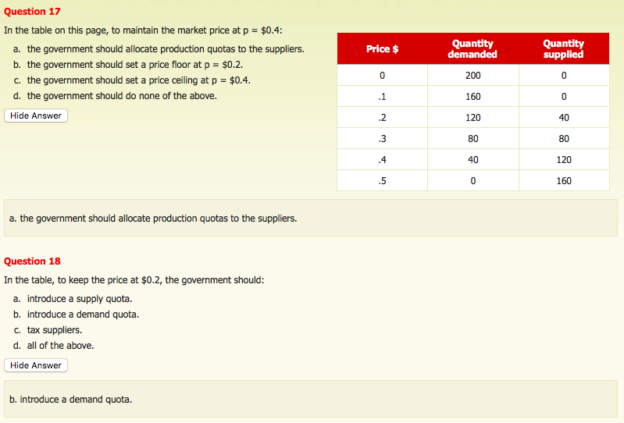

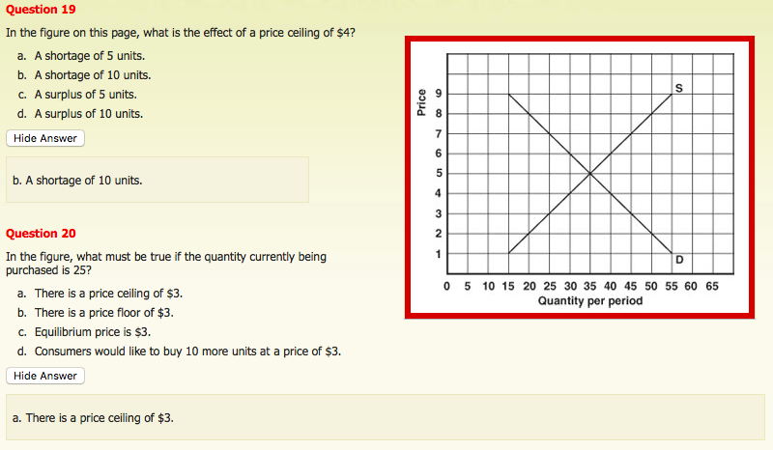

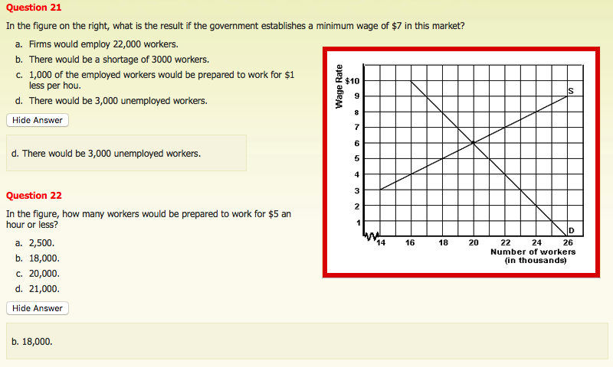

SELF-ASSESSMENT

- When a market is in equilib:
- No shortage exists
- Qty demanded equals qty supplied
- A price is established that clears the market
- All of the above

- The supply curve:
- Shows the qty supplied at each specific price
- Slopes downward
- Shows the positive relationship b/w price & qty supplied
- A & C

- All of the following statements are incorrect except:
- When a market is in equilibrium, there may be either excess demand or excess supply
- When a market is in equilibrium, buyers are happy b/c price is low
- When a market is in equilibrium, both excess demand & excess supply are zero
- When a market is in equilibrium, sellers are happy b/c price is high

- All of the following are incorrect except:
- The amount of goods bought always equals the amount sold
- Demand always equals supply
- Qty demanded always equals qty supplied
- The price paid by buyers of a good is always lower than that received by sellers

- Other things being equal, when the price of a good increases, we would expect: qty supplied to increase

- When we study the qty demanded of a good & invoke the “other things being equal” assumption, we assume all of the following are constant except the: price of the good itself

- A negative relationship exists b/w changes in price &: qty demanded

- The demand curve for a good slopes downward & to the right b/c when the price of the good falls: consumers substitute the relatively lower-priced good for the now more expensive goods

- If goods J & K are substitutes, an increase in the price of J causes: a decrease in qty demanded for J & an outward shift of K’s demand curve

- 2 goods are complements if:
- A decrease in the price of 1 causes more of the other to be consumed
- They are consumed together
- An increase in the price of 1 causes less of the other to be consumed
- All of the above

- All of the following will cause the demand curve to shift to the left except:
- A reduction in income if the good is normal
- An increase in the price of a complementary good
- An increase in the price of a substitute good
- An increase in income if the good is inferior

- When the price of a good rises, consumers reduce the qty if the good demanded in a given time period b/c: substitute goods become relatively cheaper

- Assuming that peanut butter & jam are complementary goods, an increase in the price of peanut butter will cause: a decrease in the demand for jam

- A downward sloping demand curve for beef means that: as the price of beef rises, consumers substitute other meats for beef, & as the price of beef falls, consumers substitute beef for other goods

- An improvement in overall technology that allows more output to be produced w/ the same level of inputs causes: a rightward shift of the supply curve so that more is offered for sale at every price

- If South Carolina experiences a late frost that damages the state’s peach crop, then we would expect: the price of nectarines, a substitute fruit, to rise

- An increase in both demand & supply causes an: increase in equilibrium qty & either an increase or decrease in equilibrium price

- What do economists mean when they speak of price as a rationing mechanism? That shortages of goods in the market price will disappear as a result of price rising which results in the qty demanded decreasing

- The market demand is obtained by: taking the horizontal sum of individual demands

- Given the following supply curves for the only 2 producers in a market: P=2+0.01q & P=2+0.02q, the total supplied when the price is $5 is: 450

