BOOK NOTES

2.1 Data analysis

- The analysis of behaviour necessarily involves data
- Variables: measures that can take on diff values
- The interest rate on a student loan, for ex, is a variable w/ a certain value at 1 point but perhaps a diff value at an earlier or later date
- Economic theories & models explain the causal relationships b/w variables
- In contrast, Data: recorded values of variables
- Sets of data provide specific values for the variables we want to study & analyze
- The economist’s task is to distinguish b/w coincidence & economic causation
- Once specified on the basis of economic logic, a model must be tested to determine its usefulness in explaining observed economic events

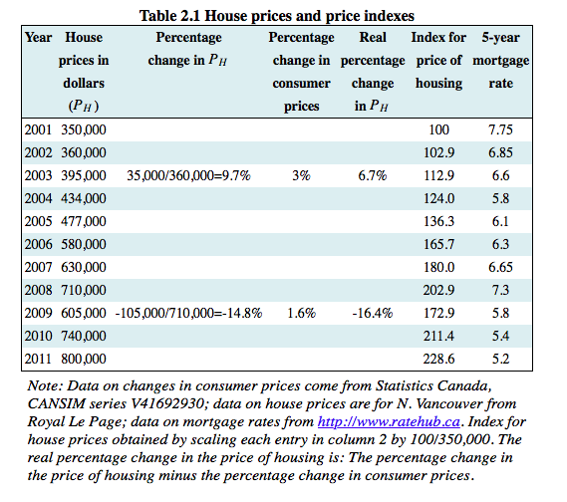

Data types

- Data come in several forms
- Time-series: a set of measurements made sequentially at diff points in time
- High/low frequency data: series w/ short/long intervals b/w observations
- In contrast to time-series = cross-section
- Cross-section data: values for diff variables recorded at a point in time
- Repeated cross-section data: cross-section data recorded at regular or irregular intervals
- Longitudinal data: follow the same units of observation through time

Graphing the data

- Data can be presented in graphical as well as tabular form
- The graphical presentation of data simply provides a visual rather than numeric perspective
- Using diff scales when plotting data or constructing diagrams can mislead the unaware viewer

Percentage changes

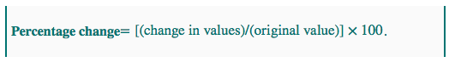

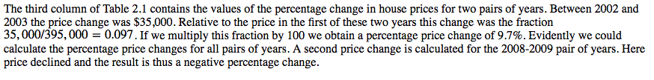

Consumer prices

- Consumer price index: the ave PL for consumer goods & services
- Inflation/deflation rate: the annual percentage increase/decrease in the level of consumer prices
- Real price: the actual price adjusted by the general (consumer) PL in the economy

Index #s

- Index #: value for a variable, or an ave of a set of variables, expressed relative to a given base value
- Index #s simplify the interpretation of data

2.2 Data, theory, & economic models

- To summarize the relationship b/w these variables, the pattern suggests that a straight line through the scatter plot would provide a reasonably good description of the relationship b/w these variables
- Obviously it is important to define the most appropriate line–1 that fits the data well
- The way have drawn through the data points is informative, b/c it relates the 2 variables in a quantitative manner
- Straight line = unchanging slope
- Regression line: representation of the ave relationship b/w 2 variables in a scatter diagram

2.3 Ethics, efficiency, & beliefs

- Positive economics studies objective or scientific explanations of how the economy functions
- Its aim is to understand & generate predictions about how the economy may respond to changes & policy initiatives
- Normative economics offers recommendations that incorporate value judgements

- Scientific research can frequently resolve differences that arise in positive economics–not so much in normative economics
- If we claim that “the elderly have high medical bills, & the gov should cover all of the bills,” we are making both a positive & normative statement
- Positive economics does not attempt to show that 1 of these views is correct & the other false
- The views are based on value judgements, & are motivated by a concern for equity
- Economic equity is concerned w/ the distribution of well-being among members of the economy
- Equity is a vital guiding principle in the formation of policy & is frequently, though not always, seen as being in competition w/ the drive for economic growth
- Equity is driven primarily by normative considerations

- Conservative economists see a smaller role for gov than left-leaning economists

Revisiting the definition of economics–core beliefs

- Economics is a set of ideas & methods for the betterment of society
  - 1st of all we believe that markets are critical b/c they facilitate exchange & .:. encourage efficiency
  - Specialization & trade creates benefits for the trading parties
  - Frequent complaint against trade is that its modern-day form (globalization) does not benefit the poor
  - From this perspective, most of the gains from trade go to the western consumers & capitalists, come at the expense of jobs to western workers, & provide Asian workers w/ meagre rewards

  - Incentives matter
  - Economists believe strongly that the price mechanism influences behaviour, & .:. favour the use of price incentives in the marketplace & public policy more generally

  - Importance of the rule of law,
  - Legal institutions that govern contracts are critical to the functioning of an economy
  - If goods & services are to be supplied in a market economy, the suppliers must be guaranteed that they will be remunerated
  - & this requires a developed legal structure w/ penalties imposed on individuals or groups who violate contracts
  - Markets alone will not function efficiently
  - Modern development economics sees the implementation of the rule of law as perhaps the central challenge facing poorer economies
  - There is a strong correlation b/w economic growth & national wealth on the 1 hand, & an effective judicial & policing system on the other

  - Finally, economists believe in the centrality of gov
  - Govs can solve a # of probs that arise in the market economies that cannot be addressed by the private market place
  - Ex: govs can best address the potential abuses of monopoly power
  - Govs are also best positioned to deal w/ environmental or other types of externalities–the impact of economic activity on sectors of the economy that are not directly involved in the activity under consideration
- Summary, govs have a variety of roles to play in the economy
- These roles involve making the economy more equitable & more efficient by using their many powers

REVIEW QUESTIONS

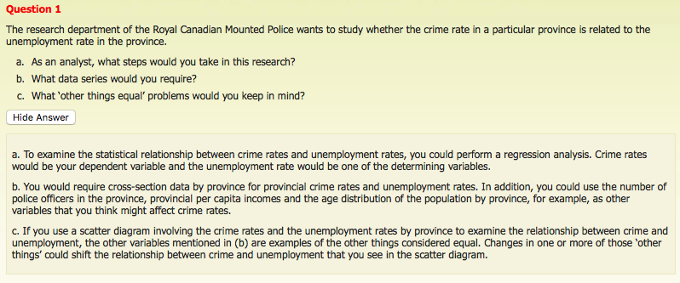

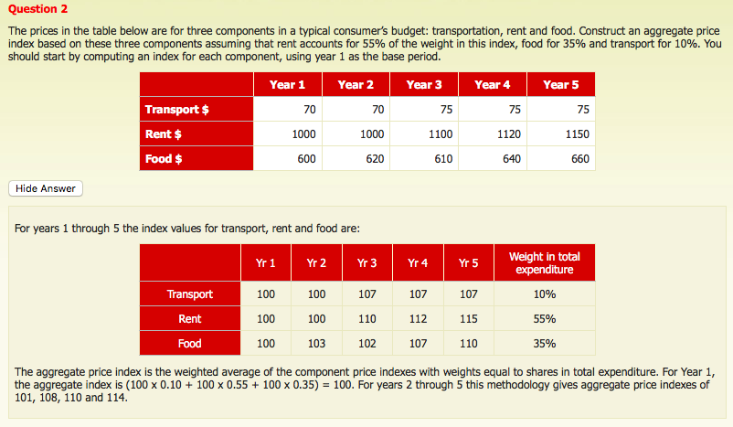

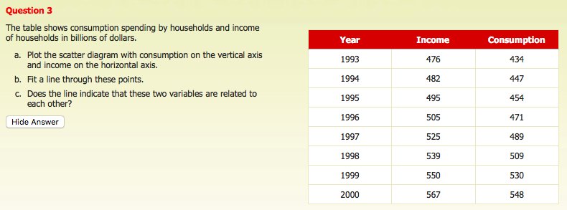

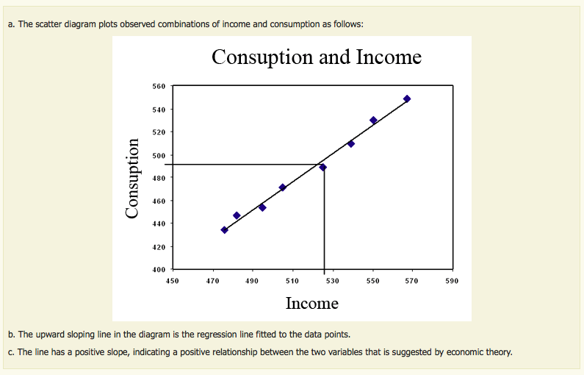

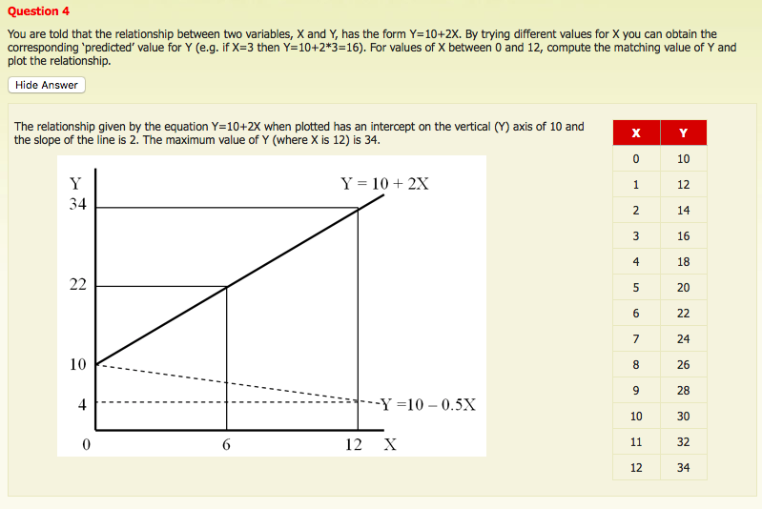

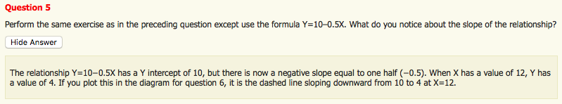

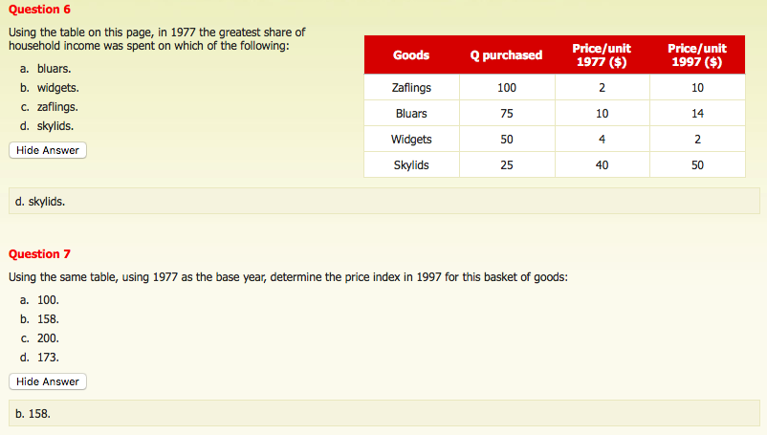

SELF-ASSESSEMENT

- What do economists always do when they are constructing theories or models? They make simplifying assumptions

- The primary reason why economists use models in their analysis is b/c a model: helps organize & clarify the thinking process about an issue

- When specifying economic models, economists often make assumptions about the real world. The purpose of assumptions in economics is to: simplify the model & provide a primary focus for the theory

- Time-series data: measure a variable or variables at diff points in time

- Data that follow the same individuals over time are called: longitudinal data

- A basket of goods in 1987 cost $783, while the value of the same basket in 1997 was $1133. The value of this price index in 1997, based on 1987=100, was: 144.7

- The weights used in the consumer price index: show the relative importance of the prices of the diff components in the HH’s expenditures

- If the CPI for 2005 was 284.1, & economists predicted an inflation rate of 3.5% for 2006, the predicted CPI at the end of 2006 was: 294.1

- Adjusting for changes in prices allows us to: derive a real value from a nominal value

- The nominal value of an economic variable is: expressed in current dollar terms

- If you earn a salary of $24,000 & the CPI is 300 (1970=100), then the real value of your income, expressed in 1970 dollars is: 8,000

- Suppose that the CPI has a value of 87 (1980=100) for 1987. This means that: on ave, prices fell by 13% since 1980

- Suppose that in 2006, the CPI was 285 (1982=100). This index shows that the real value of a dollar in 2006: was much less than it was in 1982

- Economic models claim to be: reasonable abstractions of how ppl make choices, highlighting the most important factors

- X

- X

- X

- When a negative relationship exists b/w x & y: an increase in x results in a decrease in y

- The reason that economists often use a scatter diagram in their analysis is that: it reveals whether there may be an obvious relationship b/w 2 variables

