BOOK NOTES

  - What’s it all about?

The big issues

- Economics is the study of human behaviour
- Since it uses scientific methods it is called a social science
- We study human behaviour to better understand our world

- Inference & policy recommendations based on earlier theories, observations, & institutional structures require constant analysis & updating if they are to furnish valuable responses to changing conditions & probs

- Much of today’s developed world still faces severe challenges as a result of the financial crisis that began in 2008
- Unemployment rates among young ppl are at historically high levels in several economies, many gov balance sheets are in disarray, & inequality is on the rise
- World simultaneously faces structural upheaval: Overpop, climate change, political instability & globalization challenge us to understand & modify our behaviour

- Literacy rates have been rising dramatically in the developing world for decades; child mortality has plummeted; family size is a fraction of what it was 50 yrs ago; prosperity is on the rise in much of Asia; life expectancy is increasing universally & deaths through wars are in a state of long-term decline

- Macroeconomics: the study of the economy as a system in which interactions & feedbacks among sectors determine national output, employment, & prices

Individual behaviours

- Microeconomics: the study of individual behaviour in the context of scarcity
- Not all individual behaviour are motivated by self-interest; many are motivated by a concern the well-being of society-at-large
- Microeconomics is also about how we choose to spend our time & money
- B/c both time & income are limited we cannot do all things all the time
- Critically, microeconomics seeks to understand & explain how we make choices & how those choices affect our behaviour in the workplace, the marketplace, & society more generally

- A critical element in making choices is that there exists a scarcity of time, income, or productive resources
- Decisions are invariably subject to limits or constraints, & it is these constraints that make decisions both challenging & scientific

- In the micro-level behaviours the decision makers have a common goal: To do as well as they can, given the constraints imposed by the operating environment

Markets & gov

- Markets play a key role in coordinating the choices of individuals w/ the decisions of business
- In modern market economies goods & services are supplied by both business & gov
- Mixed economy: goods & services are supplied both by private suppliers & gov

- The market allows for specialization & specialization b/w production & use
- If businesses can produce food more cheaply than individuals the individual obviously gains from using the market–by both having the food to consume, & additional income w/ which to buy other goods & services

- Govs supply goods & services for ex health & education
- The provision of law & order, through our legal system broadly defined, represents more than a commitment to a just society at the individual level; w/out a legal system that enforces contracts & respects property rights, the private sector of the economy would diminish dramatically as a result of corruption, uncertainty & insecurity

  - Understanding through the use of models

- Model: a formalization of theory that facilitates scientific enquiry
- In short, models are frameworks we use to organize how we think about a prob
- Theory: a logical view of how things work, & is frequently formulated on the basis of observation

  - Opportunity cost & the market

- Opportunity cost: what must be sacrificed when a choice is made
- That cost may be financial; it may be measured in time, or simply the alternative foregone
- It is precisely b/c individuals & organizations have diff opportunity costs that they enter into exchange agreements
- You each specialize in the performance of specific tasks as a result of having diff opportunity costs or diff efficiencies

  - A model of exchange & specialization

Production & specialization

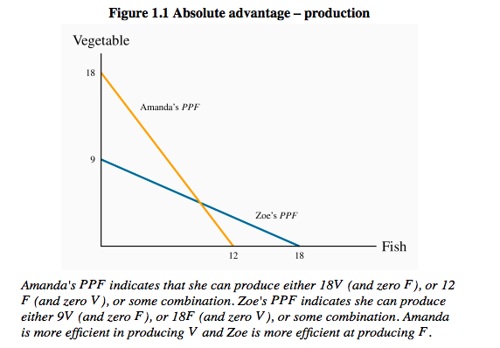

- Production possibility frontier (PPF): the combination of goods that can be produced using all of the resources available

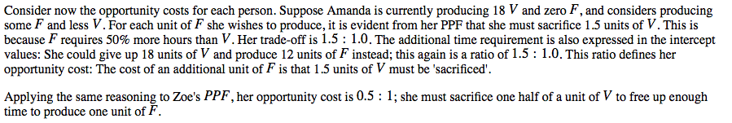

The gains from exchange

- Consumption possibility frontier (CPF): the combination of goods that can be consumed as a result of a given production choice

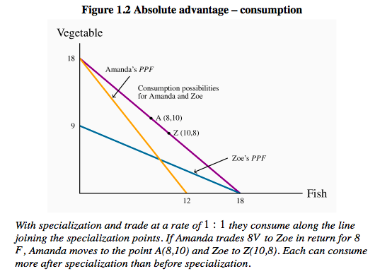

- A zero-sum game is an interaction where the gain to 1 party equals the loss to another party

  - Economy-wide production possibilities

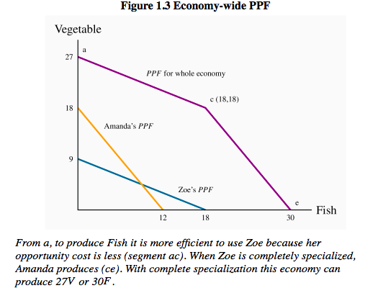

- Economy-wide PPF: the set of goods & services combinations that can be produced in the economy when all available productive resources are in use
- Since this has an outward kink, we call it concave

- It is still possible that the economy’s producers might work some additional time in exceptional circumstances, & this would increase total production possibilities
- This event would be represented by an outward mvmt of the PPF

  - Aggregate output, growth, & business cycles

- The PPF can be used to illustrate several aspects of macroeconomics: in particular, the level of an economy’s output, the growth of national & per capita output over time, & SR business-cycle fluctuations in national output & employment

Aggregate output

- The productivity of labour depends on:
  - Skill, knowledge, & experience of the LF
  - Capital stock
  - Current state of technology
- The productivity of labour is the output of goods & services per worker
- An economy’s capital stock is the buildings, machinery, equipment & software used in producing goods & services
- Y= economy’s output

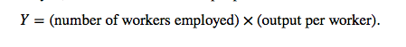

- Full employment is when everyone willing to work at current wage rates & normal hrs of work is working, Y_{c}
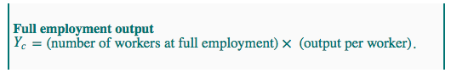

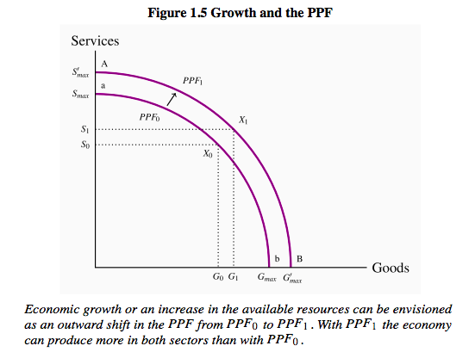

- An aggregate economy produces a large variety of outputs in 2 broad categories
- Goods are the products of the agriculture, forestry, mining, manufacturing & construction industries
- Services are provided by the wholesale & retail trade, transportation, hospitality, finance, health care, education, legal, & other service sectors
- High income economies spend more on services than goods & produce higher ratios of services to goods
- Middle income countries produce lower ratios of services to goods, & low income countries much lower ratios of services to goods

Economic growth

- 3 things contribute to growth in the economy
- The labour supply grows as the pop expands; the stock of capital grows as spending by business (& gov) on buildings, machinery, info tech & so forth increases; & LF productivity grows as a result of experience, the development of scientific knowledge combined w/ product & process innovations, & advancements in the tech of production
- Combined, these developments expand capacity output over time

- But improvements in standards of living require more than growth in total output
- Increases in output per worker & per person are necessary
- Sustained increases in living standards require sustained growth in labour productivity, which in turn is based on advances in tech along w/ the amount of capital each worker has to work w/

Recessions & booms

- Prime objective of economic policy is to ensure that the economy operates on or near the PPF–it should use its resources to capacity & have minimal unemployment
- An economic recession occurs when output falls below the economy’s capacity output
- A boom is a period of high growth that raises output above normal capacity output

Macroeconomic models & policy

- The PPF diagrams illustrate the main dimensions of macroeconomics: Capacity output, growth in capacity output & business cycle fluctuations in actual output relative to capacity

REVIEW QUESTIONS

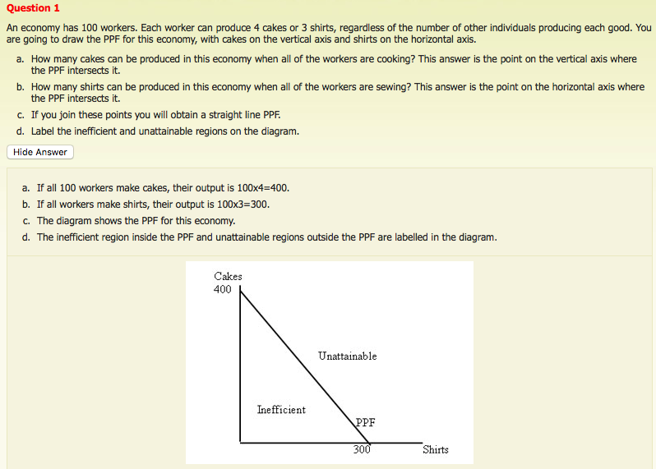

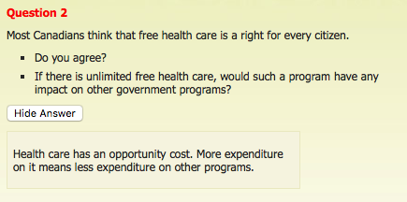

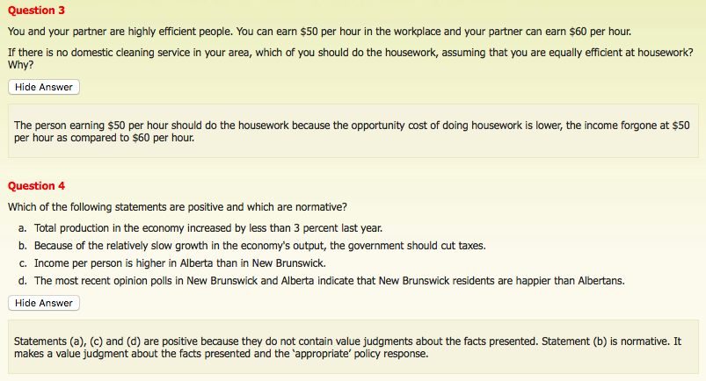

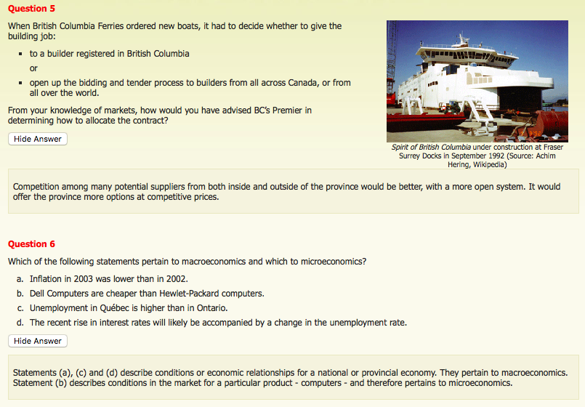

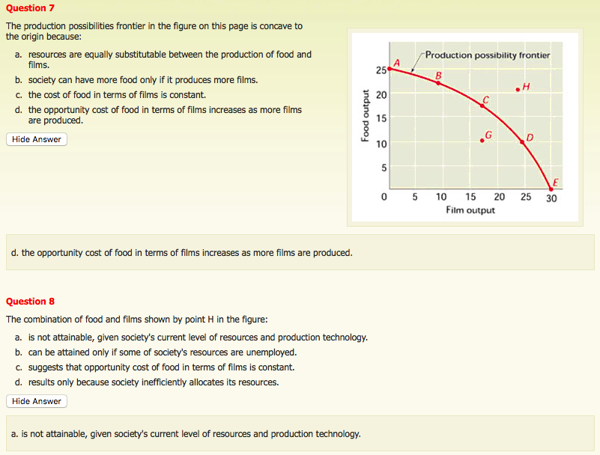

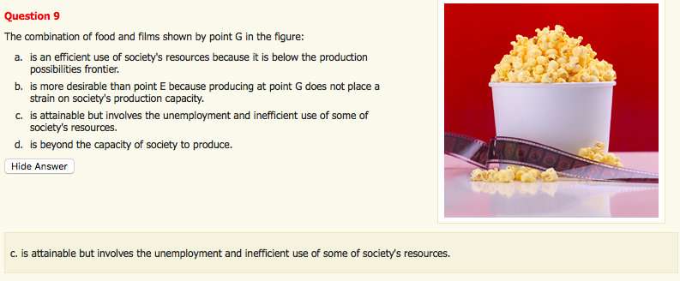

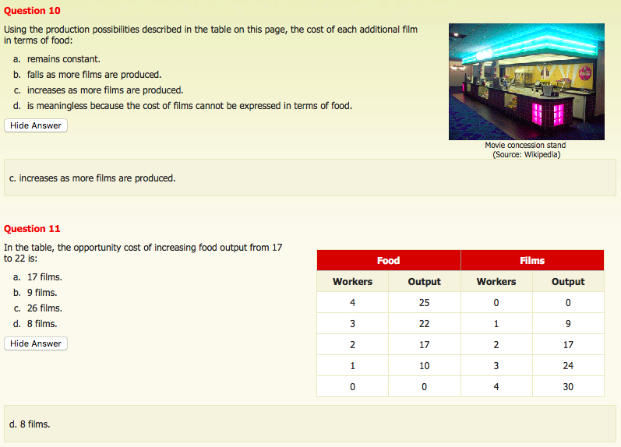

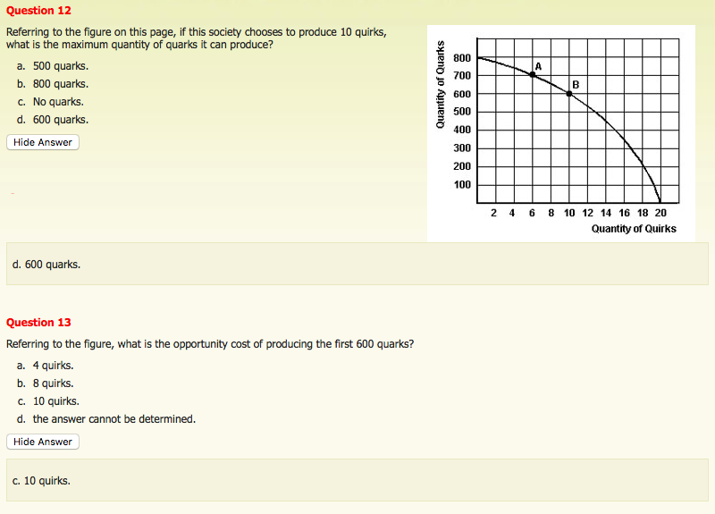

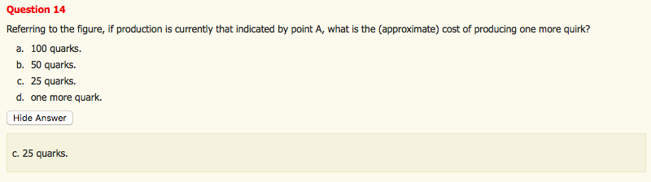

SELF-ASSESMENT

- All of the following statements, except 1, are valid examples of the way economists use the term “scarcity.” Which is the exception?
- HHs face a scarcity of income
- Individuals face a scarcity of time
- Economies face a scarcity of resources
- The world faces a scarcity of ideas

- Which of the following would not promote economic growth w/in a society?
- Increasing the skill level of the workforce
- An increase in technological expertise
- More ppl looking for jobs than there are jobs available
- An increase in the stock of machines & productive equipment

- Which of the following statements is correct for a society that emphasizes the production of capital goods over consumer goods?
- The society could enjoy the same qty of capital goods & a larger qty of consumer goods in the future
- The society would have to save more now than a society that did not emphasize the production of capital goods
- The society will grow faster than a society that emphasizes the production of consumer goods
- All of the above

- The opportunity cost of producing an extra apple is: what must be given up in order to produce the extra apple

- When economists say there is no such thing as a free lunch, they mean that: every choice we make involves a trade-off

- Forest is a mountain man living in complete isolation in the Yukon. He is self-sufficient through hunting, fishing, & farming. He has not been in the city to buy anything in 5 years. .:. : the scarcity prob still applies b/c more hunting means less fishing & so on

- W/ ATM machines it is possible to retrieve cash from the bank at any time. 100 yrs ago, 1 could only get cash from the bank during business hrs. The difference is b/c: the cost of providing 24-hr-a-day service is much lower today

- Amy is thinking about going to the movies tonight. A ticket costs $7 & she will have to cancel her-baby-sitting job that pays $30. The cost of seeing the movie is .:. : $37

- When considering an economy producing only 2 goods, economic growth can be illustrated by: an outward shift of its production possibilities frontier

- All of the following conditions will cause an outward shift of the production possibilities frontier except:
- An improvement in the overall tech of production
- Existing factors of production become more productive
- The qty of the factors of production increases
- Previously unemployed factors of production are put back to work

- Most real world economic systems are: mixed economic systems

- All of the following statements are false except:
- Normative economic statements are statements of fact
- In positive economics, we are detached scientists & personal values do not enter our description of economic events
- “The unemployment rate for Sept, 1987 was 5.9%” is a normative statement
- “The gov should provide a minimum income to every citizen” is a positive statement

- The propositions that emerge from positive economics can generally be supported or refuted: by facts

- Microeconomics best describes the study of the: behaviour of individual economic agents

- Macroeconomics is distinguished by its concentration on: the performance of national economies & ways to improve upon their performances

