Midterm 1 ENGR-242 (ch. 1-3.4)
Review:
- Dot product:
  - Multiply each component then add all together.
    - Ex: u*v= (u1v1+u2v2+u3v3)=____(this will be a number not a vector).
- u*v = ||u||||v||cosθ if u,v≠0 and θ is the angle between the vectors.
  - θ=cos⁻¹(u*v/||u||||v||)
  - u*v >0, θ =acute angle
  - u*v <0,θ=obtuse angle
  - u*v=0 then u┴v
  - u*v=1 then u is parallel to v
- ||u||=$\sqrt{({u_{1}}^{2}+{u_{2}}^{2}+{u_{3}}^{2}) }$ this is the magnitude or norm of a vector

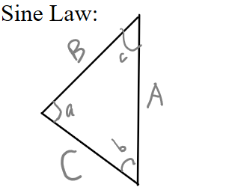
Cosine rule:
$$\frac{A}{\sin\left(a\right)}=\frac{B}{\sin\left(b\right)}=\frac{C}{\sin\left(c\right)}$$
$C=\sqrt{A^{2}+B^{2}-2ABcos(c)}$
$A=\sqrt{C^{2}+B^{2}-2ACcos(a)}$
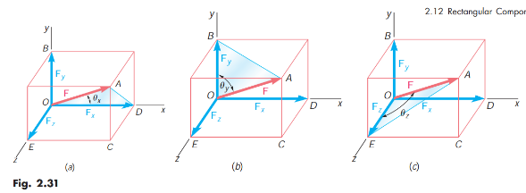
$B=\sqrt{A^{2}+C^{2}-2ACcos(b)}$
Finding a Force vector knowing only two points on its line and its magnitude:
F =||F||*λ where λ is $\frac{\underline{AB}}{\left|\left|\underline{AB}\right|\right|}$
AB is a vector along the same line of action as F

$$F_{x}=Fcosθ_{x}, F_{y}=Fcosθ_{y}, F_{z}=Fcosθ_{z}$$

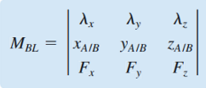
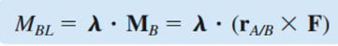
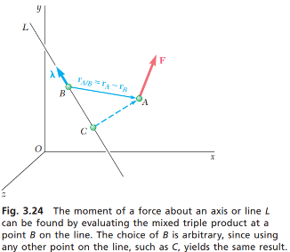
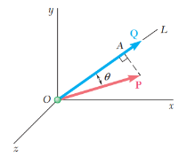
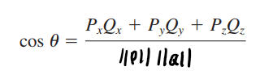
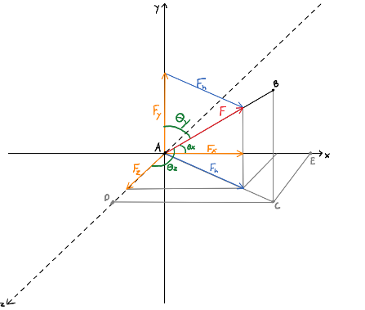
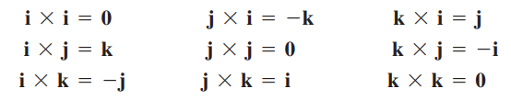
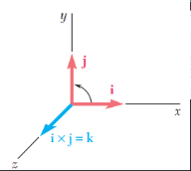
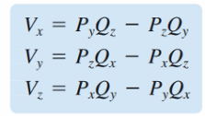
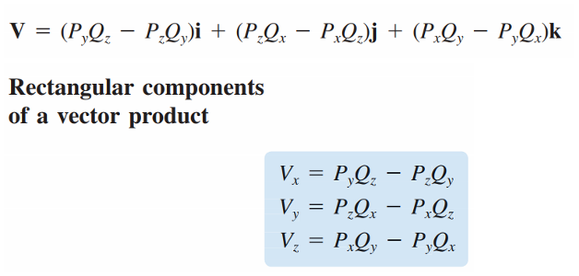
Cross product:

Projections:
Of a Force Vector on an axis OL: P_{OL}=Pλ
Of a Moment vector on an axis BL:

Angle between two vectors:
F_{h}=Fsinθ_{y} $\frac{F}{F_{h}}=\frac{AB}{AC}$
F_{x}=F_{h}cosθ_{x}
F_{z}=F_{h}cosθ_{z} = F_{h} sinθ_{x}
$\frac{F_{x}}{F_{h}}=\frac{AE}{AC} and \frac{F_{z}}{F_{h}}=\frac{AD}{AC}$
Use similar triangles
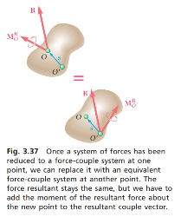
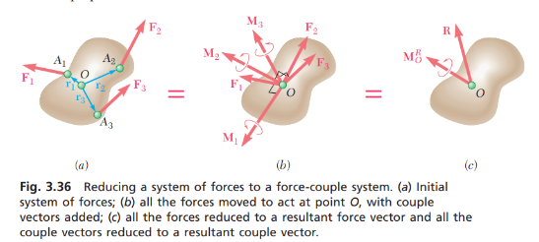
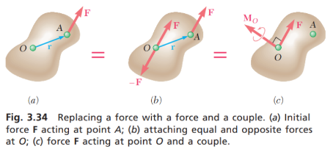
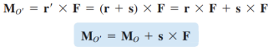
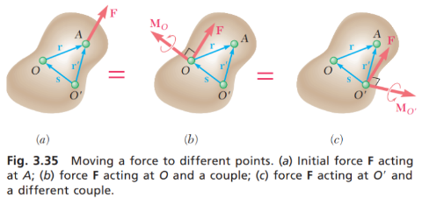
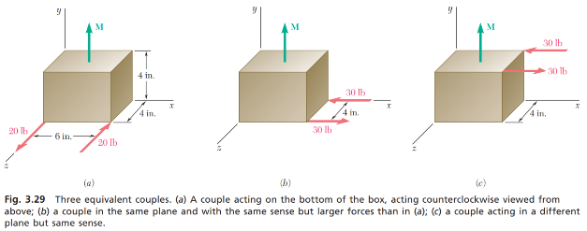
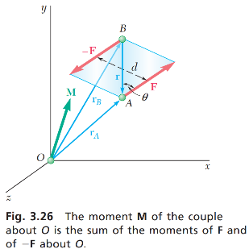
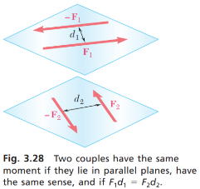
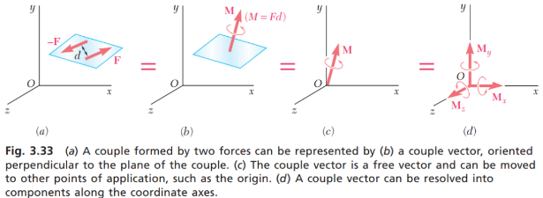
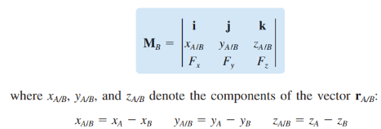
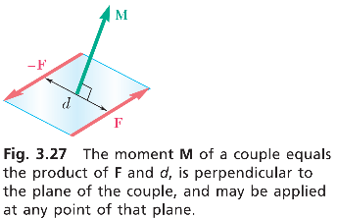
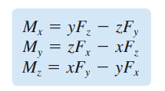
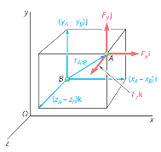
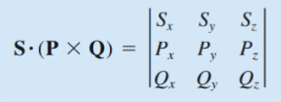
Resultant of Parallel Forces
Reduction of Coplanar Forces
Reducing a System of Forces to a Force-Couple System

This helps us with the next section (seen below)
Moment of a couple

Equivalent couples

Moment:

M=r × F=d*F=F*r*sinθ
Scalar triple product:
S *(P×Q)=S_{x}(P_{y}Q_{z}-P_{z}Q_{y})+S_{y}(P_{z}Q_{x}-P_{x}Q_{z})+S_{z}(P_{x}Q_{y}-P_{y}Q_{x})

\ S(PxQ)=-S(QxP)=Q(SxP)=P(QxS)

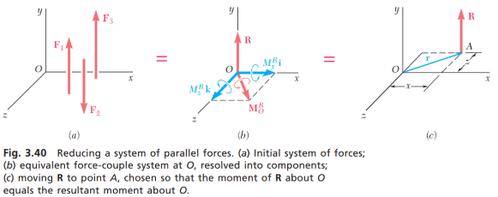

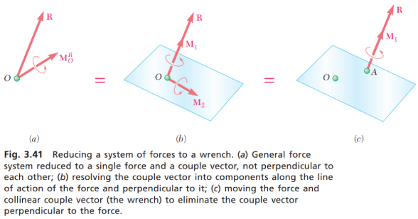
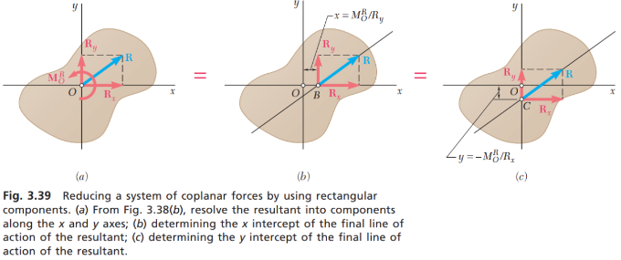
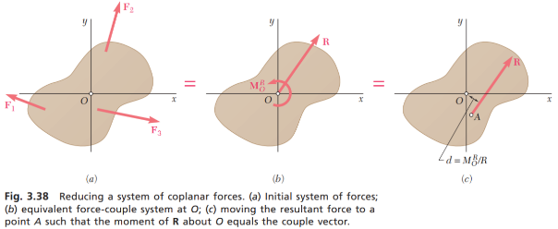
The previous reductions are only possible if the moments and the forces are perpendicular. To solve when they aren’t, split them into perpendicular components.
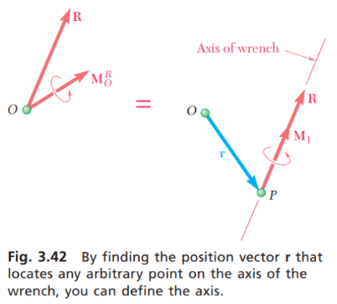
Wrench

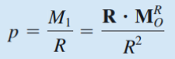

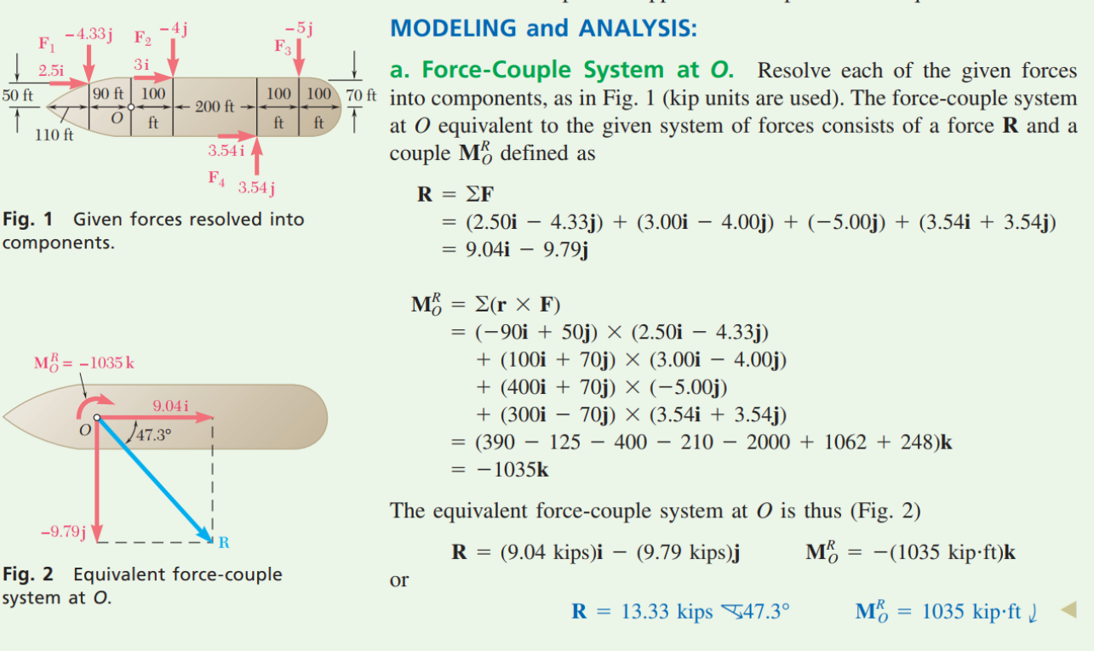

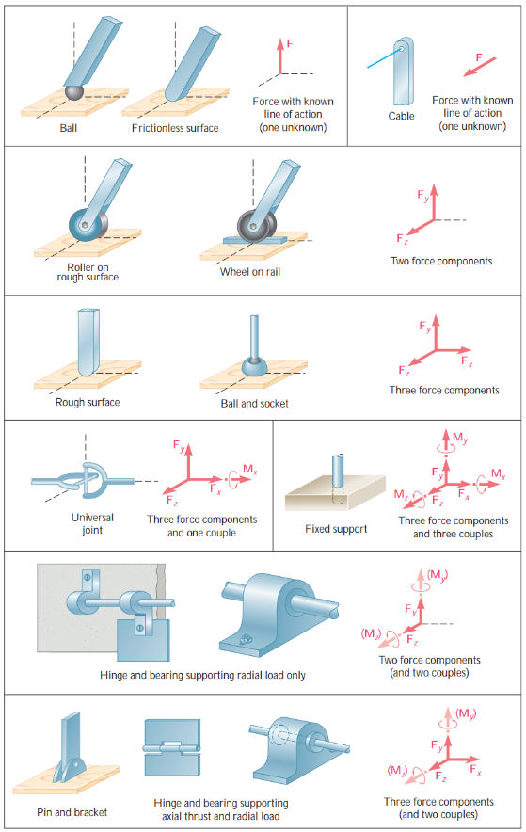
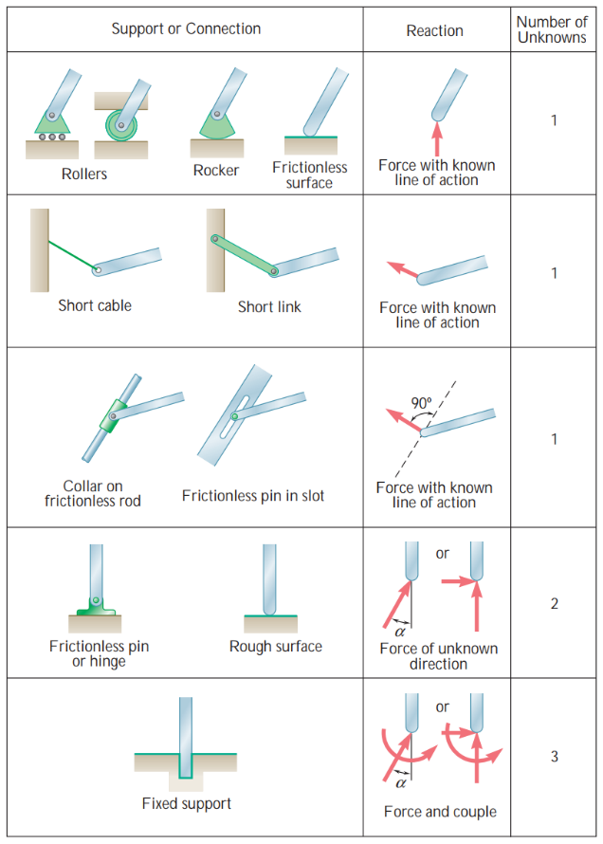
To solve:
- Draw free body diagram.
- Equilibrium gives:
F_{net}x=0
F_{net}y=0
F_{net}z=0
M_{net}(about any point)=0
- Solve for all unknowns.

3D Reactions
2D Reactions

Method of Joints
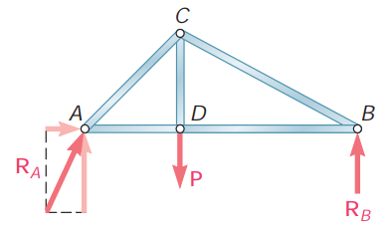

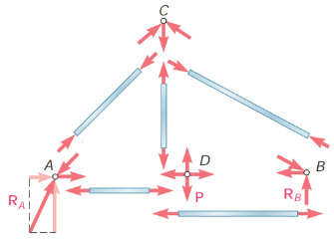

Method of joints:
- Draw a free body diagram for entire truss (to find reaction forces).
  - Use F_{net}x, F_{net}y, M_{net} all =0 to find forces
- Draw a free body diagram for each joint (to find forces in each member). Start with the joints with the smallest number of unknown forces, preferably at one of the ends of the truss.
  - Use F_{net}x, F_{net}y, M_{net} all =0 to find forces
Note: use similar triangles and trig to help find ratios of forces.
Method of sections: (use to find forces in a specific truss member).
- Draw a free body diagram for entire truss (to find reaction forces).
  - Use F_{net}x, F_{net}y, M_{net} all =0 to find forces.
- To find the force in member BE:
  - Split the truss so that you split member BE.
  - Pick the side of the truss with the least unknowns and external forces to simplify
future work, then treat that section as its own truss and solve using F_{net}x, F_{net}y,
M_{net} all =0.

Members:
Zero-Force members:
- Forces in opposite members must be equal so any 3rd member joining them is a zero force member.
  - Ex: Members AC and CE are opposite, so BC is a zero-force member. Same for JK and IJ.
Also:
- AC=CE, HJ=JL, GI=IK=KL
- JL_{y}=±L_{y}, and JL_{x}=±KL etc.

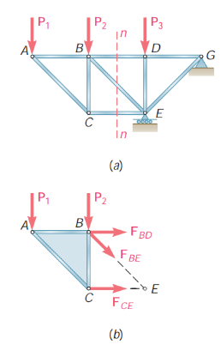

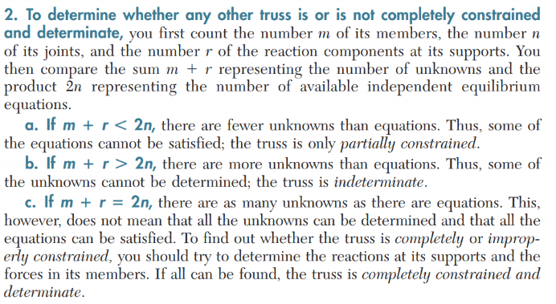
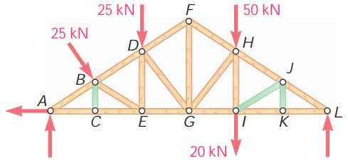

Frames and Machines:
- Have more than just axial forces on each end, so may have other forces acting at 63º to the member.
Steps:
- Free body for entire frame with equations F_{net}x=0, F_{net}y=0, F_{net}z=0, M_{net}(about any point)=0
- Free body for each 2 force member.
- Free body for all multi-force members.
*If there is an external force acting on a joint between two
members, only use it in one of the free body diagrams.
**This does not apply to reaction forces, those are shown
on all free body diagrams but will be positive in one and negative
in the other.
***Where a multi-force member connects to a two force member,
draw a force equal and opposite to that shown on the two force
member diagram.
****Where a multi-force member connects with another multi-
force member, draw the vertical and horizontal components and
draw the equal but opposite components on the 2nd attached
mulri-force member.
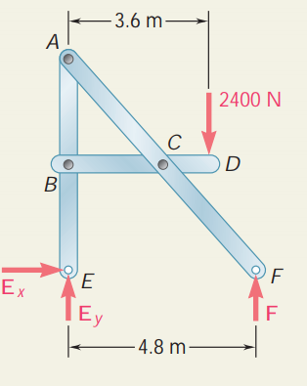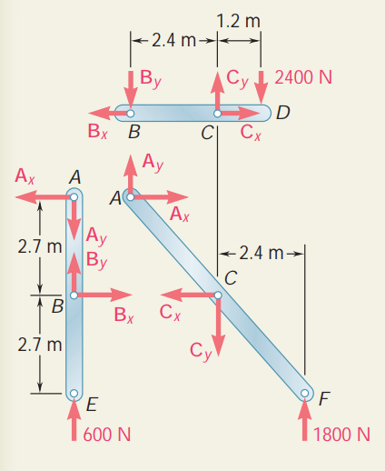

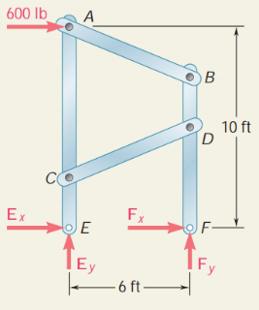
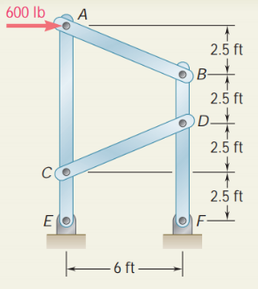

1

2
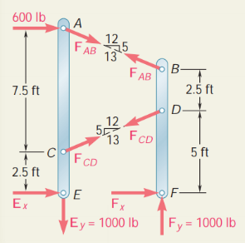
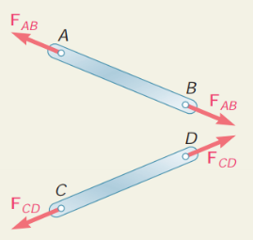
3

Note: if you obtain a negative value for a force that you arbitrarily drew onto the diagram, it just mean the force should be in the other direction. Do not change it however because if you do then you need to rewrite all your equations.

Forces in 3D:
- A vector = $\frac{\left(its magnitude\right)\left(a direction vector\right)}{(norm of the direction vector)}$
- Find the moment about a point (using cross product)
  - You know in equilibrium that that moment =0, so that means
    - Sum of all i components=0
    - Sum of all j components=0
    - Sum of all k components=0
  - Use that to solve for unknowns.
- 6 Equilibrzium equations are:
  - F_{net}x=0
  - F_{net}y=0
  - F_{net}z=0
  - M_{(point)}=0
    - $\sum{i_{coefficients}}=0$
    - $\sum{j_{coefficients}}=0$
    - $\sum{k_{coefficients}}=0$
Note: If axis are not given, place them so that as many forces as possible lie on them. That way those forces don’t affect the moment about that axis.

Centroids:
- If an object has two lines of symmetry that intersect at 90 degrees, they intersect at the axis of symmetry.

$$Centroid \left(do for x and y\right)=\overline{x}=\frac{1}{A_{total }}\int{xdA}=\frac{1}{A_{total }}\sum_{i}{A_{i}{\overline{x}}_{i}} x_{center of mass}m_{total}=\int{xdm}=\sum_{i}{m_{i}x_{i}}$$
Total $\overline{x}$*(A_{total})=$\overline{x}$₁A₁+$\overline{x}$₂+A₂, meaning you
can add up all the areas and all their
centroids, while subtracting the negative
areas.

Steps:
- Make table of values for
L or A, $\overline{x}$, $\overline{y}$, $\overline{x}(L or A)$,
$\overline{y}(L or A)$
- Sum all the values.
- Divide $\overline{x}A$ value by total
area to find $\overline{x}$. (same thing
for L).
Notes:
- A center of symmetry is an axis of symmetry that is just 0 so on the origin. This is when there are two perpendicular lines to an axis that divides a shape. Then the centroid is on that intersection.
First moment:
- $Q_{y}=\overline{x}A_{total }=\int{xdA} Q_{x}=\overline{y}A_{total }=\int{ydA}$
Distributed loads:
- A distributed load can be replaced by a single force of the same magnitude located at the centroid of the distributed load. This load is also equal to the magnitude of the area under the curve or the integral of that curve.
- If you have a form load made of various shapes, split it up and find each single force with relation to each centroid.
Distributed loads on submerged bodies:
- W=bp=bgh=brgh
  - Where: p is the pressure at depth h, g is the specific weight of the liquid, r is the specific density of the liquid, b is the width of the submerged surface
  - The line of action of the resulting force is perpendicular to the surface of the submerged plane.
- Use this W as a distributed load.

Note: chapter 5.10-11-12 is missing, so nothing on 3D shapes.

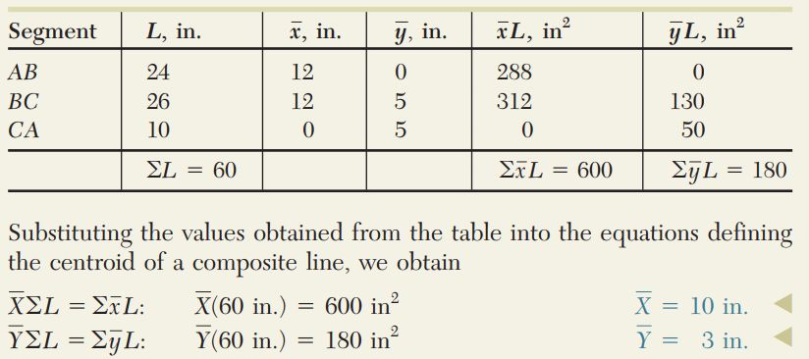
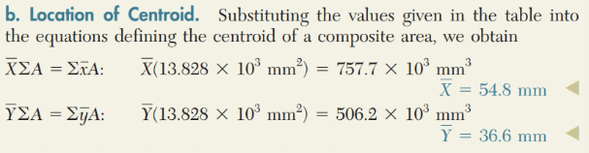
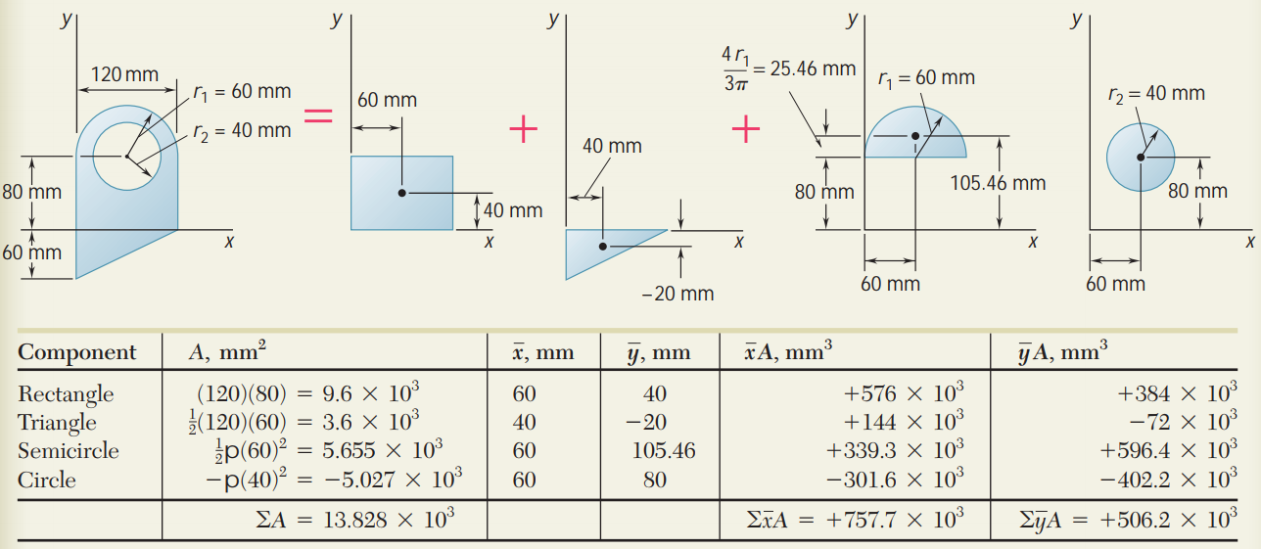
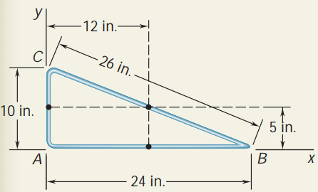

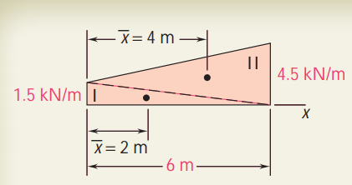
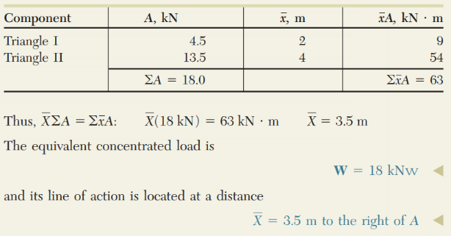
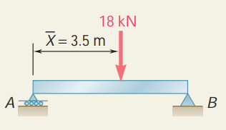

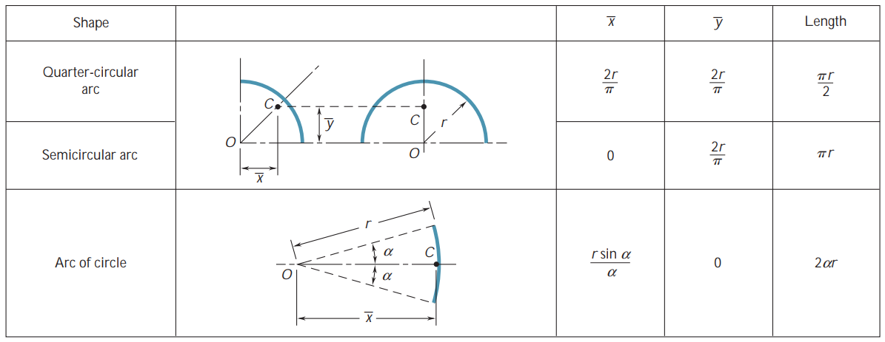
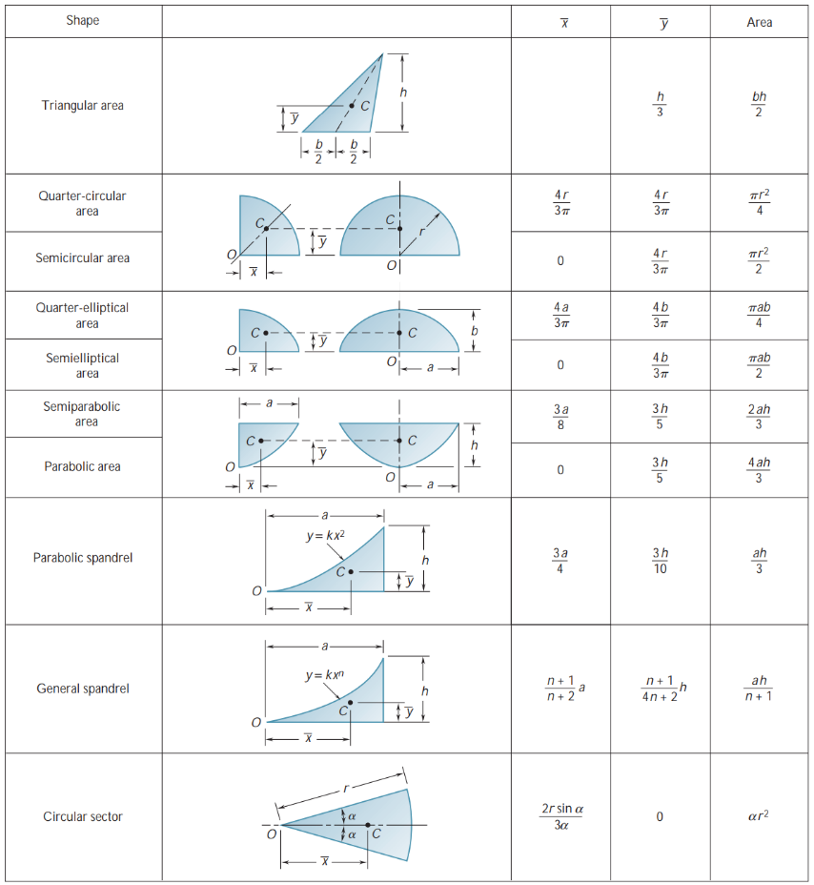
Internal Forces in members:
- If you cut a member, you will find the internal forces:
  - F which is the axial force and is directed axially.
  - V which is the sheering force and is perpendicular to the member.
  - M which is the bending moment at that point.
  - Note that on one side of the cut, the values are
positive and on the other side they are negative.
To solve these, use the regular three equations with the
added axial force, sheer force and bending moment.

Steps for making the diagram
- Find reaction forces
- Draw the blank diagrams with discontinuities anywhere where there is a force on the FBD.
- Sheer:
Start from the left add or subtract forces on the plot as you walk along the beam. In the example here, start at 515 lb because of the reaction at A, then subtract 480lb linearly slope until x=12in. Then the force remains constant until x=18in. Then subtract 400lb and keep that value until x=32in. Then reaction at B adds 365lb.
Note: if its in equilibrium and you don’t end at 0lb, there is a mistake somewhere.
The bending moment diagram can be found by integrating the sheer force diagram or by calculating the area of each shape.

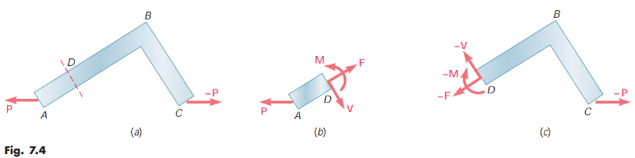

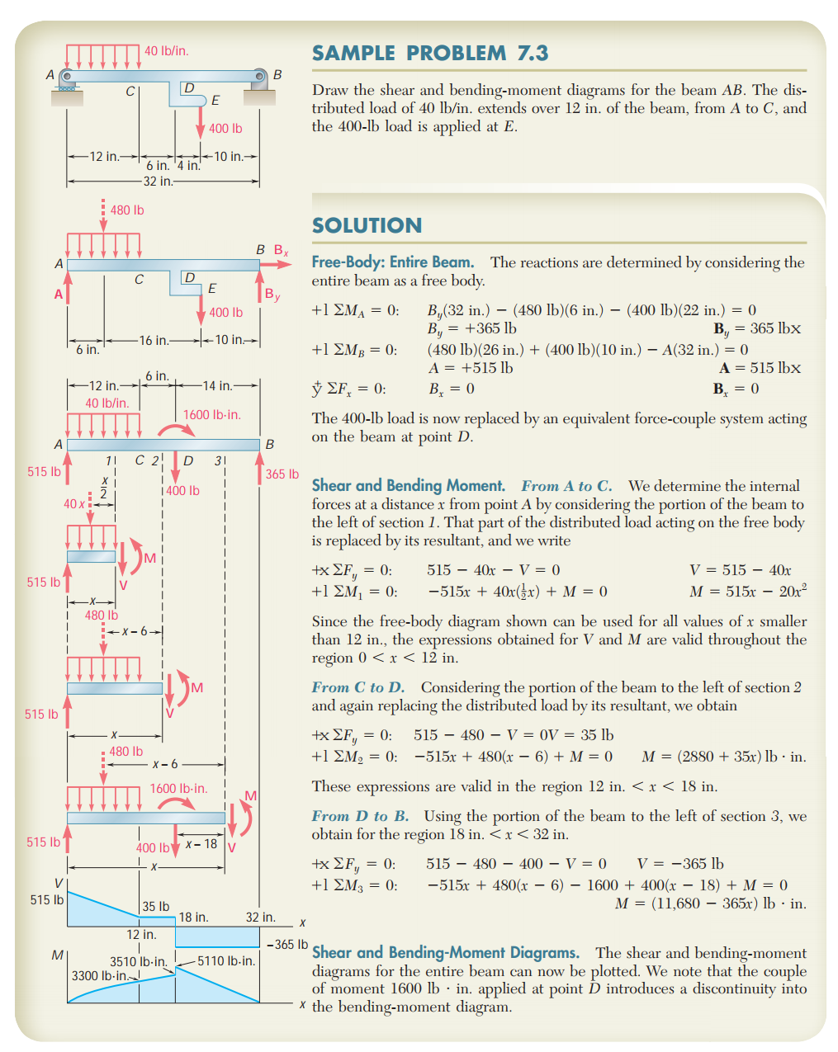
Positive or Negative Sheer and Bending


