Chapter 2
Positives vs. Normatives
- As scientists, economists make positive statements
  - Describing the world as it is (quantitative, fact based)
  - Can be confirmed or refuted
- As policy makers, economists make normative statements
  - Describing the world as it should be (not fact based)
Models
- A model is a highly simplified representation of a more complicated reality
- Assumptions simplify the complexity of the world
- The Circular Flow Diagram
  - Two Markets
    - Goods and Services
    - 4 Factors of Production
  - Two Economic Agents
    - Households
      - Own the F.O.P, and sell them to firms
      - Buy and consume goods and services
    - Firms
      - Buys/Hires F.O.P, and use them to produce goods
      - Sell goods and services
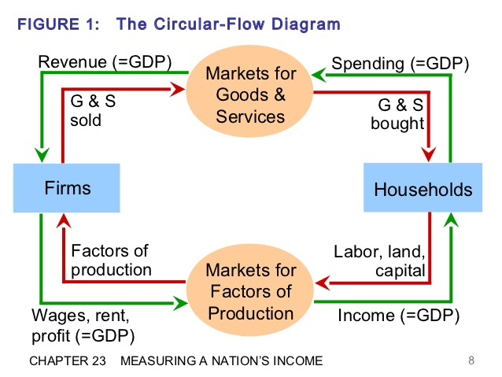
      - The Production Possibilities Frontier
        - A graph that shows the maximum combinations of two goods that an economy can produce given an equal amount of resources.
        - Anything inside the graph (Point F)is inefficiency
        - Anything outside the graph (Point G) is unattainable
        - The slope of the PPF tell you the opportunity cost
- Economists as Policy Advisors
  - Economists often give conflicting policy advice
  - They have different values, thus different normative views on what the policy is trying to accomplish

