Lecture 4 – Mitosis

Pre-Lecture Readings (Chapter 8)

1) Phases and main characteristics of the cell cycle.
- Interphase (G1, S, G2)
- Mitosis
- Cytokinesis
- Length of cell cycle depends primarily on G1, other phases are relatively fixed

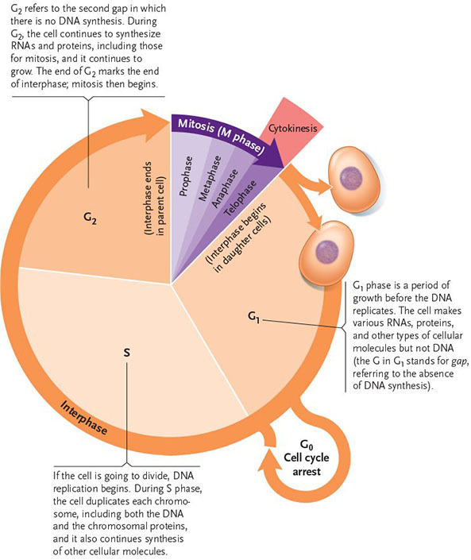
2) Stages and main characteristics of mitosis.
Interphase: 3 phases; G1, S, G2
- G1: Cell functions carried out; cell may grow
- S: chromosomes replicated
- G2: cell grows and prepares for mitosis
Prophase:
- Chromosomes condense, nucleolus disappears, spindle fibres form and migrate
Prometaphase:
- Kinetochore forms, spindles enter nuclear area and attach to it
Metaphase:
- Microtubules move chromatids to metaphase plate
Anaphase:
- Chromatids separate at centromere and migrate to opposite ends
Telophase:
- Nuclear membranes form around chromosomes which extend
3) Stage of cell division, given a micrograph or diagram of a dividing cell.
Cytokinesis occurs near the end of mitosis, usually starting with telophase or even the end of anaphase. In animals, protists and some fungi, a furrow is formed along the former spindle midpoint plane. Microfibres tighten like a belt and daughter cells are pinched off of each other. In plants, layers of vesicles collect in the spindle midpoint plane, fusing together and creating a cell plate, dividing the two daughter cells

4) Changes in amount of DNA throughout the cell cycle.
Using fruit fly example: start off with 8 chromosomes. These are duplicated during S phase of interphase. However, the pair of DNA molecules are held together as sister chromatids (number of chromosomes does not change; still 8, but number of DNA molecules doubled). In mitosis, the sister chromatids split apart into two daughter cells, and are now chromosomes once more. Finish off with 8 DNA molecules in each of the two daughter cells.
***Note that the number of chromosomes never changes, rather the amount of DNA does. C number represents the amount of DNA in a cell, while n represents the number of complete sets of a cell’s genome.

Post Lecture

1) Location of DNA in eukaryotic cells
DNA is found in the nucleus and nucleolus, as well as the mitochondria and chloroplast (chloroplast only in plant cells)
2) Shape of nuclear vs. organelle chromosomes in eukaryotics cells
Nuclear DNA is linear, while mitochondrial and chloroplast DNA are circular. Linear DNA has multiple origins, circular DNA has one origin.
3) Location of actively cycling cells in multicellular animals/plants
In animals: bone marrow, stomach lining, reproductive organs
In plants: meristematic tissue in roots/shoots, just under bark
4) Function of rapid cycling cells at various stages of the life cycle
Rapid cycling cells are important to repair damaged tissue, growth in infants, and gametogenesis (forming gametes)
5) Examples of situations in which cells would be programmed to die by apoptosis
If DNA is unbalanced or damaged, if you have a surplus of cells in an area, in xylem plant tissue (cells that function when they are dead), or when you die (death signals sent out to cells tell them to die)
6) Main features of each stage of mitosis with respect to cytoskeleton and chromatin
Prophase: Chromatin condenses, spindle produced (microtubules)
Prometaphase: Nuclear membrane disintegrates, centrosomes migrate
Metaphase: Microtubules attach to chromatids and pull them apart
Anaphase: Chromatids separated to opposite poles (kinetochores pull along microtubules)
Telophase: Nuclear membrane forms around daughter chromatids
7) Main features of chromosome anatomy
Chromosomes are long, double stranded molecules of DNA. Nuclear chromosomes are linear while mitochondrial and chloroplast chromosomes are circular. Centromere is middle portion of chromosome; repetitive portion that attracts kinetochore attachment. Kinetochores bind to microtubules to pull apart sister chromatids
8) Meaning of "n" and "C"
n: Number of complete chromosomal sets in a cell; one entire copy of genome
C: Amount of DNA in one set of organism’s nuclear chromosomes
9) Changes in the coefficient of n and C throughout the cell cycle (ie. n vs. 2n, 2C vs. 4C etc.)
G1: 2n and 2C
S: 2n and 4C
G2: 2n and 4C
Mitosis: 2n and 4C
Cytokinesis end: 2n and 2C

10) Composition of microtubules, intermediate filaments and microfilaments
Microtubules are made of tubulin, intermediate filaments are made of keratin, microfilaments are made of actin
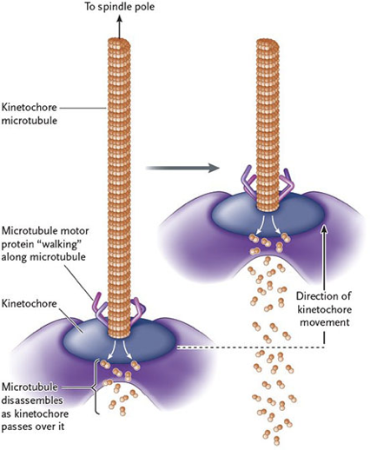
11) Interaction between spindle fibers and kinetochores
In metaphase, motor proteins attached to kinetochores grab onto the microtubules (spindle fibres) and pull the chromosomes along to either pole of the cell. The spindle fibre does not pull the chromosomes towards it; rather the chromosomes pull themselves towards the spindle fibre.
12) Role of motor proteins in chromosome segregation
Motor proteins attached to kinetochores pull the chromosomes apart to the poles. They “walk” the kinetochore along the microtubules, which disassemble, which in turn pulls the chromosomes towards the poles.
13) Role of cell cycle checkpoints
Cell cycle is regulated with checkpoints. 3 checkpoints in cycle: first one is just before S phase: Cells will not enter S phase until all of the DNA is repaired – any damaged DNA must be fixed before it is copied in S phase. Second checkpoint is just before mitosis: cells do not enter mitosis until the chromosomes are condensed and ready. Third checkpoint is just after metaphase, before anaphase: cell does not move onto anaphase until the chromatids are lined up properly.

