Lecture 2 – Viruses

Pre-Lecture Readings (Chapter 23)

1. Characteristics of viruses and why they are not generally considered to be “alive”.
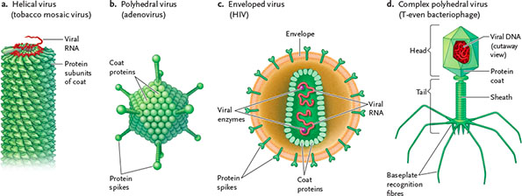
Viruses are one ore more nucleic acid molecules surrounded by a protein coat (capsid). Some capsids may be enclosed in an envelope from the host cell’s membrane. There are two basic structures of viruses: helical (protein subunits in rodlike structure around genome) and polyhedral (coat proteins make triangle units). They lack several basic properties of life, such as lack of mobility and not being able to reproduce, as well as not having a metabolizing system. This classifies them as infectious biological particles rather than organisms.

2. Why viral infections are usually difficult to treat with drugs, and exceptions to this general principle.
Viral infections are usually difficult to treat with drugs because they are hidden in the host cell and so it is difficult to locate and attack virus-specific products. An exception to this general principle is when a virus uses its own polymerase. This allows us to use drugs that target these viruses and attack them at a specific stage in the life cycle of the virus.

3. Whether viruses are always pathogenic.
Viruses are not always pathogenic. Some viruses are beneficial to the host cell. For example, bacteriophages target and destroy bacteria, which is why the planet is not overrun by bacteria. Other viruses work to defend a host cell against other pathogenic viruses.

4. Hypotheses for the evolutionary origin of viruses.
There are several different hypotheses for the origin of viruses. One suggests that viruses came after the first cells, since they need cells to duplicate. Another hypothesis is that they are “escaped” fragments of DNA surrounded by a protein coat. Most recent hypothesis: viruses are very ancient, predating the first cell. Come from primordial gene pool.

5. Lifecycle of HIV.
A) Virus genome attaches to host cell through protein receptors
B) Viral RNA, along with reverse transcriptase, enter the cell through endocytosis
C) Reverse transcriptase polymerizes complementary DNA strand onto single RNA, then second DNA strand onto first DNA
D) Double stranded DNA incorporated into host cell genome, this creates provirus (host DNA with viral DNA inserted)
E) Host cell genome can now transcribe RNA for new virus genomes
F) Complete HIV particles assembled through translation of RNA in host cell. HIV exits host cell and capsid is enveloped

6. Characteristics of HIV that affect the prospects for drug design and vaccine development.
HIV mutates very quickly, which causes it to develop resistance to drugs through evolution. Drug-resistant viruses are more likely to survive and pass on the resistance to future generations. It also hides itself, making it very difficult for drugs to locate it. It has more genetic variation than the flu.

7. The general mechanisms by which vaccines protect against diseases.
Vaccines pre-train the body to recognize viruses. They may place a small amount of the virus, which results in the body to produce antibodies and fight them off.

8. Why developing a vaccine against HIV is relatively challenging, compared to other diseases.
HIV mutates quickly and aggressively. Mutation rate is thousands of times higher than normal cells.

9. Why people are encouraged to get a flu vaccine each year (as opposed to one time only).
Different flu strains come up every year. Influenza RNA is made up of 8 separate pieces, and when it infects a person, it can create different combinations of the pieces to increase the resistance to antibodies. The body must develop new antibodies to fight off the new strains every year.

Post-Lecture

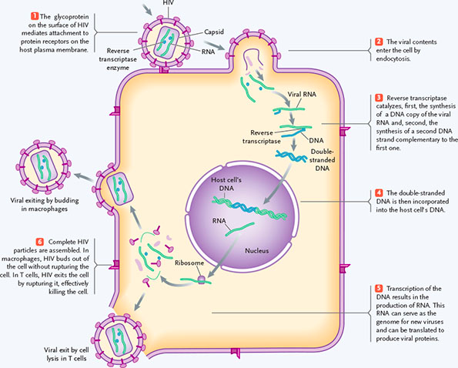
1. Major steps in lifecycle of HIV, and which of these are appropriate targets for antiviral drug design
HIV attaches onto the host cell through the protein receptors. It then releases its contents into the host cell, including the viral ssRNA and reverse transcriptase enzymes. The RT transcribes complementary DNA strand, then another DNA to make double strand DNA. Integrase splices DNA onto host cell DNA. New viral RNA is transcribed, then viral proteins are translated. HIV buds or bursts out of host cell and enters bloodstream. Reverse transcriptase enzyme is an appropriate target for antiviral drug design b/c it is unique enzyme to the virus.

2. Mechanism by which AZT interferes with HIV replication
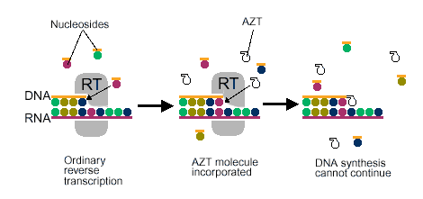
AZT mimics thymine, which causes RT to attach it to complementary DNA strand when it is copying it. This causes reverse transcriptase to stop prematurely and DNA synthesis cannot occur.

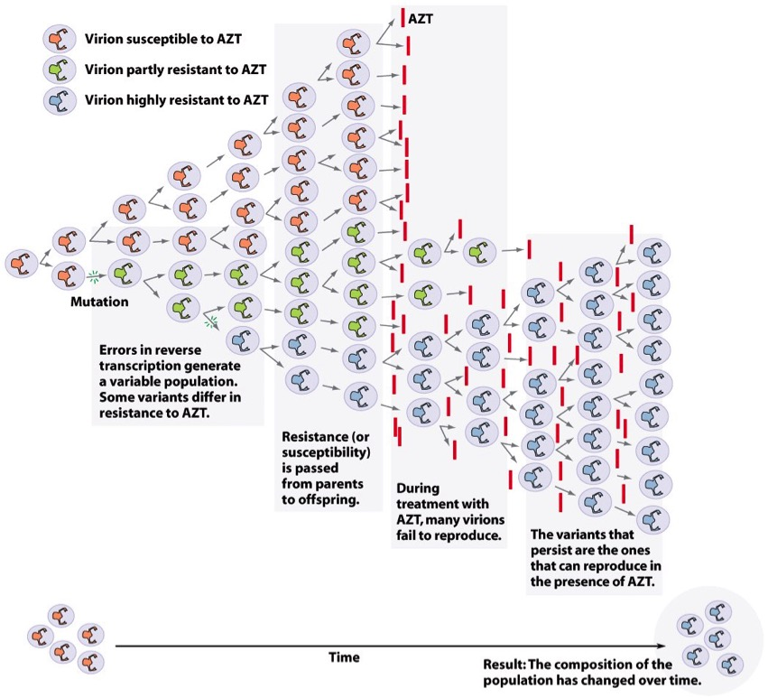
3. Why the effectiveness of AZT decreases over time
Over many generations of viruses, they evolve to develop resistance to AZT. Mutations in reverse transcriptase changed the active site so it doesn’t pick up AZT anymore. These viruses are more successful in surviving so this trait gets passed on to offspring. Eventually, the entire viral population becomes resistant to AZT.

4. Principles underlying evolution by natural selection: variation, heritability, differential reproduction, change in genotype of the population
Variation: Mutations create virions that vary in drug resistance
Heritability: Resistance is passed on to next generation
Differential reproduction: Only virions that are resistant to AZT are successful and are able to reproduce
Change in genotype of the population: Eventually all population becomes resistant

5. Rationale for using multiple drugs simultaneously to treat viral infections
Much lower chance for HIV to mutate to be able to develop resistance for all drugs at once. Drugs target several different times in life cycle of HIV, so chances for all drugs to fail simultaneously are extremely slim. Very likely to develop resistance to one drug if used alone, but unlikely for multiple drugs
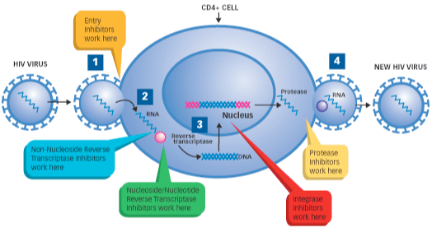

6. Evolutionary origins of HIV and why the virus is much more common in some parts of the world than others
HIV came from SIV which is a similar virus that infects chimpanzees. Zoonotic disease; came from animals and spread to humans. First case likely around 1908; chimps infected by SIV were butchered. Virus carried along river to Kinsaha where epidemic begins. HIV more common in Africa because that is where it originated. Africa also has a lack of proper hygiene/sexual education in regions where HIV is common

7. Role of CCR5-∆32 mutation in human resistance to HIV, and possible reasons why this mutation is more common in some populations than others
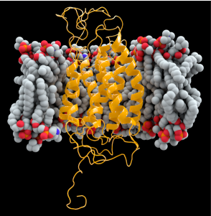
CCR5∆D32 is a receptor protein that lies on white blood cells; site where HIV attaches on to. Some people have a mutation in this allele, which prevents HIV from attaching to site. Those with 2 copies of mutated allele, cell is highly resistant, but with 1 copy offers some protection still. Mutation is more common in northern Europe area. Possible reason for this is bubonic plague; natural selection caused people with allele to survive and pass on to future generations. Or could possibly be random chance that it is common in Europe.

