BTM - Assignment 2 (Unit 6)

CPU and memory usage over a typical school day
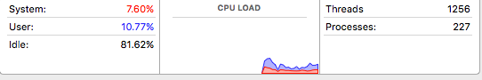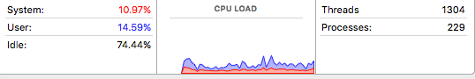
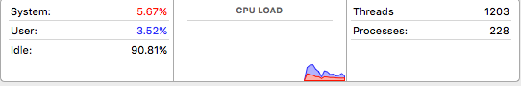

As I have a MacBook, I used Activity Monitor to collect data on CPU utilization and memory usage over a normal school day. The results show that my CPU usage levels vary from 9.19% to 25.56%, meaning my computer system is not limited by CPU performance. These percentages also imply that my CPU meets my needs and thus, an upgrade or a new purchase would not be necessary.

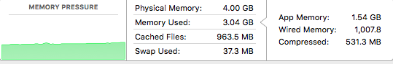

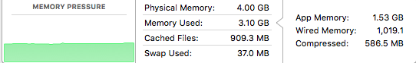

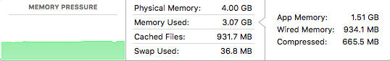

The results indicate that, during a typical school day, the total amount of memory I have used varies from 3.04 GB to 3.10 GB out of my total of 4 GB of RAM (physical memory). The memory usage is constant at about 3 GB and there is still have memory available, suggesting the memory capacity with my workload does not limit my system.

Benchmark program: evaluation of the CPU and GPU
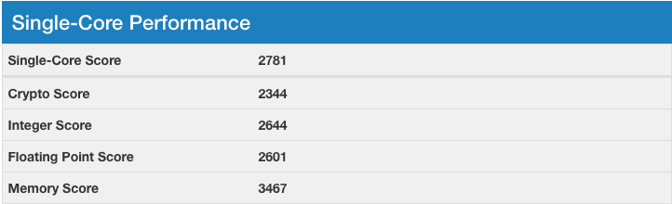

I used the benchmarking program called Geekbench 4, which evaluates the CPU and the GPU. The single-core scores, used to evaluate CPUs, are measured against a baseline score of 4000 (score of an Intel Core i7-6600U). My processor, the Intel Core i5-3210M, received a score of 2781, suggesting that the Intel Core i7-6600U performs around 1.5 times better than the Intel Core i5-3210M.



For evaluating the GPU, the OpenCL score was used and my Intel HD Graphics 4000 received 5911. Its performance is not nearly as good as the Intel HD Grphics 6000 that received a score of 15512, nor the Intel HD Graphics 610 that received a score of 12082.

