chapter 2
quality management

what is quality?
- Oxford American Dictionary
  - A degree or level of excellence
- American Society for Quality
  - Totality of features and characteristics that satisfy needs without deficiencies
- Consumer’s and producer’s perspective

quality from the customer’s perspective
- Fitness for use
  - How well the product or service does what it is supposed to
- Quality of design
  - Designing quality characteristics into a product or service
- A Mercedes and a Ford are equally “fit for use,” but with different design dimensions.

dimensions of quality for manufactured productions
- Performance
  - Basic operating characteristics of a product; how well a car handles or its gas mileage
- Features
  - “Extra” items added to basic features, such as a stereo CD or a leather interior in a car
- Reliability
  - Probability that a product will operate properly within an expected time frame; that is, a TV will work without repair for about seven years
- Conformance
  - Degree to which a product meets pre–established standards
- Durability
  - How long product lasts before replacement; with care, L. L. Bean boots may last a lifetime

- Serviceability
  - Ease of getting repairs, speed of repairs, courtesy and competence of repair person
- Aesthetics
  - How a product looks, feels, sounds, smells, or tastes
- Safety
  - Assurance that customer will not suffer injury or harm from a product; an especially important consideration for automobiles
- Perceptions
  - Subjective perceptions based on brand name, advertising, etc.

dimensions of quality for services
- Time and timeliness
  - How long must a customer wait for service, and is it completed on time?
  - Is an overnight package delivered overnight?
- Completeness:
  - Is everything the customer asked for provided?
  - Is a mail order from a catalogue company complete when delivered?
- Courtesy:
  - How are customers treated by employees?
  - Are catalogue phone operators nice and are their voices pleasant?
- Consistency
  - Is same level of service provided to each customer each time?
  - Is your newspaper delivered on time every morning?
- Accessibility and convenience
  - How easy is it to obtain service?
  - Does service representative answer your calls quickly?
- Accuracy
  - Is service performed right every time?
  - Is your bank or credit card statement correct every month?
- Responsiveness
  - How well does company react to unusual situations?
  - How well is a telephone operator able to respond to a customer’s questions about items not fully described in the catalogue?

quality from the producer’s perspective
- Quality of conformance
  - Making sure a product or service is produced according to design
    - if new tires do not conform to specifications, they wobble
    - if a hotel room is not clean when a guest checks in, hotel is not functioning according to specifications of its design

final perspective on quality
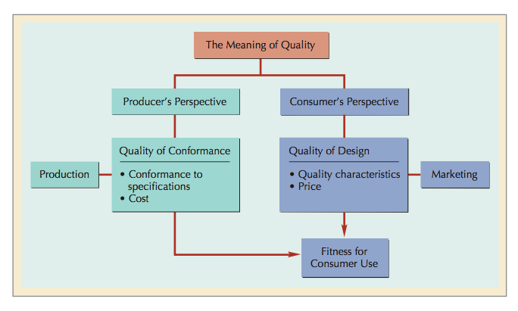
- Customer’s and producer’s perspectives depend on each other
- Producer’s perspective:
  - Production process and COST
- Customer’s perspective:
  - Fitness for use and PRICE
- Customer’s view must dominate

quality management system

evolution of quality management
- Walter Shewhart
  - In 1920s, developed control charts
  - Introduced term “quality assurance”
- W. Edwards Deming
  - Developed courses during WW II to teach statistical quality- control techniques to engineers and executives of military suppliers
  - After war, began teaching statistical quality control to Japanese companies
- Joseph M. Juran
  - Followed Deming to Japan in 1954
  - Focused on strategic quality planning
  - Quality improvement achieved by focusing on projects to solve problems and securing breakthrough solutions
- Armand V. Feigenbaum
  - In 1951, introduced concepts of total quality control and continuous quality improvement
- Philip Crosby
  - In 1979, emphasized that costs of poor quality far outweigh cost of preventing poor quality
  - In 1984, defined absolutes of quality management— conformance to requirements, prevention, and “zero defects”

- Kaoru Ishikawa
  - Promoted use of quality circles
  - Developed “fishbone” diagram
  - Emphasized importance of internal customer

deming’s 14 points
- Create constancy of purpose
- Adopt philosophy of prevention
- Cease mass inspection
- Select a few suppliers based on quality
- Constantly improve system and workers
- Institute worker training
- Instill leadership among supervisors
- Eliminate fear among employees
- Eliminate barriers between departments
- Eliminate slogans
- Eliminate numerical quotas
- Enhance worker pride
- Institute vigorous training and education programs
- Develop a commitment from top management to implement the above 13 points

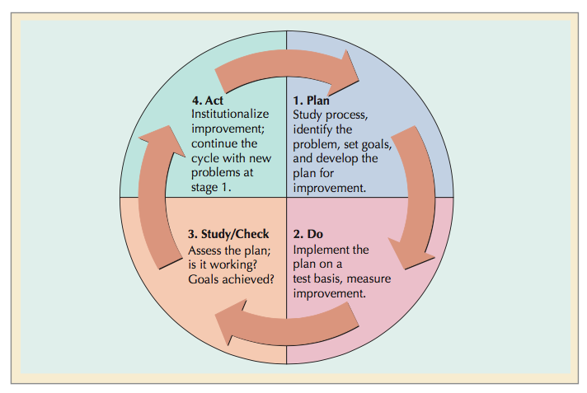
deming wheel: PDCA cycle

quality tools

process flowcharts
- A diagram of the steps in a job, operation or process.
- Helps focus on location of problem in a process

cause-and-effect diagrams
- Cause-and-effect diagram (“fishbone” diagram)
  - Chart showing different categories of problem
- Cause-and-effect matrix
  - grid used to prioritize causes of quality problems

check sheets and histograms
- check sheet
  - A list of causes of quality problems with the number of defects resulting from each cause.
- Histogram
  - A diagram showing the frequency of data related to a quality problem.

pareto analysis
- Most quality problems result from a few causes

scatter diagrams
- Graph showing relationship between 2 variables in a process
- Identifies pattern that may cause a quality problem

process control charts and statistical quality control
- A chart with statistical upper and lower limits
- In its simplest form, if sample statistics (i.e. points plotted on the chart) remain between these limits, we assume the process is in control

tqm & qms
- Total Quality Management (TQM)
  - Customer-oriented, leadership, strategic planning, employee responsibility, continuous improvement, cooperation, statistical methods, and training and education
- Quality Management System (QMS)
  - System to achieve customer satisfaction that complements other company systems

the focus of quality management – customers
- TQM and QMSs
  - Serve to achieve customer satisfaction
- Satisfied customers are less likely to switch to a competitor
- It costs 5-6 times more to attract new customers as to keep an existing one
- 94-96% of dissatisfied customers don’t complain
- Small increases in customer retention mean large increases in profits

quality management in the suply chain
- Companies need support of their suppliers to satisfy their customers
- Reduce the number of suppliers to have more influence on supplier’s quality & delivery performance.
- Partnering
  - A relationship between a company and its supplier based on mutual quality standards

measuring customer satisfaction
- An important component of any QMS
- Use customer surveys to hear “Voice of the Customer”
- American Customer Satisfaction Index (ACSI)
  - In 2008, Amazon had an ACSI score of 86.
  - Apple was the leading company in computer industry with a score of 85.
  - Lexus and BMW were the highest scoring car companies with a score of 87.

the role of employees in quality management
- Every employee has undergone extensive training to provide quality service to Disney’s guests.
- At Ritz-Carlton, first year employees receive over 300 hours of training
- Participative problem solving
  - Employees are directly involved in the quality management process

kaizen & continuous improvement
- Involves everyone in the process of continuous improvement
- Employees determining solutions to their own problems

quality circles
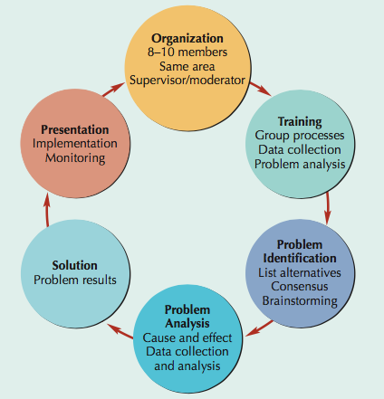
- Voluntary group of workers and supervisors from same area who address quality problems

process improvement teams
- Focus attention on business processes rather than separate company functions
- Includes members from the interrelated departments which make up a process
- Important to understand the process the team is addressing
- Process flowcharts are key tools

quality in services
- Service defects are not always easy to measure because service output is not usually a tangible item
- Services tend to be labor intensive rather than capital-intensive as in the case of manufacturing.
- Services and manufacturing companies have similar inputs but different processes and outputs

quality attributes in services
- Principles of TQM apply equally well to services and manufacturing
- Timeliness is an important dimension
  - How quickly a service is provided
- Benchmark
  - “best” level of quality achievement in one company that other companies seek to achieve

six sigma
- A process for developing and delivering virtually perfect products and services
- Six Sigma is a measure of how much a process deviates from perfection, or zero defects
- Goal: 3.4 defects per million opportunities (DPMO)

the six sigma process
- Align
  - Executives create balanced scorecard & identify high-impact improvement projects.
- Mobilize
  - Project teams formed and empowered to act
- Accelerate
  - Black and green belts execute project
- Govern
  - Monitor and review projects

improvement projects
- Champion: An executive responsible for project success

the breakthrough strategy: DMAIC
- Define
  - Problem is defined
- Measure
  - Process measured, data collected
- Analyze
  - Data analysis to find cause of problem
- Improve
  - Develop solutions to problem & implement them
- Control
  - Ensure improvement is continued

black belts & green bets
- Black Belt : Project leader who implements DMAIC
- Master Black Belt : A teacher and mentor for Black Belts
- Green Belts : Project team members

six sgma tools
- Quality Function Deployment (QFD)
  - Capture the “voice of the customer”
- Cause & Effect Matrix
  - Identify and prioritize causes of a problem
- Failure Modes and Affects Analysis(FMEA)
  - Analyze potential problems before they occur
- t-Test
  - Test for differences between groups
- Statistical Process Control (SPC) Chart
  - Monitor a process over time for variations
- Design of Experiments (DOE)
  - Determining relationships between factors affecting inputs and outputs of a process

design for six sigma
- A systematic approach to designing products and processes that will achieve Six Sigma
- Uses same basic approach as breakthrough strategy
- Employs the strategy up front in the design and development phases
- A more effective and less expensive way to achieve Six Sigma

lean six sigma
- Integrate Six Sigma and “lean systems”
- Lean seeks to optimize process flows
- It gets the product through the process faster
- Lean extends earlier efforts in efficiency
- Lean process improvement steps
- determine what creates value for customers
- identify “value stream”
- remove waste in the value stream
- make process more responsive to customer needs
- continually repeat attempts to remove waste
- Six Sigma and Lean seek
  - Process improvements & Increased value to customers
- They approach the goals in different, complementary ways.
  - Lean improvements cause products to flow through processes faster.
  - Six Sigma improves quality and reduces defects by reducing variation through individual projects.

the bottom line – profitability
- The typical criterion for selecting Six Sigma projects
- One of the factors distinguishing Six Sigma from TQM
- “Quality is not only free, it is an honest-to- everything profit maker”
- Quality improvements reduce costs of poor quality

the cost of quality

the cost of achieving good quality
- Prevention costs
  - Quality planning costs
    - costs of developing and implementing quality management program
  - Product-design costs
    - costs of designing products with quality characteristics
  - Process costs
    - costs expended to make sure productive process conforms to quality specifications
  - Training costs
    - costs of developing and putting on quality training programs for employees and management
  - Information costs
    - costs of acquiring and maintaining data related to quality, and development and analysis of reports on quality performance
- Appraisal costs
  - Inspection and testing
    - costs of testing and inspecting materials, parts, and product at various stages and at end of process
  - Test equipment costs
    - costs of maintaining equipment used in testing quality characteristics of products
  - Operator costs
    - costs of time spent by operators to gather data for testing product quality, to make equipment adjustments to maintain quality, and to stop work to assess quality

the cost of poor quality
- Internal failure costs
  - Scrap costs
    - costs of poor-quality products that must be discarded, including labor, material, and indirect costs
  - Rework costs
    - costs of fixing defective products to conform to quality specifications
  - Process failure costs
    - costs of determining why production process is producing poor-quality products
  - Process downtime costs
    - costs of shutting down productive process to fix problem
  - Price-downgrading costs
    - costs of discounting poor- quality products—that is, selling products as “seconds”
- External failure costs
  - Customer complaint costs
    - costs of investigating and satisfactorily responding to a customer complaint resulting from a poor-quality product
  - Product liability costs
    - litigation costs resulting from product liability and customer injury
  - Lost sales costs
    - costs incurred because customers are dissatisfied with poor- quality products and do not make additional purchases
  - Product return costs
    - costs of handling and replacing poor-quality products returned by customer
  - Warranty claims costs
    - costs of complying with product warranties

measuring & reporting quality costs
- Index numbers
  - Ratios that measure quality costs against a base value

- labor index
  - ratio of quality cost to labor hours
- cost index
  - ratio of quality cost to manufacturing cost
- sales index
  - ratio of quality cost to sales
- production index
  - ratio of quality cost to units of final product

the quality – cost relationship
- Cost of quality
  - Difference between price of nonconformance and conformance
  - Cost of doing things wrong
    - 20 to 35% of revenues
  - Cost of doing things right
    - 3 to 4% of revenues

effect of quality management on productivity

productivity
- Productivity = output / input
- Quality impact on productivity
  - Fewer defects increase output, and quality improvement reduces inputs
- Yield
  - A measure of productivity

measuring product yield & productivity
- $Yield=Y=\left[\left(I\right)\left(\%G\right)\right]+[\left(I\right)\left(1-\%G\right)\left(\%R\right)]$
  - where
    - I = initial quantity started in production
    - %G = Percentage of good units produced
    - %R = Percentage of defective units that are successfully reworked
- $Product Cost=\frac{\left(K_{d}\right)\left(I\right)+(K_{r})(R)}{Y}$
  - where
    - K_{d} = direct manufacturing cost per unit
    - I = input
    - K_{r} = rework cost per unit
    - R = reworked units
    - Y = yield

computing product yield for multistage processes
- $Y=\left(I\right)\left({\%g}_{1}\right)\left({\%g}_{2}\right)… \left({\%g}_{n}\right)$
  - where
    - I = input of items to the production process that will result in finished products
    - g_{i} = good-quality, work-in-process products at stage i

quality-productivity ratio
- QPR
  - Productivity index that includes productivity and quality costs
- $QPR=\frac{\left(goods-quality units\right)}{[\left(input\right)\left(processing cost\right)]+[\left(reworked units\right)\left(reworked cost\right)]}(100)$

quality awards

the Malcolm baldrige award

- Created in 1987 to stimulate growth of quality management in the United States
- Categories

  - Leadership
  - Information and analysis
  - Strategic planning
  - Human resource focus
  - Process management
  - Business results
  - Customer and market focus

other awards of quality
- National individual awards

  - Armand V. Feigenbaum Medal
  - Deming Medal
  - E. Jack Lancaster Medal
  - Edwards Medal
  - Shewhart Medal
  - Ishikawa Medal

- International awards

  - European Quality Award
  - Canadian Quality Award
  - Australian Business Excellence Award
  - Deming Prize from Japan

iso 9000
- Procedures and policies for international quality certification

standards

- ISO 9000:2008
  - Quality Management Systems—Fundamentals and Vocabulary
  - defines fundamental terms and definitions used in ISO 9000 family
- ISO 9001:2008
  - Quality Management Systems—Requirements
  - standard to assess ability to achieve customer satisfaction
- ISO 9004:2008
  - Quality Management Systems—Guidelines for Performance Improvements
  - guidance to a company for continual improvement of its quality-management system

certification, implications & registrars
- ISO 9001:2008—only standard that carries third-party certification
- Many overseas companies will not do business with a supplier unless it has ISO 9000 certification
- ISO 9000 accreditation
- ISO registrars

