MANAGERIAL ECONOMICS: MGCR-293-005
Professor: Tariq Nizami
Book: Managerial economics: theory, application and cases, 8th edition

LECTURE 1
CHAPTER 1: Introduction to Managerial Economics
- To succeed in business, you must win in the marketplace
- Market forces: supply & demand
  - They determine the price of products, resources, cost of production, number of rivals in the market, pricing strategies and ultimately the profitability of business investments
- Goal of corporations: maximizing the value of the firm by maximizing the profits of the firm
- Managers must be aware of new developments in the marketplace

What is managerial economics?
- ME is derived from microeconomic theory
- It uses those concepts and techniques that enable managers to choose strategic directions and to efficiently allocate available resources and to respond effectively to tactical issues
- Shows how managers make decisions to maximize the value of the firm and profit

What does managerial economics provide?
- ME provides a systematic and logical way of analyzing business decisions which focuses on economic forces that shape day to day short-run decisions and long-run planning decisions.
  - The largest most successful corporations use that strategy
- Microeconomics: focuses on consumers decide which products they will choose
- ME: focus is managerial behaviour. How they should price products.
- A manager’s most important task is to make good decisions.
- The objective of the ME:
  - Help business students become architects of business strategy
- Manager:
  - person who directs resources (Land, labour, Capital) to achieve a goal, directs employees, quality of goods

- Economics:
  - the science of making decisions in the presence of scarce resources (scarcity implies trade off)
- ME:
  - How to direct scarce resources in a way that most efficiently achieves a managerial goal
  - Is prescriptive: there are rules and techniques to fulfill specified goals

- Economic Theory is used because it allows people to understand complicated problems by using simplicity. Using ET is like using a map, it helps you concentrate on what’s relevant while ignoring what is not.

Economic Profit vs Accounting Profit
- Economic profit = Total Revenue – Total Economic Costs
- EP = TR – (Explicit costs + Implicit costs)

- Explicit costs: resources owned by others (raw material purchases, K rented or purchased, labour). Cash payed out

- Implicit costs (Normal profits) : resources owned by the owner of the firm (money you invest in your business, land, building and machinery owned by the owner). Cash sacrificed

- Normal profit: owners make as much as they would make if they didn’t have a businessi
AP = TR – Explicit costs

- This means AP will always be higher than EP

- Possible results of the equation: π > 0 profit
π = 0 Normal profit
π < 0 loss

LECTURE 2
- A good business should always be able to pay back for all resources used
- If someone was looking to buy out a company, they would look at the EP of a company because AP does not accurately portray a company’s profit since implicit costs are excluded.

- EXAMPLE:
EP = 100000 – 60000 – 40000 = 0 Normal profit
AP = 100000 – 60000 = 40000
This shows how AP and EP will never be equal even though it’s the same firm

- If a company has a large revenue it doesn’t necessarily mean it has a large profit

The Theory of the Firm
- When managers maximize a firm’s profit, they are maximizing its value
- Describes how firms behave (what are their goals)
- Various parties involved: shareholders, managers, employees, consumers, suppliers, society.
- Model of business is called the theory of the firm
- A firm’s primary goal today is to cover uncertainty and time value of money. The firm tries to maximize the value of the firm.
- Value of the firm: the present value (PV) of its expected future profits.

PV of all future profits = $\frac{π1}{(1+i)} + \frac{ π2}{{\left(1+i\right)}^{2 }}$ … +$\frac{π_{n}}{({1+i)}^{t}}$

PV of all future profits =
$$\sum_{t=1}^{n}{\frac{π_{t}}{{\left(1+i\right)}^{t}}}$$
Because π = TR – TC
This shows why managers influence performance. Their actions determine revenue & cost for a company
$$PV= \sum_{t=1}^{n}{\frac{{TR}_{t}-{TC}_{t}}{{\left(1+i\right)}^{t}}}$$

π = profit
i = interest rate
t = goes from 1 to n
TR_{E} = total revenue in years (t)
TC_{E} = total costs in years (t)

Role of Constraints
- Input constraints: specialized equipment, essential raw material, skilled labour, energy etc…
- Legal & contractual constraints: minimum wage laws, wrongly estimating costs, health and safety standards, federal, provincial and local taxes, environmental laws, anti-trust laws (a big company driving a small one out of business)

Principle-Agent Problem
- When the manager of the firm is also the owner of the firm there is no conflict
- When owners and managers are not the same people, conflict can arise because of different perspectives on what objectives should be. Usually when a manager’s plan will not result in maximal profit
- Some managers don’t care about profit, instead they care about being dominant companies with large market shares
  - Private corporation: only members have access to buying stocks
  - Public corporation: everyone has access
- SOLUTION: corporations give managers incentives to pursue the objective of maximization of the firm’s value.
  - Stock options: to purchase stocks at less than market price. Changes manager’s attitudes toward their work.

LECTURE 3
What is economics?
- The study of how limited resources are used to satisfy unlimited wants and needs
- Resources: land, labour, capital, entrepreneurship, technology
- When sold, resources generate income
- Wants: what people would buy if they had unlimited income
- Needs: what people buy to survive
- Scarcity: the result of not enough G & S to satisfy all wants and needs. When the resources to produce the G & S are not sufficient to satisfy all wants and needs.
- Choice: choice is the result of scarcity, decisions are made on both micro & macro levels
- Microeconomics: the study of decision making by individual segments of the economy (individuals/firms). How consumers make purchasing decisions and how firms make hiring decisions etc…

- Macroeconomics
  - the study of the behavior of the economy as a whole of major groups such as households, govts, foreign sector (deals with inflation, unemployment, money & banking, stability, employment and growth

Economic Systems
- Describes how a particular society distributes its resources to produce G & S
- Agrarian/traditional economies
- Market economies (capitalist) none exist in reality none exist in pure form today
- Command/planned economies
- Mixed economies virtually all economies existing today

Market Strategy and Managerial Decision Making
- 4 types of markets
- Perfect competition
- Monopoly
- Monopolistic competition
- Oligopoly
- Price-taker
  - take the price, whatever it is because of the forces of demand on the market. Increasing the price results in losing probably the entire market.
- Price setter
  - a firm that has market power. Increasing the price results in losing some of the market, but not all.
- Market
  - firms and individuals who are in touch with each other to perform a transaction
- Market processes are facilitated by the market forces of supply & demand

What is Supply & Demand?
Demand
- Demand
  - is the various quantities of a good or service that consumers are willing and able to buy at various prices over a specified period of time. When all non-price determinants are held constant (income, taste, expectation of future prices, prices of related goods, population). If any one of these changes, the demand will change.

- Law of demand
  - Q_{d} of a G or S is inversely related to price.

P ↑ Q_{d}↓ and P↓ Q_{d} ↑

- Market demand schedule
  - a table showing a list of possible prices & their corresponding Q_{d} by consumers during a specified period of time
- Market demand curve
  - a graph showing the inverse relationship between P & Q when all non-price determinants are held constant
- Shift in demand
  - curve moves either left or right when any of the non-price determinants of demand change.
- Non-price determinants of DEMAND:
- Income
- Taste & preferences
- Prices of related goods (complements & substitutes)
- Expectation of future prices
- Population

Change in demand | VS | Change in QUANTITY demanded
- A change in 1+ non-price determinants results in a change in demand. This is a SHIFT of the curve. |  | - A change in the price of a G or S will result in a change of Q_{d}. This is a movement ALONG the curve.

Supply
- Supply
  - The various quantities of G & S that sellers are able & willing to supply for sale at various prices during a specific period of time when all other non-price determinants are held constant (input prices, taxes & subsidies, price expectation, number of firms in the industry, technology & productivity).
- Law of supply
  - price of a G or S and the quantity supplied are directly related.

↑P ↑Q_{S} and ↓P ↓Q_{s}

- Market supply schedule
- Market supply curve
- Shift in supply
  - shifts right or left when any of the non-price determinants of supply change
  - Non-price determinants of SUPPLY:
- Cost of inputs: labor, capital, raw materials, energy, etc…
- Technology & productivity
- Taxes & subsidies: tax breaks, subsidies, etc…
- Price expectations
- Number of firms in industry: if there are more firms in an industry, more goods will be produced at each and every price (and vice versa)

Change in supply vs change in Quantity Supplied
- A change in 1+ non-price determinants of supply will lead to a change in supply, this is a SHIFT of the supply curve.
- A change in a good’s own price is a change in quantity supplied. This is a movement ALONG the curve.

LECTURE 4
Determinants of Market Equilibrium
- Competitive Market Equilibrium
  - where quantity of the product demanded = the quantity of the product supplied at a specific price
- Equilibrium Price
  - the price at which Q_{d} = Q_{s}
  - The quantity traded is called equilibrium point

- Shortage
  - Q_{d} > Q_{s} at a price below equilibrium level

- Surplus
  - Q_{s} > Q_{s} at a price above equilibrium level
  - There would be a reduction in price so that suppliers could sell more

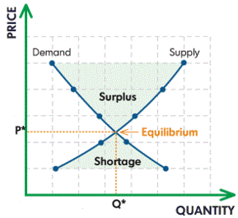

CHAPTER 18: Optimization Techniques
Economic Optimization Process
- Optimal decisions: when alternative courses of action are available, the decision that produces the result most consistent with the managerial objectives.

Concepts & Terminology
- Objective function

Functional Relationships
- Relationships of 2+ economic variables
- An equation is an expression of functional economic variables
Q = f (P)

Marginal Analysis
- To know the output level at which profit will be maximized
- Marginal value of a dependent variable: the change in this dependent variable associated with a 1-unit change in a particular independent variable

The Derivative (Rate of Change)
- If Y dependent variable & X is independent variable
Y = f(x)

Rules to Find the Derivative
- Derivative of constant: y=a $\frac{dy}{dx}=0$

- Derivative of the power function: $y=a^{n}$
$$\frac{dy}{dx}=(n)ax^{n-1}$$

- Derivative of sum & difference: suppose $u + w$ are two variables each of which depends on “x”, then $u=g\left(x\right) \& w=h(x)$
$$y=u+w$$
$\frac{dy}{dx}= \frac{du}{dx }+ \frac{dw}{dx}$

- Derivative of products: $y=uw$
$$\frac{dy}{dx}=u\frac{dw}{dx}+w\frac{du}{dx}$$

- Derivative of quotients: $y = u/w$
$$\frac{dy}{dx}= \frac{u\frac{dw}{dx}+w\frac{du}{dx}}{w^{2}}$$

LECTURE 5
Using derivatives to solve maximization & minimization problems
- Total profit (y) is maximized at a point where its marginal value goes from positive to negative
- EXAMPLE:
- The maximum occurs where the slope of the tangent is zero
- Second derivative is always negative at the point of maximization & is positive at the point of minimization
- Through comparing the optimal with the actual you can an idea of where your business stands

Marginal Revenue = Marginal Costs & the calculus of optimization
MR = MC
- Point of maximization
- Beyond this point, cost per unit is higher than revenue per unit
- Rate of change TC = rate of change TR

- The slope of the TC curve shows the marginal cost
- The slope of the TR curve shows you the marginal revenue
- The largest vertical difference between TR & TC (where both curves have the same slope) shows maximum profit
- Marginal revenue is a change in your total revenue by a difference of 1 unit

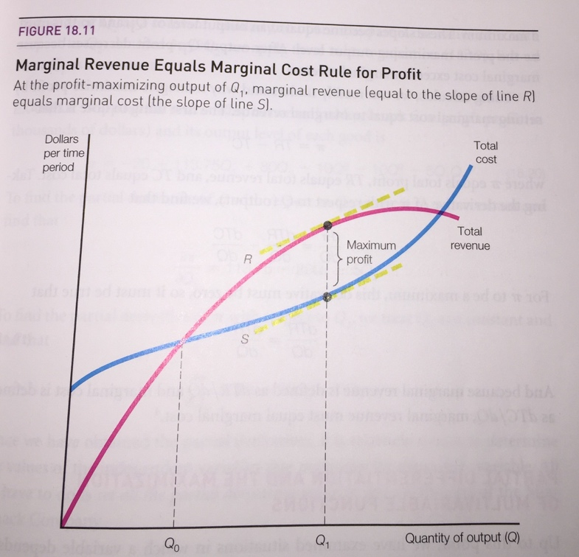

- Calculus of optimization
  - Step 1: make the rate of change = 0

Marginal differentiation & the maximization of multi-variable functions
- EXAMPLE: A company’s profits depend on the amount that it produces of two goods, Q1 & Q2
  - π = f(Q1, Q2) Q1 Output of 1st good, Q2 Output of 2nd good
  - to find the values at which both goods maximize profit, we have to find the derivative while holding the other one constant

Constrained Optimization
- EXAMPLE: Company producing 2 products Q1 + Q2
TC = 4Q₁² +5Q₂²-Q₁Q₂
What output levels of Q₁ & Q₂ will minimize the cost given the combined output of the 2 products is 30/hour
The constraint on the total cost: its subject to Q₁ + Q₂ = 30
Solving the constraint for Q₁ we get Q₁ = 30 – Q₂
Substitute the value of Q₁

LECTURE 6
- EXAMPLE: π = -5 + 20Q – 0.5Q²
  - The curve is increasing. It reaches a maximum then it slows down.
  - When the slope is 0 its at the maximum

Find Q Substitute Q
$\frac{dπ}{dQ}=20-Q$ π = -5 + 20(20) – 0.5(20)²
$Q=20$ π = 195

- If you want to be sure you’re at the maximum, take the 2nd derivative

- EXAMPLE
Q_{d} = 40 - 2P & TC = 0.5Q² , we are looking for the profit maximizing price (MR = MC)
Option 1 | Option 2
- 2P = 40 – Q  - P = 20 – 0.5Q - - - - - multiply by Q to get your total revenue  - TR = 20Q – 0.5Q² - - - - -derivative of TR is MR  - (dTR/dQ) = MR = 20-Q  - MR = MC  - 20 – Q = Q  - 2Q = 20  - Q = 10 | - π = 20Q – 0.5Q²  - (dπ/dQ) = 20 – Q – Q = 0  - 20 = 20Q  - Q = 10

CHAPTER 2: DEMAND THEORY

- Demand is an inverse relationship between price & quantity

Price Elasticity of Demand
- Allows managers, economists & policy makers to understand why consumers in some markets are extremely responsive to a change in price while consumers in other markets are not

The Market Demand Curve
- Market demand schedule P
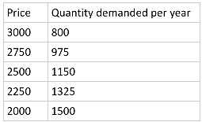 D
Q

Generalized Demand Function
- Q = f (price of x, income, tastes, related goods, advertising expeditions, population etc…)
- If good X is laptop computers, the marker demand function can be written as
Q = b₁P +b₂I +b₃S +b₄A

Q = quantity of laptops demanded during a year
P = average price of laptops during that year
I = per capita disposal income during that year
S = average price of software that year
A = advertising expenditure by producing laptops during that year

- A change in Q due to a change in P is b₁
- A change in Q due to a change in I is b₂
- EXAMPLE
Q = -700P + 200I – 500S + 0.01A
Q = 700P + (200x13000) – (500 x 400) + (0.01 x 50000000)
Q = 2900000 -700P

Solve for P
700P = 2900000 – Q
P = 4143 – 0.00142857

LECTURE 7

