Experiment 1. Verification of Boyle’s Law
Introduction:
A characteristic property of gases is the abundance of empty space between its molecules. This allows us to compress gases through the use of outside pressure, thus altering its volume. Boyle’s Law states that the absolute pressure (P) and volume of a gas (V) are inversely proportional at a constant temperature and fixed mass, and that the product of the absolute pressure and the volume is always constant (K),
P ∝ 1/V K=PV
This is derived from the ideal gas law, PV=nRT, where n represents the number of moles of the gas, and R represents the ideal gas constant.
Boyle’s law applies to the ideal gas model, which is based on the assumptions that the molecules of gas have negligible volume and no forces amongst them. As the pressure of a gas increases, it behaves less like an ideal gas as the molecules become closer to each other, forming intermolecular forces. As well, the molecules start to take up a significant portion of the volume of their container, since intermolecular distances decrease with higher pressures. During the time of Boyle’s publication, the law was unlikely to have many deviations because the technology available could not produce very high pressures. However, the gases in this experiment are assumed to act as an ideal gas.
The purpose of this experiment is to verify Boyle’s law and to determine the value of Boyle’s constant (K). This will be done by varying the volume (the independent variable) through the compression of a syringe, and recording the resultant changes in pressure (the dependant variable) using a gas pressure sensor. The temperature and amount of gas will not be varied.
Procedure:
- Prepare gas pressure sensor and air sample:
- Connect sensor to Lab Quest 2
- Move plunger of syringe to chosen volume and attach syringe to valve of pressure sensor
- Set up Lab Quest 2
- Collect/Plot measurements
- Keep plunger at initial volume mark
- Allow pressure reading to stabilize before entering corresponding volume
- Move plunger to change volume and repeat with pressure readings 6-8 times
- For final volume measurement, move back to original volume
- Decide on a measurement at original volume to keep.

Observations/Data/Results:
Table 1. Data and Results in the verification of Boyle’s Law
Trial Number | Volume (mL) | Pressure (kPa)
1 | 20.8* | 100.91*
2 | 18.8 | 114.08
3 | 16.8 | 125.50
4 | 14.8 | 143.68
5 | 12.8 | 166.40
6 | 10.8 | 199.95
7 | 20.8 | 102.57
*this data point was removed

Figure 1. The relationship between volume and pressure as observed through obtained data
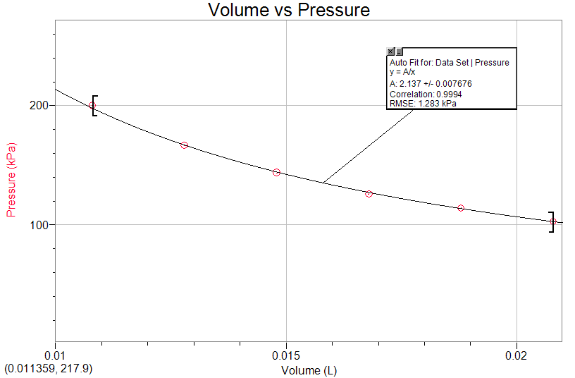

Figure 2. The relationship between volume and pressure on a logarithmic scale as observed through obtained data
Volume vs Pressure
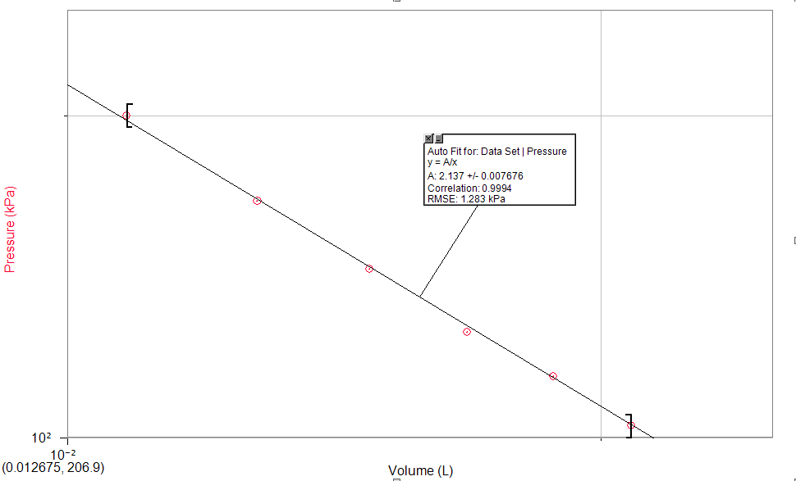
P ∝ 1/V
P= K/V
As observed from the graph, K=2.137

Calculations:
Ex : Trial 3:
PV=nRT
Since the number of moles and the temperature are not being varied, and R is a constant,
PV=K
K = (0.0168L)(125.50 kPa)
K = 2.11 L*kPa

Table 2. K value for each trial
Trial Number | K (P*V)
2 | 2.14
3 | 2.11
4 | 2.13
5 | 2.13
6 | 2.16
7 | 2.13

Discussion:
Boyle’s Law was effectively validated in this experiment. As the volume was decreased through the compression of the syringe, the resulting pressure measured by the gas sensor increased. The results demonstrate that the mathematical relationship between pressure and volume is inversely proportional because the K constant remained very similar from trial to trial. K was determined by multiplying together the pressure and the volume for each trial. Similarly, the resulting graph was a rational function (1/x), with a vertical stretch of K. In the second graph, the graph is plotted using a logarithmic scale to represent volume versus pressure in a linear fashion.
Due to the slight variation in the K value, the results did not demonstrate a perfect inverse relationship. When reading the pressure value in Lab Quest 2, the pressure fluctuated a lot, and rarely attained a constant value. The first and last measurements were taken at the same mark on the syringe. It is important to take multiple readings of the dependant variable for the same value of the independent variable due to this fluctuation causing a variation in the resulting pressure each time. The initial measurement at the initial volume was removed from the results because the data point deviated more from the curve of y=1/x. Thus, multiple measurements at the same value of volume provide more accurate data.
Since Boyle’s law requires a constant temperature, and amount of gas, it is possible that the inconstancy in these factors acted as a source of error. We presumably kept a constant temperature, as nothing was done to change it purposefully. The amount of gas in the syringe also presumably stayed constant, but this is with the assumption that there was no gas leakage. Thus, slight fluctuations in temperature, as well as potential gas leakage (a syringe is not perfectly sealed) are both possible sources of error.
It was also noticed that as the volume of gas decreased, it became increasingly difficult to obtain accurate measurements of the pressure because of the counteracting force of the gas against the syringe at high pressures. The range of volumes that could be measured were therefore very limited, which was amplified by the small size of the syringe. A greater range of the independent variable could have yielded different results.

Conclusion:
The value of Boyle’s law constant, as represented in both graphs, is 2.14 L*kPa. Therefore an equation for Boyle’s Law is P=2.14/V.

References:
Current, John D. Physics Related to Anesthesia. Second Edition, https://books.google.ca/books?id=RgcpOQ444vgC&printsec=frontcover#v=onepage&q&f=false

John Olmsted III, Greg Williams, Robert C. Burk, Chemistry Third Canadian Edition, Chapter 2, Wiley & Sons Canada, Ltd, page 83, 2016

Trefil, James S. The Nature of Science: an A-Z Guide to the Laws and Principles Governing Our Universe. Houghton Mifflin, 2003.
What in the World ISN’T Chemistry, Dr. Rashmi Venkateswaran, 2000, Exp.1, p.1

Raw data:



