Assessment of Learning
Lessons 15: Trigonometric Identities and Equations
- Determine the equivalent positive standard-position angle:
  - $-98°$
RA=$98°$$$360°-RA=Positive Standard-Position Angle \\ 360°-98°=262° is the equivalent Positive Standard-Position Angle$$
  - $-\frac{π}{3}$$$RA=\frac{π}{3} \\ 2π-RA=Positive Standard-Position Angle \\ 2π-\frac{π}{3} \\ =\frac{6π}{3}-\frac{π}{3} \\ =\frac{5π}{3} is the equivalent Positive Standard-Position Angle$$
- Solve, with domain $0≤x≤360°$$$cotθ=1.6 \\ \frac{1}{tanθ}=\frac{1.6}{1}∴\frac{tanθ}{1}=\frac{1}{1.6} \\ tanθ=0.625 \\ θ=\tan^{-1}\left(0.625\right) \\ θ=32°, this is the Standard-Position Angle in the first quadrant \\ Using CAST rule, tanθ will equal 0.625 in quadrants 1 and 3∴ \\ RA=0+SA \left(in first quadrant\right) \\ RA=0°+32° \\ RA=32°, the related acute angle is 32° which can be used to determine the standard-position angle in quadrant 3 (where tanθ is also positive) \\ In quad 3:180°+32°=212° \\ θ=212°, in quadrant 3, the SA is 212°, while in quadrant 1 it is 32°.$$
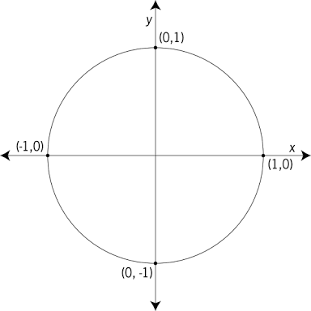
- Use the unit circle to evaluate the following:
$$0°,360°=0,2π$$
$$270°=\frac{3π}{2}$$
$$180°=π$$
$$90°=\frac{π}{2}$$
  - $sin90°$: $\left(x,y\right)=\left(0,1\right)$$$r=1 \\ sin90°=\frac{y}{r}=\frac{1}{1}=1$$
  - $cosπ: \left(x,y\right)=\left(-1,0\right)$$$r=1 \\ cosπ=\frac{x}{r}=-\frac{1}{1}=-1$$
  - $\csc\left(\frac{3π}{2}\right):\left(x,y\right)=\left(0,-1\right), r=1$$$\left(\frac{3π}{2}\right)=θ, \csc{θ=\frac{1}{\sin{θ}}}=\left(\frac{3π}{2}\right)=\frac{r}{y}=\frac{1}{-1}=-1$$
- Convert the following angles from degrees to radians:
  - $220°$$$220°×\frac{π radians}{180°} \\ =\frac{220°}{1}×\frac{π radians}{180°} \\ =\frac{220π}{180}radians \\ =\frac{11π}{9}radians$$
  - $48°$$$48°×\frac{π radians}{180°} \\ =\frac{48π}{180}radians \\ =\frac{4π}{15}radians$$
- Convert the following angles from radians to degrees:
  - $\frac{3π}{4}$$$=\frac{3π radians}{4}×\frac{180°}{π radians} \\ =\frac{3\left(180°\right)}{4} \\ =135°$$
  - $1.5$$$=1.5 radians×\frac{180°}{π radians} \\ ≈86°$$
- Determine the related acute angle for $\frac{7π}{12}.$ In which quadrant does this angle lie?
From looking at the unit circle, it can be determined that
the angle, $\frac{7π}{12}$, is located in the second quadrant
(between $\frac{6π}{12} and\frac{12π}{12}$). Knowing this, the
related acute angle (RA) can be
determined using the formula for
quadrant 2: $RA=π-SA$
$$RA=π-\frac{7π}{12} \\ RA=\frac{12π}{12}-\frac{7π}{12} \\ RA=\frac{5π}{12}, ∴the related acute angle is\frac{5π}{12}.$$
$$π=\frac{12π}{12}$$
$$0, 2π=0,\frac{24π}{12}$$
$$\frac{π}{2}=\frac{6π}{12}$$
$$\frac{3π}{2}=\frac{18π}{12}$$
- Determine the exact value for the following trigonometric ratios:
$$\frac{3π}{2}=\frac{9π}{6}=\frac{6π}{4}$$
$$π=\frac{6π}{6}=\frac{4π}{4}$$
$$0, 2π=0,\frac{12π}{6}=\frac{8π}{4}$$
$$\frac{π}{2}=\frac{3π}{6}=\frac{2π}{4}$$
  - $\tan\left(\frac{5π}{6}\right)$
$$RA=π-\frac{5π}{6} \\ RA=\frac{6π}{6}-\frac{5π}{6} \\ RA=\frac{π}{6}$$For quadrant 2, using CAST rule:
$$\tan\left(\frac{5π}{6}\right)=-\tan{RA} \\ \tan\left(\frac{5π}{6}\right)=-\tan{\frac{π}{6}} \\ \tan\left(\frac{5π}{6}\right)=-\frac{1}{\sqrt{3}}$$
  - $\cos\left(\frac{7π}{4}\right)$In quadrant 4, $RA=2π-\frac{7π}{4}$
$$RA=\frac{8π}{4}-\frac{7π}{4} \\ RA=\frac{π}{4}$$For quadrant 4, using CAST rule:
$$\cos\left(\frac{7π}{4}\right)=+\cos{RA} \\ \cos\left(\frac{7π}{4}\right)=+\cos{\frac{π}{4}} \\ \cos\left(\frac{7π}{4}\right)=\frac{1}{\sqrt{2}}$$
- Use the mapping formula to map the point (0,1) on the graph of $y=\cos{x}$ onto the graph of
$y=3\cos\left(x-5\right)+11$.
$$a=3, k=1, c=11, d=5 \\ \left(x,y\right)→\left(\frac{1}{k}\left(x\right)+d, a\left(y\right)+c\right) \\ \left(0,1\right)→\left(\frac{1}{1}\left(0\right)+5, 3\left(1\right)+11\right) \\ \left(0,1\right)→\left(\left(0\right)+5, 3+11\right) \\ \left(0,1\right)→(5, 14)$$
- Determine the standard-position angle formed by the point (-8,-6).
$$\tan{θ}=\frac{y}{x} \\ y=-6, x=-8 \\ θ=\tan^{-1}\left(\frac{-6}{-8}\right) \\ θ=RA≈37° \\ SA=180°+RA (In third quadrant) \\ SA=180°+37° \\ SA=217°∴the standard-position angle formed by the point \left(-8,-6\right)is around 217°.$$
Special Features: | Value for:$y=tanθ$
$$Period$$ | $$π$$
$$\frac{1}{4}Wave$$ | $$\frac{π}{4}$$
Vertical Asymptotes | $$x=-\frac{3π}{2},-\frac{π}{2},\frac{π}{2},\frac{3π}{2}$$
Domain | $$\{x∈R∣ -2π≤x≤2π, \\ x≠-\frac{3π}{2},-\frac{π}{2},\frac{π}{2},\frac{3π}{2}\}$$
Range | $$\{y∈R\}$$
- 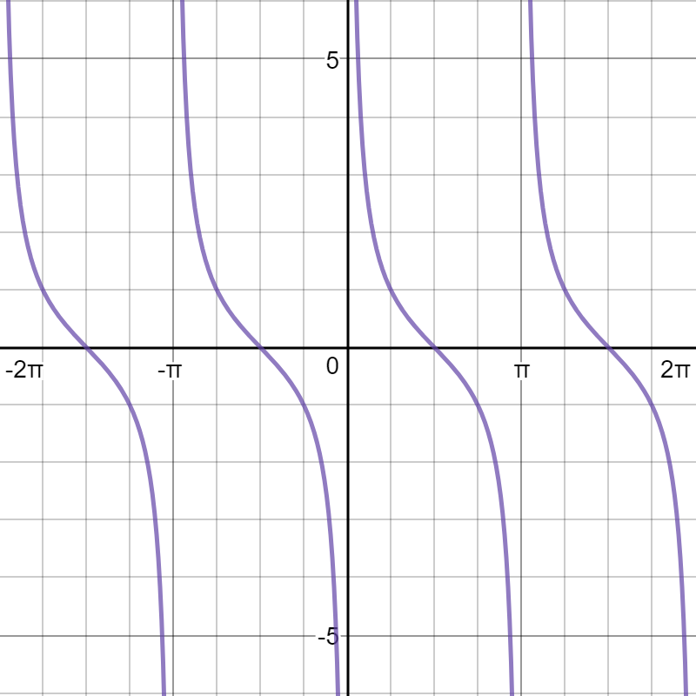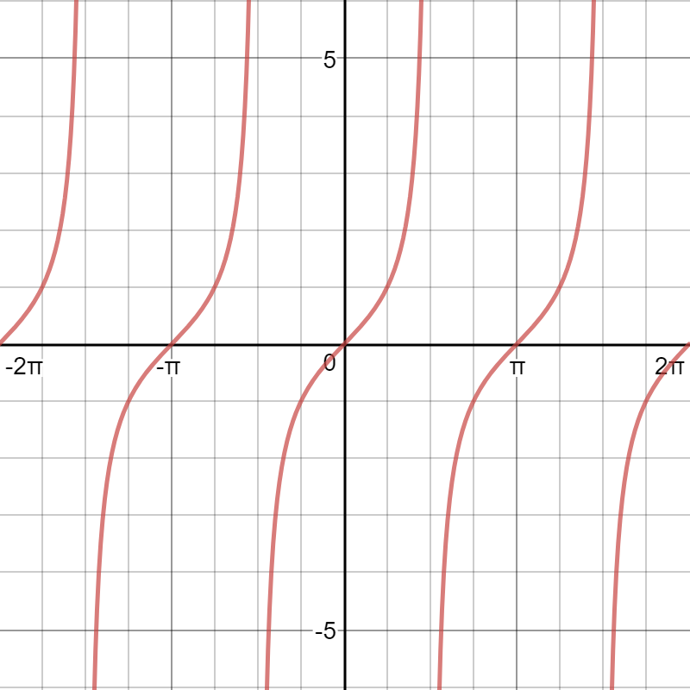Draw $y=\tan{θ}$ and its reciprocal for the interval $-2π≤θ≤2π$. List the special features of each graph.
Graph of y=tan$θ$
Graph of y=cot$θ$
Special Features: | Value for:$y=cotθ$
$$Period$$ | $$π$$
$$\frac{1}{4}Wave$$ | $$\frac{π}{4}$$
Vertical Asymptotes | $$x=-2π,-π,0,π,2π$$
Domain | $$\{x∈R∣ -2π≤x≤2π, \\ x≠-2π,-π,0,π,2π\}$$
Range | $$\{y∈R\}$$

- Using the compound angle formulas, determine the exact value of $\cos\left(\frac{11π}{6}\right)$$$\cos\left(x-y\right)=\cos{x}\cos{y}+\sin{x}\sin{y} \\ \left(\frac{11π}{6}\right)=\left(x-y\right) \\ \left(\frac{11π}{6}\right)=\left(\frac{12π}{6}-\frac{π}{6}\right) \\ \left(\frac{11π}{6}\right)=\left(2π-\frac{π}{6}\right), ∴x=2π, y=\frac{π}{6} \\ \cos\left(2π-\frac{π}{6}\right)=\cos{2π}\cos{\frac{π}{6}}+\sin{2π}\sin{\frac{π}{6}}$$
$$\cos\left(2π-\frac{π}{6}\right)=\left(1\right)\left(\frac{\sqrt{3}}{2}\right)+\left(0\right)\left(\frac{1}{2}\right)$$
$$\cos\left(2π-\frac{π}{6}\right)=\cos\left(\frac{11π}{6}\right)=\frac{\sqrt{3}}{2}, ∴the exact value is \frac{\sqrt{3}}{2}.$$
- Simplify $\cos\left(x+\frac{π}{2}\right)$
$\cos\left(x+y\right)=\cos{x}\cos{y}-\sin{x}\sin{y}$
$$\cos\left(x+\frac{π}{2}\right)=\cos{x}\cos{\frac{π}{2}}-\sin{x}\sin{\frac{π}{2}} \\ \cos\left(x+\frac{π}{2}\right)=\cos{x}\left(0\right)-\sin{x}\left(1\right) \\ \cos\left(x+\frac{π}{2}\right)=\left(0\right)-\sin{x} \\ \cos\left(x+\frac{π}{2}\right)=-\sin{x}$$
- If $\cos{x}=\frac{12}{13}, where 0<x<90°, find the value of\sin\left(2x\right).$
$$\sin\left(2x\right)=2\sin{x}\cos{x} \\ \cos{x}=\frac{12}{13}=\frac{x}{r} \\ x^{2}+y^{2}=r^{2} \\ y^{2}=r^{2}-x^{2} \\ y=\sqrt{r^{2}-x^{2}} \\ y=\sqrt{{13}^{2}-{12}^{2}} \\ y=5 \\ \sin{x}=\frac{y}{r}=\frac{5}{13} \\ \sin\left(2x\right)=2\left(\frac{5}{13}\right)\left(\frac{12}{13}\right) \\ \sin\left(2x\right)=2\left(\frac{60}{169}\right) \\ \sin\left(2x\right)=\left(\frac{120}{169}\right)∴the value of sin\left(2x\right)is\frac{120}{169} or around 0.71.$$
- Solve $2\cos{x}-2=\sin^{2}{x} for the interval 0≤x≤2π.$$$2\cos{x}-2=(1-\cos^{2}{x)} \\ 2\cos{x}-2-(1-\cos^{2}{x)}=0 \\ 2\cos{x}-2-1+\cos^{2}{x}=0 \\ \cos^{2}{x}+2\cos{x}-3=0 \\ \cos^{2}{x}-\cos{x+3}\cos{x}-3=0 \\ \cos{x}\left(\cos{x}-1){+3}(cos{x}-1\right)=0 \\ (cos{x}+3)(cos{x}-1)=0 \\ ∴\cos{x+3}=0,\cos{x-1 }=0 \\ \cos{x=-3} \\ x=\cos^{-1}\left(-3\right)=No solution \\ \cos{x=}1 \\ x=\cos^{-1}\left(1\right) \\ x=0,2π∴the angle x for the interval 0≤x≤2π can have a value of 0 or 2π.$$
- Define the following terms:
  - Identity: an identity is an equation which remains true regardless of the value of any variables contained within it. An identity is proven by showing that the left side and the right side of an equation can be reduced, expanded and/or simplified to appear exactly the same.
  - Compound angle formula: there are four compound angle formulas, representing alternative ways of representing $\cos{θ} or\sin{θ}$ as $\cos\left(x-y\right),\cos\left(x+y\right) and \sin\left(x-y\right),\sin\left(x+y\right)$, respectively. Essentially, the angle ($θ$) is rearranged as the sum or difference of two other angles. The four compound angle formulas are:
$\sin\left(x+y\right)=\sin{x}\cos{y}+\cos{x}\sin{y}$
$$\sin\left(x-y\right)=\sin{x}\cos{y}-\cos{x}\sin{y} \\ \cos\left(x+y\right)=\cos{x}\cos{y}-\sin{x}\sin{y} \\ \cos{(x-y)}=\cos{x}\cos{y}+\sin{x}\sin{y}$$
  - Distributive law: the distributive law states that multiplying a group of numbers added together will yield the same result as multiplying each of the numbers by the same value individually and then adding together the products.
- Answer the following:
  - What is a radian?
A radian is a standard unit of measurement for angles based on the relation between the radius of a circle and the arc created by an angle in the center of the circle, with 1 radian representing an equal arc and radius length. If the arc was to have a length twice that of the radius, the angle created would have a value of 2 radians.
  - Give an example of how the formula $θ=\frac{arc length}{radius}$ might be used to calculate the size of an angle in radians:
Given a hypothetical arc length of $π$ subtending the angle $θ,$ and a radius of 1, the size of the angle could be calculated using the formula $θ=\frac{arc length}{radius}θ=\frac{π}{1}=π$, meaning the angle would have a size of $π$ radians.
- List the values of a, k, c, and d in the equation $y=-4\cos\left(\frac{1}{2}x-\frac{π}{4}\right)-7$, and describe each transformation.
$$y=-4\cos{\frac{1}{2}\left(x-\left(\frac{π}{4}÷\frac{1}{2}\right)\right)}-7 \\ y=-4\cos{\frac{1}{2}\left(x-\left(\frac{π}{4}×\frac{2}{1}\right)\right)}-7 \\ y=-4\cos{\frac{1}{2}\left(x-\left(\frac{2π}{4}\right)\right)}-7 \\ y=-4\cos{\frac{1}{2}\left(x-\frac{π}{2}\right)}-7$$$a=-4$, (amplitude) a vertical stretch by a factor of 4 is applied with a reflection in the x-axis.
$k=\frac{1}{2},$ a horizontal stretch by a factor of 2 is applied.
$c=-7$, a vertical translation of 7 units down is applied, the vertex is now $y=-7$.
$d=\frac{π}{2}$, there is a phase shift (horizontal translation) of $\frac{π}{2}$ units to the right.
- Prove the following identities:
  - $\frac{\sin^{2}{θ}}{1+cosθ}=1-\cos{θ}$
L.S.$=\frac{\sin^{2}{θ}}{1+cosθ}$ R.S.$=1-\cos{θ}$
$$\sin^{2}{θ=1-\cos^{2}{θ∴}} \\ =\frac{{1-cos}^{2}{θ}}{1+cosθ} \\ x^{2}-y^{2}=\left(x-y\right)\left(x+y\right) \\ 1-\cos^{2}{θ}=(1-\cos{θ)(1+\cos{θ)}} \\ =\frac{(1-\cos{θ)(1+\cos{θ)}}}{1+cosθ} \\ =1-\cos{θ} \\ ∴ LS=RS; \frac{\sin^{2}{θ}}{1+cosθ}=1-\cos{θ} is a true identity.$$
  - $\frac{\cos\left(2x\right)+1}{\sin\left(2x\right)}=\cot{x}$L.S.$=\frac{\cos\left(2x\right)+1}{\sin\left(2x\right)}$ R.S.$=\cot{x}$
$=\frac{{{(cos}^{2}{x}-sin}^{2}{x)+}1}{\left(2\sin{x}\cos{x}\right)}$ $=\frac{1}{\tan{x}}$
$=\frac{{{(cos}^{2}{x}-(1-cos}^{2}{x))+}1}{\left(2\sin{x}\cos{x}\right)}$ $=\frac{\cos{x}}{\sin{x}}$
$=\frac{{{(cos}^{2}{x}-1+cos}^{2}{x)+}1}{\left(2\sin{x}\cos{x}\right)}$
$$=\frac{{2cos}^{2}{x}}{2\sin{x}\cos{x}} \\ =\frac{\cos^{2}{x}}{\sin{x}\cos{x}} \\ =\frac{\cos{x}}{\sin{x}} \\ ∴ LS=RS; \frac{\cos\left(2x\right)+1}{\sin\left(2x\right)}=\cot{x} is a true identity$$
- Calculate the amplitude, period, $\frac{1}{4}$ wave, axis, phase shift, domain, and range of the function $f\left(x\right)=2\sin{\frac{2}{3}(x}+π)+5$. Draw a graph of the function.
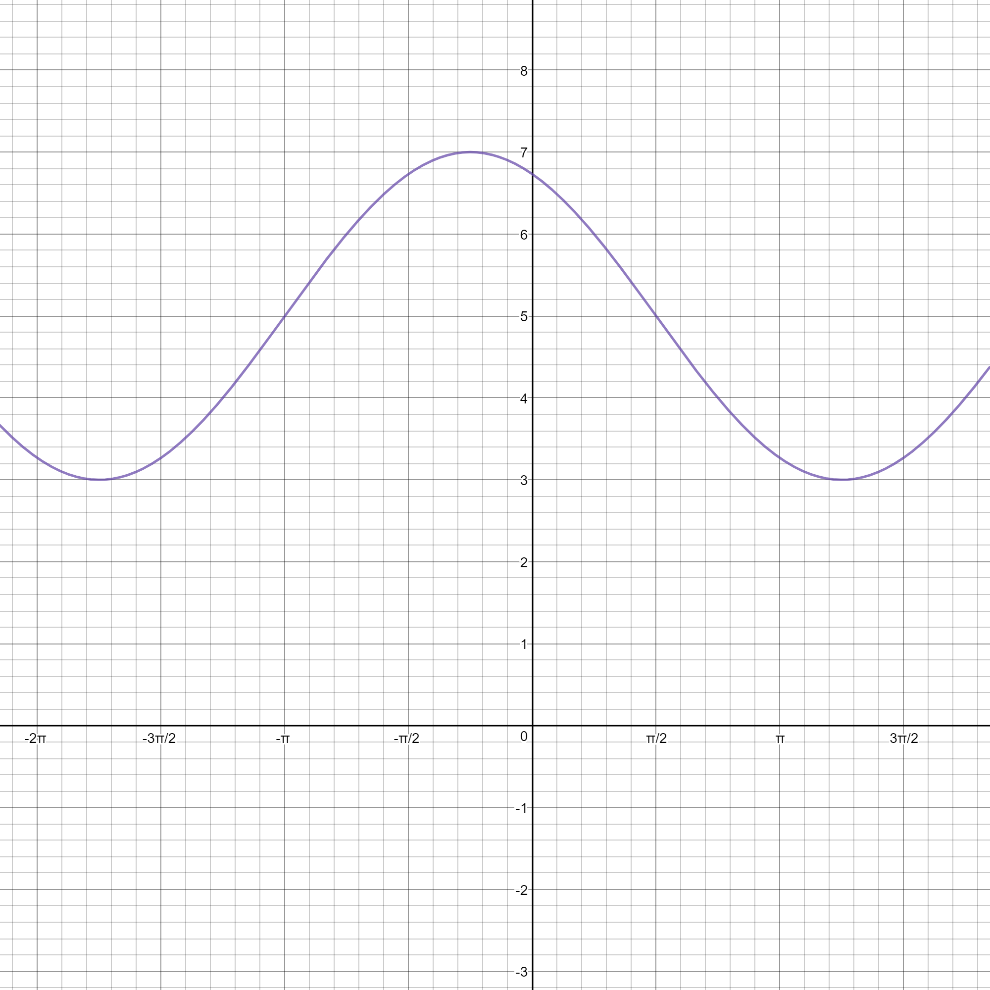
Graph of a Transformed Sine Function

Feature | Value
Amplitude | a=2
Period | $$P=\frac{2π}{k},P=\frac{2π}{\frac{2}{3}}=\frac{6π}{2}$$$P=3π$
$\frac{1}{4}$ wave | $$\frac{3π}{4}$$
Axis | $y=5$ ($c=5$)
Phase shift | $d=-π$ ($π$units to the left)
Domain | $$\{x∈R\}$$
Range | $$\{y∈R∣3≤y≤7\}$$

- 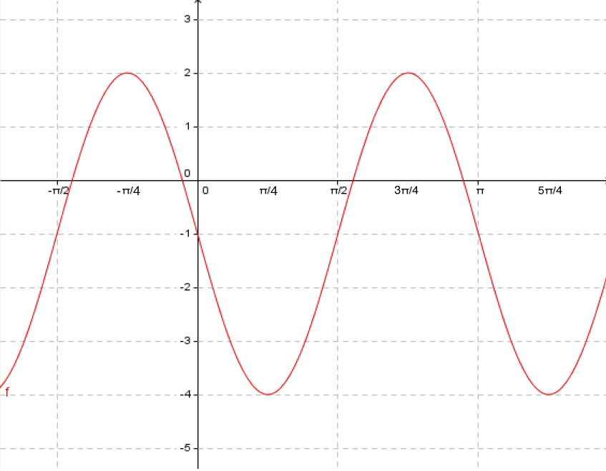Determine the equation of the graph with a starting point of (0,-1).
  - This equation will be written in terms of sine.
  - $Amplitude=\frac{maximum-minimum}{2}$$$Amplitude=\frac{2-\left(-4\right)}{2}=\frac{6}{2} \\ Amplitude=3 with reflection in x-axis \\ ∴a=-3$$
  - $P=π, P=\frac{2π}{k}$$$k=\frac{2π}{P}, k=\frac{2π}{π} \\ k=2$$
  - $Formula for axis: y=\frac{maximum+minimum}{2}$$$y=\frac{2+\left(-4\right)}{2}=-\frac{2}{2}, y=-1∴c=-1 \\ (vertical translation 1 unit down)$$
  - There is no phase shift $∴d=0$
Putting all this information together: $y=\operatorname{asin}\left[k\left(x-d\right)\right]+c$$$y=-3sin{(2x)}-1$$
- The blade on a windmill takes 8 seconds to make a full rotation. Each blade is 2 metres in length. At their lowest point the blades are 1.5 m above the ground.
  - Determine the maximum height of the blades above the ground:
$$radius=2m, diameter=2r=2\left(2\right)m=4m \\ Maximum height=Diameter+minimum height \\ Maximum height=4m+1.5m \\ Maximum height=5.5m,∴the maximum height of the blades above the ground would be 5.5 metres$$
  - 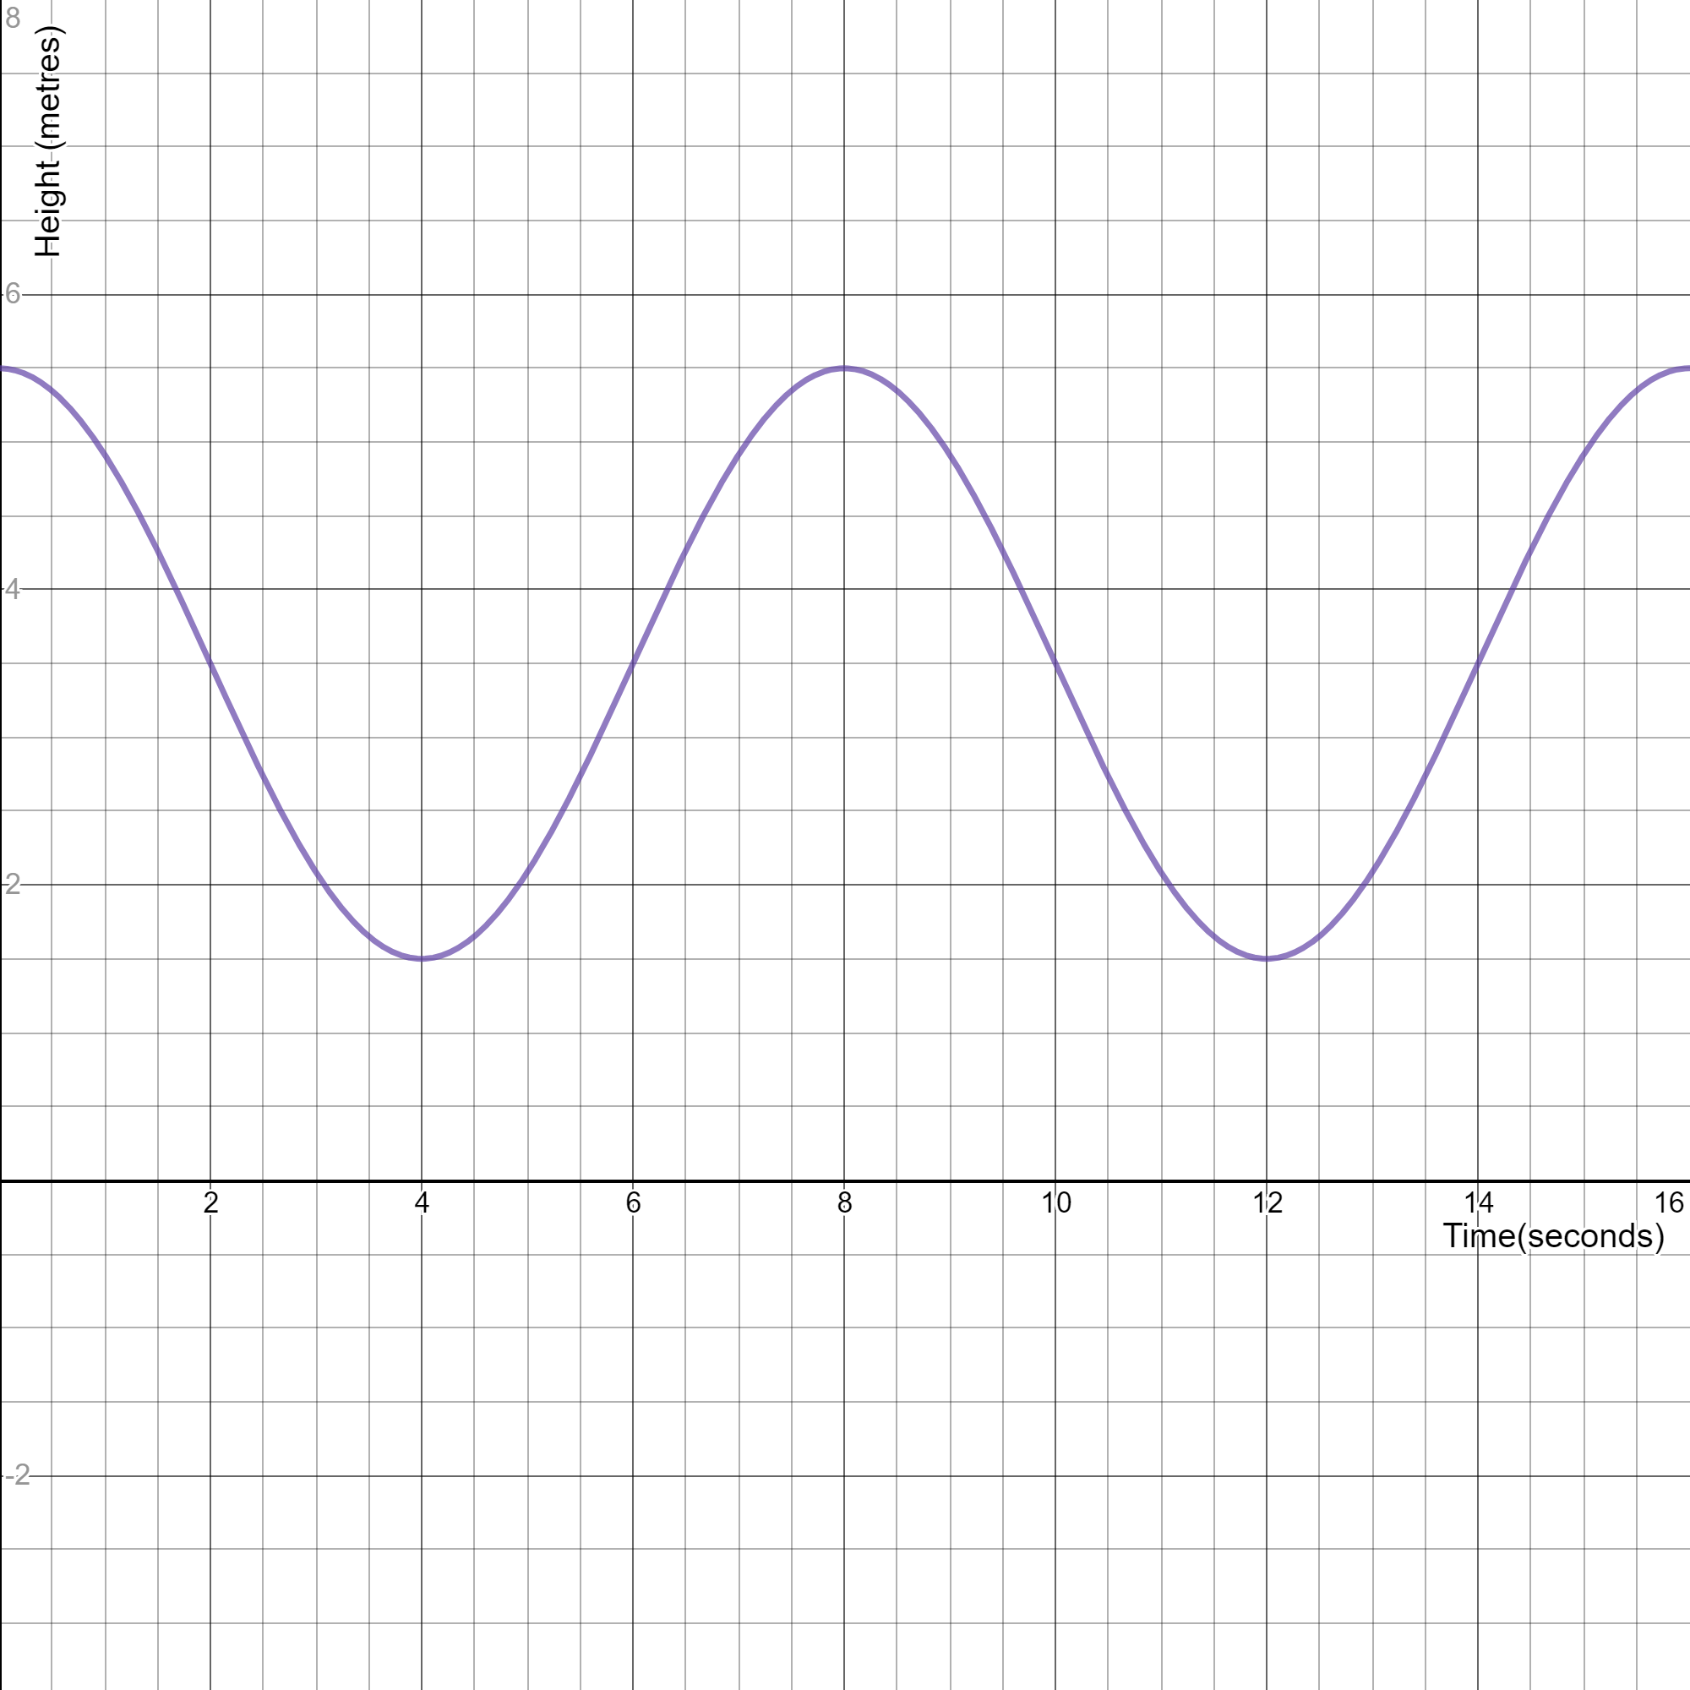If one blade starts at the maximum height, sketch a graph of the height of the blade in relation to the time it takes the blade to make two complete rotations.
$$axis: y=\frac{maxiumum+minimum}{2}=\frac{5.5+1.5}{2}=\frac{7}{2} \\ ∴c=3.5, d=0(no phase shift) \\ P=\frac{2π}{k}=8s \\ ∴k=\frac{2π}{8}=\frac{π}{4}$$$a=\frac{maxiumum-minimum}{2}=\frac{5.5-1.5}{2}$$=\frac{4}{2}$$$a=2$$
Graph of a Windmill Blade’s Height over Two Revolutions
  - Determine the equation of the graph.
1. This is a cosine curve with no phase shift, and no reflections.2. $axis:y=\frac{max+min}{2}$$$=\frac{5.5+1.5}{2}=\frac{7}{2} \\ ∴c=3.5$$3. $d=0 \left(no phase shift\right)$
4. $k=\frac{2π}{P}=\frac{2π}{8}$$$k=\frac{π}{4}$$5. $a=\frac{max-min}{2}=\frac{5.5-1.5}{2}=\frac{4}{2}$$$a=2 \\ h(x)=\operatorname{acos}\left[k\left(x-d\right)\right]+c \\ ∴h(x)=2cos\left(\frac{π}{4}x\right)+3.5$$
  - How high is the tip of the blade at 7 seconds?
$$h\left(7\right)=2cos\left(\frac{π}{4}\left(7\right)\right)+3.5 \\ h(7)=2cos\left(\frac{π}{4}\left(7\right)\right)+3.5 \\ \cos{\frac{7π}{4}}=+\cos{RA} \left(using CAST rule for fourth quadrant\right) \\ RA=2π-\frac{7π}{4}=\frac{8π}{4}-\frac{7π}{4}=\frac{π}{4} \\ \cos{\frac{π}{4}}=\frac{1}{\sqrt{2}} \\ h\left(7\right)=2\left(\frac{1}{\sqrt{2}}\right)+3.5 \\ h\left(7\right)=\left(\frac{2}{\sqrt{2}}\right)+3.5 \\ h\left(7\right)=\sqrt{2}+3.5 \\ h\left(7\right)=4.9m ∴the height of the tip of the blade at 7 seconds is around 4.9 metres above the ground.$$
  - At what point during the first revolution is the blade 4.5 metres above the ground?
$$4.5=2\cos\left(\frac{π}{4}x\right)+3.5 \\ 4.5-3.5=2\cos\left(\frac{π}{4}x\right)+3.5-3.5 \\ 1=2\cos\left(\frac{π}{4}x\right) \\ \frac{1}{2}=\frac{2\cos\left(\frac{π}{4}x\right)}{2} \\ \frac{1}{2}=\cos\left(\frac{π}{4}x\right) \\ Let a=\left(\frac{π}{4}\left(x\right)\right) \\ \frac{1}{2}=\cos\left(a\right) \\ Using special triangles and CAST rule, the value of the possible angles can be determined in the first \\ and fourth quadrant \left(where cosRA is positive\right) \\ \cos\left(\frac{π}{3}\right)=\frac{1}{2} \\ 0+\frac{π}{3}=\frac{π}{3} \left(First quadrant\right) \\ 2π-\frac{π}{3}=\frac{6π}{3}-\frac{π}{3}=\frac{5π}{3}\left(Fourth quadrant\right) \\ ∴a=\frac{π}{3} or \frac{5π}{3} \\ \left(\frac{π}{4}\left(x\right)\right)=\frac{π}{3} \\ x=\frac{π}{3}÷\frac{π}{4} \\ x=\frac{π}{3}×\frac{4}{π} \\ x=\frac{4π}{3π} \\ x=\frac{4}{3}≅1.3 seconds \\ \left(\frac{π}{4}\left(x\right)\right)=\frac{5π}{3} \\ x=\frac{5π}{3}÷\frac{π}{4} \\ x=\frac{5π}{3}×\frac{4}{π} \\ x=\frac{20π}{3π} \\ x=\frac{20}{3}≅6.7 seconds \\ ∴Within the first revolution of 8 seconds, the blade is 4.5 metres above the ground \\ after approximately 1.3 seconds and 6.7 seconds.$$

