CHAPTER 1: THE PURPOSE OF A FINANCIAL STATEMENT
1.1 - Identifying the uses and users of accounting information
- Accounting: a system that records the economic events of a company, and then communicates them to interested users.
- Internal users
  - Anyone within the company (position management) that has access to accounting information, which they use to make decisions on how to manage the company
- External users
  - Only have access to the information made public by the company
  - Investors: to know whether or not they should buy or sell shares
  - Leaders: bankers have to know whether or not the firm will be able to pay back loans
  - Creditors: to decide whether or not to grant credit
- Ethics: it’s important for people to act morally, legally and responsibly, while considering the organization’s best interest

1.2- Describe the primary forms of business organization
- Proprietorships
  - Owned by 1 person who has unlimited liability to the business (the owner receives any income, loss, and is personally responsible for any debts)
  - Income is reported as self-employment & taxed on personal income tax
  - Reporting entity concept: separation of business & personal records
- Partnerships
  - Owned by 2+ people who have unlimited liability to the business (partners are liable for debts caused by either of them)
  - There must be a formalized partnership agreement
  - Income reported as self-employment & taxed on personal income tax
  - Reporting entity concept
- Corporations
  - Separate legal entity owned by shareholders (you can invest a small amount)
  - Advantages:
    - Life is indefinite
    - Buying shares in a large corporation rather than a proprietorship/partnership is more attractive because they are easier to sell
    - Shareholders are not responsible for debts
  - Public
    - Required to distribute their financial statements to the public quarterly & yearly
    - Use IFRS
  - Private
    - Issue shares but do not make them public/appear on stock exchange
    - ASPE
    - Use IFRS for 3 reasons
          - In case they want to enter public sector in the future
          - To be able to compare financial results with competitors that use IFRS
          - Foreign subsidiaries that are required to use IFRS

- Generally accepted accounting principles (GAAP)
- Rules on how to prepare financial statements

1.3 – Business Activities
- Financing activities
  - Primary ways of raising funds: issuing shares & borrowing money
  - Financing provided by lenders & creditors is riskier than financing provided by shareholders because debt must be paid back at a specific point in time
  - The first transaction when starting a corporation is selling shares
  - Common shares: amount payed by investors
  - If a corporation ceased activities, it would pay back all its debts before the shareholders would have any right to a capital return
  - Dividends: a portion of income distributed to shareholders
  - Bank indebtedness: overdrawing from bank account
  - Short-term borrowing: bank loan payable
  - Long-term borrowing
- Mortgages payable, bonds payable, finance lease obligations

Inflows | Outflows
- Issuing shares  - taking out loans | - Paying dividends  - Repurchasing shares  - Repaying loans

2. Investing activities
- Purchase or sale of long-lived assets that a company needs to operate
- Goodwill: when a company buys another company but payed a price higher than the value of the purchased company’s net identifiable assets
Inflows | Outflows
- Buying long-lived assets  - Buying shares of other companies | - Proceeds from selling long-lived assets & shares in other companies

3. Operating activities
- Day to day activity of the business
- Income results from an increase in an asset but sometimes a decrease in liability
- This is the result of the sale of a G or S
  - Account receivable: when credit is extended to a customer, this means they can pay at a later date
  - Expenses
            - Decreases in economic resources
            - Cost of goods sold, selling, operating, administrative expense, interest expense, income tax expense
          - Goal of every business: sell G or S at a price higher than the cost of production

Inflows | Outflows
- Revenues  - Collection of receivables  - Sale of G or S | - Expenses  - Payment of payables  - Purchase of inventory & supply

1.4– Describe the purpose and content of each of the financial statements
1)Income statement
    - Reports revenues & expenses which demonstrate a company’s performance over a period of time
    - Lists revenues first then expenses

2)Statement of changes in equity
  - Shows a change in each component of shareholders’ equity for the period

  - Shareholders’ equity:
    - Share capital: amounts contributed by shareholders
    - Retained earnings: cumulative amounts of net income that have been retained in the corporation
        - If retained earnings is negative then
net loss > net income
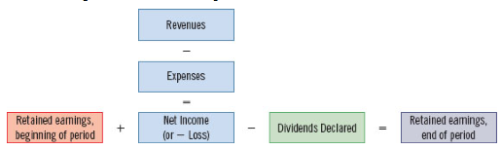
    - Share capital + retained earnings

- Did a company pay out earnings or keep them?
3)Statement of financial position (balance sheet)
  - Presents a company’s assets, liabilities & shareholders’ equity at a given point in time
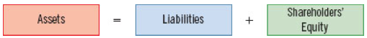

  - External users reference this document to see whether or not the company will be able to repay loans

4)Statement of cash flows
  - Shows where a company obtained cash and how it was used during a specific period of time
  - Reports the effects of cash on the company’s business activities (1.3)
  - If a company has to pay back debts at the end of the month, this statement is looked at

- Relationships between statements
  - Changes in equity & income statement: net income is added to the beginning amount of retained earnings in order to determine ending retained earnings
  - Financial position & changes in equity: the changes in equity reported at the end of the month on its respective statement are then reported in the shareholders’ equity section of the balance sheet
  - Cash flows & financial position: the ending amount of cash shown on the statement of cash flows agrees with the amount of cash shown in the assets section of the balance sheet
- Annual report
  - Document including financial & non-financial (mission, goals, products etc) info about a company during the previous fiscal year
  - Financial info:
      - Management discussion & analysis (MD&A) provides management’s perspective on firm’s financial results
      - Forward looking perspectives, auditors’ reports, financial statements

- Relationships between statements
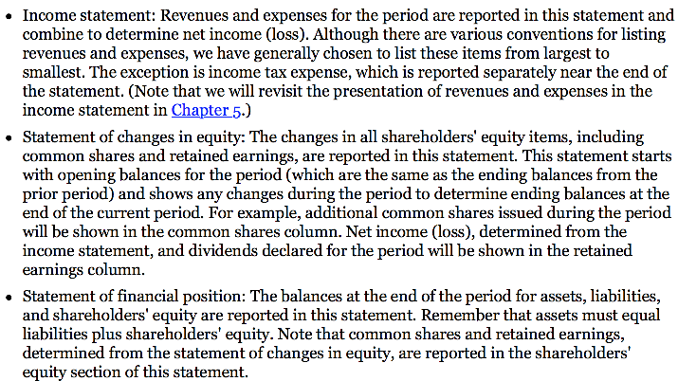
- Expanded accounting equation
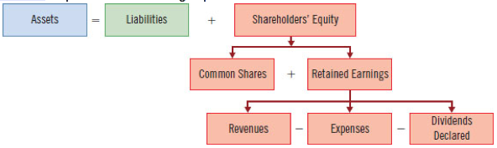

CHAPTER 2: A FURTHER LOOK AT FINANCIAL STATEMENTS
2.1 – Identify the sections of a classified statement of financial accounting
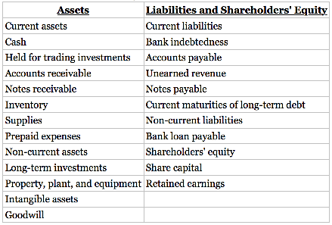
- Financial statements help readers asses
  - Does the company have enough assets to pay off their debts as they're due
  - The claims of short-term and long-term creditors & lenders on the company’s total assets

- Operating cycle
- Average period of time it takes for a business to pay cash to obtain products or services & then receive cash from customers for them
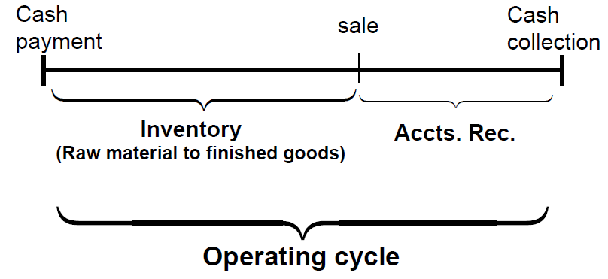

- Assets
- Resources that a company owns that will provide future economic benefits
- Current assets
    - Expected to be converted into cash or be sold within one year of the company’s financial statement date or operating cycle, whichever is longer
    - Common types:
- Cash
- Held for trading investments: investments in debt securities such as bonds of another company, equity securities such as shares of another company, that are both with the intention of reselling them after a short period of time in order to make income from fluctuations in their price
- Accounts receivable: amounts owed to companies by consumers who purchased G or S
- Notes receivable: amounts owed to company by consumers supported by a written promise to repay
- Inventory: goods held for sale to customers
- Prepaid expenses: represent costs of things like insurance payed in advance of use
- Prepaid expenses

- List in the order of their liquidity

- Non-current assets
  - Not expected to be converted into cash, sold or used up by the business within one year of the company’s financial statement date or operating cycle, whichever is longer

  - Common types
- Long term investments: multi-year investments in debt securities (loans, notes, bonds that management holds to earn interest) & equity securities (shares in other companies)
- Property, plant & equipment: tangible assets with long, useful lives that are being used to operate the business. Listed in order of longest useful life (land is first). Because they benefit future periods, their cost is allocated through depreciation.
- Intangible
- Goodwill: represents a value not attributable to any recorded asset or liability and relates to something intangible like the reputation of the company and the quality of its employees
$$goodwill =price paid for the company-value of net assets acquired$$

- Intangible assets
  - Non-current assets that do not have physical substance and represent a privilege or right held by the company
  - Ex: patents, copyrights, trademarks, licenses
  - Generate future value to the firm
  - Amortized if they have a definite life
- Depreciation:
  - Allocation of the plant, and equipment over their estimated useful lives
    - Companies assign a portion of the cost of an asset to expense each year
- Accumulated depreciation account shows the total amount of depreciation taken to date and it will be reported as a contra-asset
  - Only assets with finite lives are depreciated
  - Reported on the SFP at a cost less than their accumulated depreciation
$$carrying amount=cost-accumulated depreciation$$
(amount left to pay)
- Liabilities
  - Obligations that result from past transactions and will result in the transfer of an economic resource
  - Current liabilities:

2.2 – Identify and calculate ratios for analyzing a company’s liquidity, solvency & profitability
- Ratio analysis
  - Expresses the relationships between selected items of financial statement data
  - Give clues about underlying conditions that might not be easy to see when items of a particular ratio are examined separately

- Liquidity ratios
  - measure a company’s short-term ability to pay its debts & to meet unexpected needs for cash
  - when working capital is (+): greater likelihood that a company will be able to pay liabilities on time
  - when working capital is (-): less likely that the company will be able to pay on time
  - **CR makes it possible to compare companies of different sizes
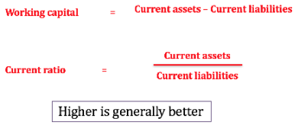

- Solvency ratios
  - Measure a company’s ability to survive over a long period of time by having enough assets to settle its liabilities when they are due
  - The higher the percentage of debt to total assets, the greater the risk that debts can’t be repaid when due
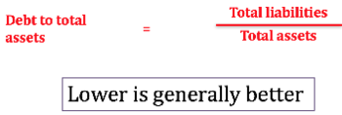

- Profitability ratios
  - measure a company’s operating success for a given period of time
    - Earnings per share
      - At the bottom of the income statement it is mandatory to report earnings per share
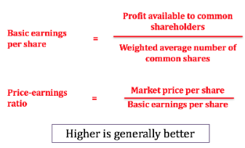
    - CS: common share
    - Better to look at the PE ratio (market price/EPS)
    - Incomplete indicator: we don’t know the price of stock, nor the amount of investment
      - You can compare it historically (only if no stock splits, share repurchases…)

- Comparisons
  - Intracompany comparisons: covering 2+ periods for the same company
  - Intercompany comparisons: based on comparisons with a competitor in the same industry
  - Industry average comparisons: based on average ratios for particular industries with specific company ratios

- The going concern assumption
  - The assumption that a business will continue operating for the foreseeable future

CHAPTER 3: THE ACCOUNTING INFORMATION SYSTEM
3.1 – Analyze the effect of transactions on the accounting equation
- Accounting system
  - The system used to collect & process transaction data and communicate financial information to decision makers
- Accounting transaction
  - Occurs when an economic event results in a company’s financial position (assets, liabilities, or share holders’ equity) changing in a measurable way

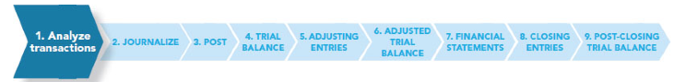

- Analyzing transactions
  - Is only recorded if the financial position of a company is changed
  - Ex: 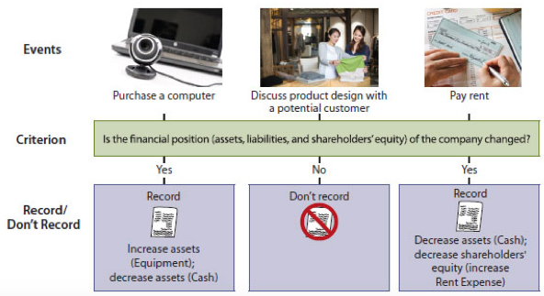

  - Some possible transactions: see page 108 of textbook

- Summary of transactions
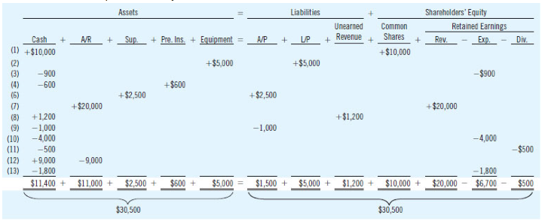

3.2 – How accounts, debits & credits are used to record transactions
- T Accounts
  - Title of the account, debit side (left), credit side (right)
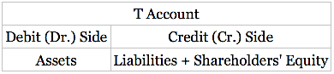
- Normal balances and debit and credit effects
  - Normal balance: the side that is used to increase the account
- Assets
  - Increases in assets are entered on the debit side & decreases in assets are entered on the credit side
  - Accounts are increased by debits & decreased by credits
  - If debit > credit, the account has a debit balance
  - If credit > debit, the account has a credit balance
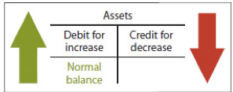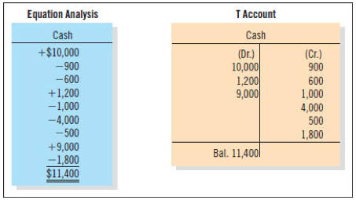

  - HINT: increases in expense & dividends declared accounts are recorded by normal debit balances

- Liabilities
  - Increased liabilities are entered on the credit side & decreases in liabilities are entered on the debit side
  - Accounts are increased by credits & decreased by debits
  - HINT: increases in liability accounts are recorded by credits & liability account credit balances
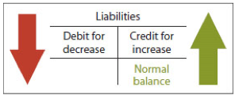
- Shareholders’ equity
  - Increases in shareholder’s equity
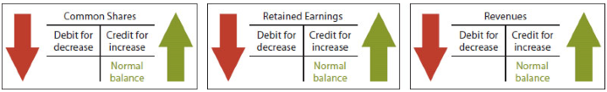
- Decreases in shareholder’s equity
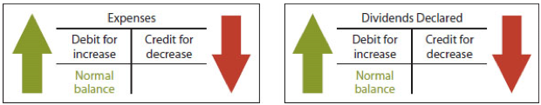
- Summary
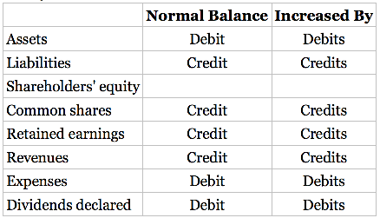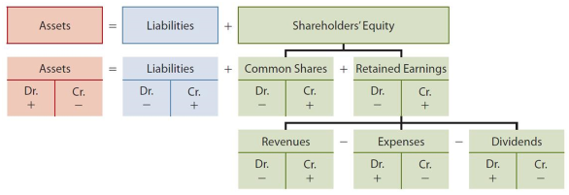

2. Journalize the transactions
- It discloses the complete effect of a transaction in one place
- Provides chronological record of transactions
- Helps prevent location errors because debit & credit amounts can be quickly compared
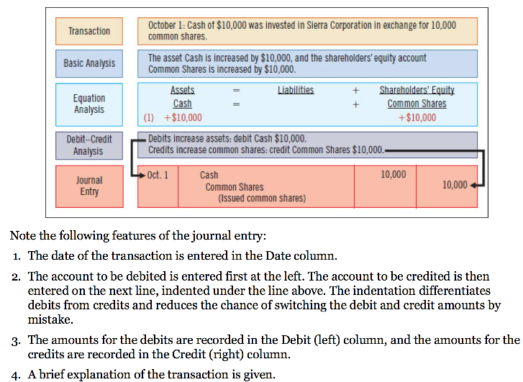

3. Post Transactions to the General Ledger
- General ledger contains all asset, liabilities, shareholders’ equity, dividends declared, revenue & expense accounts
- Arranged in the order that accounts are presented in the financial statements, starting with SFP accounts (order is as listed in the previous point)
- Chart of accounts
  - The framework for the accounting IS
  - A table of content for the ledger
  - Starts with SFP, followed by income statement

  - Ex:
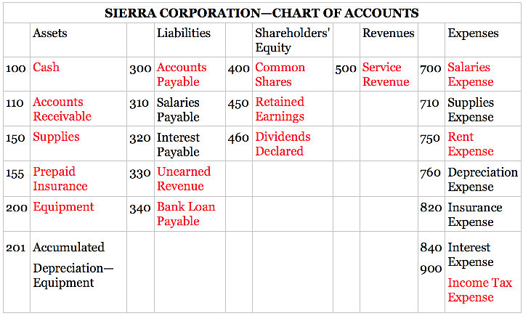

- Posting
  - Transferring journal entries from the general journal to the general ledger accounts
  - Done in chronological order
  - Ex: the date & amount shown on the first line of a general journal entry is entered in the debit column of the appropriate account in the GL. The same is done for the credit side of the entry.
  - Possible cases: see page 126 of textbook

4. Prepare a Trial Balance
- Procedure
  - List the account titles & their balances in the same order as the general ledger & chart of accounts
  - Enter debit balances on the left & credit balances on the right
  - Total both columns to ensure they are equal

  - Ex:
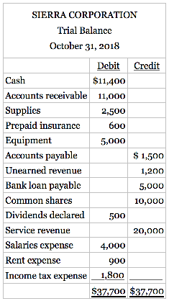

- Limitations of a trial balance
  - If the sum of debit & credit don’t agree, we can spot the problem using a trial balance
  - Solutions
    - Regardless of the error size, re-add the columns
    - If the error can be evenly divided by 2, scan the trial balance to see if a balance equal to half the error has been entered in the wrong column
    - If the error can evenly be divided by 9, retrace the account balances to see if they have been incorrectly copied from the edger.
    - If the error can’t be evenly divided by 2 or 9, scan the ledger to see if an account balance in the amount of the error has been omitted
  - Problem: the trial balance might still balance when
    - A transaction is not journalized
    - A correct journal entry is not posted
    - Journal entry is posted twice
    - Incorrect accounts are used in journalizing or posting
    - Errors that cancel each other’s effects are made

- The Accounting Cycle (review)
  - P.135 textbook
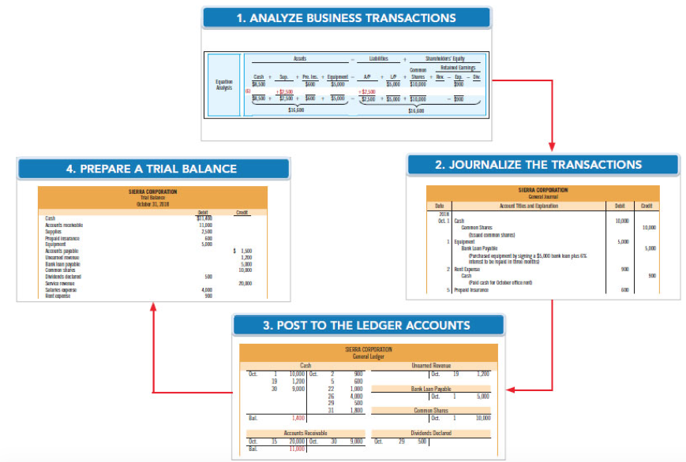

POSSIBLE EXAM QUESTION: Here’s an error, what are the implications? How does it affect the ratio? How does it affect the accounting equation?

