Assignment 1
Business Interaction with its broader Economic, Social and Environmental Context

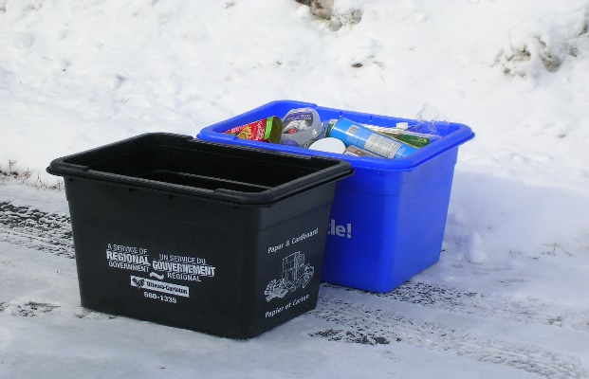
This is an example of how business interacts with environmental context. These two bins are used to help recycle paper and plastic. The black bin is used for papers while the blue bin is used for plastics. By businesses providing these two bins the environment becomes greatly improved. People will start to recycle papers and plastics where they will be reused. This will help prevent pollution and make the environment clean and safe. By keeping the environment safe and clean no harm will come to the animals living in the wild or the plants consumed by humans. These bins are provided in Schools, universities, homes, shops, etc. With that in mind you can see how businesses interact with environmental context on the level of recycling and keeping the environment safe.

This is an example of how business interacts with the economy. Giant tiger is known for having great deals for low prices. Giant tiger provides everything a person would need including clothes, food, kitchen items, toys, school supplies, etc. The quality of their product is good and they are priced reasonably. A lot of people would consider shopping there for the things they need. Giant Tiger’s products will be on high demand which will lead to the economy’s growth. With the economy’s growth, the country would prosper. With this in mind you can see how businesses interact with the economy.


This is an example of how business interacts with social context. Facebook is one of the most used social media’s in today’s age. It is an online social networking service that is greatly used to connect with other people and to advertise products. Businesses can use Facebook as a marketing technique to advertise their products and earn a customer base. This will help businesses grow globally. With this in mind you can see how businesses connect with people on a social media platform.

