A1-1
True, opportunity cost occurs when there is a loss of a potential gain from the next best alternative. Therefore, the opportunity cost of the concert in Toronto would be the next best thing you would have done if you didn’t go. SO

A1-2

True, when this individual takes on his part-time job, he/she is participating in the factor market because the individual is selling the service of the factor to the market. When he/she gets enough money to buy the latest iPhone he/she is participating in the goods market as he is buying an item which a producer is selling. This is linked to the flow of income and expenditure.
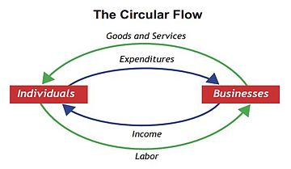

Picture taken from: https://upload.wikimedia.org/wikipedia/commons/thumb/8/8f/Circular_flow_of_income_and_expenditure.jpg/360px-Circular_flow_of_income_and_expenditure.jpg

A1-3
False. Positive statements are statements that have no value judgements in them. Furthermore, they are not statements about “what ought to be” but rather they are statements about “what actually is”. Which means existing evidence can be used to prove the validity of the statement. Although the first two parts of the statement may be considered positive as they can be tested through statistics and censuses, the last part of the statement has an opinion in it and therefore not allowing it to be a positive statement.

A1-4
True, since the graph is concave to its origin it indicates to us that the opportunity cost will rise as either good increases and as the amount of it that we produce increases. As we move down the PPB, the more resources allocated toward Canadian Defense the extra output gets smaller, so more of “other goods” has to be given up increasing the Canadian defense spending.

A1-5
False,
This statement is false because if a Prof A has an absolute advantage in both then it is not possible for him to have a comparative advantage too. What having a comparative advantage indicates to us is that there is a lower opportunity cost. For this scenario, Prof B is the one who has the comparative advantage for the preparation of assignments if Prof A has a comparative advantage of production of webpages (losing fewer assignments).

A1-6
True,
Since Kijiji is an online market in which sellers decide the price according to each product, we cannot predict any price of the good but only the quantity because of Kijijis convenience. The sellers may have an exact price that they want the buyers to pay or they may involve the system of setting up auctions in which the highest bidder wins the item.

A1-7
False,
The items tea and coffee are not compliments of each other, rather they are substitutes of one another. So, if tea comes more expensive relative to coffee, consumers will just switch to coffee increasing the demand causing a rightward shift in the demand curve.
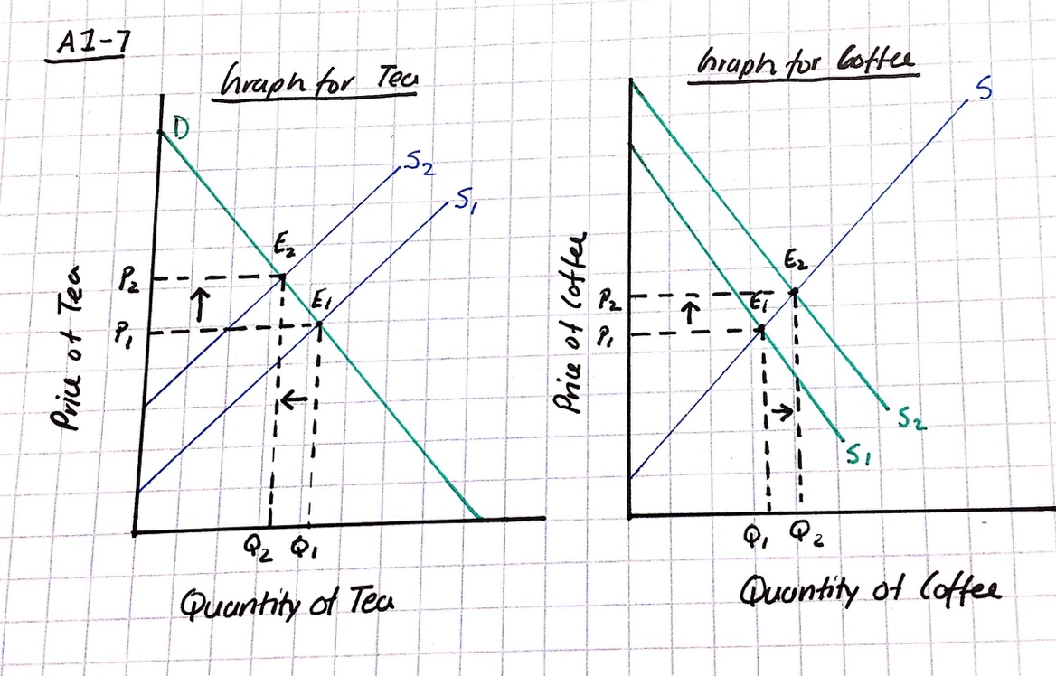

A1-8
False, a decrease in price would cause the quantity traded to increase. As represented in the graph below the supply curve moves rightward along the demand curve. When the price drops from P₁ to P₂ the quantity traded at the equilibrium increases from Q₁ to Q₂, also setting a new equilibrium at E₂. Both price and quantity are outcomes of the market fluctuations.
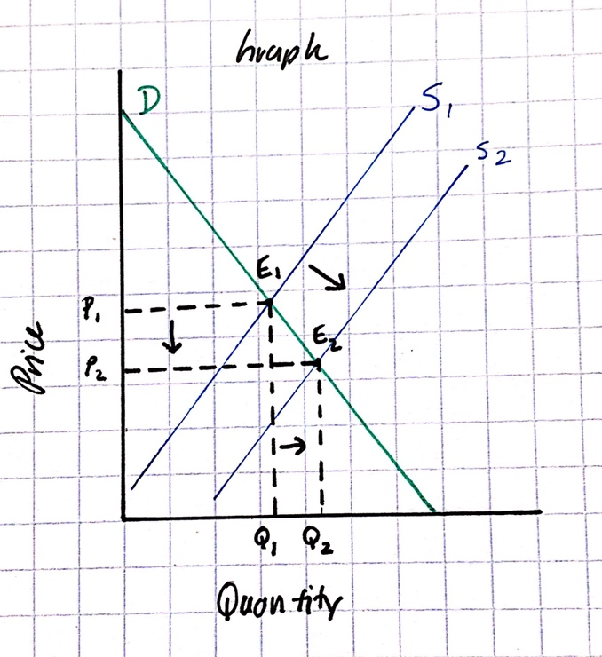

A1-9
a)

b) If this economy was in autarky and it chose to produce at point C, the opportunity cost of x is 1.5y.

c) Suppose this economy opens to trade with the rest of the world at a price ratio such that each unit of x costs 2 units of y. Explain why domestic producers would begin to produce more x and less y.

If this country was to reallocate its resources to produce more of x than y, then the country would increase its profits from trade. If they are to trade in some of their x for other country’s y then they would have more of both x and y compared to what they would have had if they continued in their old production. This is a matter of having advantages over another country so that you can benefit.

d)
Since the country now has a ratio of 1x to 2y it would consume more of both x and y. As it can be seen in the graph below this country now consumes more of both products.

x | y
10 | 20
20 | 40
30 | 60
40 | 80
50 | 100

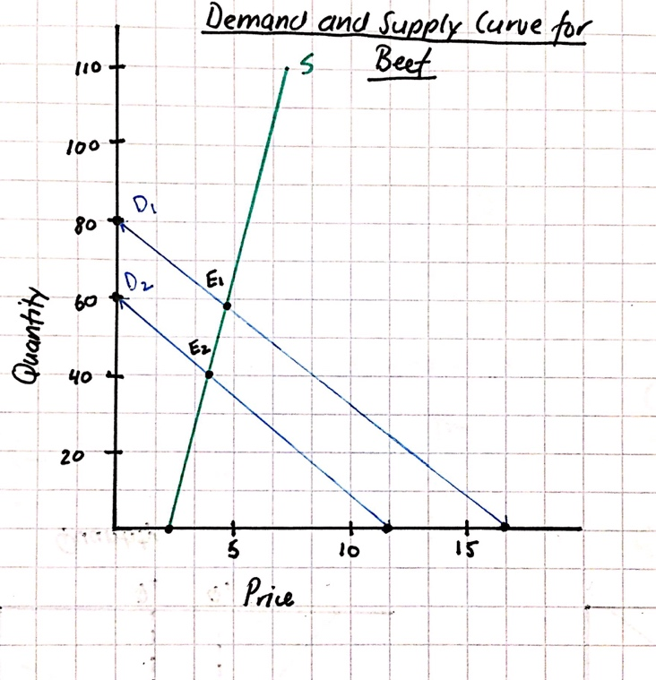

A1-10
Supply Curve: If P = 0, Q = -20
If Q=0, P = 16

Demand Curve: If P = 0, Q= 80
If Q = 0, P = 1

a)
D

b) At equilibrium Q_{S} = Q_{D}
Q_{S}= -20+20P Q_{D}=80-5P

-20+20P=80-5P Substitute back into equation: Q=80-5(4)
20P+5P=80+20 Q=80-20
25P=100 Q=60
P=100/25
P=4

At Equilibrium (point E₁ on graph from part a) P=4 while Q=60.

c) Demand decreases 25 units

Original Equation: Q_{D}=80-5P New Intercepts: If P = 0, Q = 55
New equation: Q_{D}=80-5P -25 If Q = 0, P = 11
Q_{D}=55-5P

d) The price calculated in b) is no longer the equilibrium because there was a decrease in demand, therefore causing the demand curve to shift leftward creating a new equilibrium.

e) At equilibrium Q_{S} = Q_{D}
Q_{S}= -20+20P Q_{D}=55-5P

-20+20P=55-5P
20P + 5P = 55+20 Substitute back into equation Q=55-5(3)
25P=75 Q=55-15
P=75/25 Q=40
P=3

New equilibrium is represented by E₂ on the graph.
Quantity traded has not fallen by a full 25 units because the adjustment is made when the price dropped down one unit.

A1-11
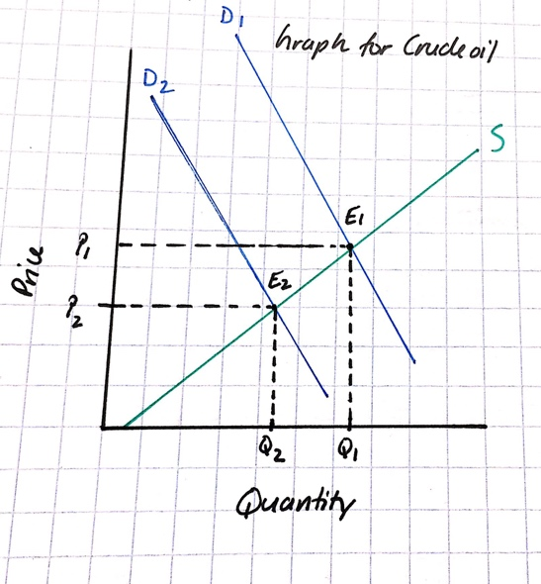
a) Since many of the refineries shut down, they no longer require the crude oil as an input for their gasoline therefore the demand for oil will go down. This will cause the demand curve to shift leftwards from D₁ to D₂. This shift in the demand curve cause the price to drop to P₂ from P₁ and the quantity to go down from Q₁ to Q₂. The new equilibrium E₂ is lower relative to the old equilibrium E₁.

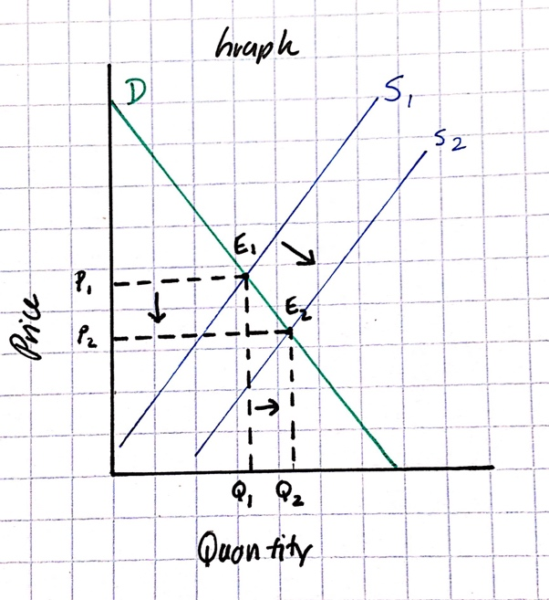
b) If many of the refineries shut down then there will be less of supply of gasoline in the market for consumers. Therefore, the supply curve will shift leftwards which will cause the price of gasoline to go up from P₁ to P₂ and the quantity to go down from Q₁ to Q₂ causing a higher equilibrium at E₂.

(c)
If early September was a large driving weekend then the demand for gasoline would have come up again causing the demand curve to move rightwards along the new supply curve S₂. This would put a strain on the market equilibrium because the supply for gasoline has now gone down but the weekend is causing an upward pressure for the demand of this gasoline. This would further increase the price for gasoline.

