2.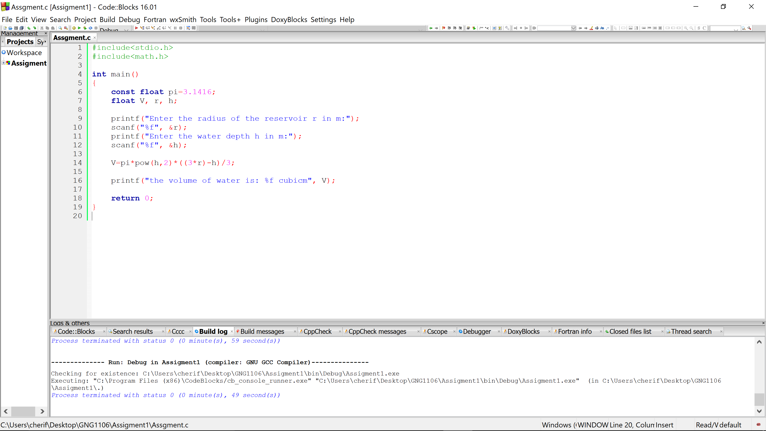

- For radius R of 2m and depth h of 0.75m
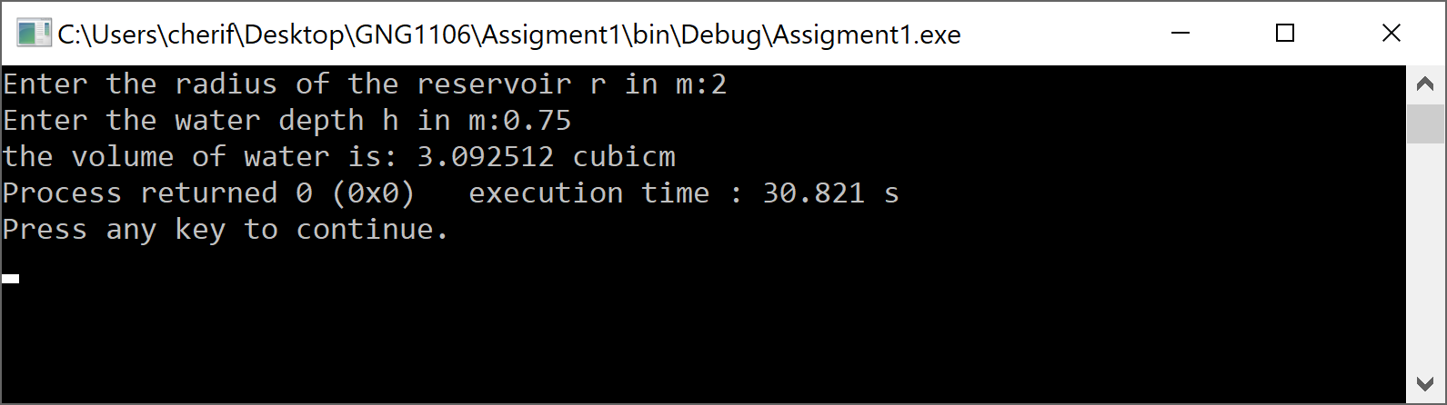

- For radius R of 2m and depth h of 2m
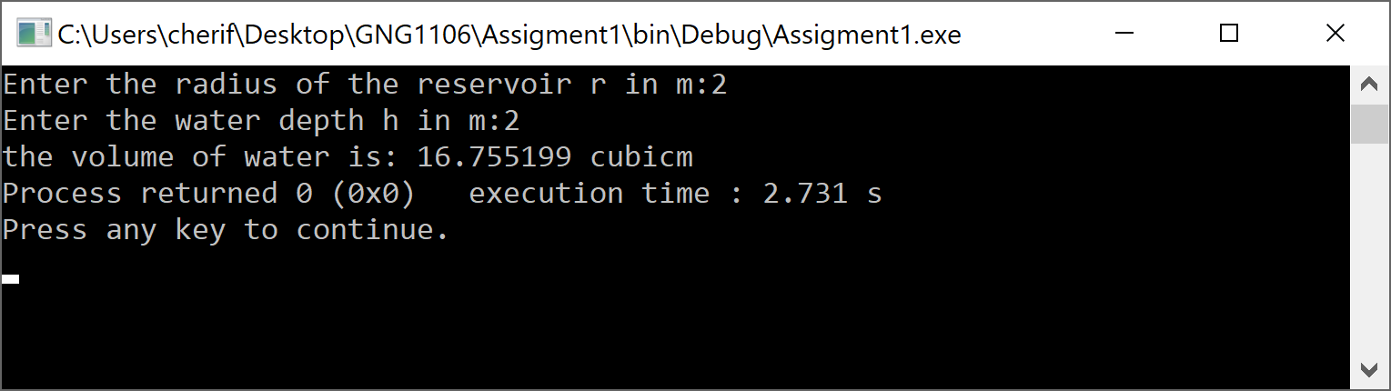

- For radius R of 5.35m and depth h of 7.45m
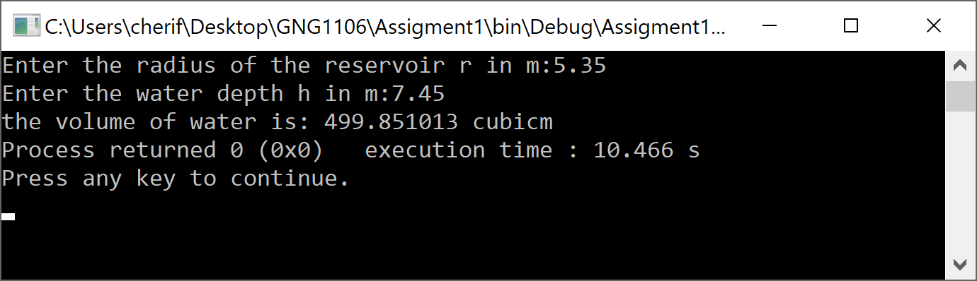

- For radius R of 8.10m and depth h of 0.23m
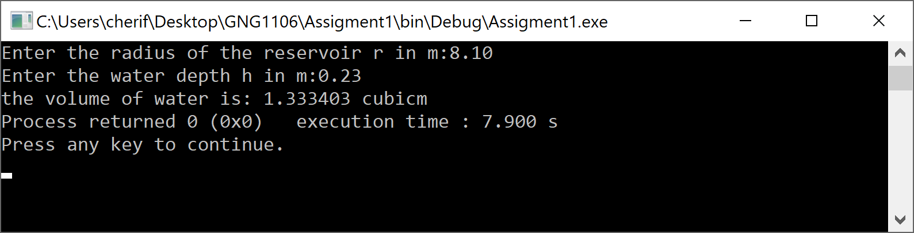

- For radius R of 1m and depth h of 2m


