Chapter 2: Investing and Financing Decisions and the Statement of Financial Position

- Expanding the company’s sales required the acquisition of productive capacity, which was financed by both shareholders and creditors.

- The growth of Canadian Tire is shown through the increase in assets, liabilities and shareholder’s equity over time.

- Financial statements are intended to communicate the economic facts, measured in monetary units, in a standardized formal way.

- Framework (exhibit 2.1 page 47):
  - prescribes the nature, function, and limitations of both financial accounting and financial statements
  - embodied in the IASB
  - provides guidance to accounting standard setters in developing new accounting standards and in revising existing standards

- The primary objective of external financial reporting is to provide financial information about the reporting entity that is useful to existing and potential investors, lenders, and other creditors in making decisions about providing resources to the entity.
  - To achieve this, decision makers (investors, creditors etc) must understand the financial value of the assets owned and claims against those assets (liabilities and equity

- Creditors and potential creditors need to assess an entity’s ability to pay interest on a loan over time and repay the initial amount borrowed, called the principal.

- Investors and potential investors want to assess the entity’s ability to pay dividends in the future and evaluate the company’s success in the future in order to know if the share price rises

Qualitative Characteristics of Useful Accounting Information

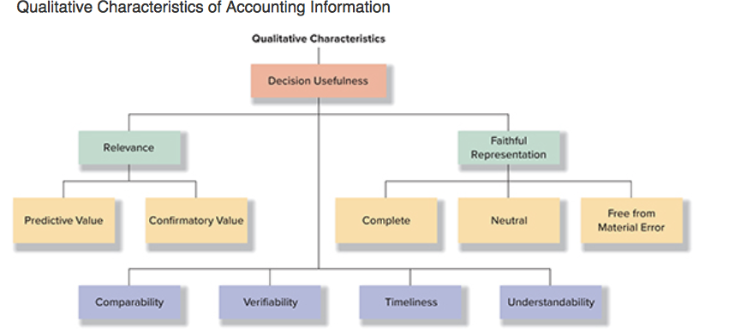
- two fundamental qualitative characteristics—relevance and faithful representation—supported by four enhancing qualitative characteristics: comparability, verifiability, timeliness, and understandability.
- Relevance:
  - info in financial statements are relevant and influences user’s decisions by helping them assess the economic effect of past activities and/or predict future events
  - info has confirmatory value if it confirms or changes prior expectations based on previous evaluations.

- Faithful representation:
  - The info must be complete, neutral and free from material error.
  - Ex: using revenue that was not within the period of time that the statement claims to be in causes a lack of faithful representation of current-period revenues
  - The usefulness of accounting info is enhanced when it is neutral, that is free from bias in its measurement and presentation; no understatement or overstatement of values
  - the development of accounting standards for measurement and reporting of transaction effects should not result in favouring one group of users over others.

- Verifiability:
  - Verifiable if independent accountants can agree on the nature and amount of the transaction.

- Timeliness:
  - Info that is not available to users in a timely manner loses its relevance because it cannot be considered in making decisions.
  - The relevance of accounting info for decision making declines as time passes which is the reason why companies produce quarterly reports.
  - Timely info enhances both its predictive and confirmatory values.

- Understandability:
  - The quality of info that enables users to comprehend its meaning.
  - The classification and presentation of info within the financial statements and related notes enhance its understandability.

- Constraints of Accounting Measurement:
  - Accurate interpretation of financial statements requires that the statements’ reader be aware of important constraints of accounting measurement.

- Cost:
  - Companies produce and disseminate accounting info to users with the expectation that the benefits to users of such info exceed the cost of producing it (cost constraint)
  - Benefits may be difficult to measure however the cost of producing it can be estimated with reasonable accuracy.

- Prudence:
  - Must be taken in order to avoid
    - Overstating assets and revenues
    - Understating liabilities and expenses.
  - Companies care more about the downside risk than the upside potential.
  - More companies have perished through excessive optimism than through excessive caution.
  - Prudence is viewed as a constraint rather than a desirable quality.
  - Contradicts the concept of neutrality and is likely to result in bias in the values.

Recognition and Measurement Concepts

- Separate-entity assumption: the activities of each business must be accounted for separately from the activities of its owners, all other persons, and other entities.

- Stable monetary unit assumption: accounting info should be measured and reported in the national monetary unit

- The stable monetary unit assumption allows accountants to combine dollar amounts from various years, even though the purchasing power of the monetary unit has changed over time.

- The continuity (going-concern) assumption states that businesses are assumed to continue to operate into the foreseeable future. Violation of this assumption means that assets and liabilities should be valued and reported on the statement of financial position as if the company were to be liquidated (i.e., discontinued, with all assets sold and all debts paid)

- Mixed-attribute measurement model: applied to measuring different assets and liabilities

- Historical cost principle or cost principle: requires that assets are recorded as their cash-equivalent value on the date of the transaction and that such a value is recorded on the statement of financial position at subsequent (following) dates.

- Assets are initially recorded at the cash paid plus the monetary value of all non-cash considerations (any assets, privileges, or rights)

Elements of the Classified Statement of Financial Position

ASSETS
- Assets: economic resources controlled by an entity as a result of past transactions or events and from which future economic benefits may be obtained.

- When purchasing an asset, the company acquires the right for future benefits to be derived from that asset, as well as any future risks and obligations arising from control of the asset.

- Assets are important to:

  - External users because a company’s assets embody the future financial benefits
  - Lenders because assets and their productivity are the basis upon which they can generate forecasts about how readily the company can repay its financial obligations.
  - Shareholders because the increase in the value of their investment will depend in larger part on the realized future benefits arising from assets under the company’s control.
- There are various formats for presenting statements of financial position.

- Current assets (short term)
  - Cash
  - Short-term investments
  - Accounts receivable
  - Inventories
  - Prepaid expenses
  - Other current assets
- Non-current assets (long term)
  - Property and equipment (at cost less accumulated depreciation)
  - Financial assets
  - Goodwill
  - Intangible assets
  - Other (miscellaneous) assets

*Assets are usually listed in order of liquidity; how fast it can be transformed into cash

- Current assets: economic resources that will typically transform into cash or use within the next year or the operating business cycle of the company, whichever is longer

- Short-term investments: represent the reported values for shares of other companies, certificates of deposit with banks and other financial assets purchased as investments of excess cash.

- Receivable: amount of money owed; usually customers have paid on credit and amounts collected within one year of the statements date.

- Inventories (current assets no matter what) are goods that are:
- Held for sale to customers in the normal course of business
- Used to produce goods or services for sale

- Prepaid expenses (e.g., insurance premiums and rent paid in advance for use of equipment) reflect available benefits (e.g., monthly insurance protection, office space) that the company will use within one year.

- Investors analyze the financial statements of a company to decide whether or not to purchase its shares or to lend it money.
  - An important decision factor is how easily a company can access cash to pay both debts to its creditors and dividends to its shareholders.

- Inventories: products that are stored in the warehouse before they are sold.
- If the balance of accounts receivable increases over time, this indicates that the amount of sales on credit exceeded the cash collected from customers.

- Non-current assets (fixed assets or capital assets): long term since they will be used or turned into cash over a period longer than the next year; usually tangible.

- Goodwill is an intangible asset that arises when a company purchases another business to control its operating, investing, and financing decisions. Goodwill reflects assets that are not easily identifiable or measured, such as customer confidence, quality of products, reputation for good service, and financial standing of the acquired business

- Intangible assets: no physical substance but have a long life; include such items as franchises, patents, trademarks and copyrights.

- Unrecorded but valuable assets: trademarks, patents and copyrights, which are developed inside a company (not purchased) are not reported on the statement of financial position.

LIABILITIES

- Liabilities (listed in order of maturity): present debts or obligations arising from an entity’s past transactions that will be paid with assets or service; future outflows of assets (mainly cash) to creditors
  - Creditors receive the full amount as well as interest

- Current liabilities (short term):
  - Accounts payable
  - Short-term debt (or borrowings)
  - Income taxes payable
  - Accrued liabilities
  - Provisions
  - Other current liabilities

- Non-current liabilities (long term):
  - Long-term debt (or borrowings)
  - Provisions
  - Other liabilities

SHAREHOLDERS’ EQUITY

- Shareholders’ equity (owners’ equity or stockholders’ equity): the financing provided to the corporation by both its owners and the operations of the business

- One key difference between shareholders and creditors is that creditors are entitled to settlement of their legal claims on the corporation’s assets before the shareholders receive a penny, even if this consumes all of the corporation’s assets.

- Includes:
  - Contributed capital (financing provided by shareholders)
  - Retained earnings (accumulated earning that have not been declared as dividends)
  - Other components

- Earned capital or retained earnings: financing provided by operations. Most companies that operate profitably retain part of their earnings for reinvestment in their business.

Nature of Business Transactions

- Transaction: any event that is recorded as a part of the accounting process

- Only economic resources and debts resulting from past transactions are recorded on the statement of financial position.

- Two types of transactions:
  - External events: exchanges of assets, goods, or services by one party for assets, services or promises to pay (liabilities) by one or more other parties.
  - Internal events: certain events that are not exchanges between the business and other parties but, nevertheless, have a direct and measurable effect on the accounting entity.

- Signing a contract is not considered to be a transaction because it involves the exchange only of promises not of assets, such as cash, goods, services, or property.

Accounts

- Account: a standardized record that organizations use to accumulate the monetary effects of transactions on each financial statement item.

- The cumulative result of all transactions that affect a specific account, or its ending balance, is then reported on the appropriate financial statement.

- Each company establishes a chart of accounts; that is, a list of accounts and their unique numeric codes.

- The chart of accounts is organized by financial statement element, with asset accounts listed first (by order of liquidity), followed by liabilities (by order of time to maturity), shareholders’ equity, revenue, and expense accounts, in that order

- Deferred: liabilities

- The accounts you see in the financial statements are actually summations (or aggregations) of a number of specific accounts in a company’s recordkeeping system (ex: equipment, buildings, and land are combined into an account called property and equipment)

How do Transactions Affect Accounts?

- Managers must make the right decisions suitable for their company’s situation since these decisions will result in transactions affecting financial statements.

Principle of Transaction Analysis

- Transaction analysis: the process of studying each transaction to determine its economic effect on the entity in terms of the accounting equation (A = L + SE, also known as the fundamental accounting model).

- Every transaction affects at least two accounts (dual effect); it is critical to correctly identify the accounts affected and the direction of the effect (increase or decrease); the entity receives something and gives up something in return.
- The accounting equation must remain in balance after each transaction.
- If the transaction was done on credit then there are two transactions:
1. | The purchase of an asset on credit | In the first transaction, Canadian Tire would receive office supplies (an increase in an asset) and would give in return a promise to pay later, called accounts payable (an increase in a liability).
2. | The eventual payment | In the second transaction, Canadian Tire would eliminate, or receive back, its promise to pay (a decrease in the accounts payable liability) and would give up cash (a decrease in an asset).

*look at page 62-63 for examples of accounting equation

How do Companies Keep Track of Account Balances
- In order to handle the several transactions that business generate, the companies establish accounting systems that follow a cycle.
- The accounting cycle highlights the primary activities performed during the accounting period to analyze, record, and post transactions.

- During the accounting period, transactions that result in exchanges between the company and other external parties are analyzed and recorded in the general journal in chronological order, and the related accounts are updated in the general ledger

The Direction of Transaction Effects
- T-account: useful took for summarizing the transaction effects and determining the balances for individual accounts; shows the direction of the effects; a ledger account
- Each T-account has two sides: a left side, known as the debit side, and a right side, known as the credit side
- The increase symbol, +, is located on the left side of the T for accounts that appear on the left side of the accounting equation (assets), and on the right side of the T for accounts that are on the right side of the equation (liabilities and shareholders’ equity).
- The term debit (dr) is always written on the left side of each account, and the term credit (cr) is always written on the right side.
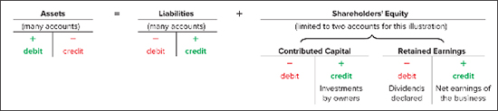
- In summary,
Assets | = | Liabilities | + | Shareholders’ Equity
↑ with debits |  | ↑ with credits |  | ↑ with credits
Accounts have  debit balances |  | Accounts have  credit balances |  | Accounts have  credit balances

Analytical Tools
- In a bookkeeping system, transactions are initially recorded in chronological order in a general journal

- After analyzing the business documents (such as purchase invoices, receipts, and cash register tapes) that describe a transaction, the bookkeeper prepares the formal journal entry and enters the effects on the accounts by using debits and credits

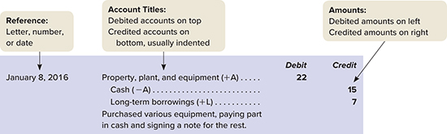
- Journal entry: an accounting method for expressing the effects of a transaction on various accounts, using the double-entry bookkeeping system explained previously.

- Any journal entry that affects more than two accounts is called a compound entry.

- After the journal entries have been recorded, the bookkeeper posts (transfers) the monetary values to each account affected by the transaction to determine the new account balances.
- As a group, the accounts are called a general ledger (t-account).

*look at page 69 for examples of general journal and general ledger

How is the Statement of Financial Position Prepared and Analyzed

- statement of financial position is one of the financial statements that will be communicated to users, especially those external to the business.

- businesses will create a trial balance spreadsheet first for internal purposes before preparing financial statements for external users. A trial balance lists the titles of the T-accounts in one column, usually in financial statement order (assets, liabilities, shareholders’ equity, revenues, and expenses), with their ending debit (left) or credit (right) balances in the next two columns.

*example of trial balance on page 74

Classified Statement of Financial Position

- Some statements include comparative data. That is, it compares the account balances at two different dates. When multiple periods are presented, the most recent statement of financial position amounts are usually listed on the left.

- Canadian companies typically list assets in decreasing order of liquidity, but European companies have typically listed their assets in increasing order of liquidity.

Current Ratio
- Current ratio: an important indicator of a company’s ability to meet its current obligations

Current Ratio= Current Assets
Current Liabilities
(All info taken from Financial Accounting Textbook)

