- Single Proprietorship – 1 owner, responsible
- Ordinary Proprietorship – Multiple owners, responsible
- Limited Partnership – General: manage, liable, Limited: not managing, risk only for invested
- Corporation – legal entity separate from owners
- State Owned Enterprise – owned by gov. Crown corp.
- Non-profit Org. – Provide good/services, just covering costs, also NGO’s

- MNE – Multi National Enterprises, usually large corporations, unusual for single proprietor, and ordinary partnerships, more common for limited partnerships
- Financing: Debt & Equity
- Inputs
  - Intermediate Products
  - Land: raw materials
  - Labour
  - Capital
- Production function: Q = f(K,L), output = production function (capital, labour)
- Account profit = revenue – explicit costs
- Economic = revenue – explicit – implicit
  - Opportunity cost and such
- If all firms making economic profit, firms enter industry

- Time Horizons
  - Shortrun: some factors of production fixed such as machines, equipment, capital. Resources/Inputs, Labour are variable
  - Long run: factors of production can be varied but technology is fixed
  - Very LR: All factors of production AND technology can be varied

- Average Product (AP)= Total Product / # of labour units
- Marginal

- Product (MP)= Change in total product/Change in # of labour units
- Point of diminishing Average Productivity: when the AP starts declining
- Point of diminishing Marginal Productivity: When the MP starts declining
- Law of diminishing returns: So much inputs applied to a given quantity of a fixed factor eventually marginal product of the variable factor declines
- 1-person vs 100k people working in the same size room ^^^
- AP is increasing till where it intersects with MP
- For AP to be increasing, MP>AP

- Total Fixed Cost(TFC)
- Total Var. Cost (TVC)
- TC = TFC + TVC
- AFC = TFC / Q
- AVC = TVC/Q
- ATC = TC/Q
- Marginal Cost (MC) = change in TC/ change in Q
- Short run curves
  - Total fixed cost doesn’t change w/ input
  - TC and TVC increase w/ input
  - TC shape is TVC + TFC, starts at level of TFC
  - AFC decrease at a decreasing rate
  - AVC and ATC are u-shaped because diminishing average product…
- Capacity: Level of output @ minimum short run average total cost
  - Largest output a firm can produce without rising average costs per next unit
- EFFICENY IS NEXT ONE!?
- Shift in SR cost curve:
  - Change in factor prices
    - Change in VC both MC and ATC shift up
    - Change in FC per unity, ATC shift up
  - Change in the amount of Fixed Factor
    - Hard to tell unless ALL factors shown, normally long run…

- LR: no fixed factors
- LR firms try to be technically efficient
- Most efficient combo of inputs, lowest cost
- LR decisions are not easy to reverse, big decisions -> success or failure
- LR Cost minimization: MP(K)/ P(K) = MP(L)/P(L) and MP(K)/MP(L) = P(K)/P(L)
- Principle of Substitution: methods of production Will change if relative price of inputs change, more of the cheaper input, less of more expensive
- LR cost curves
  - Boundary between attainable cost levels with known stuff and those that are unattainable
  - No FC so no need to plot AFC,AVC,ATC because they are all combined into THE LRAC
  - LRAC shows the lowest cost of producing any output when all the factors are variable
  - LRAC falls -> rises
    - Decreasing costs: producing lowers AC
    - Constant: min. efficient scale
    - Increasing costs: diseconomies of scale, additional inputs are increasing outputs at rate lower than quantity of inputs
  - LR and SR cost relationship
  - 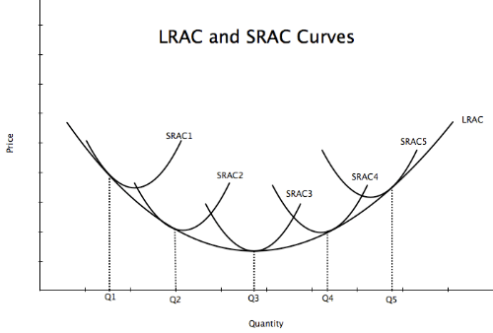
  - Lowest point (optimal point) of each SRATC curve rests on LRAC
  - Very Long Run
  - Changes in tech and resources shifts LRAC curve
  - Measure tech change
    - Productivity
    - Output produced per unit of some input
    - Total output/quantity of input
  - Tech change
    - New techniques
    - Improved Inputs
    - New products
  - Firm Choice in VLR
    - Substitute Away
    - Innovate Away
    - Possibly both over diff. time horizons

- Competitive Market
  - Homogenous goods
  - Many buyers and sellers
  - Free movement of firms
  - Consumer awareness of price/quantity
  - Price takers = Firms
  - AR = TR/Q = Price
  - Price = MR = AR
  - D = MR
  - MR. DARP they all equal each other, nice acronym thing
  - Individual firms face a flat supply curve
  - Firm in competitive mrkt
    - 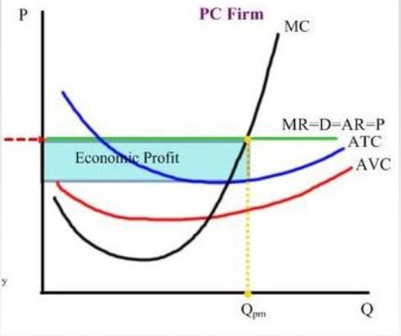
    - So economic profits can exist in competitive markets
  - Profit Maximization
    - MC = MR. DARP
    - If MR>MC, firms increase q to increase profit
    - If MR<MC, firms decrease q to increase profit
    - MC curve determines the q to supply so it is competitive firms supply curve
    - SR – supply curve is portion of the MC curve above AVC
    - LR – supply curve is portion of the MC curve above ATC, this is because it is all variable
  - Shut Down Point
  - 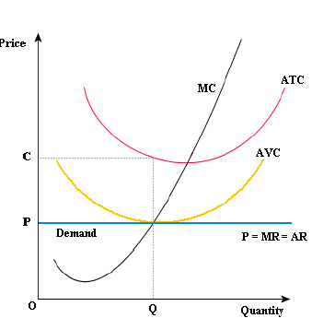
    - SR decision not to produce
    - Continue to pay FC but no VC
    - Shut down if Price < AVC
    - This is why MC>AVC is SR supply
  - Exit Decision
  - 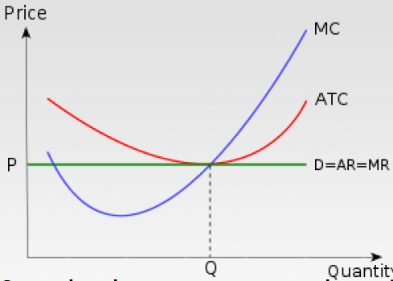
    - LR decision to stay or not
    - Leave if price < ATC
    - Therefore MC > ATC is the long-term supply
    - LR all costs variable
  - Summary
  - MR. DARP
  - Profit Max.: MC=MR
  - Shut Down Pint if P<AVC – SR decision
  - Exit Point: If P < ATC – LR decision
- Monopolies, Cartels and Price Discrimination
  - Monopolies
    - Created barriers
      - Gov. regulations
      - Patents and copyrights
      - Exclusive license
      - Resource Access
    - Natural Barriers
      - Larger firms more efficient
      - ATC downward sloping
      - Network effects
    - MC =/ Price
    - To increase quantity sold firms must lower price
    - 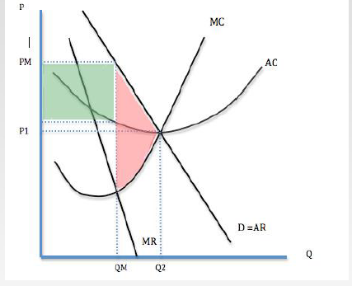
    - >=2 firms are a cartel and act as a monopoly
    - Effects of a price change
      - Firms choose! The price where profit is max.
      - Price decreases:
        - Price effect: revenue decreases due to a lower price
        - Output effect: revenue increases due to increased quantity sold
    - Monopoly DWL
      - Monopolies don’t meet market equil so they create deadweight loss
      - 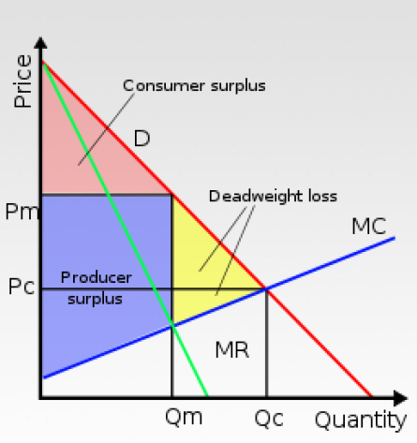
  - Price Discrimination
    - Same good at diff. prices to diff. customers
    - Not in competitive markets
    - Perfect price discrim.: charging each customer exactly as much as they will pay
    - 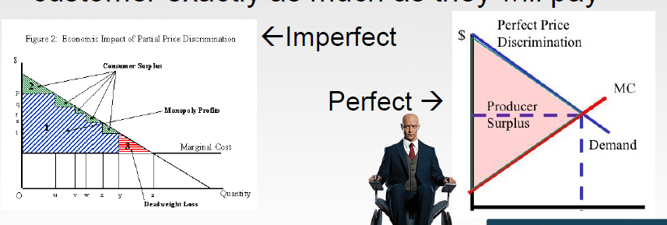
- Imperfect competition:
  - Monopolistic Competition
    - Differentiated products but similar
    - Enter and exit easy
    - SR act like monopolies
    - Production is MC=MR
    - LR market adjusts
    - 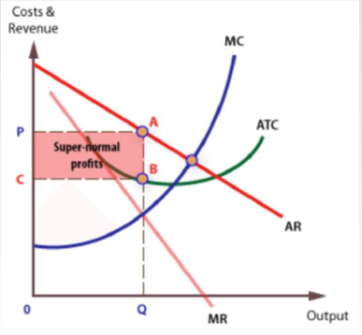
    - LR market acts like a perfectly competitive mrkt
    - Firms enter when profits and exit when losses
    - 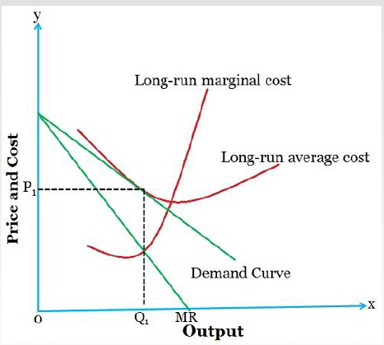
- Oligopoly
  - Few sellers offer similar or identical
  - Cannot exit or enter freely
  - Act strategically in response to another
  - Can come together and become cartel which acts as monopoly
  - GAME THEORY BABY
  - The prisoners dilemma
  - Police arrest two criminal
  - Dominant strategy to confess
  - THE DOMINANT STRATEGY: the best choice for a player regardless of choice
  - Nash Equilibrium
  - 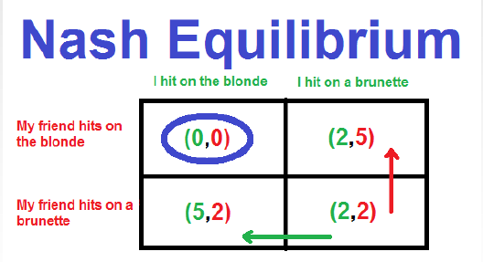
  - Reached when each player doing the best they can given the current behavior of the other player
  - No firm has an incentive to leave the equil. Once its established
  - Advertising
    - Useful
      - Informed buyers are more responsive to price changes
      - Feeds competition
      - Lower markup
    - Wasteful
      - Exaggerates small differences between firms
      - Higher markup
- Productive efficiency
  - Factors of production are fully employed
  - When the firm produces any given level of output at the lowest possible cost
  - SR: firm uses enough variable factors to produce desired output level
  - LR: firm uses least costly available methods of producing any given output
  - When an industry’s total output is allocated among its induvial firms such that total cost in the industry is minimized (MC of production is same for each firm)
- If firms and industries are productively efficient, the economy will be on – not inside – the production possibilities boundary fuck
- Allocative efficient
  - Market is efficient, price is equal to marginal value that consumers have for the product. Same idea
  - If marginal cost to producers exceeds marginal value to consumers, too much of that product will be produced – the last unit produced exceed the benefits of consuming it
- 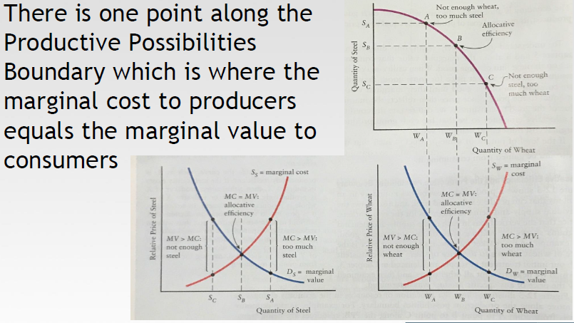
- Which market structures are efficient
  - Perfect Competition
    - Productively efficient industry and firm
    - MAYBE allocatively efficent
  - Monopoly
    - Productively Efficient industry and firm
  - Monopolistic Competition & Oligopoly
    - Productively efficient

