Homeostasis: a system in which variables are regulated so that internal conditions remain stable and relatively constant w/in limits
- Ex: temp regulation (shivering/sweating), blood/ion [ ] control
- Not unchanging, dynamic state of equilibrium using many systems
  - Adequate blood levels of vital nutrients
  - Heart activity/BP monitored and adjusted as needed
  - Waste must not accumulate
  - Body temp

3 essential characteristics of homeostatic control mechanism
- Receptor: senses change (stimulus) and send info (afferent pathway)
- Control centre: determines a set point for variable maintenance; analyzes and determines how to respond
- Effector: provides stuff to respond (output along afferent pathway); feedback (-/+) allows for regulation w/in a range/enhanced response

Negative Feedback
- Shuts off the original effect of the stimulus or reduces intensity
- 1 hormone regulating process
- Changes in direction opposite, returns to “ideal” setting
- Goal: prevent sudden, severe changes
- Examples: blood-glucose; as blood sugar increases, receptors sense the change and pancreas (control centre) secretes insulin into the blood

Positive Feedback
- Enhances original stimulus, response is accelerated
- Proceeds in same direction as initial change, deviates further from original value
- Controls infrequent events
- Ex: labour, blood clotting
- Destructive

Homeostatic imbalance Results in disease
- Ageing: decrease ability to maintain homeostasis therefore increased risk of disease
- Occurs when negative feedback systems are overwhelmed, makes positive feedback take over (bad)

Autonomic nervous system (ANS)
- Self-governing
- Motor neurons that innervate smooth and cardiac muscles and glands
- w/o our awareness
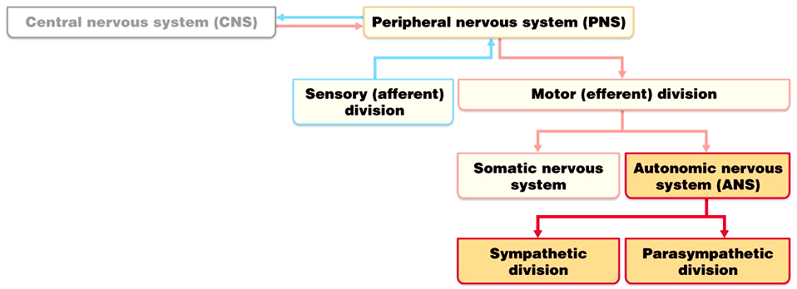
ANS:
- Shunt blood to more needy areas
- Speed up/slow down HR and respiratory rates
- Adjust BP, body temp
- increase/decrease gastric secretions

The PNS and SNS differ:
- Where nerves originate
  - PNS: brain and spinal cord
  - SNS: thoracolumbar
- Relative lengths of fibers
  - PNS: long pre and short postganglionic
  - SNS: short pre and long postganglionic
- Locations of ganglia
  - PNS: near visceral organs
  - SNS: spinal cord

Compare Autonomic and Somatic nervous system
- Effectors
  - SNS stimulates skeletal muscles
  - ANS innervates cardiac and smooth muscle
- Efferent pathways and ganglia
  - SNS: thick, myelinated axon from spinal cord to skeletal; rapid conduction of impulses, no ganglia
  - ANS: 2 neuron chain:
    - Preganglionic neuron: originates in brain or spinal cord; preganglionic axon synapses w/ 2nd motor neuron (postganglionic) in ganglia outside CNS
    - Postganglionic axon to effector organ
  - Conduction through ANS is slower than SNS
    - Preganglionic axons are thin and myelinated; postganglionic axons are thinner and unmyelinated

Parasympathetic division:
- Non-stressful situations, resting and digesting
- Body energy is low
- “D”-system: digestion, defecation, diuresis

Sympathetic division:
- “Fight or flight”
- Increases HR, deep breathing, sweaty skin, dilated pupils
- “E”-system: exercise, excite, emergency, embarrassment

SNS and vascular tone:
- Alpha blocking drugs to treat hypertension
- Blood shunting possible via vasoconstriction/vasodilation
- Aka vasomotor tone
- When BP is too low to maintain blood flow sympathetic fibers fire more rapidly
- Blood “shunting” maintains circulation to vital organs and skeletal muscles

PNS and tone:
- Heart, smooth muscle of GI and urinary tracts
- Drugs that block the PNS increase HR and cause fecal and urinary retention
- Can be overridden by the SNS

Abtagibsustic interactions
- Ex: activity of the heart, respiratory, and GI systems
- How the PNS and SNS work together

Cooperative Effects
- Ex: regulation of external genitalia during sex
  - 1. PNS: erection; dilation of blood vessels in penis
  - 2. SNS: ejaculation, reflex peristalsis of vagina

Unique roles of the sympathetic ns:
- Sns regulation only: adrenal medulla, sweat glands, kidneys, most blood vessels
- Thermoregulatory responses to heat
- Release of renin from kidneys

Metabolic effects of sns:
- Increases metabolic rate of body cells
- Raises blood-glucose levels
- Stimulates mobilization of fats
- Increases mental alertness
- Increases speed and strength of muscle contraction

G-Proteins:
- Protein that relays info between extracellular 1st messengers (ie. hormones or nt) and intracellular 2nd messengers (cyclic AMP) via effector enzyme

3 levels of regulation of autonomic function
- Brainstem and spinal cord controls
  - Significant direct effects on ANS-regulated activities
  - Ex: certain motor centers in the ventrolateral medulla reflexively regulate HR and blood vessel diameter
- Hypothalamic controls
  - Main integrator of the ANS
  - Anterior regions: parasympathetic
  - Posterior regions: sympathetic
  - Hypothalamus Coordinates heart activity, BP, body temp, water balance, endocrine activity, emotions and biological drives
- Cortical controls
  - ANS subject to voluntary controls
  - Ex: meditation lowers HR and breathing rate, O2 use, metabolic rate

Homeostatic imbalances of ANS
- Ex: hypertension, raynaud's disease, autonomic dysreflexia

Hormone: chemical substance released into the ECF that regulates the metabolic function of other cells in the body
- Must bind to specific receptors to influence target cell function
- Level of target cell activation depends on:
  - Hormone [ ]
  - Target cell receptor content
  - Affinity of hormone for receptor
Different glands
- Pineal gland
  - Melatonin
- Hypothalamus
  - Regulates ANS and endocrine function
- Thyroid gland
  - Control metabolic rate
- Parathyroid gland
  - Calcium regulator into blood
- Pancreas
  - Release of insulin to control glucose
- Liver
  - Acted on by glucagon
- ovaries/testes
  - Steroid hormones

Mechanism of hormone action:
- hormones alter levels of cell activity
  - Membrane permeability/potential (channels)
  - Synthesis of enzyme w/in cells
  - Enzyme activation/deactivation
  - Induction of secretory activity
  - Stim of mitosis

3 structural groups of hormones:
- Amino acids, peptides, proteins
- Steroid hormones (derivatives of cholesterol)
- Eicosanoids (from arachidonic acid)

2 main mechanisms of action
- peptide/protein hormones
  - Bind to cell surface receptor → activation of membrane bound g-protein → production of 2nd messenger (ie. cyclic AMP, calcium) → activation of protein kinases to regulate activity of key enzymes

How do steroid hormones enter into the nucleus?
- Diffuses through PM and binds to intracellular receptor
- Receptor-hormone complex enters nucleus
- Receptor-hormone complex binds a hormone response-element
- Binding initiates transcription of the gene to mRNA
- The mRNA directs protein synthesis

Half-life, Onset, and Duration of Hormone Activity
- Hormones are potent chemicals
- [ ] of circulating hormone in blood depends on
  - Rate of release
  - Rate of degradation/removal from body
- Half-life: persistence of a hormone in the blood: usually < 1 min to 30 mins
- Time to onset of hormone action variable:
  - Enzyme activation: rapid (minutes)
  - Enzyme synthesis: slow (hours/days) (steroids)
  - ** some hormones are secreted as prohormones, activated at target cell**
- Duration is variable (hours-days)

Control of hormone release
- Usually negative feedback; sometimes positive
- 3 types of stimuli
- Humoral: hormone secretion in direct response to change in blood level of a nutrient or ion
  - Ex: parathyroid hormone and blood calcium; insulin and blood glucose
- Neural stimuli: not as common
  - Ex: sympathetic ns and epinephrine release by adrenal medulla, hypothalamic neurons and oxytocin release
- Hormonal stimuli: 3-tiered system involving hypothalamus, pituitary and target endocrine gland
  - Ex: hypothalamic-pituitary axis

Hypothalamus is neural; produces many hormones which travel → anterior pituitary via hypophyseal portal system
- A portal system is a system of blood vessels in the brain that connects the hypothalamus with the anterior pituitary.
Pituitary gland:
- Size and shape of a pea
- Infundibulum connects pituitary to hypothalamus

Posterior lobe
- Axon terminals
- Neural tissue
- Hormone storage
- Releases neurohormones
- Antidiuretic hormone, oxytocin
- Infundibulum + posterior = neurohypophysis
- Not a true endocrine gland b/c doesn’t make hormones
Anterior lobe
- Glandular tissue
- Makes and releases hormones

** structurally similar (both are nonapeptides); but very different functions**

Blood is the transport system: 3 parts
- Blood vessels
- Heart
- Blood

3 main functions of blood and circulatory system
- Regulation: body temp, pH in tissues, blood/fluid volume
  - Interstitial fluid volume + blood volume
  - How does blood regulate temp? Vasodilation and vasoconstriction
  - Regulates pH by removing hydrogen ions
- Transport
  - Bringing nutrients and oxygen and bring it to body tissue that require these things to make energy then it will transport waste and CO2 out
  - Transports hormones
- Protection
  - Not commonly known
  - Actions of immune system: t-cells, b-cells
  - Blood clotting to maintain blood volume since if you lose too much blood you can go into hypoglycemic shock

Physical characteristics of Blood
- Oxygen rich = scarlet, oxygen poor = dark red
- More viscous than water
- Ph = 7.35-7.45, around 38 degrees celcius, 8% body weight is blood

Blood components:
- Only fluid tissue in body (formed elements suspended in plasma)
- Formed elements
- Erythrocytes (RBCs)
- Leukocytes (WBCs)
- Platelets

How to collect blood:
- Withdraw blood and put in tube (coated in a substance to stop clotting)
- Centrifuge
- You will then be able to see the components
  - Plasma
    - 55% of whole blood
    - Least dense component
  - Buffy coat (WBCs and platelets)
    - <1% of whole blood
  - Erythrocytes (RBCs)
    - 45% of whole blood (hematocrit)
    - Hematocrit: total amount of blood volume occupied by erythrocytes
    - Lower in women, higher in men
    - Most dense component
Blood plasma
- 90% water
- Solutes
  - Electrolytes
    - Ex: potassium, sodium, calcium
    - If dissolved in water it forms a current
    - Osmotic ion: water tends to follow it. Principle one is Sodium. Higher [ ] of sodium = more water is drawn to it
  - Plasma proteins
    - Produced in liver (except gamma globulins); functional proteins which remain in blood
      - Albumin is 60% of all plasma proteins; carrier of various molecules, important blood buffer, major osmotic protein
      - Alpha and beta globins are transport proteins (36% of plasma protein)
      - Fibrinogen is involved in the clotting process; usually soluble. Ogen = inactive form of a protein (4% of plasma proteins)
  - Respiratory gases
  - Hormones
  - Nutrients
** serum is exactly like plasma except it is missing fibrinogen (clotting factor)**

Formed elements:
- Erythrocytes
- Leukocytes
- Platelets
- Most of the formed elements are short-lived and disposable (replaced by bone marrow)

Why do we say that only leukocytes are complete cells?
- They have typical organelles of a cell, platelets and erythrocytes do not

Erythrocytes (RBCs)
Structural characteristics
- Small diameter cells
  - Has biconcave disc shape, is anucleate, and no organelles
  - Diameters are 25% larger than some capillaries (spectrin lines intracellular surface of RBC so that it can squeeze but then go back to original shape)
- Spectrin allows RBCs to maintain their shape
- Filled w/ Hb for gas transport
- 3 features for efficient gas transport
- Small size: concave shape offers huge SA:V ratio for gas exchange
- Hb: makes up 97% of cell volume (not counting water)
- NO MITOS: this is important for ATP production b/c if it was aerobic it would use all the oxygen while it was transporting it to the target tissue
- # of RBCs is a major factor contributing to blood viscosity
  - Women have less RBCs
  - Rate of blood flow inversely affected by RBC count (more RBC = more viscous = slow = less oxygen transported to target tissues , less RBC = less viscous = faster)

Structural organization of Hb
- Heme groups (4)
  - Each consists of an iron ion in the center of an organic ring called a porphyrin
  - Each iron can reversibly bind one molecule of oxygen (4 per Hb molecule; each RBC contains 2.4 x 10^8 Hb)
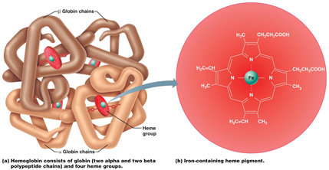
- Globin
  - 4 polypeptide chains ( 2 alphas, 2 betas)
- Benefits of having Hb in RBC vs free in plasma
  - Keep Hb from fragmenting and being lost
  - Keeps Hb from contributing directly to osmotic pressure and blood viscosity
- OxyHb a diff shape and colour than DeoxyHb
  - Oxygen binds to heme group: CO2 binds to globin → carbaminohemoglobin

Hematopoiesis = production of blood cells; occurs in the bone marrow in a network of reticular CT
- Network contains
  - Immature blood cells
  - Macrophages
  - Fat cells
  - Reticular cells
- Hemocytoblast (hematopoietic stem cell)
  - Stem cell for all formed elements → cells become committed to a particular pathway
  - Stem cell: cell that can give rise to several different types of cells

Start w/ 1 stem cell which produces all formed elements of blood
- 1 stem cell will keep replicating itself
- Commitment step
- RBC and platelets from myeloid stem cell, WBC from lymphoid stem cell

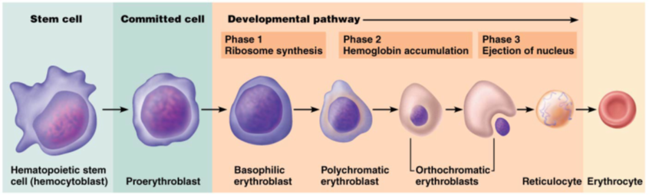

Erythropoiesis: production of RBCs
- What is the diff between a reticulocyte and RBC
  - Reticulocyte still contains a scant network (reticulum) of clumped ribosomes, erythrocyte doesn’t

Hormonal regulation of erythropoiesis
- Balance between production and destruction
  - Too few = anemia resulting in tissue hypoxia
  - Too many = polycythemia resulting in an increase of blood viscosity

- Erythropoietin (EPO)
  - Glycoprotein produced in kidney
    - Always some EPO in blood
    - Additional EPO release by kidney
  - Hypoxia due to
    - High altitude/pneumonia
    - Increase demand
    - hemorrhage/excess RBC deconstruction
    - Insufficient Hb/RBC
  - Enhances maturation rate of committed RBC precursors
    - See results in 1-2 days
  - What is monitored and acts as a signal?
    - The level of oxygen transport
  - Athletes and EPO abuse
    - EPO increases hematocrit from 45 → 65%
    - But increase viscosity and dehydration during race can lead to clotting, stroke, heart failure
    - What is the effect of testosterone on renal EPO production?
    - Speeds up production of EPO → same effect indirectly
  - Renal failure patients
    - Additional problem is lack of EPO (RBC counts can be 50% of normal)
    - Treated w/ recombinant EPO
    - If kidney isn’t functioning properly you aren’t making EPO and you could

- Erythropoiesis dietary requirements ( iron, B-vit)
  - Amino acids, lipids, and carbs
  - Iron: available from diet
    - 65% of iron is found in Hb, w/ the rest in liver, spleen, and bone marrow
    - Free iron ions are toxic so they are usually bound w/ proteins
      - Stored in cells as ferritin and hemosiderin
      - Transported in blood bound to protein transferrin
  - Vitamin B12 and folic acid are necessary for DNA synthesis for rapidly dividing cells such as developing RBCs

Fate/Destruction of Erythrocytes
- Mature RBCs become rigid/fragile w/ time b/c it doesn’t have a nucleus or any organelles. Proteins don’t live long so squeezing and expanding takes its toll and they die
  - Spleen = RBC graveyard
  - Useful lifespan 100-120 days

Hemoglobin → heme// globin
- Heme → porphyrin and Fe
  - Fed is stored and reused
  - Porphyrin is degraded to bilirubin → stercobilin or urobilinogen
- Globin → aa of globin is recycled
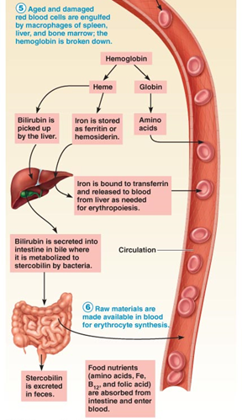
Anemia: decrease/impairment in oxygen carrying capacity of RBC
- Signs and symptoms: tired, pale, short of breath, cold
  - Tired and cold b/c when you don’t have enough oxygen you’re messing w/ cellular respiration (needed for energy/heat)
  - Pale b/c of decrease in iron and Hb in blood
  - Short of breath simply b/c # of RBCs is lower

Causes of Anemia
- Insufficient # of RBCs
  - Blood loss → hemorrhaging; blood volume drops and so # of RBCs decrease and there is not enough oxygen going to tissues
  - RBC destruction → hemolysis
  - Destruction of bone marrow → aplastic anemia bone, marrow becomes plastic-like
- Decrease in Hb content
  - Iron deficiency anemias
    - Signs: pallor (paleness) and glossitis (swelling of the tongue)
  - Considered a micronutrient b/c it's only required in small amounts
  - No iron = no proper Hb
- Ex: sickle cell anemia
  - Base pair changes from GAG to GLU which changes structure of Hb, only comes up in stressful situations. In these moments RBCs sickle (circle and hook onto each other forming clumps in small vessels causing pain)
  - Treatment: blood transfusion. Hydroxyurea causes Hb to go back to fetal Hb so that it doesn’t sickle under stressful situations
  - Genetic cause

Polycythemia: RBC excess
- Polycythemia vera (true)
  - Associated w/ neoplastic transformation of bone marrow (bone marrow cancer)
  - You lose the regulatory mechanism in cancer, so you have uncontrolled productions of RBCs (as well as platelets and WBCs b/c they all come from the same source)
- Secondary polycythemia
  - Due to chronic hypoxemia (deficient blood oxygen)
  - Physiological modification: moving to higher altitude so there is less oxygen in the air so you require more RBC
  - This is why athletes train at high altitudes
- Relative polycythemia
  - Due to dehydration
  - Decrease in blood volume but # of RBCs is the same so the [ ] is higher
  - Increase work load on the heart, tissues aren’t getting enough oxygen at the rate they should
Blood doping
- Athlete donates a pint or 2 of their own blood
- Centrifuge
- RBCs which carry oxygen are forced to the bottom of the tube
- Liquid part on top is re-injected into athlete
  - Lower [ ] of RBCs, so increase in production of RBCs
- RBCs are stored
- A day or so before the competition the stored RBCs are reinjected into the athlete to enable blood to carry more oxygen

Platelets (thrombocytes)
- Cytoplasmic fragments of megakaryocytes
- Contain: serotonin, calcium, enzymes, ADP and platelet derived growth factor (PDGF) needed for clotting
- Platelet formation is regulated by thrombopoietin
- PM surrounds granules, lifespan is 10-12 days
- normal= 150 000 - 400 000 platelets/ul of blood

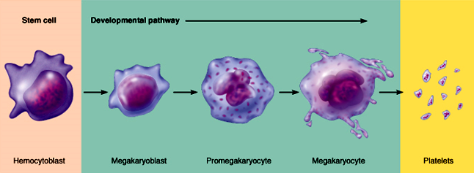

Hemostasis: fast series of rxns for stoppage of bleeding, require clotting factors and substances released by platelets and injured tissues 3 steps involved:
- Vascular spasm
  - Vasoconstriction of vessel in response to damage. Triggered by
    - Damage to vascular smooth muscle starts contraction to top flow of blood to the area
    - Chemicals from endothelial cells and platelets (line the cavity of the blood vessel: provide smooth surface and secrete diff chem)
    - Pain reflexes
    - Purpose: to protect the body
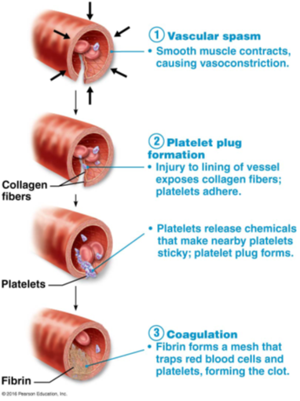
- Platelet plug formation
  - Usually platelets do not stick to each other or to endothelial linings
  - Under normal conditions: NO and PGI2 (prostacyclin or PGI2): produced by endothelial cells; inhibits platelet aggregation
    - Important b/c it restricts the aggregation of platelets all over the body
  - When vessel damage occurs: exposed collagen causes platelet adhesion
    - Von Willebrand factor ( a large plasma protein) helps adhesion by forming a bridge between the collagen and platelets
    - Platelets activated: swell, become spiky and sticky
      - Degranulation (release chem messengers)
      - ADP: enhances aggregation and degranulation
      - Serotonin and thromboxane A2- enhance vascular spasm and aggregation
      - Domino effect
- Coagulation (blood clotting)
  - Reinforces platelet plug w/ fibrin threads
  - Series of rxns use clotting factor (procoagulants), mostly plasma proteins. Numbered I to XIII in order of discovery
  - Vitamin K needs to synthesize 4 factors
    - Where do we get vitamin k? Our food, vitamin K helps w/ blood flow and is fat soluble
  - Blood is transformed from liquid to gel
  - Coagulation occurs in 3 phases
    - Prothrombin activator formed
    - Prothrombin to thrombin
    - Fibrinogen molecules → fibrin mesh
Phase 1: 2 pathways (intrinsic and extrinsic) to prothrombin activator
- Triggered by tissue-damaging events
- Each pathway cascades toward and ends w/ the activaton of Factor X
- Activated Factor X then complexes with calcium, PF3 (platelet factor 3), and Factor V to form Prothrombin activator
- Prothrombin activator is the rate-limiting step
- Once achieved, clot forms in 10-15 seconds via phase 2 and 3 common pathways

Intrinsic pathway
- Called “intrinsic” b/c clotting factors are present w/in the blood
- Triggered by negatively charged surfaces such as activated platelets, collagen, or even glass of a test tube

Extrinsic pathway
- Called “extrinsic” b/c factors needed for clotting are located outside blood
- Triggered by exposure to tissue factor; also called factor III
  - TF is a protein that is subendothelial protein so when there is damage this is exposed
- Bypasses several steps of intrinsic pathway
  - Faster pathway

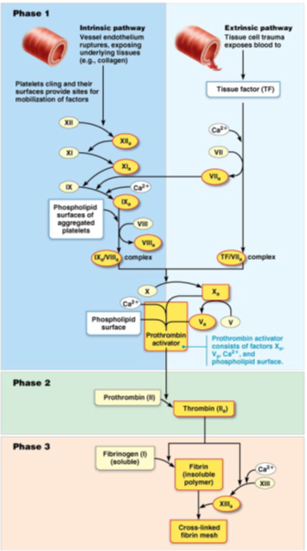

Phase 2: Pathway to thrombin
- Prothrombin activator catalyzes transformation

Phase 3: common pathways to fibrin mesh
- Thrombin converts soluble fibrinogen to fibrin
- Fibrin strands form structural basis of clot
- Fibrin causes plasma to become a gel-like trap catching formed elements
- Thrombin (along with calcium) activates factor XIII (fibrin stabilizing factor) which:
  - Cross-links fibrin
  - Strengthens and stabilizes clot
- Anticoagulants: factors that normally dominate in blood to inhibit coagulation
Clot retraction and repair
- Occurs w/in 30-60 mins; platelets contract (contain actin and myosin), exerting pull on surrounding fibrin strands
- Serum squeezed from clot and ruptured edges of blood vessels pulled closer
- PDGF released during degranulation stimulates smooth muscle cells and fibroblasts to divide and rebuild wall
- Endothelial cells multiply to fill gap in lining (VEGF = vascular endothelial growth factor)
Fibrinolysis
- Process of clot removal when no longer needed
- Begins w/in 2 days and continues until clot is dissolved
- Key enzyme: plasmin (precursor = plasminogen)
- Plasminogen is activated by tPA (tissue plasminogen activator) released by endothelial cells
What limits clot size?
- 2 mechanisms
- Swift removal and dilution of clotting factors
- Inhibition of activated clotting factors
- Limited amount of thrombin is restricted to clot by fibrin threads, preventing clot from getting too big or escaping into bloodstream
  - Antithrombin III inactivates any unbound thrombin that escapes into blood
  - Heparin in basophil and mast cells inhibits thrombin by enhancing antithrombin III
- Factors preventing platelet adhesion
  - Smooth endothelium of blood vessels prevents platelets from clinging
    - Platelets need any surface that isn’t smooth and they will start the whole process (ex: coronary artery disease, smoking, obesity)
  - Endothelial cells secrete antithrombotic substances such as nitric oxide and prostacyclin
  - Vitamin E quinone, formed when vitamin E reacts w/ oxygen, is a potent anticoagulant
Thromboembolic conditions:
- Undesirable intravascular clotting
- Thrombus: clot that develops and persists in an unbroken blood vessel → can block critical blood circulation to those tissues
- Embolus: a thrombus which has broken free, can get stuck in a vessel of small diameter (ex: pulmonary or cerebral emboli)
- Drugs such as tPA, streptokinase to dissolve clots
- What might promote thrombus formation in an unbroken blood vessel?
  - Cause by athrosclorotic packs
- Why is aspirin a good preventative therapy in heart attack risk patients
  - It thins blood

Bleeding disorders
- Interference w/ normal clotting

Causes:
- Thrombocytopenia: lower than normal # of platelets in your blood, small injury huge detriments
  - Causes: any condition harmful to bone marrow (malignancy, radiation, drugs), any movement leads to bruising (internal hemorrhage)
  - Platelet count <50 000/ul
  - Whole blood transfusions provide temporary relief, why?
    - b/c platelets only live for 10-12 days
- Impaired liver function
  - Ex: hepatitis, cirrhosis (liver is source of procoagulants)
  - Liver disease also associated w/ reduced bile production can lead to bleeding disorder. Why?
    - b/c the bile helps absorb fat soluble vitamins such as vitamin K which is fat soluble. So messed up bilirubin will reduce the amount of bile produced, which will not allow as much fat soluble vitamins to be absorbed which will thin out your blood b/c vitamin k is used to help clot
- Hemophilia
  - Hereditary bleeding disorders
    - Hemophilia A (83% of cases) → deficiency in factor VIII
    - Hemophilia B → deficiency in factor IX
    - If you can’t get these under control you bleed excessively
    - Sex-linked conditions → require transfusions/injections of purified clotting factors

Human Blood groups
- RBC membranes bear 30 naturally occurring types of glycoprotein antigens
  - Anything perceived as foreign; generates an immune response
  - Promoters of agglutination; called agglutinogens
- Only the ABO and Rh antigens cause serious agglutination problems during transfusion
- Mismatched transfused blood perceived as foreign
- May be agglutinated and destroyed; can be fatal
- Presence or absence of each antigen is used to classify blood cells into diff groups
ABO Blood Groups:
- Types A, B. AB, and O
- Based on presence or absence of 2 agglutinogens (A and B) on surface of RBCs
- Blood contain preformed anti-A or anti-B antibodies (agglutinins)
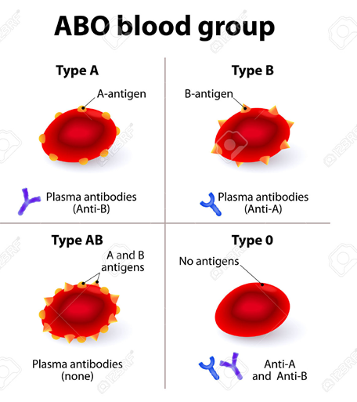
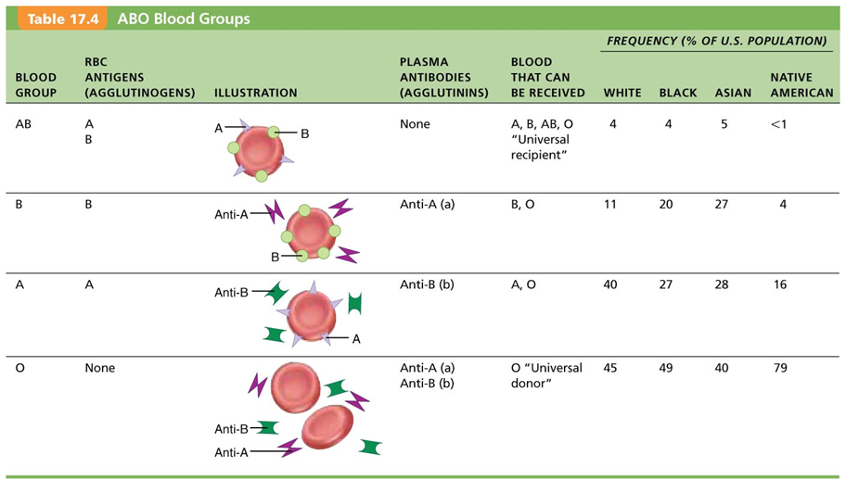

Why is type O the universal donor?
- No antigens present, and even though they have both anti-A and anti-B, its such a small amount of antibodies that it diffuses out and doesn’t affect the blood transfusion
Why is type AB the universal recipient?
- No antibodies, so w/e you put in won’t react. No agglutination.
Which blood type is most common? Least common?
- O is most common, AB is the least common

Rh Blood Groups:
- 52 named Rh agglutinogens (Rh factors) C,D and E are most common
- Rh positive indicates presence of D antigen
  - 85% Americans are Rh positive
- Anti-Rh antibodies are not spontaneously formed in Rh negative individuals
  - Anti-Rh antibodies form if Rh negative individual receives Rh positive blood, or an Rh negative mother is carrying a Rh positive fetus
  - Rh negative mothers carrying Rh positive fetus treated w/ RhoGAM (anti-Rh serum) to prevent erythroblastosis fetalis (hemolytic disease of the newborn)

Blood typing:
- Donor blood is mixed w/ antibodies against common agglutinogens
  - If agglutinogen is present, clumping of RBCs will occur
- Blood is typed for ABO and for Rh factor in same manner
- Cross matching: typing between specific donor and specific recipient
  - Mix recipient’s serum w/ donor RBCs
  - Mix recipient’s RBCs w/ donor serum

Transfusion and Blood replacement
- Cardiovascular system minimizes effects of blood loss by
- Reducing volume of affected blood vessels
- Stepping up production of RBCs
- Body can compensate for only so much blood loss

Loss of 15-30% causes pallor and weakness
Loss of more than 30% results in potentially fatal severe shock

Whole blood transfusion: substantial blood loss or thrombocytopenia
Packed red cells (PRBC) for anemia
- Donor blood mixed w/ heparin (calcium chelator, anticoagulant) can be stored for several weeks at 4 degrees celsius

Transfusion Rxns: Agglutination and Hemolysis
- Occur if mismatched blood is infused
- Problems recipients agglutinins (antibodies), not donors
- Agglutinate and clog small vessels RBCs rupture and release Hb into bloodstream
- Transfused blood is wrong ABO or Rh
- Antibodies are so diluted into the recipient's circulation that it usually doesn’t present a problem
Overall result
- Blocked flow to tissues
- Reduced oxygen-carrying ability of blood
- Hb precipitates/clogs kidney tubules , possible kidney failure
Symptoms:
- Fever, chills, nausea, vomiting, general toxicity - critical to prevent kidney failure by administering alkaline fluids to dilute and dissolve Hb; also diuretics
  - Autologous transfusion (1 unit/4days up to 3 days before surgery of patients own blood)
  - If there is a risk that a patient will need a blood transfusion they will store their own blood 35 days earlier

The heart
Pulmonary circuit
- Right side receives deoxygenated blood from the tissues
- Pumps blood to lungs via pulmonary trunk to get oxygen
- Oxygenated blood is returned to left side of the heart

Systemic Circuit
- Left side receives oxygenated blood from lungs
- Pumps blood to body tissues via the aorta
- Deoxygenated blood is returned to right side

The heart
- A transport pump; hollow blood vessels provide delivery routes; enclosed w/in mediastinum thorax
- Extends obliquely from 2nd rib to 5th intercostal space
- Broad, flat base directed towards right shoulder; apex points towards left hip

Coverings of the heart
- Pericardium
  - Double walled, fibrous sac
    - Fibrous pericardium (strongest, restricts how much blood is in the heart at one time)
      - Anchors and protects the heart
      - Prevents overfilling of the heart
    - Serous pericardium
      - Parietal and visceral (epicardium) layers
      - 2 layers separated by fluid-filled pericardial cavity
        - Fluid reduces friction between layers
      - Ex: put air in a balloon punch ballon w/ fist, space between layers is representative of the pericardial cavity
    - Pericarditis
      - Inflammation of pericardium
      - Roughens membrane surfaces, causing pericardial friction rub (creaking sound)
    - Cardiac tamponade
      - Excess fluid that leaks into pericardial space
      - Can compress heart’s pumping ability
      - Treatment: fluid is drawn out of cavity (usually w/ syringe)
3 layers of heart wall
- Epicardium: visceral layer of serous pericardium
- Myocardium: cardiac muscle = bulk of heart wall; circular or spiral bundles of contractile cardiac muscle cells
  - Cardiac skeleton: crisscrossing, interlacing layer of connective tissue
    - Anchors cardiac muscle fibers
    - Supports great vessels and valves
    - Limits spread of AP to specific paths
- Endocardium: (endothelium + connective tissue); innermost layer; is continuous w/ endothelial lining of blood vessels
  - Lines heart chambers and covers cardiac skeleton of valves
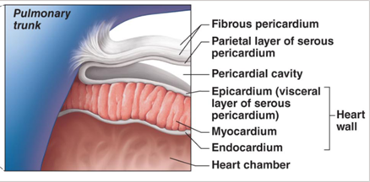

Chambers of the heart:
- 4 chambers; 2 superior atria, 2 inferior ventricles

What are the interatrial and interventricular septa?
- Interventricular septa is a wall of cardiac tissue that separates left and right ventricles
- Interatrial are walls separating left and right atriums

Surface features
- Coronary sulcus
  - Atrioventricular groove
- Anterior interventricular sulcus
  - Front of heart
- Posterior interventricular sulcus
  - Back of heart

Great vessels:
- SVC: superior vena cava
- IVC: inferior vena cava
- PT: pulmonary trunk
- LPA: left pulmonary artery
- RPA: right pulmonary artery

- Atria: receiving chambers
  - Small thin walled → need only convey blood to ventricles
  - Right receives deoxygenated blood from SVC via 3 vessels
    - SVC: systemic from head structures
    - IVC- systemic from rest of body
    - Coronary sinus- from heart muscle itself
  - Left atria gets oxy blood from lungs via pulmonary veins (2 left, 2 right, right/lungs, both feed to right atria)
  - Depression in wall of right atria; fossa ovalis
  - During development there is a hole in the heart between the right atria and right ventricle
- Ventricles: discharging chambers
  - Pumps of the heart; walls much thicker (esp. Left ventricle) b/c of how far blood needs to go from left side
  - Right ventricle pumps blood to pulmonary trunk
  - Left ventricle pumps blood to aorta
  - Internal walls have muscle bundles:
    - Papillary muscles (valve function)
    - Trabeculae carnae are crossbars of the flesh
    - Chordae tendineae are attached to valves
- Heart Valves
  - Ensures blood flow is unidirectional, enforced by 4 heart valves that open and close in response to pressure changes
  - Anchored by chordae tendinae
  - Two major types of valves
    - Atrioventricular valves
      - Paired between atria and ventricles
        - Right is tricuspid valve
        - Left is bicuspid (mitral) valve
      - Semilunar valves
        - Paired from either pulmonary or systemic circuits
          - Pulmonary valve = right ventricle to pulmonary trunk
          - Aortic valve = left ventricle to aorta

The function of the AV valves
- Av valves open; atrial pressure is greater than ventricular pressure
  - Blood returning to heart fills the atria, pressing against the AV valves, increasing pressure forces the valves to open
  - As the ventricles fill, AV valves flaps hang limply into the ventricles
  - Atria contract, forcing additional blood into ventricles
- AV valves close, atrial pressure less than ventricular pressure
  - Ventricles contract, forcing blood against AV valve cusps
  - AV valve closes
  - Papillary muscles contract and chordae tendinae tighten preventing valve flaps from everting into the atria

Importance of chordae tendinae: attached to AV valve, anchors valves

The function of the SL valves
- Semilunar valves open
  - As ventricles contract and intraventricular pressure rises, blood is pushed ip against semilunar valves, forcing them to open
- Semilunar valves close
  - As ventricles relax and intraventricular pressure falls, blood flows back from arteries, filling semilunar valve cusps and forcing them to close

2 side-by-side pumps
- Pulmonary circuit
  - SVC, IVC, coronary artery
  - Right atrium
  - Tricuspid valve → right ventricle
  - Pulmonary semilunar valve → pulmonary trunk
  - To lungs and back to heart
- Systemic circuit
  - 4 pulmonary veins
  - Left atrium
  - bicuspid/mitral valve → left ventricle
  - Aortic semilunar valve → aorta
  - To body and back to the heart

Congestive heart failure
- Blood can’t flow through, pressure in lungs increases, right ventricle is over worked, backup of blood somewhere
  - Same for other side

Diff between pulmonary and systemic circuits
- Equal volume of blood pumped into pulmonary and systemic circuits, but 2 ventricles have unequal workloads
- Pulmonary circuit (right ventricle)
  - Short, low-pressure circulation, deoxy blood
  - Lung capillaries is where blood is oxygenated from breathing
- Systemic circuit (left ventricle)
  - Long pathway, oxy blood, 5x resistance
  - Walls of left ventricle are 3x thicker
  - All tissues and organs receive oxy blood
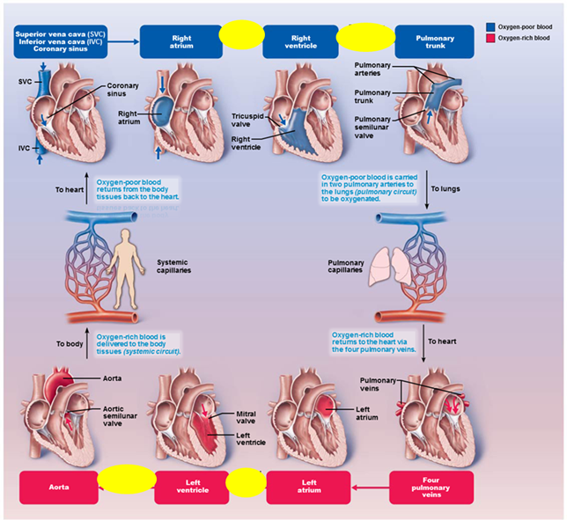

Functional blood supply to heart muscle itself
- Shortest, most important
- Right and left coronary arteries from base of aorta: encircle heart in coronary sulcus (AV groove)
- Actively deliver blood when heart is relaxed
- Consumes a lot of oxy blood it produces
- Largely ineffective when ventricles contract b/c the ventricles are compressed by the contracting myocardium
- Anastomoses are imp b/c they provide alternative routes for the heart is obligate aerobic. They are interconnections in blood vessels

Coronary arteries
- Right artery supplies the right atrium and most of the right ventricle. 2 branches
- Marginal artery
- Posterior interventricular artery
- Left coronary artery 2 branches
- Circumflex artery: supplies blood to the left atrium: the side and back wall of the left ventricle, sits in AV groove
- Anterior interventricular artery: supplies blood to front and bottom of the left ventricle anterior interventricular sulcus

Coronary Veins
- Drainage of the heart
- Coronary veins take oxygen-poor blood that has already been used by the muscles of the heart and return it to the right atrium
  - Coronary sinus empties into right atrium, formed by merging cardiac veins
  - Great cardiac vein of anterior interventricular sulcus
  - Middle cardiac vein in posterior IV sulcus
  - Small cardiac vein runs along right inferior margin

Homeostatic imbalances of coronary circulation
- Angina pectoris
  - Thoracic pain caused by fleeting deficiency in blood delivery to myocardium
  - Cells are weakened
- Myocardial infarction (heart attack)
  - Prolonged coronary blockage
  - Area of cell death are repared w/ noncontractile scar tissue

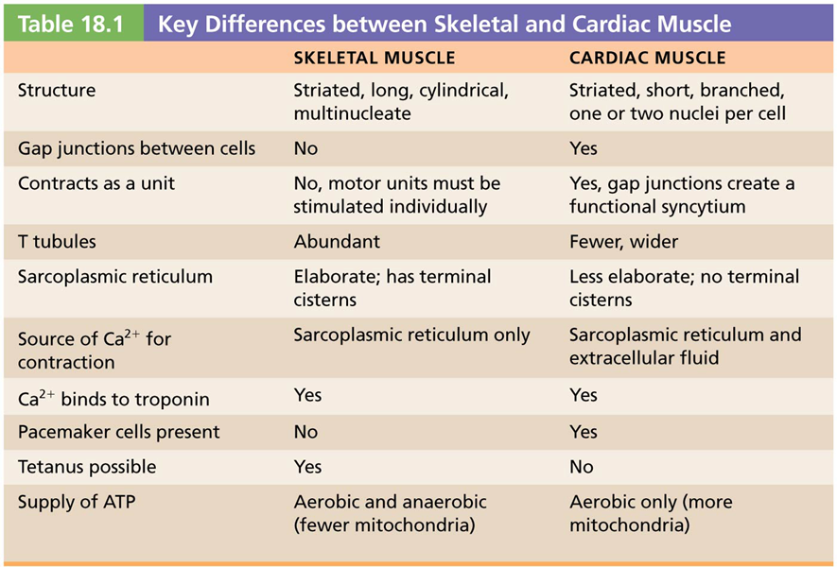
Intercalated discs
- Connecting junctions between cardiac cells that contain
  - Desmosomes: for strong cell-cell adhesion; prevent cells from separating during contraction
  - Gap junctions: allows ions to pass from cell to cell electrically coupling adjacent cells → functional syncytium

Two kinds of cardiomyocytes
- Contractile cells: responsible for contraction
- Pacemaker cells: non-contractile cells that spontaneously depolarize
  - Initiate depolarization of entire heart
    - Do not need nervous system stimulation, in contrast to skeletal fibres

Intrinsic conduction system
- AP initiation by pacemaker cells which have unstable RMP called pacemaker potentials or pre potentials

3 parts of the AP
- Pacemaker potential: K channels are closed but slow Na channels are open, causing interior to become more positive
- Depolarization: Ca channels open (around -40 mV), allowing huge influx of Ca, leading to rising AP
- Repolarization: K channels open allowing efflux of K, and cell becomes more negative
- Heart depolarizes and contracts w/o NS simulations, although rhythm can be altered by AND through hormones

Coordinated heartbeat is a function of:
- Presence of gap junctions
- Intrinsic cardiac conduction system
  - Network of noncontractile (autorhythmic cells)
  - Initiate and distribute impulses to coordinate depolarization and contraction of the heart
  - Works w/ contractile cells to tell them to contract

Sequence of Excitation
- Sinoatrial (SA) node
  - Pacemaker of heart in right atrial wall b/c it has the fastest depolarization/repolarization rate
  - Sets rate of heart
  - Impulse spreads across atria and to the Av node
  - Generates impulses about 75x/minute (sinus rhythm)
- Atrioventricular AV node (in inferior interatrial septum)
  - Delays impulses approximately 0.1 second
    - Allows atrial contraction prior to ventricular contraction
  - Inherent rate of 50x/minute in absence of SA node input
- Atrioventricular (AV) bundle (bundle of His)
  - In superior interventricular septum
  - Only electrical connection between atria and ventricles
    - Atria and ventricles not connected via gap junctions
- Right and left bundle branches
  - Two pathways n interventricular septum
  - Carry impulses toward apex
- Subendocardial conducting network (purkinje fibers)
  - Complete pathway through interventricular septum into apex and ventricular walls; more elaborate on left side of heart
  - AV bundle purkinje fibers depolarize 30x/minute; ventricular contraction immediately follows from apex toward atria
  - Process from initiation at SA node to complete contraction take ~ 0.22 seconds

Rate of SA node depolarization regulated by ANS
- Parasympathetic NS
  - Decreases depolarization rate
- Sympathetic NS
  - Increases depolarization and repolarization rates

Contractile muscle fibers
- Make up bulk of heart, and are responsible for pumping action
- Cardiac muscle action potentials have plateau
- Absolute refractory period almost = muscle twitch. Allows heart to fill again

Electrocardiograms
- Can detect electrical currents generated by heart
- Electrocardiogram (ECG or EKG) is a graphic recording of electrical activity
  - Composite of all AP at given; not tracing of a single AP
  - Electrodes are placed at various points on body to measure voltage differences
    - 12 lead ECG is most typical
Main features of an ECG:
- P wave: depolarization of SA node and atria
- QRS complex: ventricular depolarization and atrial repolarization
- T wave: ventricular repolarization
- P-R interval: beginning of atrial excitation to beginning of ventricular excitation
- S-T segment: entire ventricular myocardium depolarized
- Q-T interval: beginning of ventricular depolarization through ventricular repolarization

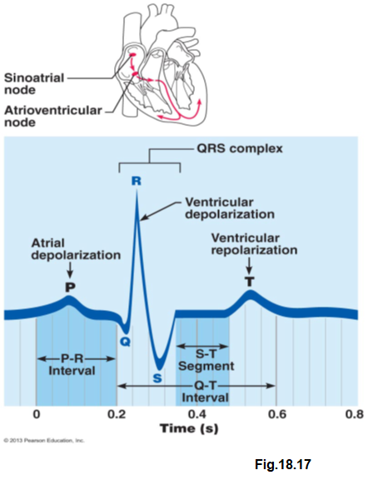
Sequence of depolarization and repolarization
- Atrial depolarization, initiated by the SA node, causes P wave
- w/ atrial depolarization complete, the impulse is delayed at the AV node
- Ventricular depolarization begins at the apex, causing QRS complex. Atrial repolarization occurs
- Ventricular depolarization is complete
- Ventricular repolarization beings at apex, causing T wave
- Ventricular repolarization is complete

- Changes in patterns or timing of ECG may reveal diseased or damaged heart, or problems w/ heart’s conduction system
- Problems that can be detected
  - Enlarged R waves may indicate enlarged ventricles
  - Elevated or depressed S-T segment indicates cardiac ischemia/infarction
  - Prolonged Q-T interval reveals a repolarization abnormality that increases risk of ventricular arrhythmias
  - Junctional blocks, flutters, and fibrillations are also detected on an ECG
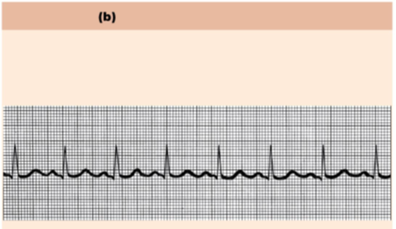
Normal ECG trace ^
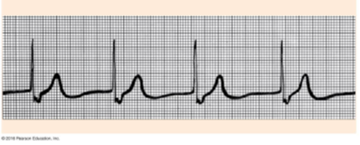
Junctional rhythm^: p wave is lost, AV node controls rhythm
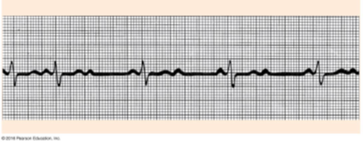
Second degree heart block: P wave is not being conducted throughout the rest of the heart
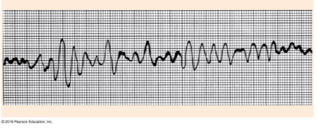
Ventricular Fibrillation: massive uncoordinated electrical impulses, chaotic, ventricles not contracting properly, can go into cardiac arrest
- Defibrillator tries to reset heart by giving a new electrical shock
- Time is important, the earlier you can affect the heart the more helpful

Bradycardia: slower than normal HR (40-50 range)
- Good: high performance athlete will already have a lower than normal HR, hypertrophy, creates extra anastomosis and w/ each contraction it pumps more blood than usual
- Bad: if you’re a normal human, especially if you’re not getting enough output to your tissues

Tachycardia: faster than normal (100+):
- Not spending enough time in the relaxation phase, the amount of blood available for pumping is decreasing which can affect CO
- If there is scar tissue, the left ventricle will enlarge to compensate for it, problem w/ that is that since it is overworked this could lead to heart failure

Cardiac cycle: all events related to the flow of blood throughout the heart during one complete heartbeat

Mechanical events of the heart
- Systole: contraction of the heart: pumping out
- Diastole: relaxation of the heart: filling up

Cardiac cycle
- Atrial systole and diastole are followed by ventricular systole and diastole
- Cycle represents a series of pressure changes and blood volume changes
- Mechanical events follow electrical events seen on ECG

3 phases of cardiac cycle (following left side, starting w/ total relaxation)
- Period of ventricular fillings: (mid-to-late diastole)
  - AV valves are open; SL valves are closed
  - Pressure low but (Patria > Pventricles)
  - After 80% ventricular filling, atrial depolarization triggers atrial systole (P wave), atria contracts; atrial pressure increases pushing remaining 20% into the ventricles
  - EDV → volume of blood in each ventricle at the end of ventricular diastole
- Ventricular systole (comprises Qrs complex and T waves)
  - Atria relax; ventricles begin to contract
  - Increases ventricular pressure causes closing of AV valves
  - Two phases
    - Isovolumetric contraction phase: all valves closed
    - Ejection phase Pventricles > Patria, forcing SL valves open
  - Pressure in aorta is around 120 mmHg
  - ESV: volume of blood remaining in each ventricle after systole
  - Stroke volume: how much blood gets pushed out, the diff between eDV and ESV
- Isovolumetric relaxation: early diastole
  - Following ventricular repolarization (T wave), ventricles are relaxed, atria are relaxed and filling
  - Backflow of blood in aorta and pulmonary trunk closes SL valves
  - Cases dicrotic notch (brief rise in artic pressure as blood rebounds off closed valve)
  - Isovolumetric relaxation: ventricles are totally closed chambers
  - When Patria > Pventricles, AV valves open, cycle begins again
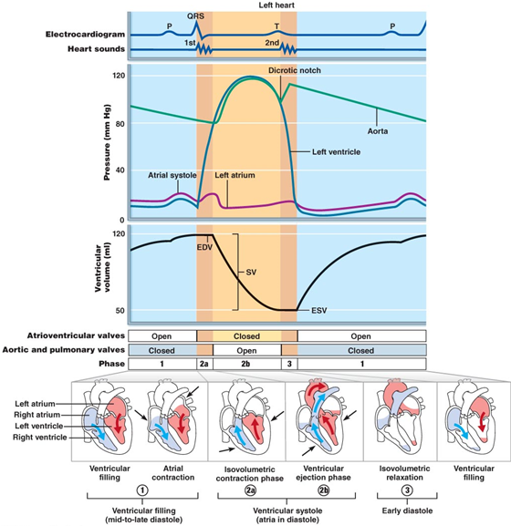
Physiological significance of the first and second of heart sounds:
- 2 sounds (lub-dup) associated w/ closing of heart valves
  - 1st sound is closing of AV valves at beginning of ventricular systole
  - 2nd sound is closing of SL valves at beginning of ventricular diastole
  - Pause between lub-dups indicates heart relaxation
- Mitral valve closes slightly before tricuspid and aortic closes slightly before pulmonary valve
  - Differences allow auscultation of each valve when stethoscope is placed in four different regions

Heart Valve Disease
- Heart murmurs: abnormal heart sounds heard when blood hits obstructions
- Incompetent (or insufficient) valve:
  - Fails to close completely, allowing backflow of blood causes swishing sound as blood regurgitates backward from ventricle into atria
- Stenotic valve:
  - Fails to open completely, restricting blood flow through valve, causes high-pitched sound or clicking as blood is forced through narrow valve

CO= amount (volume) of blood pumped by each ventricle in 1 minute
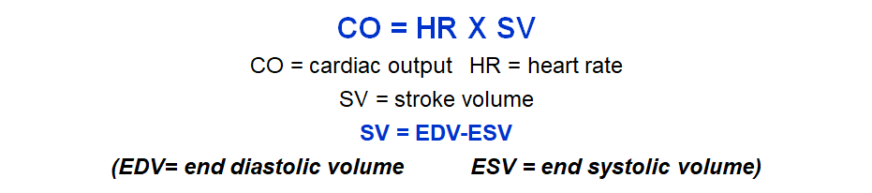
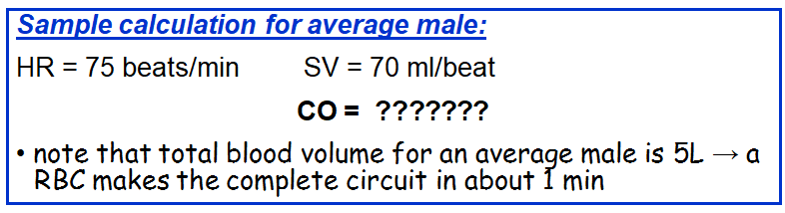
•Maximal CO is 4–5 times resting CO in nonathletic people (20–25 L/min)
•Maximal CO may reach 35 L/min in trained athletes
•Cardiac reserve: difference between resting and maximal CO
CO = HR X SV
•CO changes (increases/decreases) if either or both SV or HR is changed
•CO is affected by factors leading to:
– Regulation of stroke volume
– Regulation of heart rates

SV= EDV - ESV

EDV is affected by length of ventricular diastole and venous pressure ( around 120 ml/beat)
ESV is affected by arterial BP and force of ventricular contraction (around 50 ml/beat)

Normal SV = 120 ml- 50 ml = 70 ml/beat

3 main factors that affect SV:
- Preload: degree of stretch of heart muscle
  - Preload: degree to which cardiac muscle cells are stretched just before they contract. Changes in preload cause changes in SV
    - Affects EDV
    - Relationship between preload and SV is called the Frank-Starling law of the heart
      - Increase in venous return → increase in EDV → increase in stroke volume → increase in cardiac output
    - Most important factor in preload stretching cardiac muscle is venous return
      - Slow heartbeat and exercise increases venous return
      - Increased venous return distends (stretches) ventricles and increased contraction force
- Contractility: contractile strength at given muscle length
  - Independent of muscle stretch and EDV
  - Increased contractility, decreased ESV; caused by:
    - Sympathetic epinephrine release stimulates increased Calcium influc, leading to more cross bridge formation
  - Positive inotropic agents increases contractility
    - Thyroxine, glucagon, epinephrine, digitalis, high extracellular calcium
  - Decreased by negative inotropic agents
    - Acidosis (excess hydrogen), increased extracellular K, Calcium channel blockers
- Afterload: back pressure exerted by arterial blood
  - After load is pressure that ventricles must overcome eject blood
    - Back pressure from arterial blood pushing on SL valves is major pressure
    - Aortic pressure is around 80 mmHg
    - Pulmonary trunk pressure is around 10 mmHg
  - Hypertension increases afterload, resulting in increased ESV and reduced SV
What are the effects of chronically elevated BP on cardiac muscle cells?
- Short Term: hypertrophy; left ventricle gets bigger b/c more work
- Long term: tired and gives up so heart fails
- When you exercise it is better b/c it is shorter moments and there is time for the heart to adapt. Still results in hypertrophy
If SV decreases as a result of blood volume decreasing or weakened heart, CO can be maintained by increasing HR and contractility
- Positive chronotropic factors increase HR
- Negative chronotropic factors decrease heart rate

Regulation of HR
- Autonomic NS regulation of HR
  - Sympathetic ns can be activated by emotional/physical stressors
    - NE is released causing
      - Pacemaker to fire more rapidly, increasing HR
        - EDV decreases b/c heart doesn’t relax enough to fill w/ blood
      - Increase in contractility
        - ESV decreases b/c increased volume of ejected blood
    - b/c both EDV and ESV are decreasing, SV can remain unchanged
  - Parasympathetic nervous system opposes sympathetic effects
    - Ach hyperpolarizes pacemaker cells by opening potassium channels which slows HR
    - Has little to no effect on contractility
  - Heart at rest exhibits vagal tone
    - Parasympathetic is dominant influence on HR
    - Decreases rate about 25 beats/min
    - Cutting vagal nerve leads to HR of around 100
  - When SNS is activated, PNS is inhibited, and vice-versa
  - Atrial (Bainbridge) reflex: sympathetic reflex initiated by increased venous return, hence increased atrial filling
    - Atrial walls are stretched w/ increased volume
    - Stimulates SA node, which increases HR
    - Also stimulates atrial stretch receptors that activate sympathetic reflexes
- Chemical regulation of HR
  - Hormones
    - Epinephrine from adrenal medulla increases heart rate and contractility
    - Thyroxine increases heart rate; enhances effects of NE and E
  - Ions
    - Intra- and extracellular ion [ ] (ex. Calcium and potassium) must be maintained for normal heart function
      - Imbalances are very dangerous to heart
    - Hyperglycemia: depresses heart
    - Hypercalcemia: increases HR and contractility
    - Hyperkalemia: alters electrical activity which can lead to heart block and cardiac arrest
    - Hypokalemia: results in feeble heartbeat; arrhythmias
- Other factors that influence HR
  - Age
    - Fetus has fastest HR; declines w/ age
  - Gender
    - Females have faster HR than males
  - Exercise
    - Increases HR
    - Trained athletes can have slow HR
  - Body temperature
    - HR increases w/ increased body temp

Congestive heart failure:
- Progressive condition; CO is so low that blood circulation is inadequate to meet tissue needs
- Reflects weakened myocardium caused by:
- Either side of heart can be affected
  - Left sided failure results in pulmonary edema
  - Right sided failure results in systemic edema
  - Failure of either side ultimately weakens other side
  - Leads to seriously weakened heart
  - Treatment: removal of fluid, drugs to reduce afterload, and increase contractility

