ANP – Midterm 2 Notes

Chapter 14 – The Autonomic Nervous System

Introduction
- The thermostat in your house restores the thermal homeostasis in your house
- There’s set points
- Positive and negative regulation
- Opposing systems regulating the particular set point value in balancing
- Analogous
- Afferent information
- Efferent response
- Autonomic nervous system, below the level of conscious control, analogous to reflexes
- Endocrine system sends signals by hormones in the circulatory system

Homeostasis
- A system in which variables are regulated so that internal conditions remain stable and relatively constant
  - Very dependent on afferent information, data from the environment
  - Regulating temp, pH
  - Dynamic state, constantly changing
  - 3 essential characteristics
    - receptors
      - senses change (stimulus) and sends info (afferent pathway) to;
    - control centers
      - determines set point for variable maintenance; analyzes info and determines correct response
    - effectors
      - provides means for response (output along efferent pathway)
- Stimulus
- Receptor
- Input
- Output
- Response
  - Feedback (negative/positive) allows for regulation within a range/enhanced response

Negative Feedback Mechanisms
- Output reduces or shuts off stimulus
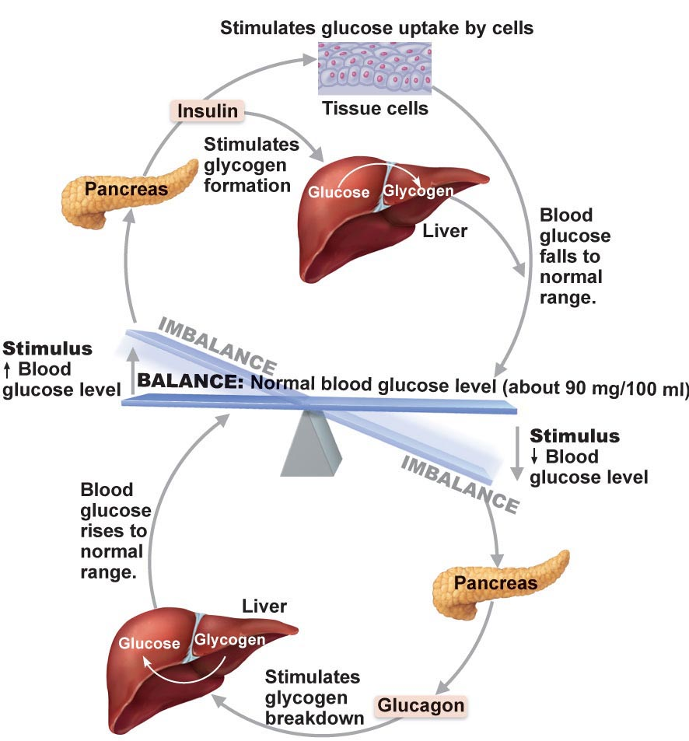
- The goal is to prevent sudden and severe changes
  - An example is how insulin and glucagon both act on the liver to degrade glucose (during an increase in blood glucose level) or synthesis glucose (during a decrease in blood glucose levels) respectively

Positive Feedback Mechanism
- Enhances original stimulus, output is further stimulated
- Change occurs in same direction as original response
- Positive feedback is always trying to reach a goal
  - An example is blood clotting (thrombosis)
    - Break or tear occurs in blood vessel walls
    - Platelets adhere to site and release chemicals
    - Released chemicals attract more platelets
    - Platelet plug is formed
  - Another example is when you get a fever, your body is trying to fight off an infection (goal). When you are fighting infections, the hypothalamus allows the body temperature to climb above set point to about 38 degrees Celsius
    - This process involves both negative (bringing fever down) and positive (fever) feedback

Autonomic Nervous System
- Self-governing
- System of motor neurons to smooth, cardiac muscles and glands to allow response usually without our awareness
- Often below our level of consciousness
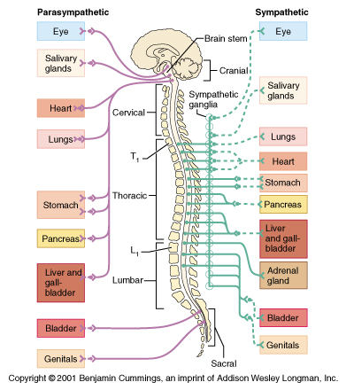
- Has dual and opposing innervation from sympathetic and parasympathetic nervous system
  - Parasympathetic is rest and digest
  - Sympathetic is fight or flight
    - The skin and blood vessels are only innervated by the sympathetic nervous system
- Differences between PNS and SNS
  - Sites where nerves originate
  - Relative lengths of pre- and post-ganglionic fibers
  - Locations of ganglia
- Cranial sacral outflow – parasympathetic opposite of sympathetic, goes to the body’s surface and the blood vessels
  - Post ganglionic neuron that innervates the tissue is very close to the target tissue
  - Ganglion can be inside the target tissue
- Thoracic lumbar outflow – sympathetic, preganglionic is short and postganglionic is long

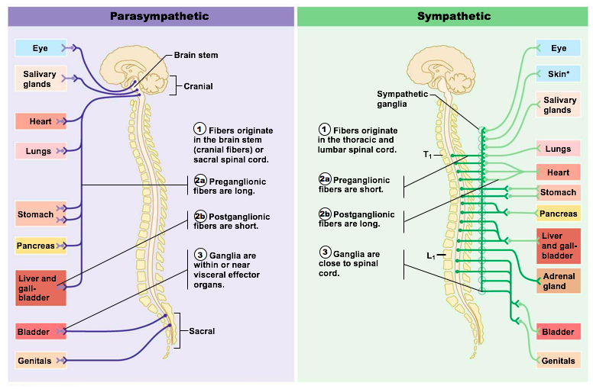

Parasympathetic Nervous System
- Active in non-stressful situations
- Fibers originate in the brain stem (cranial fibers) or the sacral spinal cord
- Preganglionic fibers are long
- Post ganglionic fibers are short
- Ganglia are within or near visceral effector organs

Sympathetic Nervous System
- Important during exercise and stressful situations
- Collateral ganglion is collection of ganglionic neurons that innervate smooth muscles and glands
- Fibers originate in the thoracic and lumbar spinal cord
- Preganglionic fibers are short
- Postganglionic fibers are long
- Ganglia are close to spinal cord

Pathways and Ganglia
- ANS
  - Two neuron chain; pre- and post-ganglionic neurons
  - Conduction is slow
    - Preganglionic axons are thin and lightly myelinated
    - Postganglionic axons are thinner and unmyelinated
  - Stimulatory or inhibitory depending on neurotransmitter and receptors on effector organs
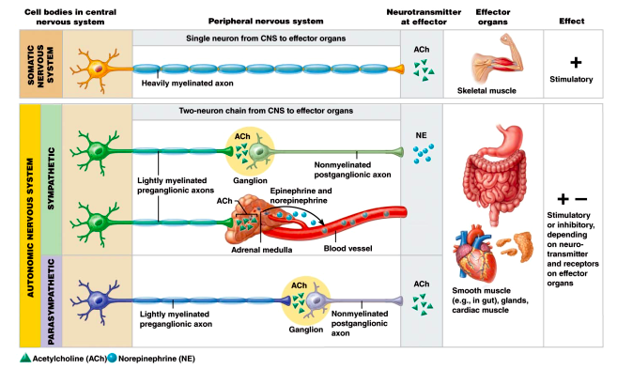

- Sympathetic is acetyl CoA norepinephrine
- Parasympathetic is acetyl CoA acetyl CoA
- Nicotinic receptors (ligand gated ion channel), muscarinic (depends on the tissue, acetyl CoA acting on this type of receptor can be excitatory or inhibitory)
- Neurotransmitter secreted is almost always noradrenaline for the sympathetic, fight or flight, all responses are excitatory by norepinephrine
- Neurotransmitter released is always acetyl CoA for parasympathetic, rest and digest isn’t inhibitory acetyl CoA at the GI tract is excitatory, don’t ask the neurotransmitter, ask the tissue because the tissue makes the excitatory or inhibitory response

Unique Roles of the SNS
- Antagonistic interactions mean they interfere with each other; heart, GI system
- Organs and tissues that only receive innervation from sympathetic division include;
  - Adrenal medulla
  - Kidneys
  - Sweat glands
  - Erector pili muscles of skin (goosebumps?)
  - Most blood vessels
- Metabolic effects
  - Increases metabolic rate of body cells
  - Increases mental alertness
  - Increases speed/strength of muscle contraction
- Thermoregulatory effects
- Release of renin from kidneys

G Proteins
- Act as middle men or relays between extracellular first messengers and intracellular second messengers that cause responses within a cell
- Ligand (1st messenger) binds to the receptor
- The activated receptor binds to a G protein and activates it
- Activated G protein activates or inactivates an effector protein by causing its shape to change
- Activated effector enzymes catalyze reactions that produce 2nd messengers in the cell
- Second messengers activate other enzymes or ion channels
- Kinase enzymes activate other enzymes

Three Levels of Regulation of Autonomic Function
- Brain stem and spinal cord controls
  - Direct effects on ANS activity
  - Motor centers in ventrolateral medulla (ex; cardiovascular center)
- Hypothalamic Controls
  - The hypothalamus is the integration center of the autonomic nervous system
  - Anterior regions parasympathetic nervous system
  - Posterior regions sympathetic nervous system
- Cortical controls
  - Cerebral cortex can influence the autonomic nervous system very easily
  - The cerebral cortex knows that you’re in a race on field day
  - Something about people who play the flute
  - Nerves interfere with performance so you drop beta blockers to inhibit performance anxiety
  - Cognitive anticipation is activating your sympathetic nervous system
  - We don’t need to know about the bio feed back
    - Just that there are cognitive components
    - Don’t take beta blockers they muddy your thinking

Hormones
- Hormones are chemical substances released into the ECF that regulates the metabolic function of other cells in the body
  - Pineal melatonin, received light sort of like a third eye
  - Hypothalamus control and coordinating center, autonomic nervous regulator, regulates endocrine system
  - Thyroid control metabolic state
  - Parathyroid key regulator of calcium concentrate in the blood stream
  - Adrenals medulla releases adrenaline and noradrenaline, adrenal cortex releases steroid hormones
  - Pancreas insulin to control glucose levels
  - Liver glucagon does the opposite of insulin
  - Ovaries and testes sex hormones

3 Structural Groups of Hormones
- Amino acid, peptides, proteins
  - Most hormones are amino acid based
  - Usually water soluble and cannot cross the plasma membrane
  - Quick effect but doesn’t last long
  - How it works
    - Binds to cell surface receptor
    - Activation of membrane bound G protein
    - Production of second messenger (cyclic AMP, calcium)
    - Activation of protein kinases to regulate activity of key enzymes
- Steroid hormones (derivatives of cholesterol)
  - Only gonadal and adrenocortical hormones are steroids
  - These hormones are lipid soluble and can cross the plasma membrane
  - Slow effect but lasts longer
  - How it works
    - Steroid hormone diffuses through plasma membrane and binds to intracellular receptor
    - The receptor hormones complex enters the nucleus
    - The receptor hormone complex binds a hormone response-element (a specific DNA sequence)
    - Binding initiates transcription of the gene to mRNA
    - The mRNA directs protein synthesis
- Eicosanoids (from arachidonic acid)
  - Inflammation and allergies
  - Do not fit the definition of true hormones

3 Types of Endocrine Gland Stimulus
- Humoral stimuli
  - Simplest endocrine controls
  - Stimulation from the body fluids, serum, glucose triggering the release of insulin on one side or glucagon on the other side
  - Hormone secretion in direct response to change in blood level of a nutrient or ion
    - Parathyroid glands monitor the body’s crucial blood Ca⁺² levels and release parathyroid hormone as needed
    - Insulin is released in response to increased blood glucose
- Neural stimuli
  - In very few cases, nerve fibers stimulate hormone release
    - In response to stress, the sympathetic nervous system stimulates the adrenal medulla to release norepinephrine and epinephrine
- Hormonal stimuli
  - Hormone stimulated hormone release
    - Releasing and inhibiting hormones produced by the hypothalamus regulate the secretion of most anterior pituitary hormone, and many anterior pituitary hormones in turn stimulate other endocrine organs to release their hormones
    - TRH (hypothalamus) TSH (anterior pituitary) thyroid hormones
Hypothalamus and Pituitary Interactions
- Posterior pituitary
  - AP’s travel down the axons of hypothalamic neurons, causing hormone release from their axon terminals in the posterior pituitary
    - Oxytocin and ADH
- Anterior Pituitary
  - Hypothalamic hormones released into special blood vessels (the hypophyseal portal system) control the release of anterior pituitary hormones
    - Growth hormone, TSH (thyroid stimulating hormone), etc.

Chapter 17 - Blood

Functions of Blood
- Transport
  - Oxygen, nutrients, metabolic waste (CO₂ in lungs, nitrogenous waste in kidneys), hormones
- Regulation
  - Body temperature (vasoconstriction and vasodilation), maintaining normal pH, maintaining adequate fluid volume
- Protection
  - Preventing blood loss (thrombosis), preventing infection (antibodies + red blood cells)

Composition of Blood
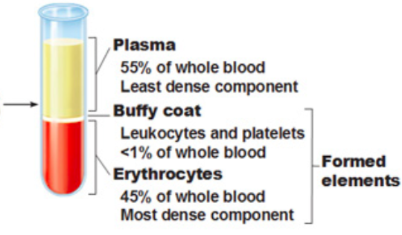
- Plasma
  - About 90% water but contains nutrients, gases, hormones, proteins, inorganic ions (electrolytes)
  - Most plasma proteins are produced by the liver
  - Albumin accounts for some 60% of plasma protein, contributes to plasma osmotic pressure
- Formed Elements
  - Only leukocytes are real cells as erythrocytes don’t have nuclei and platelets are cell fragments
  - Blood cells don’t live very long in the blood stream and they don’t divide, as stem cells divide into them continuously in the bone marrow
    - Erythrocytes
      - Shaped like biconcave discs, packed with hemoglobin which transports gases, spectrin allows it to change shapes when squeezing through very small blood vessels,
      - Three characteristics that are essential
        - Small size and shape provide a huge surface area
        - Over 97% hemoglobin
        - No need for ATP production aerobically, so it doesn’t use up the oxygen it carries, no mitochondria
      - Hemoglobin is made up of the red heme pigment and the protein globin
        - Globin consists of 4 polypeptide chains, two alpha and two betas, each binding a ring like heme group, and each heme group has an iron molecule in the center
        - Can transport 4 oxygen, a single RBC contains about 250 million hemoglobin so each RBC can pick up about a billion molecules of oxygen
        - Hemoglobin being contained in the erythrocytes prevents it from (1) breaking into fragments and leaking out of the bloodstream and (2) making the blood more viscous and raising the osmotic pressure
        - Hemoglobin draws water to it, it has this idea of allosteric binding, once O2 binds to one it changes shape and allows for others to bind easier
        - It knows when to unload the oxygen because it senses CO2 and binds to the globin part which is almost a signal to release oxygen, once on CO2 or H attaches it triggers the release of oxygen due to shape change
    - Leukocytes
      - Leukocytes are complete cells because they are the only formed elements to have the typical elements that all cells have (organelles)
    - Platelets
      - Also called thrombocytes
      - Cytoplasmic fragments of megakaryocytes
      - Life span of 10-12 days so they need to be constantly replenished
      - Formation is regulated by thrombopoietin

Hematopoiesis
- Production of red blood cells in the bone marrow in a network of reticular connective tissue
- Released in the bone marrow from leaky capillaries called sinusoids
- One stem cell makes all the formed elements
  - HEMOCYTOBLAST
- Hemocytoblast forks into myeloid or lymphoid stem cells which cannot reverse back to hemocytoblasts

Erythropoiesis
- In the first phase, you have ribosome synthesis protein synthesis,
- Then you accumulate hemoglobin and get rid of organelles and the reticulocyte is what is released into the blood stream and let’s go of the rest of its ribosomes and becomes an erythrocyte
- 120-day life span of RBC
- The heath of bone marrow may increase or decrease number of reticulocytes

Hormonal Regulation of Erythropoiesis
- Number of red blood cells
  - Too few anemia resulting in tissue hypoxia (low level of oxygen available to tissues)
  - Too many polycythemia resulting in increased blood viscosity
- Erythropoietin (EPO)
  - Glycoprotein produced in the kidneys
    - Additional EPO released in kidneys if hypoxia due to
      - High altitude or pneumonia
      - Increased demand
      - Hemorrhage/excess RBC destruction
      - Insufficient hemoglobin/ RBC
  - Enhances maturation rate of committed RBC precursors
  - Kidneys monitor level of oxygen and not number of RBC
  - Athletes and abuse
    - EPO increases hematocrit from 45% - 65%
    - But also increases viscosity and dehydration during race cause lead to clotting, stroke, heart failure
    - You tire less quickly because more oxygen is being transported
  - Testosterone speeds up EPO production
  - Renal failure is a problem because kidneys make EPO which is needed for RBC production, if the kidney doesn’t function you’re not making EPO and your blood cells only live for 120 days so you’d see anemia
- Erythropoiesis dietary requirements
  - You need iron always, can’t make proper hemoglobin, oxygen deficit
    - Too much is toxic and can be deposited in different organs, it’s always bound to something
  - 65% is found in hemoglobin which leaves the rest to liver, spleen and bone marrow
  - Free iron ions are toxic so it is bound with proteins
    - Stored in cells as ferritin and hemosiderin
    - Transported in blood bound to protein transferrin

Destruction of Erythrocytes
- Takes place in the spleen
- Iron is stored and reused, porphyrin ring is degraded into bilirubin
  - Bilirubin is secreted into intestine in bile where it is metabolized to stercobilin by bacteria and excreted in feces
- Most of the hemoglobin is recycled
- Rigid and fragile because no nucleus or organelles, proteins don’t live forever, the squeezing and expanding gets too old
- Very little is wasted as the red blood cells are recycled
- Bilirubin is a problem for newborns if their livers don’t function and don’t degrade the bilirubin and you get a build up

Anemia
- Decrease/impairment in O₂ carrying capacity of RBC
- Signs and symptoms include; tired, pale, short of breath, chilly (lack of oxygen)
- Causes are
  - Insufficient # of RBC
    - Blood loss hemorrhaging, leads to not enough RBC bringing oxygen to tissues because you’re losing it all
    - RBC destruction hemolysis
    - Destruction of bone marrow aplastic anemia, usually your other formed elements are messed up too
  - Decrease in hemoglobin content
    - Iron deficient anemias, when you have this you can’t make hemoglobin
  - Abnormal hemoglobin
    - Deficiency that is of genetic cause, example is sickle cell anemia, one base pair changes (glutamine to valine) affects the function of RBC especially when in stressful or low oxygen situation, hemoglobin works and they can supply oxygen, crisis situation is when you’re in a stressful situation your blood cells start sickling and form clumps and clog small blood vessels and causes pain downstream of the clumps because the tissues aren’t getting oxygen, current treatment is with hydroxyurea (causes hemoglobin to revert to fetal hemoglobin), even if you have this mutation it doesn’t sickle, even under stressful situations.
    - Cold can trigger a crisis in sickle cell patients

Polycythemia
- RBC excess
- Poly for too many, cyt for cells, emia for having to do with blood
  - Polycythemia vera
    - Neoplastic transformation of bone marrow
    - Cancer of the bone marrow, you lose the regulatory stopping mechanism and unregulated growth occurs, uncontrolled production of red blood cells, platelets, RBC and WBC will all go up because they all come from the same origin
  - Secondary polycythemia
    - Due to chronic hypoxemia (deficient blood O₂)
    - High altitude, as you go up, less oxygen in air, the body gradually makes more blood cells, but if you’re not careful it can cause polycythemia, high performance athletes practice at high altitude to increase RBC and carrying capacity and you can compete at sea level
  - Relative polycythemia
    - Due to dehydration
    - Total blood volume drops but same amount of RBC and the concentration is much more and then you become polycythemia, it occupies more than 45% of blood volume, doesn’t take much to get dehydrated, can cause thrombosis and increase viscosity, cardiac output goes down

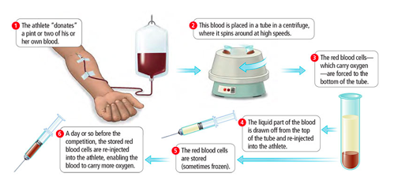
Blood Doping
- EPO stimulates bone marrow to make more RBC
- Testosterone enhances effects of EPO
- Reinjecting plasma creates a lower concentration of RBC and then the body ramps up production of RBC

Hemostasis
- Fast series of reactions for stoppage of bleeding. Requires clotting factors and substances released by platelets and injured tissues. Three steps
  - Vascular spasm
    - Vasoconstriction in response to damage, to slow down the leakage of blood it reduces the flow of blood
  - Platelet plug formation
    - Platelets don’t stick to each other or endothelial lining
    - Exposed collagen when damage occurs causes platelet adhesion
    - Von Willebrand factor helps adhesion by forming a bridge between collagen and platelets
    - Platelets activate; swell, become spiky and stickier
      - Degranulation; releases chemical messengers (trigger positive feedback mechanism)
  - Coagulation
    - Reinforces platelet plug with fibrin threads
    - Series of reactions use clotting factor (procoagulants)
      - 13 procoagulants numbered on the order in which they were discovered, not how they appear in the pathway
      - Vitamin K comes from our food, vitamin k is fat soluble so, in order for fat to be absorbed you need bile, made by liver, emulsifies fat and that is how it is transported through the body
    - Coagulation occurs in three phases
      - Prothrombin activator formed
      - Prothrombin thrombin
      - Fibrinogen molecules fibrin mesh
    - Phase 1: Two pathways (intrinsic and extrinsic)
      - Triggered by tissue damaging events
      - Each pathway cascades toward and ends with the activation of Factor X
      - Prothrombin activator is the rate limiting step
      - Just a series of activation reactions after rate limiting it goes pretty fast
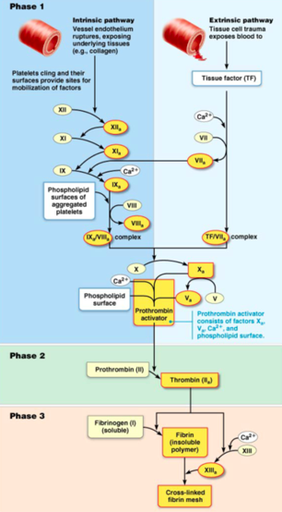
    - Intrinsic pathway
      - “Intrinsic” because clotting factors are present within the blood
      - Triggered by negatively charged surfaces such as activated platelets, collagen, or even glass of a test tube
    - Extrinsic pathway
      - “Extrinsic” because factors needed for clotting are located outside the blood
      - Triggered by exposure to tissue factor; also called factor III (sub endothelial protein)
      - Need to know factor 10, 5 and Ca²⁺
        - Prothrombin activator consists of factors X_{a}, V_{a}, Ca²⁺, phospholipid surface
    - Phase 2: Pathway to thrombin
      - Prothrombin activator catalyzes transformation of prothrombin to active enzyme thrombin
    - Phase 3: Common pathway to the fibrin mesh
      - Thrombin convers soluble fibrinogen to fibrin
      - Fibrin strands form structural basis of clot
      - Fibrin causes plasma to become gel like trap, catching formed elements
      - Thrombin along with factor XIII (fibrin stabilizing factor) which;
        - Cross link fibrin
        - Strengthens and stabilizes clot
      - Anticoagulants are factors that normally dominate in blood to inhibit coagulation
  - Clot retraction and repair
    - Occurs within 30-60 minutes
    - Serum squeezed from clot and ruptured edges of blood vessels pulled closer
    - PDGF released during degranulation stimulates smooth muscle cells and fibroblasts to divide and rebuild wall
    - Endothelial cells multiply to fill in gap lining (VEGF – vascular endothelial growth factor)
  - Fibrinolysis
    - Process of clot removal when it is no longer needed
    - Begins within two days and continues until the clot is dissolved
    - Key enzyme is plasmin (precursor = plasminogen)
    - Tissue plasminogen activator activates plasminogen which turns into plasmin and degrades fibrin

Thromboembolic conditions
- Undesirable intravascular clotting
  - Can be caused by plaque buildup, aspirin works to inhibit blood formation
  - Thrombus
    - Clot that develops and persists in an unbroken blood vessel – can block critical blood circulation to those tissues
  - Embolus
    - A thrombus which has broken free and can get stuck in a vessel of smaller diameter (pulmonary or cerebral embolism)
    - Can lodge anywhere

Bleeding disorders
- Thrombocytopenia
  - Lower than normal number of platelets in blood
  - Causes are anything that is harmful to the bone marrow
  - Any movement will lead to bruising (internal hemorrhaging)
  - Whole blood transfusions will provide temporary relief as the platelets only live for 10-12 days
- Impaired liver function
  - Associated with reduced bile production can lead to a bleeding disorder
- Hemophilia
  - Hereditary bleeding disorder
    - 83% of cases are hemophilia A which is a deficiency in factor 8
    - Hemophilia B is a deficiency in factor 9
  - Sex linked condition
  - Males would be hemophiliacs with symptoms because it is carried in the x chromosome and the male doesn’t have another x gene to compensate., females would be carrier because their second x gene will compensate.

Human blood groups
- RBC membranes bear 30 naturally occurring antigens
- Anything that is perceived as foreign generates an immune response
- Only ABO and Rh antigens cause serious agglutination problems

ABO blood groups
- Types A, B, AB, O
- Based on presence or absence of two agglutinogens (A and B on surface)
- Agglutinins are the antibodies present in the blood stream
- Type A has B antibodies, type B has A antibodies, AB has none and O has both A and B antibodies
- Blood type O is the universal donor, such a small concentration of antibodies in transfusion that it gets diluted out and doesn’t cause a problem
- Blood type AB is the universal recipient, doesn’t have any antibodies so it won’t create a reaction
Rh blood groups
- 52 named Rh agglutinogens (Rh factors)
  - D antigen triggers the strongest reaction
  - Rh⁺ indicates presence of D antigen
- Anti Rh antibodies are not spontaneously formed in Rh⁻ individuals
  - Anti Rh antibodies form if Rh⁻ individual receives Rh⁺ blood, or Rh⁻ mother is carrying Rh⁺ baby
    - Treated with RhoGAM to prevent erythroblastosis fetalis
    - The mom starts producing anti Rh-positive antibodies and the first pregnancy will be fine but after that, the antibodies can cross over and get into the baby’s circulation and destroy its blood cells

Transfusion and blood replacement
- Cardiovascular minimizes effects of blood loss by
  - Reducing volume of affected blood vessels
  - Stepping up production of RBC’s
  - Loss of 15 – 30% causes pallor and shock
  - Loss of over 30% and you go into hypovolemic shock, not enough blood pumping
  - Packed red blood cells for anemia
  - Plasma for hemophiliacs

Chapter 18 – The Heart

