Experiment 1: Verification of Boyle’s Law
Student Number: 300018138
Lab By: Amenah Waheed
Partner: Nishwara Tarannum
Due: Tuesday September 19, 2017
CHM1311 – Section D, 6:30 pm – 9:30 pm, Odd weeks
Dr. Rashmi Vankateswaran, TA: Maykon Lemes

INTRODUCTION

Gases, like all other states of matter, are subject to the kinetic molecular theory, which states that all particles of matter are constantly moving in random directions, and colliding with other molecules in a perfectly elastic fashion. Due to the weak intermolecular forces between the particles of gases, collisions with other gas molecules result in more freedom of movement of the particles, resulting in fluidity. Unlike the Ideal Gas Law,
PV=nRT
where gas molecules would ideally have no collisions and intermolecular forces, the spaces between non-theoretical gas molecules also make gases susceptible to changes in temperature (T), pressure (P), and volume (V), resulting in a different amount of collisions per change in variable. Boyle’s Law, which may be derived from the Ideal Gas Law, by keeping the temperature and amount of gas consistent in a closed system, is the focus of this investigation. In equation form, Boyle’s Law states that:
PV=k
only as long as the temperature and amount of gas is constant in the system, thus being excluded from the equation. Boyle’s Law may also be stated as:
P₁V₁=P₂V₂
to help show the inverse proportional relationship between the dependent variable of pressure with respect to the independent variable representing changes in volume of the enclosed system.

Reference:
Peter Mahaffy, Roy Tasker, Bob Bucat, Jon C. Kotz, Gabriela C. Weaver, Paul M. Treichel, Dr. John E. McMurry, Chemistry: Human Activity, Chemical Reactivity, Chapter 11.7, Nelson, Pages 425 – 427, Published: 2010.

MATERIALS AND EQUIPMENT
- LabQuest2
- Vernier Gas Pressure Sensor
- 20 mL gas syringe
- Gas (air)
- USB key

PROCEDURE
As described in the lab manual, “Do I dare disturb the universe?” (T.S. Elliot) Verification of Boyle’s Law, 2017, Experiment 1, Pages 4-5.

DATA AND OBSERVATIONS

Table 1.0: Volume vs. Pressure of air in an enclosed environment of a syringe – Trial 1
 | Volume (mL) | Pressure (kPa) | 1/Volume (mL) | K constant (mL*kPa)
 | 10.8 | 193.75 | 9.3 x 10⁻² | 2092.5
A | 12.8 | 164.23 | 7.8 x 10⁻² | 2102.1
B | 14.8 | 142.17 | 6.8 x 10⁻² | 2104.1
 | 16.8 | 124.29 | 6.0 x 10⁻² | 2088.1
 | 18.8 | 111.27 | 5.3 x 10⁻² | 2091.9
 | 20.8 | 101.42 | 4.8 x 10⁻² | 2109.5
 | 10.8 | 193.67 | 9.3 x 10⁻² | 2091.6

Table 2.0: Volume vs. Pressure of air in an enclosed environment of a syringe – Trial 2
Volume (mL) | Pressure (kPa) | 1/Volume (mL) | K constant (mL*kPa)
10.8 | 195.85 | 9.3 x 10⁻² | 2115.2
12.8 | 165.20 | 7.8 x 10⁻² | 2114.6
14.8 | 142.08 | 6.8 x 10⁻² | 2102.8
16.8 | 125.54 | 6.0 x 10⁻² | 2109.1
18.8 | 112.02 | 5.3 x 10⁻² | 2106.0
20.8 | 101.29 | 4.8 x 10⁻² | 2106.8
10.8 | 195.31 | 9.3 x 10⁻² | 2109.3

Table 3.0: Volume vs. Pressure of air in an enclosed environment of a syringe – Trial 3
Volume (mL) | Pressure (kPa) | 1/Volume (1/mL) | K constant (mL*kPa)
10.8 | 197.30 | 9.3 x 10⁻² | 2130.8
12.8 | 165.16 | 7.8 x 10⁻² | 2114.0
14.8 | 141.55 | 6.8 x 10⁻² | 2094.9
16.8 | 124.55 | 6.0 x 10⁻² | 2092.4
18.8 | 112.19 | 5.3 x 10⁻² | 2109.2
20.8 | 99.93 | 4.8 x 10⁻² | 2078.5
10.8 | 196.92 | 9.3 x 10⁻² | 2126.7

Qualitative Observations:
- As volume decreased in the syringe, greater amount of force was required to depress the plunger
- No chemical changes occurred, therefore air remained:
  - Odourless
  - Colourless
  - Transparent

CALCULATIONS
Trial 1 – Finding k constant
- K= volume x pressure
= 12.8 mL x 164.23 kPa
= 2102.144 mL*kPa (carried 4 extra SD)
= 2.10 x 10³ mL*kPa

- 1/Volume
= 1/(14.8 mL)
= 0.0675 mL (carried 1 extra SD)
= 6.8 x 10⁻² 1/mL

Trial 1 – Slope Calculation from Graph 1b)
Due to the inverse relationship between pressure and volume in Boyle’s law, P*V=k, calculating the slope of the Pressure vs. 1/Volume graph will result in a linear proportional relationship. The slope of the graph will thus be the value of the k constant.
From Table 1, using points, (1/volume, pressure): (7.8 x 10⁻² mL, 164.23 kPa), (4.8 x 10⁻² mL, 101.42 kPa)
K = Slope of graph
= (y₂ – y₁) / (x₂ – x₁)
= (pressure₂ – pressure₁) / (1/volume₂-1/volume₁)
= (101.42 kPa - 164.23 kPa) / (4.8 x 10⁻² 1/mL – 7.8 x 10⁻² 1/mL)
= ( -62.81 kPa) / (- 0.03 1/mL)
= 2093.667 kPa*mL
= 2.1 x 10³ kPa*mL

DISCUSSION
To calculate the k constant in Boyle’s Law, the relationship of P * V = k is used.
In a similar fashion to the calculations in Trial 1, A), all k constant values are calculated to be approximately 2.1 x 10³ kPa*mL, thus resulting in the constant value in this experiment. This value is supported by the calculations of the k constant in Trials 2 and 3, where the computed values of k also result as 2.1 x 10³ kPa*mL.
Another method for calculating the k value is to take the slope of the graphs referring to Pressure vs. 1/Volume, (as pressure and volume are inversely proportional to each other) which results in k = 2.1 x 10³ mL*kPa for all trials, with regards to significant digits.
Taking the measurements of the pressure corresponding to the first volume at the beginning and end of the trials helps ensure accuracy of the lab quest, and ensures that no air has escaped through the syringe throughout the trials. For example, if the air had escaped from the syringe during the trial, then the final pressure recorded for the first volume of air would be drastically lower than the initial pressure recorded at the beginning of the trial. This would result in discarding the trial, as the amount of air in the syringe will have changed, thus disrupting the parameters of Boyle’s Law.
Aside from amount of air in the syringe, temperature was also to be kept constant in the lab environment. This was done so by working in a lab with no drafts of air coming in from the external environment to disrupt the overall temperature of the lab.
As per all experiments, sources of error are always present, yet should be minimized for the least amount of inaccuracy and disruption of resulting data. The possible escapement of air in the syringe is an error that can decrease the recorded pressure as amount o fair is no longer constant in the closed system. The improbability of depressing the plunger at a consistent measurement can both increase and decrease the recorded pressure as the volume of air in the syringe is not consistent. Finally, random error occurs in all data due to the use of significant figures. This error has random fluctuations on the results of the data.
For future improvements, consider adding stable weights to the syringe for a measure of force vs. volume vs. pressure as a study. This helps keep the plunger held at a constant point, to reduce the error on volume of the air in the syringe. Using an enclosed chamber with a stable piston will also help get a more accurate reading of the volume and pressure of the air. This will also prevent thermal energy from entering the closed system to impact the pressure readings of the air.
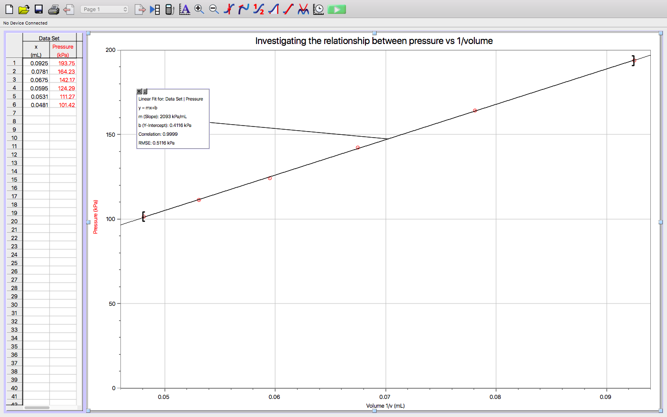
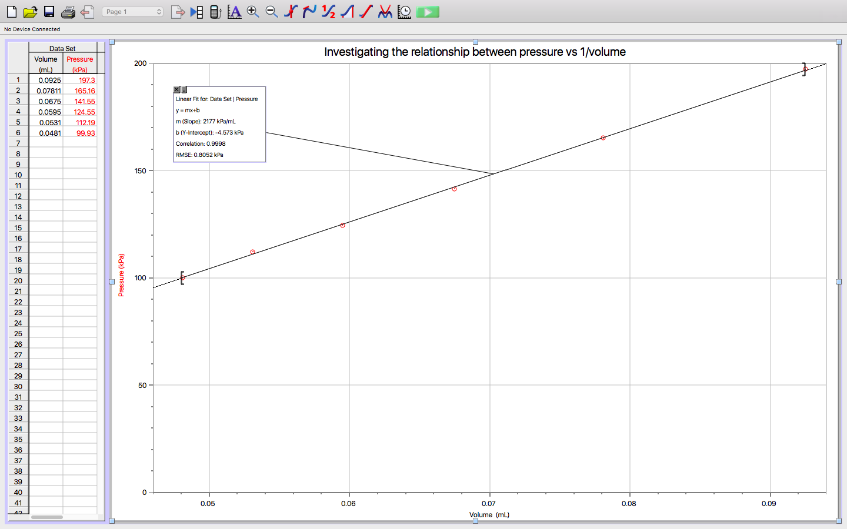
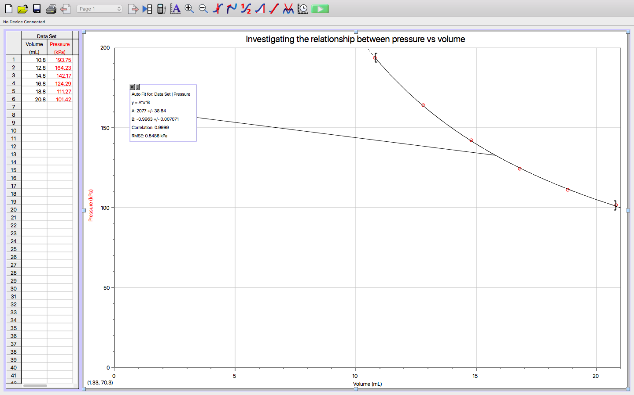
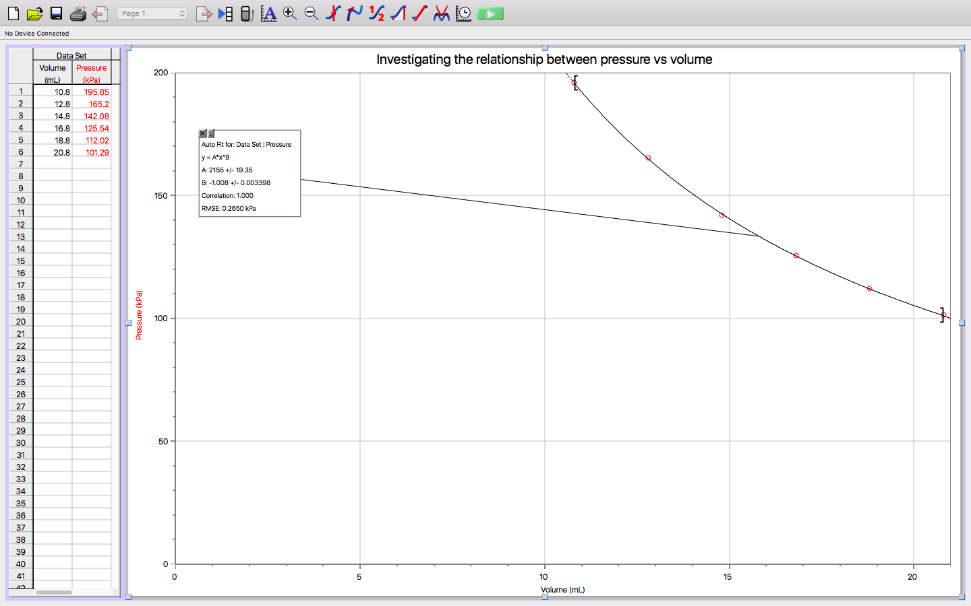
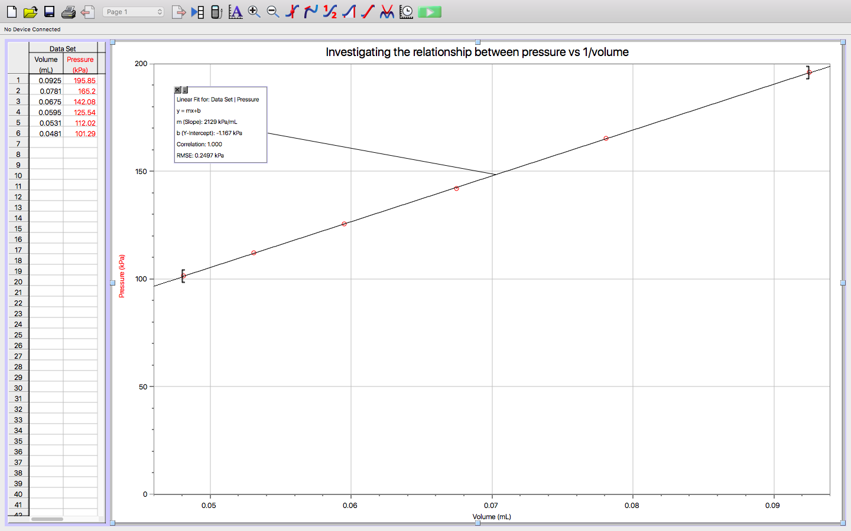
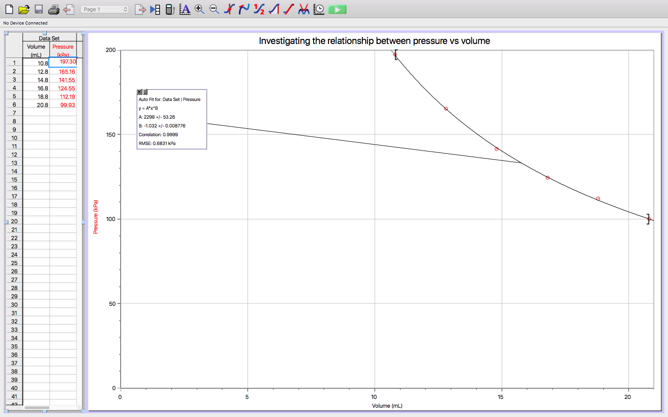
** LAB QUEST WAS GLITCHY, SO NO ELECTRONIC DATA, BUT GRAPHED ON LOGGER PRO – HAVE SPOKEN TO DR. RASHMI**
CONCLUSION
When keeping temperature and amount of air constant in the syringe, the parameters for discovering the relationship between pressure and volume, as per Boyles Law, were established. It was determined that pressure and volume were inversely related variables, with the calculated k constant for the air at a value of 2.1 x 10³ mL*kPa. Therefore, through this experiment, Boyle’s Law was indeed verified to be correct.

APPENDIX 1: RAW DATA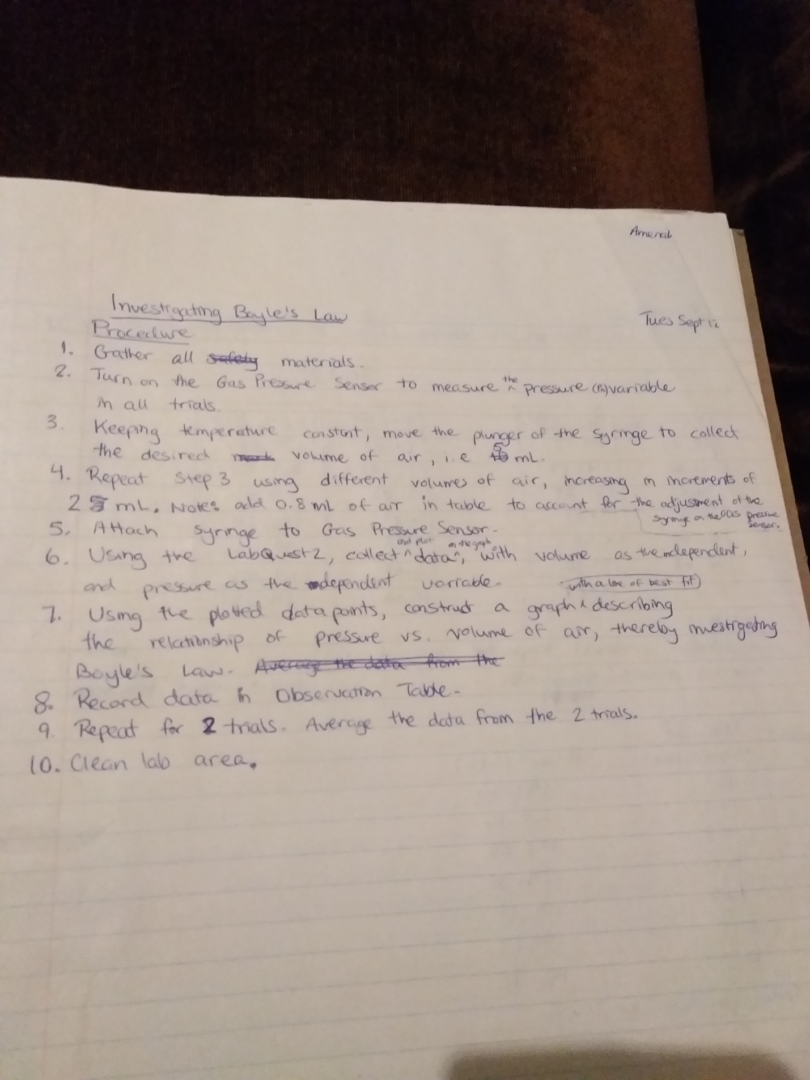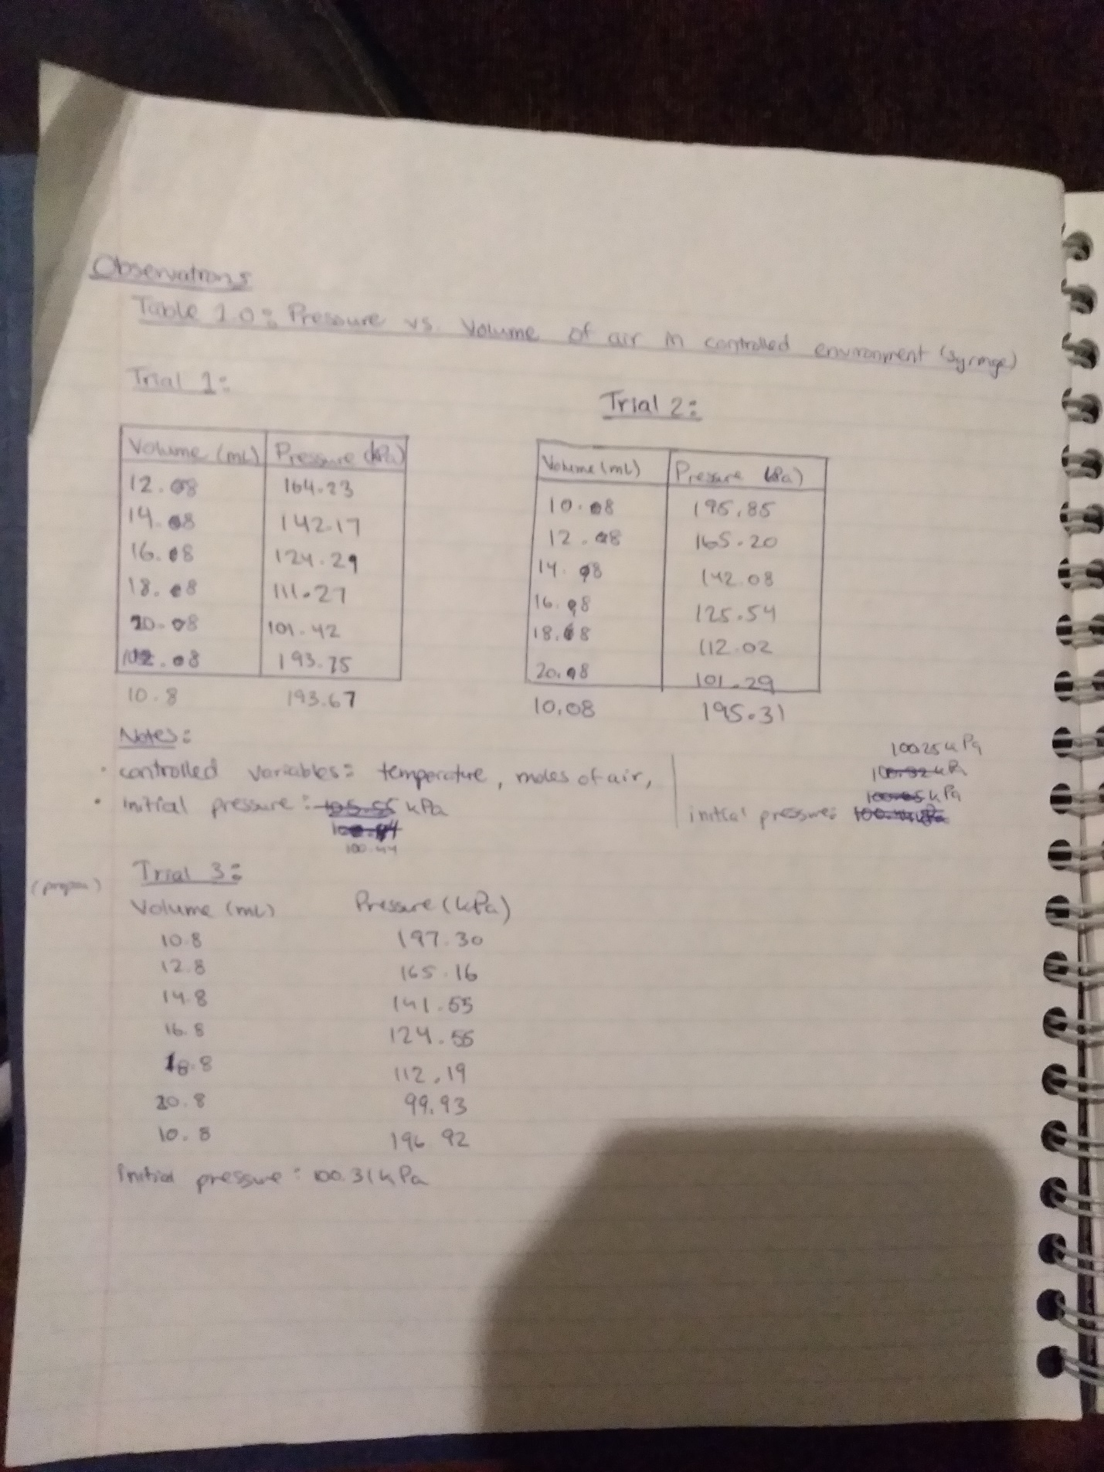
** PLEASE REFER TO EMAILS ABOUT LACK OF SIGN ON RAW DATA**

