BTM 200
ASSIGNMENT 1: COMPUTER CONFIGURATION

1.
There are three parts for the team computers which I consider to be the most important:
- The CPU
- The RAM
- The graphics card
Understandably, the CPU is the brain of the whole configuration. Nowadays, most developer create content creation softwares that require multi-core processor and multi-threading in order to run smoothly and efficient. When we are dealing with graphic design and video editing, the number of cores on the CPU can speed up the whole process. And the number of threads it has can boots the performance of the application we are using. Another qualification I considered to be important for the CPU is the speed. The higher the speed, the more instructions per second it can process, the shorter the time needed to do the task.
The second part are RAMs. RAMs provide quick read-and-write access to the computer storage devices as well as a fast way to load data into the CPU. Content creation softwares rely heavily on RAMs so they are the second key point to the configuration.
The third part is the graphic cards. CPUs have integrated Graphics Processing Unit but they are simply not strong enough to handle the amount of heavy graphics task required for the jobs. A graphics card will remove the heavy graphics data from the integrated GPU in the CPU and move it straight to the graphics card to be processed. This can free up a lot of space in our configuration for other task and also boost the graphics performance in the process of video editing and rendering, animations and 3D models making.

2.
My recommendation for the parts I mentioned above:
For the CPU, I would consider to buy the Intel Core - i7 - 6700k with operating speed of 4.0 GHz. It comes with four cores and eight threads, with supported multi-threading. Alots of editing application softwares such as Adobe Premiere, Sony Vegas, … support multi-threading. As a result, the i7 – 6700k is a good choice for the team.
As for RAMs, although the i7-6700k is compatible with 64GB of DDR4 memory with maximum speed of 2133 MHz, I would only recommend up to 32GB of DDR4 2133. The 32GB is at the comfortable zone for most current day editing softwares to run smoothly.
I recommend the the GTX 1070 8GB Mini from Zotac. This video card comes with a high-end video processor as well as 8GB of graphics RAM. Also, the GTX 1070 Mini comes with a great price but delivers an outstanding performance more than you would expect.

3.
For this question, I use ca.pcpartpicker.com instead of Sigmawave’s website.
Link to the quotation: https://pcpartpicker.com/user/mattsama1999/saved/gYg3FT
Here is the quotation:
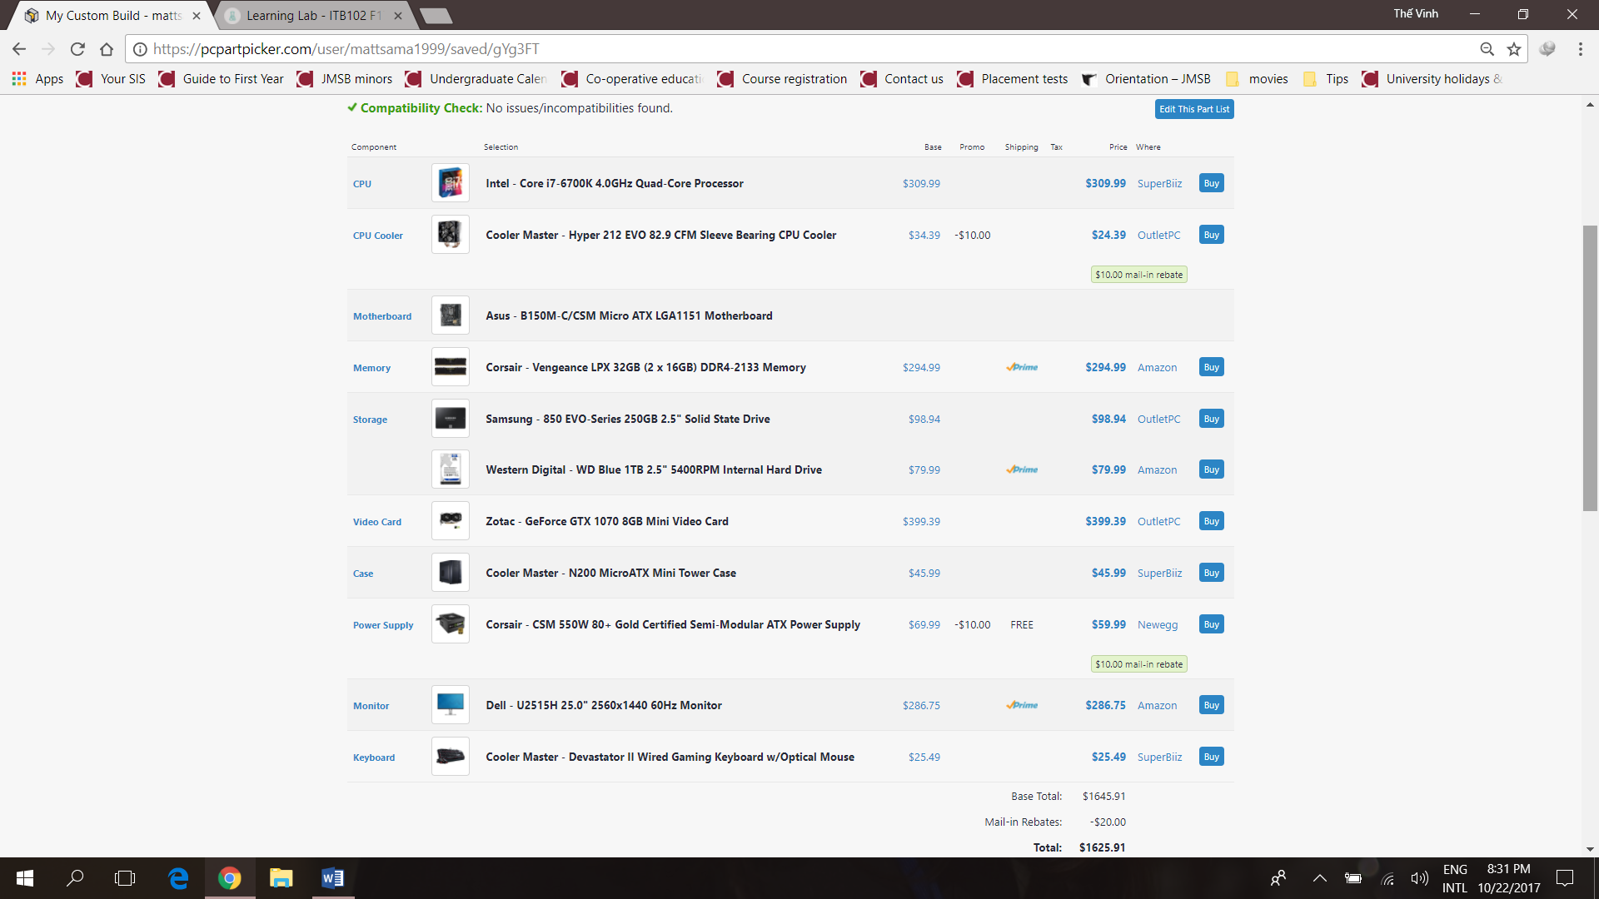
I used this website on October 22, 2017.


