*Lesson 2
Define the meaning of human resource management, performance management, training and development
Human resource management: Strategic approach to the management of an organization’s employees. Objective is to recruit, motive, develop and retain employees who’s performance is necessary for the company’s achievement. To learn necessary skills & to meet current and future job demands
Performance management: Establishing performance expectations with employees, holding interventions and programs to improve performance and develop employees, and monitoring the success of these programs and interventions. It is an ongoing and continuous process.
Training and development: Training= acquisition of knowledge skills and abilities to improve one’s performance, a company’s way of facilitating their employees’ learning abilities. (Right away)
Development= Acquisition of knowledge, skills and abilities required to perform job responsibilities and the long term achievement of individual career goals and the organizations achievements. (For future situations)
Education= develop on one’s intellect, is individual…Training= learning to perform specific skills for social and economic benefits
Performance management process: performance goals feedback performance evaluationperformance goals. ALL lead to employee development
List the organizational, employee and societal benefits of training and development (T&D).
Employee benefits: Intrinsic (more personal) = improves knowledge and skills, higher self-efficacy, feel more useful, more positive attitude towards job and organization
Extrinsic= higher earnings, more marketable, greater job security, enhanced promotion prospects
Organizational benefits: organizational strategies= helps organizations achieve their long-term and short-term goals, increase organizational benefits= better productivity, fewer errors, fewer accidents, less supervision needed, return on investment, employee recruitment and selection= a company’s training and development program can help recruit new employees and keep old ones.
Societal Benefits: Educated population= helps create educated and skilled work force and provides skills that serves employees outside of the work environment. Better standard of living= better trained workforce means better economy….more educated population will lead to better standard of living
Describe the state of T&D in Canada and Quebec.
- In Canada, over 11 million workers receive some type of workplace training each year.
- In 2008 more than 2/3 (69%) of full time employees in Canadian organizations received training, part-time and seasonal receive less training
- Less and less organizations spend money to train each employee, Canada spend the least compared to other countries
- Average number of hours spent training employees in 2010 was 25
- Baby boomers are now retiring, rate with which workers are leaving the workforce is greater than the ability of new employees to fill that void
- Will likely have to rely on immigration.
- Causing a loss of expertise and knowledge.
- Greater need for knowledge management initiatives.
- Increase in unemployment increased rate in 2008= amount of people seeking work divided by amount of people who can work
- T&D provide opportunities to enhance their skills to get jobs and is necessary due to new information technology (new ways of communication, new products)
- Small and medium organizations spend more than large organizations
- Quebec’s 1% law: Law requires the investment of a minimum of 1% of a company’s total payroll on the training of its employees if payroll exceeds 1 million, if they fail to do so they get taxed on the unspent amount
- Quebec spends the most in Canada to train employees
Why are employers reluctant: employers lack confidence in the training program, they are concerned about employees taking advantage of training opportunities and then go elsewhere, and small and medium-sized enterprises lack the economies
Understand the context of T&D and high performance work systems.
An interrelated system of HR practices and policies which typically includes:
- rigorous recruitment and selection procedures
- performance-contingent incentive compensation
- performance management
- a commitment to employee involvement
- extensive training and development programs
Workplace training is not an independent activity.
- It is influenced by a broader organizational and environmental context, and a human resource system.
Context of T&D
Environmental Factors:
- Laws
  - Quebec's 1% Law is an example of legislation that has a direct effect on a company's attitude towards training its employees.
- Global competition (and globalization)
  - International competitors, customers, suppliers and employees require increased cross-cultural awareness training.
- Technology
  - Employees must be trained in using new technologies if they are to be adopted.
  - Technology will lead to productivity gains only when employees receive technology training
- Demographics
  - An ageing workforce means that there will be a significant "brain drain" as experienced workers retire. Transferring the know-how to new employees will be a challenge.
- Labour market
  - Changes in demographics of the Canadian workforce will require adaptations in the amount and type of training required.
  - It has been estimated that a critical shortage of skilled workers in Canada could reach 1 million by the year 2020
  - Changes are required in the types of training
  - Economy
    - The economic downturn of 2009-10 caused higher unemployment and a return to school for many to upgrade their skills in an attempt to find a new job.
  - Change
    - Trends, new laws, economic changes and other events (external to the company) that affect the organization.
    - In order to remain competitive organizations must adapt and change
  - Social Climate
    - Specialized training programs that deal with diversity, security, and stress management are examples of the effects of the social climate on training needs.
Organizational factors:
- Strategy
  - One of the most influential factors of training and development.
  - The alignment of human resources practices with an organization’s business strategy is called: Strategic Human Resources Management (SHRM).
  - Training becomes strategic when it is related to the business strategy.
  - Strategic training and development (ST&D) the alignment of an organizations training needs and programs with and organizations strategy and objective
- Structure
  - Changes in employee tasks and responsibilities due to structural change within the organization.
  - Emphasis on teamwork may require additional training in communication, supervision and cross-training (skills needed to complete all tasks that work team is responsible for).
  - Structural changes include downsizing and reengineering
- Culture
  - Organizational Culture: The shared beliefs, values and assumptions that exist in an organization are referred to as the organizational culture.
- Human Resources Management System
  - All functional areas of HR work together to create an HR system
  - Human resource practices should be linked to business strategy and to each other so they work together to achieve an organization’s strategy
  - Driven by organizational strategy and SHRM
  - Is what constitutes a High Performance Work System (HPWS)
  - High performance work system: interrelated system of human resources practices and policies that include rigorous recruitments and selection procedure, compensation for good performance, performance management, commitment to employee involvement and extensive T&D programs
  - Leads to a Strategic Model of training and Development
Explain the meaning of strategic human resources management and strategic T&D. 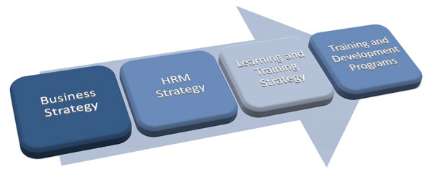(chain reaction)

Recognize the instructional systems design model of T&D.
ISD (instructional systems design model): A rational and scientific model of the training and development process that consists of a needs analysis, training design and delivery, and training evaluation. Training process begins with performance gap, needs analysis determines issue and if training is needed.

Identify resources for learning about trends and practices within the field of T&D.
Instructional design is sometimes referred to as the

ADDIE process:
  - Analyze the situation (learners, content, resources, and environment).
  - Design the instruction (objectives, method).
  - Develop the learning material (content, multimedia, resources).
  - Implement the training (face-to-face, online, blended delivery).
  - Evaluate the outcome (make changes if necessary).

*Lesson 3
Define organizational learning and describe a learning organization along with its disciplines and principles.
Organizational learning: the process of creating, diffusing, sharing and applying knowledge in an organization
Organizational learning focuses on the systems used to create and distribute new knowledge on an organization-wide basis. Continuous learning,
The learning organization: Organization that acquires, organizes, and shares information and knowledge, and uses new information and knowledge to change its behaviour in order to achieve its objectives
5 disciplines of the learning organization:
  - Personal Mastery: individuals have to be willing to learn on a continuous basis
  - Building a shared vision: a common goal that everyone is committed is committed to achieve
  - Mental models: people are aware of how they influence their own behaviours (like self-reflection)
  - Team-learning: learning takes place in teams with dialogue, discussion and thinking together
  - Systems thinking: views organization as a whole and being able to see and understand individual parts and how they interrelated

Discuss the four dimensions critical for creating and sustaining a learning organization.
Four dimensions: Vision: requires clear visions of organization’s strategy and goal
Culture: Fosters information, sharing and continuous learning, supports risk taking and learning, everyone in organization is responsible
Learning systems/dynamics: seek solutions to problems through a systematic view of the organization and its environment, employees are expected to manage their own learning and development & are coached by their managers
Knowledge management/infrastructure: learn from own experience and competitors, customers and experts, they have systems to acquire, store and distribute important info so that it’s available to those who need it and when they need it.
Learning culture: attitudes and practice within the organization associated with organizational learning and people development
Explain what knowledge is and give examples of explicit and tacit knowledge.
Knowledge: Sum of what is known; a body of truths, information, and principles. Transferred and stored in information systems in the organization, found in the minds’ of employees.
Explicit knowledge: Things that you can buy or trade, such as patents or copyrights and other forms of intellectual property. Knowledge that has been codified or documented. (10$ ct policy)
Tacit knowledge: Known only by the individual and is not necessarily known by the organization. Valuable wisdom learned from experience and insight that has been defined as intuition, know-how, little tricks, and judgment. Difficult to transfer (people are often not aware of the tacit knowledge they possess and how valuable it is to others). (know not to tell customer)
Describe and explain intellectual capital, knowledge management and informal learning.
Intellectual capital: An organization’s knowledge, experience, relationships, process discoveries, innovations, market presence, and community influence.- grows with use
- Human: knowledge, skills and abilities of employees
- Renewal: intellectual property such as patents, licences, copyrights and marketable innovations
- Structural: systems and relationships that allow employees to communicate, solve problems and make decisions
- Relationship: Organization’s relationship with suppliers, customers, and competitors that influence how they do business, customer capital: value of organizations relationships with customer
Knowledge management: Involves the creation, collection, storage, distribution, and application of compiled ‘know-what’ and ‘know-how’ or, seeks to identify and connect individuals based on their expertise and areas of activity.
- Knowledge acquisition: environment scanning (tapping into internal and external sources of info and establishing connections), formal learning, informal learning (largest proportion of how employees learn
- Knowledge interpretation: learning occurs when employees form their view of the organization and its environment, these views are often called mental model
- Knowledge dissemination: moving products, services and money through and between organizations is a standard process, moving ideas requires different set of skills, knowledge sharing, Information and Communication Technologies (ICT) allow for increased codification of knowledge (ex. Communicating through technology)
- Use/application: monitor how knowledge is being used, where it’s being used and who’s using it
- Evaluation: a consideration of the value and potential of the knowledge
- Knowledge retention: organizations must build tools to quickly compile, store and retrieve this knowledge, encourage its use to facilitate interaction
Communities of Practice (COP): groups of employees who share similar concerns and problems and meet regularly to share their experiences and knowledge and identify new approaches for working and solving problems.
- To create them, managers need to focus on 3 things: identify potential COPs that will enhance an organization’s abilities, develop an infrastructure to support COPs and enable members to share their expertise, assess a value of the COPs (listen to stories about their experience)
Formal learning: learning that structured and planned by organization, represents a small, but critical proportion of how employees learn. Controlled by organization
Informal Learning: learning that occurs naturally as a part of work and is not planned. Represents the largest proportion of employee learning. Often spontaneous, immediate and task-specific. Can be based on trial and error, search or social network. Controlled by learner
Workplace learning: process of acquiring job related knowledge and skills through both formal training and informal social interactions among employee
Describe the multilevel systems model and explain how learning is related to training and development.
The model shows that there are three levels of learning in organizations:
- The organization level (organization’s leadership, culture, vision, strategy, and structure)
- The group level (group climate, culture, norms, dynamics, and processes, as well as the nature of the group task in terms of its complexity and task interdependence)
- The individual level (organization needs to provide structured and formal training and development programs in order for employees to acquire new knowledge and skills, as well as opportunities to share and exchange info, employees must also be rewarded).
*Lesson 4
Define learning
Learning: The process of acquiring knowledge and skills, and a change in individual behaviour as a result of some experience. Learning is a persisting change in human performance or performance potential as a result of experience
List Gagne’s five learning outcomes.
Verbal information: Facts, knowledge, principles, information (declarative knowledge). Verbs: state, recite, tell, declare, define. Example: “Define the term learning.”
Intellectual skills: Concepts, rules, and procedures (procedural knowledge). Categories: discrimination, concrete concept, defined concept, rule, higher-order rule. Verbs: distinguish, identify, classify, solve, label, specify. Example: “Identify each instance as an example of procedural or declarative knowledge.
Cognitive strategies: Application of information and techniques. Understanding how and when to use the information. Verbs: adopt, create, originate, invent. Example: “Create and explain your own strategy to solve the following problem.”
Motor skills: Coordination and execution of physical movements. Verbs: execute, perform, demonstrate. Example: “Hit a ball with a baseball bat.”
Attitudes: Preferences and internal states associated with beliefs and feelings. Verbs: elect, favour, prefer, choose. Example: “Which learning theory do you prefer and why?
Identify the three stages of learning and Kolb’s learning styles.
Declarative knowledge: learning knowledge, facts and information. Attempts at reading involve the application of this knowledge
Knowledge compilation: Integrating tasks into sequence to simplify and streamline the task
Procedural knowledge: Learner has mastered the task and performance is automatic & habitual
Kolb’s learning styles:
- Converging: abstract conceptualization + active experimentation= thinking and doing
- Diverging: concrete experience + reflective observation= feeling and watching
- Assimilating: abstract conceptualization + reflective observation= thinking and watching
- Accommodating: concrete experience + active experimentation= feeling and doing
Describe conditioning theory, social learning theory, and situated cognition and their implications for T&D.
Learning theory: A learning theory consists of a set of propositions and constructs that attempt to explain how change in behaviour (learning) is achieved.
Conditioning Theory (from Behaviourism): Learning is a result of reward and punishment contingencies that follow a response to a stimulus. A stimulus or cue would be followed by a response, which is then reinforced. Strengthens the likelihood that response will occur again and that learning will result.
-Positive reinforcement, negative reinforcement, punishment, shaping (reinforcement of each step), chaining (reinforcement of entire sequence), generalization (conditioned response)
Situated Cognition (from Cognitivism): Theory that builds on cognitive approaches to understanding learning. Cognitivism focuses on the structures that are created in the mind, through experience, and that further mediate our interpretation of experience.
- These structures are called mental models or schema.
- Schema evolve through different processes in which they are tweaked or extended to deal with new experiences, or undergo radical restructuring, if required (“accretion”, “tuning”, “restructuring”).
- Schema serve as filters that focus our attention in different ways
Social Learning Theory:
- Observation: Learning through interactions with others. Four key critical elements: Attention, Retention, Reproduction, Reinforcement
- Self-efficacy: Judgments people have about their ability to successfully perform a specific task. Influenced by four sources of information in order of importance:
  - Task performance outcomes
  - Observation
  - Verbal persuasion & social influence
  - Physiological/emotional state
- Self-management: Managing one’s own behaviour through a series of internal processes.
- Observe personal behaviour, as well as the behaviour of others
- Setting performance goals
- Assessing personal progress
- Rewarding oneself for goal achievement
- Concepts: self-regulation, metacognition
Describe adult learning theory, and its implications for T&D.
Adult learning theory: based on how adults and children are different in the implications of these differences for learning
Andragogy: An adult-oriented approach to learning that takes into account the differences between adult and child learners
Pedagogy: The traditional approach to learning used to educate children and youth.
Define motivation and describe need and process theories of motivation and their implications for T&D.
Motivation: degree of persistent effort that one direct toward a gol
Extrinsic Motivation: stems from factors in the external environment.
Intrinsic Motivation: stems from a direct relationship between worker and task.
Theories:
Need theories: Needs refer to physiological and psychological desires. Needs are motivational because people are motivated to obtain the things that will satisfy their needs.
Process theory: energy or force that a person directs toward an activity is a direct result of 3 factors. Expectancy theory:
  - Expectancy: individual’s subjective probability that they can achieve a particular level of performance on a task (probability that you’ll get A or C in the course)
  - Instrumentality: likelihood that attainment off a first level outcome will lead to attractive consequences that are known as second-level outcomes (probability that A or C will get you a job offer)
  - Valence: refers to the attractiveness of the first and second level outcome,
Define training motivation and discuss its predictors and consequences.
Training motivation: The direction, intensity, and persistence of learning-directed behaviour in training contexts.
Personality variables that predict training motivation: anxiety, locus of control, achievement motivation, self-efficacy, conscientiousness
Locus of control: people’s beliefs about whether their behaviour is controlled mainly by internal or external forces
Achievement motivation: desire to perform challenging tasks
Conscientiousness: the degree to which a person is responsible and achievement-oriented
Job involvement: The degree to which an individual identifies psychologically with work and the importance of work to their self-image
Define all of the variables in the model of training effectiveness and describe how they are interrelated.
- Training motivation is also a strong predictor of learning and training outcomes.
- Self-efficacy, cognitive ability, and personality characteristics also have an effect on learning.
- Attitudes (i.e., job involvement, job satisfaction, and organizational commitment).

*Lesson 5:
Transfer of training
Define transfer of training (positive, negative, zero, far, near, horizontal, and vertical transfer).
Transfer of training: refers to generalization of knowledge and skills learned in training on the job and maintenance of acquired knowledge and skills over time.
  - Generalization: use or application of material on the job
  - Maintenance: Use of application of material on the job over a period of time (repeated behaviour)
The extent of transfer of training:
- Positive: Trainees effectively apply new learning on the job.
- Zero: Trainees do not apply new learning on the job.
- Negative: Trainees perform worse on job after training

Types of transfer of training:
- Near: Applying new learning to situations that are very similar to those in which training occurred.
- Far: Applying new learning to situations that are different from those in which training occurred.
- Horizontal: Transfer across different setting at the same level.
- Vertical: Transfer from trainee level to organizational level.
Describe the major barriers to transfer of training.
- Immediate manager does not support the training.
- The culture in the work group does not support the training.
- No opportunity exists to use the skills.
- No time is provided to use the skills.
- Skills could not be applied to the job.
- The systems and processes did not support the skills.
- The resources are not available to use the skills.
- Skills no longer apply because of changed job responsibilities.
- Skills are not appropriate in our work unit.
- Did not see a need to apply what was learned.
- Old habits could not be changed.
- Reward systems don’t support new skills.
Describe Baldwin & Ford’s model of the transfer of training process.
Training inputs:
- Trainee characteristics: Cognitive ability, training motivation, self-efficacy, personality characteristics, motivation to transfer
- Training design: Active practice and conditions of practice
- Work environments: Pre-training (management actions send messages/signals regarding importance and organizational support of training) & Post-training (support provided by trainees’ supervisor, training transfer climate: Characteristics in the work environment that can foster or inhibit applying the training to the job, learning culture: Transfer of training is greater in an organization that values the acquisition of knowledge and skill (a learning organization))
Training Output: Learning and retention
Conditions of transfer: Generalization and maintenance
Describe the activities that managers, trainers, and trainees can do before, during, and after training to improve transfer of training.
Transfer of training activities BEFORE training:
Management | Trainer | Trainees
Decide who should attend  - Readiness to learn/trainability  (Ability x Motivation x Perceptions of the Work Environment) = Readiness to Learn and Trainability.  - Trainability tests  Increase motivation to learn  - Meet with employees to discuss training needs.  - “WIIFM” (“what’s in it for me?”)  Provide employees with support for learning and training. | - Ensure application of ISD model.  - Ensure both trainees’ supervisor and trainees are prepared in terms of knowing objectives and benefits.  - Find out supervisor and trainee needs and expectations.  - Ensure that trainees are prepared for training in terms of prerequisite courses/readings, etc. | - Find out about training objectives prior to attendance.  - Meet with supervisor to discuss training program and develop action plan for learning and transfer.  - Prepare for training program.
During training
1. Management | 2. Trainer | 3. Trainees
- Participate in training programs.  - Speak about importance of training programs.  - Attend training programs before trainees.  - Reassign employees' work while they are attending training. | - Incorporate conditions of practice, adult learning principles, and other learning principles in design.  - Include content and examples that are relevant and meaningful.  - Include instruction on transfer of training.  - Have trainees prepare a performance contract. | - Enter training program with positive attitude and motivation to learn.  - Engage themselves by actively participating.  - Develop an action plan for application of training on the job.

After training
1. Management | 2. Trainer | 3. Trainees
- Ensure trainees have immediate and frequent opportunities to practice and apply what they learned.  - Encourage and reinforce trainees’ application of new skills.  - Develop action plan with trainees, reduce job pressures and workload, arrange practice sessions, give promotional preference to employees who have received training and, transfer and evaluate employees’ use of trained skills on the job. | Conduct field visits  - Observe trainees, provide feedback and support.  Offer booster sessions  - Definition: Extensions of training programs that involve periodic face-to-face contact between the trainer and trainees. | - Begin using new knowledge and skills on the job ASAP.  - Meet with supervisor to discuss opportunities for transfer.  - Form a “buddy system”.  - Consider high-risk situations that might cause a relapse and develop strategies for overcoming them and avoiding a relapse.

Define identical elements, general principles, and stimulus variability and explain how they can improve transfer of training.
Identical elements: Providing trainees with training experiences and conditions that closely resemble those in the actual work environment
General principles: teaching trainees the general rules and theoretical principles that underlie the use and application of trained knowledge and skills
Stimulus variability: involves providing trainees with a variety of training stimuli and experiences such as multiple examples of a concept or practice experience in a variety of situations
Explain what a transfer intervention is and describe relapse prevention, self-management, and goal-setting interventions.
Transfer of training intervention: interventions provided at the end of a training to facilitate the transfer of training
Relapse prevention: Anticipate transfer obstacles and develop coping skills to overcome them, relapse occurs when trainees go back to using their old skills, these interventions also inform trainees that temporary slips are normal
Self-management and self-coaching: Perform a series of steps to manage transfer behaviour and establish performance maintenance and improvement goals
Goal setting: Set specific, challenging goals to enhance transfer
Goal setting interventions: Teach trainees about the goal setting process
Booster sessions: Extensions of training programs that involve a review of the training material, can also involve a discussion of problems that trainees are having using their trained skills on the job as well as success stories
Define transfer systems and describe the transfer system factors.
Transfer system: All factors in the person, training and organization that influence transfer of learning to job performance.
Specific Factors
1. Learner readiness. The extent to which individuals are prepared to enter and participate in training.
2. Motivation to transfer. The direction, intensity, and persistence of effort toward utilizing in a work setting skills and knowledge learned.
3. Positive personal outcomes. The degree to which applying training on the job leads to outcomes that are positive for the individual.
4. Negative personal outcomes. The extent to which individuals believe that not applying skills and knowledge learned in training will lead to outcomes that are negative.
5. Personal capacity for transfer. The extent to which individuals have the time, energy, and mental space in their work lives to make changes required to transfer learning to the job.
6. Peer support. The extent to which peers reinforce and support use of learning on the job.
7. Supervisor support. The extent to which supervisors and managers support and reinforce use of training on the job.
8. Supervisor sanctions. The extent to which individuals perceive negative responses from supervisors and managers when applying skills learned in training.
9. Perceived content validity. The extent to which trainees judge training content to reflect job requirements accurately.
10. Transfer design. The degree to which (1) training has been designed and delivered to give trainees the ability to transfer learning to the job, and (2) training instructions match job requirements.
11. Opportunities to use. The extent to which trainees are provided with or obtain resources and tasks on the job enabling them to use training on the job.
General Factors
1. Transfer effort–performance expectations. The expectation that effort devoted to transferring learning will lead to changes in job performance.
2. Performance–outcomes expectations. The expectation that changes in job performance will leads to valued outcome
3. Resistance or openness to change. The extent to which prevailing group norms are perceived by individuals to resist or discourage the use of skills and knowledge acquired in training
4. Performance self-efficacy. An individual’s general belief in the ability to change performance at will.
5. Performance coaching. Formal and informal indicators from an organization about an individual’s job performance.

*Lesson 6:
The needs analysis process
What is a needs analysis?
- Most important
- Needs analysis is a process designed to identify gaps or deficiencies in employee and organizational performance. Needs analysis is concerned with the gaps between actual performance and desired performance.
- In the simplest terms, needs = required results - current results
- Needs analysis identifies, prioritizes, and selects needs that will have an impact on internal and external stakeholders.
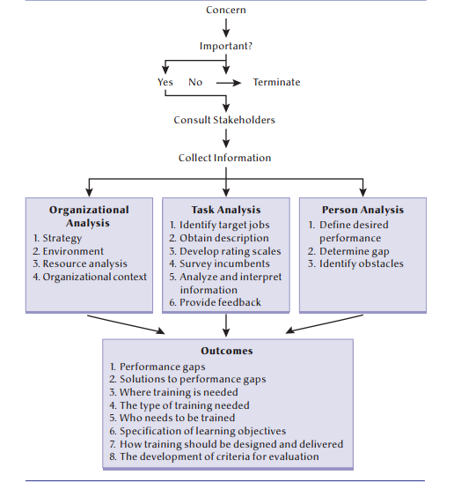

- Step one is a concern: This concern is sometimes referred to as an itch or a pressure point, something that causes managers to notice it. This concern might be as subtle as noticing that employees are treating customers in an abrupt manner, or observing that employees are spending a lot of time asking one another for help with a new system
- Step 2 is importance: this step is to determine whether the concern that was raised in step one is important or not to the organization. The goals, plans, introduction of products and services, changes in technology, practices, and regulations should be clear. Another important concern is the cost of money. Does current performance cost the company in lost productivity or dissatisfied customers? If the performance problem is important, then there must be some way to demonstrate that correcting the problem will result in increased productivity or client satisfaction.
- Step 3 is to consult stakeholders: The next step in the needs analysis process is to involve the stakeholders who have a vested interest in the process and outcomes. Training analysts must obtain agreement on why the needs analysis is being done and who will be involved. All stakeholders must buy into the needs analysis process to ensure that the data collection will result in accurate information and that they have a vested interest in the success of the program
- Step 4 is the data outcome: s is the most extensive and involves the documentation of the concern through the collection of information from three levels of analysis. The analysis of the organization provides information about its strategies and context and answers the question, “Where is training needed in the organization?” The task analysis provides information about the tasks and the relevant knowledge, skills, and abilities needed to perform selected jobs and answers the question, “What knowledge, skills, and abilities are required to perform the job effectively?” And a person analysis provides information about an employee’s level of performance and answers the question, “Who needs to be trained?”
- The purpose of a needs analysis outcome: Besides clarifying the nature of performance gaps, a needs analysis helps to determine whether training and development is a good solution to performance problems or if some other intervention might be more effective. If training and development is part of the solution, needs analysis information is used to determine where training is needed in the organization, what type of training is required, and who in the organization should receive training.
- Organizational analysis involves the study of the entire organization: its strategy, environment, resources, and context. An organizational analysis can help identify potential constraints and problems that can derail a training program so that they can be dealt with prior to the design and delivery of a costly program.
- Strategy ( part of organizational analysis): Most organizations have a strategy that consists of an organization’s mission, goals, and objectives such as a dedication to quality or innovation. An organization’s strategy should indicate the type and amount of training required.
- Environment: training and development is embedded within the external environment and how factors in the environment can impact the organization, human resource practices, and training and development. The environment is dynamic and uncertain. New technologies, competitors, recessions, and trade agreements can profoundly affect not only the need for and content of training, but also employees’ receptivity to being trained.
- Resource analysis: involves identifying the resources available in the organization that might be required to design and implement training and development programs. Training programs are costly and require considerable resources. In addition to the financial costs, the design and implementation of a training program requires considerable time and expertise. A resource analysis enables an organization to determine whether it has the resources required for a training and development solution or whether another less costly solution will be better.
- Organizational context: They are social entities made up of people. The people within the buildings have feelings, attitudes, and values that make up the climate of an organization. Organization climate refers to the collective attitudes of employees toward work, supervision, and company goals, policies, and procedures. One aspect of climate that is particularly important for training is the training transfer climate. Training transfer climate refers to characteristics in the work environment that can either facilitate or inhibit the application of training on the job. A strong training transfer climate is one in which there exist cues that remind employees to apply training material on the job, positive consequences such as feedback and rewards for applying training on the job, and supervisor and peer support for the use of newly acquired skills and abilities. The training transfer climate has been found to be a strong predictor of training effectiveness and whether or not trainees apply newly trained skills on the job
- A continuous learning culture refers to a culture in which members of an organization believe that knowledge and skill acquisition are part of their job responsibilities and that learning is an important part of work life in the organization.
- Task analysis: The process of obtaining information about a job by determining the duties, tasks, and activities involved and the knowledge, skills, and abilities required to perform the tasks. 6 steps:
- 1. Identify the Target Jobs After a problem or performance discrepancy has been identified in an organization, the focus shifts to the job level to determine which jobs are contributing to the performance problem and have a performance gap
- 2. Obtain a Job Description A job description lists the specific duties carried out through the completion of several tasks. In large organizations, most positions have a description of the tasks and minimum qualifications required to do the job. If this description has not been updated within the last year, consult with both the manager and several employees in the position (subject-matter experts) to obtain a current listing of tasks and qualifications. The job description should contain a summary of the major duties of the job, a listing of these duties, the knowledge, skills, and abilities required to perform the tasks, and the conditions under which they are performed
- 3. Develop Rating Scales to Rate the Importance of Each Task and the Frequency with Which It Is Performed Rating scales must be developed to rate the importance of each task as well as how often a task is performed. Tasks that are more important for the effective performance of a job as well as those that are frequently performed need to be identified
- 4. Survey a Sample of Job Incumbents Job incumbents as well as supervisors and subject-matter experts who are familiar with the job must then provide task importance and frequency ratings. A questionnaire and a structured interview as well as observation of employees performing their jobs can be used to rate the importance of tasks and the frequency with which they are performed.
- 5. identify those tasks that are the most important and most frequently performed. Statistical software packages can assist in this task and can be used for more complex analyses. Comparisons between groups may reveal additional important information
- 6. Provide Feedback on the Results Because employees and managers might not be aware of the need for training, it is important to provide small groups of managers and employees with feedback about the responses to task analysis. This feedback encourages employees to talk about areas of strengths and weaknesses and to propose solutions to problems. By owning the problem and generating the solution, employees may be more willing to change their behaviours and managers will be more likely to support a training program
- Cognitive task analysis: refers to a set of procedures that focuses on understanding the mental processes and skills required for performing a job. Cognitive task analysis describes mental and cognitive activities that are not directly observable, such as decision making, problem solving, pattern recognition, and situational assessment.
- Team task analysis: An analysis of tasks as well as the team-based competencies (knowledge, skills, and attitudes) associated with the tasks. Teamwork competencies include things such as how to communicate, interact, and coordinate tasks effectively with team members. The main objective is to identity the key team competencies required for the tasks of the job, which will be used to write training objectives and to design a training program.
- Differences between the two: There are a number of important differences between a traditional task analysis and a team task analysis. The main difference is that a team task analysis must identify the interdependencies of the job as well as the skills required for task coordination. Another difference is that a team task analysis must also identify the cognitive skills that are required for interacting in a team. In general, a team task analysis should focus on the knowledge of taskspecific goals; knowledge of task procedures, strategies, and timing; knowledge of team members’ roles and responsibilities; interpositional knowledge; and knowledge of teamwork.
- Person analysis: The process of studying employee behaviour to determine whether performance meets standards. The objective is to provide answers to these kinds of questions: How well does the employee perform the tasks? Who, within the organization, needs training? And what kind of training do they need? A threestep process should help answer these questions:
- 1. Define the Desired Performance The first step is to establish standards for performance. These norms will be important in the needs analysis, during training, and in evaluating the effectiveness of training. The idea is to determine the standard or the acceptable level of task performance.
- 2. Determine the Gap between Desired and Actual Performance In this step, a comparison is made between the standard level of performance and each employee’s performance. Employee performance data can be obtained from performance appraisals, work samples, observations, self-assessments of competencies, and formal tests.
- 3. Identify the Obstacles to Effective Performance When a gap exists between the standard and an employee’s performance, it is necessary to determine the cause or source of the gap. Performance problems can be the result of deficiencies in execution as well as deficiencies in knowledge, skills, or abilities.
- 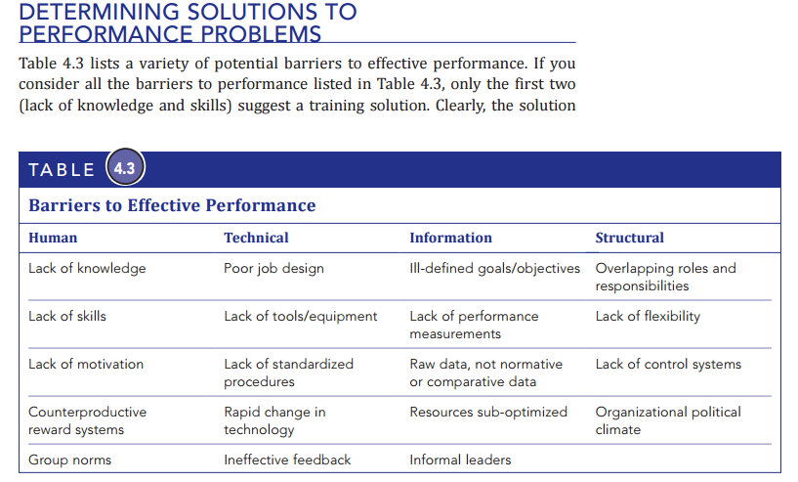
- This is to describe the different methods and sources for conducting a needs analysis

- 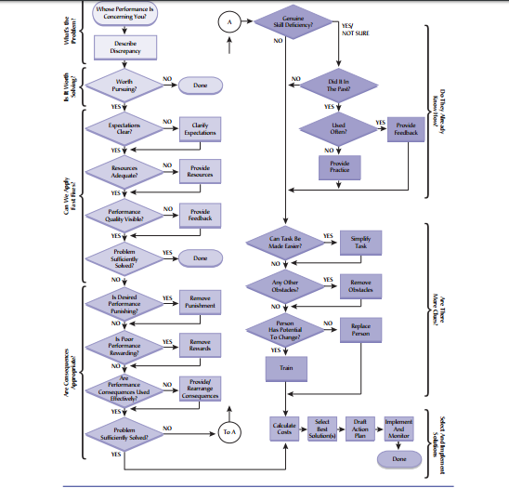
- 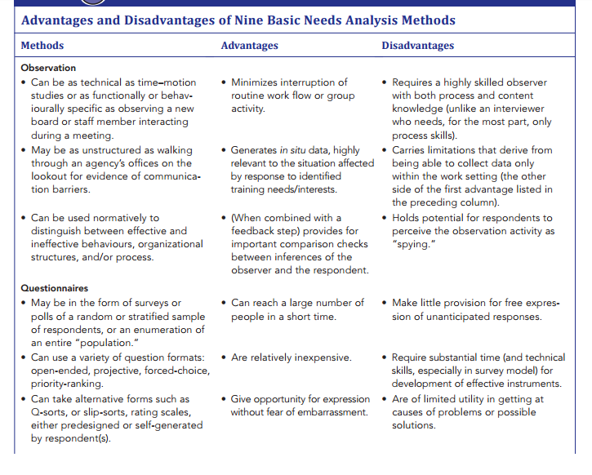
- 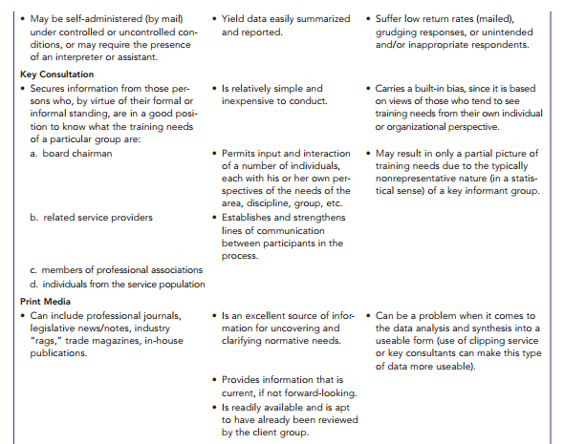
- 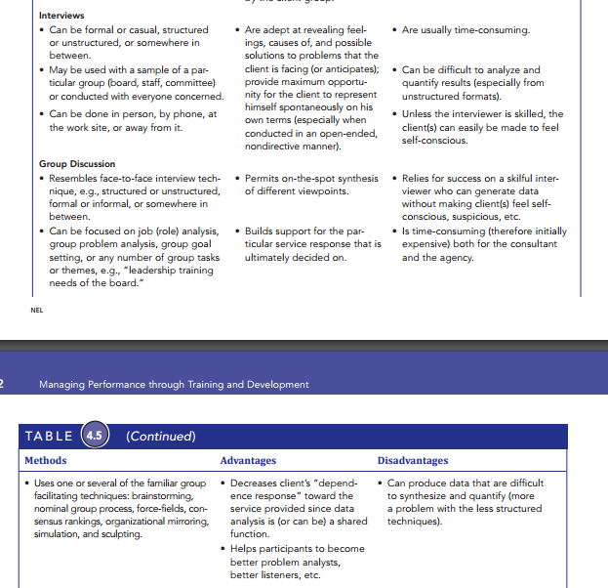
- 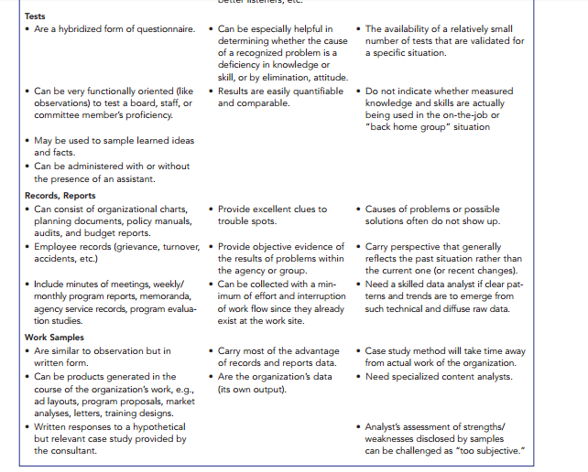
- Obstacles to performing a needs analysis: trainers often claim that they are not rewarded for taking the time (and money) to conduct a needs analysis. Managers prefer action over analysis and they want to see training resources used to train employees.
- Time can also be a constraint. For example, new equipment might be arriving and it is easier to train all employees on all procedures instead of determining who needs training on which aspects of the new equipment. In fact, time is increasingly a concern and needs analysis can take months to complete, and yet employees need to be trained and back on the job in a matter of weeks or even days.
*Lesson 7:
training design
- training objectives: A training objective is a statement of what trainees are expected to be able to do after a training program, and answers the question, “What should trainees be able to do at the end of a training program?
- Writing training objectives:
- 1. Who is to perform the desired behaviour? Employees and managers are the easiest to identify. The trainer is not the “who,” although it is tempting for some trainees to write, for example, that the trainer will present five hours of information on communication. The goal of the instructor is to maximize the efficiency with which all trainees achieve the specified objectives, not just present the information.

- this pic is one of the short answer questions: 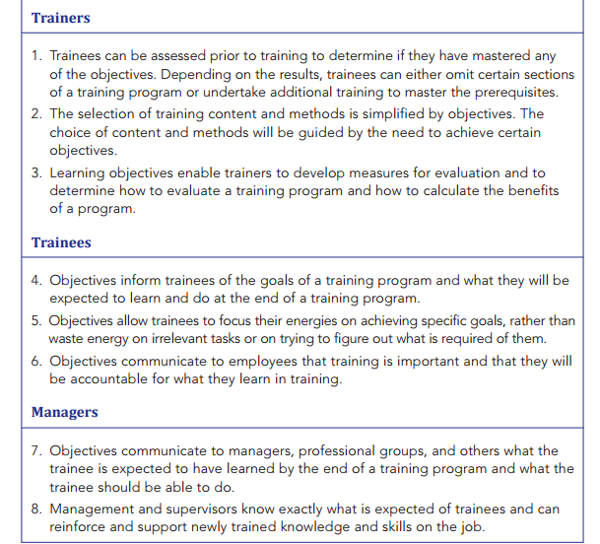
- 2. What is the actual behaviour to be employed to demonstrate mastery of the training content or objective? Actions described by words like “type,” “run,” and “calculate” can be measured easily.
- 3. Where and when is the behaviour to be demonstrated and evaluated (i.e., under what conditions)? These could include “during a 60-minute typing test,” “on a ski hill with icy conditions,” “when presented with a diagram,” or “when asked to design a training session.” The tools, equipment, information, and other source materials for training should be specified..
- 4. What is the standard by which the behaviour will be judged? Is the trainee expected to type 60 words per minute with fewer than three errors? Can the trainee list five out of six purposes for training objectives?
- An example of a training objective that includes the four elements is as follows: The sales representative (who) will be able to make 10 calls a day to new customers (what) in the territory assigned (where and when), and will be able to generate three (30 percent) sales worth at least $500 from these calls (how or the criterion)
- 1. Performance: What the trainee will be able to do after the training. In other words, what work behaviour the trainee will be able to display.
- 2. Condition: The tools, time, and situation under which the trainee is expected to perform the behaviour. In other words, where and when the behaviour will occur.
- 3. Criterion: The level of acceptable performance or the standard or criteria against which performance will be judged.
- The purchase or design decision: In many cases, it is more economical for an organization to purchase these materials, packaged in a professional format, than to develop the materials themselves, which in many cases will be used only once or twice. For example, most organizations do not design training courses in basic skills; rather, they form alliances with educational institutions, community colleges, or private organizations that specialize in developing and delivering basic skills training programs.
- Purchase decision factors: what factors should be considered when making such a decision? One of the most important factors is the cost of each alternative. A cost–benefit analysis would be necessary to determine the best option. In addition to the cost of training, other factors should also be considered. For example, the human resource staff must have the time and expertise to design a training program. Designing a training program requires expertise in many areas such as training methods and principles and theories of learning. Time is also a factor in terms of how soon the organization wants to begin training. Given the amount of time required to design a new training program, if there is a need or desire to begin training as soon as possible then the organization will need to purchase a training program. the number of employees who need to be trained and the extent to which future employees will require training.
- request for proposal (RFP), which is a document that outlines to potential vendors and consultants the organization’s training and project needs. This will help to ensure that the organization purchases what it really needs and also communicates the training needs and required project to stakeholders and potential vendors. Failure to prepare a detailed RFP can result in an organization purchasing a program that it really does not need and at a much higher cost than necessary.
- Training content: This is a crucial stage as the training content must be based on the training needs and objectives. As noted by Campbell, “By far the highest-priority question for designers, users, and investigators of training is, ‘What is to be learned?’ That is, what (specifically) should a training program try to accomplish, and what should the training content be?”
- Training methods: Training methods can be arranged into a number of different categories such as active versus passive methods, one-way versus two-way communication, or informational versus experiential. For our purposes, we distinguish training methods in terms of where they take place, since this is a fairly tangible distinction. That is, some training methods take place on the job, such as coaching and performance aids, while others take place off the job in a classroom with an instructor.
- Productive responses The trainee actively uses the training content rather than passively watching, listening to, or imitating the trainer
- Blended training The use of a combination of approaches to training such as classroom training, on-the-job training, and computer technology
- Practice Physical or mental rehearsal of a task, skill, or knowledge in order to achieve some level of proficiency in performing the task or skill or demonstrating the knowledge
- Active practice Providing trainees with opportunities to practice performing a training task or using knowledge during training
- Conditions of practice Practice conditions that are implemented before and during training to enhance the effectiveness of active practice and maximize learning and retention
- 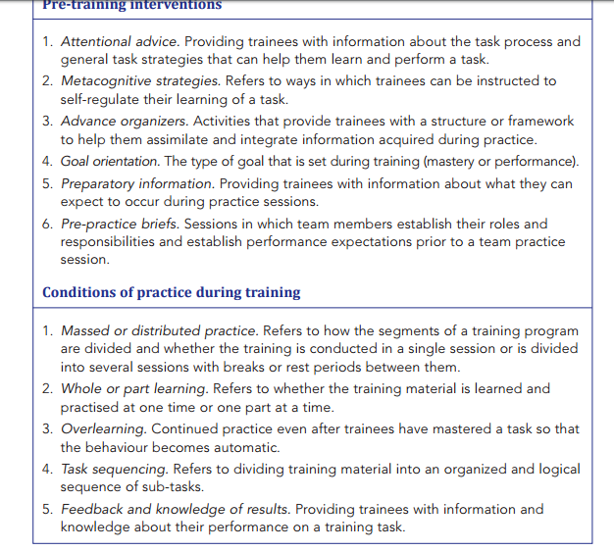
- Pre-training interventions Activities or material provided before a training program or practice session to improve the potential for learning as well as the efficiency and effectiveness of practice during training.
- Attentional advice Providing trainees with information about the task process and general task strategies that can help them learn and perform a task
- Metacognition A self-regulatory process that helps people guide their learning and performance
- Metacognitive strategies Refers to ways in which trainees can be instructed to self-regulate their learning of a task
- Advance organizers Activities that provide trainees with a structure or framework to help them assimilate and integrate information acquired during practice
- Goal orientation The type of goal that is set during training (mastery goal or performance goal)
- Preparatory information Providing trainees with information about what they can expect to occur during practice sessions so that they can develop strategies to overcome performance obstacles
- Pre-practice briefs Sessions in which team members establish their roles and responsibilities and performance expectations prior to a team practice session
- Massed versus distributed practice Refers to how the segments of a training program are divided and whether the training is conducted in a single session (massed) or is divided into several sessions with breaks or rest periods between them (distributed)
- Whole versus part learning Refers to whether the training material is learned and practiced at one time or one part at a time
- Overlearning Continued practice even after trainees have mastered a task so that the behaviour becomes automatic
- Automaticity The performance of a skill to the point at which little attention from the brain is required to respond correctly
- Routine expertise The ability to reproduce specific behaviours in similar settings and situations
- Adaptive expertise The ability to use knowledge and skills across a range of tasks, settings, and situations
- Active learning An approach to training that gives trainees control over their own learning experience
- Exploratory/discovery learning Trainees are given the opportunity to explore and experiment with the training tasks to infer and learn the rules, principles, and strategies for effective task performance
- Proceduralized instruction Trainees are provided with step-by-step instructions on how to perform a task and the rules, principles, and strategies for effective performance.
- Emotion control A strategy to help trainees control their emotions during active learning
- Error-management training Training that explicitly encourages trainees to make errors during training and to learn from them
- Error-avoidant training Training that is highly structured and provides trainees with detailed step-by-step instructions on how to perform a task so they are less likely to make errors
- Error-management instructions Statements that errors are a necessary and natural part of learning and emphasize the positive function of errors
- Adaptive tasks Tasks that differ from those worked on during training and require different solutions
- Analogical tasks Tasks that are similar to those worked on during training
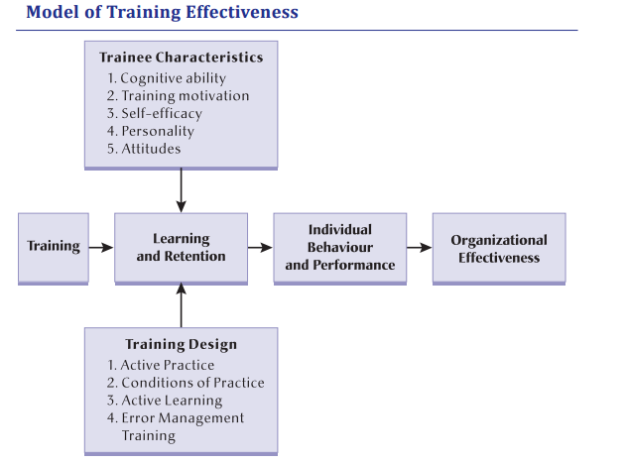

*Lesson 8:
off-the-job training methods
- Instructional methods refer to the techniques used to stimulate learning.
- 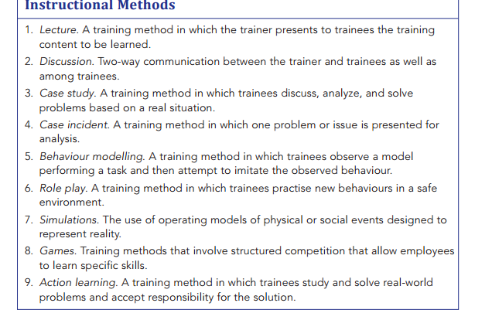
- Lecture: The lecture offers a number of advantages. Large amounts of information can be provided to large groups of trainees in a relatively short period of time at a minimal expense, which makes the lecture method very efficient. Key points can be emphasized and repeated. it is not as effective for the development of skills or for changing attitudes. The lecture does not accommodate differences in trainee ability, and all trainees are forced to absorb information at the same rate. Trainees are also forced to be passive learners with little opportunity to connect the content to their own work environment, or to receive feedback on their understanding of the material.
- Discussion method serves 5 purposes:
- 1. It helps trainees recognize what they do not know but should know.
- 2. It is an opportunity for trainees to get answers to questions.
- 3. It allows trainees to get advice on matters that are of concern to them.
- 4. It allows trainees to share ideas and derive a common wisdom.
- 5. It is a way for trainees to learn about one another as people.
- Case study method: The objectives of a case study are to:
- 1. Introduce realism into trainees’ learning.
- 2. Deal with a variety of problems, goals, facts, conditions, and conflicts that often occur in the real world.
- 3. Teach trainees how to make decisions.
- 4. Teach trainees to be creative and think independently
- Case incident method: Case incidents are useful when the trainer wants to focus on one topic or concept. Because they are short, trainees can read them during a training session and valuable time will not be taken up by differences in trainees’ reading speeds. The main disadvantage of case incidents is that some trainees are bothered by the lack of background material. Indeed, at times it is necessary for trainees to make assumptions and trainers may be asked by some trainees to sketch in the background
- Behavior modeling: Behavioural modelling is one of the most widely used and researched training methods.18 It has been used to teach interpersonal skills such as supervision, negotiation, communication, and sales as well as motor skills and it is the most popular method for teaching interpersonal and supervisory skills.
- Role play: A role play consists of three phases: 1. development, 2. enactment, and 3. debriefing.
- Simulations: Simulations are a popular method of training and are widely used in business, education, and the military. A major disadvantage of simulations is that they are expensive to develop and, in the case of emergency response simulations, very expensive to stage. On the positive side, simulations are an excellent method for adding some realism into a training program
- Games: Games incorporate many principles of learning such as learning from experience, active practice, and direct application to real problems. They are used to enhance the learning process by injecting fun and competition, generating energy, and providing opportunities for people to work together. A disadvantage of the use of games is the possibility of learning the wrong things, a weak relation to training objectives, and an emphasis on winning
- Action learning: The goals of action learning are to involve and to challenge the trainee and move employees from passive observation to identification with the people and the vision of the organization
- Instructional media: One advantage of audio-visual methods is the ability to control the pace of training. A slide or a video clip can be used to clarify a concept. Trainees receive consistent information from these methods no matter where or how often the training is given. Most important, a video can show a situation that is difficult for a trainer to describe, such as a hostile customer or a dangerous malfunction in equipment. Video allows a trainer to show complex and dynamic situations in a realistic manner. Not surprisingly, videos remain one of the most popular forms of instructional media.
- 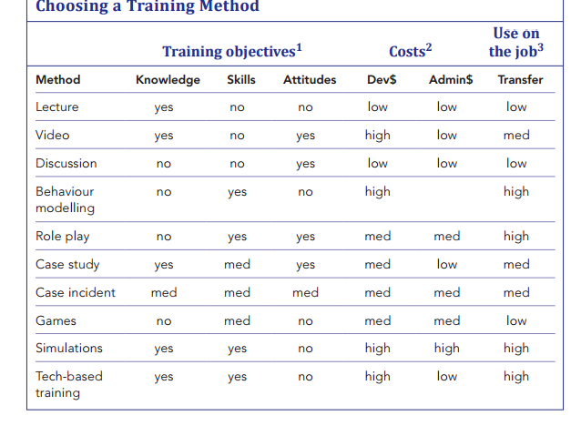
- Blended training The use of a combination of approaches to training such as classroom training, on-the-job training, and computer technology
- blended delivery approach has a number of benefits. It allows participants to learn in ways that work for them, allows multiple learning outcomes to be achieved, and increases the possibility that the training will be applied on the job. Trainers must therefore be skilled in a variety of training methods. In conclusion, when it comes to choosing training methods, each method has its place and there are many factors to consider. Ultimately, mixing, adapting, combining, and blending training methods will usually be the best approach for maximizing trainee learning and retention and facilitating the transfer of training.

*Lesson 9:
on the job training methods:
- 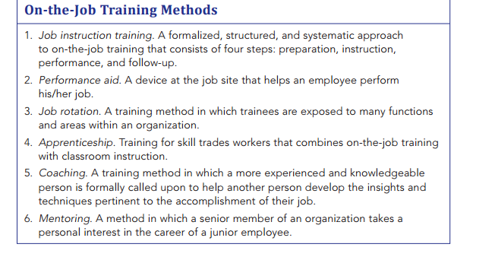
- On-the-job training A training method in which a trainee receives instruction and training at his or her workstation from a supervisor or an experienced co-worker
- Although on-the-job training is the most common approach to training, it has also been described as the most misused.5 This is because on-the-job training is often not well planned or structured. Another problem is that most people assigned the task of training others on the job have not received training on how to be a trainer. As a result, managers and employees do not have the knowledge and skills required to be effective trainers and are not familiar with learning principles such as active practice, feedback, and reinforcement.
- Job instruction training A formalized, structured, and systematic approach to on-the-job training that consists of four steps: preparation, instruction, performance, and follow-up
- Step 1: preparation: During the preparation step, the trainer breaks down the job into small tasks, prepares all the equipment and supplies necessary to do the task, and allocates a time frame to learn each task. A key activity during the preparation step is to develop a communication strategy that fits the trainee and to find out what the trainee already knows. Putting the Trainee at Ease The trainer must remember that the trainee might be apprehensive. It is unwise to begin too abruptly. Some small talk might be appropriate to relax the trainee and to set the tone for the training session. Guaranteeing the Learning When the conversation turns to the training, the trainer needs to guarantee to the trainee that learning is possible. Again, use a simple statement, “Don’t worry about this machine, Nadine. In about three hours you will be operating it almost as well as everyone else. I’ve trained at least 10 people in this procedure.” Building Interest and Showing Personal Advantage Trainees might be apprehensive or might not understand the effect that training will have on the quality of their work. Developing trainee enthusiasm is sometimes difficult, but pointing out some personal gain helps to create interest.
- Step 2: instruction
- Show the Trainee How to Perform the Job • Break the job into manageable tasks and present only as much as can be absorbed at one time. Remember that individuals learn at different speeds, so while some trainees might be able to learn six or seven sequences at once, others can absorb only four or five. • Repeat Step 1 as necessary and be patient. • Explain why as well as how. • Point out possible difficulties as well as safety procedures. • Encourage questions.
- Repeat and Explain Key Points in More Detail • Safety is especially important. • Take the time to show how the job fits into any larger systems. • Show why the job is important. • Show why key points are more important than others. • Repeat Step 2 as necessary and be patient. • Encourage questions.
- Allow the Trainee to See the Whole Job Again • Ask questions to determine the level of comprehension. • Repeat Step 3 as necessary and be patient. • Encourage questions.
- Step 3: performance
- Ask the Trainee to Perform Less Difficult Parts of the Job • Try to ensure initial success. • Don’t tell how. If possible, ask questions, but try to keep the trainee’s frustration level low. • Ask the trainee to explain the steps.
- Allow the Trainee to Perform the Entire Job • Gently suggest improvements where necessary. • Provide feedback on performance. • Reinforce correct behaviour
- Step 4: follow-up: Once the performance step is complete, the trainee will be left on his/her own to perform the task. This does, not, however mean that the training is over. In the follow-up step, the trainer monitors the trainee’s performance. It is important that the trainer keep track of the trainee’s performance and provide support and feedback.
- Performance aid A device at the job site that helps an employee perform his/her job. The reasoning behind the use of performance aids is that requiring the memorization of sequences and tasks can take too much training time, especially if the task is not repeated daily. They are also useful when performance is difficult, is executed infrequently, can be done slowly, and when the consequences of poor performance are serious
- Job rotation A training method in which trainees are exposed to different jobs, functions, and areas within an organization. Job rotation is an effective method of training employees who need to learn a variety of skills. By providing employees with a series of on-the-job experiences in which they work on a variety of tasks, jobs, and assignments, they will acquire the skills required to perform their current job as well as future job responsibilities.
- Apprenticeships Training methods for skilled trades workers that combines on-the-job training and classroom instruction. Many employers are reluctant to provide apprentice training because they do not see the benefits. However, there is evidence that the returns on apprenticeship training investments are realized much sooner than many employers believe
- Coaching An experienced and knowledgeable person is formally called upon to help another person develop the insights and techniques pertinent to the accomplishment of their job. Research has found coaching to be highly effective for both individuals and organizations. In general, the results of a number of studies indicate that individuals who participated in coaching showed dramatic improvements in specific skills and overall performance. Coaching has also been found to improve working relationships and job attitudes, and to increase the rate of advancement and salary increases
- Mentoring A senior member of an organization takes a personal interest in the career of a junior employee. Mentors play two major roles: career support and psychosocial support. Career support activities include coaching, sponsorship, exposure, visibility, protection, and the provision of challenging assignments. Psychosocial support includes being a friend who listens and counsels, who accepts and provides feedback, and who offers a role model for success.
- Research has found that mentoring is highly effective for those who are mentored and their organizations. Both professional and academic research consistently has indicated that mentored individuals have greater career prospects and higher incomes than those who have not been mentored
- Off-the-Job Training Methods Advantages A trainer can use a wide variety of instructional training methods when training is off-the-job. For example, a trainer can combine a lecture with discussion, a case study or case incident, or games and simulations, and also use instructional media such as a video and slides.
- Another advantage of off-the-job training is that the trainer is able to control the training environment. In other words, the trainer can choose a training site that is comfortable, free of distractions, and conducive to learning
- A third advantage is that a large number of trainees can be trained at one time. This is especially the case when the lecture method is used. Thus, off-thejob training is generally more efficient given that many more trainees can be trained at one time and in one place
- Disadvantages: First, off-the-job training can be much more costly than on-the-job training. This is because of the costs associated with the use of training facilities, travel, accommodation, food, and so on.
- A second disadvantage of off-the-job training is that because the training takes place off-the-job in a training environment that is different from the work environment, trainees might have difficulty in the application of the training material on the job. For example, while a trainee might be able to perform a training task in a role play during training, he or she might have difficulty performing the same task on-the-job.
- On-the-Job Training Methods Advantages A major advantage of on-the-job training methods is that the cost is much lower given that the need for training facilities, travel, accommodation, and so on is eliminated. Thus, on-the-job training tends to be much less costly than off-thejob training
- A second advantage is the greater likelihood of the application of training on the job. That is, because training takes place in the trainees’ actual work area, the application is much more direct and in some cases immediate. Thus, there is less difficulty in the transfer of training since the training environment and work environment are the same
- Disadvantages First, the work environment is full of distractions that can interfere with learning and interrupt training. Noise might make it difficult for trainees to hear and understand the trainer, and at times the trainer might be interrupted and called away from the training to solve a problem or work on something else.
- Second, when trainees are being trained on an actual machine or equipment on the job, there is always the potential for damage to expensive equipment
- A third problem is the disruption of service or slowdown in production that occurs during training. You have probably had the experience of being served by an employee who is being trained. The result is usually slower service and the potential for errors.
- when safety issues are associated with the use of equipment or dangerous chemicals, on-the-job training can compromise safety. A trainee learning on the job can make a mistake and harm him or herself, other employees, or customers. Therefore, extra precaution and care need to be taken whenever onthe-job training involves working with equipment or dangerous chemicals.

*Lesson 10:
technology based training methods

- Technology-based training Training that involves the use of technology to deliver courses. including CD-ROMs, DVDs, and diskettes); satellite or broadcast TV; and video-, audio-, or teleconferencing. Any technology that delivers education or training, or supports the delivery of these subjects.
- Traditional training Training that does not involve using technology to deliver courses. such as classroom training with a live instructor (regardless of the instructor’s or learners’ use of technology during the class); non-computerized self-study, such as textbooks or workbooks; noncomputerized games; seminars; lectures; or outdoor programs. 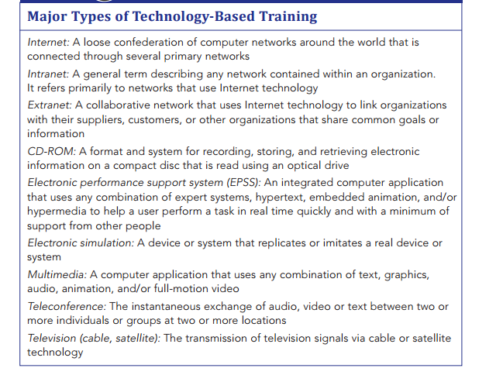
- Computer-based training Training that is delivered via the computer for the purpose of teaching jobrelevant knowledge and skills. It can include text, graphics, and/or animation and be delivered via CD-ROMs, intranets, or the internet.11 Among the various forms of computer-based training, Web-delivered and CD-ROM formats have received the most attention.
- E-learning The use of computer network technology such as the intranet or Internet to deliver information or instruction to individuals.
- Instructor-led training (ILT) Training methods that involve an instructor or facilitator who leads, facilitates, or trains online.
- Self-directed learning (SDL) A process in which individuals or groups take the initiative and responsibility for learning and manage their own learning experiences
- Asynchronous training Training that is prerecorded and available to employees at any time and from any location
- Multimedia training Computer-based training programs that include text, graphics, animation, audio, and video
- 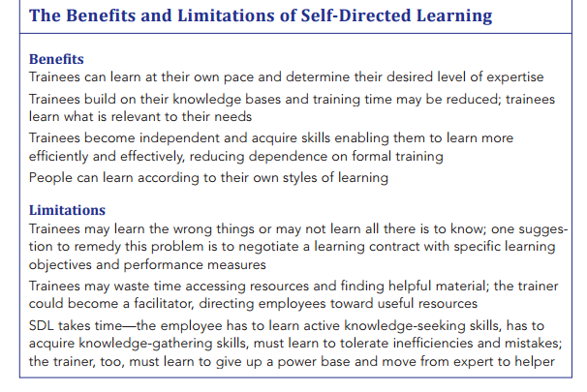
- Synchronous training Training that is live and requires trainees to be at their computer at a specific time
- Electronic performance support system (EPSS) A computer-based system that provides information, advice, and learning experiences to improve performance
- Video conferencing Linking an expert or trainer to employees via two-way television and satellite technology
- Virtual classroom A web-based platform to deliver live, instructor-led training to geographically dispersed learners
- Web conferencing A live meeting or conference that takes place on the internet
- Webinar A seminar that takes place live over the Web
- A webcast is a live or recorded video or audio broadcast over the internet. Webcasts are used primarily for presentations, while web conferencing and webinars are used for live meetings and seminars, respectively
- Social constructivism An approach to learning that emphasizes interactive learning environments
- Social media The use of technology for sharing and exchanging information
- Web 2.0 Internet tools that enable the communication and sharing of information and knowledge
- Generative learning A self-initiated and learnercontrolled form of collaborative learning in which individuals in a social network share ideas and information and in the process solve problems and create new knowledge
- Blog A website that contains commentary and information on a subject
- Web 3.0 A fundamental shift in how people interact with the web that consists of the semantic web, the mobile web, and the immersive internet
- Computer Simulations Computer simulations provide trainees with hands-on training for a particular task. Computer simulations are reality based in that they are designed to replicate on-the-job experiences by providing trainees with opportunities to practise and master knowledge and skills in an interactive environment.
- Games Computer-based games are designed to engage trainees with realistic and entertaining experiences. It is important to note that games are also in effect simulations in that they often simulate work-related tasks and experiences
- Role Plays Role plays can be used with computer-based training programs. For example, Rogers Wireless Communications Inc. has an interactive customer-service training program for sales representatives that includes online role play
- Stories Stories and narratives have also been used in e-learning in order to engage trainees
- Customization Customization involves tailoring instructional elements to meet trainee preferences and needs. This can increase trainee satisfaction with the training and improve learning.
- Personalization Personalization refers to structuring the program so that trainees feel they are engaged in a conversation with the program
- Human Interaction A potential problem of computer-based training for some trainees is the lack of face-to-face interaction with an instructor and other trainees. This can result in trainees feeling isolated and less motivated to learn
- Feedback Regardless of the nature of the training experience, it is important that feedback be provided to trainees. In fact, students who received feedback in computer-based training have been found to learn more than students who were not given feedback
- Benefits of computer based training
- Advantages Trainees A major advantage for trainees is flexibility. For example, trainees do not have to coordinate and arrange their schedule and workload to accommodate training schedules. Another advantage for trainees is greater control over their learning, or what is known as learner control. Learner control refers to the degree to which the trainee has control over various instructional features during a lesson or training program such as the content, sequence, and/or pace of training.48 In other words, trainees can choose the content they want to view, the order in which they will view the content, enter and leave training as they choose, and progress at their own pace. Self-pacing means that trainees can work on training tasks as quickly or as slowly as they want. Perhaps most beneficial for trainees is the convenience of being able to learn whenever they want to or need to, and to do so from any location where they have access to a computer.
- Organizations: A major advantage for organizations is that they can ensure that all trainees receive the same training regardless of where they are situated. Thus, organizations can deliver standardized and consistent training to large numbers of employees across the organization and even worldwide. Another advantage is that large numbers of employees can be trained within a short period of time. There is no limit to the number of employees who can be trained, as one is not constrained by the number of instructors available or the need for classroom space. Perhaps the greatest advantage for organizations is the reduction in the cost of training as a result of the elimination of the cost of travel, training facilities, hotel rooms, meals, trainers, and employee time off from work while travelling and attending training
- Disadvantages Trainees A common disadvantage of computer-based training for trainees is that there is less interpersonal contact and interaction with other trainees. Furthermore, individuals have learning preferences and styles, and if a trainee prefers to receive training in a classroom with a trainer and other trainees then computer-based training would disadvantage that employee. Trainers who are not computer literate might also resist and fear computerbased training. A low-threat opportunity to allow trainees to test the technology is to place the learning stations in the classroom.
- Organizations: a disadvantage is that some employees will be uncomfortable with computers and might refuse training. This is especially likely for older workers who have less experience using computers. the major disadvantage for organizations is the cost of development, especially for sophisticated multimedia programs.
- Effectiveness of computer based training: . Many have claimed, for various reasons, that computer-based training is more effective than classroom instruction. One reason is that it provides a greater variety of instructional methods (e.g., text, audio, graphics) that are tailored to individual needs and preferences for learning. Other explanations include greater learner ease, control, flexibility, and immediate feedback. Still some argue that it is a more cost-effective method of training than face-to-face instruction. The results indicated that, on average, computer-based training was 6 percent more effective than classroom instruction for declarative knowledge. However, both methods were equally effective for teaching procedural knowledge. In addition, trainees were equally satisfied with both training methods
- This is an important finding because it suggests that one reason computerbased training has been found to be more effective than classroom instruction is that the instructional methods differ, such as when classroom instruction involves a lecture and computer-based training involves a variety of instructional techniques
- Another important factor was trainee choice of training method. Computerbased training was more effective than classroom instruction only when trainees were able to choose the training method. Furthermore, when trainees were not able to choose a training method (i.e., they were randomly assigned to computerbased training or classroom instruction), classroom instruction was 10 percent more effective. This suggests thatthere might be pre-existing differences between trainees who choose a computer-based program compared to those who choose classroom instruction (e.g., motivation, cognitive ability, computer experience, skills, and self-efficacy) and these differences might be the reason that computerbased training is more effective than classroom instruction
- Computer-based training was also more effective than classroom instruction when trainees had greater learner control and the training included practice and feedback, especially when classroom instruction did not include practice and feedback. However, it should be noted that both training methods were more effective when they included opportunities for practice and feedback
- Finally, unless trainees experience technical problems, they tend to respond positively to computer-based training programs. A number of studies have reported that after taking a computer-based training program, trainees report satisfaction with their learning experience, more positive attitudes toward technology-based training, and a willingness to try it again

*Lesson 11:
THE EVALUATION OF TRAINING
Define training evaluation and the main reasons for conducting evaluations.
Training evaluation: a process to assess the value (and worthiness) of training programs to employees and to organization
- It involves analysis of data collected from trainees, supervisors and other stakeholder
- Objective and subjective information is collected at different points: before, during and after training
- More sophisticated evaluations get more information however they are more costly
Why conduct training evaluations?
- Helps managers determine what and who should be trained
- Determines the costs benefits of a program and if the training program has achieved its expected results
- Determines strengths and weaknesses of a program and pinpoints what needs improvements (can use ADDIE design to re-evaluate program)
- Justify and reinforce the value of training
- Training is necessary for competitiveness in the global environment
Discuss the barriers to evaluation and the factors that affect whether or not an evaluation is conducted.
Barriers:
- Pragmatic: requires time and a lot of collaboration from trainees and supervisors (which causes loss of production) to organize the collection of the data and specialized knowledge to properly analyze and interpret it. Training evaluation tasks requires knowledge about evaluation models/ research designs/ data analysis, which can be and intimidating prospect
- Political: pressure from administration to justify the costs, potential to reveal ineffectiveness of training, conflict of interest (may require added resources to get external audit)
Describe the different types of evaluations.
- The data gathered: evaluations differ in the type of information gathered and how that is accomplished
- Trainee perceptions, learning and behavior at the conclusion of training: did they like it? Did they learn and change their behaviour?
- Assessing psychological forces that operate during training: helps identify psychological states (cognitive, affective and skills-based) that influences learning
- Information about the work environment: training transfer climate and learning culture
- The purpose of the evaluation:
- Formative evaluations: helps evaluators assess the value of training materials, focuses on the content and the goal of improving it, is based on feedback and can be carried out on a regular basis (progress reports), provides data that is of interest to training designers and instructors
- Summative evaluations: Provide data about the worthiness or effectiveness of a training program, Based on evidence (data) gathered at the conclusion of the training intervention (can also be carried out at mid-point), cost-benefit analyses are usually summative, of greater interest to managers and administrators
- Descriptive evaluations: provide info that describes the trainee once he or she has completed a training program, what has he/she learned
- Causal evaluations: Provide information to determine whether training caused the post-training behaviours
Describe the models of training evaluation and the relationship among them.
Kirkpatrick’s hierarchical model: oldest, best known and most frequently used
- Level 1: trainees report positive reactions to a training program (L1= reactions), methods: the “smiley” sheets, post-training surveys
- Level 2: trainees learn the training material (L2= learning), methods: before and after assessments
- Level 3: trainees apply what they learn (L3= behaviours), methods: observation and interviews (over time), self-reports, supervisor reports, production records
- Level 4: training has a positive effect on organizational outcomes (L4= results), methods: Expenses, revenues, sales, and other existing business measures
L1 trainee reactions causes L2 trainees to learn more which leads to L3 behavioural displays of new skills which leads to L4 impacts organizations effectiveness.
Kirkpatrick’s guidelines critics.
- Doubt about the validity: No evidence of correlation between the levels.
- Insufficiently diagnostic.
- Reliance on the same variables and outcome measures.
- Lack of clarity: What is meant by learning?
- Not a “one-size-fits-all” model.
His model lead to COMA model: A training evaluation model that involves the measurement of four types of variables
The COMA model improves on Kirkpatrick’s model in three ways:
- Integrates a greater number of measures
- Measures are causally related to training success
- Defines variables with greater precision
- Cognitive: level of learning trainee has gained from a training program
- Organizational Environment: variables in the work environment that impact transfer of training
- Motivation: desire to learn and transfer training
- Attitudes: individual’s feelings and thinking processes
Decision-based evaluation model (DBE): A training evaluation model that specifies the target, focus, and methods of evaluation
- Decision-based evaluation goes further than either of the two preceding models:
  - Identifying the target of the evaluation
  - General to any evaluation goals
  - Flexibility: guided by target of evaluation
Learning Transfer system: This inventory contains all of the variables from COMA, plus additional ones such as: learner readiness, resistance/openness to change, and opportunity to use learning.
Identify the main variables to measure in a training evaluation and describe how they are measured.
- Reactions:
- Affective reactions: measures that assess trainees’ likes and dislikes of a training program
- Utility reactions: measures that assess the perceived usefulness of a training program
- Learning:
- Declarative learning: refers to the acquisition of facts and information, and is by far the most frequently assessed learning measure
- Procedural learning: refers to the organization of facts and information into a smooth behavioural sequence
- Behaviour:
- Self-reports
- Observations
- Production indicators
- Motivation:
- Motivation to learn
- Motivation to apply the skills
- Self-efficacy: Refers to the beliefs that trainees have about their ability to perform the behaviours that were taught in a training program.
- Perceived and anticipated support:
- Perceived support: The degree to which the trainee reports receiving support in attempts to transfer the learned skills
- Anticipated support: The degree to which the trainee expects to be supported in attempts to transfer the learned skills
- Organizational concepts:
- Transfer climate: can be assessed via a questionnaire that identifies eight sets of “cues”
- Continuous learning culture: can be assessed via questionnaire presented in Trainer’s Notebook in chapter 10 of your text.
- Organizational results:
- Hard data: Results that can be measured objectively (i.e., number of items sold)
- Soft data: Results that are assessed through perceptions and judgments (i.e. attitudes)
- Return on expectations: Measurement of a training program’s ability to meet managerial expectations

Discuss the different types of designs for training evaluation, as well as their requirements, limits, and when they should be used.
Data collection designs in training evaluation: manner in which the data collection is organized and how the data will be analyzed
- Non-experimental designs: Comparison is not made to another group of (untrained) people.
- Experimental designs: Trained group is compared to another group that does not receive the training and when the assignment of people to the training group and the non-training group is random.
- Quasi-experimental designs: Trained group is compared to another group that does not receive the training, but when the assignment of people to the training group and the non-training group is not random.
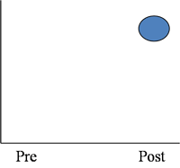 | 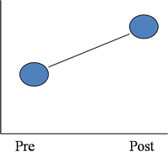 | 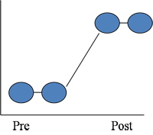
A: Single Group Post-Only Design | B: Single Group Pre-Post Design | C: Time Series Design

Experimental and Quasi-Experimental Designs
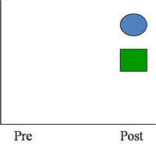 |  | 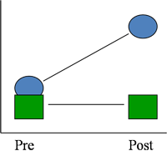
D: Single Group Design with Control Group |  | E: Pre-Post Design with Control Group

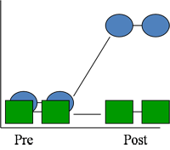 |  | 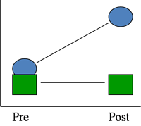
F: Time Series Design with Comparison Group  Causal Models: experimental or quasi-experimental |  | G: Internal Referencing Strategy Hybrid Design that permits some conclusions drawn from causal designs

*Lesson 12:
Explain why organizations should calculate the costs and benefits of training and development programs.
Costing: process of identifying all the expenditures used in training
Five Cost Categories
1. Direct costs | Costs that are directly linked to the training program, would not be incurred if training was cancelled  - e.g. trainer salary and benefits, equipment rental, room rental, course materials, food/refreshments, travel.
2. Indirect costs | Costs that support training activities, but are not directly linked to a particular training program. These are costs that would still exist even if the training was cancelled.  - e.g. administrative support, trainer preparation and planning, marketing.
3. Development costs | Costs that are related to the design of a training program.  - e.g. doing a needs analysis, conducting the needs analysis, development of materials (audiovisual, graphics, manuals), evaluation.
4. Overhead costs | Costs incurred by the training department that are not associated with a particular training program.  - e.g. maintenance of training facility (heat and lighting), equipment, salaries of clerical and administrative staff.
5. Trainee compensation | Cost associated with the salaries and benefits paid to trainees while they are attending a training program (and subsequently, not working).  - e.g. cost of replacing the employee.

Describe the different approaches for costing training programs.
Comparing costs of training programs: Cost Analysis Worksheets (Costing Sheets) are helpful tools that not only help to identify the costs of the training program, but also allow for the comparison of training program alternatives.
  - They can be modified to meet an organization’s needs.
  - The level of detail varies according to needs.
  - There is choice regarding what to include.
  - Helps to identify the cheapest option.
Describe how to calculate the benefits of training programs and the difference between cost-effectiveness and cost-benefit evaluation.
Cost-effectiveness evaluation | A comparison of the monetary costs of training to the benefits of training in monetary terms.
Cost-benefit evaluation | A comparison of the costs of training in monetary terms to the benefits of training in non-monetary terms (non-monetary terms similar to level 4 results criteria that include things such as rate of turnover and customer satisfaction).
Net benefit | The estimated value of the benefit minus the cost of the training program
Benefit-cost ratio (BCR) | The benefits divided by the costs of the training program.
Return on Investment (ROI) | A comparison of the costs of a training program relative to its benefits that involves dividing the net benefits by the cost of training program  ROI= benefits-costs of program/ costs of program  Two values need to be identified:  - The costs of the development and implementation of the training program (in $)  - cost to develop the training, lost production of employees attending the training, materials, etc...  - The benefits of the training program (in $)  - additional sales, decreased insurance costs related to on-the-job accidents, more efficient workflow, etc...  Example: Training program costs: $100,000 and financial benefit is $300,000, ROI:  300,000-100,000/100,000=2…so there is a return of 2$ for every 1$ spent on training (1:2)

Describe how utility analysis can be used to calculate the financial benefits of training programs.
Utility analysis: A method to forecast the net financial benefits that result from human resource programs such as training and development.
- Important factors to consider in calculating the utility of training program:
  - Effectiveness (effect size).
  - Standard deviation of job performance in dollars of untrained employees.
  - Number of employees trained.
  - Duration training benefits will last.
- Break-even analysis: Finding the value at which benefits equal costs and utility is equal to zero.
ΔU = (T)(N)(d_{t})(SDy) – (N)(C)
ΔU | Utility, or dollar value of the program
T | Number of years the training has a continued effect on performance
N | Number of people trained
d_{t} | Effect size
SDy | Standard deviation of job performance in dollars of the untrained group
C | Cost of training each employee

Describe the activities for supporting the costing function.
Increasing credibility of benefit estimates:
  - Take a conservative approach
  - Use credible and reliable sources
  - Explain approaches and assumptions
  - Results must appear realistic
  - Use hard data
Supporting the Costing function:
- Cost-Benefit Tracking Systems
- Accounting Treatment of Training Cost
  - Three ways to administer training accounts:
    - Allocation of costs.
    - Selling the service/cost recovery.
    - Policy costs.
- Record Keeping

CHAPTER 13 TRAINING PROGRAMS
Describe orientation training programs and basic skills and literacy training.
Describe technical skills training and information technology training.
Discuss WHMIS legislation and describe the type of information that should be included in health and safety training programs.
Describe total quality management and quality training programs.
Describe team training and the kinds of skills that team members require to work in teams.
Describe sales training and the skills required to be effective in sales.
Discuss customer service training and the skills that employees require to interact effectively with customers.
Define sexual harassment and describe sexual harassment training.
- Sexual Harassment: Unwelcome sexual advances, requests for sexual favours, and verbal or physical conduct of a sexual nature that is a condition of employment, interferes with work performance, or creates a hostile work environment.
- Consequences:
  - Decreased morale and job satisfaction.
  - Negative effects on psychological well-being and physical well-being.
- Two kinds of sexual harassment:
  - Quid pro quo: Explicit requests for sexual favours as a condition of employment.
  - Hostile environment: Work environment in which language/actions or both create an uncomfortable and offensive work environment that interferes with job performance.
Sexual harassment training: to educate employees about sexual harassment and the organization’s policies and procedures regarding sexual harassment
Describe ethics training, diversity training and cross-cultural training and their use in organizations.
Ethics training: educate employees about the organization’s values and ethical policies and on making ethical decisions
- involves opportunities for employees to practise applying company values and its code of ethics to hypothetical situations
- 32% increase in organizations offering ethics training since 1994.
- In Canada, most organizations have ethics policies, but less than 30% have training programs to support them.
- Ethics training programs involve teaching employees about the organization’s values and ethical policies.
- Components of an effective ethics training program: mandatory, include copy of organization’s code of ethics, discussion of relevant compliance laws, an ethical decision making model, resources for help, role playing scenarios
Diversity Training: Training that focuses on differences in values, attitudes, and behaviours of individuals with different backgrounds.
Objectives: Increase awareness about diversity issues, reduce biases and stereotypes, change behaviours to those required to work effectively in a diverse workforce
Diversity training should focus on: Increasing awareness of diversity, providing skills required, application strategies.
Cross-cultural training: Training that prepares employees for working and living in different cultures and for interactions with persons from different backgrounds.
- Expatriates: Employees who work outside their home countries .
  - 20% of U.S. expatriates fail in their global assignments.
- A critical factor in the success of cross-cultural training is training rigour.
  - Training Rigour: The degree of mental involvement and effort that must be expended by the trainer and the trainee in order for the trainee to learn the required concepts.
  - Also refers to the length of time spent on training.
  - The degree of rigour required depends on three dimensions:
    - Cultural toughness
    - Communication toughness
    - Job toughness

Examples of Different Levels of Training Rigour:
Low Rigour  - Lectures  - Films | Medium Rigour  - Role plays  - Cases | High Rigour  - Field trips  - Interactive language training

*Lesson 13:
Describe orientation training programs and basic skills and literacy training.
Orientation training
- Usually conducted in-house by human resource practitioners.
- Effective orientation programs have a positive effect on new employee attitudes and adjustment, can shape corporate culture, increase speed-to-proficiency, and lower turnover.
Essential skills training
Designed to provide employees with the essential skills requires to perform the job and adapt to workplace change
Literacy
The ability to understand and employ printed information in daily activities. Different types of literacy include:
- Prose literacy
- Document literacy
- Quantitative literacy (basic math)

Describe technical skills training and information technology training

Technical skills: Training in specific job-related skills that all employees need to perform their jobs
Information technology training: training programs that focus on the use of computers and computer system

Discuss WHMIS legislation and describe the type of information that should be included in health and safety training programs.
WHMIS: Legislation to ensure workers across Canada are aware of potential hazards of chemicals in the workplace, and are familiar with emergency procedures for the clean-up and disposal of a spill.
Health and safety
- An effective health and safety training program should include:
  - The organization’s safety rules, practices, accident, and injury reporting procedures.
  - Duties of employer, supervisor, and worker as specified in the Occupational Health & Safety (OHS) legislation.
  - Importance of strict compliance with warning and emergency signs and signals.
  - Types and use of emergency equipment.
  - Use, care, and acquisition of personal protective equipment.
  - Organization benefits.
  - Known hazards and safeguards against them.
  - Importance of reporting other hazards and the mechanism for doing so.
  - Emergency and evacuation procedures for dealing with things such as fires, spills, and so on.
  - Need for good housekeeping.
  - Courses in first aid, CPR, and defensive driving where applicable.

Describe total quality management and quality training programs.
Total quality management (TQM): Systematic process of continual improvement of the quality of an organization’s products and services.
Quality training programs: involve team training as well as training in the use statistical tools that are used for problem-solving and decision-making process

Describe team training and the kinds of skills that team members require to work in teams.
Team training: are designed to improve the functioning and effectiveness of teams in areas such as communication and coordination
Three types of skills:
  - Task work skills
  - Teamwork skills
  - Management/supervisory team skills

Describe sales training and the skills required to be effective in sales.
Sales training: designed to upgrade sales professional’s skills and help them deal with new competitive challenges
Skills:
- Relationships with customers.
- Understanding of customers’ needs and problems.
- Solutions to customers’ problems.
- A business partner mentality.
- Knowledge about their own products and business.
- Knowledge about their customers’ business needs.

Discuss customer service training and the skills that employees require to interact effectively with customers.

Customer service training: designed to provide employees with interpersonal and service skills that are required for interacting with customers and for providing equality
Skills:
- Reliability
- Responsiveness
- Competence
- Access
- Courtesy
- Communication
- Credibility
- Security
- Understanding the customer
- Tangibles

*Lesson 14:
Define management and management development and explain how it is different from employee training.
Management: The process of getting things done, efficiently and effectively, through and with other people.
- Roles: interpersonal, informational, decisional
- Functions: controlling, planning, organizing, leading work organizations.
Management development: Complex process by which individuals learn to perform effectively in managerial roles.

Management development vs Employee Training
Managers:
- work mainly through other people.
- Need to focus on interpersonal skills and the development of the individual.
- Training design techniques tend to be different.
- Manager training tends to be more experiential
- Managerial personalities must be taken into account.
- Management development is a longitudinal process.

Describe the main functions, roles, and critical skills of managers.
Main functions:
Organizing
Planning
Leading
Roles
Interpersonal role: relationship developed with other people, provide leadership towards group goals, liaisons with outside units
Informational role: monitor internal/external environment for info, distribute info to others, spokesperson
Decisional role: make decisions about people and goals, entrepreneurs, resource allocator, negotiator, trouble-shooter.

Skills
Management time and stress
Verbal communication
Delegating
Self-awareness
Problem solving

Discuss emotional intelligence and its relevance for management.
Emotional intelligence: manage your own and others’ emotions and your relationship with others
Five sets of skills of emotional intelligence
- Self-awareness
- Self-control
- Motivation or drive
- Empathy
- Interpersonal skills

Describe the models of management skills development.

Skills Assessment | - Identifies strengths and weaknesses of managers relative to the specific skills to be trained.  - Builds self-awareness.  - Contributes to training motivation.  - Identifies managers’ learning and behavioural styles.
Skill Acquisition (Learning) | - Usually involves group discussion of opportunities, obstacles, and strategies pertaining to skill use.  - Focus on learning principles, not specific approaches.  - Objective is to promote procedural learning.
Skill Practice | Three fundamental purposes:  - Reinforces learning and shifts learning from the declarative to the procedural learning stage.  - Enhances self-efficacy.  - Maintains trainees’ interest, attention and motivation.
Skill Application on the Job (Transfer) | - During training managers establish specific plans for the application of learning.  - Follow-ups, coaching and reinforcement are frequently required to ensure transfer

Describe the content of management skills development programs.
Three categories
Conceptual skills: problem solving, decision making, planning
Technical skills: using PowerPoint, excel
Interpersonal skills: communication, managing conflict and stress

Discuss the different types of management development programs.
Experiential learning: actively involve the learner ex: role play, simulations
Management education: Broad range of managerial knowledge and conceptual abilities ex: colleges and universities and MBA programs
Management training: meant to develop specific managerial skills ex: outdoor wilderness training develops teamwork and leadership
On the job management development: provide individuals with managerial learning experiences on the job ex: job rotation, coaching

Define job rotation and coaching and discuss the characteristics of great coaches, the five conditions that are necessary to ensure the development of managers, and the challenges of coaching.
Job rotation: exposing and individual to different areas and experiences throughout the organization
Coaching: one on one learning, a more experienced person is called upon to help another person develop insight
Coaching characteristics: goal orientation, challengers, person focused
Five conditions:
Insight: understand own strength and weaknesses
Motivation: caring about changing in changing the ways they operate
Capabilities: dealing with complex situations
Real world practices: identify changes on a daily basis and what should be implemented
Accountability: encourage the manager to demonstrate new skills through commitment

Challenges of coaching
- Gaining trust of the coachee
- Applying new skills
- Building self-efficacy

*Lesson 15:

- Discuss emerging technologies and their implications for training and development.

Audio casting
- The use of audio-only content
  - should not be used as the main mode of content delivery. Use it for announcements, interviews, and other shorter segments when video is not needed
Streaming Video
- The use of streaming technology to deliver high-quality video through the Internet.
  - although streaming video is increasingly available in high definition (same as TV quality), the most common educational use is still the “talking head”. Keep these segments short (no more than 10-15 minutes) and always indicate the viewing time so learners can set their expectations and schedules accordingly.
Voice-over Internet Protocol (VoIP)
  - Voice-over Internet Protocol (VoIP) refers to the use of the Internet to mediate live audio and video conversations.
    - Suggestion: this medium can be used to have live office hours and tutorials (with one student) and to avoid long-distance fees.
    - Skype
Web Conferencing
  - The use of VoIP technology to create a virtual classroom environment that could include whiteboards, the ability to create breakout rooms, live quizzing/polling, and the ability for the learners to pose questions.
    - Most expensive because of the utter dependence on the technology, instructors must take the necessary time to familiarize themselves with this environment to the point where they are quite comfortable with it.
Serious Games
  - . The edutainment (combining education and entertainment) character of games attracts the user and fosters informal learning opportunities.
        - Strong instructional methods should be embedded in a game to make it a more effective teaching or problem-solving tool.
M-Learning
  - m-Learning, or “mobile learning” is a subset of e-learning, and refers to learning that is carried out with the aid of mobile, handheld devices.
  - Any space can therefore be transformed into a ‘learning space’ that can be convenient and collaborative in nature.

Discuss the shift from a formal training paradigm to increasing emphasis on just-in-time, lifelong, and informal learning.

Informal Learning

Is learning through experience and has no objective learning outcomes

According to a 2009 survey from the Conference Board of Canada:
- Although more informal learning seems to be occurring, organizations are not taking any particular actions to promote and foster it.
  - This makes sense in an environment where organizations cannot afford to increase the budget for their formal training programs and continue to plead their case for formal learning to their organizations.
Lifelong Learning
  - An approach to learning that recognizes that learning takes place throughout a person’s life and involves all aspects of one’s life including the workplace, personal development, the community, and physical well-being.
  - Not something that occurs between childhood and adulthood, happens throughout life.
Four pillars of lifelong learning
- Learning to know: development of skills needed to function in the world ex: reading
- Learning to do: applied skills for occupational success ex: learning to use a computer
- Learning to live together: development of values of respect for others, social skills, appreciation of diversity
- Learning to be: development of a person’s body, mind and spirit ex: personal discovery and creativity

Just-in-time
Provide learning and training opportunities when they are needed and where they are needed.
Trainers are required to use
- Redesign programs and find creative ways to reduce the content of the training intervention. This can be done by assigning material outside of the “class”, using more job-aids after the training.
- Rapid prototyping: In the case of training, this would include the quick creation and testing of a portion of a curriculum before deciding whether or not to complete it as is, redesign it, or scrap the project altogether. Used mainly in the manufacturing industry.
- Rapid e-learning: Software that allows organizations to develop e-learning more quickly and easily and at a lower price.

Compare learning management systems to learning content management systems and their implication in knowledge management.
A learning management system is a software application for the administration, documentation, tracking, and reporting of training programs, classroom and online events, e-learning programs, and training content.
Benefits:
- Reduce travel costs
- Reduce program time
- Increase accessibility to training
- Provide administrative functions
- Provide an inventory of employee competencies

A learning content management system (LCMS) is a form of content management system that is designed specifically to support the development, dissemination and maintenance of learning content.
- It is comprised of repository which contains content (text, video, graphics, etc.)

Differences:
LMS | LCMS
An LMS automates HR functions.  - It is designed to provide learners with access to online content, and to track and report such information as: course completions, certifications, scores, expenditures against training budgets, allocation and scheduling of classrooms and instructors. | An LCMS addresses content.  - It enables the development, production, publication, and maintenance of content. It is able to provide reporting concerning detailed content use and re-use, and various aspects of the work that is involved in content development and production.

- Discuss the main reasons why training programs fail and the best practices to make them effective.

- Lack of alignment: Training programs often fail because they are not linked to business and organizational needs.
- Failure to recognize non training solutions: Training is often implemented with the intention of solving a performance problem, even though it is not the best solution
- Lack of objectives to provide direction and focus
- Solution was too expensive: ROI is negative
- Regard to training as an event: When training is treated as an isolated event, it is likely to fail.
- Participants are not held responsible for results: Employees are not likely to show improvement in performance or change in behavior if they do not feel responsible for what they do learn and do with the acquired skills/ knowledge.
- Failure to prepare the job environment for transfer
- Lack of management reinforcement support
- Failure to isolate the effects of training
- Lack of commitment and involvement from executives
- Failure to provide feedback and use information about results

Examine other trends that are affecting the field of training and development.

Massive Open Online Courses
MOOCs are not-for-credit courses developed by professors from reputed universities which are offered for free online to anyone who has Internet access.

Competency based learning
- A competency is a collection or combination of knowledge, skills and attitudes that is reflected in a workplace behavior on the job.

