Ankle Joints
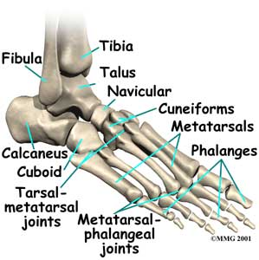
Ankle joint also known as the talocrural joint(tibiotarsal joint). It links the tibia, the fibula and the talus. There are only movements of flexion and extension.
Foot – the skeleton of the foot includes 26 short and long bones. 31 joints and 20 muscles moving the foot. The foot acts as a lever to propel the body forword during walking to allow to adapt to uneven ground(flexibility). The foot includes the 7 tarsal bones(prox.), 5 metatarsal bones(sole of foot), and the 14 phalanges(toes).
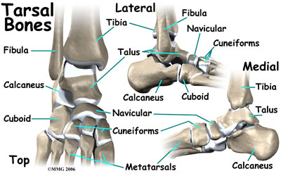

Tarsus – made up of 7 short bones separate in 2 parts. Posterior tarsus has 2 large bones which carry the body weight
- Talus – articulates superiorly with the tibia and the fibula
- Calcaneus – is the heel of the foot. The part that touches the ground is the calcaneal tuberosity the part that supports the talus is sustentaculum tali.
Anterior tarsus has 5 bones. The cuboid bone(lateral), navicular bone(medial), and 3 cuneiform bones(lateral, intermediate, and medial).
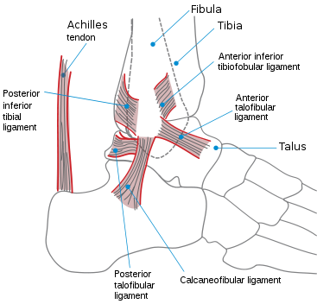

Talocrural joint – links the distal ephysis of the tiba and fibia to the superior surface of the talus; hinge joint. The joint is strengthened by 4 ligaments
- Medial ligament(deltoid) – has 2 layers. Superficial(tibionavicular and tibicalcaneal ligament) & deep(anterior tibiotalar ligament and posterior tibiotalar ligament)
- Anterior talofibular ligament – origin: anterior border of the lateral malleosus. Insertion: lateral surface of the neck of the talus(ligament that is damaged most in ankle sprains)
- Posterior talofibular ligament(lateral) – origin: lateral malleolar fossa(fibular). Insertion: lateral tubercle of the talus
- Calcaneofibular ligament(lateral) – origin: lateral end of malleolus(fibula). Insertion: lateral surface of calcaneus
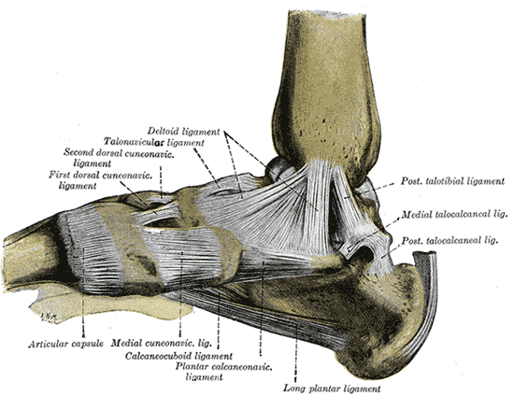

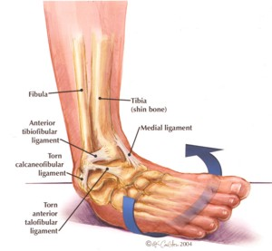
Ankle sprains – distension or tear(partially or complete) of ligaments maintain the joints(no dislocation)
- 1st degree – simple distension of ligament without ligament laxity. Heals in 2 weeks
- 2nd degree – partial tear of the ligament with slight laxity. Heals in 3-6 weeks
- 3rd degree – complete tear of ligament with high laxity. Sugery is sometimes needed and possible fracture may occur in the malleolar. Heals in 8-12 weeks

Movements of the ankle:
NAME | ACTION | ORIGIN | INSERTION
Tibialis Anterior  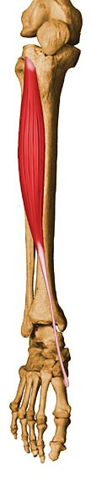 | Flexion | Tibia(lateral condyle and body), interosseus membrane | Medial cuneiform M1
Extensor Digitorum longus  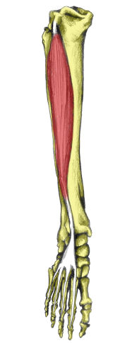 | Flexion | Tibia(lateral condyle) | Middle and distal phalanges of toes 2-5
Extensor hallucis longus  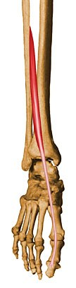 | Flexion | Fibular(ant. Surface), IML | Distal Phalanx of 1
Fibularis tertius  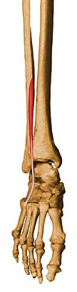 | Flexion | Fibular(ant. Surface), IML | M5(BASE)
Gastrocnemii(medial and lateral)  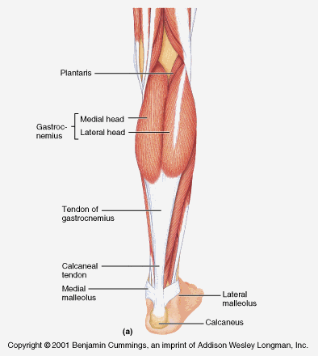 | Extension | Femur(lateral and medial condyles) | Calcaneus tendon(Achilles tendon)
Soleus  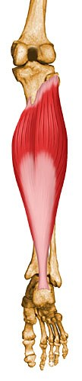 | Extension | Tibia(medial border) Fibula(head), MJ | Calcaneus(by calcaneal tendon)
Plantaris  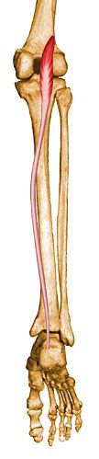 | Extension | Femur(lateral condyle) | Calcaneus(by calcaneus tendon)
Tibialis Posterior  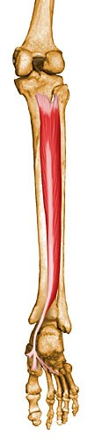 | EXTENSION | Tibia, fibular, MIJ | Tarsus bones, M2, M3, M4
Flexor hallucis longus  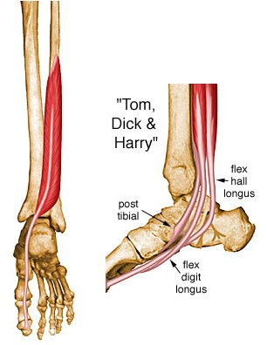 | Extension | Fibular(inferior 2/3) | Distal phalanx of 1
Flexor digitorum longus  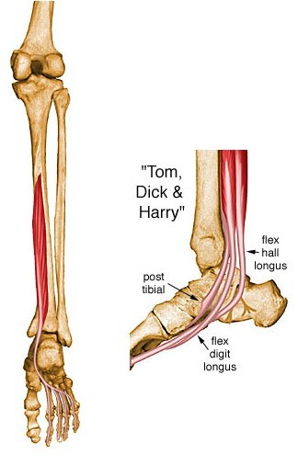 | Extension | Tibia(posterior surface) | Distal phalanges of toes 2-5
Fibularis(peroneus) longus  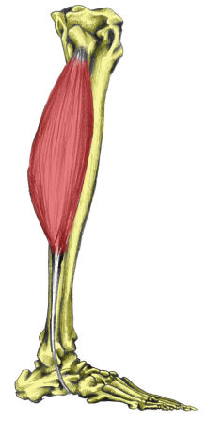 | Extension | Fibula(head and body) | M1, and medial cuneiform
Fibularis(peroneus) Brevis  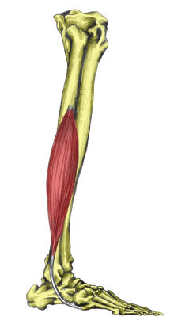 | Extension | Fibula(body) | M5(base)

