Experiment 1: Thin Layer Chromatography

Observations and Results:

The procedures used in this experiment are described on pages 16-18 of CHM 1321 Introductory Organic Chemistry, University of Ottawa, June 2013.

Part A involved developing and visualizing two TLC plates using an unknown sample #81. The solvent used was a 2:8 mixture of ethyl acetate and hexanes. The plates were prepared by drawing 3 equally spaced tic marks on a marked line near the bottom of the TLC plate and spotting specific lanes (labeled the reference, co-spot, and sample lane) with the reference solution and unknown sample #81. The two reference solutions used for part A were benzophenone and biphenyl. The TLC plates were placed in to a developing jar filled with approximately 10 mL of the solvent and allowed to develop. After they had developed and dried they were visualized under UV light.

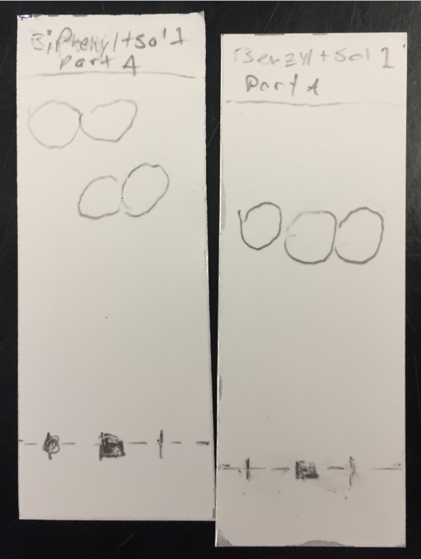
Figure 1: TLC plates for part A with solvent mixture 2:8 ethyl acetate to hexanes

In figure 1, from left to right, are the reference lane, the co-spot lane, and the sample lane. The TLC plate on the left used reference solution biphenyl and the one on the right used benzophenone.

 | Solvent Front Distance (D_{sf})/cm | Reference Solution Distance(D_{r})/cm | Sample Distance(D_{s})/cm | R_{f} Value of Reference Solution | R_{f} Value of Sample
TLC Plate 1:  Biphenyl | 4.9 | 4.2 | 3.2 | 0.86 | 0.65
TLC Plate 2:  Benzophenone | 4.8 | 3.0 | 3.0 | 0.63 | 0.63

Table 1: R_{f} values of unknown sample #81 and reference solutions

Based on the R_{f} values calculated above and from the TLC plates, unknown sample #81 must contain benzophenone because the reference solution spot and the sample spot eluted the same distance with the solvent.

Part B of the experiment involved following the same procedure as described in part A. 4 TLC plates were prepared in total. The first 2 TLC plates were developed using 10 mL of ethyl acetate as the solvent and benzophenone and biphenyl as the reference solutions.

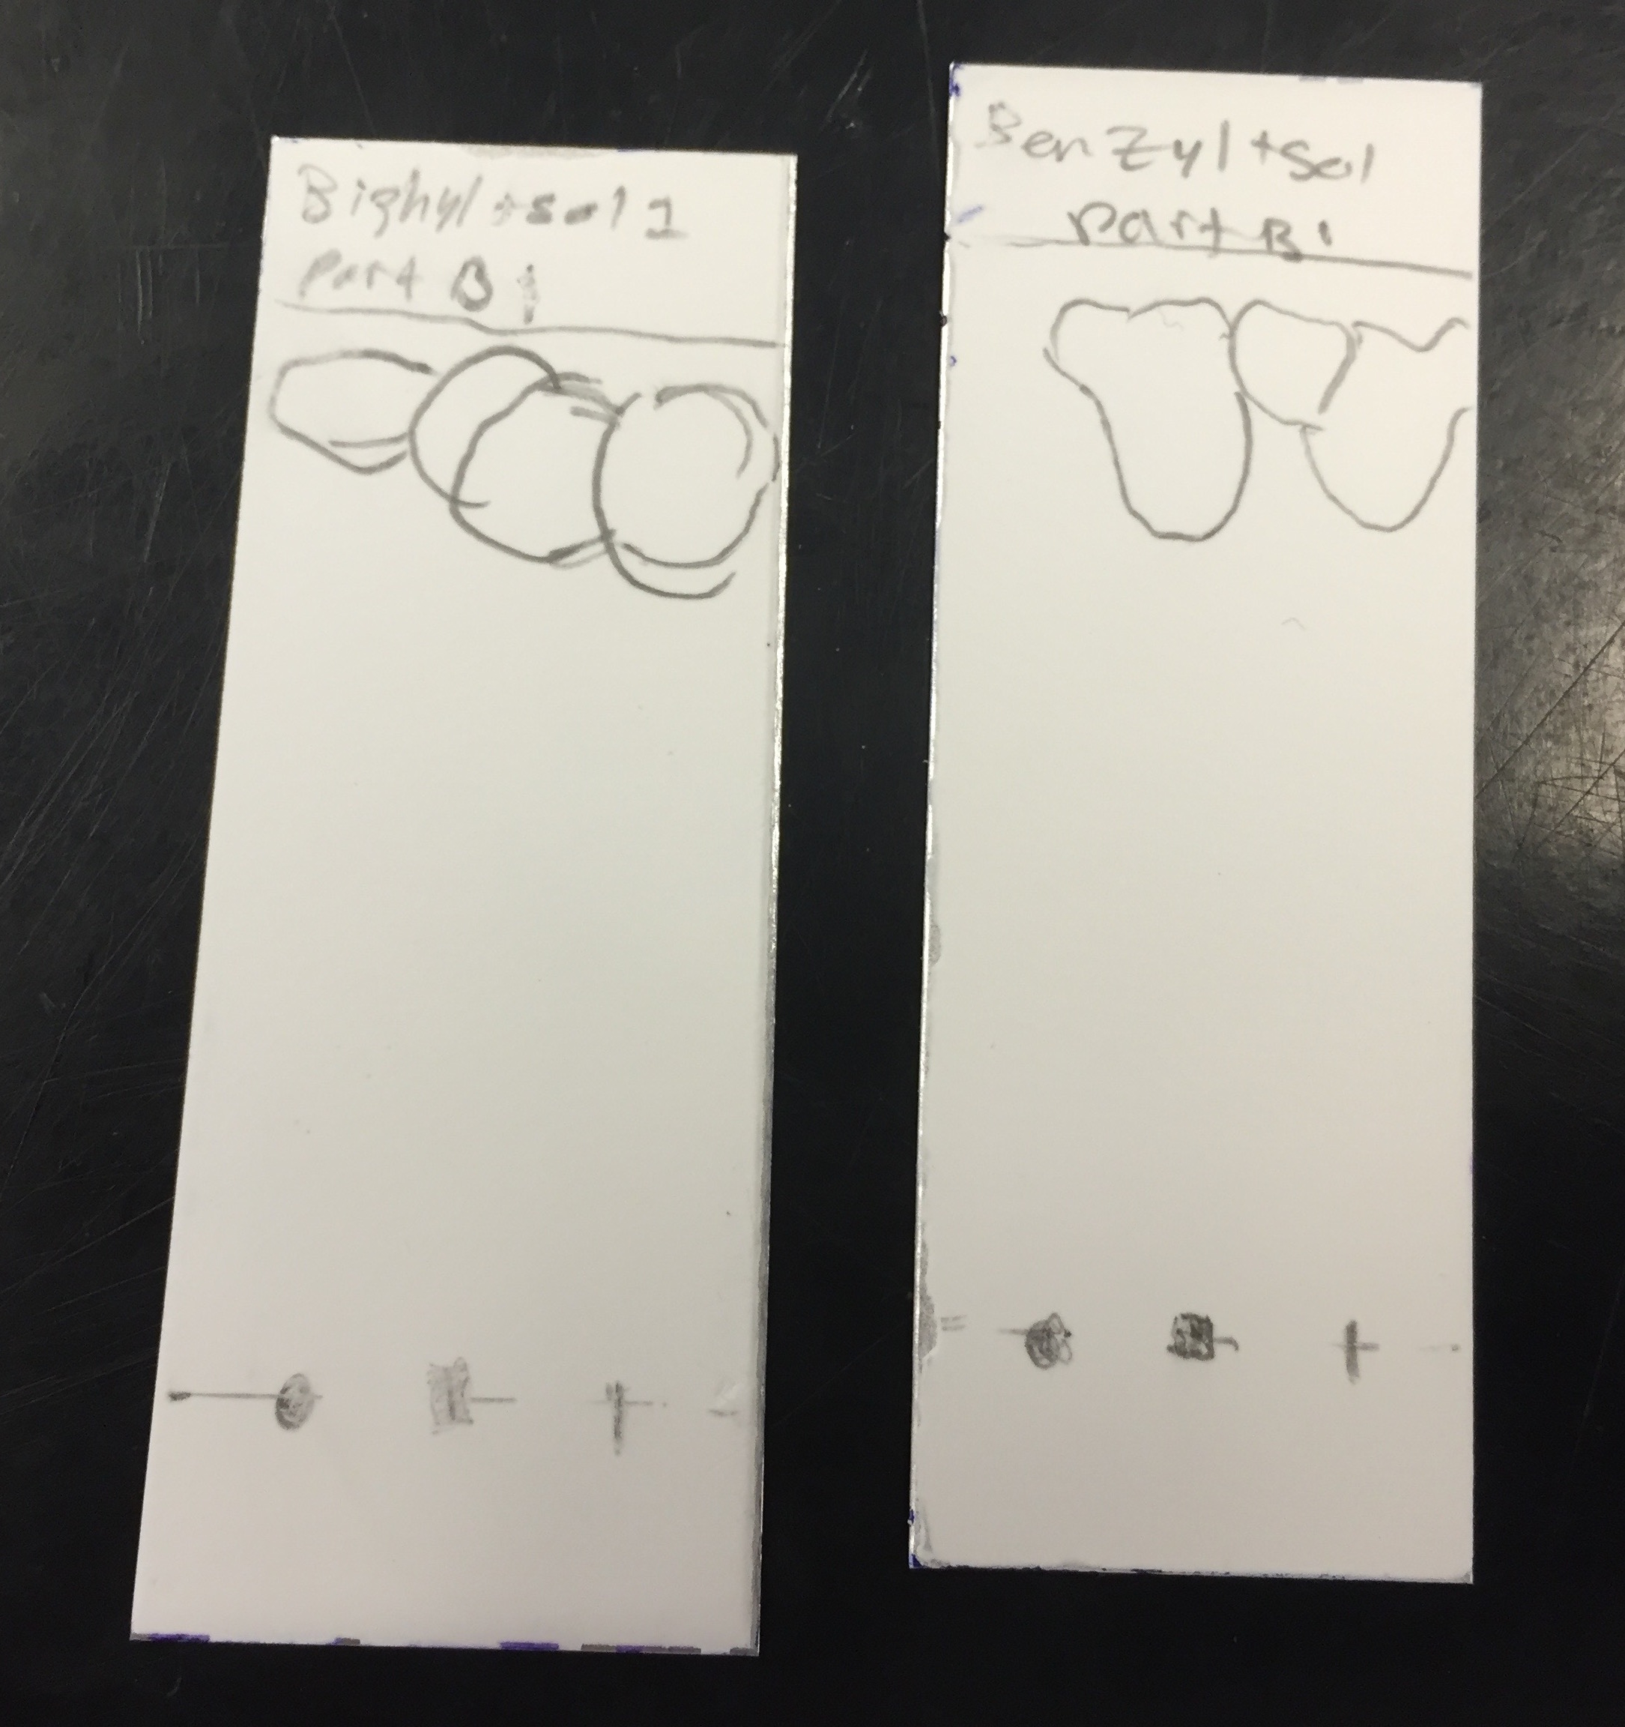
Figure 2: TLC plates for part B with ethyl acetate as the solvent

Figure 2 shows the TLC plates for part B with ethyl acetate as the solvent. The TLC plate on the left used biphenyl as the reference solution and benzophenone was used for the TLC plate on the right.

 | Solvent Front Distance (D_{sf})/cm | Reference Solution Distance(D_{r})/cm | Sample Distance(D_{s})/cm | R_{f} Value of Reference Solution | R_{f} Value of Sample
TLC Plate 1:  Biphenyl | 4.9 | 4.3 | 4.3 | 0.88 | 0.88
TLC Plate 2:  Benzophenone | 4.8 | 4.1 | 4.1 | 0.85 | 0.85

Table 2: TLC values of unknown sample #81 and reference solutions

Based on the R_{f} values calculated above and the TLC plates, it can be determined that ethyl acetate was not able to separate the compounds in the unknown sample as it eluted with it up the TLC plate. This is because of the high polarity of the solvent.

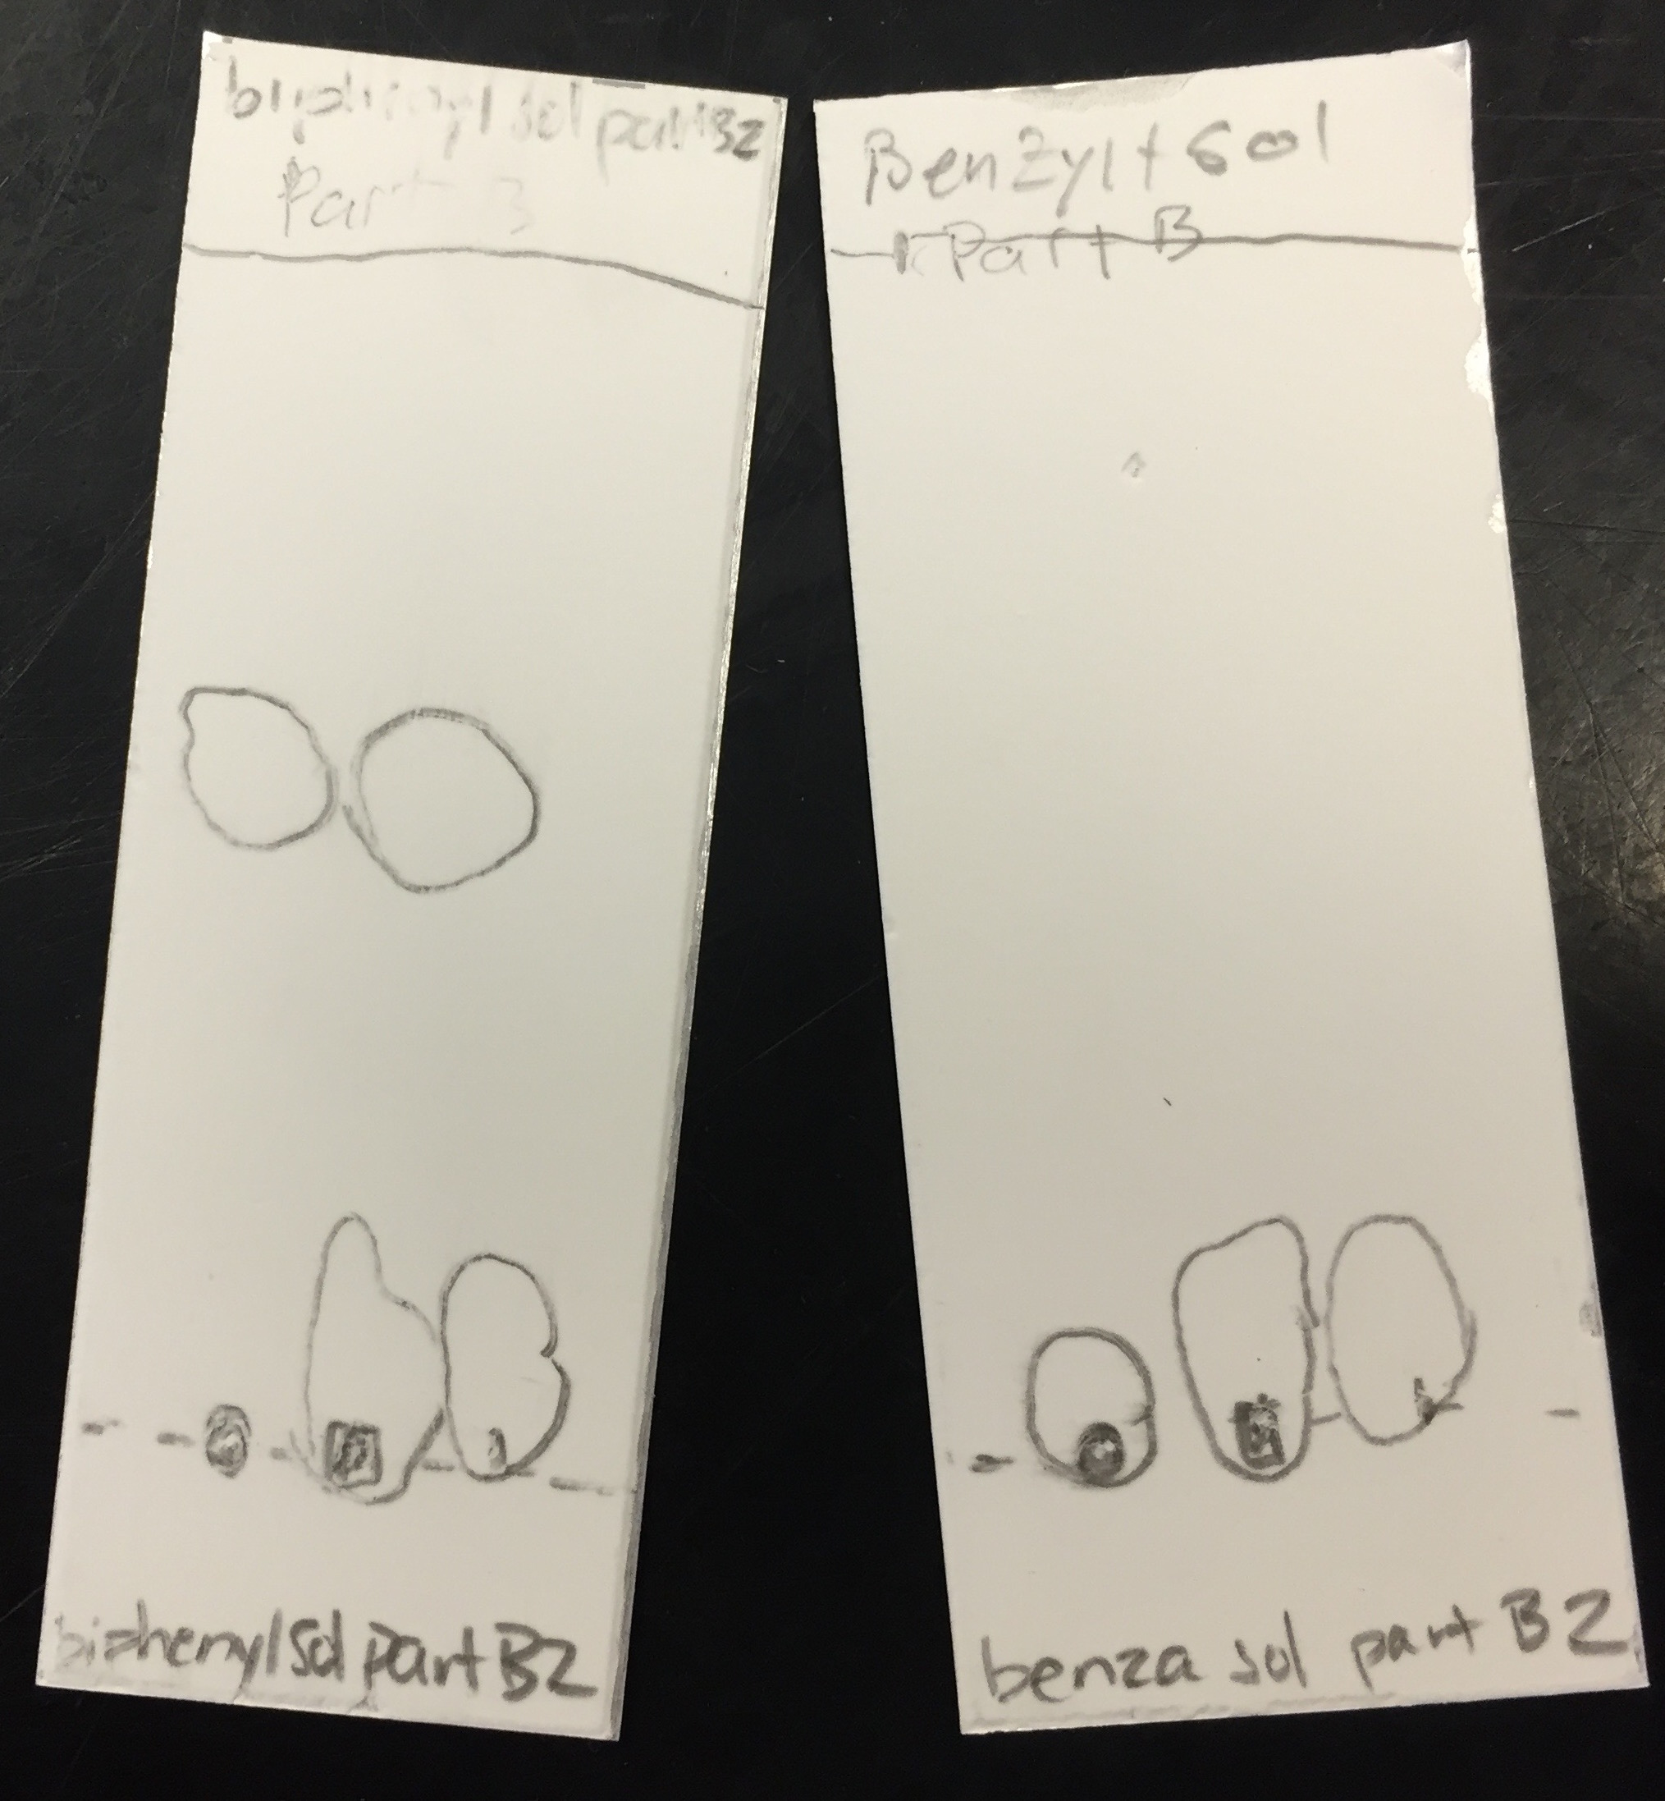
The following 2 TLC plates were developed using 10 mL of hexanes as the solvent and benzophenone and biphenyl as the reference solutions. It followed the same procedure as previously described in part A to prepare the TLC plates.

Figure 3: TLC plates for part B with hexanes as the solvent

Figure 3 shows the TLC plates for part B with hexanes as the solvent. The plate on the left used biphenyl as the reference solution. The plate on the right used benzophenone as the reference solution.

 | Solvent Front Distance (D_{sf})/cm | Reference Solution Distance(D_{r})/cm | Sample Distance(D_{s})/cm | R_{f} Value of Reference Solution | R_{f} Value of Sample
TLC Plate 1:  Biphenyl | 4.8 | 2.6 | 0.3 | 0.54 | 0.063
TLC Plate 2:  Benzophenone | 4.9 | 0.3 | 0.3 | 0.061 | 0.061

Table 3: R_{f} values of the unknown sample #81 and reference solutions

Based on the calculated R_{f} values and the TLC plates, it can be determined that the hexane solvent was unable to elute the solutions up the plate or separate the compounds in the solution. This is due to the low polarity of the hexane solvent.

Part C involved developing 3 TLC plates, one each with reference solutions o-bromonitrobenzene, p-bromonitrobenzene, and m-bromonitrobenzene, using a solvent mixture of 9:1 hexanes to ethyl acetate. The purpose of this part was to determine the presence of these compounds in an unknown mixture, sample ZZ.

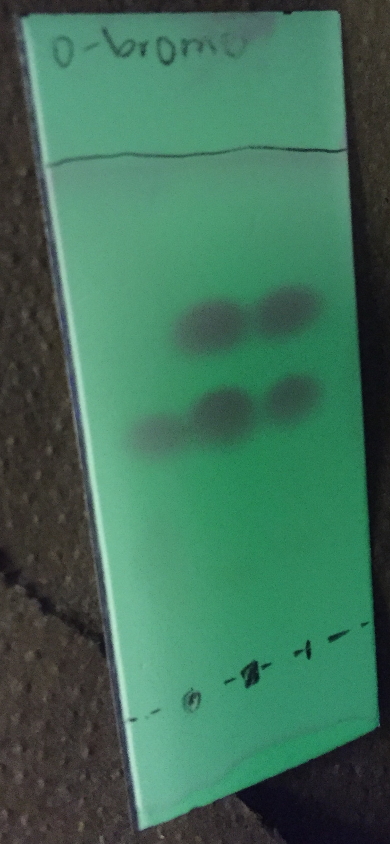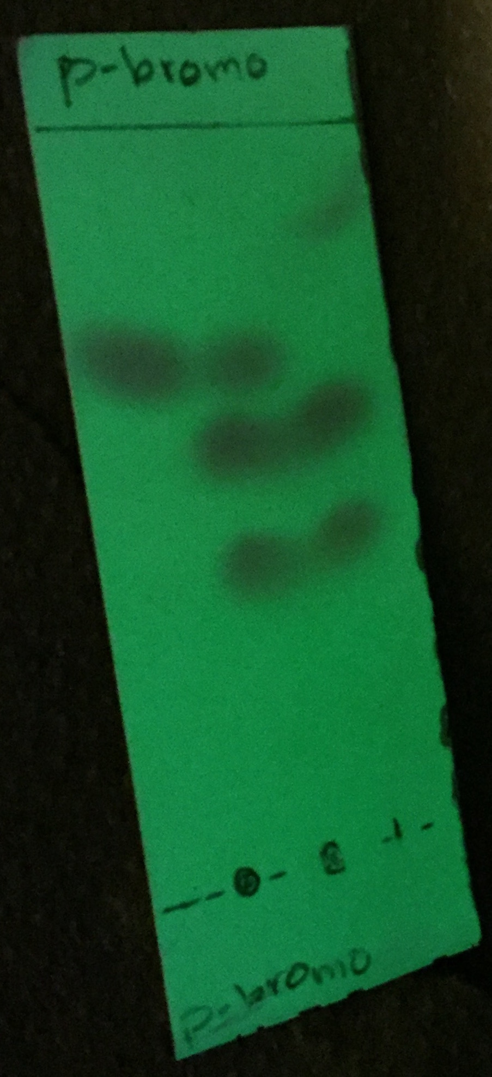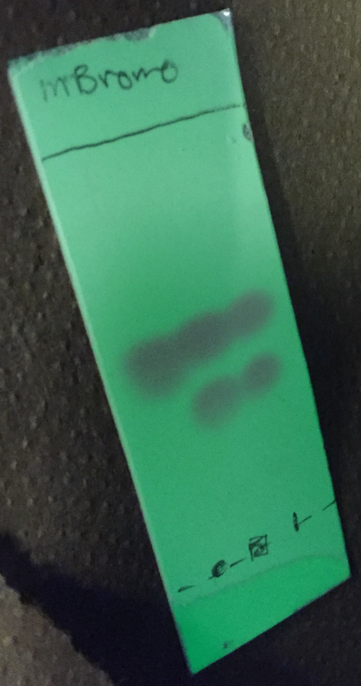
Figure 4: TLC plates for part C with solvent mixture 9:1 hexanes to ethyl acetate

Figure 4 shows the TLC plates developed in part C of the experiment with a solvent mixture of 9:1 hexanes to ethyl acetate. The reference solution for each plate from left to right were o-bromonitrobenzene, p-bromonitrobenzene, and m-bromonitrobenzene.

 | Solvent Front Distance (D_{sf})/cm | Reference Solution Distance(D_{r})/cm | Sample Distance(D_{s})  /cm | R_{f} Value of Reference Solution | R_{f} Value of Sample
TLC Plate 1:  o-bromonitrobenzene | 4.5 | 2.3 | 2.3 | 0.51 | 0.51
TLC Plate 2:  p-bromonitrobenzene | 4.9 | 3.5 | 2.9, 2.1 | 0.71 | 0.59, 0.42
TLC Plate 3:  m-bromonitrobenzene | 4.7 | 2.5 | 2.5 | 0.53 | 0.53
Table 4: R_{f} values of the unknown sample ZZ and the reference solutions

Based on the calculated R_{f} values and the TLC plates, it can be determined that the unknown sample ZZ must contain a mixture of compounds of m-bromonitrobenzene and o-bromonitrobenzene. This is because the R_{f} values for the reference solution spots and sample spots are the same on the TLC plates for these solutions, meaning they eluted the same distance and must be the same compound.

The equation used to calculate the above R_{f} values is:

R_{f} = D_{x}
D_{sf}

Where D_{x} represents the distance travelled by the spotted solution and D_{sf} represents the distance travelled by the solvent.

Discussion:
In this experiment it was observed that polar and non-polar molecules travel at different rates on a TLC plate. Polar molecules are attracted more to the stationary phase than the mobile phase, the solvent, so they move more slowly up the plate. This means they have a smaller R_{f} value. Non-polar molecules are more attracted to the solvent than the stationary phase so they move more quickly up the plate. This results in a large R_{f} value. The stationary phase remained constant throughout the experiment while the mobile phase was changed. This allowed us to focus on the difference the solvent could make in the movement of molecules and the different rates at which molecules elute in different solvents.

In part A a solvent mixture of 2:8 ethyl acetate to hexanes was used with reference solutions benzophenone and biphenyl. As seen in figure 1 the reference and sample spots travelled the same distance on the benzophenone plate, meaning they will have the same R_{f} values. This means that the unknown sample #81 must contain benzophenone.

In part B two solvents were used. Ethyl acetate was used as a solvent first with the same reference solutions as in part A. As seen in figure 2, the reference solutions and the sample travelled up the plate with the solvent but the ethyl acetate was unable to separate the compound. This is due to the high polarity of the ethyl acetate. The other solvent used for part B was hexanes. The same reference solutions from part A were also used for this part of the experiment. As seen in figure 3, the hexane solvent did not separate the compounds and did not move the compounds up the plate at all. This was due to the low polarity of hexane.

In part C a 9:1 mixture of hexanes to ethyl acetate was used as a solvent. The reference solutions used were o-bromonitrobenzene, p-bromonitrobenzene, and m-bromonitrobenzene and the sample used was an unknown sample ZZ. Each reference solution was used on one TLC plate. As seen in figure 4, the sample spot and reference solution spot travelled the same distance on the o-bromonitrobenzene and m-bromonitrobenzene plates. This means they have the same R_{f} values and the unknown sample ZZ must contain both o-bromonitrobenzene and m-bromonitrobenzene.

Questions:

1) By increasing the polarity of the solvent system, both the polar and non-polar compounds will become more attracted to the solvent than the stationary phase, the silica gel in our experiment. This will cause the compounds to elute more quickly and farther up the TLC plate. Sometimes a non-polar compound is too strongly attracted to the solvent and moves too quickly up the TLC plate. This is why mixed solvents of non-polar and polar solvents are useful in order to allow the time for the compound to separate and elute.

2)
a) Benzyl alcohol is most likely to use hydrogen bonding, making it the most polar, which means it will have the smallest R_{f} value.
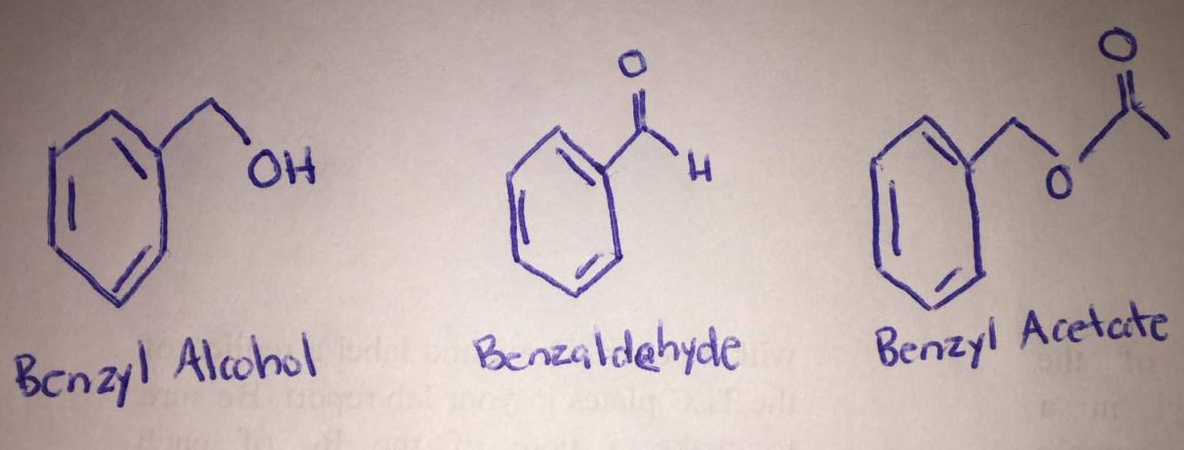
b) Aniline is most likely to use hydrogen bonding, which means it is the most polar and will have the smallest R_{f} value.
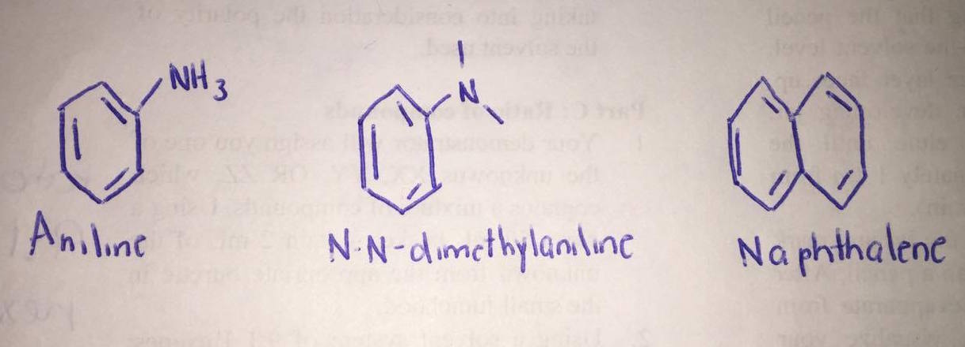

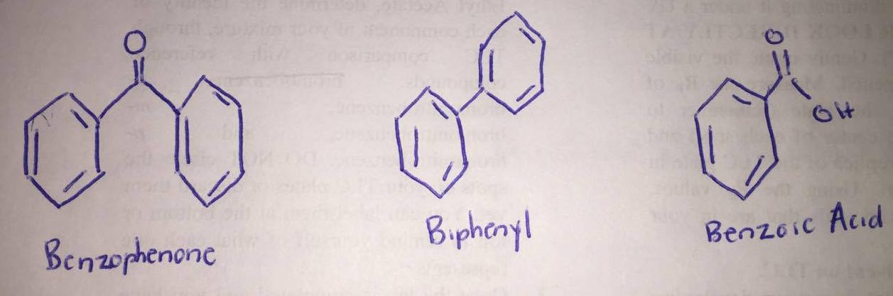
c) Benzoic Acid is most likely to use hydrogen bonding. This means it is most polar and will have the smallest R_{f} value.

